Australian Capital Territory

Heritage (Decision about Provisional Registration of Fitters’ Workshop (acoustic values), Kingston) Notice 2021

**Notifiable instrument NI2021–671**

made under the

Heritage Act 2004, s 34 (Notice of decision about provisional registration)

**1 Name of instrument**

This instrument is the *Heritage (Decision about Provisional Registration of Fitters’ Workshop (acoustic values), Kingston) Notice 2021*.

**2 Decision about provisional registration**

On 11 November 2021, the ACT Heritage Council (the ***Heritage Council***) decided not to provisionally register Fitters’ Workshop (acoustic values), Block 15, Section 49, Kingston (the ***Place***).

**3 Description of the Place**

The description of the Place is in the schedule.

**4 Reasons for the decision**

The Heritage Council is not satisfied on reasonable grounds that the Place is likely to have heritage significance as defined by section 10 of the *Heritage Act 2004*. A detailed statement of reasons, including an assessment against the heritage significance criteria, is provided in the schedule.

**5 Date decision takes effect**

The decision not to provisionally register the Place takes effect on 12 November 2021 (being the day after the Heritage Council made its decision in writing as set out in the schedule).

Edwina Jans  
A/g Secretary (as delegate for)  
ACT Heritage Council

11 November 2021



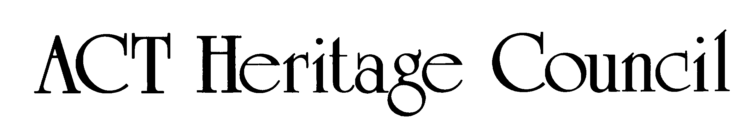

STATEMENT OF REASONS

DECISION NOT TO PROVISIONALLY REGISTER

Fitters’ Workshop (acoustic values)WamboinName of Place

BLOCK 15 SECTION 49, Kingston

IN THE ACT HERITAGE REGISTER

In accordance with s 32 of the *Heritage Act 2004,* the ACT Heritage Council has decided not to provisionally register the Fitters’ Workshop (acoustic values), Kingston. This Statement of Reasons provides an assessment of the Fitters’ Workshop (acoustic values), Kingston, and finds that the place does not meet any of the criteria under s 10 of the *Heritage Act 2004.*

The Fitters’ Workshop is already a registered place included in the Kingston Power House Historic Precinct. This assessment is only considering if the acoustic values of the building should be added as a significant heritage feature and this document should be read as an addendum to the existing Kingston Power House Historic Precinct decision. This decision does not impact upon or change the original register entry and the Fitters’ Workshop remains a registered place.

The Council does not dispute the particular excellent acoustic properties of the Fitters’ Workshop; but what is under consideration is whether these values are heritage values and if they are particular aesthetic characteristics that are both important and valued by the community or a cultural group. The acoustic values of the Fitters’ Workshop are a recent discovery and incidental to its design and function. What has been shown is that it is a special place for certain types of musical performance and with the fullness of time this may develop beyond the amenity value of ideal acoustic patterns into a true enduring connection to place that may lead to a reassessment of the heritage values in the future. However, at this time, the Council has found that the acoustic values of the Fitters’ Workshop do not pass any of the thresholds against the significance criteria under s 10 of the *Heritage Act 2004* and therefore cannot be added to the existing heritage significance of the place.

This statement refers to the location of the place as required in s 34 (5) (b) (ii) of the *Heritage Act 2004*.

**LOCATION OF THE PLACE**

The Fitters’ Workshop, Block 15 Section 49 (proposed Block 38 Section 50), 11 Wentworth Avenue, Kingston.

This section refers to the description of the place as required in s 34 (5) (b) (iii) of the *Heritage Act 2004*. The boundary of the place and extent of features listed below is illustrated at Image 1.

**DESCRIPTION OF THE PLACE**

The Fitters’ Workshop (acoustic values), consisting of the following attributes:

* The acoustic characteristics of the internal volume of open space.

This statement refers to the Council’s reasons for its decision as required in s 34 (5) (b) (iv) of the *Heritage Act 2004*.

**REASONS FOR DECISION**

The Council is not satisfied on reasonable grounds that the place is likely to have heritage significance as defined by s 10 of the *Heritage Act 2004*.

This statement refers to the Council’s assessment of the place against the heritage significance criteria as a part of its reasons for its decision as required in s 34 (5) (b) (v) of the *Heritage Act 2004*.

**ASSESSMENT AGAINST THE HERITAGE SIGNIFICANCE CRITERIA**

The Council’s assessment against the criteria specified in s 10 of the *Heritage Act 2004* is as follows.

In assessing the heritage significance of the Fitters’ Workshop (acoustic values), Kingston, the Council considered:

* the original nomination and documentary evidence supplied by the nominator;
* the Council’s *Heritage Assessment Policy* (March 2018); and
* the existing Heritage Register entry for the Kingston Powerhouse Historic Precinct, which includes the Fitters’ Workshop.

Pursuant to s 10 of the *Heritage Act* *2004*,a place or object has heritage significance if it satisfies one or more of the following criteria. Future research may alter the findings of this assessment.

1. importance to the course or pattern of the ACT’s cultural or natural history;

The Council has assessed the Fitters’ Workshop (acoustic values) against criterion (a) and is not satisfied that the place meets this criterion.

The Fitters’ Workshop and the surrounding Kingston Powerhouse Historic Precinct that it is a part of have been important to the course of the ACT’s cultural history as the place that first provided power to the ACT and as an early source of employment and materials in the newly formed capital. Since that time, it has also been important as a landmark being prominently sited in the centre of Canberra and being part of a precinct that has changed over time and is only recently being utilised for its social and other economic purposes. Its use from 2009 as an acoustic venue is one of the more recent revelations of the place that has the potential to add further importance to the place’s contribution to the ACT’s cultural heritage, however it is not yet clear if this is an enduring feature of the place that will have a lasting effect on the course of pattern of the ACT’s cultural history. As such, the acoustic values of the place have not been demonstrated to be important enough, i.e. they have not been demonstrated to be strong enough to pass the threshold for inclusion under this criterion, in terms of their effect on the course or pattern of the ACT’s cultural history. This may change in time.

1. has uncommon, rare or endangered aspects of the ACT’s cultural or natural history;

The Council has assessed the Fitters’ Workshop (acoustic values) against criterion (b) and is not satisfied that the place meets this criterion.

The Fitters’ Workshop has been nominated as a venue with unique acoustic values; however the Council considers this to be too specific a classifier (almost any place can be considered uncommon, rare or endangered if given too narrow a definition) and note that a more appropriate descriptor would be as a live music venue if focusing purely on its nominated acoustic values. It was noted in a 2 June 2011 letter to Ms Joy Birch MLA as the Minister for the Arts that “…it is often difficult for Canberra choirs to find suitable performance venues…the Fitters’ Workshop offers an opportunity to solve these problems…importantly, *no* Canberra venue has or will have an acoustic comparable…”. It has been described as the best place in Canberra for specific types of music, notably unamplified live music that benefits from reverberation, such as choral music for smaller audiences up to 300 people. The nomination documentation makes comparisons with church spaces for similar performances, but notes that they are not as well proportioned to produce the desired acoustic effect. However being the best example of a type of place does not make it rare. The place may have great amenity value in the quality of sound it produces and its size, location and other attributes, but there are other venues and the relatively recent use of the Fitters’ Workshop as a music venue limits its ability to be placed within the ACT’s cultural history for comparative rareness. As such, it cannot be said to have uncommon, rare or endangered aspects of the ACT’s cultural history.

1. potential to yield important information that will contribute to an understanding of the ACT’s cultural or natural history;

The Council has assessed the Fitters’ Workshop (acoustic values) against criterion (c) and is not satisfied that the place meets this criterion.

The discovery of incidental acoustic properties for performance in a previously industrial manufacturing place is unlikely to have any potential to yield important information that will contribute to an understanding of the ACT’s cultural history.

1. importance in demonstrating the principal characteristics of a class of cultural or natural places or objects;

The Council has assessed the Fitters’ Workshop (acoustic values) against criterion (d) and is not satisfied that the place meets this criterion.

The Fitters’ Workshop demonstrates the dimensions in the proper proportions and hard surfaces required to produce an acoustic volume that produces desired reverberation evenly across the listening area. However, this single characteristic is not an important feature of industrial buildings nor has it been shown to demonstrate the principal aspects of a class of ACT cultural places, so it has yet to meet an important requirement of this criterion. This may change in the future at which point it can be revisited with new information.

1. importance in exhibiting particular aesthetic characteristics valued by the ACT community or a cultural group in the ACT;

The Council has assessed the Fitters’ Workshop (acoustic values) against criterion (e) and is not satisfied that the place meets this criterion.

The Fitters’ Workshop exhibits a particular aesthetic characteristic, in this case an exceptional auditory quality characterised by the internal volume and its ability to evenly reverberate certain types of unamplified music in a euphonious manner, that is valued by a section of the community. However good the acoustic values of the space are, in order to meet this criterion those characteristics must be valued by the ACT community or a cultural group within the ACT.

The Council notes that the ‘ACT community’ encompasses the broad community of the ACT, across the full geographical context, and a broad spectrum of society; while ‘a cultural group’ has a narrower focus, taken to be a ‘group of people within a society with a shared ethnic or cultural background’ or ‘a group of people connected through the same way of living, which has been transmitted from one generation to another’. The definition specifically precludes professional organisations or special interest groups, so for this criterion the musical community and the National Trust cannot be considered to be representative of the ACT Community nor do they represent a cultural group in the ACT.

1. importance in demonstrating a high degree of creative or technical achievement for a particular period;

The Council has assessed the Fitters’ Workshop (acoustic values) against criterion (f) and is not satisfied that the place meets this criterion.

The acoustic values of the Fitters’ Workshop are incidental to its design and later modifications and cannot be demonstrative of a creative or technical achievement.

1. has a strong or special association with the ACT community, or a cultural group in the ACT for social, cultural or spiritual reasons;

The Council has assessed the Fitters’ Workshop (acoustic values) against criterion (g) and is not satisfied that the place meets this criterion.

Parts of the ACT’s musical community feel very strongly about preserving the acoustic qualities of the Fitters’ Workshop as a performance venue. However, this does not necessarily translate into heritage values for a place, but rather as an amenity value that may over time become part of the heritage of a place and it is this enduring connection to place that is currently missing.

Regardless, the other important condition of this criterion is that the association of the place must be to the ACT Community or a cultural group in the ACT which is not fulfilled by either the musical community or heritage groups. The Council notes that the ‘ACT community’ encompasses the broad community of the ACT, across the full geographical context, and a broad spectrum of society; while ‘a cultural group’ has a narrower focus, taken to be a ‘group of people within a society with a shared ethnic or cultural background’ or ‘a group of people connected through the same way of living, which has been transmitted from one generation to another’. The definition specifically precludes professional organisations or special interest groups, so for this criterion the musical community and the National Trust cannot be considered representative of the ACT Community nor do they represent a cultural group in the ACT.

1. has a special association with the life or work of a person, or people, important to the history of the ACT.

The Council has assessed the Fitters’ Workshop (acoustic values) against criterion (h) and is not satisfied that the place meets this criterion.

The acoustic values of the Fitters’ Workshop are a relatively recent and incidental discovery and do not yet have a special association with the life or work of a person, or people, important to the history of the ACT. Several people within the ACT’s musical community and acoustic experts have indicated that the place has special acoustic properties favourable to particular types of musical performance, which may lead to certain performers or groups forming a special association with the place over time. However, with just over a decade of the space being utilised for this purpose the acoustic values of the Fitters’ Workshop cannot be said to have a special or enduring association with anyone at this time. Additionally, anyone who is important to the history of the ACT can have only had a short connection with the place and any assessment of how special it is to their life’s work cannot yet be assessed.

SITE PLAN

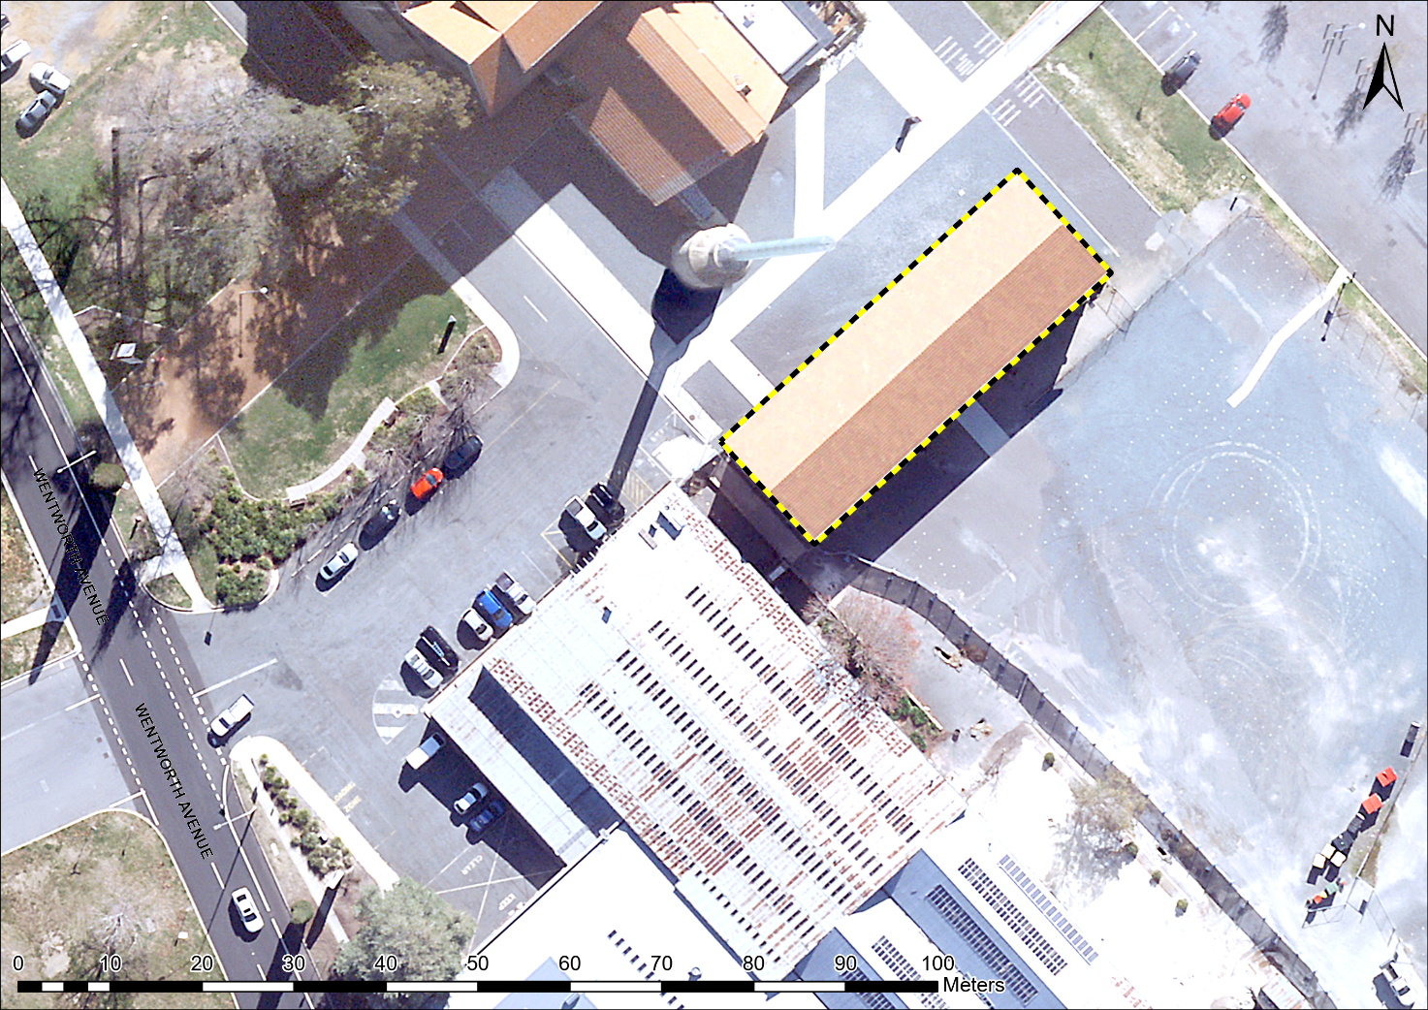

Image 1 the Fitters’ Workshop (acoustic values) site boundary