Australian Capital Territory
Liquor (Temporary Alcohol-Free Place) Declaration 2021 (No 1)
Notifiable instrument NI2021-780
made under the
Liquor Act 2010, s 198 (alcohol-free places)

1 Name of instrument
This instrument is the Liquor (Temporary Alcohol-Free Place) Declaration 2021(No 1).
2 Commencement
This instrument commences at 7am on 6 January 2022.
3 Declaration
I declare the following locations as temporary alcohol-free areas from 7am on 6 January 2022 to 5pm on 9 January 2022:
  - The Federal Highway within the Australian Capital Territory;
  - Northbourne Avenue, north of the southernmost point of its intersection with Macarthur Avenue and Wakefield Avenue;
  - The hatched area shown on the attached map in Attachment 1 that is within the heavy black line on the map and is a public place.
  - Any unleased land adjoining a public place mentioned in paragraphs a) to c).
But excluding:
  - The areas designated for Summernats 34, highlighted by the bold red line on the map at Attachment 2.
  - licensed premises or permitted premises; or
  - premises where food is sold for consumption at the premises; or
  - at a place that is within 50m from premises mentioned in paragraph (f) or (g) by a person using furniture or other facilities provided by the proprietor or lessee of the premises.
4 Expiry
This instrument expires at 5pm on 9 January 2022.

Derise Cubin
Commissioner for Fair Trading
20 December 2021
Attachment 1
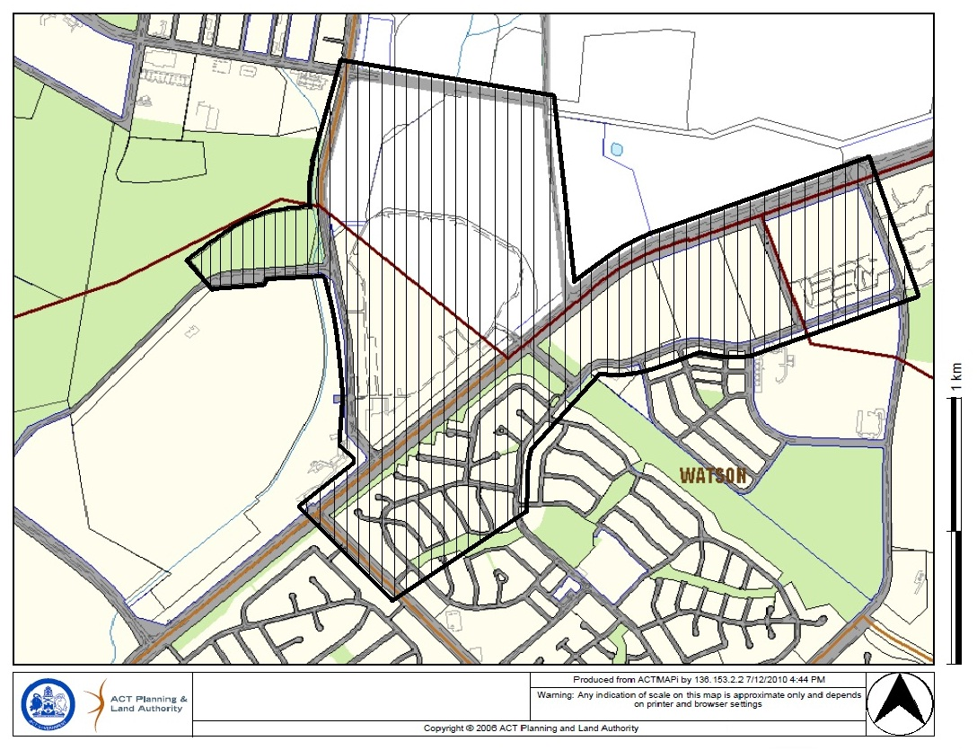

Attachment 2
