Australian Capital Territory

Nature Conservation (Closed Reserves) Declaration 2022 (No 2)

Notifiable instrument NI2022–287
made under the
Nature Conservation Act 2014, s 259 (Conservator may close reserve)

1 Name of instrument
This instrument is the Nature Conservation (Closed Reserves) Declaration 2022 (No 2).

2 Commencement
This instrument commences on 23 May 2022.

3 Declaration
I declare that public access to:
- the reserves mentioned in schedule 1; and
- those parts of Mount Ainslie Nature Reserve and Red Hill Nature Reserve indicated in the maps at schedule 2,
is prohibited during the closure times mentioned in schedule 3.

4 Exceptions
Section 3 does not apply to:
- a conservation officer exercising a function under the Act within the areas declared under section 3 (closed reserves); or
- a person who is implementing the Nature Conservation (Eastern Grey Kangaroo) Controlled Native Species Management Plan 2017 (DI2017-37) within the closed reserves and is:
  - contracted by the Territory to do so; or
  - authorised in writing to do so by the custodian of the reserve accessed by the person.

5 Expiry
This instrument expires on 31 July 2022.
Fiona Wright
Acting Conservator of Flora and Fauna
20 May 2022
Schedule 1 Reserves fully closed
(see s 3)

Reserves

Callum Brae Nature Reserve
Isaacs Ridge Nature Reserve
Mount Majura Nature Reserve
Mount Mugga Mugga Nature Reserve
Jerrabomberra West Grasslands Nature Reserve

Schedule 2 Reserves partially closed
(see s 3)
Mount Ainslie Nature Reserve
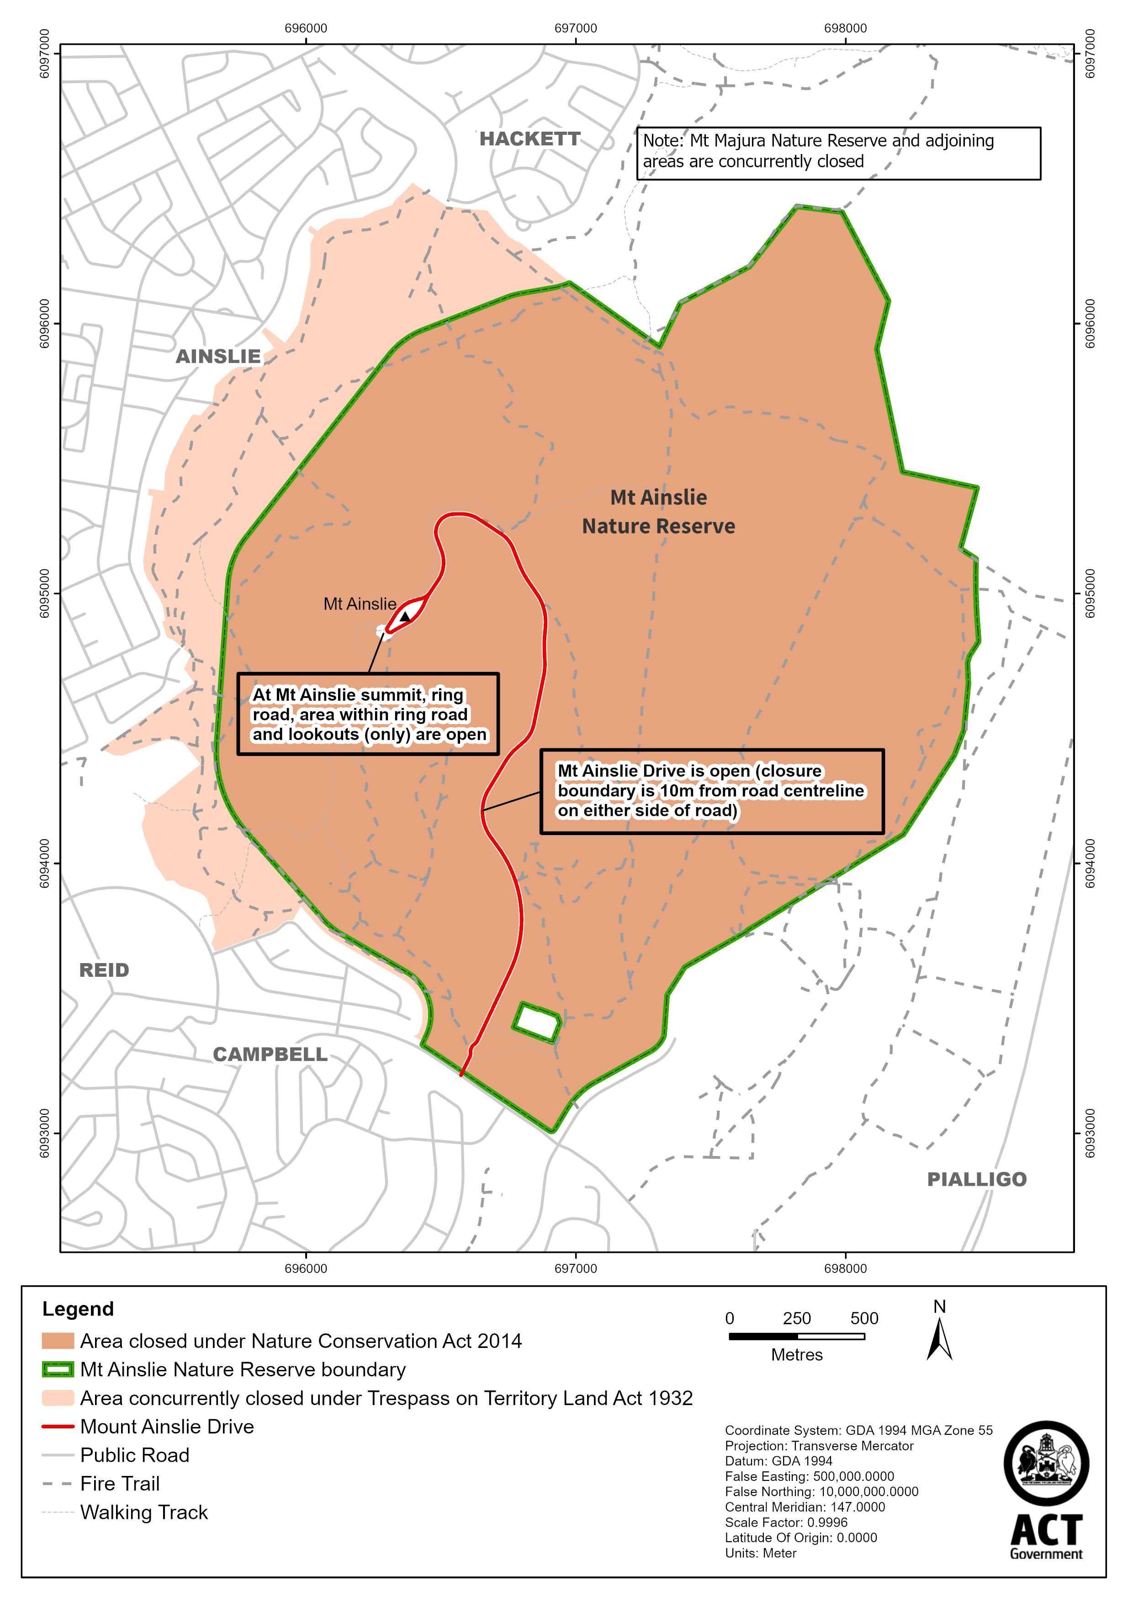
Red Hill Nature Reserve
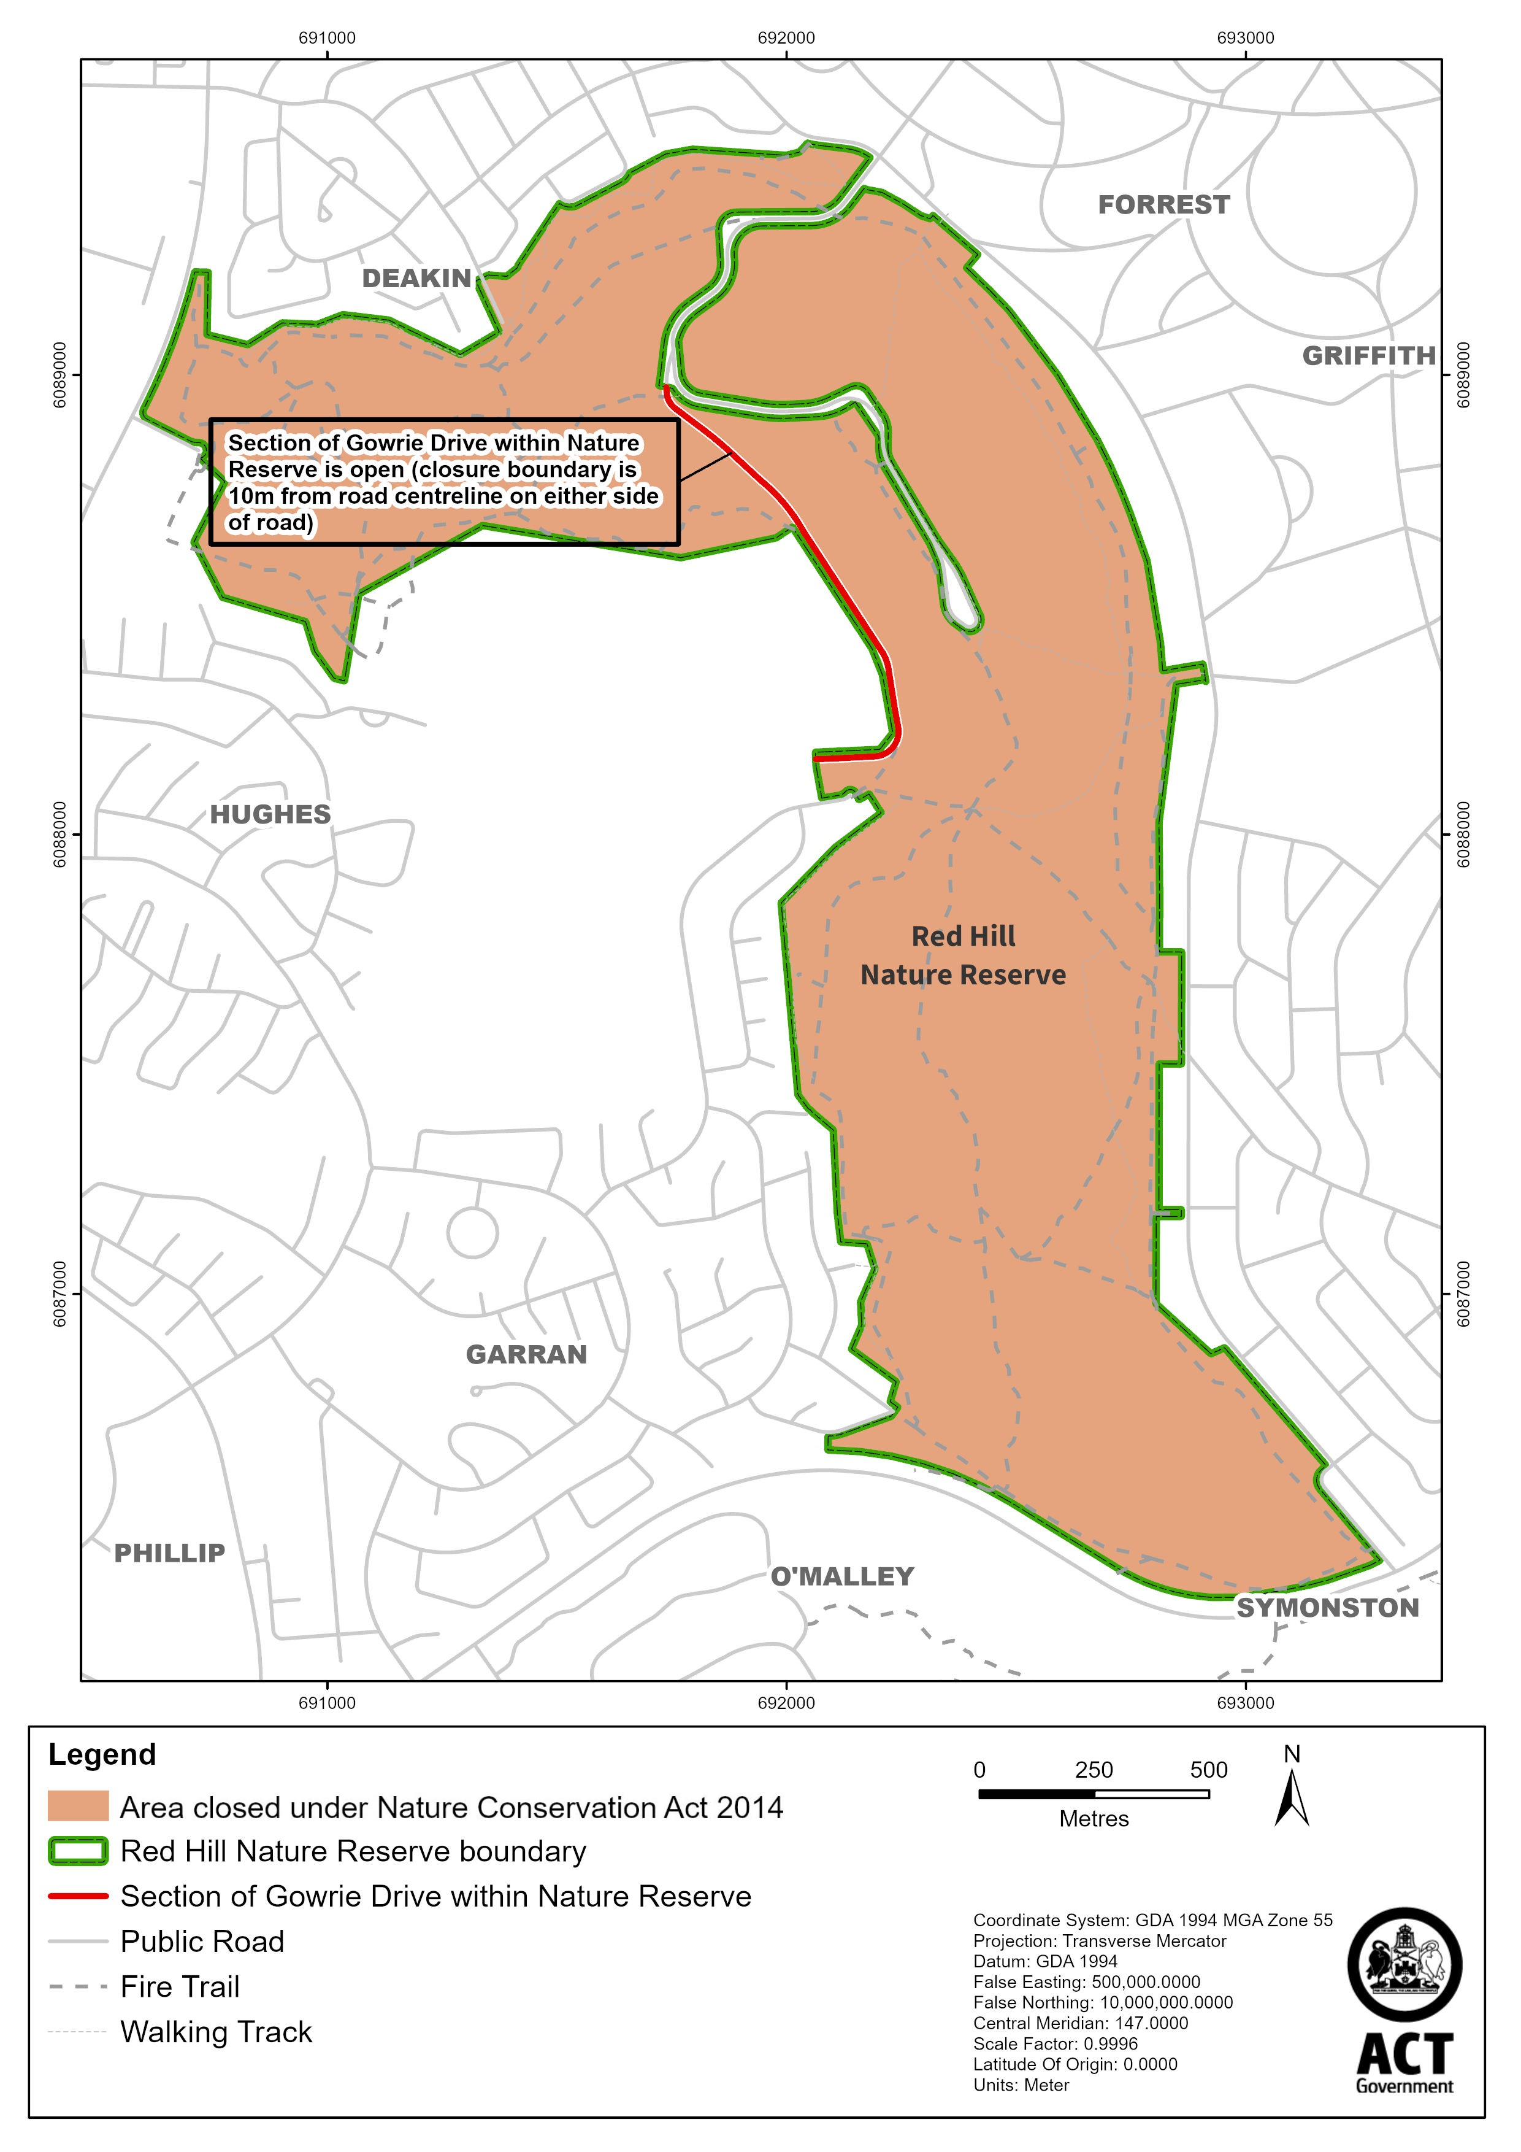
Schedule 3 Closure times
(see s 3)

Times when public access is prohibited

Beginning at 6:00 pm every Sunday, Monday, Tuesday, Wednesday and Thursday evening and ending on the following morning at 7:00 am during the period beginning on Monday, 23 May 2022 and ending on Sunday, 31 July 2022.

