Australian Capital Territory
Planning and Development (Draft Variation 380) Consultation Notice 2022
Notifiable instrument NI2022—514
made under the
Planning and Development Act 2007, s 63 (Public consultation—notification)

- Name of instrument
This instrument is the Planning and Development (Draft Variation 380) Consultation Notice 2022.
- Draft variation to the Territory Plan
The planning and land authority (the Authority) has prepared a draft plan variation 380 – Deakin Office Park and Public Open Space Deakin section 66 and section 78 block 13 (the draft variation) to vary the Territory Plan. The draft variation proposes to amend the Territory Plan and Map to rezone and incorporate Deakin section 66 blocks 2 and 6 into the Deakin office area under the Deakin Precinct Map and Code. It proposes to rezone and include Deakin section 66 blocks 7 and 8 and section 78 block 13 into the surrounding urban open space network. It is also proposed to add the urban open space zoned land into the ‘pc – nature reserve’ public land overlay. This will allow the land to be formally incorporated into the adjoining Red Hill Nature Reserve.
- Documents available for public inspection
(1) The Authority gives notice that the following documents are available for public inspection and purchase:
(a) the draft variation; and
(b) the background papers relating to the draft variation.
(2) Copies of the documents mentioned in section 3 (1) are available for inspection and purchase at Access Canberra, Land Planning and Building Services Shopfront, 8 Darling Street Mitchell ACT, Monday to Friday (except public holidays) between 8:30am and 4:30pm for the period commencing on the day this notice commences and ending on 25 November 2022 (the consultation period).
(3) Copies of the documents mentioned in section 3 (1) are also available for inspection during the consultation period online at www.act.gov.au/draftvariations.
- Invitation to give written comments
(1) The Authority invites written comments about the draft variation during the consultation period. Comments should include reference to the draft variation and be addressed to the Territory Plan Section of the Environment, Planning and Sustainable Development Directorate (EPSDD). Please also provide your name and contact details to assist in the assessment of the comments provided and to enable the Authority to contact you in relation to your comments, if required.
(2) Written comments should be provided to the Authority by:
(a) email to terrplan@act.gov.au; or
(b) mail to Territory Plan Section, EPSDD, GPO Box 158, Canberra, ACT 2601; or
(c) hand delivery to Access Canberra, Land Planning and Building Services Shopfront, 8 Darling Street, Mitchell ACT.
Note All personal information will be managed in accordance with the Information Privacy Act 2014 and the EPSDD Information Privacy Policy which are available through the EPSDD website.
- Public inspection of written comments
(1) Copies of written comments about the draft variation given in response to the invitation in section 4, or otherwise, or received from the National Capital Authority will be available (unless exempted) for public inspection for a period of at least 15 working days starting 10 working days after the day the consultation period ends, at Access Canberra, Land Planning and Building Services Shopfront, 8 Darling Street, Mitchell, Monday to Friday (except public holidays) between 8:30am and 4:30pm and may be published on the EPSDD website at www.planning.act.gov.au.
(2) You may apply under section 411 of the Planning and Development Act 2007 (the Act) for part of your consultation comments to be excluded from being made available to the public. A request for exclusion under this section must be in writing, clearly identifying what you are seeking to exclude and how the request satisfies the exclusion criteria. Please note that your name and contact details and other personal information will not be made public unless you request otherwise.
- Effect of the draft variation
Section 65 of the Act does not apply in relation to the draft variation and therefore it does not have interim effect as a result of notification of this instrument. Where a draft variation does not have interim effect, the current Territory Plan will continue to apply.
- Obtaining further information
Further information about the draft variation can be obtained through email correspondence with the Territory Plan Section, EPSDD, at terrplan@act.gov.au. A reference to the draft variation should be included in any email.
- Dictionary
In this instrument:
draft plan variation 380 – Deakin Office Park and Public Open Space Deakin section 66 and section 78 block 13 means the draft plan variation in Schedule 1.
Dianne Stewart
Delegate of the Planning and Land Authority
12 October 2022

Planning and Development Act 2007

Draft
Variation to the
Territory Plan
380

Deakin Office Park and Public Open Space
Deakin section 66 and
section 78 block 13

October 2022

Draft variation for public consultation prepared
under s 60 of the Planning and Development Act 2007

Contents
1. INTRODUCTION 3
1.1 Summary of the Proposal 3
1.2 Outline of the process 3
1.3 Public Consultation 4
2. EXPLANATORY STATEMENT 5
2.1 Background 5
2.2 Site Description 5
2.3 Current Territory Plan Provisions 7
2.4 Proposed Changes 8
2.4.1 Proposed Changes to the Territory Plan Map 8
2.4.2 Proposed Changes to Territory Plan 8
2.5 Reasons for the Proposed Draft Variation 8
2.6 Planning Context 8
2.6.1 National Capital Plan 8
2.6.2 ACT Planning Framework 9
2.7 Interim Effect 9
2.8 Consultation with Government Agencies 10
3. DRAFT VARIATION TO THE TERRITORY PLAN 13

- INTRODUCTION
  - Summary of the Proposal
This draft variation proposes to implement recommendation 6 of the Integrated Plan for Red Hill Nature Reserve and Surrounds - June 2021:
6. The Deakin Section 66 site is rezoned as follows:
- Blocks 2 and 6 are rezoned from the existing Transport TSZ2 Services Zone to the Commercial CZ2 Business Zone primarily to reflect current uses on the site and consistent with uses in the surrounding Deakin office park (residential uses not permitted).
- (Block 13 Section 78 is rezoned to the PRZ1 Urban Open Space Zone primarily to reflect ecological values of the site.
- Blocks 7 and 8 are rezoned to the PRZ1 Urban Open Space Zone primarily to reflect ecological values of parts of the site.
DV380 also seeks to implement part of recommendation 1 (ii) of the Integrated Plan:
(ii) Options be investigated to incorporate areas of high ecological values at Deakin Section 66 and at the Federal Golf Club into the adjoining nature reserve.
The Integrated Plan is available at:
https://www.planning.act.gov.au/__data/assets/pdf_file/0010/1776772/Red-Hill-Integrated-Plan-June-2021.pdf
DV380 proposes to amend the Territory Plan and Map to rezone and incorporate Deakin section 66 blocks 2 and 6 into the Deakin office area under the Deakin Precinct Map and Code. DV380 further proposes to rezone and include Deakin section 66 blocks 7 and 8 and section 78 block 13 into the surrounding urban open space network. It is also proposed to add the urban open space zoned land into the ‘pc – nature reserve’ public land overlay. This will allow the land to be formally incorporated into the adjoining Red Hill Nature Reserve.

  - Outline of the process
The Commonwealth’s Australian Capital Territory (Planning and Land Management) Act 1988 allows for the Legislative Assembly to make laws to establish a Territory Planning Authority and for that Authority to prepare and administer a Territory Plan. The Planning and Development Act 2007 (the Act) establishes the planning and land authority as the Authority that prepares and administers the Territory Plan, including continually reviewing and proposing amendments as necessary. The functions of the planning and land authority are administered by the Environment, Planning and Sustainable Development Directorate (EPSDD). The Director-General of EPSDD is the planning and land authority.
The Territory Plan is comprised of a written statement and a map. The written statement contains a number of parts, namely governance; strategic directions; zones (including objectives and development tables and zone development codes); precinct codes; general codes; overlays; definitions; structure plans, concept plans and development codes for future urban areas.
The Territory Plan Map graphically represents the applicable land use zones (under the categories of residential, commercial, industrial, community facility, urban parks and recreation, transport and services and non-urban), precincts and overlays. The zone, precinct and overlay requirements are detailed in the Territory Plan.
Draft variations to the Territory Plan are prepared in accordance with the Act. Following the release of the draft variation under section 63 of the Act, submissions from the public are invited. At the conclusion of the consultation period EPSDD (planning and land authority) submits a report on consultation and a recommended final variation to the Minister responsible for planning for referral to the Legislative Assembly standing committee responsible for planning. The Minister must consider any recommendations of the committee before deciding whether to approve the draft variation. If the Minister approves the variation, the variation and associated documents will be tabled in the Legislative Assembly. Unless disallowed by the Legislative Assembly within five sitting days, the variation commences on a day nominated by the Minister.

  - Public Consultation
Written comments about the draft variation are invited from the public by 25 November 2022.
Comments should include reference to the draft variation and be addressed to the Territory Plan Section, EPSDD. Please also provide your name and contact details to assist in the assessment of the comments provided, and to enable EPSDD to contact you in relation to your comments, if required. Your personal information will be managed in accordance with the Information Privacy Act 2014 and the EPSDD Information Privacy Policy, which is available for viewing on EPSDD’s website.
Comments can be provided by:
- email to terrplan@act.gov.au
- mail to Territory Plan Section, GPO Box 158, Canberra, ACT 2601
- hand delivery to the Access Canberra Land, Planning and Building Services Shopfront, 8 Darling Street, Mitchell ACT.
Copies of written comments received with respect to the draft variation will be made available for public inspection for no less than 15 working days starting 10 working days after the closing date for comment. The comments will be available at the Access Canberra, Land, Planning and Building Services Shopfront, 8 Darling Street, Mitchell ACT and will be published on EPSDD’s website. Comments made available will not generally include personal contact details unless you request otherwise.
A request may be made for parts of a submission to be excluded under section 411 or 412 of the Act. A request for exclusion under these sections must be in writing, clearly identifying what parts of your submission you are seeking to exclude and how the request satisfies the exclusion criteria.
Further Information
The draft variation and background documents are available online at: www.act.gov.au/draftvariations until the closing date for written comments.
Printed copies of the draft variation (this document) and background documents are available for inspection and purchase at the Access Canberra Land, Planning and Building Services Shopfront, 8 Darling Street, Mitchell ACT, Monday to Friday (except public holidays) between 8:30am and 4:30pm. Please call 13 22 81 to arrange a copy for purchase.

- EXPLANATORY STATEMENT
  - Background
The ACT Government has prepared an Integrated Plan for the Red Hill Nature Reserve and Surrounds, primarily in response to the resolution of the Legislative Assembly of 25 October 2017. The resolution calls upon the ACT Government to complete the Integrated Plan before proceeding to prepare and determine any separate proposed draft Territory Plan variations adjoining the Red Hill Nature Reserve. At the time the site was the subject of a proposed rezoning to allow a mixed use residential, commercial and office development.
The Integrated Planning Process was conducted over several years and involved extensive input from local and surrounding community and stakeholder groups. It was released for public engagement in December 2019.
The Integrated Plan made a number of recommendations about future development within the area adjoining and surrounding the Red Hill Nature Reserve. This draft variation seeks to implement recommendation 6 of the Integrated Plan by rezoning Deakin Section 66 from the Territory Plan Transport TSZ2 Services Zone to part Commercial CZ2 Business Zone and part Parks and Recreation PRZ1 Urban Open Space Zone to reflect existing uses on the site.

  - Site Description
Figure 1 identifies the blocks that are to be rezoned, which are Deakin section 66 blocks 2,6, 7 and 8 and Deakin section 78 block 13. The land is located on Kent Street at Deakin and is located adjacent (to the east and north) to the Canberra Nature Park which is designated land under the National Capital Plan. To the south the land adjoins the PRZ1 Urban Open Space Zone.
Deakin section 66, blocks 2 and 6 are developed with the Deakin offices and a Telecommunications facility. The remaining blocks (Deakin section 66 blocks 7 and 8 and section 78 block 13) are undeveloped.
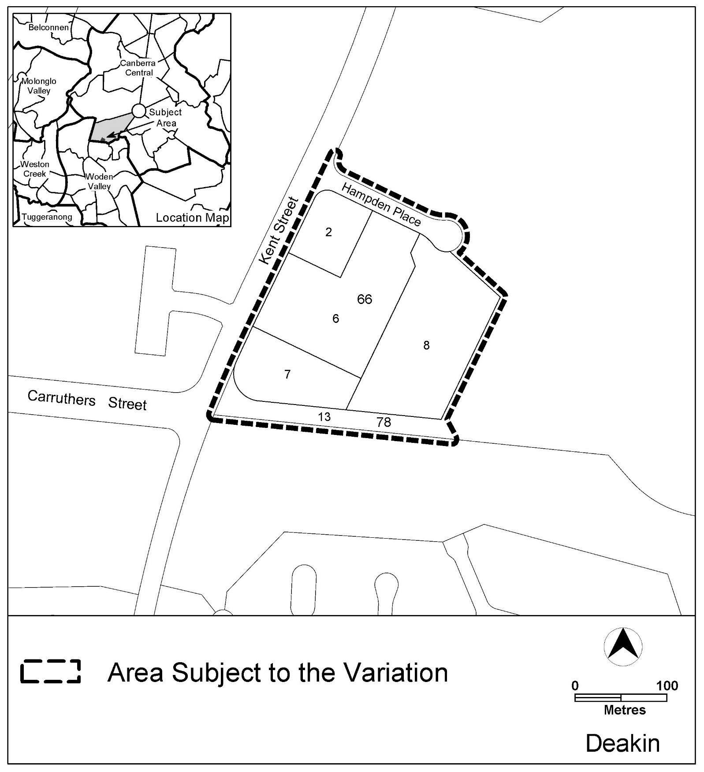

Figure 1 Site Plan

  - Current Territory Plan Provisions
The Territory Plan map zone for the area subject to this variation is shown in Figure 2.

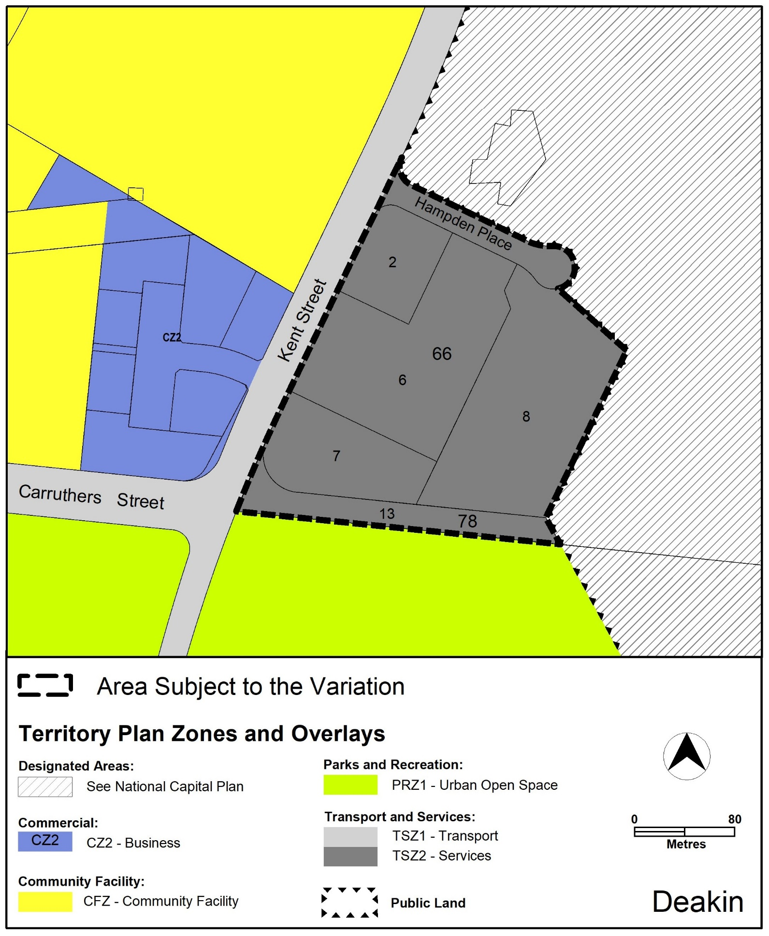
Figure 2 Territory Plan Zones Map

  - Proposed Changes
    - Proposed Changes to the Territory Plan Map
The proposed changes to the Territory Plan map are indicated in Figure 3 at Part 3 of this document and are detailed as follows:
- rezone Deakin section 66 blocks 2 and 6 from the TZ2 Services Zone to the CZ2 Business Zone;
- rezone Deakin section 66 blocks 7 and 8 and section 78 block 13 from the TZ2 Services Zone to the PRZ1 Urban Open Space Zone;
- Apply the Pc – nature reserve public land overlay to section 66 blocks 7 and 8 and section 78 block 13.
    - Proposed Changes to Territory Plan
This draft variation proposes to change the Territory Plan - Deakin Precinct Map and Code to incorporate Deakin section 66 blocks 2 and 6 into the Deakin office area. It further proposes to apply the existing planning provisions for the Deakin office area to this land to guide future development and redevelopment in this location. Figure 1 of the Deakin Precinct Code is also proposed to be amended to require environmental assessment for any future development at Deakin section 66, due to the historic uses and potential contamination in the area.
  - Reasons for the Proposed Draft Variation
The primary reason for the draft variation is to implement the recommendations of the Integrated Plan for Red Hill Nature Reserve and Surrounds by:
- rezoning Deakin section 66 blocks 2 and 6 to better reflect the existing uses of the site consistent with the surrounding Deakin office area; and
- protecting ecological values at Deakin section 66 blocks 7 and 8 and Section 78 block 13 consistent with the surrounding open space network and the adjoining Red Hill Nature Reserve.
  - Planning Context
    - National Capital Plan
The Australian Capital Territory (Planning and Land Management) Act 1988 established the National Capital Authority (NCA) with two of its functions being to prepare and administer a National Capital Plan (NCP) and to keep the NCP under constant review and to propose amendments to it when necessary.
The NCP, which was published in the Commonwealth Gazette on 21 January 1990 is required to ensure that Canberra and the Territory are planned and developed in accordance with their national significance. The Planning and Land Management Act 1988 also requires that the Territory Plan is not inconsistent with the NCP.

    - ACT Planning Framework
Statement of Strategic Directions
The Statement of Strategic Directions sets out the principles for giving effect to the main objective of the Territory Plan as required by theAct. The proposal is consistent with the Territory Plan’s statement of strategic directions in terms of environmental, economic and social sustainability and spatial planning and urban design principles including:
- 1.3 Economic, social and environmental objectives will be pursued in a balanced and integrated way, having regard to both short-term and long-term factors, such that present needs can be met without prejudicing the welfare of future generations, and without serious or irreversible loss of life-supporting natural resources or damage to the environment.
- 1.6 The pattern of development is to reflect land capability constraints resulting from topography, soils, geotechnical factors, drainage, natural hazards, microclimate and the sensitivity of ecosystems. Particular attention will be given to the need to conserve soil, water and vegetation; maintain biological diversity; safeguard important ecosystems and ecological processes; and provide and protect wildlife corridors.
- 1.9 Urban expansion will be contained in order to minimise impacts on valuable natural and rural areas.
- 1.12 Planning policies will facilitate the widest possible range of commercial, retail, industrial, rural, tourism, and other forms of economic activity in order to promote new investment and a more diversified economy, to underpin employment growth, and to respond to changing economic opportunities.
DV380 proposes to protect and enhance existing ecological values of the land by including part of the site in the PRZ1 Urban Open Space Zone and applying the Pc – nature reserve public land overlay to this urban open space zoned land. It also seeks to consolidate the existing office and Telstra uses on the balance of the land by including the balance of the site into the CZ2 Business zone and into the Deakin Office Area within the Deakin Precinct Map and Code of the Territory Plan.
DV380 is also consistent with the following strategic directions of the ACT Planning Strategy 2018 including:
- Direction 2.5 Plan for adequate employment land in the right location that supports a diverse range of uses including commercial and industrial land linked to supportive infrastructure, transport options and investment opportunities.
- Direction 3.5 Protect biodiversity and enhance habitat connectivity to improve landscape resilience.

  - Interim Effect
Section 65 of the Act does not apply in relation to the draft variation, so it does not have interim effect. The current Territory Plan will continue to apply while the variation remains in draft form.

  - Consultation with Government Agencies
EPSDD is required to, in preparing a draft variation under section 61 (b) of the Act, consult with each of the following in relation to the proposed draft variation:
- the National Capital Authority
- the Conservator of Flora and Fauna
- the Environment Protection Authority
- the Heritage Council

National Capital Authority
The NCA provided the following comments on 25 May 2021:
Thank you for the referral for Draft Variation 380, Deakin Office Park and Public Open Space expansions. The site is zoned as Urban Areas in the National Capital Plan (the Plan). The proposed land uses are not inconsistent with the Plan and the NCA has no concerns with DV380.
The NCA can be contacted if EPSDD wishes to discuss options for including the PRZ1 area into the Red Hill Nature Reserve and NCA Designated Area.
Response
The comments are noted. Since these comments the ACT Government has received additional advice, from the NCA in relation to another parcel of land as follows:
An amendment to the Plan is not required for the Territory to incorporate the subject land in a nature reserve; detailed planning responsibility for this portion of the nature reserve can remain with the Territory. This is similar to some other nature reserve areas in the ACT, such as parts of Bruce Ridge.
Accordingly, an amendment will not be sought to the National Capital Plan for land to be included in the Red Hill Nature Reserve.

Conservator of Flora and Fauna
The Conservator of Flora and Fauna made the following comments on 21 June 2021:
The Conservator supports rezoning Deakin Section 66 and Block 13 Section 78 as per part 7.2 of the INTEGRATED PLAN FOR RED HILL NATURE RESERVE AND SURROUNDS JUNE 2021.
Response
The comments about part 7.2 of the Integrated Plan are noted. Part 7.2 informs the recommendations of the plan including recommendation 6 which is the basis of this DV380.

Environment Protection Authority
The Environment Protection Authority provided the following comments on
7 June 2021
Environment Protection Authority (EPA) records indicate that there was a plunge sheep dip located within Block 15 (formerly Block 14) Section 78 Deakin. It has been identified but not investigated. Under the precautionary principal all blocks within 100 metres of sheep dip sites which have not been investigated are identified and persons making enquiries are made aware of potential for impacts due to the ability for contamination to have impacted surrounding land. Hampden Place and Blocks 2 and 6 Section 66 Deakin fall within the 100 metre buffer.
EPA records also indicate that there is a historic municipal landfill located on Block 15 Section 78 Deakin. The landfill’s inferred extent extends into Hampden Place and Blocks 2, 6 and 8 Section 66 Deakin.
Blocks 2 and 6 Section 66 Deakin are currently occupied by commercial complexes. Commercial complexes prior to the introduction of natural gas to the ACT in the 1980s utilised boiler heating or similar systems. These systems were generally fuelled by diesel or heating oil which was mainly stored in underground fuel storage tanks.
The Contaminated Sites Environment Protection Policy 2017 lists fuel storage, sheep dips and landfilling as activities associated with land contamination.
Prior to the area subject to DV380 being used for other purposes:
- An environmental assessment must be undertaken by a suitably qualified environmental consultant in accordance with EPA endorsed guidelines to determine whether past activities have impacted the site from a contamination perspective and to determine whether the site is suitable for the proposed uses;
- All assessment and remedial works must be independently audited by an EPA approved environmental auditor;
- The auditor’s findings into the site's suitability for the proposed and permitted uses from a contamination perspective must be submitted to the EPA in accordance with the Contaminated Sites Environment Protection Policy and EPA Information sheet 11 - EPA Report Submission Requirements for review and endorsement.
Response
The comments are noted. The requested investigations and EPA approvals will be sought prior to the subject area being used for other purposes. The Deakin Precinct Map and Code contains a provision to require the preparation of an environmental assessment.

Heritage Council
The Heritage Council provided the following comments on 2 June 2021
Following review of the ACT Heritage Register, I advise that no registered or recorded heritage places or objects occur within the subject blocks.
I also advise that a 2017 Cultural Heritage Assessment of Blocks 7 and 8 Section 66 and Block 13 Section 78 Deakin, undertaken by Navin Officer Heritage Consultants and Representative Aboriginal Organisations, did not identify any Aboriginal places or objects within the subject blocks, including cultural values or potential archaeological deposits.
In this context, there are no Heritage Act 2004 constraints to DV380, subject to the future management of any unexpected finds in accordance with Heritage Act 2004 requirements.
Response
The comments are noted.

- DRAFT VARIATION TO THE TERRITORY PLAN
The Territory Plan is varied in all of the following ways:

Variation to the Territory Plan Map
substitute
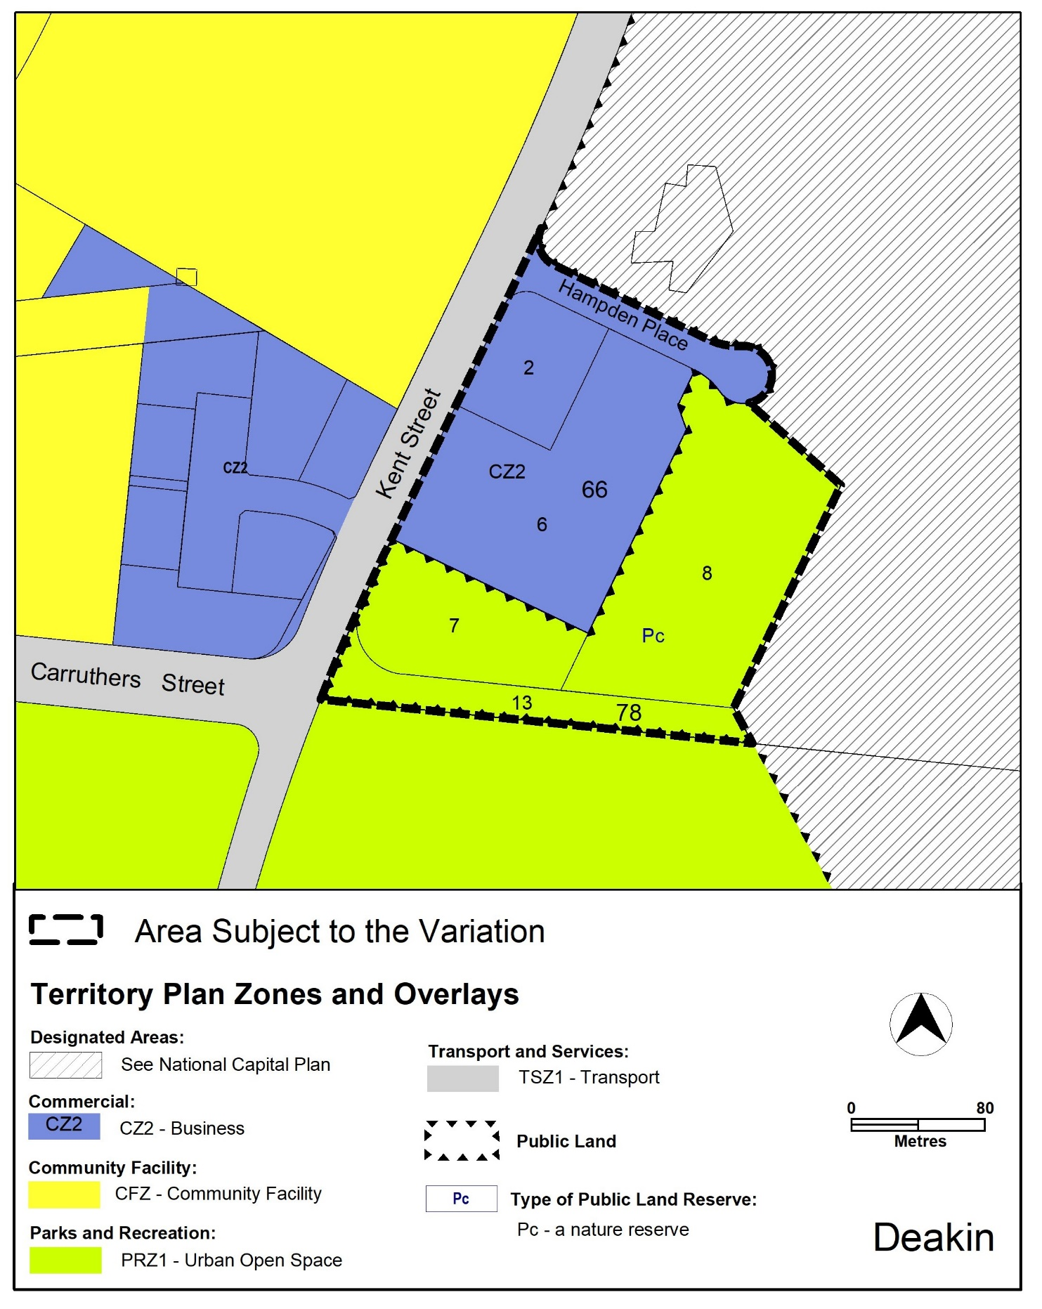
Figure 3: changes to the Territory Plan Map

Variation to the Deakin Precinct Map
substitute
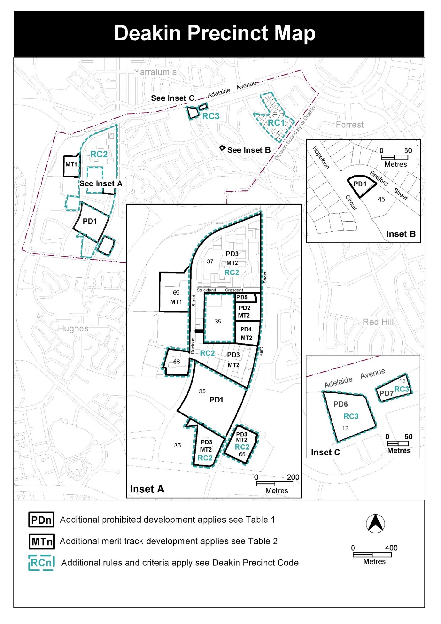

Variation to the Deakin Precinct Code
- RC2 Deakin office site – Figure 1

Substitute with the following Figure 1
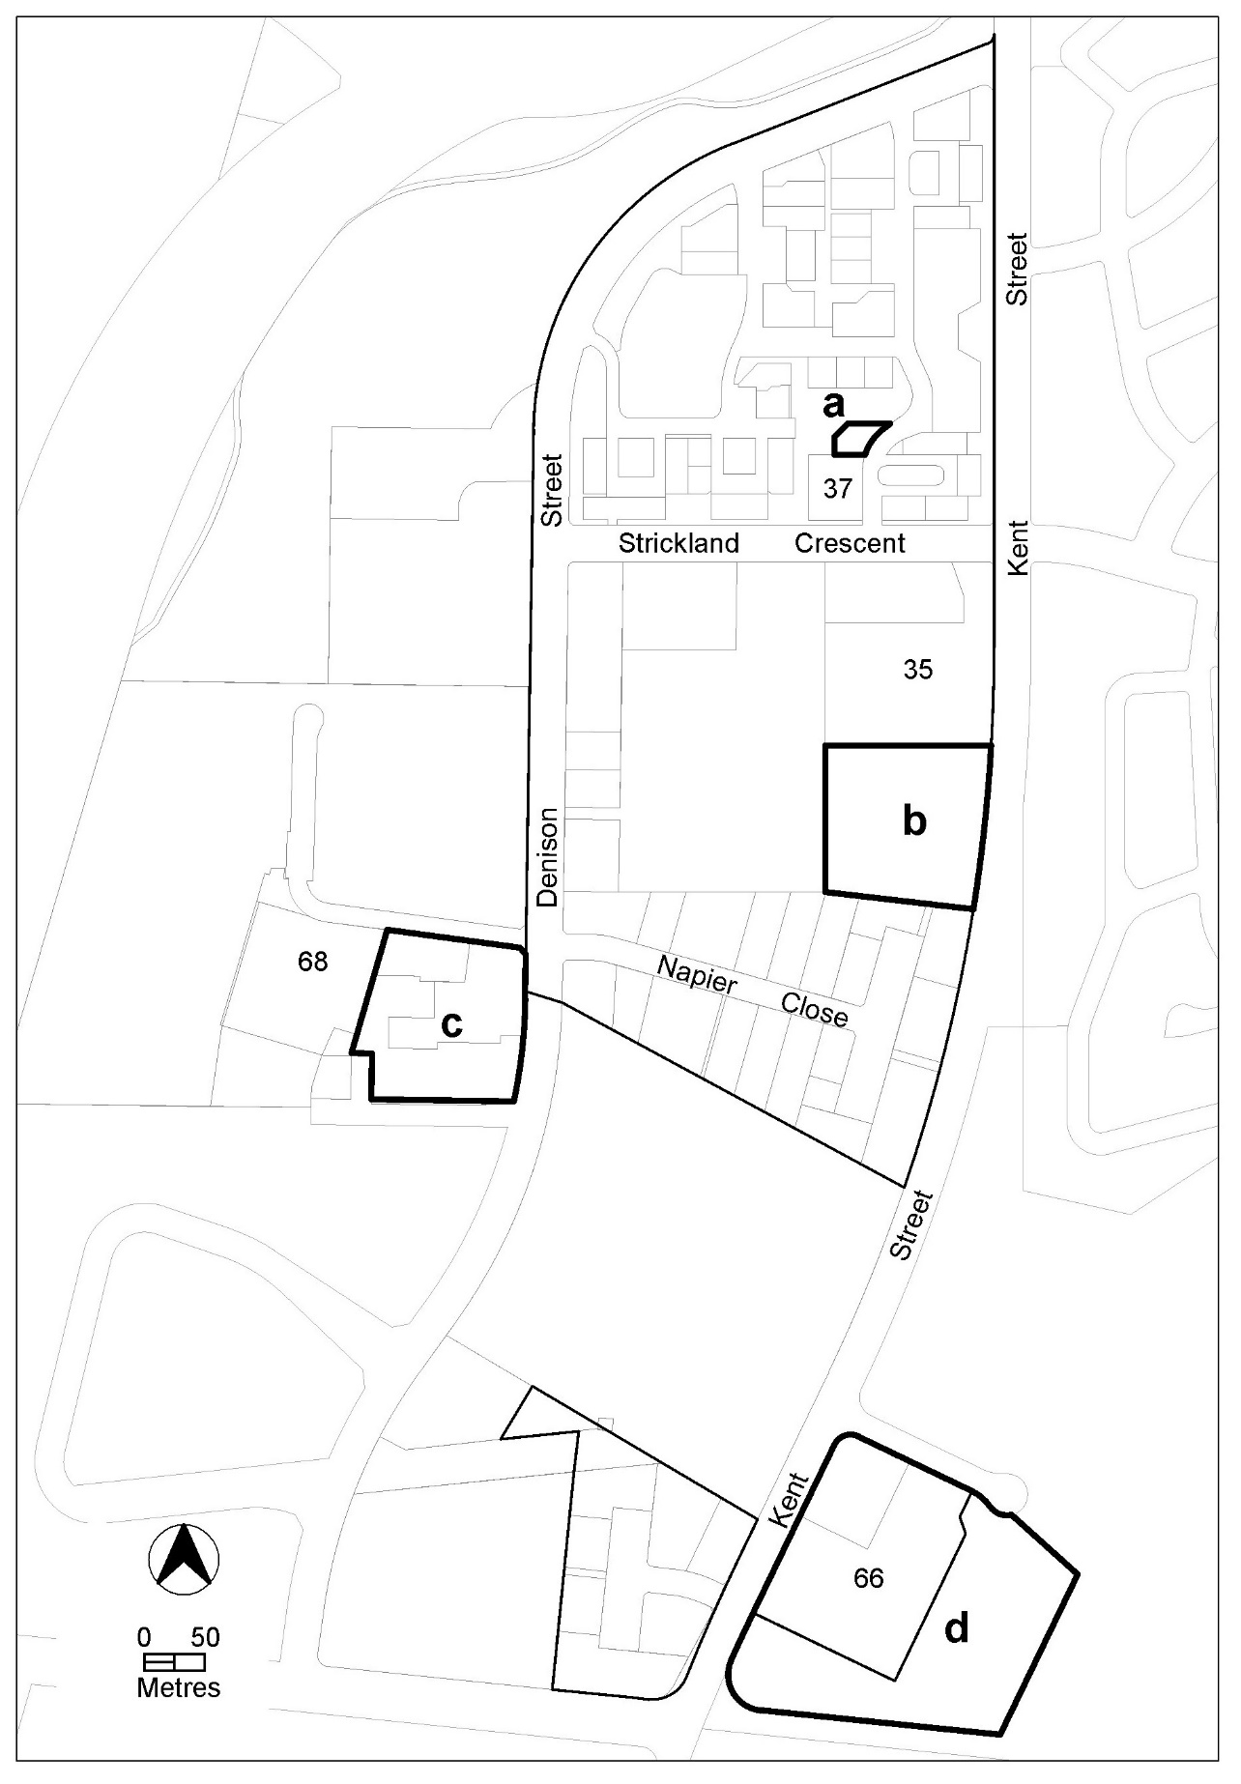
- RC2 – Deakin office park – Element 5 - Environment

Insert Element 5 – Environment after Element 4 – Building and renumber the following elements and rules and criteria.

 | Rules |  | Criteria
5.1 Contamination
R12  This rule applies to area d shown on figure 1.  An environmental assessment report for the development is endorsed by the Environment Protection Authority.  Note: A condition of development approval may be imposed to ensure compliance with the endorsed site assessment report. |  | This is a mandatory rule. There is no applicable criterion.

Interpretation service
