Australian Capital Territory
Planning and Development (Plan Variation 372) Approval 2022
Notifiable instrument NI2022-66
made under the
Planning and Development Act 2007, s 76 (Minister’s powers in relation to draft plan variations)

1 Name of instrument
This instrument is the Planning and Development (Plan Variation 372) Approval 2022.
2 Approval of draft plan variation
(1) I approve under section 76 (2) (a) of the Planning and Development Act 2007 the plan variation 372 to the Territory Plan.
(2) In this section:
plan variation 372 to the Territory Plan means the plan variation in the schedule.

Mick Gentleman MLA
Minister for Planning and Land Management
8 February 2022

Planning and Development Act 2007

Variation to the
Territory Plan
372

Watson Section 76

Final variation prepared under s76 of the
Planning and Development Act 2007

This page is intentionally blank.

Contents
1. EXPLANATORY STATEMENT 1
1.1 Background 1
1.2 Summary of the Proposal 2
1.3 The National Capital Plan 2
1.4 Site Description 3
1.5 Current Territory Plan Provisions 5
1.6 Changes to the Territory Plan 6
1.7 Consultation on the Draft Variation 6
1.8 Revisions to the Draft Variation Recommended to the Minister 6
2. VARIATION 7
2.1 Variation to the Territory Plan Map 7
2.2 Variation to the Territory Plan 8

This page is intentionally blank.

- EXPLANATORY STATEMENT
  - Background
1.1.1 Early planning investigations
In 2016, the former Land Development Agency prepared a planning report to support a Territory Plan Variation for Watson section 76. Prior to progressing to a draft variation to change the planning policy in the Territory Plan, the ACT Government decided further planning, infrastructure and environmental studies were required to inform planning policy change. At the time section 76 was largely unused vacant land, zoned as Commercial CZ6 Leisure and Accommodation, consistent with the current zoning.
Community engagement was undertaken in 2014 to consider allowing residential use and among other issues, the importance of providing a range of housing options at Watson section 76.
Key issues identified during consultation remain relevant to the current variation, including future residential impacts on:
• traffic and parking infrastructure
• future development and design
• preferences for low to medium rise density of 2-3 storeys
• community facilities
• retention of trees and landscapes

1.1.2 Pre-Community Consultation on a draft planning report
In 2018 EPSDD undertook pre-community consultation on a draft planning report for section 76, which proposed adding residential use to the current Commercial CZ6 Leisure and Accommodation zone. There is a Future Urban Area (FUA) overlay on this site.
The planning report has since been updated to respond to key community concerns, agency comments and the outcomes of planning, background and technical studies.
Key community concerns related to the implications of future residential use including impacts on the:
• existing environment and trees
• future traffic, parking and walking and cycling connections
• perceived need for community and commercial facilities
• provision of lower-rise housing of no more than 2 storeys for new residences and people to age-in-place
• the importance of the local character of North Watson.

  - Summary of the Proposal
Variation to the Territory Plan No 372 (V372) rezones Watson section 76 block 2 from Commercial CZ6 (CZ6) Leisure and Accommodation to:
• RZ4 Medium Density Residential; and
• Parks and Recreation PRZ1 Urban Open Space.
A concept plan is introduced to inform an estate development plan on important planning considerations. These considerations include maximum building heights, shared paths and public roads, demonstration housing, areas of environmental concern and requirements for a public park.
Building heights of up to a maximum of 4 storeys or 16.5 metres are permitted in the southern portion of the site, which is consistent with the surrounding character.
The site is on the 2022-23 Indicative Land Release Program for 200 dwellings. The CZ6 zone does not allow for residential uses, including medium density residential development. The site is rezoned to RZ4 Medium Density Residential, with part of the site rezoned to Parks and Recreation PRZ1 Urban Open Space for the development of a one-hectare park and the retention of trees for wildlife, amenity and cooling for a changing climate.
The provisions allow for the demonstration housing process, as announced in the Minister for Planning and Land Management’s 2015 Statement of Planning Intent. Demonstration housing provides the community and industry with examples of how flexibility and innovation in planning can result in more liveable, inclusive and sustainable communities.
The variation removes the dwelling limit in the North Watson Structure Plan which had a maximum dwelling limit of 1,300 within an identified boundary, consistent with servicing for the area. The ACT Government will provide appropriate infrastructure to support increased development in the area.
Changes to the Watson precinct code include adding definitions of co-housing and social enterprise. These uses, as well as craft workshop, are included as additional merit assessable uses and limited to the area proposed for demonstration housing in the precinct code.

  - The National Capital Plan
The Australian Capital Territory (Planning and Land Management) Act 1988 established the National Capital Authority (NCA) with two of its functions being to prepare and administer a National Capital Plan (NCP) and to keep the NCP under constant review and to propose amendments to it when necessary.
The NCP, which was published in the Commonwealth Gazette on 21 January 1990 is required to ensure that Canberra and the Territory are planned and developed in accordance with their national significance. The Planning and Land Management Act 1988 also required that the Territory Plan is not inconsistent with the NCP.
In accordance with section 10 of the Australian Capital Territory (Planning and Land Management) Act 1988, the NCP defines the planning principles and policies for Canberra and the Territory, for giving effect to the object of the NCP and sets out the general policies to be implemented throughout the Territory, including the range and nature of permitted land uses.
It also sets out the detailed conditions of planning, design and development for areas that have special significance to the National Capital known as designated areas and identifies special requirements for the development of some other areas.

  - Site Description
Watson section 76 is currently unleased, undeveloped land, under the custodianship of Transport Canberra and City Services (TCCS) and is approximately nine hectares in size (see Figure 1). The site is bounded by Aspinall Street to the south, and the Federal Highway to the north. There are a number of existing residential units, two to three storeys in height to the west of the site. To the east is the Youth with a Mission facility. There are a number of residential units south of Aspinall Street, which are generally two storeys in height, with a limited number of accompanying on-street parking spaces.
Across the Federal Highway to the north is Non Urban NUZ1 Broadacre zoned land. An informal unsurfaced walking/cycling path also runs along the northern border of the block, parallel with the Federal Highway. In addition, several informal tracks have developed travelling in a north-south direction through the site.
The Watson local centre is approximately one kilometre from the site and includes a pharmacy, supermarket, café, restaurants and a post office. Mount Majura Primary public school and pre-school is located approximately one kilometre from the site.
The block is relatively flat, with a gentle downward slope towards the north-west corner. Non-local native trees and a mix of native and exotic vegetation lines each side of the block, with the densest areas lining the eastern border. There is also a cluster of similar trees in the western half of the site. Tree species on the site include Tasmania Blue Gum (Eucalyptus globulus), Argyle Apple (E. cinerea), Ribbon Gum (E. viminalis), Brittle Gum (E. mannifera) as well as Radiata Pine (Pinus radiata). Other vegetation includes the native Cherry Ballart (Exocarpos cupressiformis) and various wattles, and exotic species including Cotoneaster (Cotoneaster glaucophyllus), Japanese Privet (Ligustrum japonicum), Hawthorn (Crataegus monogyna), and Broad-level Privet (Ligustrum lucidum).
The trees on the western and northern edge of the site are considered important foraging habitat for birds, specifically, the Superb Parrot (Polytelis swainsonii), which is listed as vulnerable in the ACT and is on the National Register, with a limited number of breeding pairs known to be left in Australia.
After detailed site soil testing, naturally occurring heavy metals have been discovered in part of the north-east of the site. A risk audit for the heavy metals is being undertaken to recommend any potential remediation works, if required, and if an ongoing management plan for the affected area to the north-east of the site is needed.
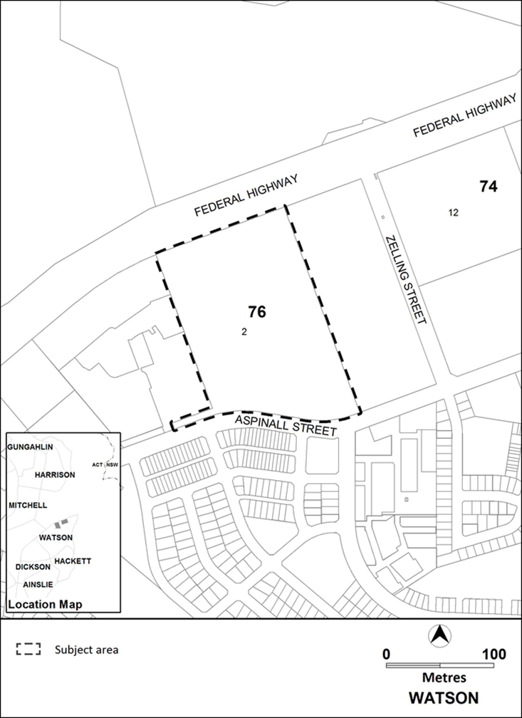
Figure 1: Location map

  - Current Territory Plan Provisions
The Territory Plan map for the area subject to this variation is shown in Figure 2.
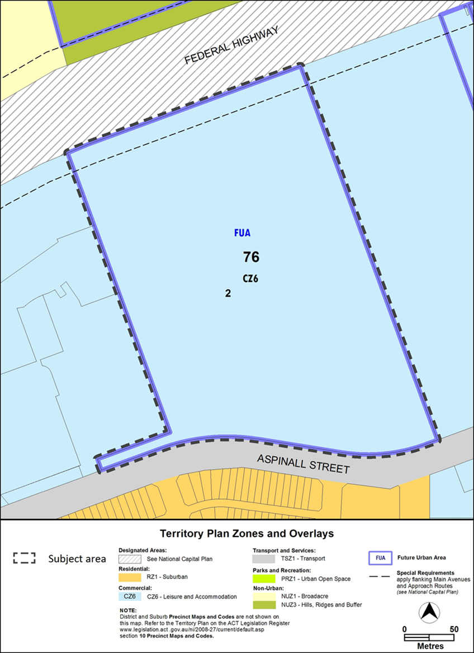
Figure 2 Territory Plan Zones Map

  - Changes to the Territory Plan
Detailed changes to the Territory Plan are noted in section 2 of this document.

  - Consultation on the Draft Variation
Draft Variation 372 (DV372) was released for public comment between 1 February and 19 March 2021. A consultation notice under section 63 of the Planning and Development Act 2007 (P&D Act) was published on the ACT Legislation Register on 1 February 2021. A public notice was placed on the ACT Government public notices website on 1 February 2021.
A total of 45 written submissions were received, which included 40 submissions from individuals and 5 submissions from community and business groups or organisations. Comments related to the following:
Matters raised in submissions | Number of submissions
Objection to any development, and keeping the site as public space | 11
Concern over the cumulative density in suburb and along the street | 7
The need to retain the trees | 20
Comments on the park and green space | 18
Desire to reduce maximum building heights and number of storeys; and impacts arising from building heights | 26
Desire to reduce dwelling numbers | 7
Suggestions on site design | 30
Concern over increased traffic and street access and parking | 38
Suggested pathway design and extensions | 7
Request for a shop / services on site or in North Watson | 6
Support for and comments on demonstration housing / co-housing | 14
Concerns over suburb and off-site issues | 13

The above issues were considered and are detailed in a report on consultation. Changes were informed by the issues raised. The outcomes of consultation were considered by the Minister responsible for planning prior to approval of this variation.
  - Revisions to the Draft Variation Recommended to the Minister
No changes were made to the draft variation recommended to the Minister.

- VARIATION
  - Variation to the Territory Plan Map
The Territory Plan map is varied in all of the following ways:
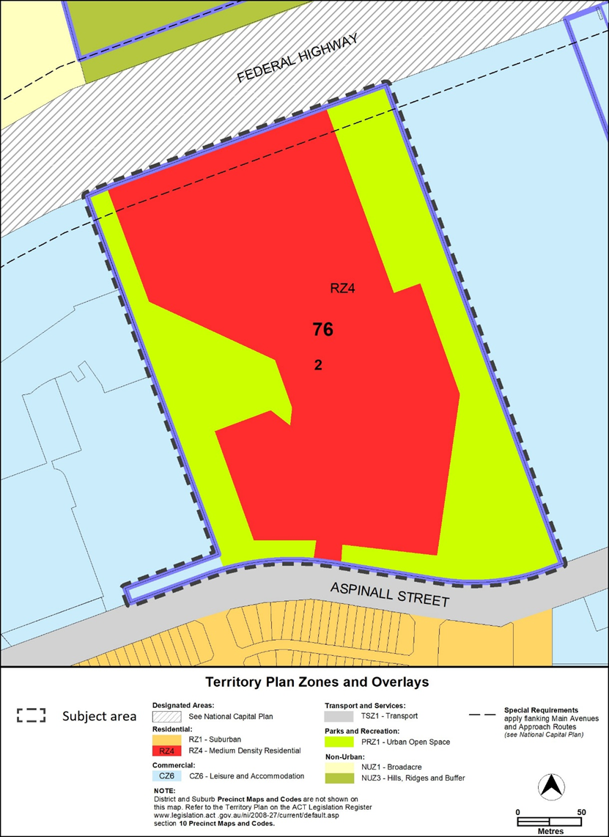

  - Variation to the Territory Plan

Variation to the Watson Precinct Map and Code
Substitute
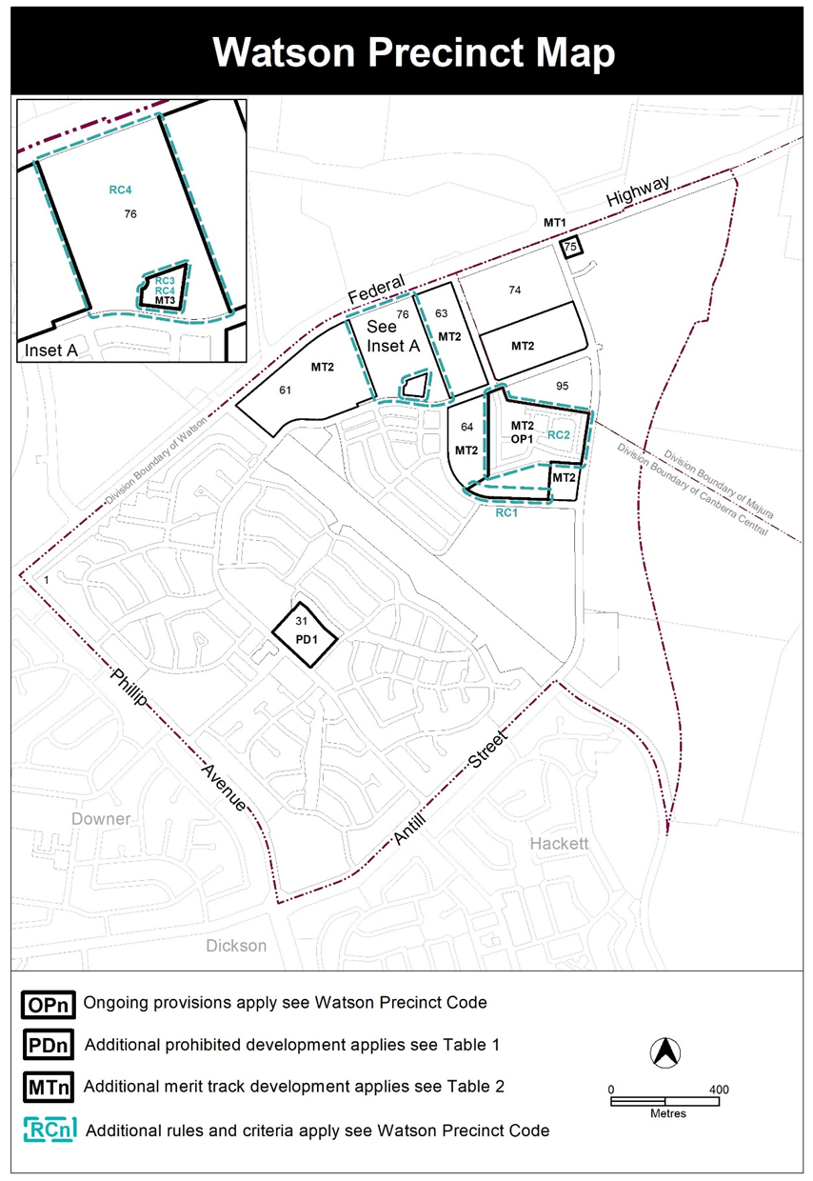
- Introduction, Definitions

Substitute second paragraph with:

Definitions of terms used in this code are listed in part 13 of the Territory Plan or, for terms applicable only to this code listed below.

Co-housing means a development with separate dwellings or private living areas, with some common/shared indoor components such as kitchens, living areas, bedrooms, and laundries. Private living areas must each contain a bedroom and a bathroom as a minimum and may contain a kitchenette. The common/shared indoor components may be provided in a separate building.

Social enterprise is a commercial organisation that exists to create social benefit as its primary purpose and may or may not be for profit and which may include employment and skills development for on-site residents.

- Assessment Tracks, Table 2 – Additional merit track development

Add

Suburb precinct map label | Zone | Development
MT3 | RZ4 | co-housing social enterprise craft workshop

- Additional rules and criteria, RC2 – Residential, Table 2 Fencing
materials
Insert after Table 2 Fencing materials

RC3 – Residential
This part applies to blocks and parcels identified in area RC3 shown on the Watson Precinct Map.
Element 3: Use
Rules | Criteria
3.1 Co-housing and social enterprise
R23  Co-housing and social enterprise development can only be undertaken by the Demonstration Housing Project lessee(s) identified on a register published on an ACT Government website. | This is a mandatory requirement. There is no applicable criterion.

RC4 – Residential
This part applies to blocks and parcels identified in area RC4 shown on the Watson Precinct Map.

Element 4: Buildings
Rules | Criteria
4.1 Built form
There is no applicable rule. | C24  The design of the built form will contribute to all of the following:  - existing context and character of the local area, including density and scale.  - existing landscape character and setting.  - ecological values.  - sustainability and resilience for a changing climate.  - connectivity, legibility and safety of the area including passive surveillance onto public spaces.  - diversity and amenity of public spaces that promote community life; and will  - not negatively impact surrounding neighbours.
There is no applicable rule. | C25  Where development includes fencing that face public footpaths, communal spaces and/or public open space, the fencing is to incorporate:  - high quality materials that are semi-transparent  - direct access from private dwellings, such as providing gates, and  - landscaping in front of the fencing.  Solid fencing or courtyard walls are not permitted for more than 50% of a block frontage when facing public footpaths, communal spaces and/or public open space.

Variation to the North Watson Structure Plan
- Introduction

Omit

First two sentences in the second paragraph

To assist in understanding the original application of the principles and policies for the “defined land”, the area identified in this structure plan is the original “defined land” area. Over time, part of the former defined land areas was undefined through statutory processes.

Omit

Third paragraph

Further information on the area subject to this structure plan can be found in the original Territory Plan Variation, available on the ACTPLA website

- Principles and Policies (Refer to Figure 1)

Omit

(Refer to Figure 1)

- Principles and Policies, 3. Maximum Number of Dwellings
Omit

3. Maximum Number of Dwellings
The maximum number of new dwellings within the total area to which this Variation applies excluding accommodation specifically for tourist uses shall not exceed 1300 dwellings.

- Principles and Policies, 5. Building Height

Omit

5. Building Height
Building heights shall be two storeys. Where existing approved development exceeds a building height of two storeys, development compatible with the authorised height may be approved.

- Principles and Policies, 5. Building Height, Figure 1

Omit

Figure 1

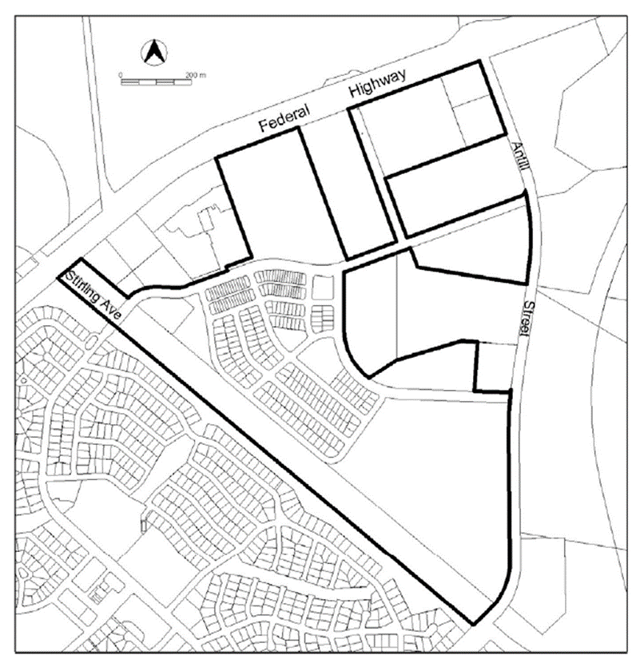

Variation to the Concept Plans
- Concept Plans – Precinct Codes for Section 93 of the Planning and Development Act 2007

Insert the Watson Section 76 Concept Plan at Appendix A.
Interpretation service
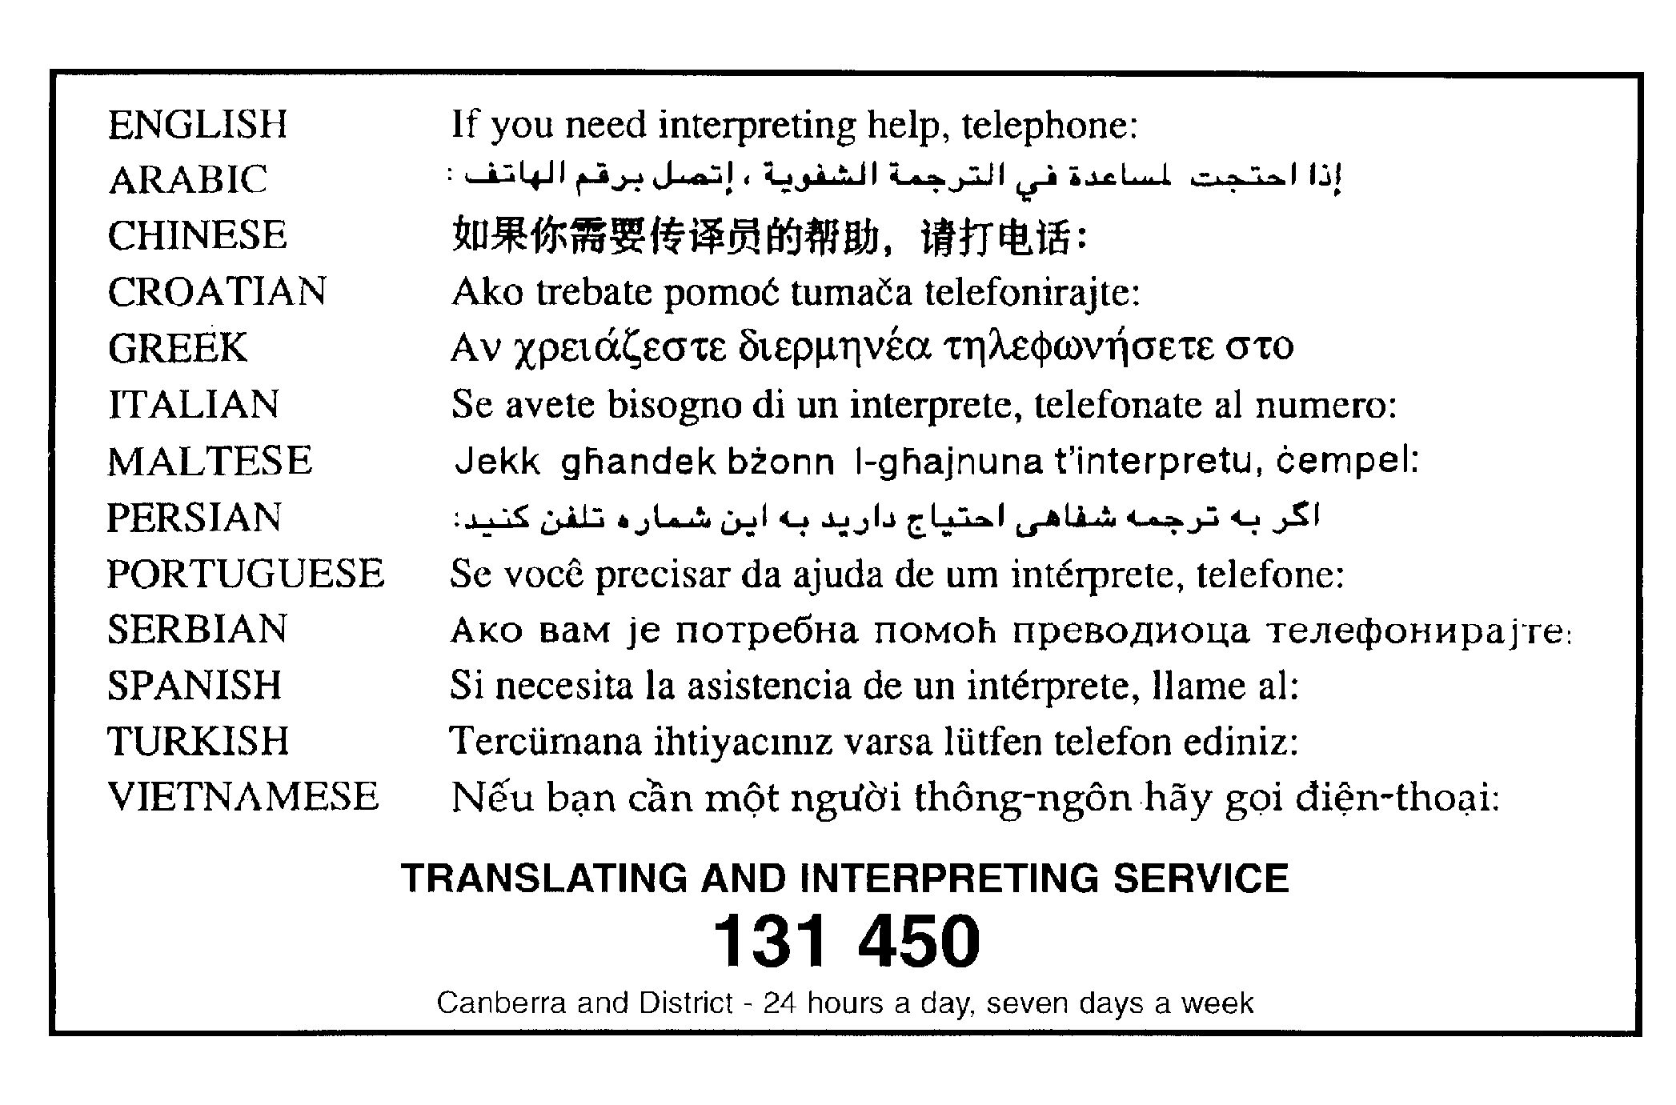

Appendix A

Concept Plan Watson, Section 76

Concept Plan for Watson Section 76

Table of Contents
Part A – Land use 3
- Land use plan 3
Part B – Subdivision 3
- Shared Paths 3
- Public road 3
- Public open space 3
- Cultural Heritage 4
- Demonstration housing 4
- Environmental assessment 4
Part C – Buildings 4
- Building heights 4

Concept Plan for Watson Section 76

Introduction

A Concept Plan is required to provide guidance about the future land uses and provisions for the site and to assess an Estate Development Plan against. Any ongoing provisions will be uplifted into the Territory Plan via a technical amendment after approval of and consistent with the Estate Development Plan for the site. The ongoing provisions of the Concept Plan will form part of the Watson Precinct Map and Code.
There is an opportunity to use Watson section 76 for medium density housing to increase residential development in the existing urban footprint while retaining wildlife habitat and mature trees.

Application
This plan applies to land at Watson section 76 as shown in Figure 1.
This plan contains rules, which provide the quantitative or definitive controls for development, and criteria, which provide qualitative controls for development. In some instances rules are mandatory. Mandatory rules are marked by the words “This is a mandatory requirement. There is no applicable criterion” in the adjacent criteria column. Non-compliance with a mandatory rule will result in the refusal of a development application. In other instances the words “There is no applicable rule” is contained in the rule column. In this case the proposal is assessed against the relevant criterion. Where both rule and criterion apply, compliance with the rule is deemed to satisfy the particular requirement.
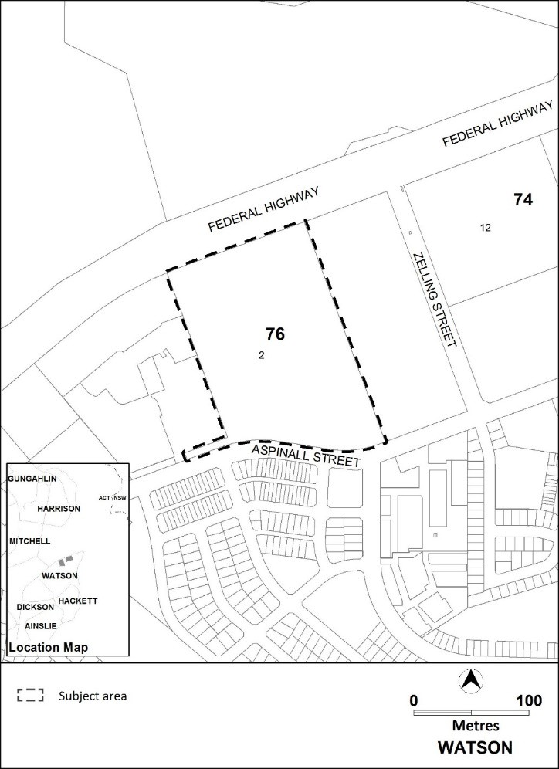
Figure 1 Location map

Purpose
The purpose of this plan is to:
  - guide the design and assessment of estate development plans (subdivision proposals) for the site
  - inform the allocation of final zones at the time when a parcel of land ceases to be part of the future urban area following subdivision
  - guide the development of individual blocks in concert with other relevant codes under the Territory Plan
  - guide the development and management of the public domain, including the urban open space and a public park and active travel connections
  - guide the development of housing to provide housing choices
  - adopt bushfire protection measures appropriate to the site.

Desired planning outcomes
The purpose of the development controls (i.e. rules and criteria) is to:
- provide housing zones, types and densities to meet the changing needs of the community and opportunities for demonstration housing
- allow for zoning to accommodate residential densities and building heights generally close to public transport routes within the urban intensification area
- provide for some community uses such as a social enterprise and craft workshop, or a community activity centre
- provide a safe, compact, and walkable residential precinct with convenient vehicular, pedestrian, cycle and public transport access to recreational, retail/commercial and community facilities
- encourage walking, cycling and the use of public transport
- retain important landscape and trees for wildlife, urban heat reduction and general amenity.

Code hierarchy
This concept plan is a precinct code under the Planning and Development Act 2007.
More than one type of code may apply to a particular development proposal. Occasionally inconsistencies between the provisions arise, particularly where a precinct code seeks to apply special provisions in response to particular local circumstances or planning issues.
Where this occurs, a precinct code prevails over a development code and a general code, but only to the extent of the inconsistency.

Part A – Land use
Rules | Criteria
1. Land use plan
R1  Zoning as shown on a land use plan lodged with an Estate Development Plan is consistent with the Territory Plan map. | This is a mandatory requirement. There is no applicable criterion.

Part B – Subdivision
Rules | Criteria
2. Shared Paths
R2  Connection of the public shared path for pedestrians and cyclists is consistent with Figure 2. | This is a mandatory requirement. There is no applicable criterion.
There is no applicable rule. | C3  Public paths are to address all of the following:  - incorporate lighting to enhance public safety  - provide areas for seating along main paths  - incorporate shade trees and soft landscaping
3. Public road
R4  A public road will be provided consistent with Figure 2. | This is a mandatory requirement. There is no applicable criterion.
4. Public open space
R5  This rule applies to land in the PRZ1 Urban Open Space zone. Public open space addresses all of the following:  - a public local neighbourhood park of at least one hectare in the south- east corner of the site, consistent with Figure 2.  - the retention of the western, eastern and southern portions of the site for wildlife habitat, improved amenity and reduction of urban heat. | This is a mandatory requirement. There is no applicable criterion.

5. Cultural Heritage
R6  The recommendations of the cultural heritage assessment provided by EPSDD are reflected in the Estate Development Plan application. | This is a mandatory requirement. There is no applicable criterion.
6. Demonstration housing
There is no applicable rule. | C7  A site will be reserved for the demonstration housing process, involving innovative housing types and may include tiny houses, within the area identified as MT3 in the Watson Precinct Map and Code.  Demonstration housing is to be endorsed by the planning and land authority in accordance with the list of criteria published on the Environment Planning and Sustainable Development Directorate website.
7. Environmental assessment
R8  This rule applies to section 76 Watson as shown in Figure 3. The Development Application for development on the site must be accompanied by an environmental assessment into the site’s suitability from a contamination perspective in accordance with the ACT Contaminated Sites Environment Protection Policy and be endorsed by the Environment Protection Authority.  This rule does not apply if the Environment Protection Authority has provided written advice that section 76 Watson has been assessed for contamination to its satisfaction. | This is a mandatory requirement. There is no applicable criterion.

Part C – Buildings
Rules | Criteria
8. Building heights
R9  This rule applies to areas shown in Figure 4. Maximum height of building is:  a) for area A: the lesser of 2 storeys and  8.5 metres  b) for area B: the lesser of 4 storeys and  16.5 metres. | This is a mandatory requirement. There is no applicable criterion.

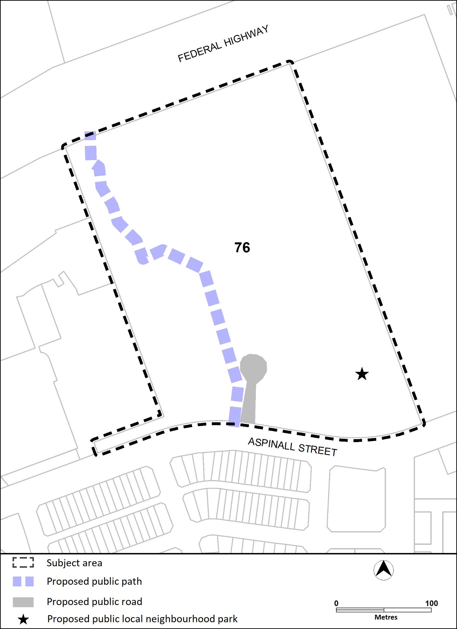
Figure 2 Shared path, public road and location of public local neighbourhood park

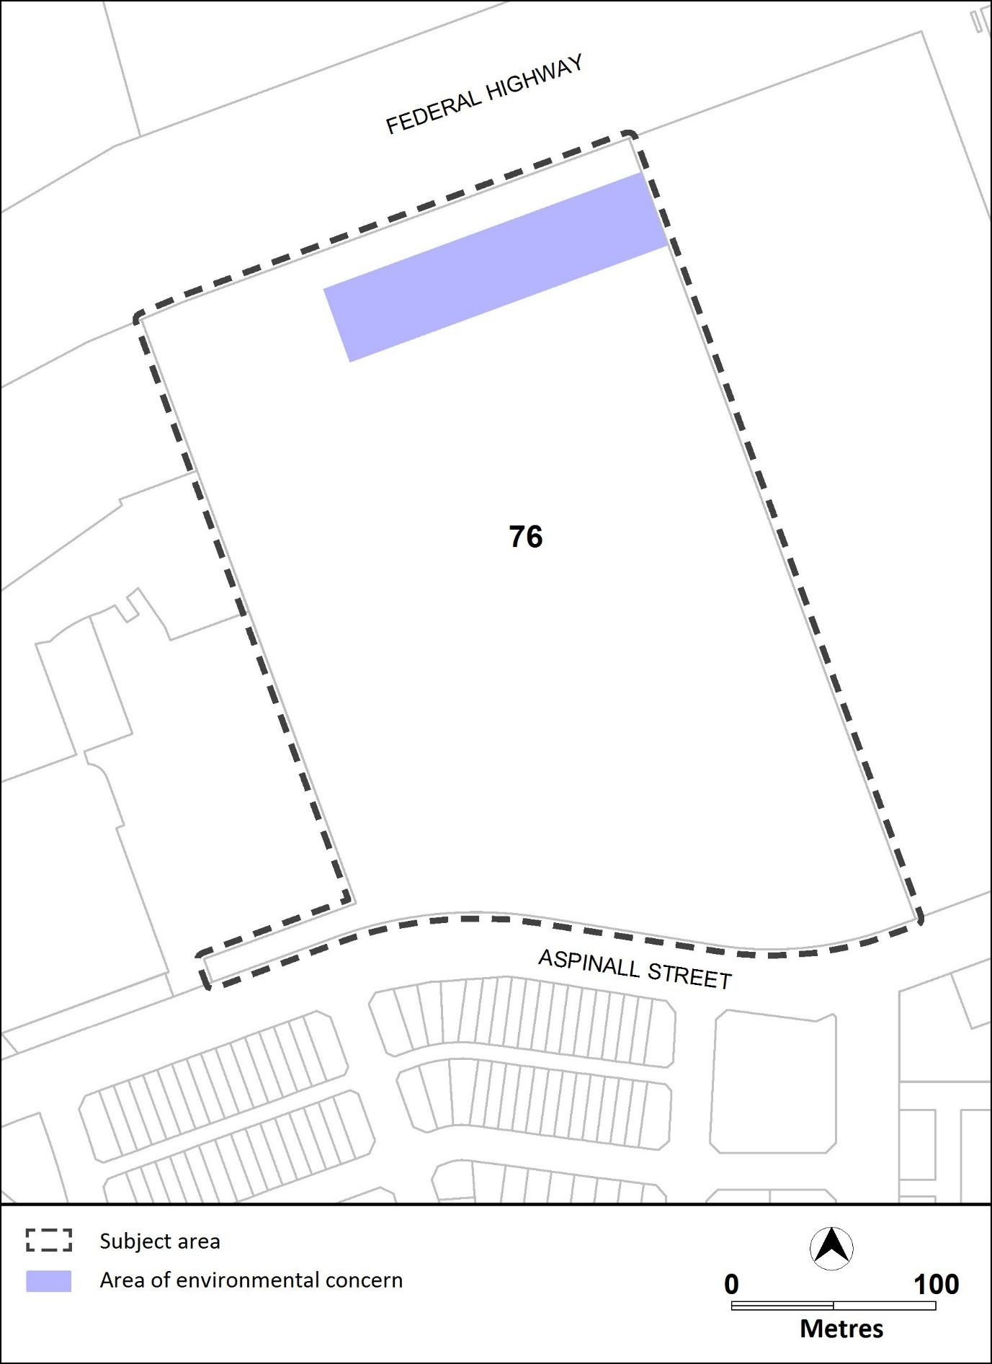
Figure 3 Environmental assessment requirements

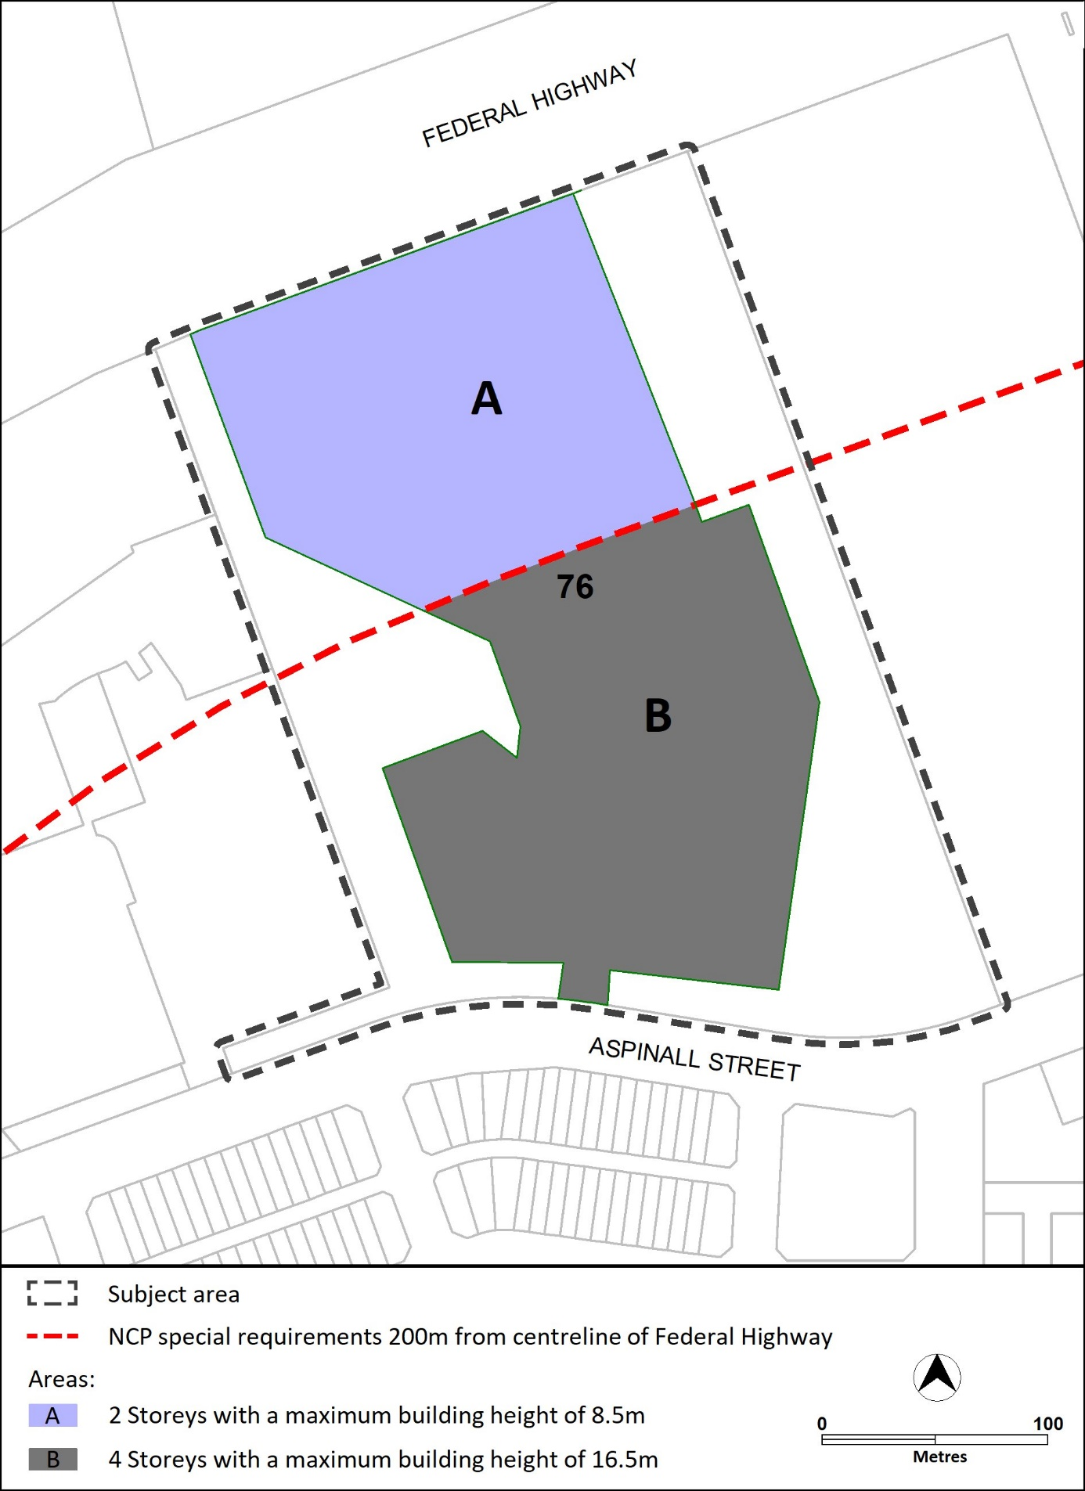
Figure 4 Building heights

