Australian Capital Territory
Corrections Management (Emergency Management) Policy 2022
Notifiable instrument NI2022-660
made under the
Corrections Management Act 2007, s14 (Corrections policies and operating procedures)

1 Name of instrument
This instrument is the Corrections Management (Emergency Management) Policy 2022.

2 Commencement
This instrument commences on 3 April 2023.
3 Policy
I make this policy to facilitate the effective and efficient management of correctional services.
4 Revocation
This instrument revokes NI2019-10 Corrections Management (Emergency Management) Policy 2019.

Ray Johnson APM
Commissioner
ACT Corrective Services
16 December 2022

emergency Management
policy no. S2

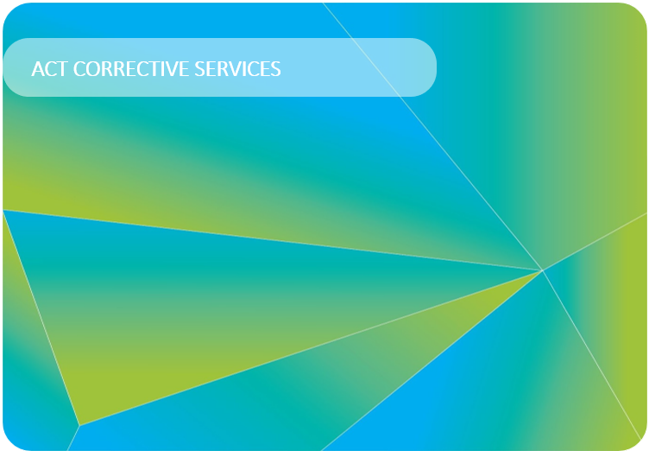
Contents
1 PURPOSE 4
2 SCOPE 4
3 DEFINITIONS 4
4 PRINCIPLES 5
5 POLICY REQUIREMENTS 5
6 MANAGEMENT AND REPORTING 7
RELATED DOCUMENTS 7

PURPOSE
The purpose of this Policy is to set minimum standards to ensure that a clear, consistent, and comprehensive approach to emergency management is undertaken across ACT Correctional Centres. The Policy requires that ACT Correctional Centres have arrangements in place to respond appropriately in an Emergency.
This policy does not provide details of specific operational level actions or tasks. It does, however, list the requirements that employees with emergency management responsibilities must ensure are met.
Declaration of Emergency
Pursuant to section 26 of the Corrections Management Act 2007, the Commissioner has delegated power to declare an emergency in relation to a correctional centre for a period of three (3) days or, if another period is prescribed by regulation — the period prescribed, if an emergency threatens, or is likely to threaten the:
- security or good order at the centre or
- the safety of anyone at the centre or elsewhere.
Declarations may be made for two (2) or more consecutive periods in relation to the same emergency and are subject to review periods set out in the Corrections Management Act 2007.

SCOPE
This policy applies to all ACTCS staff working within an ACT Correctional Centre.
While applying to all specified staff, the primary focus is to provide direction to staff who have responsibility for ensuring emergency management arrangements are in place and operational.

DEFINITIONS
Emergency | An event that arises internally or from external sources, which may adversely affect the occupants or visitors in a facility, and which requires an immediate response.
Emergency Planning Committee | A group of relevant personnel responsible for the documentation and maintenance of a facility’s emergency management plan. For the AMC this is the Security Committee. For CTU this is the ACT Courts and Tribunal Emergency Planning Group.
Incident Command System | A standardised approach to the command, control, and coordination of emergency response providing a common hierarchy within which responders can be effective.

PRINCIPLES
  - ACTCS must maintain a workplace that protects its workers, as defined under the Work Health and Safety Act 2011 (ACT), including employees, contractors, and visitors, from the negative impact of potential emergencies.
  - ACTCS must meet its legislative obligations under the Corrections Management Act 2007, Work Health and Safety Act 2011 (ACT) and section 43 of the Work Health and Safety Regulations 2011.
  - The number, scale, and complexity of emergencies requires that ACT Correctional Centres have robust and integrated emergency management arrangements in place to prevent, prepare for, respond to, and recover from, emergencies, disasters, and other disruptive events.
  - If the duration of an emergency or any potential remediation works are likely to impinge on a maximum allowable outage for a function undertaken within the facility, the Assistant Commissioner Custodial Operations (ACCO) must consider enacting the impacted business unit’s business continuity management arrangements.
  - In the event the ACT Emergency Plan is activated, ACTCS must align its actions with the broader priorities.

POLICY REQUIREMENTS
AUSTRALIAN STANDARD 3745-2010– PLANNING FOR EMERGENCIES IN FACILITIES
  - All emergency management arrangements including plans, roles and supporting activities must be developed and managed in accordance with the Australian Standards 3745-2010 – Planning for emergencies in facilities.
EMERGENCY ARRANGEMENTS
  - The ACCO must ensure that facility specific Emergency Planning Committees are in place and emergency plans are prepared for the workplace.
BUSINESS CONTINUITY PLANNING
  - The ACCO must practice business continuity management and ensure Business Continuity Plans are established, maintained, tested, reviewed, and updated on a regular basis in alignment with the Justice and Community Safety Business Continuity Planning Standard Operating Procedure.
EQUIPMENT AND MAINTENANCE REQUIREMENTS
  - The ACCO must ensure emergency response equipment is always maintained in a functional state of readiness. Equipment includes but is not limited to:
- Personal Protective Equipment (PPE)
- command structure tabards
- templates and forms used to document decisions and assist with planning the emergency response.
  - The ACCO must ensure all fire suppression and emergency warning systems in ACTCS owned facilities have been appropriately serviced and maintained in accordance with AS 1851 – 2012 – Routine service of fire protection systems and equipment and other relevant Australian Standards.
INCIDENT MANAGEMENT
  - Operational staff must use a recognised incident command system and activate an operations centre as required under the approved facility emergency plan.
TESTING OF EMERGENCY PROCEDURES
5.7 Each facility’s emergency management procedures must be tested. The frequency of this testing is to be whichever is greater between the:
- requirement of the Standard (annually) or
- approved emergency plan for the facility.
INFORMATION
5.8 The ACCO must ensure staff are appropriately informed about the emergency response arrangements that apply to the facility.
  - A current list of emergency wardens and first aid officers for each facility must be made available on the ACTCS and Directorate intranets and provided to the Directorate’s Emergency, Security and Business Continuity Committee, in accordance with timeframes specified by the JACS.
  - A copy of the facility’s emergency management plan must be made available on the ACTCS and Directorate intranet and provided to the Emergency, Security and Business Continuity Committee, where the Commissioner has indicated their approval in writing. This copy may include redactions to preserve the security of the facility as determined by the Commissioner.

TRAINING AND INSTRUCTION
  - The ACCO must ensure that all facility staff are provided with instruction and training relevant to implementing the emergency procedures as specified in the emergency plan and relevant Commissioner/Assistant Commissioner Instructions.
  - The Assistant Commissioner Custodial Operations must ensure there are sufficient persons trained to effectively undertake the role of Incident Commander.
DUE DILIGENCE
  - In work environments where there are shared responsibilities, the accountability for ensuring the due diligence obligations under the Work Health and Safety Act 2011, section 27(5) are met remains with the Agency (JACS Business Unit) Head for their respective locations (Commissioner, ACTCS).

MANAGEMENT AND REPORTING
COMMITTEES
  - Emergency management planning activities across the Directorate are coordinated through the Emergency, Security and Business Continuity Committee. The Commissioner must provide an ACTCS representative for each Committee meeting.
  - The AMC Security Committee establishes and reviews security priorities. Responsibilities of this Committee include review and oversight of the Emergency Management Plan.
EMERGENCY EVENT REPORTING
6.4 Emergency Services, ACT Policing and/or other internal and external parties must be notified of the incident or emergency in accordance with the facility emergency plan and the Incident Reporting and Notifications Policy.
6.5 Reporting to the JACS Safety, Health and Wellbeing unit within People and Workplace Safety is done via RISKMAN and to Governance, Coordination and Reporting at JACSGR@act.gov.au.

RELATED DOCUMENTS
- Facility Emergency Management Plans
- Australian Standards 3745-2010 – Planning for emergencies in facilities
- Justice and Community Safety Directorate Emergency Management Policy
- Justice and Community Safety Business Continuity Planning Standard Operating Procedure.
- Incident Reporting and Notifications Policy
- Business Continuity Plan

Ray Johnson APM
Commissioner
ACT Corrective Services
16 December 2022

Document details
Criteria | Details
Document title: | Emergency Management Policy 2022
Document owner/approver: | Commissioner, ACT Corrective Services
Date effective: | The day after the notification date
Review date: | Three years after the notification date
Compliance: | This policy reflects the requirements of the Corrections Management (Policy Framework) Policy 2020 and Justice and Community Safety Directorate Emergency Management Policy
Responsible officer:

Version Control
Version no. | Date | Description | Author
V1 | Dec-22 | First issued | T Cussen

