Australian Capital Territory
Planning and Development (Plan Variation 385) Approval 2023

Notifiable instrument NI2023-137
made under the
Planning and Development Act 2007, s 76 (Minister’s powers in relation to draft plan variations)

1 Name of instrument
This instrument is the Planning and Development (Plan Variation 385) Approval 2023.
2 Commencement
This instrument commences on the day after its notification day.
3 Approval of draft plan variation
(1) I approve under the Planning and Development Act 2007, section 76 (2) (a), plan variation 385 to the Territory Plan.
(2) In this section:
plan variation 385 to the Territory Plan means the plan variation in the schedule.

Mick Gentleman MLA
Minister for Planning and Land Management
15/3/2023

Planning and Development Act 2007

Variation to the
Territory Plan
385

SYMONSTON – Amtech Estate

March 2023

Final variation prepared under s76 of the
Planning and Development Act 2007

Contents
1. EXPLANATORY STATEMENT 1
1.1 Background 1
1.2 Summary of the Proposal 1
1.3 The National Capital Plan 2
1.4 Site Description 2
1.5 Current Territory Plan Provisions 3
1.6 Changes to the Territory Plan 4
1.7 Consultation on the Draft Variation 4
1.8 Revisions to the Draft Variation Recommended to the Minister 5
2. VARIATION 6
2.1 Variation to the Territory Plan 6

- EXPLANATORY STATEMENT
  - Background
The Symonston Amtech Estate was established in the 1990s as a high-tech research and technology hub. The intended uses of the Amtech Estate were exclusively for advanced technology manufacturing industries and uses, which would benefit from co-locating with similar businesses.

In the 20 years since its inception, the demand for exclusive business parks has waned as technological based industries have evolved. Amtech Estate did not achieve full occupancy and the ‘Advanced Technology Park’ was not fully realised. Many existing lessees of Amtech Estate are no longer benefiting from co-locating, with many buildings remaining vacant, are under-developed or experiencing high turnover with such a restrictive range of permitted uses.

The opportunity exists to support a contemporary business and technology hub within Amtech Estate by permitting a range of additional uses that promote supporting commercial uses that underpin the primary business park uses.

Additionally, a co-purpose of DV385 is to provide amenities and services such as cafes and restaurants for the local work force, which are otherwise provided outside Amtech Estate.

As the site is situated adjacent to Canberra Avenue it is defined as an Approach Route under the National Capital Plan. Development Control Plan 21/02 Amtech Estate Symonston applies to this site, and includes provisions relating to building, roofscape and landscape design, building height, vehicle access and carparking.

  - Summary of the Proposal
Variation 385 (V385) amends the Symonston Precinct Map and Code by making changes to the additional merit track development and the additional prohibited development tables. V385 allows for six new merit track developments that may be approved subject to assessment.
The variation also amends a criterion and includes additional rules and criteria within the Symonston Precinct Map and Code to articulate the new purpose of the Amtech Estate, specify the gross floor area of a restaurant, protect environmental and heritage values and consider urban heat effects.
The site is zoned IZ1 General Industry under the Territory Plan and V385 does not change the land use zoning.

  - The National Capital Plan
The Australian Capital Territory (Planning and Land Management) Act 1988 established the National Capital Authority (NCA) with two of its functions being to prepare and administer a National Capital Plan (NCP) and to keep the NCP under constant review and to propose amendments to it when necessary.
The NCP, which was published in the Commonwealth Gazette on 21 January 1990 is required to ensure that Canberra and the Territory are planned and developed in accordance with their national significance. The Planning and Land Management Act 1988 also requires that the Territory Plan is not inconsistent with the NCP.
In accordance with section 10 of the Australian Capital Territory (Planning and Land Management) Act 1988, the NCP defines the planning principles and policies for Canberra and the Territory, for giving effect to the object of the NCP and sets out the general policies to be implemented throughout the Territory, including the range and nature of permitted land uses.
It also sets out the detailed conditions of planning, design and development for areas that have special significance to the National Capital known as designated areas and identifies special requirements for the development of some other areas.

  - Site Description
Amtech Estate is located on the south side of Canberra Avenue in Symonston. The site borders Fyshwick industrial area to the north; undeveloped IZ2 Industrial Mixed Use zoned land to the east; Parks and Recreation PRZ1 Urban Open Space zoned land to the south; and the South Side Village long stay caravan park zoned Non-Urban NUZ1 Broadacre is directly to the west. Jerrabomberra Creek is located approximately 50m to the south of the site.
The Amtech Estate is 11.5 ha in size and encompasses blocks 20, 22 and 23 section 112, blocks 1, 6, 7, 9 and 10 section 113, blocks 1 and 2 section 116, blocks 1, 2 and 3 section 117, block 1 section 18 and block 1 section 119 Symonston.
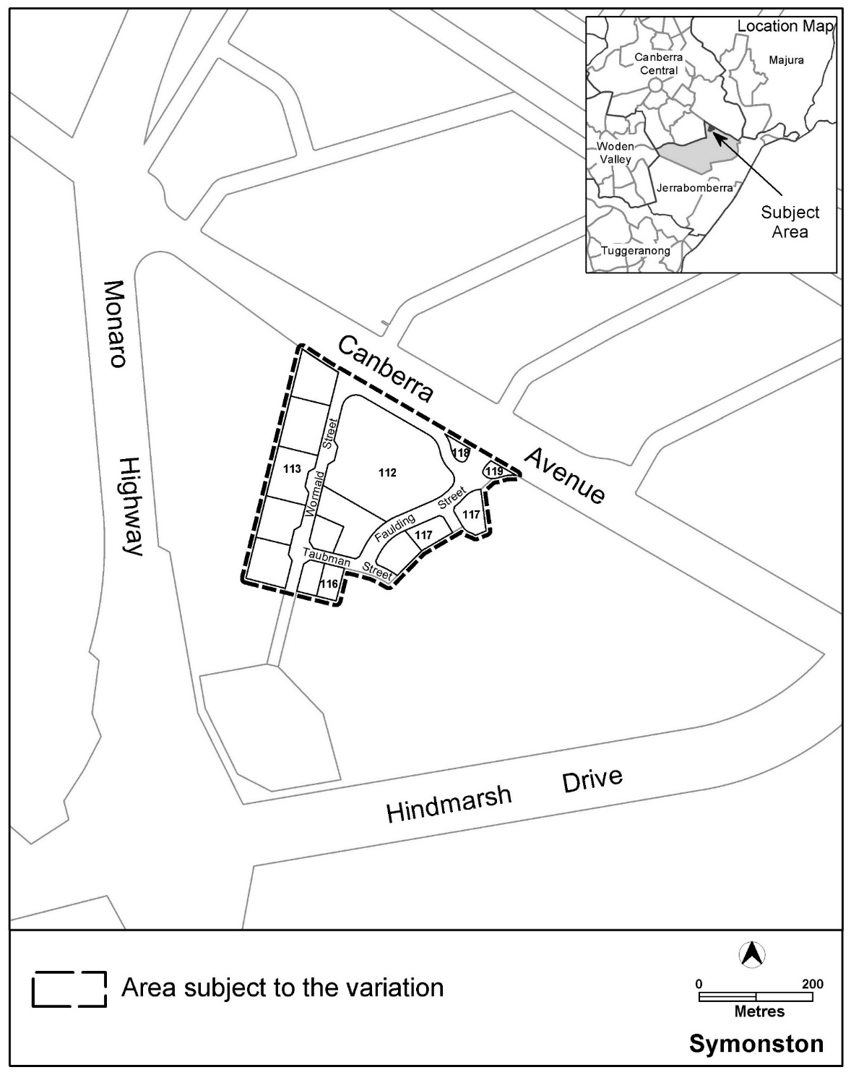
Figure 1 Site Plan

  - Current Territory Plan Provisions
The current provisions in the Symonston Precinct Map and Code:

- Specify additional prohibited uses that are ordinarily permitted in the IZ1 zone. These are listed in Table 1 – Additional prohibited development, and include:
- bulk landscape supplies
- craft workshop
- freight transport facility
- general industry
- hazardous waste facility
- incineration facility
- indoor recreation facility
- liquid fuel depot
- municipal depot
- offensive industry
- plant and equipment hire establishment
- public transport facility
- railway use
- recycling facility
- service station
- store transport depot
- waste transfer station

- Specify additional development that may be approved subject to assessment, that would ordinarily not be permitted in the IZ1 zone. These are listed in Table 2 – Additional merit track development, and include:
- SHOP (excluding bulky goods retailing)

- Describes the purpose of the Amtech Estate in criterion C1 as:
The proposed use is primarily related to the research, development, manufacture, processing, assembly, marketing or service provision of advanced technology and scientific products including allied goods and services and supporting processes.

- Provides a control through a mandatory requirement in Rule R2 that specifies the maximum gross floor area per lease of a shop is 50m².

  - Changes to the Territory Plan
Detailed changes to the Territory Plan are noted in section 2 of this document.

  - Consultation on the Draft Variation
Draft Variation 385 (DV385) was released for public comment between 30 September 2022 and 14 November 2022. A consultation notice under section 63 of the Planning and Development Act 2007 (P&D Act) was published on the ACT Legislation Register on 30 September 2022.
No written submissions were received.
A report on consultation detailed consultation with the public and mandatory agencies. No changes were made as a result of consultation. The outcomes of consultation were considered by the Minister responsible for planning prior to approval of this variation.
  - Revisions to the Draft Variation Recommended to the Minister
No changes were made to the planning provisions of the draft variation recommended to the Minister. Corrections were made to the numbering of elements, provisions, and instructions about how to insert the provisions into the Territory Plan. A reference under the ‘rules’ column for provision C4 (corrected to C2B) was corrected from ‘There is not an applicable rule’ to ‘There is no applicable rule.’

- VARIATION
  - Variation to the Territory Plan

Variation to the Symonston Precinct Map and Code
- Assessment Tracks; Table 1 – Additional prohibited development
Substitute

Additional prohibited development
Suburb precinct map label | Zone | Development
PD1 | IZ1 | bulk landscape supplies  freight transport facility general industry hazardous waste facility incineration facility  liquid fuel depot municipal depot offensive industry  plant and equipment hire establishment  public transport facility  railway use recycling facility service station  transport depot  waste transfer station
PD2 | NUZ1 | animal care facility caravan park / camping ground  cemetery communications facility community activity centre corrections facility defence installation  emergency services facility  health facility land management facility  MAJOR UTILITY INSTALLATION  municipal depot place of worship  residential care accommodation scientific research establishment  supportive housing  tourist facility transport depot veterinary hospital  woodlot
- Assessment tracks; Table 2 – Additional merit track development
Substitute

Additional merit track development that may be approved subject to assessment
Suburb precinct map label | Zone | Development
MT1 | IZ1 | Drink establishment  NON-RETAIL COMMERCIAL USE  Restaurant  SHOP (excluding bulky goods  retailing)
MT2 | NUZ1 | cultural facility
MT3 | NUZ1 | mobile home park
MT4 | NUZ1 | Mental health facility

- Additional rules and criteria, RC1 – Amtech Industrial Estate, Element 1: Use, 1.1 Advanced technology and scientific production
Substitute
Rules | Criteria
1.1 Business park
There is no applicable rule. | C1  The proposed use is primarily related to the establishment of uses in a business park that:  - does not adversely impact on the air quality (limiting emissions to clean air expulsion free of heat, dust, odour and chemicals as a by-product of on-site activities), and  - demonstrates that it does not emit noise in excess of the provisions of the Environmental Protection Regulations 2005 Schedule 2.

- RC1 – Amtech Industrial Estate RC1 – Amtech Industrial Estate, Element 1: Use, 1.2 SHOP – floor space limit, R2
New Elements

Insert
1.3 Restaurant – floor space limit
R2A  The maximum gross floor area per lease of  Restaurant is 300m². | This is a mandatory requirement. There is no applicable criterion.

Element 1A: Environment
Rules | Criteria
1A.1 Heat island
There is no applicable rule. | C2B  Development achieves no net gain of urban heat to the block on which development is occurring.  Compliance with this criterion is demonstrated in a microclimate assessment report by a suitably qualified professional which details building and place design and use of mitigating measures such as:  - use of low thermal mass, high albedo and or high emissivity building materials and or finishes where exposed to solar radiation in summer  - inclusion of canopy trees in appropriate locations to maximise summer time shading and winter time warming  - permeable surfaces in appropriate locations, particularly around canopy trees  - use of water features  - appropriate location and spacing of open space and buildings  - other types of cooling measures such as green roofs, vertical gardens and shade structures.  For the purpose of this criterion a ‘suitably qualified professional’ is a person with qualifications, experience and/or skills, relevant to urban climate science, urban modelling and microclimate assessment.
1A.2 Environmental assessment
R2C  An environmental assessment report for any development is endorsed by the Environment Protection Authority.  Note: A condition of development approval may be imposed to ensure compliance with the endorsed site assessment report | This is a mandatory requirement. There is  no applicable criterion.

1A.3 Heritage
R2D  An ‘Unanticipated Discovery Protocol’ for the management of any unexpected heritage discoveries during construction is endorsed by the ACT Heritage Council.  Note: A condition of development approval may be imposed to ensure compliance with this rule. | C2D  If an ‘Unanticipated Discovery Protocol’ endorsed by the ACT Heritage Council is not provided the application will be referred to the ACT Heritage Council.
R2E  Development adjacent to the Symonston Aboriginal Quarry Site is to include heritage conservation measures endorsed by the ACT Heritage Council.  Note: A condition of development approval may be imposed to ensure compliance with this rule. | C2E  If development adjacent to the Symonston Aboriginal Quarry Site does not include heritage conservation measures endorsed by the ACT Heritage Council, the application will be referred to the ACT Heritage Council

Interpretation service
