Australian Capital Territory
Planning and Development (Plan Variation 380) Approval 2023

Notifiable instrument NI2023-142
made under the
Planning and Development Act 2007, s 76 (Minister’s powers in relation to draft plan variations)

1 Name of instrument
This instrument is the Planning and Development (Plan Variation 380) Approval 2023.
2 Commencement
This instrument commences on the day after its notification day.
3 Approval of draft plan variation
(1) I approve under the Planning and Development Act 2007, section 76 (2) (a), plan variation 380 to the Territory Plan.
(2) In this section:
plan variation 380 to the Territory Plan means the plan variation set out in the schedule.

Mick Gentleman MLA
Minister for Planning and Land Management
17/3/2023

Planning and Development Act 2007

Variation to the
Territory Plan
380

Deakin Office Park and Public Open Space
Deakin section 66 and
section 78 block 13

Final variation prepared under s76 of the
Planning and Development Act 2007

Contents
1. EXPLANATORY STATEMENT 3
1.1 Background 3
1.2 Summary of the Proposal 3
1.3 The National Capital Plan 4
1.4 Site Description 4
1.5 Current Territory Plan Provisions 6
1.6 Changes to the Territory Plan 6
1.7 Consultation on the Draft Variation 7
1.8 Revisions to the Draft Variation Recommended to the Minister 8
2. VARIATION 9
2.1 Variation to the Territory Plan Map 9
2.2 Variation to the Territory Plan 10

- EXPLANATORY STATEMENT
  - Background
The ACT Government prepared an Integrated Plan for the Red Hill Nature Reserve and Surrounds, primarily in response to the resolution of the Legislative Assembly of 25 October 2017. The resolution called upon the ACT Government to complete the Integrated Plan before proceeding to prepare and determine any separate Territory Plan variations adjoining the Red Hill Nature Reserve. At the time (2017) the site was the subject of a proposed rezoning to allow a mixed use residential, commercial and office development.
The Integrated planning process was conducted over several years and involved extensive input from local and surrounding community and stakeholder groups. It was released for public engagement in December 2019.
The Red Hill Integrated Plan 2021 made a number of recommendations about future development within the area adjoining and surrounding the Red Hill Nature Reserve. This variation implements recommendation 6 of the Integrated Plan by rezoning Deakin Section 66 from the Territory Plan Transport TSZ2 Services Zone to part Commercial CZ2 Business Zone and part Parks and Recreation PRZ1 Urban Open Space Zone to reflect existing uses on the site.

  - Summary of the Proposal
This variation (V380) proposes to implement recommendation 6 of the Red Hill Integrated Plan June 2021:
6. The Deakin Section 66 site is rezoned as follows:
- Blocks 2 and 6 are rezoned from the existing Transport TSZ2 Services Zone to the Commercial CZ2 Business Zone primarily to reflect current uses on the site and consistent with uses in the surrounding Deakin office park (residential uses not permitted).
- Block 13 Section 78 is rezoned to the PRZ1 Urban Open Space Zone primarily to reflect ecological values of the site.
- Blocks 7 and 8 are rezoned to the PRZ1 Urban Open Space Zone primarily to reflect ecological values of parts of the site.
V380 also seeks to implement part of recommendation 1 (ii) of the Integrated Plan:
(ii) Options be investigated to incorporate areas of high ecological values at Deakin Section 66 and at the Federal Golf Club into the adjoining nature reserve.

The Integrated Plan is available at:
www.planning.act.gov.au/__data/assets/pdf_file/0010/1776772/Red-Hill-Integrated-Plan-June-2021.pdf
V380 amends the Territory Plan and Map to rezone and incorporate Deakin section 66 blocks 2 and 6 into the Deakin office area under the Deakin Precinct Map and Code. V380 further rezones and includes Deakin section 66 blocks 7 and 8 and section 78 block 13 into the surrounding urban open space network. Additionally, the urban open space zoned land is added into the ‘pc – nature reserve’ public land overlay, allowing the land to be formally incorporated into the adjoining Red Hill Nature Reserve.

  - The National Capital Plan
The Australian Capital Territory (Planning and Land Management) Act 1988 established the National Capital Authority (NCA) with two of its functions being to prepare and administer a National Capital Plan (NCP) and to keep the NCP under constant review and to propose amendments to it when necessary.
The NCP, which was published in the Commonwealth Gazette on 21 January 1990 is required to ensure that Canberra and the Territory are planned and developed in accordance with their national significance. The Planning and Land Management Act 1988 also requires that the Territory Plan is not inconsistent with the NCP.
In accordance with section 10 of the Australian Capital Territory (Planning and Land Management) Act 1988, the NCP defines the planning principles and policies for Canberra and the Territory, for giving effect to the object of the NCP and sets out the general policies to be implemented throughout the Territory, including the range and nature of permitted land uses.
It also sets out the detailed conditions of planning, design and development for areas that have special significance to the National Capital known as designated areas and identifies special requirements for the development of some other areas.

  - Site Description
Figure 1 identifies the blocks subject to rezoning by V380, which are Deakin section 66 blocks 2,6, 7 and 8 and Deakin section 78 block 13. The land is at Kent Street, Deakin, and is located adjacent (to the north and east) to the Canberra Nature Park which is designated land under the National Capital Plan. To the south the land adjoins the PRZ1 Urban Open Space Zone.
Deakin, section 66, blocks 2 and 6 are developed with the Deakin offices and a Telecommunications facility. The remaining blocks (Deakin section 66 blocks 7 and 8 and section 78 block 13) are undeveloped.
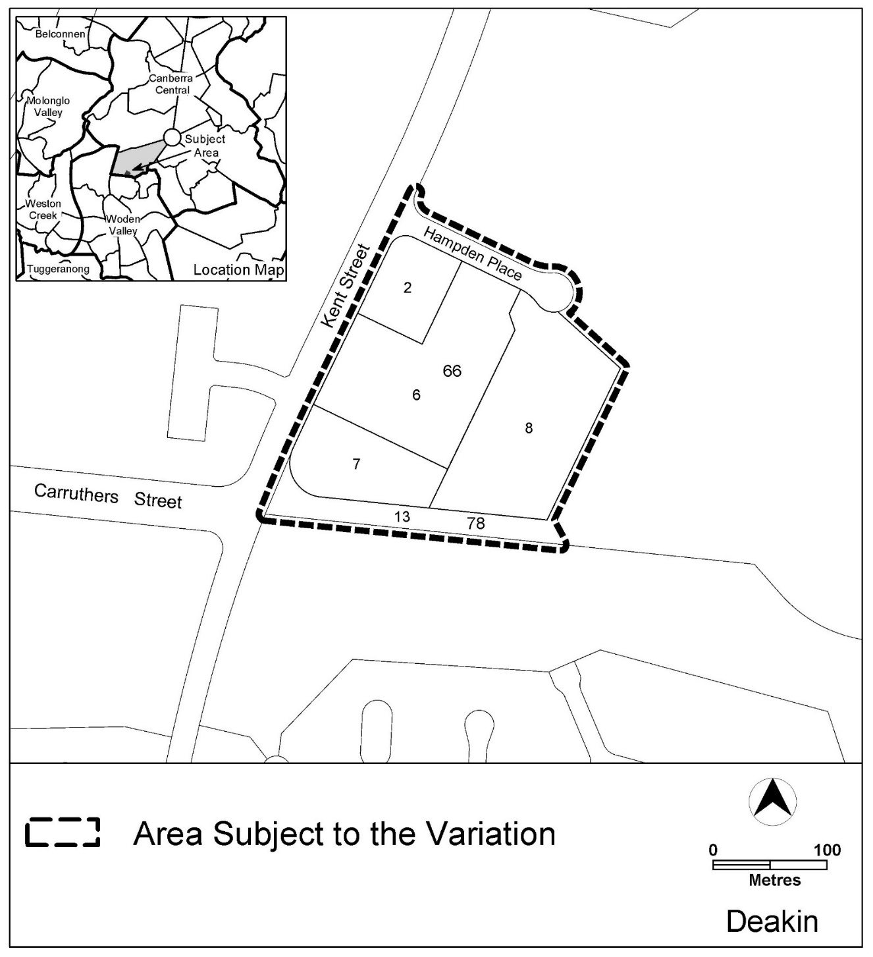
Figure 1 Site Plan

  - Current Territory Plan Provisions
The Territory Plan map for the area subject to this variation is shown in Figure 2.
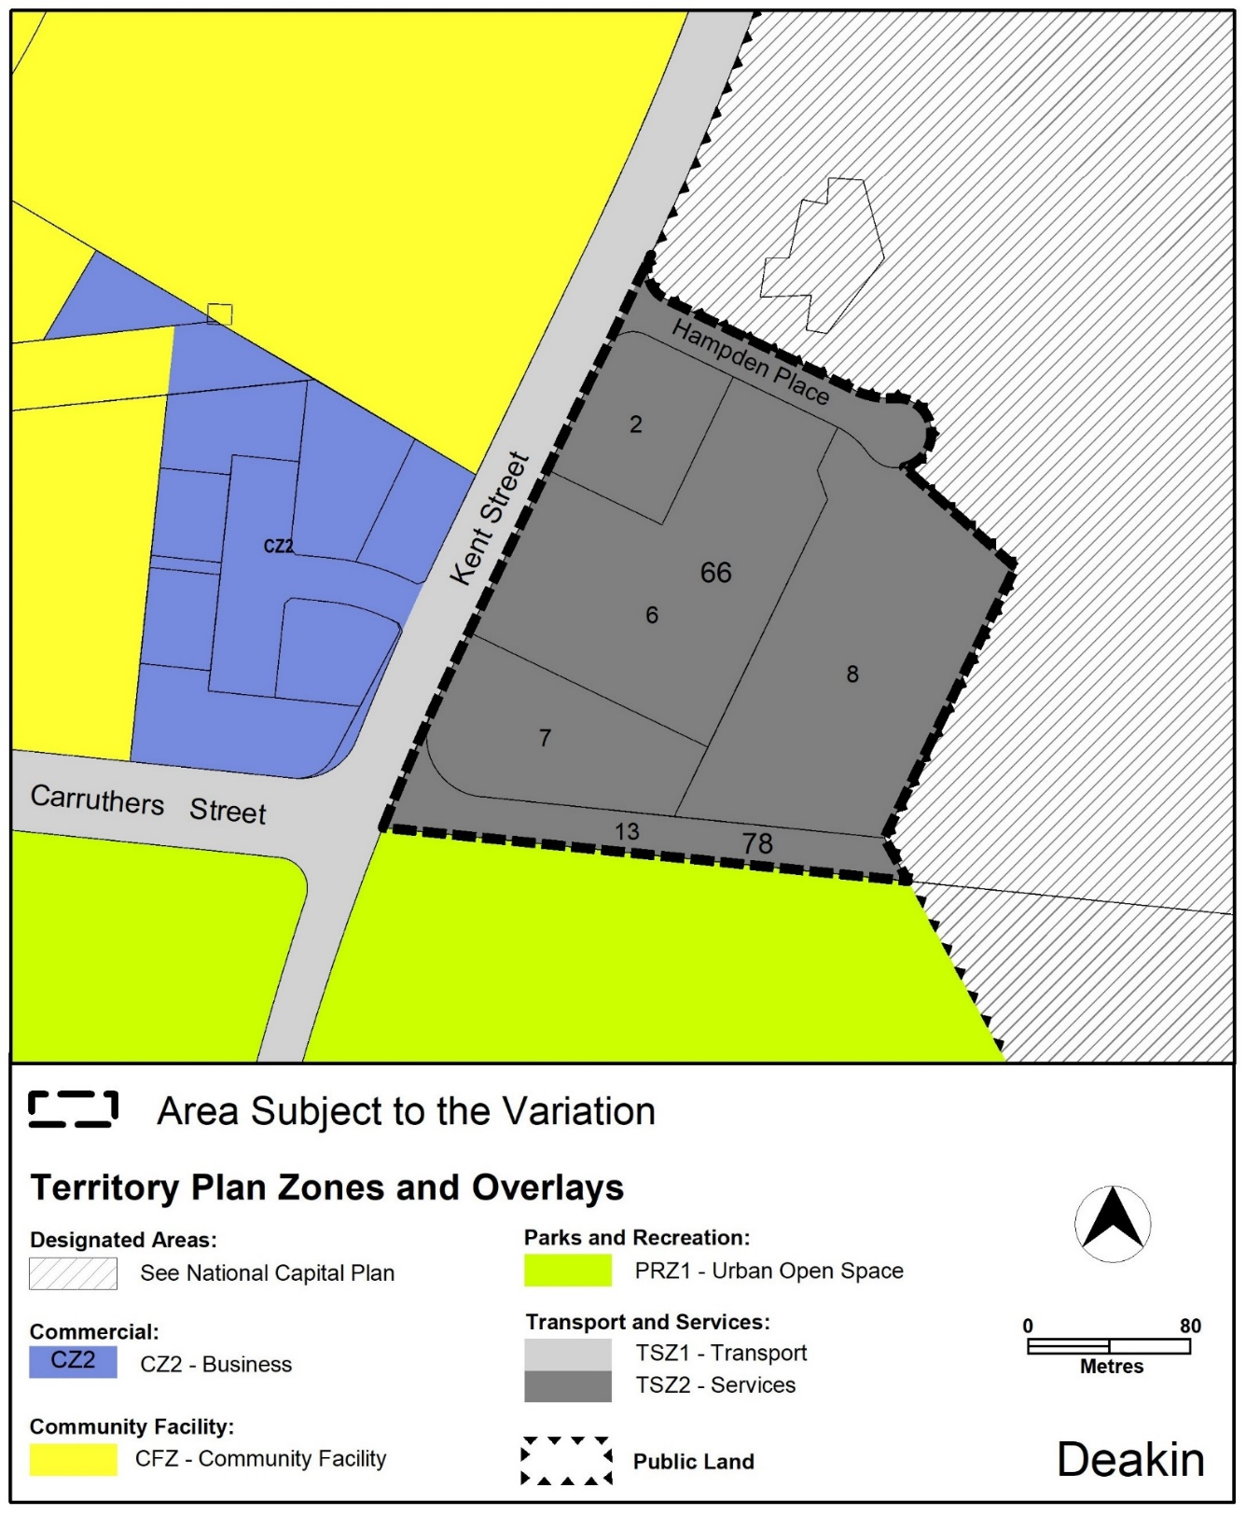
Figure 2 Territory Plan Zones Map

  - Changes to the Territory Plan
Detailed changes to the Territory Plan are noted in section 2 of this document.

  - Consultation on the Draft Variation
Draft Variation 380 (DV380) was released for public comment between 15 October 2022 and 25 November 2022. A consultation notice under section 63 of the Planning and Development Act 2007 (P&D Act) was published on the ACT Legislation Register on 17 October 2022.
A total of 14 written submissions were received. The main issues raised by submitters included:
- five submissions from wildlife and conservation groups, being the ACT National Parks Association, Friends of Grasslands, the Red Hill Bush Regenerators ParkCare Group Inc., also known as the Red Hill Regenerators, Canberra Ornithologists Group and the Conservation Council (ACT region)
- eight submissions from individuals
- one submission from the current lessee of the blocks proposed to be rezoned to the PRZ1 urban open space zone.
Comments related to the following considerations:
Table 1 Summary of reasons for supporting DV380
Reasons for supporting Draft Variation 380 | Number of submissions
Support for DV380 which achieves balanced outcomes consistent with the Integrated Plan. | 7
Supportive of requirements for an environmental assessment | 5
Support for the addition of land into the Red Hill Nature Reserve | 8
Congratulations on thorough and professional investigations, consultations and assessment and the high calibre of draft variations | 2
Credit for the foresight of the legislative Assembly in initiating the integrated plan process | 1
Table 2 Summary of matters raised in public submissions on DV380
Considerations raised in public submissions | Number of submissions
Request for some of the land set aside for a 'dirt jump park' for BMX and mountain bike riders | 1

Support for the draft variation with recommendations for retention, management and rehabilitation of ecological values and environmentally sensitive office development | 1
Request Territory to compulsorily acquire the leases over the blocks to transform the land from a private to a public asset | 1
Request to protect heritage value of the telephone exchange building on block 2 section 66 Deakin | 1

The above comments were considered and are detailed in a report on consultation.
The outcomes of consultation were considered by the Minister responsible for planning prior to approval of this variation.
  - Revisions to the Draft Variation Recommended to the Minister
No changes were made to the draft variation recommended to the Minister.

- VARIATION
  - Variation to the Territory Plan Map
The Territory Plan map is varied in all of the following ways:
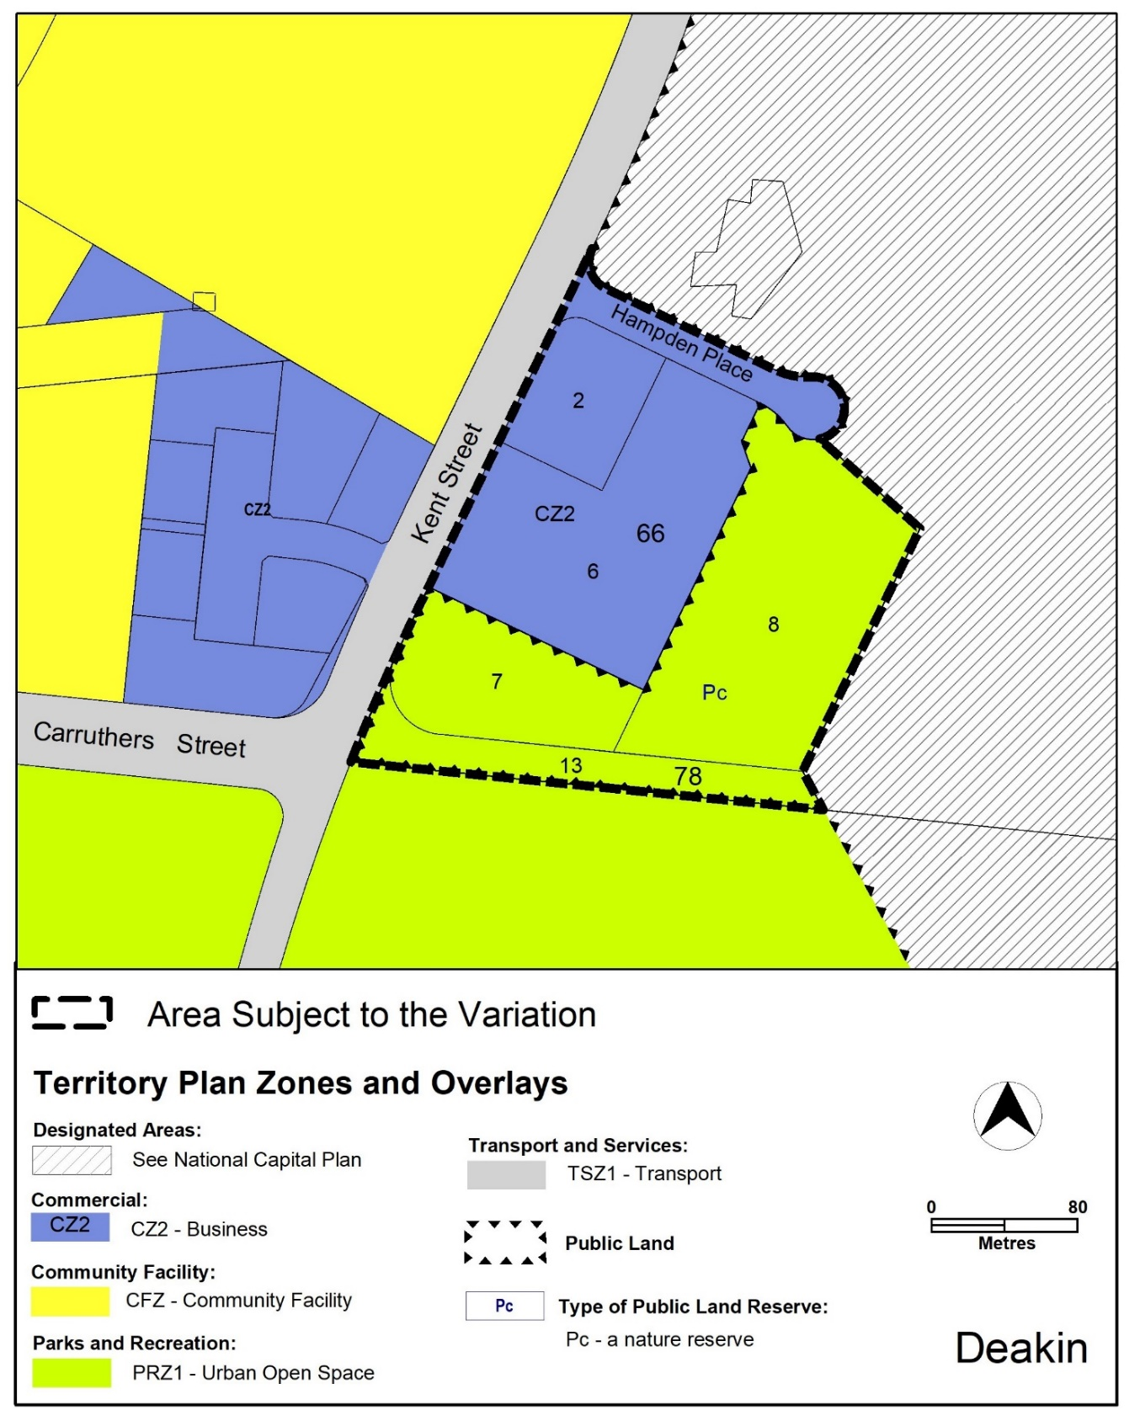

  - Variation to the Territory Plan

Variation to the Deakin Precinct Map
substitute
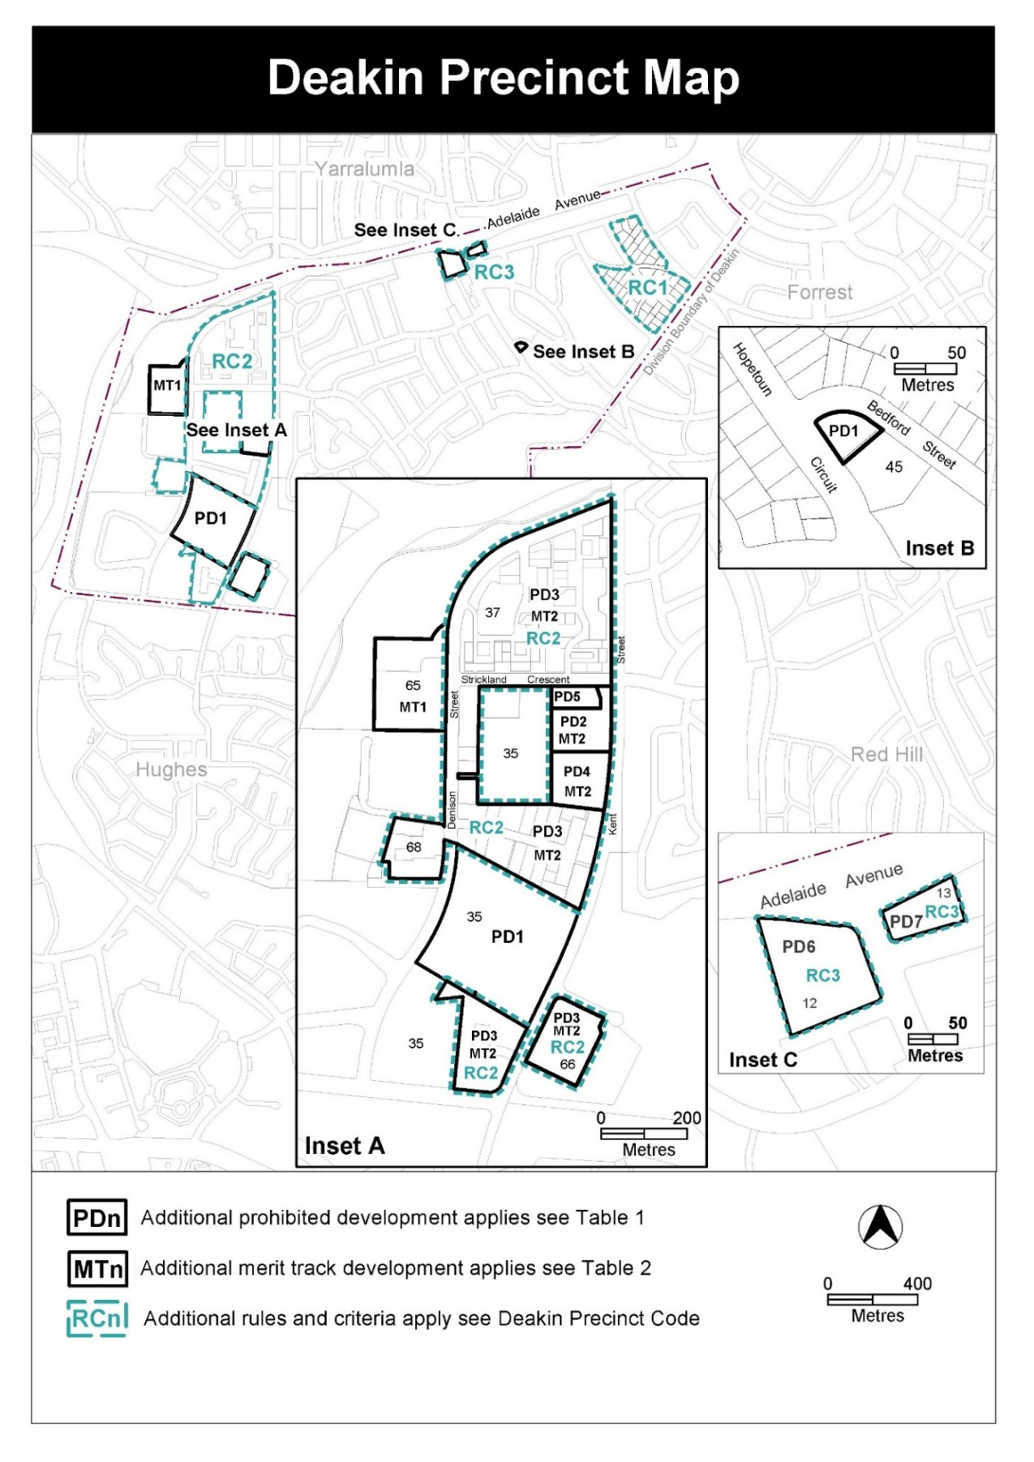

Variation to the Deakin Precinct Code
- RC2 Deakin office site – Figure 1

Substitute
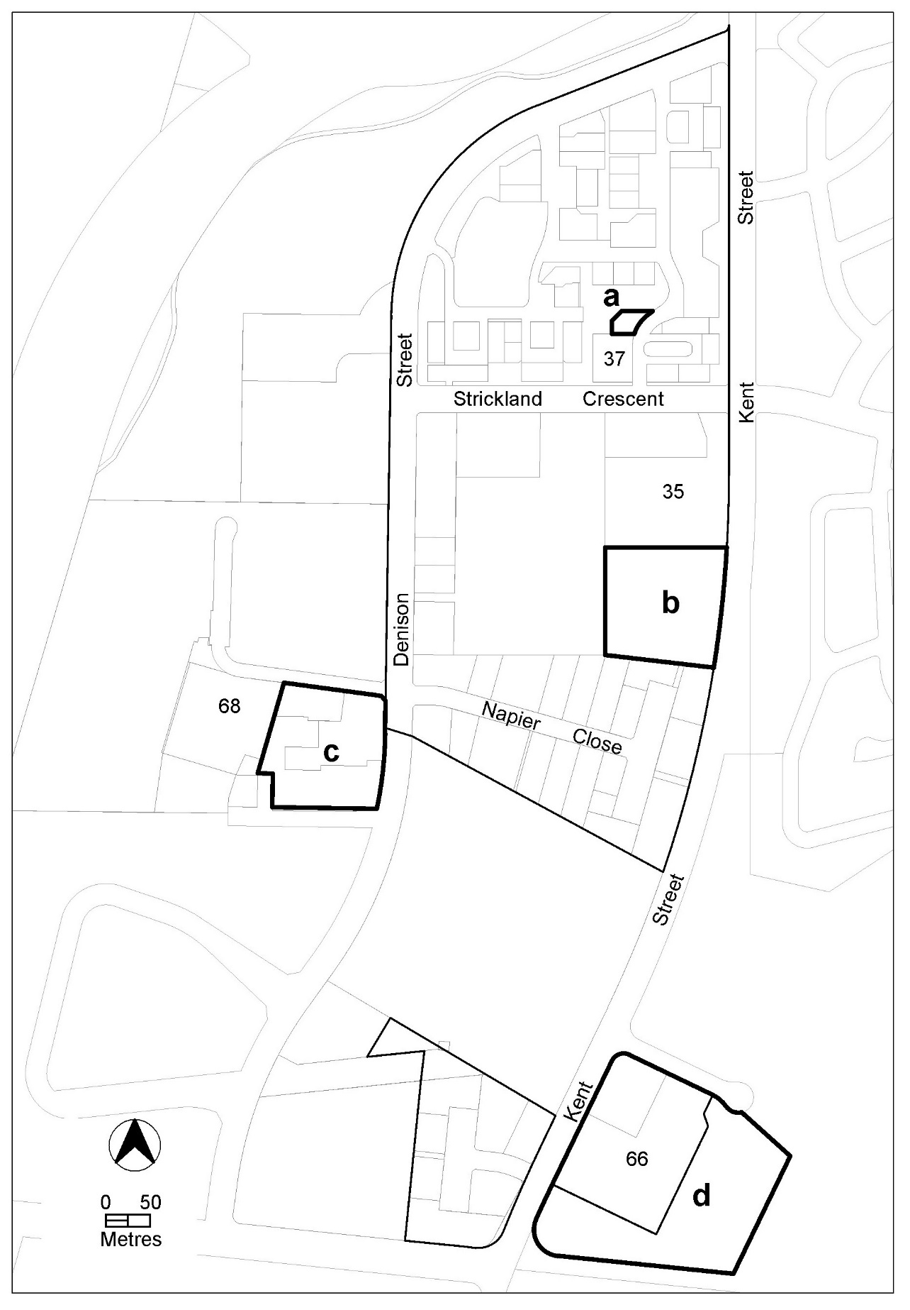
- RC2 – Deakin office site
New Element 4A: Environment

Insert

Element 4A: Environment
 | Rules |  | Criteria
4A.1 Contamination
R12  This rule applies to area d shown on figure 1.  An environmental assessment report for the development is endorsed by the Environment Protection Authority.  Note: A condition of development approval may be imposed to ensure compliance with the endorsed site assessment report. |  | This is a mandatory rule. There is no applicable criterion.

Interpretation service
