Australian Capital Territory

Nature Conservation (Canberra Grassland Earless Dragon) Conservation Advice 2023

Notifiable instrument NI2023–218
made under the
Nature Conservation Act 2014, s 90C (Conservation advice)

1 Name of instrument
This instrument is the Nature Conservation (Canberra Grassland Earless Dragon) Conservation Advice 2023.

2 Commencement
This instrument commences on the day after its notification day.

3 Conservation advice for Canberra Grassland Earless Dragon
Schedule 1 sets out the conservation advice for Canberra Grassland Earless Dragon (Tympanocryptis lineata).

Arthur Georges
Chair, Scientific Committee
14 April 2023
Schedule 1
(see s 3)

Conservation Advice
Canberra Grassland Earless Dragon – Tympanocryptis lineata

Conservation Status
The Canberra Grassland Earless Dragon – Tympanocryptis lineata Peters, 1863 – is recognised as threatened in the following jurisdictions:
National Critically Endangered, Environment Protection & Biodiversity Conservation Act 1999 (EPBC Act)
ACT Critically Endangered, Nature Conservation Act 2014 (NC Act)
NSW Critically Endangered, Biodiversity Conservation Act 2016

ELIGIBILITY
The Canberra Grassland Earless Dragon is listed as Critically Endangered in the ACT Threatened Native Species List under IUCN Criteria: A–A4(b); B–B1ab(i,ii,iii,iv,v); C–C1&C2a(i) owing to an accelerated trajectory of very severe decline despite variable year-to-year abundance records; an Extent of Occurrence (EOO) of 70 km², severely fragmented subpopulations, direct observation of declines in EOO, Area of Occupation (AOO), habitat area, extent and quality, number of subpopulations, and number of mature individuals; a small population size, a very high rate of ongoing decline in the number of mature individuals and less than 50 mature individuals in each of the two main populations. Dimond et al. (2012) estimated low annual survival rates for both juveniles and adults. There is an ongoing threat of development within the Canberra region where any further grassland contraction is likely to exacerbate fragmentation, reduce connectivity and increase the risk of the species’ extinction.

DESCRIPTION AND ECOLOGY
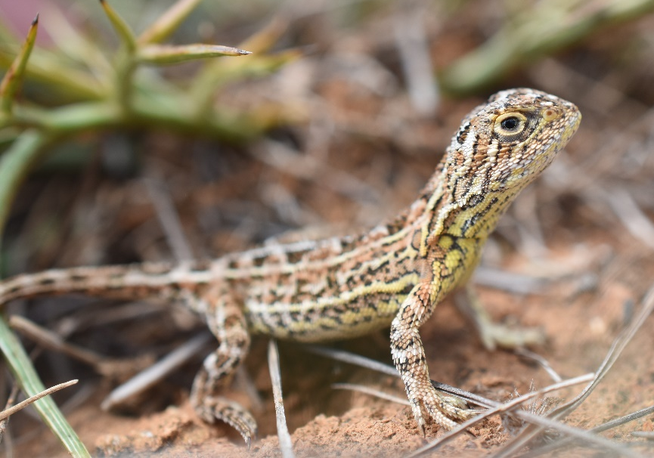
The Canberra Grassland Earless Dragon is a small, diurnal, and cryptic agamid lizard with a stout body and short robust limbs (Mitchell 1948). It lacks an external ear opening and a functional tympanum (ear drum) (Greer 1989, Cogger 2014). Total adult body length is usually less than 150 mm (Robertson and Evans 2009) with a snout vent length (SVL) of 44–61 mm (Melville et al. 2019a) and weight of 5–9 g (Robertson and Evans 2009). The species has a tapering snout, its nostril scale is below the ridge that runs from the eye to the snout, it has six or seven dark crossbands on its back and a skin fold along its side, the larger rounded scales on its back have a prominent spine that points backwards and upwards, it has no large and rounded scales on its thighs, the scales under its throat are smooth, it often has dark speckling on its underside and especially on the throat, and it has 11 or fewer blotches on its tail (Melville et al. 2019a). The pattern of the dark blotches is unique to each individual and does not change with age making it useful for identifying individual animals (Nelson et al. 1996; Dimond 2010). There is usually a pale bar above the eye but it is usually weakly contrasting.
Canberra Grassland Earless Dragon (Emma Carlson – EPSDD)
Breeding commences in September and egg laying takes place from mid-October through to February (Doucette and Sarre 2018). Females lay a clutch of three to seven (typically five) eggs at around 10 months of age in an arthropod burrow 10–13 cm deep (Doucette and Sarre 2018). Hatching occurs mainly in January–March but may well extend through to May (Langston 1996; Dimond 2010; Doucette unpublished data), and high abundance of invertebrate prey coincides with the juvenile recruitment period (Benson 1999; Nelson 2004). Juveniles grow rapidly and males mature at six months, around two months earlier than females (Langston 1996; Nelson 2004). The Canberra Grassland Earless Dragon has an average life span in the wild of less than two years (Dimond 2010) although they can live to five years or even older in captivity (Doucette and Sarre, 2018).
The Canberra Grassland Earless Dragon is a sit-and-wait predator and eats a variety of small invertebrates, especially ants, beetles, spiders and moths (including larvae) (Howe 1995; Benson 1999; Dimond 2010) with beetles being the preferred food at three sites in 2007.
Genetic analyses indicate the Canberra Grassland Earless Dragon has high levels of population structure with no interchange of individuals between populations and very little gene flow between subpopulations (Hoehn et al. 2013; Carlson et al. 2016; Colley 2021). Even within populations, the sites and even sampling grids within sites are connected by only very low levels of gene flow. The genetic data suggest that even a distance of 100 m of sub-optimal grassland will prevent most genetic exchange in this species. Within subpopulations, Canberra Grassland Earless Dragons occupy mostly one or two natural burrows within a home range of 925–4768 m², with some overlap in home ranges (Stevens et al. 2010). Adults and juveniles frequently move from one burrow (natural or artificial) to another (Benson 1996; Langston 1996; Nelson 2004; Stevens et al. 2010; AECOM 2014; Doucette unpublished data), with dispersal of greater than 100 m rare (Colley 2021).

Distribution and Habitat
The Canberra Grassland Earless Dragon was thought to be extinct in the Australian Capital Territory (ACT) after not being recorded for 30 years until an opportunistic observation was made near Canberra (ACT) in the early 1990s (Osborne et al. 1993). It is now known to be geographically isolated and restricted to Natural Temperate Grassland (a listed Critically Endangered ecological community under the EPBC Act and NC Act) around Canberra in the ACT and immediately adjacent in New South Wales. Surveys conducted in the 1990s and early 2000s by the ACT Government Conservation Research section identified 14 sites containing the Canberra Grassland Earless Dragon (Figure 1, Table 1). The continuous area encompassed by these sites is 70 km² (EOO) but the area of the sites occupied by dragons is only 26 km² (Gruber unpublished data; Figure 1).
The effective population size at the three most closely monitored sites (Cookanalla, Jerrabomberra West Grasslands Nature Reserve, and the Majura Training Area) are well below the 100 considered to be the minimum number required to avoid rapid inbreeding (Frankham et al. 2014).
Figure 1: Extent of Occurrence (over last 30 years) of the Canberra Grassland Earless Dragon
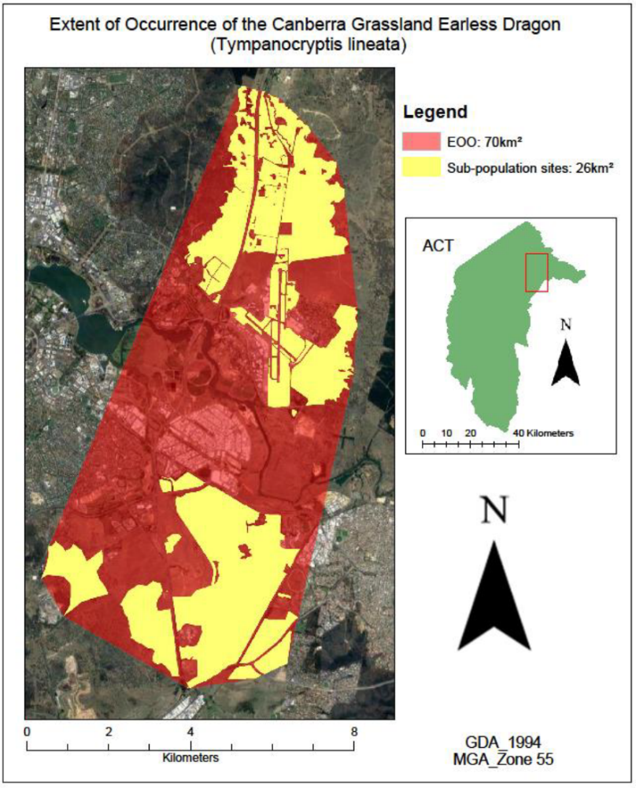
Table 1: Monitoring 2002–2022
Site | 02 | 03 | 04 | 05 | 06 | 07 | 08 | 09 | 10 | 11 | 12 | 13 | 14 | 15 | 16 | 17 | 18 | 19 | 20 | 21 | 22
AP | - | - | - | - | - | - | - | 36 | - | - | - | - | - | - | - | - | - | - | - | - | -
AT | - | - | - | - | - | - | - | - | - | 1 | - | 2 | - | 4 | - | 1 | - | 0 | - | 0 | -
BW | - | - | - | - | - | 13 | 7 | 9 | - | 1 | - | - | - | - | - | - | - | - | 0 | 0 | 0
CA | - | - | - | - | - | - | - | - | - | - | - | 27 | - | 34 | 28 | - | 34 | 16 | 18 | 13 | 10
JE | - | - | - | - | - | - | - | 2 | 3 | 6 | 5 | 2 | 6 | 7 | 33 | 30 | 16 | 1 | 3 | 1 | 1
JW | - | - | - | - | 208 | 28 | 30 | 16 | 6 | 2 | 2 | 18 | 23 | 12 | 7 | 4 | 1 | 2 | 0 | 0 | 0
MTA | 25 | 18 | 18 | - | 11 | 5 | 5 | 16 | 19 | 1 | 2 | 11 | 16 | 32 | 51 | 12 | 13 | 2 | 2 | 0 | 2
PS | - | - | - | - | - | - | - | - | - | 10 | 9 | 12 | 10 | 11 | 30 | 12 | 23 | 29 | 2 | 0 | 3
QN | - | - | - | - | 31 | 6 | 0 | 4 | 3 | 3 | 12 | 9 | 11 | 5 | 24 | 8 | 35 | 5 | 1 | 0 | 1
Ave per site | 25 | 18 | 18 |  | 83.3 | 13 | 10.5 | 13.8 | 7.8 | 3.4 | 6 | 11.6 | 13.2 | 15 | 28.8 | 11.2 | 20.3 | 7.9 | 3.7 | 1.8 | 2.1
The number of unique individuals captured at monitoring grids and transects at the nine sites known to contain populations of the Canberra Grassland Earless Dragon and subjected to standardised monitoring.
AP–Aerial Paddock; AT–Canberra Airport; BW–Bonshaw; CA–Cookanalla; JE–Jerrabomberra East Grasslands;
JW– Jerrabomberra West Grasslands NR; MTA–Majura Training Area; PS–Private site, NSW; QN–Queanbeyan Nature Reserve, NSW. Data supplied by the ACT (S. Pulsford and E Carlson) and NSW (R. Pietsch and R. Armstrong) Governments.
‘–’ Surveys not conducted at those sites in those years. Only one site (MTA) was surveyed in the first three years of records and no sites were surveyed in 2005. Surveys conducted in the 1990s are not included here because the methods and sites used then were different and do not allow direct comparison. An analysis of those data can be found in Dimond et al. 2012.
In 2021, the species was found to comprise three populations: (1) Canberra North (Majura Training Area, Canberra Airport); (2) Jerrabomberra West (Jerrabomberra West Grasslands Nature Reserve); and (3) Canberra South (Jerrabomberra East Grasslands, Queanbeyan Nature Reserve (NSW), NSW private property, Bonshaw, Aerial Paddock, Cookanalla). Each of these populations consists of a series of subpopulations that exist at the site and sampling grid level (Colley 2021).
Within the grassland habitat the dragons rely on the existence tussocks and arthropod burrows made by the Common Wolf Spider (Lycosa godeffroyi) and the Canberra Raspy Cricket (Cooraboorama canberrae) (Osborne et al. 1993b, Benson 1999). These are critical for shelter to survive the extreme (low and high) temperatures experienced in these grasslands (Nelson and Cooper 2020; Stevens et al. 2010; Doucette unpublished data). While dragons are more often found in areas where herbage biomass is lower (Osborne et al. 2013; Cook et al. 2015; Osborne 2015), maintaining a varied grassland structure and avoiding herbage biomass extremes is a management aim to maximise the range of shelter and thermal niches, and types of prey (Stevens et al. 2010; Taylor 2014; M. Evans pers. comm.).

A captive breeding population, comprising individuals from Cookanalla and Jerrabomberra West, was established at the University of Canberra (UC) in 2013 for the purpose of research and insurance against extinction. Two additional colonies, founded from wild caught animals from the south Canberra population, were recently initiated at Melbourne Zoo (2019) and Tidbinbilla Nature Reserve (2021). One live animal from the northern Majura Training Area site has now been incorporated into the breeding colony at the Tidbinbilla Nature Reserve. Further details are provided in the listing assessment (ACT Scientific Committee and DCCEEW 2022).

Threats
The threats to the species are detailed in the listing assessment (ACT Scientific Committee and DCCEEW 2022) and summarised here. The main threats that contributed to the species’ decline include the destruction, degradation, fragmentation and reduced connectivity of Natural Temperate Grassland (NTG) and associated native grassland habitat due to:
- urban, industrial and agricultural development encroachment (Melville et al. 2018) of grasslands
- overgrazing of habitat by kangaroos, rabbits or livestock, or close mowing that led to the loss of tussock structure and excessive bare ground (ACT Government 2017)
- the interaction between high temperatures and lack of ground cover caused by drought and exacerbated by overgrazing (Dimond 2010; Dimond et al. 2012) that reduced suitable habitat, food availability and opportunities for subpopulations of this species to seek refugia (Dimond et al. 2012) resulting in increased mortality from exposure
- the effect of high, including extreme, temperatures on physiological function and performance may compromise survival and reproduction, independent of its interacting effect with habitat
- cultivation that likely destroyed arthropod populations, particularly of the Wolf Spider (Lycosa spp.) and the Canberra Raspy Cricket (Cooraboorama canberrae), that the Canberra Grassland Earless Dragon relies on to form burrows (Nelson 2004, Stringer 2018, ACT Government 2017)
- the application of pasture improvement techniques and introduced pasture species to outcompete native species for water, light and nutrients
- invasive weeds, including the highly invasive African Lovegrass (Eragrostis curvula), that changed the structure of the grassland habitat to that of a monoculture, destroying NTG and associated native grassland, making it uninhabitable for the Canberra Grassland Earless Dragon by obscuring invertebrate burrows and filling inter-tussock gaps, which reduced the availability of basking and nesting sites (TSSC 2008; ACT Government 2017).
Many further threats are detailed in the listing assessment (ACT Scientific Committee and DCCEEW 2022) including climate change related threats, excessive biomass/insufficient grazing and predation.

Major Conservation Objective
The overall conservation objective of the species current action plan is to maintain in the long term, viable, wild populations of the species as a component of the indigenous biological resources of the ACT and as a contribution to regional and national conservation of the species. This includes the need to maintain natural evolutionary processes.

Conservation PRIORITIES
In the action plan (ACT Government 2017) and in recommendations made in Evans et al. 2018 (released after the action plan), the main conservation effort for the species is focused on protecting viable populations in functional native grassland habitat within two clusters of sites across its geographical range—the Majura Valley and the Jerrabomberra Valley. However, given recent populations reductions, ex-situ management has already been deemed necessary. Priorities in the action plan, updated with Evans et al. 2018, that continue to be important include to:
- conserve all populations
- protect existing CGED habitat in the ACT and prevent further fragmentation
- assume the species is present at any site where it previously occurred since 1991 unless this is disproved by rigorous survey (especially given the recent "reappearance" of other earless dragon species at sites in Cooma and in Victoria where the relevant species was assumed to be extinct).
- conserve optimal habitat quality, particularly through an appropriate herbage mass management regime (biomass neither too high nor too low – see above) and in line with other Natural Temperate Grassland species’ needs
- manage adjacent grassland to increase habitat area and connect populations or establish/re-establish populations
- not allow any environmental offsets for this species or its habitat (even though populations may occur on offset sites for other species and the Natural Temperate Grassland ecological community)
- undertake further surveys at ACT sites where the abundance of the species across the site is not well understood, confirming distribution of remaining populations in the ACT region using rapid survey assessment methods
- monitor a representative set of sites to determine long-term population trends and to evaluate the effects of management
- establish relevant monitoring and research for adaptive management
- collaborate with research institutions to undertake required research and non-government organisations to undertake on ground actions
- liaise with NSW and other land holders (Commonwealth Government and Canberra Airport) with responsibility for the conservation of a threatened species or community.
Research and adaptive management are required to better understand the habitat requirements for the species and techniques to maintain the species’ habitat. Specific research priorities in the current action plan and in Evans et al. 2018 that remain as priorities include:
- identifying relationships between Grassland Earless Dragon abundance and habitat structural elements (grass sward structure and factors affecting invertebrate burrow abundance) through time
- land management practices compatible with, or required for, maintaining suitable habitat (such as grazing, slashing, burning)
- breeding requirements, oviposition sites, reproductive rates, and their relationship to habitat structure, seasonal conditions and predicted effects of climate change (which are underway)
- importance of availability and density of natural burrows, relationship between CGED and burrowing arthropods, effect of burrow supplementation on sparse CGED populations
- sensitivity of the species to weeds in its habitat, the weeds of major concern, and suitable control and revegetation methods
- techniques to maintain and breed the species in captivity for captive insurance populations and subsequently to maintain the colonies that have been recently established since the action plan commenced
- determine the magnitude and significance of seasonal/annual population fluctuations (which may require annual or biennial monitoring at key sites) and the relationship with seasonal/annual conditions and habitat characteristics.
- continue work with experimental reintroductions.

CONSERVATION ISSUES
Broader conservation issues need to be considered in developing and implementing actions arising from this advice and the species listing assessment (ACT Scientific Committee and DEECCW 2022).

Critical Habitat
Given the perilous state of this species (recently redefined taxonomically) it is critical that all available habitat, suitable for this species is protected in the ACT, both in the interests of existing resident populations and in the interests of maintaining opportunities for the re-establishment of the species in areas subject to local extirpation. Particular attention needs to be paid to incremental change (the tyranny of a thousand cuts) and emphasis on the avoidance of impacts on this species and its habitat is critical, with mitigation of impacts, and offsets not being appropriate mechanisms for proponents.

Climate Change
Climate change impacts appear inevitable and will affect the likelihood of persistence, within the ACT, of many species. Most vulnerable in this regard are those species that occupy highly fragmented habitat with highly restricted distributions, such as the Canberra Grassland Earless Dragon. Capacity must be developed to model the impact on the Canberra Grassland Earless Dragon and its habitat under likely climate change scenarios if we are to anticipate and manage the impacts of climate change. This will require a combination of research and the development of in-house capacity for the collection of relevant data and its application in climate change modelling.
Kangaroo grass (Themeda triandra) is a diagnostic species within NTG habitat. Modelling by Mackenzie et al. (2019) suggests climates are likely to become increasingly unsuitable for maintaining this conservation asset locally, except for small subalpine grassland patches along the southern-most reaches of the Territory. Therefore, additional research is needed to improve model performance, and the understanding of distribution, for such critical grassland species, as it is unclear how their removal may impact the structure and function of NTG, with theory suggesting resilience may decrease and potential for ecological invasion will increase (Mackenzie et al. 2019).

Captive Colonies
The establishment of captive colonies of the Canberra Grassland Earless Dragon is beneficial to provide insurance against stochastic losses in the wild, to manage the progressive loss of genetic diversity in the wild, and to provide a source of individuals for the re-establishment of the Canberra Grassland Earless Dragon in local patches where it has been lost or that have been rehabilitated to be suitable for the establishment of the dragon. Insurance colonies do not come without risk, which includes disease risk and progressive selection for traits that are advantageous or neutral in captivity but deleterious in the wild (e.g. simplification of natural complex behaviours). In the context of disease, normal practice is to prohibit the release of animals from captive colonies to the wild in order to manage disease risk, but we make an exception in the case of insurance colonies. This requires that the insurance colonies are subject to strict quarantine, that the colony is strictly isolated from potential reservoirs of disease (e.g. other reptile species) and that animals scheduled for release are subject to stringent disease assessment. This needs appropriate oversight by qualified experts in establishing and maintaining quarantine conditions.

Population Viability
With species on the brink of extinction, such as the Canberra Grassland Earless Dragon, the question often raised is whether the species is already functionally extinct. That is, have the populations declined in abundance and become fragmented to such an extent and has the genetic diversity of the species declined to such an extent that the species no longer has the capacity to rebound should conditions improve or to respond to management intervention. Such an assessment needs to be made in the case of the Canberra Grassland Earless Dragon, and if it is determined that the species is functionally extinct, to explore more drastic options for bringing the species to a position where it has the potential to recover (e.g. outbreeding with related taxa).

Jurisdictional Collaboration
The ACT is subject to complex jurisdictional arrangements as considerable areas of grassland are managed by the Commonwealth (including important habitat for the species at Canberra Airport and on Department of Defence Land in the Majura Valley. Developing policies and action/recovery plans in this context therefore requires discussion/negotiations across these jurisdictional entities.

Ngunnawal Community Engagement
The ACT Government should facilitate, the inclusion of the Ngunnawal people in the conservation of this species and its habitat as part of Ngunnawal Country. Reference to the draft Cultural Resource Management Plan (ACT Government in prep.) would be useful to inform culturally appropriate resource management including of native species that aligns with achieving conservation outcomes for the species.

Other Relevant Advice, plans or Prescriptions
- Commonwealth Conservation Advice – Canberra Grassland Earless Dragon (ACT Scientific Committee and DCCEEW 2022)
- ACT Native Grassland Conservation Strategy and Action Plans (ACT Government 2017)
- Grassland Earless Dragon Action Plan (ACT Government 2017)
- Grassland Earless Dragon Action Plan Progress Report (ACT Government 2022)

Listing Background
The Canberra Grassland Earless Dragon is now conventionally accepted as Tympanocryptis lineata Peters, 1863. The Eastern Lined Earless Dragon Tympanocryptis lineata pinguicolla was initially listed 15 April 1996 as an Endangered species under the Nature Conservation Act 1980 which was the highest category of threat at that time. In making its assessment the ACT Flora and Fauna Committee concluded that it satisfied the criteria:
1.2 Species is observed, estimated, inferred or suspected to be at risk of premature extinction in the ACT region in the near future, as demonstrated by:
1.2.1 Current severe decline in population or distribution from evidence based on:
1.2.1.3 severe decline in quality or quantity of habitat
1.2.1.5 severe threats from herbivores, predators, parasites, pathogens or competitors.
1.2.4 Severely fragmented distribution for a species currently occurring over a small range or having a small area of occupancy within its range.
1.2.6 Extremely small population.
The Committee assessed that this species met the criteria for listing as Endangered for the following reasons:
- There has been a serious decline in the quality and quantity of habitat of this species throughout its range including the ACT and known populations are now fragmented in distribution
- The grassland habitat of this species has been and continues to be exploited for agricultural and urban and industrial development. The remaining areas are vulnerable to further fragmentation associated with urban infrastructure and there is little likelihood of the creation of any ecological links between remaining disjunct areas.
- The very small known current range of the species and the very low proportion of this range which the species now occupies is the primary concern for its conservation.
On 26 October 2001, the listed scientific and common names were changed under the Nature Conservation Act 1980 to Grassland Earless Dragon (Tympanocryptis pinguicolla). Under the Nature Conservation Act 2014 the category of Critically Endangered was included on the Threatened Native Species List for the first time.
Recent taxonomic revisions by Melville et al. (2019a) have determined that T. pinguicolla is a complex of four species (T. pinguicolla, T. lineata, T. osbornei, T. mccartneyi) each with a distinct, non-overlapping, geographic distribution. Tympanocryptis lineata is the name now assigned to the Canberra Grassland Earless Dragon as it was discovered to be the source of the lectotype for this name (Melville et al. 2019a). This taxonomic revision warranted an assessment of the threat status of each of the new species and a likely change of status for the Canberra Grassland Earless Dragon. Assessment of new information from the ACT and NSW governments by the ACT Scientific Committee and the Commonwealth Threatened Species Scientific Committee found that the species meets the thresholds for IUCN Criteria: A–A4(b); B–B1ab(i,ii,iii,iv,v); C–C1&C2a(i) to make it eligible for listing as Critically Endangered.
This species met the listing eligibility criteria to be listed as Critically Endangered under the Environment Protection and Biodiversity Conservation Act 1999 (EPBC Act) in 2023. In 2023, under the Nature Conservation Act 2014, the ACT Scientific Committee recommended the Canberra Grassland Earless Dragon be listed in the Critically Endangered category in the ACT Threatened Native Species List to align with the proposed EPBC Act listing.

Action Plan Decision
An Action Plan for this species is in place in the ACT (ACT Government 2017) under the Nature Conservation Act 2014 and the ACT Scientific Committee recommends that the Minister for the Environment should make the decision to continue that action plan subject to drawing from the National Recovery Plan for this species and subject to any necessary changes highlighted in the 5-yearly progress report on that action plan (Conservator of Flora and Fauna in prep.).

References
ACT Flora and Fauna Committee 1996. Recommendation for Declaration of an Endangered Species Tympanocryptis lineata pinguicolla Eastern Lined Earless Dragon. Unpublished recommendation to the Minister. ACT Government, Canberra.
ACT Government 2009. ACT Weeds Strategy 2009–2019. Department of the Environment, Climate Change, Energy and Water. ACT Government, Canberra.
ACT Government 2017. ACT Native Grassland Conservation Strategy and Action Plans. Environment, Planning and Sustainable Development Directorate, ACT Government, Canberra.
ACT Government 2019. Draft Herbage Mass Management Guidelines for Lowland Grassy Ecosystems of the ACT. Environment, Planning and Sustainable Development Directorate, ACT Government, Canberra.
ACT Government 2019. Ecological Guidelines for Fire, Fuel And Access Management Operations: Part 1 Background and Explanatory Section. Environment, Planning and Sustainable Development Directorate, ACT Government, Canberra.
ACT Government 2021. Canberra Nature Park Reserve Management Plan 2021. Environment, Planning and Sustainable Development Directorate, ACT Government, Canberra. https://www.environment.act.gov.au/__data/assets/pdf_file/0009/1899396/2021-CNP-Plan_FA4.pdf
ACT Government in prep. Draft Cultural Resource Management Plan. Environment Planning and Sustainable Development, ACT Government, Canberra.
ACT Scientific Committee and DCCEEW 2022. Listing Advice for Grassland Earless Dragon Tympanocrytis pinguicolla. Prepared by the ACT Scientific Committee for the Department of Climate Change, Energy, the Environment and Water (Commonwealth), Canberra.
AECOM 2014. 2013–2014 ACT threatened species monitoring. Report prepared for Spotless Services and Department of Defence. AECOM Australia Pty Ltd, Canberra.
Barton PS, Manning AD, Gibb H, Wood JT, Lindenmayer DB and Cunningham SA 2011. Experimental reduction of native vertebrate grazing and addition of logs benefit beetle diversity at multiple scales. Journal of Applied Ecology 48(4): 943–951.
Benson KA 1999. Resource use and habitat selection by the Grassland Earless Dragon, Tympanocryptis pinguicolla: Microhabitat and Diet. Honours Thesis. Applied Ecology Research Group, University of Canberra, Canberra.
BOM – Bureau of Meteorology 2022. Daily maximum temperature – Canberra Airport. Commonwealth of Australia. http://www.bom.gov.au/jsp/ncc/cdio/weatherData/av?p_nccObsCode=122&p_display_type=dailyDataFile&p_startYear=&p_c=&p_stn_num=070351
Carlson E, MacDonald AJ, Adamack A, McGrath T, Doucette LI, Osborne WS, Gruber B and Sarre SD 2016. How many conservation units are there for the endangered Grassland Earless Dragons? Conservation Genetics 17(4): 761–774.
Cogger HG 2014. Reptiles and Amphibians of Australia. CSIRO Publishing, Collingwood.
Colley R. 2021. Gene flow and effective population size of the Canberra Grassland Earless Dragon (Tympanocryptis lineata). Honours Thesis. University of Canberra, Canberra.
Conservator of Flora and Fauna in prep. Grassland Earless Dragon Tympanocrytis pinguicolla Action Plan—Implementation Progress Report 2022. Environment, Planning and Sustainable Development Directorate, ACT Government, Canberra.
Cook E, Evans M and Osborne W 2015. Monitoring Grassland Earless Dragons in the Majura and Jerrabomberra Grasslands: 2014 survey update. Unpublished report. ACT Government, Canberra.
CSIRO and BOM 2020. The State of the Climate 2020. Commonwealth Scientific and Industrial Research Organisation and The Bureau of Meteorology, Canberra.
Dimond WJ 2010. Population decline in the endangered Grassland Earless Dragon in Australia: Identification, causes and management. PhD Thesis. Institute for Applied Ecology, University of Canberra, Canberra.
Dimond WJ, Osborne WS, Evans MC, Gruber B and Sarre SD 2012. Back to the brink: population decline of the endangered Grassland Earless Dragon (Tympanocryptis pinguicolla) following its rediscovery. Herpetological Conservation and Biology 7(2): 132–149.
Doucette LI and Sarre SD 2018. Maintenance and Breeding of Grassland Earless Dragons in Captivity. University of Canberra, Canberra.
Evans M, Howland B and Sato C 2018. Grassland Earless Dragon Management and Research Priorities 2018–2022. Conservation Research and Parks and Conservation Service. Environment Planning and Sustainable Development, Canberra, ACT Government, Canberra.
Frankham R, Bradshaw CJ, Brook BW 2014. Genetics in conservation management: revised recommendations for the 50/500 rules, Red List criteria and population viability analyses. Biological Conservation 170(1): 56–63.
Geyle HM, Tingley R, Amey AP, Cogger H, Couper PJ, Cowan M, Craig MD, Doughty P, Driscoll DA, Ellis RJ, Emery JP, Fenner A, Gardner MG, Garnett ST, Gillespie GR, Greenlees MJ, Hoskin CJ, Keogh JS, Lloyd R, Melville J, McDonald PJ, Michael DR, Mitchell NJ, Sanderson C, Shea GM, Sumner J, Wapstra E, Woinarski JCZ and Chapple DG 2021. Reptiles on the brink: identifying the Australian terrestrial snake and lizard species most at risk of extinction. Pacific Conservation Biology. 27(1): 3–12.
Greer AE 1989. The Biology and Evolution of Australian Lizards. Surrey Beatty & Sons, Chipping Norton.
Hill WG 1981. Estimation of effective population size from data on linkage disequilibrium. Genetics Research 38(3): 209–16.
Hoehn M, Dimond W, Osborne W, and Sarre SD 2013. Genetic analysis reveals the costs of peri-urban development for the endangered Grassland Earless Dragon. Conservation Genetics 14(6): 1269–1278.
Kirono DGC, Round V, Heady C, Chiew FHS and Osbrough S 2020. Drought projections for Australia: updated results and analysis of model simulations. Weather and Climate Extremes 30: 100280.
Langston AC 1996. The ecology and distribution of Tympanocryptis lineata pinguicolla (Southern Lined Earless Dragon) in the Australian Capital Territory and adjacent sub-region. Honours Thesis. Faculty of Applied Science, University of Canberra, Canberra.
MacKenzie JB, Baines G, Johnston L and Seddon J 2019. Identifying biodiversity refugia under climate change in the ACT and region. Environment, Planning and Sustainable Development Directorate, ACT Government, Canberra. https://www.environment.act.gov.au/__data/assets/pdf_file/0007/1404808/identifying-biodiversity-refugia-in-the-act.pdf
Melbourne BA 1993. The assessment of insect biodiversity. A case study: ants and carabid beetles in grasslands of the ACT. Honours Thesis. Australian National University, Canberra.
Melville J, Chaplin K, Hutchinson M, Sumner J, Gruber B, MacDonald AJ and Sarre SD 2019a. Taxonomy and conservation of Grassland Earless Dragons: new species and an assessment of the first possible extinction of a reptile on mainland Australia. Royal Society Open Science 6(5): 190–233.
Melville J, Chaplin K, Hipsley CA, Sarre SD, Sumner J, Hutchinson M 2019b. Integrating phylogeography and high-resolution X-ray CT reveals five new cryptic species and multiple hybrid zones among Australian earless dragons. Royal Society Open Science 6(12): 1–32.
Melville J, Hutchinson M, Clemann N, Robertson P and Michael D 2018. Tympanocryptis pinguicolla. The IUCN Red List of Threatened Species 2018: e.T22579A83494675.
Mitchell FJ 1948. A revision of the lacertilian genus Tympanocryptis. Records of the South Australian Museum 9(1): 57–86.
Nelson L 2004. Thermal ecology and implications for life history variation in Tympanocryptis pinguicolla (Grassland Earless Dragon). PhD Thesis. Division of Botany and Zoology, Australian National University, Canberra.
Nelson LS and Cooper PD 2017. Seasonal effects on body temperature of the endangered grassland earless dragon, Tympanocryptis pinguicolla, from populations at two elevations. Australian Journal of Zoology 65(3): 165–178.
Nelson LS, Smith WJS and Goldie R 1996. 1996 survey program for the Eastern Lined Earless Dragon, Tympanocryptis pinguicolla. Internal Report 96/2. Wildlife Research Unit, ACT Parks and Conservation Service, ACT Government, Canberra.
NSW Government 2020. Saving our Species – Help save the Grassland Earless Dragon Tympanocryptis pinguicolla. Department of Planning and Environment, NSW Government, Sydney.
NSW Scientific Committee 1996. Final Determination – Grassland earless dragon (Tympanocryptis pinguicolla) - endangered species listing (formerly called south-eastern lined earless dragon (Tympanocryptis lineata pinguicolla). Department of Planning and Environment, NSW Government, Sydney.
Osborne W 2015. Monitoring grassland earless dragons at Jerrabomberra East Grassland Reserve 2009–2015. Report for Canberra Nature Park, ACT Parks and Conservation Service. Institute for Applied Ecology, University of Canberra, Canberra.
Osborne WS, Kukolic K, Davis MS, and Blackburn R 1993. Recent records of the Earless Dragon Tympanocryptis lineata pinguicolla in the Canberra region and a description of its habitat. Herpetofauna 23(1): 16–25.
Osborne W, Doucette L and Gilbert M 2013. Monitoring Grassland Earless Dragons at the Jerrabomberra Grassland Reserves – 2011, 2012 and 2013. Institute for Applied Ecology, University of Canberra, Canberra.
Osborne W, Wong D and Dimond W 2009. Habitat mapping for the Grassland Earless Dragon (Tympanocryptis pinguicolla) at Cookanalla and Wendover, Symonston, ACT. Report and mapping for ACT Planning and Land Authority. Institute for Applied Ecology, University of Canberra, Canberra.
Peters WCH 1863. Eine Übersicht der von Hrn. Richard Schomburgk an das zoologische Museum eingesandten Amphibien, aus Buchsfelde bei Adelaide in Südaustralien. Monatsberichte der Königlichen Preussische Akademie des Wissenschaften zu Berlin 1863: 228–236.
Robertson P and Evans M 2009. National Recovery Plan for the Grassland Earless Dragon Tympanocryptis pinguicolla. ACT Department of Territory and Municipal Services, ACT Government, Canberra.
Sarre SD, Stringer E, Duncan R and Gruber B 2020. Future Monitoring of Canberra Grassland Earless Dragons (Tympanocryptis lineata) in the ACT. University of Canberra, Canberra.
Sharp S 2011. Distribution and Abundance of African Lovegrass in the ACT and Capital Region and options for strategic control. Report to the Southern ACT Catchment Group, Canberra.
Smith W 1994. The ecology and taxonomy of the Southern Lined Earless Dragon (Tympanocryptis lineata pinguicolla). Honours Thesis. Australian National University, Canberra.
Stevens TA, Evans MC, Osborne WS and Sarre SD 2010. Home ranges of, and habitat use by, the grassland earless dragon (Tympanocryptis pinguicolla) in remnant native grasslands near Canberra. Australian Journal of Zoology 58(2): 76–84.
Stringer EJ 2018. The detection and monitoring of Grassland Earless Dragons (Tympanocryptis pinguicolla). Honours Thesis. University of Canberra, Canberra.
Taylor KA 2014. Behavioural ecology of captive Grassland Earless Dragons (Tympanocryptis pinguicolla). Honours Thesis. University of Canberra, Canberra.
Thomson J 2021. Detecting and monitoring the Canberra Grassland Earless Dragon (Tympanocryptis lineata). Honours Thesis. University of Canberra, Canberra.
Trenberth KE, Dai A, van der Schrier G, Jones PD, Barichivich J, Briffa KR and Sheffield J 2014. Global warming and changes in drought. Nature Climate Change 4(1): 17–22.
TSSC 2008. Listing Advice: Natural Temperate Grassland of the Victorian Volcanic Plain. Threatened Species Scientific Committee. Commonwealth Department of the Environment, Water, Heritage and the Arts, Canberra.
Waples RS 1991. Genetic methods for estimating the effective size of cetacean populations. Report of the International Whaling Commission (special issue) 13: 279–300.

Further Information
Further information on the related Action Plan and Woodland Strategy or other threatened species and ecological communities can be obtained from the Environment, Planning and Sustainable Development Directorate (EPSDD): Phone: (02) 132281, EPSDD Website: https://www.environment.act.gov.au/

Attachment A: Listing Assessment (ACT Scientific Committee and DEECCW 2022)
