Australian Capital Territory

Nature Conservation (Koala) Conservation Advice 2023

Notifiable instrument NI2023–223
made under the
Nature Conservation Act 2014, s 90C (Conservation advice)

1 Name of instrument
This instrument is the Nature Conservation (Koala) Conservation Advice 2023.

2 Commencement
This instrument commences on the day after its notification day.

3 Conservation advice for Koala
Schedule 1 sets out the conservation advice for Koala (Phascolarctos cinereus).

4 Revocation
The Nature Conservation (Koala) Conservation Advice 2019 (NI2019-230) is revoked.

Arthur Georges
Chair, Scientific Committee
14 April 2023
Schedule 1
(see s 3)

Conservation Advice
Koala
Phascolarctos cinereus

- Conservation Status
The Koala Phascolarctos cinereus (Goldfuss, 1817) is recognised as threatened in the following jurisdictions:
International Vulnerable (species), International Union of Conservation of Nature (IUCN) Red List
National Endangered (QLD/NSW/ACT populations), Environment Protection and Biodiversity Conservation Act 1999
Vulnerable, The Action Plan for Australian Mammals 2012
ACT Endangered, Nature Conservation Act 2014
NSW Endangered, Biodiversity Conservation Act 2016
QLD Endangered, Nature Conservation Act 1992
- ELIGIBILITY
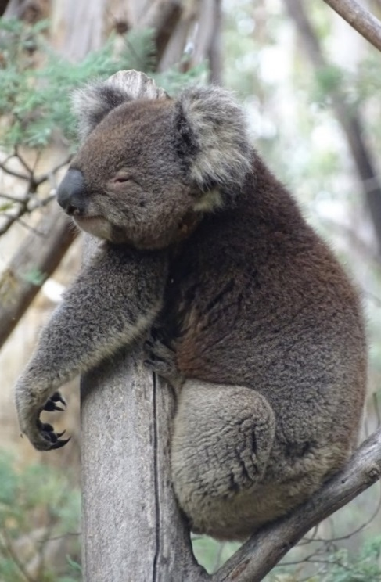
The Koala is listed as Endangered in the ACT Threatened Native Species List under IUCN Criterion A —A2(c) A4(c), due to a substantial population reduction at the national level (Attachment A). The Koala is estimated to have declined by greater than 50% over the past 20 years (three generations). This decline is expected to be greater as a result of the 2019-2020 bushfires and the decline is expected to continue into the future with the likelihood of additional compound impacts due to climate change (Attachment A) (DAWE 2022a). During the 2019–2020 bushfire season an estimated nine percent (>36,800 km2) of the QLD/NSW/ACT distribution was impacted by fire (DAWE 2021). This agrees with estimates generated by the NESP Threatened Species Recovery Hub of 9–11.4 percent (DAWE 2022a, Runge et al. 2021b).
- DESCRIPTION AND ECOLOGY
The Koala – Gula (Winanggaay Ngunnawal Language Group) is a tree-dwelling, medium-sized marsupial with a stocky body, large ears, sharp claws and variable but predominantly grey-coloured fur. It is one of Australia’s most distinctive and iconic wildlife species (DoE 2012).
The Koala is an arboreal folivorous marsupial. It occurs in forests and woodlands, typically dominated by Eucalyptus species. The Koala has a specialist diet, mostly limited to the foliage of Eucalyptus species, with occasional intake of leaves of other plant (mostly Myrtaceous) genera (Martin and Handasyde 1999, Moore and Foley 2000, 2005). The Koala is mostly solitary, but individuals have extensive overlap in home ranges.
Koala (Roy McDowall – Canberra Nature Map)
Breeding is seasonal, with births (typically of single young) occurring in October–May. Females can produce young at annual intervals, but births per adult female per year average 0.3–0.8 (McLean 2003). Female Koalas reach sexual maturity between 2–3 years of age (McLean and Handasyde 2007). In the wild, longevity of 12 (for males) to 15 years (for females) has been reported (Martin and Handasyde 1999). Generation length is 6–8 years (Phillips 2000, Woinarski and Burbidge 2020) and, for the purposes of the listing assessment, is estimated, conservatively, at 6.5 years (Attachment A) (DAWE 2022a).
- Distribution and Habitat
The Koala is endemic to Australia and is widely distributed in coastal and inland areas from north-eastern Queensland to Eyre Peninsula in South Australia. The range extends over about one million square kilometres with populations separated into areas of suitable habitat (Martin and Handasyde 1999, NSW DECC 2008). Koalas inhabit a range of temperate, sub-tropical and tropical forest, woodland and semi-arid communities dominated by Eucalyptus species (Martin and Handasyde 1999).
The Australian Capital Territory (ACT) falls at the edge of the Koala’s natural range and the species was common in the region prior to European settlement (Phillips 1990). Anecdotal evidence suggests that Koalas occupied lowland areas that were largely lost to development and agriculture in the ACT. They were also hunted for their skins in the region, with hunting reported on Black Mountain (J. Calaby pers. comm.) and nearby in NSW at Gundaroo and Bungendore (Phillips 1990). By 1901, Koalas had become extremely rare in the region (Phillips 1990).
An assessment of habitat quality for Koala’s has been undertaken for the Mulligans Flat Sanctuary (Story 2020). Habitat quality within Mulligans Flat Sanctuary was found to be of low-moderate quality, and while habitat quality has not been formally assessed in other areas of the ACT, this is consistent with the ACT being located at the edge of the species range. Recent mapping of potential habitat in the ACT was undertaken by the NSW Department of Planning, Industry and Environment (NSW DPIE). The primary area of most suitable habitat identified in the ACT (Figure 1) is in the south-east, around the Clear and Booth ranges of Namadgi National Park, parallel with the Tinderry Range in NSW (NSW DPIE 2019).
A review of Koala records in the ACT and region found that most of the post-1980 records were close to the Orroral Valley and Bushfold Flats, where Koalas were released in 1978 (Lintermans and Crisp 1986). Escapees from releases at Tidbinbilla Nature Reserve in 1939, 1969-71 and 1984 were also the likely origin of Koala records prior to 1980 from outside this reserve (Lintermans and Crisp 1986). There are records of Koalas in the wild on Canberra Nature Map for the late 1980s to early 1990s, however, they were likely to be in low abundance. Koala records on the western border of the ACT were possibly dispersing animals from the Brindabella Ranges near Wee Jasper (Lintermans and Crisp 1986). No live animals were sighted in surveys after the 2003 bushfires with the remains of one animal found on the south-east slopes of the Gibraltar Creek valley (Carey et al. 2003).
Surveys undertaken in 2018 did not detect any Koalas (or evidence of Koala habitation such as scats or characteristic scratch marks) in the wild in the ACT, however, it is possible that Koalas may still be present. While the best possible survey sites were selected for this study only a relatively small number of sites (42) and trees (1,260 in total) were surveyed and several sites of high quality/potential habitat were either not accessible or were on Commonwealth owned Defence land (Capital Ecology 2018). Limited post-fire thermal drone surveys were undertaken for Koalas in southern Namadgi National Park after the 2020 Orroral Valley fire, with no Koalas found.
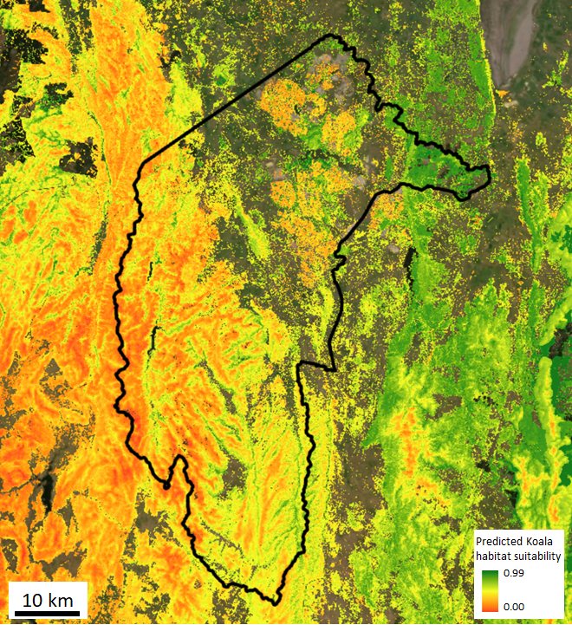
Figure 1: Koala habitat suitability based on modelling by the NSW DPIE (2019), with red indicating least suitable, yellow indicating moderately suitable and green indicating most suitable habitat, with the balance not suitable (e.g. exotic (agricultural) or native grasslands).
Opportunistic sightings: In 2014, reports of a Koala crossing the highway between Canberra Airport and Queanbeyan were made. It was believed the lone Koala was likely to be a young male pushed out of its home range in the Queanbeyan area by dominant adult males. In 2021 a Koala was observed in Oaks Estate (K. Ford pers. comm.) and another Koala was reported on a rural property near Tennent. Two recent confirmed sightings were made of wild Koalas in nearby NSW (Queanbeyan and Burra) through Canberra Nature Map (CNM 2022).
A captive population of Koalas exists at Tidbinbilla.
Outside of the ACT, Koala populations exist in nearby areas of NSW (Figure 2). Koala sighting records (NSW DPE 2022a) show that Koalas are occasionally seen in Queanbeyan and a population exists in forests from Tinderry Nature Reserve in the north to Dangelong Nature Reserve in the south. Koalas have also been observed north of the ACT near Yass, and north-east near Goulburn (NSW DPE 2022a).
As Koala populations exist near the ACT-NSW border and anecdotal evidence suggests the species was once common in the ACT, it is highly likely that the ACT supported healthy Koala populations prior to European settlement. Furthermore, habitat mapping indicates there is still habitat in the ACT capable of supporting Koalas (NSW DPIE 2019). Therefore, it is possible that through conservation action, Koala populations can be successfully re-established in carefully selected areas in the ACT.
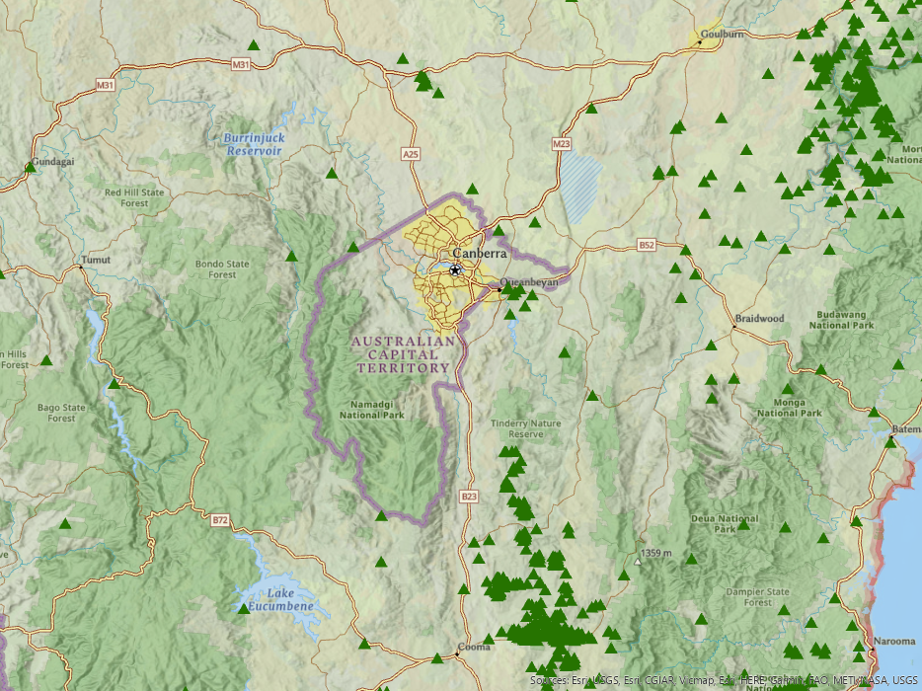
Figure 2: Koala sightings in NSW areas surrounding the ACT.
Data obtained from the NSW Department of Planning and Environment (NSW DPE) BioNet (Koala sightings) database (NSW DPE 2022a) (https://datasets.seed.nsw.gov.au/dataset/nsw-bionet-data-collection-koala-sightings)
- Threats
The main identified threats to this species are loss and fragmentation of habitat, vehicle strike, disease, and attack by dogs. Increased frequency and intensity of drought and incidences of extreme heat, large scale wildfire, and a shrinking climatically suitable area (Adams-Hosking et al. 2011, McAlpine et al. 2015, Runge et al. 2021b) are also known to cause very significant mortality. Post-drought recovery may be substantially impaired by the range of other threatening factors (DoE 2012) as climate change drivers are associated with increased levels of physiological stress in wild Koala populations (Narayan 2019).
The interaction of threats that affect the health of Koalas (including the health of trees) can increase the time Koalas need to spend on the ground and increase their exposure to dog attack (NSW DPE 2022b), especially by domestic dogs in and near urban areas. This does not necessarily translate to dingoes being a significant threat to healthy Koalas in quality habitat areas away from urban areas. Dingo populations occurring in parts of Namadgi National Park (NNP) and Tidbinbilla Nature Reserve (TNR) are an important element of the native biodiversity and contribute to maintaining a balanced ecosystem function. While dingoes are not controlled in some areas of NNP and TNR, other areas neighbouring rural lands are managed for dingoes, wild dogs and foxes as part of a long-term established control program to prevent livestock depredation. Therefore, it is recommended that any future release of Koalas into areas with dingo populations be carefully monitored. If dingo predation becomes a limiting factor to successful establishment, then no further reintroductions should be undertaken in areas occupied by dingoes. Instead, reintroductions should be focused in other suitable areas in habitat corridors that provide connectivity to NSW where dingoes are not present and/or in areas where Koalas can be protected through existing measures of control of predators.
- Major Conservation Objective
The main objective in the ACT should be to maintain Koala habitat where feasible and to investigate the appetite and potential for reinstating the Koala as a viable population in the wild in the ACT at levels sustainable for the habitat.
- Conservation PRIORITIES
Recommended conservation priorities in the ACT include to:
- undertake baseline monitoring to confirm current distribution in the ACT
- assess habitat quality, quantity, and connectivity in the ACT, including the carrying capacity of habitat, to determine how many Koalas ACT habitat is capable of sustainably supporting (i.e., whilst ensuring ecosystems, particularly endangered vegetation communities, remain healthy)
- embed Ngunnawal vision and values in any project actions undertaken to restore Koala habitat and populations in the ACT
- maintain and restore habitat where feasible (e.g. along riparian areas and within the wildlife restoration corridors identified in other strategic documents e.g. the Woodlands Strategy (ACT Government 2019) and Doerr et al. 2014)
- investigate the option of changing the Tidbinbilla captive colony to individuals that are representative of local/regional genetic provenance
- support other jurisdictions (particularly NSW) including through involvement in the National Koala Monitoring Program (NKMP), the National Koala Recovery Team and Expert Technical Advisory Panel.
- Other Relevant Advice, plans or Prescriptions
- Commonwealth Conservation Advice — Koala (DAWE 2022a)
- National Recovery Plan – Koala (DAWE 2022b)
- NSW Koala Strategy (NSW DPE 2022b)
- The Action Plan for Australian Mammals (Woinarski et al. 2014)
- Listing Background
Initially, the NSW, Queensland and ACT population of the Koala Phascolarctos cinereus was listed as Vulnerable under the Environment Protection and Biodiversity Conservation Act 1999 (EPBC Act) on 5 May 2016. In 2019, under the Nature Conservation Act 2014, the ACT Scientific Committee recommended the Koala be listed in the Vulnerable category in the ACT Threatened Native Species List to align with the EPBC Act listing.
The species was reassessed and listed as Endangered under the EPBC Act on 12 February 2022. In response, the ACT Scientific Committee recommended the Koala be transferred to the Endangered category in the ACT Threatened Native Species List under the Nature Conservation Act 2014, to align with the EPBC Act listing.
- Action Plan Decision
The ACT Scientific Committee recommends that the Minister for the Environment should make the decision to not have an action plan for the species in the ACT under the Nature Conservation Act 2014 at this time as there are no current wild Koala populations in the ACT that require management. An Action Plan or Native Species Conservation Plan (on stated land) might be required in the future if viable, wild populations are either found or re-established in the ACT. A five-year Koala research project is currently being planned with the Ngunnawal Community, with the aim to assess and, if appropriate, re-establish Koalas in the ACT.
- References
ACT Government 2015. Nil Desperandum Homestead and Surrounds – Background Information. ACT Heritage Council, Canberra. http://www.environment.act.gov.au/__data/assets/pdf_file/0004/717394/Nil-Desperandum-Background-Information-ENDORSED-HCM-20150730.pdf.
ACT Government 2019. ACT Native Woodland Conservation Strategy and Action Plans. Environment Planning and Sustainable Development Directorate, Canberra. https://www.legislation.act.gov.au/di/2019-255/
Adams-Hosking C, Grantham HS, Rhodes JR, McAlpine C and Moss PT 2011. Modelling climate change-induced shifts in the distribution of the Koala. Wildlife Research 38(2): 122–130. https://www.researchgate.net/publication/258699229_Modelling_climate-change-induced_shifts_in_the_distribution_of_the_koala
Canberra.naturemapr.org (CNM) 2022. Canberra Nature Map. Accessed 16 May 2022 from: https://canberra.naturemapr.org/Community/Species/10158
Capital Ecology 2018. Koala Phascolarctos cinereus surveys in the Australian Capital Territory, 2018. A Report to the Environment, Planning and Sustainable Development Directorate, ACT Government, Canberra. http://www.environment.act.gov.au/__data/assets/pdf_file/0020/1255142/Koala-Survey-Report-Web-Accessible.pdf.
Carey A, Evans M, Hann P, Lintermans M, MacDonald T, Ormay P, Sharp S, Shorthouse D. and Webb N 2003. Wildfires in the ACT 2003: Report on initial impacts on natural ecosystems. Technical Report No. 17 for Environment ACT by Wildlife Research & Monitoring, Canberra. http://www.environment.act.gov.au/__data/assets/pdf_file/0006/576816/wildfiresintheact.pdf
Department of Environment (DoE) 2012. Approved Conservation Advice for Phascolarctos cinereus (combined populations in Queensland, New South Wales and the Australian Capital Territory). Department of Sustainability, Environment, Water, Population and Communities, Australian Government, Canberra. http://www.environment.gov.au/biodiversity/threatened/species/pubs/197-conservation-advice.pdf
Department of Agriculture, Water and the Environment (DAWE) 2021. Bushfire Recovery Environmental Analysis Decision Support (BREADS) tool. V21_18_IBRA. Department of Agriculture, Water and Environment (Commonwealth), Canberra.
Department of Agriculture, Water and the Environment (DAWE) 2022a. Conservation Advice for Phascolarctos cinereus (Koala) combined populations of Queensland, New South Wales and the Australian Capital Territory. Department of Agriculture, Water and the Environment, Australian Government, Canberra.https://www.environment.gov.au/cgi-bin/sprat/public/publicspecies.pl?taxon_id=85104
Department of Agriculture, Water and the Environment (DAWE) 2022b. National Recovery Plan for the Koala Phascolarctos cinereus (combined populations of Queensland, New South Wales and the Australian Capital Territory). Department of Agriculture, Water and the Environment, Australian Government, Canberra. http://www.awe.gov.au/environment/biodiversity/threatened/publications/recovery/koala-2022
Doerr ED, Doerr VAJ, Micah JD, Davey C, and Allnutt J 2014. Flyways & Byways: guiding restoration of wildlife corridors. Monitoring connectivity restoration in the Australian Capital Territory. Canberra: A report prepared for the Environment and Sustainable Development Directorate, ACT Government. CSIRO Climate Adaptation Flagship, Canberra. https://www.environment.act.gov.au/__data/assets/pdf_file/0005/672233/FlywaysByways_FinalReport_Doerr-et-al-2014-A10059895.pdf
Goldfuss GA 1817. In Schreber JCD von (1774–1855). Die Säugethiere, in Abbildungen nach der Natur, mit Beschreibungen. Fortgesetzt von A. Goldfuss. pl.CVL.Aa p.338. https://www.biodiversitylibrary.org/item/97341.
Le Lievre K 2014. Two baby Koalas born at Tidbinbilla, the first since the 2003 bushfires decimated the population. Canberra Times 22 July 2016 https://www.canberratimes.com.au/national/act/two-baby-koalas-born-at-tidbinbilla-the-first-since-the-2003-bushfires-decimated-the-population-20160722-gqbqkl.html.
Lintermans M and Crisp C 1986. The status of the Koala (Phascolarctos cinereus) in the ACT. Unpublished Report to the Australian National Parks and Wildlife Service.
Martin R and Handasyde K 1999. The Koala: Natural History, Conservation and Management. UNSW Press, Sydney.
McAlpine C, Lunney D, Melzer A, Menkhorst P, Phillips S, Phalen D, Ellis W, Foley W, Baxter G, de Villiers D, Kavanagh R, Adams-Hosking C, Todd C, Whisson D, Molsher R, Walter M, Lawler I and Close R 2015. Conserving Koalas: A review of the contrasting regional trends, outlooks and policy challenges. Biological Conservation 192(1): 226–236. https://www.researchgate.net/publication/282590131_Conserving_koalas_A_review_of_the_contrasting_regional_trends_outlooks_and_policy_challenges
McLean N 2003. Ecology and management of overabundant Koala (Phascolarctos cinereus) populations. Thesis. University of Melbourne.
McLean N and Handasyde KA 2007. Sexual maturity, factors affecting the breeding season and breeding in consecutive seasons in populations of overabundant Victorian Koalas (Phascolarctos cinereus). Australian Journal of Zoology 54(6): 385–392. https://www.publish.csiro.au/zo/zo06015
Moore BD and Foley WJ 2000. A review of feeding and diet selection in Koalas (Phascolarctos cinereus). Australian Journal of Zoology 48(3): 317–333.
Moore BD and Foley WJ 2005. Tree use by Koalas in a chemically complex landscape. Nature 435: 488–490.
Narayan EJ 2019. Physiological stress levels in wild Koala sub-populations facing anthropogenic induced environmental trauma and disease. Scientific Reports 9(1): 6031. https://www.nature.com/articles/s41598-019-42448-8/?msclkid=47f12637b3d111ecb95f4e31d1fc60cb
NSW Department of Environment and Climate Change (NSW DECC) 2008. Recovery Plan for the Koala (Phascolarctos cinereus). Department of Environment and Climate Change, NSW Government, Sydney.
NSW Department of Planning and Environment (NSW DPE) 2022a. NSW BioNet. Department of Planning, Industry and Environment, NSW Government, Sydney. https://www.environment.nsw.gov.au/topics/animals-and-plants/biodiversity/nsw-bionet
NSW Department of Planning and Environment (NSW DPE) 2022b. NSW Koala Strategy. Department of Planning and Environment, NSW Government, Sydney. https://www.environment.nsw.gov.au/research-and-publications/publications-search/nsw-koala-strategy-2022
NSW Department of Planning, Industry and Environment (NSW DPIE) 2019. Koala Habitat Information Base Technical Guide. Environment, Energy and Science, Department of Planning Industry and Environment, NSW Government, Sydney. https://www.environment.nsw.gov.au/research-and-publications/publications-search/koala-habitat-information-base-technical-guide
Phillips B 1990. Koalas: the little Australians we’d all hate to lose. Australian National Parks and Wildlife Service, AGPS Press, Canberra.
Phillips S 2000. Population trends and the Koala conservation debate. Conservation Biology 14(3): 650–659.
Runge CA, Rhodes JR and Lopez-Cubillos DS 2021a. Harmonised Koala habitat mapping report. NESP Threatened Species Recovery Hub Project 4.4.12 report. The University of Queensland, Brisbane. https://www.nespthreatenedspecies.edu.au/media/fccm4wwx/4-4-12-harmonised-koala-habitat-mapping-report_v4.pdf
Runge C, Rhodes J and Latch P 2021b. A national approach to the integration of Koala spatial data to inform conservation planning, NESP Threatened Species Recovery Hub Project 4.4.12 report. Spatial data and supporting documents. The University of Queensland and Threatened Species Recovery Hub, Brisbane. https://www.nespthreatenedspecies.edu.au/projects/a-national-approach-to-the-integration-of-koala-spatial-data-to-inform-conservation-planning?msclkid=6ad36854b3d411ec888bae6b31f9bf64
Story G. 2020. Mulligans Flat Woodland Sanctuary Koala Reintroduction Background Paper.
Threatened Species Scientific Committee (TSSC) 2012. Listing advice for Phascolarctos cinereus (Koala).
Woinarski J and Burbidge AA 2020. Phascolarctos cinereus (amended version of 2016 assessment). The IUCN Red List of Threatened Species 2020. Accessed: 4 April 2022 from: https://www.iucnredlist.org/species/16892/166496779.
Woinarski JCZ, Burbidge AA and Harrison PL 2014. The Action Plan for Australian Mammals 2012. CSIRO Publishing, Collingwood.

- Further Information
Further information on this species or other threatened species and ecological communities can be obtained from Environment, Planning and Sustainable Development Directorate (EPSDD).
Phone: (02) 132281, EPSDD Website: https://www.environment.act.gov.au/

Attachment A: National Listing Assessment (DAWE 2022a)
