Australian Capital Territory

Nature Conservation (Mountain Skink) Conservation Advice 2023

Notifiable instrument NI2023–224
made under the
Nature Conservation Act 2014, s 90C (Conservation advice)

1 Name of instrument
This instrument is the Nature Conservation (Mountain Skink) Conservation Advice 2023.

2 Commencement
This instrument commences on the day after its notification day.

3 Conservation advice for Mountain Skink
Schedule 1 sets out the conservation advice for Mountain Skink (Liopholis montana)

Arthur Georges
Chair, Scientific Committee
14 April 2023
Schedule 1
(see s 3)

Conservation Advice
Mountain Skink – Liopholis montana

Conservation Status
The Mountain Skink – Liopholis montana (Donnellan, Hutchinson, Dempsey & Osborne, 2002) – is recognised as threatened in the following jurisdictions:
International Near Threatened, International Union for the Conservation of Nature Red List
National Endangered, Environment Protection and Biodiversity Conservation Act 1999
ACT Endangered, Nature Conservation Act 2014
NSW not yet listed, Biodiversity Conservation Act 2016
VIC not yet listed, Flora and Fauna Guarantee Act 1988

ELIGIBILITY
The Mountain Skink is listed as Endangered in the ACT Threatened Native Species List under IUCN Criterion B — B2ab(i,ii,iii,iv,v) due to a restricted area of occupancy (Area of occupancy (AOO) = 196 km²), severe fragmentation, ongoing loss and degradation of habitat and inferred decline in number of sub-populations and mature individuals at the national level (Attachment A). The Mountain Skink is reported as rare, declining, and its populations as fragmented (Coyne 2000, Donellan et al. 2002, Osborne and Evans 2015, Senior 2019, Clemann et al. 2018). Before the 2019–2020 fires burnt approximately 32% of the known and likely distribution, the Mountain Skink was assessed as Near Threatened on the IUCN Red List of Threatened Species, approaching Criteria B2a (Clemann et al. 2018).

DESCRIPTION AND ECOLOGY
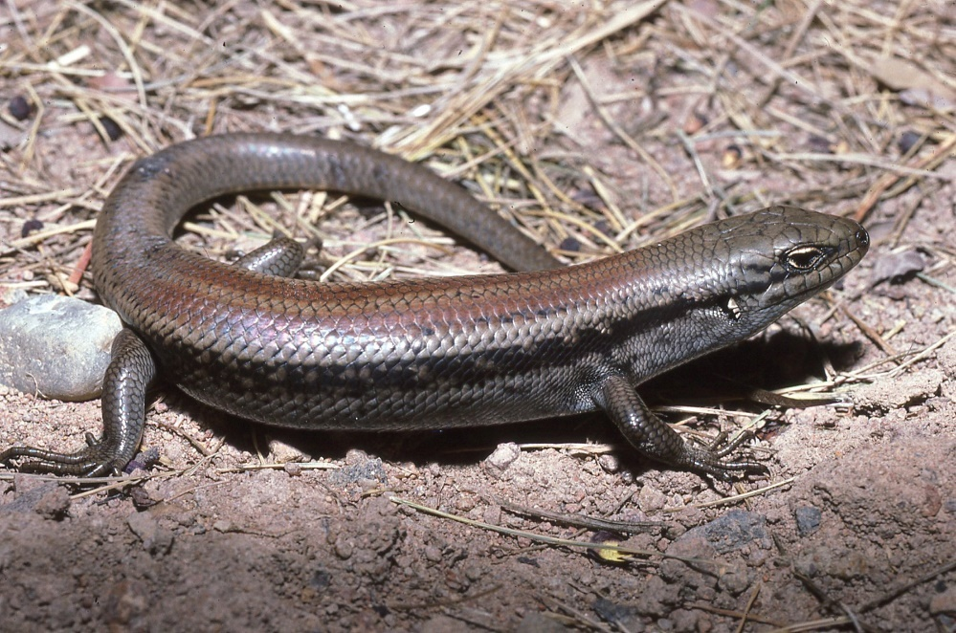
The Mountain Skink is a stoutly built species with a squarish body shape in cross-section and adults size is attained at 74 mm snout–to-vent length (SVL) with mean adult SVL 92 mm and tail length around 160% of SVL translating to a total length of 240 mm (Donnellan et al. 2002). It has two distinct colour morphs including a patterned morph and a plain morph (Chapple et al. 2008, Robertson and Coventry 2019). The basic colour of the head, body, limbs, and tail is grey-brown with most individuals having a plain, reddish-brown back generally divided by a lighter or more greyish vertebral zone (Donellan et al. 2002).
Mountain Skink (John Wombey – Canberra Nature Map)
The Mountain Skink is also known as the Tan-backed Skink and was previously considered the high-altitude form of White’s Skink (Liopholis whitii, previously Egernia whitii). The Mountain Skink can be distinguished from White’s Skink by the absence of dark-edged pale eye-like markings, particularly above the base of the forelimb and can be distinguished from the Guthega Skink (or Snowy Mountain Skink Liopholis guthega) by the absence of broad paravertebral stripes (Robertson and Coventry 2019).
It lives in colonies and appears to exhibit stable pair bonds (Senior 2019), with females giving birth to up to four young (Donnellan et al. 2002). It has an omnivorous diet that includes seasonal fruits (Donnellan et al. 2002).

Distribution and Habitat
The Mountain Skink occurs in montane and subalpine areas extending from the Bimberi Range in Namadgi National Park, through the Snowy Mountains in New South Wales (NSW), into the Alpine National Park in Victoria and beyond to lower altitude areas further east and west (Green and Osborne 2012). The current distribution of the Mountain Skink is best reflected in Figure 1 as the ‘species known to or likely to occur’.
Figure 1: Modelled Distribution of Mountain Skink (Source: DCCEEW 2022)
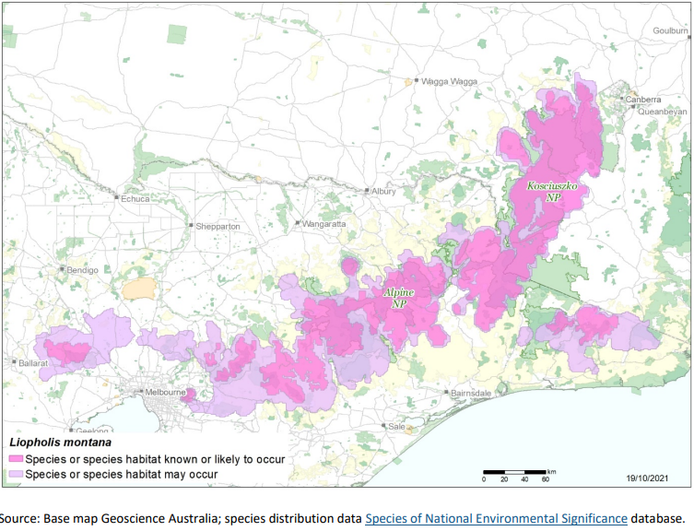
Throughout its range it occurs in a series of apparently isolated subpopulations at elevations ranging from 620 m (Wombat State Forest, VIC) to 1800 m (Mt Gingera, ACT) (Green and Osborne 2012, Wilson and Swan 2013, Cogger 2014, Clemann et al. 2018, Farquhar et al. 2021). The Mountain Skink overlaps slightly in elevational distribution with both White’s Skink (Liopholis whitii) and the Guthega Skink (Liopholis Guthega) (DCCEEW 2022). Whilst there is a broad zone of distributional overlap between the Mountain Skink and Guthega Skink at 1600–1700 m, the two species have never been found in the same habitat at the same time in any area throughout their range (Senior et al. 2021).
In the north of its range, the Mountain Skink occupies montane and subalpine conditions above 1400 m (DCCEEW 2022). In the ACT, the Mountain Skink is at the far north-eastern edge of its range and has been recorded at Mt Gingera, Ginini Flats, Mt Ginini, Stockyard Spur, Mt Scabby, Rolling Ground Gap, Square Rock in Namadgi National Park (Osborne 2021).
The Mountain Skink shelters in deep burrow systems beneath rocks and are found in high country woodlands where it is associated with mostly granitic rocky habitats such as rock outcrops, screes, tors or large logs (Donnellan et al. 2002, Cogger 2014) and was initially recorded at Cotter Source, Jacks Creek and Bimberi (Helman et al. 1988).

Threats
The Mountain Skink is primarily threatened in the ACT by climate change related threats such as increased frequency, extent and severity of wildfires (Ward et al. 2020) and predation by invasive predators (Watson 2006, Woinarski et al. 2018, Stobo-Wilson et al. 2021) especially post-fire by feral cats (Felis catus) and by loss of foraging habitat (DCCEEW 2022). If feral herbivores, including horses and deer are allowed to make incursions into Mountain Skink habitat in the ACT they will likely degrade this habitat and reduce the availability of shelter and food for the Mountain Skink, as has occurred for other skinks/reptiles in other areas (Driscoll et al. 2019, Hampton and Davis 2020).
In other parts of its range, it is threatened by logging and timber harvesting and clearing of habitat (Clemann et al.2018). In a study, conducted in the forests and subalpine woodlands of Namadgi National Park, Dixon et al. (2018) found that long-unburned forests and woodlands can be more important for reptile richness and abundance than areas with prescribed burning (Dixon et al. 2018).

Major Conservation Objective
The primary objective in the ACT should be to maintain viable, wild populations of the Mountain Skink within the scope of climate limitations as it is at the edge of its range (altitude, latitude and longitude), taking into account any projected changes to distributional limits under climate change.

Conservation PRIORITIES
Conservation and management priorities for the Mountain Skink in the ACT should be to:
- ensure core habitat and projected core habitat under climate change are protected from disturbance (including trails or park infrastructure), planned burns and fragmentation
- in collaboration with other stakeholders and jurisdictions, conduct targeted surveys to improve understanding of the species occurrence in the ACT and habitat requirements
- undertake climate modelling to predict future distribution of the species within the ACT under a range of climate change scenarios
- work with other jurisdictions and stakeholders to support the research priorities for the species where practical, including studies of population genetic structure and diversity, microhabitat requirements, minimum tolerable fire intervals and potential to create safe havens from predators and herbivores
- incorporate the ecological needs of the Mountain Skink into ecological guidelines (e.g., ACT Government 2019)
- undertake targeted control of invasive predators and weeds within the habitat around skink colonies, particularly post fire, if feasible, to manage impacts on populations
- ensure active surveillance programs are in place to detect the presence of feral horses and invasive predators (including pigs and deer) around known colonies of Mountain Skink, and undertake control as needed
- explore the implications of climate change for population persistence and conduct climate sensitive management actions where feasible. Systematic monitoring and collection of population data, including reproduction and survival data when available, should be used to assess population viability and species distribution. For species whose physiological limits are known, biophysical models can provide a predictive understanding of the habitats required for persistence in the face of climate change through an integration of data on climate and other environmental variables with measures of morphology, behaviour, physiology and life history of the species. Opportunities to address knowledge gaps for this species to establish climate change ready management actions may include university and interjurisdictional research collaborations.

Other Relevant Advice, plans or Prescriptions
- Commonwealth Conservation Advice – Mountain Skink (DCCEEW 2022)
- Namadgi National Park Plan of Management (ACT Government 2010)

Listing Background
The Mountain Skink is listed as an Endangered species under the Environment Protection and Biodiversity Conservation Act 1999 (EPBC Act), effective 10 August 2022. It is assessed as Endangered under Criterion 2 (B2ab(i,ii,iii,iv,v)) of the EPBC Act. In 2022, under the Nature Conservation Act 2014, the ACT Scientific Committee recommended the Mountain Skink be listed in the Endangered category in the ACT Threatened Native Species List to align with the EPBC Act listing.

Action Plan Decision
The ACT Scientific Committee does not recommend that the Minister for the Environment should make the decision to have an action plan for the species in the ACT under the Nature Conservation Act 2014 at this time. The key habitat areas of the species in the ACT are along the ACT/NSW border in Namadgi National Park (above 1400 m above sea level) and its habitat is protected there.

References
ACT Government 2010. Namadgi National Park Plan of Management 2010. Land Management and Planning Division, Department of Territory and Municipal Services, Canberra. https://www.legislation.act.gov.au/di/2010-192/
ACT Government 2012. Tidbinbilla Plan of Management 2012. Territory and Municipal Services Directorate, ACT Government Canberra. https://www.legislation.act.gov.au/di/2012-193/
ACT Government 2019. Ecological Guidelines for Fire, Fuel and Access Management Operations. Environment Planning and Sustainable Development Directorate, ACT Government, Canberra. https://www.environment.act.gov.au/__data/assets/pdf_file/0009/1483830/Ecological-Guidelines-2019-ver-1.3.pdf
Clemann N, Hutchinson M, Robertson P, Chapple DC, Gillespie G, Melville J and Michael D 2018. Liopholis montana. The IUCN Red List of Threatened Species 2018: e.T109478522A109478529. https://dx.doi.org/10.2305/IUCN.UK.2018-1.RLTS.T109478522A109478529.en.
Cogger HG 2014. Reptiles and Amphibians of Australia: Seventh Edition. CSIRO Publishing, Collingwood, Victoria.
Coyne PC 2000. Protecting the natural treasures of the Australian Alps. A report to the Natural Heritage Working Group of the Australian Alps Liaison Committee.
Department of Climate Change, Energy, Environment and Water (DCCEW) 2022. Conservation Advice for Liopholis montana (Mountain Skink). Department of Climate Change, Energy, Environment and Water (Commonwealth), Canberra. https://www.environment.gov.au/cgi-bin/sprat/public/publicspecies.pl?taxon_id=87162
Dixon KM, Cary GJ, Worboys GL and Gibbons P 2018. The disproportionate importance of long-unburned forests and woodlands for reptiles. Ecology and Evolution 8(22): 10952–10963. https://onlinelibrary.wiley.com/doi/10.1002/ece3.4561
Donnellan SC, Hutchinson, MN, Dempsey, P and Osborne WS 2002. Systematics of the Egernia whitii species-group (Lacertilia: Scincidae) from south-eastern Australia. Australian Journal of Zoology 50(5): 439-459 [451]. https://www.publish.csiro.au/ZO/ZO01065
Driscoll DA, Worboys GL, Allan H, Banks SC, Beeton NJ, Cherubin RC, Doherty TS, Finlayson CM, Green K, Hartley R and Hope G 2019. Impacts of feral horses in the Australian Alps and evidence-based solutions. Ecological Management & Restoration 20(1): 63–72.
Farquhar JE, Russell W and Gale N 2021. A significant range extension for the Mountain Skink Liopholis montana (Donnellan, Hutchinson, Dempsey & Osborne, 2002) on the Western Uplands of Victoria. Herpetology Notes 14: 877–882. https://www.biotaxa.org/hn/article/view/66978
Green K and Osborne W 2012. A Field Guide to Wildlife of the Australian Snow Country. New Holland Publishers, Chatswood.
Hampton JO and Davis NE 2020. Impacts of introduced deer in Victoria. Victorian Naturalist 137(6): 276–281.
Helman CE, Gilmour PM, Osborne WS, and Green K 1988. An Ecological Survey of the Upper Cotter Catchment Wilderness Area, Namadgi National Park, ACT. A Report to the Conservation Council of the Southeast Region and Canberra, Canberra.
Osborne W 2021. Locality Records from 1989–2008. Unpublished records supplied 6 April 2021, University of Canberra, Canberra.
Osborne W and Evans M 2015. Risk Assessment for the Importation of Native Reptiles into the ACT. Conservation Research, Environment Division, Environment and Planning Directorate, ACT Government, Canberra.
Robertson P and Coventry AJ 2019. Reptiles of Victoria: A Guide to Identification and Ecology. CSIRO Publishing. Clayton South.
Senior AF, Atkins ZS, Clemann N, Gardner MG, Schroder M, While GM, Wong BB and Chapple DG 2019. Variation in thermal biology of three closely related lizard species along an elevation gradient. Biological Journal of the Linnean Society 127(2): 278–291. https://academic.oup.com/biolinnean/article/127/2/278/5479372
Senior AF, Chapple DG, Atkins ZS, Clemann N, Gardner MG, While GM and Wong BB 2021. Agonistic behavioural asymmetry in two species of montane lizard that exhibit elevational replacement. Landscape Ecology 36(3): 863–876. https://link.springer.com/article/10.1007/s10980-020-01184-5
Stobo-Wilson AM, Murphy BP, Legge SM, Chapple DG, Crawford HM, Dawson SJ, Dickman CR, Doherty TS, Fleming PA, Gentle M and Newsome TM, Palmer R, Rees MW, Ritchie EG, Speed J, Stuart JM, Thompson E, Turpin J and Woinarski JCZ 2021. Reptiles as food: predation of Australian reptiles by introduced red foxes compounds and complements predation by cats. Wildlife Research 48(5): 470–480. https://www.publish.csiro.au/WR/WR20194
Ward M, Tulloch AIT, Radford JQ, Williams BA, Reside AE, Macdonald SL, Mayfield HJ, Maron M, Possingham HP, Vine SJ, O'Connor JL, Massingham EJ, Greenville AC, Woinarski JCZ, Garnett ST, Lintermans M, Scheele BC, Carwardine J, Nimmo DG, Lindenmayer DB, Kooyman RM, Simmonds JS, Sonter LJ and Watson JEM 2020. Impact of 2019-2020 mega-fires on Australian fauna habitat. Nature Ecology & Evolution 4: 1321-1326. https://doi.org/10.1038/s41559-020-1251-1.
Watson, K 2006. Aspects of the history, home range and diet of the feral cat (Felis catus) in the Perisher Range resort area of Kosciuszko National Park, New South Wales. Masters’ thesis, University of Sydney, Sydney.
Wilson SK and Swan G. 2013. A Complete Guide to Reptiles of Australia. New Holland Publishers, Chatswood.
Woinarski JCZ, Murphy BP, Palmer R, Legge SM, Dickman CR, Doherty TS, Edwards G, Nankivell A, Read JL and Stokeld D 2018. How many reptiles are killed by cats in Australia? Wildlife Research 45(3): 247–266. https://www.publish.csiro.au/WR/WR17160

Further Information
Further information on the related Action Plan and Woodland Strategy or other threatened species and ecological communities can be obtained from the Environment, Planning and Sustainable Development Directorate (EPSDD): Phone: (02) 132281, EPSDD Website: https://www.environment.act.gov.au/

Attachment A: Listing Assessment (DEECCW 2022)

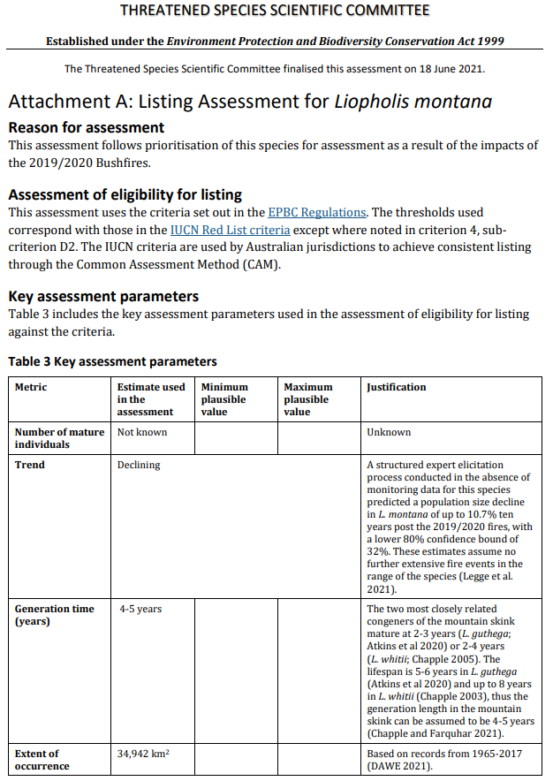

Threatened Species Scientific Committee
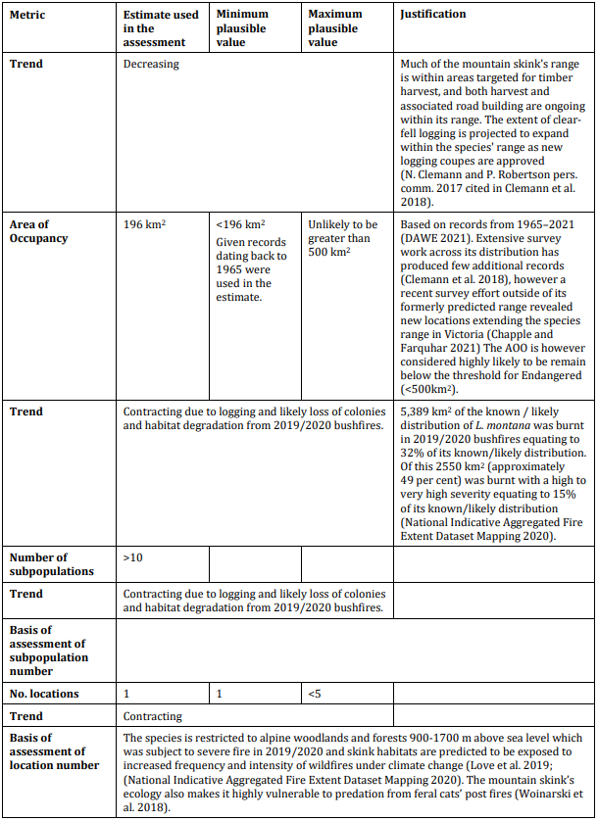

Threatened Species Scientific Committee

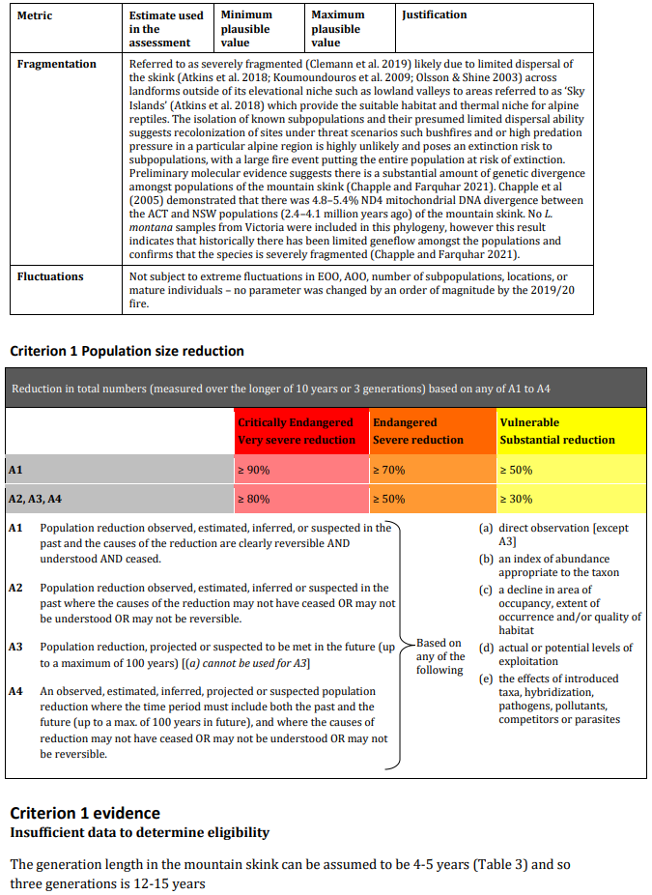

Threatened Species Scientific Committee
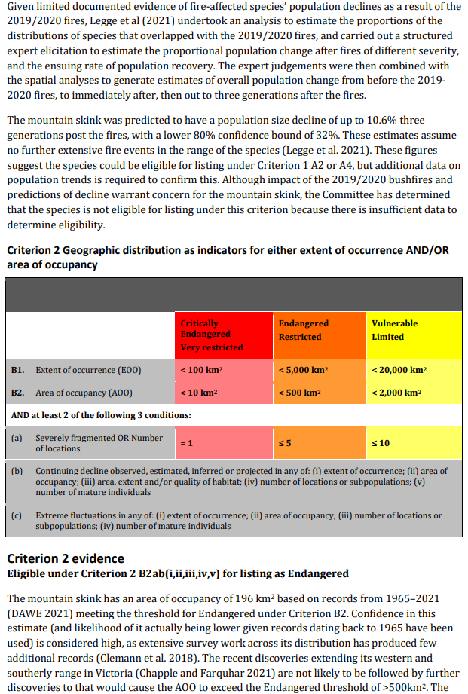

Threatened Species Scientific Committee
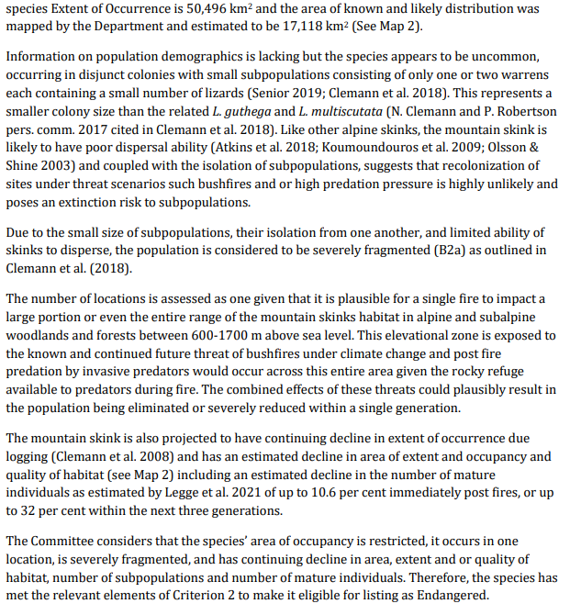

Threatened Species Scientific Committee

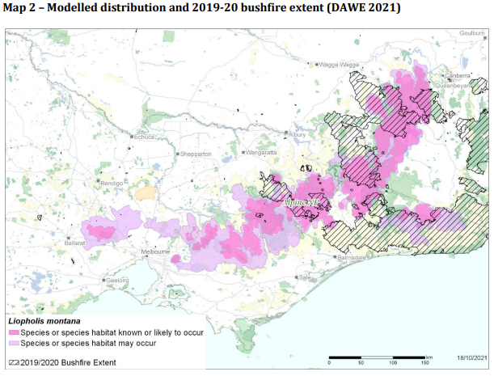
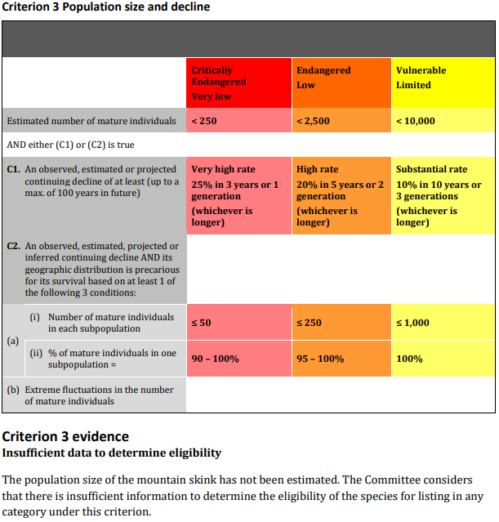
Threatened Species Scientific Committee
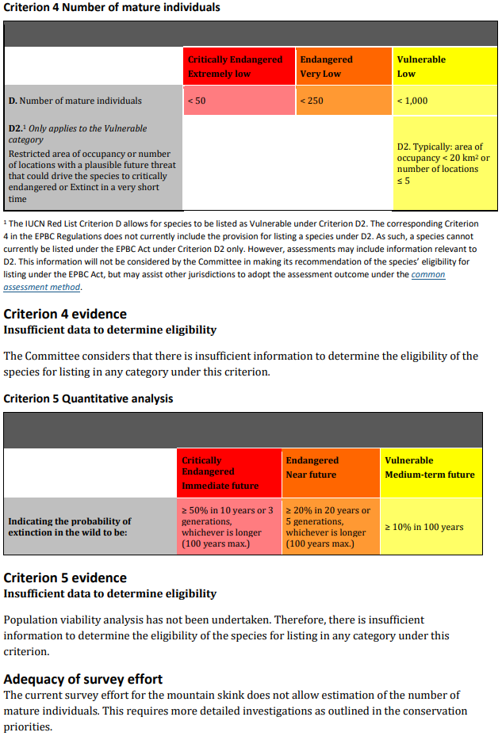
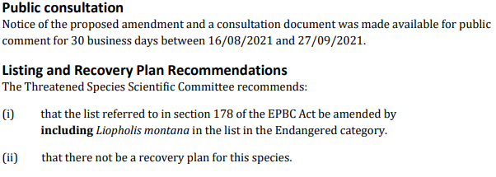
Threatened Species Scientific Committee

