Australian Capital Territory

Nature Conservation (Closed Reserves) Declaration 2023 (No 3)

Notifiable instrument NI2023–284
made under the
Nature Conservation Act 2014, s 259 (Conservator may close reserve)

1 Name of instrument
This instrument is the Nature Conservation (Closed Reserves) Declaration 2023 (No 3).

2 Commencement
This instrument commences at 6:00 pm on 12 June 2023.

3 Declaration
I declare that public access to:
- the reserves mentioned in schedule 1; and
- those parts of Mount Ainslie Nature Reserve, Red Hill Nature Reserve and Molonglo River Reserve indicated in the maps at schedule 2,
is prohibited during the closure times mentioned in schedule 3.

4 Exceptions
Section 3 does not apply to:
- a conservation officer exercising a function under the Act; or
- a person accompanied by a conservation officer exercising a function under the Act; or
- a person who is:
  - implementing the Nature Conservation (Eastern Grey Kangaroo) Controlled Native Species Management Plan 2017 (DI2017-37) within the areas declared under section 3 (closed reserves); or
  - controlling a pest animal species in the closed reserves; and
  - contracted by the Territory to conduct the activity mentioned in paragraph (i) or (ii); or
  - authorised in writing by the custodian of the closed reserve accessed by the person, to conduct the activity mentioned in paragraph (i) or (ii).

5 Expiry
This instrument expires on 31 July 2023.

Bren Burkevics
Conservator of Flora and Fauna

7 June 2023
Schedule 1 Reserves fully closed
(see s 3)

Reserves

Mount Majura Nature Reserve
Mulanggari Grasslands Nature Reserve
The Pinnacle Nature Reserve

Schedule 2 Reserves partially closed
(see s 3)

Mount Ainslie Nature Reserve
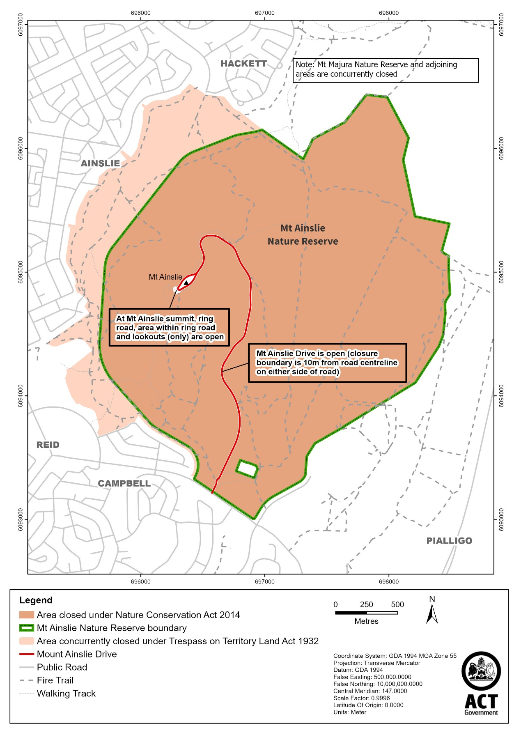
Red Hill Nature Reserve
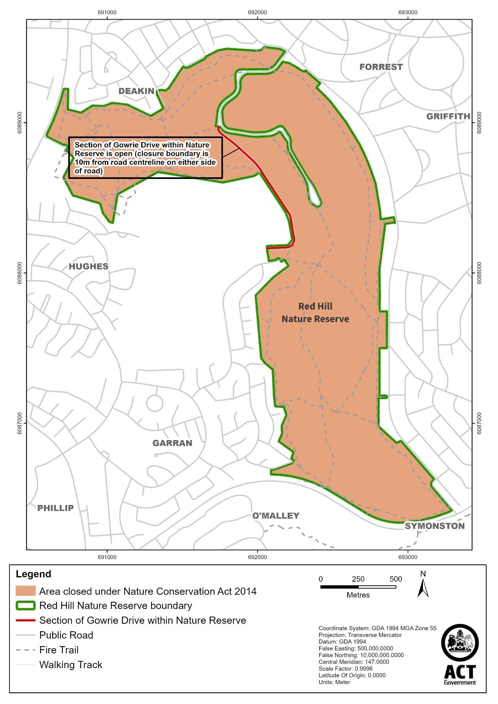
Molonglo River Reserve (nature reserve section)

Note The area closed is wholly within the former Kama nature reserve.

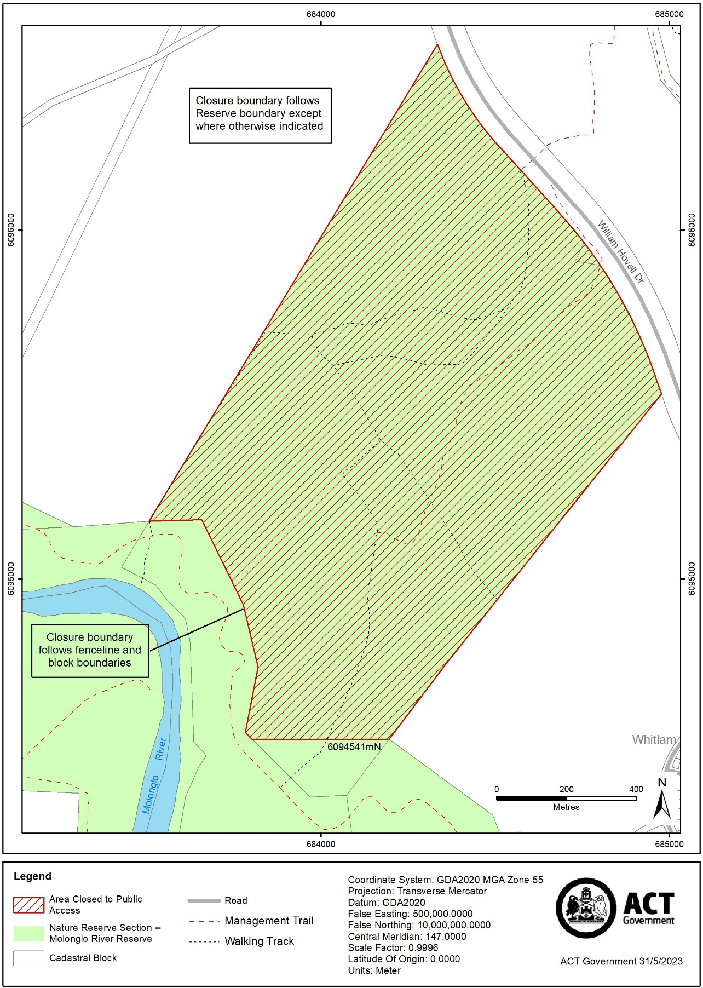
Schedule 3 Closure times
(see s 3)

Times when public access is prohibited

Beginning at 6:00 pm every Sunday, Monday, Tuesday, Wednesday and Thursday and ending on the following day at 6:00 am.

Note The closure beginning on Monday 31 July 2023 will end at midnight the same day.

