Australian Capital Territory
Discrimination (Raytheon Australia Pty Limited) Exemption 2023 (No 1)
Notifiable instrument NI2023-300
made under the
Discrimination Act 1991, section 109 (Grant of exemptions)

1 Name of instrument
This instrument is the Discrimination (Raytheon Australia Pty Limited) Exemption 2023 (No 1).
2 Exemption decision—Discrimination Act, s 109
The Human Rights Commission exempts Raytheon Australia Pty Limited from the operation of sections 10, 13, 20, 23 and 69 of the Discrimination Act 1991 for a period of 3 years.
3 Conditions on exemption
This exemption is subject to the conditions provided in the decision of the Human Rights Commission set out in Schedule 1 of this instrument.
4 Commencement
This instrument commences on 14 July 2023.

Karen Toohey
Discrimination Commissioner

Dated: 15 June 2023

Pursuant to section 109 of the Discrimination Act 1991 (ACT), the Human Rights Commission grants Raytheon Australia Pty Limited (Raytheon Australia) an exemption from the operation of sections 10, 13, 23 and 69 of the Discrimination Act subject to the following terms:
CONDUCT
Raytheon Australia may engage in the following conduct in the Australian Capital Territory:

Security Officer and Assistant Security Officer
- Request nationality or citizenship information from any person holding or applying to hold the positions of Security Officer or Assistant Security Officer (as defined in the Australian Defence Security Manual) within Raytheon Australia.
- Require any person holding the positions of Security Officer or Assistant Security Officer within Raytheon Australia to be an Australian citizen.

Australian security clearances
- Record information relating to security clearances granted to employees of Raytheon Australia ( employees ) and employees of contractors who perform work on Raytheon Australia's premises and who are subject to Raytheon Australia's control and direction ( contract workers ).

Applicants for employment
- Inform applicants for employment in roles which will require access to material ( ITAR controlled material ) subject to contractual obligations arising from the Arms Export Control Act 22 USC 2778 (2004), International Traffic in Arms Regulations ( ITAR ) and the Export Administration Regulations and any permit, licence or approval granted, or agreement made, under those laws ( ITAR controls ) that they may be adversely affected by ITAR controls or Australian security clearance procedures if they are not an Australian citizen or if they hold dual nationality and/or citizenship.

Request for information about nationality
- Request nationality-related information from job candidates whose role is likely to require access to ITAR controlled material, providing this request for information is limited to information for determining whether an application for authorisation would be required to allow the job candidate to have that access and whether in Raytheon Australia’s reasonable judgment that application would have significant prospects of success.

Use of nationality information
- Impose a condition on any offer of employment in roles which are likely to require access to ITAR controlled material that the person must, pursuant to ITAR controls, be authorised to access that material whether pursuant to an individual approval obtained from the United States Department of State or otherwise.
- Take into account the nationality-related information pertaining to an employee or contract worker when determining whether that person may be offered a role or allocated work that involves access to ITAR controlled material.
- Request nationality-related information from, and maintain records of the nationalities of, employees and contract workers who have or may have access to ITAR controlled material.
- Implement systems designed to ensure that ITAR controlled material is disclosed only to persons who are authorised by ITAR controls to receive it.
- Impose limitations or prohibitions on access to ITAR controlled material on persons not authorised to access that material.
- Establish security systems that are designed to prevent the unauthorised re-export or re-transfer of ITAR controlled material.
- If and when required by ITAR, disclose to:
  - Other parties with which Raytheon Australia works or proposes to work under contract, where that work requires access to ITAR controlled material;
  - the United States Department of State;
  - the United States Department of Commerce;
  - and the United States Department of Defence;
the nationality-related information of all employees and contract workers who have or are likely to have access to ITAR controlled materials in the performance of the contracted work.
CONDITIONS
- The exemption applies only to Raytheon Australia's conduct where:
  - it is necessary to enable it to obtain and manage ITAR export licensing or to perform contractual obligations which involve access to ITAR controlled material;
  - it has taken all steps that are reasonably available to avoid engaging in conduct which would otherwise be in breach of sections 10, 13, 23 and 69 of the Act, including:
    - reliance on ITAR exemptions, exceptions or other provisions, including clause 126.18 of ITAR, where applicable;
    - where employment job candidate, employee or contract worker is a national or dual national of a country not approved for access to ITAR-controlled material, then Raytheon Australia will either request the Department of State, or request the relevant export license holder(s) to request the Department of State to amend the relevant export licenses to enable the person to have access to ITAR-controlled material, unless Raytheon Australia, on reasonable grounds, determines that either:
- the job candidate, employee or contract worker is not the best candidate for the position; or
- such an application does not have significant prospects of success.
and
    - in the event that the United States Department of State requires Raytheon Australia to provide further information specific to the person, then with the consent of that person, Raytheon Australia will work with the person to supply all relevant information to the United States Department of State so that an application for approval may be made in relation to that person.
- Where, pursuant to this exemption, Raytheon Australia wishes to reserve the right to make a conditional offer of employment in relation to a position which will or may involve access to ITAR-controlled material, any advertisement, invitation for expressions of interest, or other promotional information referring to the position must include the information that:
  - the position will or is likely to require access to ITAR controlled material and that any person occupying the position must be able to satisfy ITAR-based requirements which may require specific authorisation for that person to access ITAR-controlled material; and
  - if a job candidate is concerned as to whether or not they will satisfy the requirement in (a), they should contact a nominated employee of Raytheon Australia who is able to provide relevant information, including information set out in condition 4 below.
- Raytheon Australia must specifically communicate to job candidates, employees and contract workers:
  - express notice that they may be adversely affected by the ITAR requirements if they are not an Australian national, if they hold dual nationality citizenship and /or citizenship, or if they are not of Australian national origin;
  - notice that Raytheon Australia has an exemption under the Act to enable it to take steps to prevent access to ITAR controlled material;
  - a reasonable explanation in plain English of the nature of any such adverse effects;
  - advice that any necessary application for specific authorisation for a person to access ITAR-controlled material would be made by Raytheon Australia, in appropriate cases;
  - information about how they can apply for Australian citizenship; and
  - information regarding their rights under Australian Federal, State and Territory discrimination laws.
Raytheon Australia may comply with this Condition 3 through a range of alternatives, including individual written notices, published policy statements, web-based posting or other similar means.
- Where, pursuant to this exemption, an employee or contract worker who is not authorised pursuant to ITAR controls to have access to ITAR controlled material (including pursuant to any individual clearance), is moved from a job involving access to ITAR controlled material to any other work performed by Raytheon Australia or any of its related entities, Raytheon Australia must, through a duly authorised officer, explain to the person why he or she is being transferred and must otherwise take all reasonable steps to avoid or limit harm or loss to that person.
- Where Raytheon Australia uses a system of security passes to reflect the fact of access to ITAR controlled material or levels of access to material subject to Australian security restrictions, the passes may be coded but not in such a manner that the nationality can obviously be identified from the coding.
- All information relating to security passes, security clearance levels and access to ITAR controlled material shall be restricted to the Security Officer, Assistant Security Officer, export control managers, Human Resources managers, legal representatives and other senior managers and to their properly appointed nominees on a "need to know" basis.
- Raytheon Australia’s employment or other relevant policies shall be amended as soon as reasonably possible so as to refer to the terms of this exemption, including all conditions attaching to it, and to make clear that the purpose of Raytheon Australia’s request for nationality information is made solely for the purposes of compliance with legal and regulatory obligations imposed pursuant to the defence export control laws of the United States.
- Raytheon Australia is required to provide a written report to the ACT Human Rights Commission on 31 July and 28 February each year, from the date of this instrument of exemption, over the period of the exemption, detailing:
  - the steps it has taken to comply with the above conditions;
  - the number of persons affected by this exemption, the nature of the effects, and the steps taken to address any adverse effects;
  - the anti-discrimination training of employees and contract workers provided by Raytheon Australia; and
  - implementation and compliance generally with the terms of this exemption order.
The exemption is granted for a period of three years commencing on 14 July 2023 and expiring on 13 July 2026.
This decision is a notifiable instrument and must be notified under the Legislation Act.
SIGNED by the ACT Discrimination Commissioner
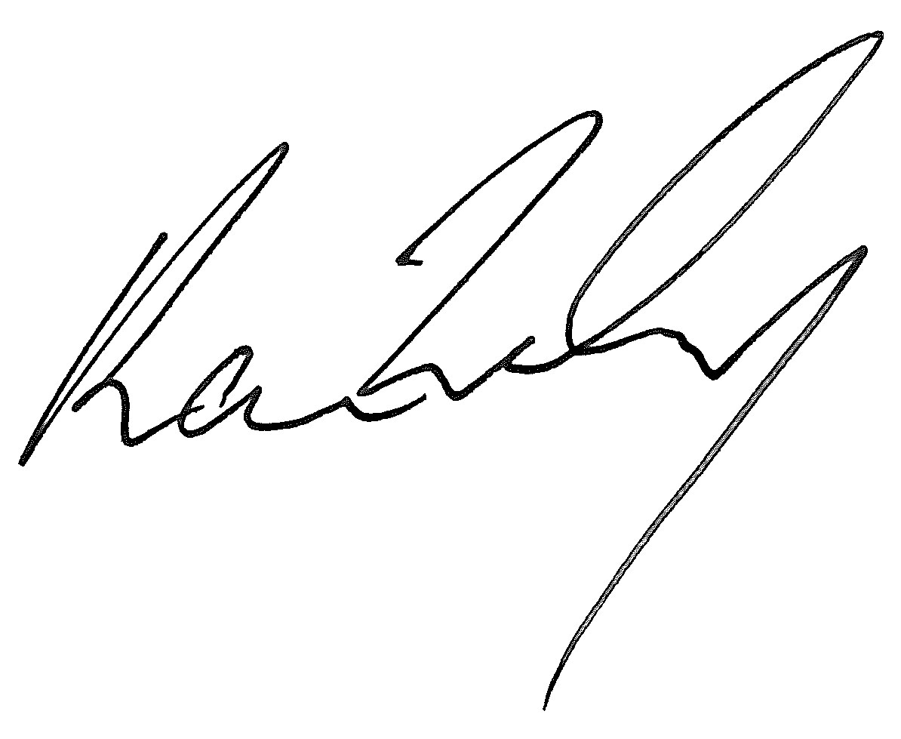
Dated 15 June 2023

