Australian Capital Territory

**Gaming Machine (Peripheral Equipment) Approval 2023 (No 4)**

**Notifiable instrument NI2023-433**

made under the

**Gaming Machine Act 2004, section 69 (Approval of gaming machines and peripheral equipment)**

**1 Name of instrument**

This instrument is the *Gaming Machine (Peripheral Equipment) Approval 2023 (No 4)*

**2 Commencement**

This instrument commences the day after the date of notification.

1. **Approval**

I approve the peripheral equipment described in the attached Schedule to this instrument.

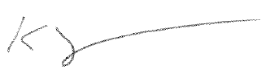

Karl Somers

Delegate

ACT Gambling and Racing Commission

30 May 2023

For further information please contact the approved supplier.

|  |  |
| --- | --- |
| Konami Australia Pty Ltd | |
| Subject: Hardware Bugfix | |
| Device Name: | KXP Coin Chute Holder |
| Device Description: | COIN CHUTE HOLDER, DIM, KAP - 195139 |
| Application Reference Number: | 39-A1565/S01 |