Australian Capital Territory

Heritage (Decision about Provisional Registration of Paral House, Narrabundah) Notice 2023

**Notifiable instrument NI2023–491**

made under the

Heritage Act 2004, s 34 (Notice of decision about provisional registration)

**1 Name of instrument**

This instrument is the *Heritage (Decision about Provisional Registration of Paral House, Narrabundah) Notice 2023*.

**2 Decision about provisional registration**

On 15 August 2023, the ACT Heritage Council (the ***Heritage Council***) decided not to provisionally register Paral House, Block 47, Section 79, Narrabundah (the ***Place***).

**3 Description of the Place**

The description of the Place is in the schedule.

**4 Reasons for the decision**

The Heritage Council is not satisfied on reasonable grounds that the Place is likely to have heritage significance as defined by section 10 of the *Heritage Act 2004*. A detailed statement of reasons, including an assessment against the heritage significance criteria, is provided in the schedule.

**5 Date decision takes effect**

The decision not to provisionally register the Place takes effect on 16 August 2023 (being the day after the Heritage Council made its decision in writing as set out in the schedule).

Stuart Jeffress

A/g Secretary (as delegate for)

ACT Heritage Council

15 August 2023

**Schedule**

(see ss 3 and 4)

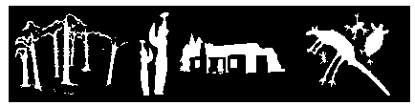

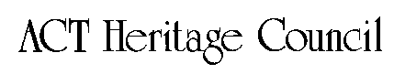

STATEMENT OF REASONS

DECISION NOT TO PROVISIONALLY REGISTER

Paral HouseWamboinName of Place

Block 47, Section 79, Narrabundah

IN THE ACT HERITAGE REGISTER

In accordance with s32 of the *Heritage Act 2004,* the ACT Heritage Council has decided not to provisionally register Paral House, Narrabundah. This Statement of Reasons provides an assessment of Paral House, Narrabundah, and finds that the place does not meet any of the criteria under s10 of the *Heritage Act 2004.*

The ACT Heritage Council received a nomination for Paral House after a Building Application (BA) for its demolition had been approved. The processes of the *Heritage Act 2004* (the Act) meant that the nomination had to be accepted, but could not override an existing approved BA. The only option would have been to issue a Heritage Direction within the short time before the demolition took place, however the Council would have had to be satisfied on reasonable grounds that the place would meet one or more of the heritage significance criteria under s10 of the Act. After a reasonable due diligence investigation that involved reviewing the source information contained in the *Background Information, Paral House*, document, the Council was unable to reach a clear conclusion that any of the criteria would be met as required to pursue further action and the place was later demolished in accordance with the legislation. This *Statement of Reasons, Decision Not to Provisionally Register Paral House*, formalises the Council’s earlier findings that the place did not pass the thresholds for inclusion against any of the criteria under s10 of the Act which is now strengthened by the lack of physical material of the place.

This statement refers to the location of the place as required in s34(5)(b)(ii) of the *Heritage Act 2004*.

**LOCATION OF THE PLACE**

Paral House, 22 Brockman Street, Narrabundah, Section 79, Block 47.

This section refers to the description of the place as required in s34(5)(b)(iii) of the *Heritage Act 2004*. The boundary of the place and extent of features listed below is illustrated at Image 1.

**DESCRIPTION OF THE PLACE**

Paral House (non-extant)

This statement refers to the Council’s reasons for its decision as required in s34(5)(b)(iv) of the *Heritage Act 2004*.

**REASONS FOR DECISION**

The Council is not satisfied on reasonable grounds that the place is likely to have heritage significance as defined by s10 of the *Heritage Act 2004*.

This statement refers to the Council’s assessment of the place against the heritage significance criteria as a part of its reasons for its decision as required in s34(5)(b)(iv) of the *Heritage Act 2004*.

**ASSESSMENT AGAINST THE HERITAGE SIGNIFICANCE CRITERIA**

The Council’s assessment against the criteria specified in s10 of the *Heritage Act 2004* is as follows.

In assessing the heritage significance of Paral House, Narrabundah, the Council considered:

* the original nomination and documentary evidence supplied by the nominator;
* the Council’s *Heritage Assessment Policy* (March 2018);
* the source material used to create the report by ACT Heritage titled, *Background Information Paral House,* August 2023;
* Minutes and previous decisions of the Heritage Council at its meeting 112 on 22 July 2021; and
* The letters of support for the nomination from the Australian Institute of Architects and the National Trust (ACT).

Pursuant to s10 of the Heritage Act,a place or object has heritage significance if it satisfies one or more of the following criteria. Future research may alter the findings of this assessment.

1. importance to the course or pattern of the ACT’s cultural or natural history;

The Council has assessed Paral House against criterion (a) and is not satisfied that the place meets this criterion.

Heather “Nicky” and Vladimir “Val” Paral were well-known social figures in the ACT and hosted several events at Paral House as noted on the background document. However, the Council was unable to show that the house was a significant factor in the roles they had in the ACT’s history, other than as a convenient place to host events that suited their lifestyles at the time. As such, this could not be used as an objection to the house being demolished; and, as it is now non-extant, the place has no ability to demonstrate any importance to the course or pattern of the ACT’s cultural history.

1. has uncommon, rare or endangered aspects of the ACT’s cultural or natural history;

The Council has assessed Paral House against criterion (b) and is not satisfied that the place meets this criterion.

Paral House was a relatively early, but not fully realised, attempt at Derek Wrigley’s eco house model and was an example of modernist architecture. While Wrigley’s specific eco-friendly design and aesthetic are unique to him and the few places he has designed, as a more general concept of passive design, modern materials and modernist aesthetic they are not so uncommon, rare or endangered as to pass the threshold for inclusion under this criterion.

1. potential to yield important information that will contribute to an understanding of the ACT’s cultural or natural history;

The Council has assessed Paral House against criterion (c) and is not satisfied that the place meets this criterion.

As a built place that was adequately recorded in architectural drawings and photographs there was no potential for the place to yield important information that would contribute to an understanding of the ACT’s cultural history; and even more so now that it has been demolished and all physical evidence of the place has been removed.

1. importance in demonstrating the principal characteristics of a class of cultural or natural places or objects;

The Council has assessed Paral House against criterion (d) and is not satisfied that the place meets this criterion.

The importance of Paral House in demonstrating the principal characteristics of Solar passive or environmental design and modernist design was considered. While Paral House was a good design and has its place in the history of design, it was not considered to be sufficiently early, at such a high level or otherwise exemplary as to be important in demonstrating the principal characteristics of solar passive or modernist design or any other class of place.

1. importance in exhibiting particular aesthetic characteristics valued by the ACT community or a cultural group in the ACT;

The Council has assessed Paral House against criterion (e) and is not satisfied that the place meets this criterion.

Paral House is an example of the Modernist architectural design and it may be appreciated for aesthetic characteristics associated with this style by the architectural profession and some members of the community. However, there is no current evidence that it is valued for such characteristics by the wider ACT community or a cultural group as required to pass the threshold for meeting this criterion.

1. importance in demonstrating a high degree of creative or technical achievement for a particular period;

The Council has assessed Paral House against criterion (f) and is not satisfied that the place meets this criterion.

Paral House demonstrated a level of creative and technical achievement in its architecture, but not at a high enough degree to be considered important for its time in demonstrating that achievement. It is a good example of modernist design and incorporated several aspects of solar passive design and modern materials, but none were particularly cutting edge, formative or a significance advancement in their particular field.

1. has a strong or special association with the ACT community, or a cultural group in the ACT for social, cultural or spiritual reasons;

The Council has assessed Paral House against criterion (g) and is not satisfied that the place meets this criterion.

Paral House has in the past been the location of several community groups meetings and gatherings and was designed in part with the Paral’s social lifestyle in mind; however, the degree to which this could be considered to have a strong or special association with the wider ACT community or a cultural group is minimal and has certainly not been an enduring connection after the Parals ceased to be associated with the house from 1982.

1. has a special association with the life or work of a person, or people, important to the history of the ACT.

The Council has assessed Paral House against criterion (h) and is not satisfied that the place meets this criterion.

Val and Nicky Paral were well known in the ACT. Nicky ran Studio 12 Interiors, focusing on bringing high quality European designer interiors to the ACT and was active in social circles. Val helped to establish the Medical Photography section at the John Curtin School of Medical Research as well as being an active member and leader of several community sport and hobby groups. Nicky worked closely with Derek Wrigley in the design of the house, including a workshop for her design work and Val’s photography, a special sunken bath and an office; however, these special considerations have been replaced and no longer provide a link to the past owners. While the original inhabitants may be considered important to the ACT and the place may have a special connection for them, it is not an enduring connection and its ability to show this connection between them and what possibly makes them important to the ACT is not clear enough to meet the threshold required to meet this criterion.

SITE PLAN

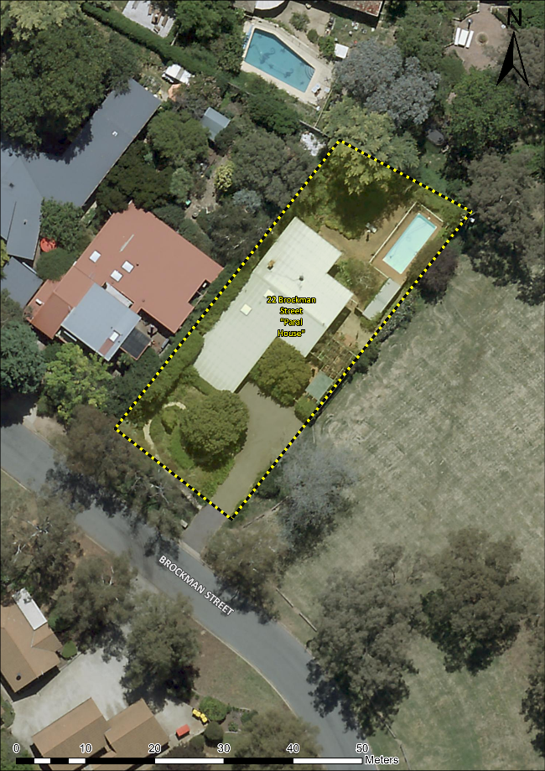 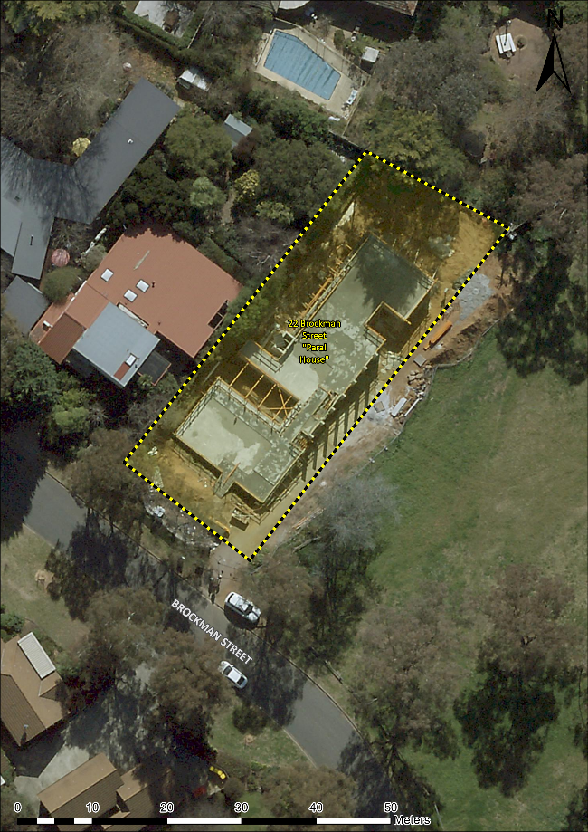

Image 1 Paral House site boundary. Left in 2021 with the original house; and right in 2022 with the new house mid‑construction.