Australian Capital Territory
Planning (Weston Creek District) Technical Specifications 2023
Notifiable instrument NI2023–549
made under the
Planning Act 2023, s 51 (Technical specifications)

1 Name of instrument
This instrument is the Planning (Weston Creek District) Technical Specifications 2023.
2 Commencement
This instrument commences on 27 November 2023.
3 Technical specifications
I make the technical specifications at schedule 1.

Ben Ponton
Chief Planner
5 September 2023

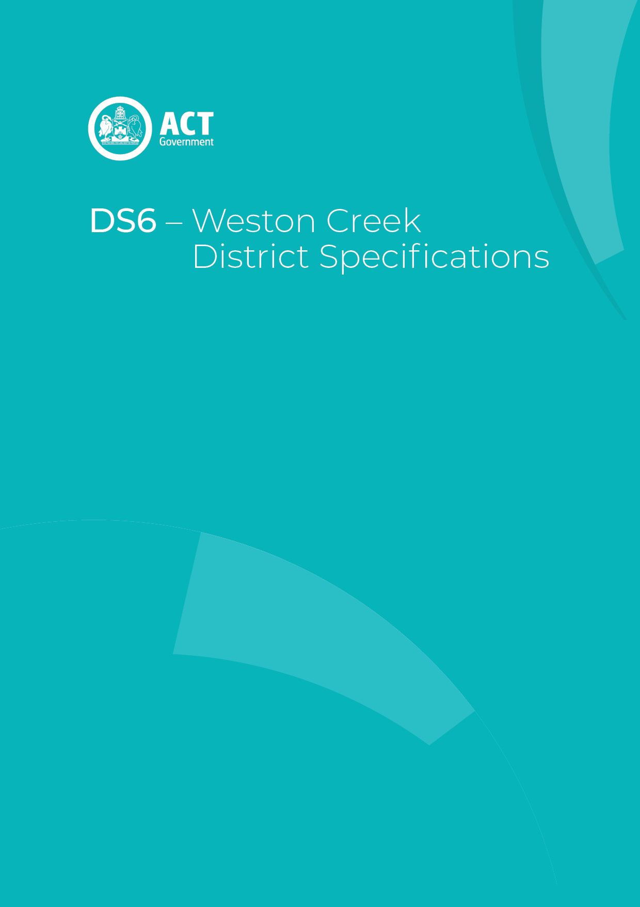
Schedule 1

Contents
Contents 3
Gungahlin District planning technical specifications 4
1. Chapman 5
2. Duffy 5
3. Fisher 5
4. Holder 5
5. Rivett 5
6. Stirling 6
7. Waramanga 6
8. Weston 6
Assessment Outcome 1: 6
Assessment Outcome 2: 6
Assessment Outcome 6
Demonstration Housing – Block 2 Section 50 Weston 7

Gungahlin District planning technical specifications
The primary assessment consideration for a development application is the assessment outcomes in the Territory Plan. In demonstrating compliance with the assessment outcomes, consideration may be given to the relevant planning technical specifications which may serve as a benchmark. While all assessment outcomes are to be met, not all outcomes are covered by a specification.
Planning technical specifications are used as a possible solution or to provide guidance for identified aspects of a development proposal. The specifications may also be used as a reference or benchmark in the preparation and assessment of development proposals to demonstrate compliance with the assessment outcomes, and the Territory Plan.
Where a proposed development complies with a relevant provision in the planning technical specifications and the development comprehensively addresses the assessment outcome, further assessment regarding those specific provisions will not be required.
The specifications in the Weston Creek District Specifications can be used to demonstrate compliance with the assessment outcomes in the Weston Creek District Policy or the relevant zone policy. Where there is a specific assessment outcome in the Weston Creek District Policy, this takes precedence over the equivalent outcome in the zone policy. Where there is no specific assessment outcome in the Weston Creek District Policy, the specification can be used to demonstrate compliance with the assessment outcomes in the zone policy.
The Territory Planning Authority may consider advice or written support from a referral entity to demonstrate compliance with a relevant assessment outcome. Where endorsement from an entity is noted as a planning specification, entity referral may be required.
Consistent with the Weston Creek District Policy, this Weston Creek District Specifications comprises specifications for specific localities, structured according to the localities.
These specifications will only apply to the specific sites or locations they refer to and should be used in conjunction with the relevant district policy, i.e., Part D6: Weston Creek District Policy.
- Chapman
The following specifications provide possible solutions that should be considered in planning, placing, designing and using buildings and structures for proposed development in Chapman:

No applicable specification for this suburb.

- Duffy
The following specifications provide possible solutions that should be considered in planning, placing, designing and using buildings and structures for proposed development in Duffy:

No applicable specification for this suburb.

- Fisher
The following specifications provide possible solutions that should be considered in planning, placing, designing and using buildings and structures for proposed development in Fisher:

No applicable specification for this suburb.

- Holder
The following specifications provide possible solutions that should be considered in planning, placing, designing and using buildings and structures for proposed development in Holder:

No applicable specification for this suburb.

- Rivett
The following specifications provide possible solutions that should be considered in planning, placing, designing and using buildings and structures for proposed development in Rivett:

No applicable specification for this suburb.
- Stirling
The following specifications provide possible solutions that should be considered in planning, placing, designing and using buildings and structures for proposed development in Stirling:

No applicable specification for this suburb.

- Waramanga
The following specifications provide possible solutions that should be considered in planning, placing, designing and using buildings and structures for proposed development in Waramanga:

No applicable specification for this suburb.

- Weston
The following specifications provide possible solutions that should be considered in planning, placing, designing and using buildings and structures for proposed development in Weston:

Assessment Outcome 1: | Development in North Weston is to accommodate a mix of residential, community facilities and small scale/commercial uses
No applicable specification for this assessment outcome. Application must respond to the assessment outcome

Assessment Outcome 2: | Residential densities and heights in North Weston are to increase generally near public transport routes, centre and areas of high amenity
No applicable specification for this assessment outcome. Application must respond to the assessment outcome

Assessment Outcome |  | Refer to zone assessment outcomes
Specification
Demonstration Housing – Block 2 Section 50 Weston | - Development of demonstration housing complies with the following:  - Buildings appear as though it is a dual occupancy and achieve reasonable solar access to dwellings on adjoining residential blocks and their associated private open space.  - The development demonstrates extensive use of one or more of the following innovative approaches to providing green infrastructure, permeability and urban heat reduction as an alternative to meeting the planting area, tree planting and tree canopy cover requirements of the Residential Zones Policy and the technical specifications for residential development:  - green roof  - green wall or vertical garden  - permeable paving  - cool roof.  - Dwellings meet the following Liveable Housing Design level, first published by Liveable Housing Australia.  - 2 dwellings achieve gold level.  - 1 dwelling achieved silver level.  - The number of driveway verge crossings for the block does not exceed one.  - A minimum of 4 car spaces in total are to be provided on site.

