Australian Capital Territory
Planning (Woden District) Technical Specifications 2023
Notifiable instrument NI2023–550
made under the
Planning Act 2023, s 51 (Technical specifications)

1 Name of instrument
This instrument is the Planning (Woden District) Technical Specifications 2023.
2 Commencement
This instrument commences on 27 November 2023.
3 Technical specifications
I make the technical specifications at schedule 1.

Ben Ponton
Chief Planner
5 September 2023

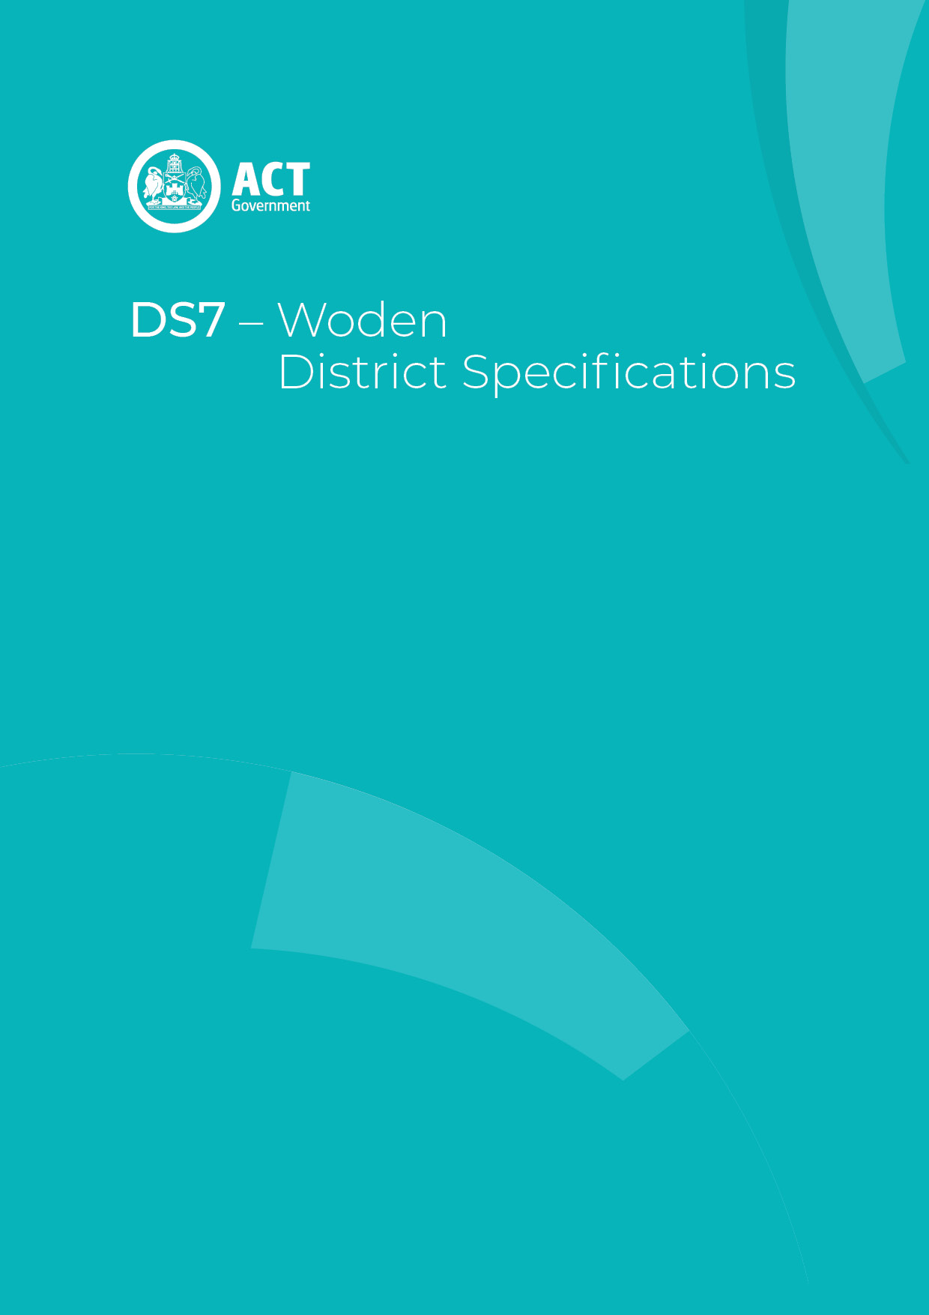
Schedule 1

Contents
Contents 2
Woden District planning technical specifications 3
1. Chifley 4
2. Curtin 4
Assessment Outcome 1: 4
Assessment Outcome 2: 4
Assessment Outcome 3: 4
3. Farrer 4
4. Garran 4
5. Hughes 5
6. Isaacs 5
7. Lyons 5
Assessment Outcome 4: 5
8. Mawson 5
9. O’Malley 6
10. Pearce 6
11. Phillip 6
Assessment Outcome 6
Retail outlets – CZ3 7
Building setback - CZ1 and CZ2 7
Building setback – Bowes and Furzer Streets 7
Building controls and design - part block 4 Section 79 8
Figure 1 Phillip – public spaces 9
12. Torrens 10

Woden District planning technical specifications
The primary assessment consideration for a development application is the assessment outcomes in the Territory Plan. In demonstrating compliance with the assessment outcomes, consideration may be given to the relevant planning technical specifications which may serve as a benchmark. While all assessment outcomes are to be met, not all outcomes are covered by a specification.
Planning technical specifications are used as a possible solution or to provide guidance for identified aspects of a development proposal. The specifications may also be used as a reference or benchmark in the preparation and assessment of development proposals to demonstrate compliance with the assessment outcomes, and the Territory Plan.
Where a proposed development complies with a relevant provision in the planning technical specifications and the development comprehensively addresses the assessment outcome, further assessment regarding those specific provisions will not be required.
The specifications in the Woden District Specifications can be used to demonstrate compliance with the assessment outcomes in the Woden District Policy or the relevant zone policy. Where there is a specific assessment outcome in the Woden District Policy, this takes precedence over the equivalent outcome in the zone policy. Where there is no specific assessment outcome in the Woden District Policy, the specification can be used to demonstrate compliance with the assessment outcomes in the zone policy.
The Territory Planning Authority may consider advice or written support from a referral entity to demonstrate compliance with a relevant assessment outcome. Where endorsement from an entity is noted as a planning specification, entity referral may be required.
Consistent with the Woden District Policy, this Woden District Specifications comprises specifications for specific localities, structured according to the localities.
These specifications will only apply to the specific sites or locations they refer to and should be used in conjunction with the relevant district policy, i.e., Part D7: Woden District Policy.
- Chifley
The following specifications provide possible solutions that should be considered in planning, placing, designing and using buildings and structures for proposed development in Chifley:

No applicable specification for this suburb.

- Curtin
The following specifications provide possible solutions that should be considered in planning, placing, designing and using buildings and structures for proposed development in Curtin:
Assessment Outcome 1: | [Group Centre] The existing public space character is retained and improved, particularly in the central courtyard
No applicable specification for this assessment outcome. Application must respond to the assessment outcome

Assessment Outcome 2: | [Group Centre] A mix of uses are provided that encourage people to live, work and spend time in the group centre
No applicable specification for this assessment outcome. Application must respond to the assessment outcome

Assessment Outcome 3: | The existing ‘Radburn’ housing pattern is maintained and improved
No applicable specification for this assessment outcome. Application must respond to the assessment outcome

- Farrer
The following specifications provide possible solutions that should be considered in planning, placing, designing and using buildings and structures for proposed development in Farrer:

No applicable specification for this suburb.

- Garran
The following specifications provide possible solutions that should be considered in planning, placing, designing and using buildings and structures for proposed development in Garran:

No applicable specification for this suburb.

- Hughes
The following specifications provide possible solutions that should be considered in planning, placing, designing and using buildings and structures for proposed development in Hughes:

No applicable specification for this suburb.

- Isaacs
The following specifications provide possible solutions that should be considered in planning, placing, designing and using buildings and structures for proposed development in Isaacs:

No applicable specification for this suburb.

- Lyons
The following specifications provide possible solutions that should be considered in planning, placing, designing and using buildings and structures for proposed development in Lyons:
Assessment Outcome 4: | Encourage development at Lyons local centre that provide for a variety of uses to ensure the centre remains a viable and active focal point for the Lyons community
No applicable specification for this assessment outcome. Application must respond to the assessment outcome

- Mawson
The following specifications provide possible solutions that should be considered in planning, placing, designing and using buildings and structures for proposed development in Mawson:

No applicable specification for this suburb.

- O’Malley
The following specifications provide possible solutions that should be considered in planning, placing, designing and using buildings and structures for proposed development in O’Malley:

No applicable specification for this suburb.

- Pearce
The following specifications provide possible solutions that should be considered in planning, placing, designing and using buildings and structures for proposed development in Pearce:

No applicable specification for this suburb.

- Phillip
The following specifications provide possible solutions that should be considered in planning, placing, designing and using buildings and structures for proposed development in Phillip:

Assessment Outcome | Refer to zone assessment outcomes
Specification
Retail outlets – CZ3 | - Retail outlets in CZ2 are limited to a scale appropriate to serve local workers and residents (nominally 200m²).
Building setback - CZ1 and CZ2 | - Development of buildings in CZ1 and CZ2 are to be built to the front boundary at ground level and the minimum setbacks above ground level are:  - Where addressing areas identified in Figure 1, Callam Street, Corinna Street, Easty Street, Irving Street, Matilda Street, Melrose Drive and Wilbow Street:  - 0m for the portion of development up to 22m above datum ground level.  - 3m for the portion of development above 22m up to 12 storeys.  - 6m for the portion of development above 12 storeys.  - Where addressing the town square:  - 0m for the portion of development up to 12m above datum ground level.  - 6m for the portion of development above 12m up to 12 storeys.  - 9m for the portion of development above 12 storeys.  - Where addressing Bradley Street:  - 0m for the portion of development up to 12m above datum ground level.  - 3m for the portion of development above 12m up to 9 storeys.  - 6m for the portion of development above 9 storeys.
Building setback – Bowes and Furzer Streets | - Building setbacks are:  - Buildings fronting Bowes and Furzer Streets:  - up to 41m in height – 4m  - above 41m in height – 6m  - unless it is demonstrated setbacks provide sufficient space for large canopy street trees, are consistent with adjoining buildings and provide sufficient space for pedestrians and cyclists.  - Buildings are setback above 41m to reduce the visual bulk and overshadowing potential of the building, unless demonstrated that the building form has significant architectural merit and has minimal overshadowing impact.
Building controls and design - part block 4 Section 79 | - Development complies with the following:  - The minimum setback from the centre line of the Yarralumla Creek and Long Gully Creek stormwater easements is (whichever is greater):  - 20 metres; or  - As recommended by an endorsed flood risk study.  - The tower element on Section 79 is to present as one distinct tower and the portion of development above 6 storeys is limited to 850m² floor plate per floor.  - floor plate includes all internal areas such as dwellings, office space, indoor amenities, elevator cores, storage spaces, stairwells and hallways.  - Inset or projecting balconies are excluded from the floor plate limit.  - Development within 50 metres of the Stellar Health and Wellness Centre and Block 16 Section 79 (Canberra College) is limited to a maximum of 6 storeys to prevent overshadowing over surrounding the areas.  - Open space on the site achieves all of the following.  - reasonable accessibility that is designed to be inclusive for all residents.  - reasonable connectivity for pedestrians and cyclists to key local destinations and community uses.  - Visitor car parking spaces are allocated for visitors of occupants of the residential parts of the development. Visitor car parking spaces are conveniently located for visitors to the development and are not allocated to any other purpose, including private spaces for dwellings or workers of the commercial components of the development.

Figure 1 Phillip – public spaces

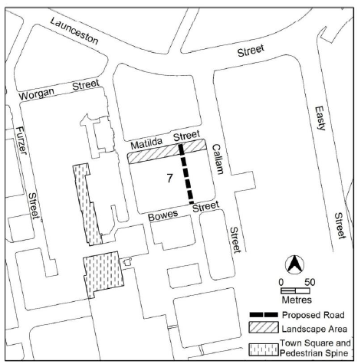

- Torrens
The following specifications provide possible solutions that should be considered in planning, placing, designing and using buildings and structures for proposed development in Torrens:

No applicable specification for this suburb.

