Australian Capital Territory

**Planning (Tuggeranong District) Technical Specifications 2023**

**Notifiable instrument NI2023–551**

made under the

**Planning Act 2023, s 51 (Technical specifications)**

**1 Name of instrument**

This instrument is the *Planning (Tuggeranong District) Technical Specifications 2023*.

**2 Commencement**

This instrument commences on 27 November 2023.

**3 Technical specifications**

I make the technical specifications at schedule 1.

Ben Ponton

Chief Planner

5 September 2023

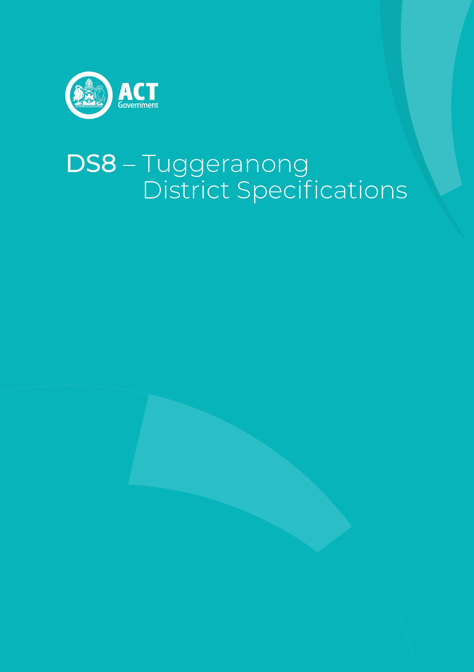

**Schedule 1**

Contents

Contents 3

Tuggeranong District planning technical specifications 4

1. Bonython 5

2. Calwell 5

3. Chisholm 5

4. Conder 5

5. Gilmore 5

6. Gordon 6

7. Gowrie 6

8. Greenway 6

Building setbacks – lakeside residential 6

Figure 1 Greenway – lakeside residential 7

9. Isabella Plains 8

10. Kambah 8

11. Macarthur 8

12. Monash 8

13. Richardson 9

14. Tharwa 9

Fences 9

Retaining walls and earthworks 9

Wastewater 9

15. Theodore 10

16. Wanniassa 10

# Tuggeranong District planning technical specifications

The primary assessment consideration for a development application is the assessment outcomes in the Territory Plan. In demonstrating compliance with the assessment outcomes, consideration may be given to the relevant planning technical specifications which may serve as a benchmark. While all assessment outcomes are to be met, not all outcomes are covered by a specification.

Planning technical specifications are used as a possible solution or to provide guidance for identified aspects of a development proposal. The specifications may also be used as a reference or benchmark in the preparation and assessment of development proposals to demonstrate compliance with the assessment outcomes, and the Territory Plan.

Where a proposed development complies with a relevant provision in the planning technical specifications and the development comprehensively addresses the assessment outcome, further assessment regarding those specific provisions will not be required.

The specifications in the Tuggeranong District Specifications can be used to demonstrate compliance with the assessment outcomes in the Tuggeranong District Policy or the relevant zone policy. Where there is a specific assessment outcome in the Tuggeranong District Policy, this takes precedence over the equivalent outcome in the zone policy. Where there is no specific assessment outcome in the Tuggeranong District Policy, the specification can be used to demonstrate compliance with the assessment outcomes in the zone policy.

The Territory Planning Authority may consider advice or written support from a referral entity to demonstrate compliance with a relevant assessment outcome. Where endorsement from an entity is noted as a planning specification, entity referral may be required.

Consistent with the Tuggeranong District Policy, this Tuggeranong District Specifications comprises specifications for specific localities, structured according to the localities.

These specifications will only apply to the specific sites or locations they refer to and should be used in conjunction with the relevant district policy, i.e., ***Part D8: Tuggeranong District Policy***.

1. Bonython

The following specifications provide possible solutions that should be considered in planning, placing, designing and using buildings and structures for proposed development in Bonython:

| **No applicable specification for this suburb.** |
| --- |

1. Calwell

The following specifications provide possible solutions that should be considered in planning, placing, designing and using buildings and structures for proposed development in Calwell:

| **No applicable specification for this suburb.** |
| --- |

1. Chisholm

The following specifications provide possible solutions that should be considered in planning, placing, designing and using buildings and structures for proposed development in Chisholm:

| **No applicable specification for this suburb.** |
| --- |

1. Conder

The following specifications provide possible solutions that should be considered in planning, placing, designing and using buildings and structures for proposed development in Conder:

| **No applicable specification for this suburb.** |
| --- |

1. Gilmore

The following specifications provide possible solutions that should be considered in planning, placing, designing and using buildings and structures for proposed development in Gilmore:

| **No applicable specification for this suburb.** |
| --- |

1. Gordon

The following specifications provide possible solutions that should be considered in planning, placing, designing and using buildings and structures for proposed development in Gordon:

| **No applicable specification for this suburb.** |
| --- |

1. Gowrie

The following specifications provide possible solutions that should be considered in planning, placing, designing and using buildings and structures for proposed development in Gowrie:

| **No applicable specification for this suburb.** |
| --- |

1. Greenway

The following specifications provide possible solutions that should be considered in planning, placing, designing and using buildings and structures for proposed development in Greenway:

|  |  |  |
| --- | --- | --- |
| **Assessment Outcome:** | | **Refer to zone assessment outcome** |
| **Specification** | | |
| **Building setbacks – lakeside residential** | * 1. Setbacks are in accordance with Figure 1.   The minimum setback of dwellings from the northern boundary of block 6 section 10 in Figure 1 is 10m. | |

## Figure 1 Greenway – lakeside residential



1. Isabella Plains

The following specifications provide possible solutions that should be considered in planning, placing, designing and using buildings and structures for proposed development in Isabella Plains:

| **No applicable specification for this suburb.** |
| --- |

1. Kambah

The following specifications provide possible solutions that should be considered in planning, placing, designing and using buildings and structures for proposed development in Kambah:

|  |  |
| --- | --- |
| **Assessment Outcome 1:** | **The Kambah Group Centre achieves a range of building heights that encourage a variety of uses and allow for good solar access onto public spaces, particularly the central courtyard** |
| **No applicable specification for this assessment outcome. Application must respond to the assessment outcome** | |

|  |  |
| --- | --- |
| **Assessment Outcome 2:** | **Development and active uses in the Kambah Group Centre focus on the central courtyard and open spaces, promoting community and outdoor activity** |
| **No applicable specification for this assessment outcome. Application must respond to the assessment outcome** | |

1. Macarthur

The following specifications provide possible solutions that should be considered in planning, placing, designing and using buildings and structures for proposed development in Macarthur:

| **No applicable specification for this suburb.** |
| --- |

1. Monash

The following specifications provide possible solutions that should be considered in planning, placing, designing and using buildings and structures for proposed development in Monash:

| **No applicable specification for this suburb.** |
| --- |

1. Richardson

The following specifications provide possible solutions that should be considered in planning, placing, designing and using buildings and structures for proposed development in Richardson:

| **No applicable specification for this suburb.** |
| --- |

1. Tharwa

The following specifications provide possible solutions that should be considered in planning, placing, designing and using buildings and structures for proposed development in Tharwa:

|  |  |
| --- | --- |
| **Assessment Outcome:** | **Refer to zone assessment outcome** |
| **Specification** | |
| **Fences** | * 1. Fencing complies with the following:  1. Maximum height above ground level: 2. In the front zone – 1.2m. 3. In the primary building zone and rear zone – 1.8m 4. Made using transparent materials such as wire, wire mesh or open timber. 5. Privacy screening is provided through landscape planting. 6. Non-transparent fences such as sheet metal are not permitted.   Courtyard walls are not permitted in the front zone or for use as boundary fencing. |
| **Retaining walls and earthworks** | * 1. Development complies with the following:  1. Retaining walls are a maximum of 1m in height and incorporated with the primary building to minimise visual impacts. 2. Where earthworks are required, battered soil slopes in conjunction with ground-cover plantings are used to accommodate level changes in preference to engineered retaining walls. |
| **Wastewater** | * 1. Onsite wastewater treatment systems located within 300m of a waterway are endorsed by the ACT Environment Protection Authority (EPA).   Note: Any new development or re-development of onsite wastewater treatment systems located within 300m of a waterway will be required to be referred to the ACT EPA for assessment. |

1. Theodore

The following specifications provide possible solutions that should be considered in planning, placing, designing and using buildings and structures for proposed development in Theodore:

| **No applicable specification for this suburb.** |
| --- |

1. Wanniassa

The following specifications provide possible solutions that should be considered in planning, placing, designing and using buildings and structures for proposed development in Wanniassa:

| **No applicable specification for this suburb.** |
| --- |