Australian Capital Territory
Planning (Non-Urban District) Technical Specifications 2023
Notifiable instrument NI2023–553
made under the
Planning Act 2023, s 51 (Technical specifications)

1 Name of instrument
This instrument is the Planning (Non-Urban District) Technical Specifications 2023.
2 Commencement
This instrument commences on 27 November 2023.
3 Technical specifications
I make the technical specifications at schedule 1.

Ben Ponton
Chief Planner
5 September 2023

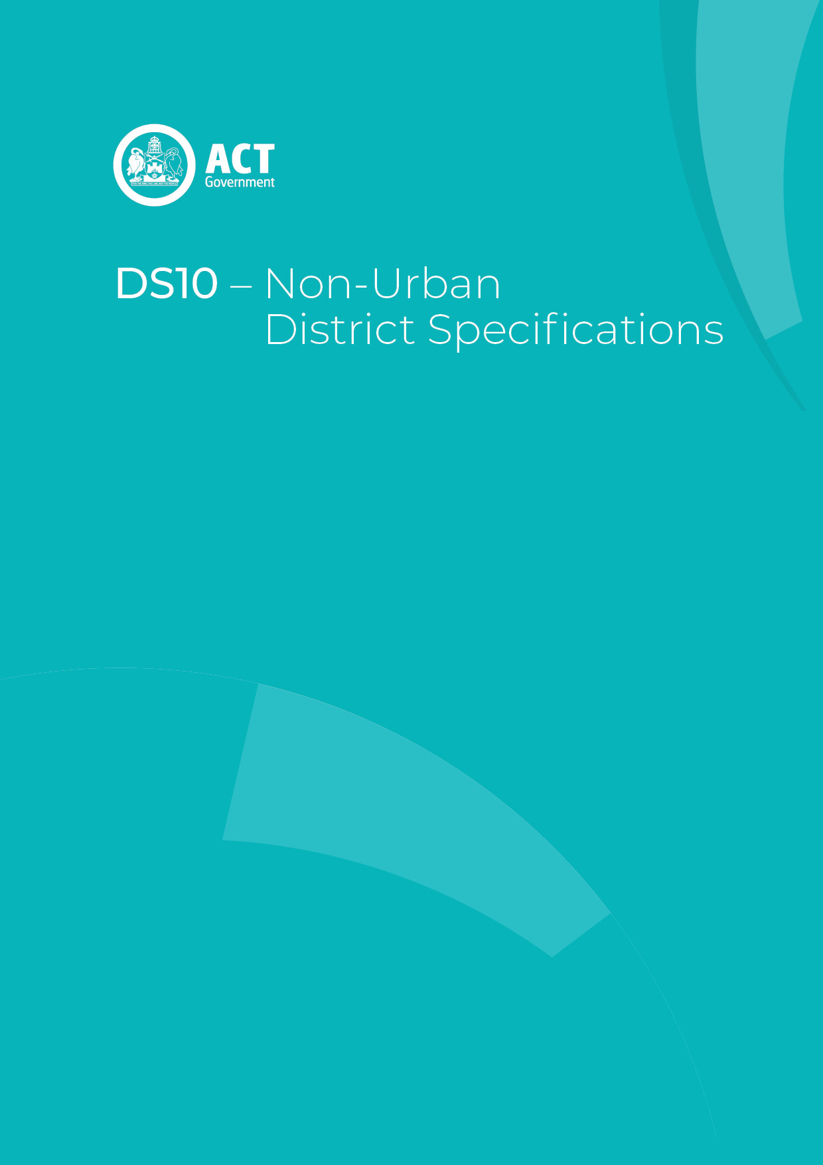
Schedule 1

Contents
Contents 2
Non-Urban District planning technical specifications 3
1. Belconnen (non-urban) 4
2. Booth 4
3. Coree 4
4. Cotter River 4
5. Gungahlin (non-urban) 4
6. Hall 5
7. Jerrabomberra 5
8. Kowen 5
9. Majura 5
10. Mount Clear 5
11. Paddy’s River 6
12. Rendezvous Creek 6
13. Stromlo 6
14. Tennent 6
15. Tuggeranong 7

Non-Urban District planning technical specifications
The primary assessment consideration for a development application is the assessment outcomes in the Territory Plan. In demonstrating compliance with the assessment outcomes, consideration may be given to the relevant planning technical specifications which may serve as a benchmark. While all assessment outcomes are to be met, not all outcomes are covered by a specification.
Planning technical specifications are used as a possible solution or to provide guidance for identified aspects of a development proposal. The specifications may also be used as a reference or benchmark in the preparation and assessment of development proposals to demonstrate compliance with the assessment outcomes, and the Territory Plan.
Where a proposed development complies with a relevant provision in the planning technical specifications and the development comprehensively addresses the assessment outcome, further assessment regarding those specific provisions will not be required.
The specifications in the Non-Urban District Specifications can be used to demonstrate compliance with the assessment outcomes in the Non-Urban District Policy or the relevant zone policy. Where there is a specific assessment outcome in the Non-Urban District Policy, this takes precedence over the equivalent outcome in the zone policy. Where there is no specific assessment outcome in the Non-Urban District Policy, the specification can be used to demonstrate compliance with the assessment outcomes in the zone policy.
The Territory Planning Authority may consider advice or written support from a referral entity to demonstrate compliance with a relevant assessment outcome. Where endorsement from an entity is noted as a planning specification, entity referral may be required.
Consistent with the Non-Urban District Policy, this Non-Urban District Specifications comprises specifications for specific localities, structured according to the localities.
These specifications will only apply to the specific sites or locations they refer to and should be used in conjunction with the relevant district policy, i.e., Part D10: Non-Urban District Policy.
- Belconnen (non-urban)
The following specifications provide possible solutions that should be considered in planning, placing, designing and using buildings and structures for proposed development in Belconnen (non-urban) area:

No applicable specification for this district.

- Booth
The following specifications provide possible solutions that should be considered in planning, placing, designing and using buildings and structures for proposed development in Booth area:

No applicable specification for this district.

- Coree
The following specifications provide possible solutions that should be considered in planning, placing, designing and using buildings and structures for proposed development in Coree area:

No applicable specification for this district.

- Cotter River
The following specifications provide possible solutions that should be considered in planning, placing, designing and using buildings and structures for proposed development in Cotter River area:

No applicable specification for this district.

- Gungahlin (non-urban)
The following specifications provide possible solutions that should be considered in planning, placing, designing and using buildings and structures for proposed development in Gungahlin (non-urban) area:

No applicable specification for this district.
- Hall
The following specifications provide possible solutions that should be considered in planning, placing, designing and using buildings and structures for proposed development in Hall area:

No applicable specification for this district.

- Jerrabomberra
The following specifications provide possible solutions that should be considered in planning, placing, designing and using buildings and structures for proposed development in Jerrabomberra area:

No applicable specification for this district.

- Kowen
The following specifications provide possible solutions that should be considered in planning, placing, designing and using buildings and structures for proposed development in Kowen area:

No applicable specification for this district.

- Majura
The following specifications provide possible solutions that should be considered in planning, placing, designing and using buildings and structures for proposed development in Majura area:

No applicable specification for this district.

- Mount Clear
The following specifications provide possible solutions that should be considered in planning, placing, designing and using buildings and structures for proposed development in Mount Clear area:

No applicable specification for this district.

- Paddy’s River
The following specifications provide possible solutions that should be considered in planning, placing, designing and using buildings and structures for proposed development in Paddy’s River area:

No applicable specification for this district.

- Rendezvous Creek
The following specifications provide possible solutions that should be considered in planning, placing, designing and using buildings and structures for proposed development in Rendezvous Creek area:

No applicable specification for this district.

- Stromlo
The following specifications provide possible solutions that should be considered in planning, placing, designing and using buildings and structures for proposed development in Stromlo area:

No applicable specification for this district.

- Tennent
The following specifications provide possible solutions that should be considered in planning, placing, designing and using buildings and structures for proposed development in Tennent area:

No applicable specification for this district.

- Tuggeranong
The following specifications provide possible solutions that should be considered in planning, placing, designing and using buildings and structures for proposed development in Tuggeranong (non-urban) area:

No applicable specification for this district.

