Australian Capital Territory
Planning (Subdivision) Technical Specifications 2023
Notifiable instrument NI2023–561
made under the
Planning Act 2023, s 51 (Technical specifications)

1 Name of instrument
This instrument is the Planning (Subdivision) Technical Specifications 2023.
2 Commencement
This instrument commences on 27 November 2023.
3 Technical specifications
I make the technical specifications at schedule 1.

Ben Ponton
Chief Planner
5 September 2023

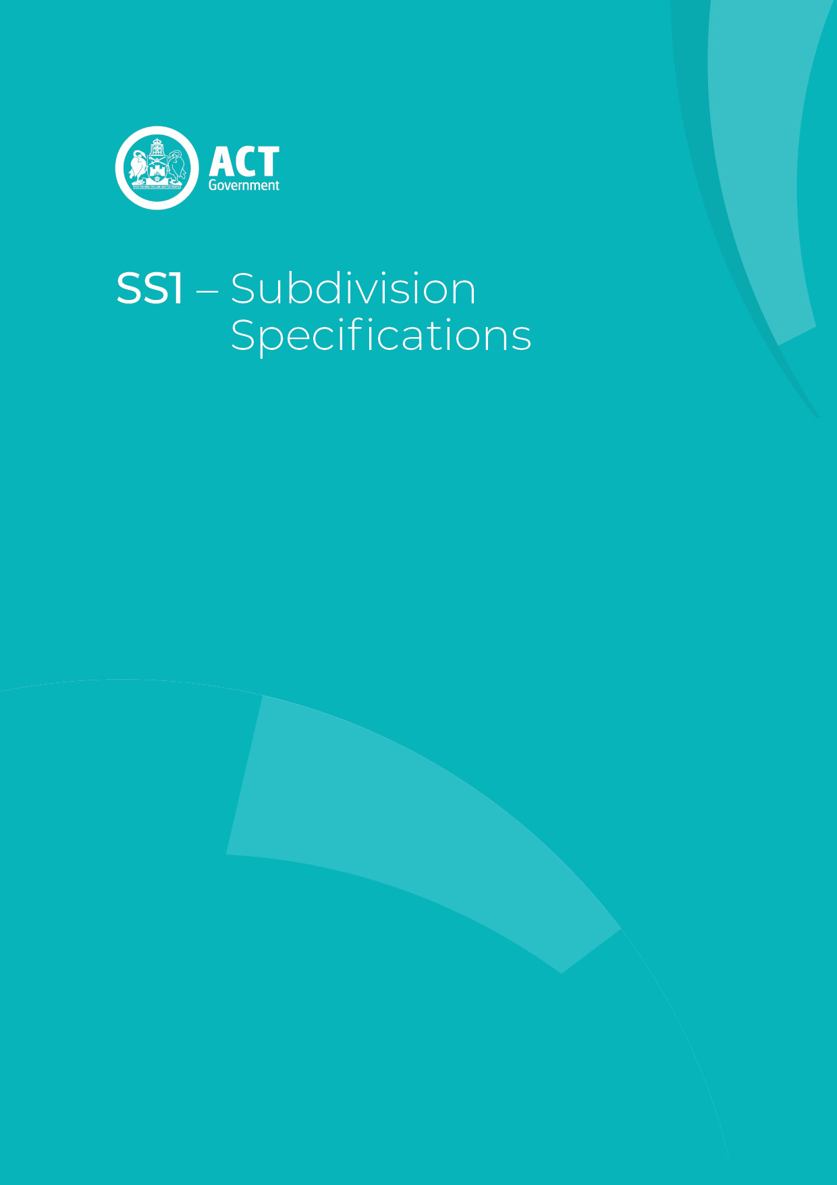
Schedule 1

Contents
Contents 2
Subdivision planning technical specifications 5
Country and Place 6
Assessment Outcome 1 6
Urban Structure and Natural Systems 6
Assessment Outcome 2 6
Residential block configuration – new residential blocks 6
Residential block configuration – current leased blocks 6
Specification: Blocks in industrial zones 7
Assessment Outcome 3 7
Land use zoning 7
Residential zoned blocks 7
Assessment Outcome 4 7
Assessment Outcome 5 7
Assessment Outcome 6 8
Assessment Outcome 7 8
Ongoing provisions 8
Site and Land Use 8
Assessment Outcome 8 8
Access and Movement 8
Assessment Outcome 9 8
Road hierarchy 9
Street network 9
Assessment Outcome 10 9
Shared paths 9
Assessment Outcome 11 9
Cul-de-sac blocks 9
Rear lanes 9
Public Space and Amenity 10
Assessment Outcome 12 10
Assessment Outcome 13 10
Recreation uses 10
Assessment Outcome 14 10
Sustainability and Environment 11
Assessment Outcome 15 11
Permeability – sites greater than 2000m2 11
Landscaping – tree canopy cover 11
Reducing urban heat - Cool paving 11
Protection from heat 12
Assessment Outcome 16 12
Assessment Outcome 17 12
Assessment Outcome 18 13
Site disturbance 13
Assessment Outcome 19 13
Bushfire prone area 13
Flood risk 13
Stormwater retention and detention 13
Site contamination 14
Hazardous materials 14
Assessment Outcome 20 14
Assessment Outcome 21 14
Parking, Services and Utilities 14
Assessment Outcome 22 14
On-street parking 14
Assessment Outcome 23 15
Assessment Outcome 24 15
Battery storage 15
Schedule 1 – Public spaces 16

Subdivision planning technical specifications
The primary assessment consideration for a development application is the assessment outcomes in the Territory Plan. In demonstrating compliance with the assessment outcomes, consideration may be given to the relevant planning technical specifications. While all assessment outcomes are to be met, not all outcomes are covered by a specification.
Planning technical specifications are used as a possible solution or to provide guidance for identified aspects of a development proposal. The specifications may also be used as a reference or benchmark in the preparation and assessment of development proposals to demonstrate compliance with the assessment outcomes, and the Territory Plan.
Where a proposed development complies with a relevant provision in the planning technical specifications and the development comprehensively addresses the assessment outcome, further assessment regarding those specific provisions will not be required.
The Territory Planning Authority may consider advice or written support from a referral entity to demonstrate compliance with a relevant assessment outcome. Where endorsement from an entity is noted as a planning specification, entity referral may be required.
Consistent with the Subdivision Policy, this Subdivision Specification comprises specifications under eight categories:
- Country and Place;
- Urban Structure and Site;
- Access and Movement;
- Public Space and Amenity;
- Land Use and Development;
- Built Form and Building Form;
- Sustainability and Environment; and
- Parking, Services and Utilities.
These specifications will primarily be for subdividing land and for development of new subdivisions. Some of these specifications may be referred to in other circumstances, e.g., larger developments and developments that may require significant infrastructure.
Other planning technical specifications may be referred to as required, for example, to consider the requirements for proposed zones and development permitted in it.

Country and Place
The following specifications provide possible solutions that should be considered in the planning of a proposed development:
Assessment Outcome 1 | - The subdivision design considers and responds appropriately to cultural significance and history or heritage.
No applicable specification for this assessment outcome. Application must respond to the assessment outcome

Urban Structure and Natural Systems
The following specifications provide possible solutions that should be considered in the planning of a proposed development:
Assessment Outcome 2 | - New blocks are of a size and configuration that can accommodate the intended use for the site (for example an appropriately sized and configured site for single dwelling use)
Specification
Residential block configuration – new residential blocks | - New residential blocks comply with all of the following:  - minimum block depth:  - for compact blocks: 17m  - for mid-sized blocks: 25m  - for large blocks: 28m.  - minimum block width:  - for compact blocks: 6m  - for mid-sized blocks: 10m  - for large blocks: 14m.  - for compact blocks: slope is no greater than 10%.  Note: Slope means the slope of land, expressed as a percentage, calculated using the difference in datum ground level from the highest to lowest points on the proposed block boundary and the horizontal distance between those points.
Residential block configuration – current leased blocks | - For blocks created by the subdivision of a currently leased block, minimum block sizes are as follows:  Zone: Minimum block size  RZ1 400m²  RZ2 350m²  RZ3 325m²  RZ4 300m²  RZ5 250m²  Notes:  - Minimum areas exclude any battle axe handle i.e., an access handle is not measured as part of the minimum area compliance.  - Unit titling of blocks can rely on the above table however the table is not intended to address unit titling of individual units/dwellings.
Specification: Blocks in industrial zones | - The slope across the frontage or length of the block does not exceed 10%

Assessment Outcome 3 | - The proposed scale and range of uses in the subdivision are appropriate to the context and consistent with the Territory Plan Map, where applicable. This includes consideration of a range of block sizes to promote housing diversity and choice, and to meet a range of housing needs
Specification
Land use zoning | - New land use zones comply with all of the following:  - is in accordance with the Territory Plan Map under the future urban area overlay  - is compatible with the land use zoning adjacent to the subdivision  - proposed land use zoning generally intensifies in density closer to:  - public transport routes and stops  - commercial centres, particularly with community services and facilities.  - lower density zoning is generally segregated from higher densities zoning  - creates a clear and logical configuration of zones and response to centres, services and connecting road and active travel networks.
Residential zoned blocks | - Residential zoned blocks comply with the following:  - RZ1 contains:  - no more than 10% compact blocks  - no more than 30% mid-size blocks.  - RZ2 contains:  - no more than 15% compact blocks  - no more than 40% mid-size blocks.  - RZ3, RZ4 contains:  - at least 25% compact blocks  - at least 50% mid-sized blocks.  - RZ5 contains:  - At least 30% compact blocks  At least 60% mid-sized blocks.

Assessment Outcome 4 | - Biodiversity connectivity is maintained across the landscape
No applicable specification for this assessment outcome. Application must respond to the assessment outcome

Assessment Outcome 5 | - Loss of native habitat and biodiversity is avoided and/or minimised
No applicable specification for this assessment outcome. Application must respond to the assessment outcome

Assessment Outcome 6 | - The health and functionality of waterways and catchments is maintained, including through application of water sensitive urban design principles
No applicable specification for this assessment outcome. Application must respond to the assessment outcome

Assessment Outcome 7 | - The subdivision is designed in a way to minimise the need for ongoing site-specific provisions (such as front or side boundary setbacks) to apply to blocks.
Specification
Ongoing provisions | - Ongoing provisions:  - Blocks to which ongoing provisions apply, are nominated on a planning control plan, with no more than 30% of the blocks within the subdivision subject to ongoing provisions.  - For blocks intended to accommodate single dwelling development each ongoing provision must apply to at least 10% of the blocks within the estate. All ongoing provisions are to be in accordance with the Planning Act 2023.

Site and Land Use
The following specifications provide possible solutions that should be considered in the planning of a proposed development:
Assessment Outcome 8 | - The functionality and usability of the subdivision is appropriate for its intended purpose/use. This includes limiting future adverse impacts between permissible land uses and on surrounding areas
No applicable specification for this assessment outcome. Application must respond to the assessment outcome

Access and Movement
The following specifications provide possible solutions that should be considered in relation to access, travel modes and movement to and within a proposed development:

Assessment Outcome 9 | - Road hierarchy, layout and design (including entry and egress points) enables the distribution of traffic in a legible, convenient and safe manner. This includes providing a high level of internal accessibility for pedestrians, cyclists and public transport.
Specification
Road hierarchy | - The proposed road hierarchy, layout and design is endorsed by Transport Canberra and City Services (TCCS).
Street network | - The street network within a subdivision complies with all of the following:  - Maximum driving distance between any dwelling and specified roads complies with the following:  - minor or major collector street or higher order road: 700m  - arterial road: 1200m.  - No more than three turning movements at intersections are required in order to travel from any dwelling to the nearest collector street or arterial road.  - For blocks with a front boundary less than 8m, no direct vehicular access is provided to either of the following:  - a major collector road  - any minor collector road or access street that is adjacent to an address street boundary with a bearing between 70° and 120°.  - Intersection spacing is endorsed by Transport Canberra and City Services (TCCS).

Assessment Outcome 10 | - Clear and high quality movement corridors enable effective external connections for local vehicle, pedestrian and cycle movements, while minimising through traffic from external areas (other than for pedestrians, cyclists and public transport) and ‘rat runs
Shared paths | - The following applies to shared paths:  - Shared paths are provided in the following locations:  - the entire frontage of any block used or proposed to be used for one or more of the following:  - schools  - shops  - community facilities.  - the entire frontage of any block adjacent to an existing or proposed bus stop.  - the entire frontage of any block used or proposed to be used for multi-unit housing containing 10 or more dwellings.  - on both sides of endorsed bus routes.  - Shared paths are connected to one or more of the following:  - any existing or proposed shared path networks.  - open space networks.  - community facilities such as educational establishments and local activity centres.  - public transport routes and bus stops.

Assessment Outcome 11 | - The use of rear lane accessways, cul-de-sac roadways and battle-axe blocks are minimised
Specification
Cul-de-sac blocks | - No more than 15 per cent of blocks in a subdivision have vehicular access to cul-de-sac.
Rear lanes | - Rear lanes are only permitted where the block has an alternate street frontage.

Public Space and Amenity
The following specifications provide possible solutions that should be considered in relation to public areas (areas accessible to residents, visitors and community) and amenity outcomes associated with a proposed development:
Assessment Outcome 12 | - The subdivision design achieves reasonable solar access and microclimate conditions for individual blocks to enable the design of sustainable buildings, and to public areas and streets to support their use by the community
No applicable specification for this assessment outcome. Application must respond to the assessment outcome

Assessment Outcome 13 | - Public spaces provided within a subdivision accommodates a range of uses, users and activities. This includes consideration of recreational opportunities, including facilities for pedestrians and cyclists
Specification
Recreation uses | - The following applies:  - The development comprises of public spaces consistent with Schedule 1.  - Recreation spaces meet the following:  - Local neighbourhood parks have an area not less than 0.5ha.  - Central neighbourhood parks have an area of at least 1ha.  - Blocks for residential use satisfy at least one of the following:  - not more than 300m from at least one of the following:  - a local neighbourhood park  - town park or a pedestrian parkland containing recreational facilities such as picnic and barbeque areas and playgrounds.  - not more than 500m from at least one of the following:  - a central neighbourhood park  - neighbourhood oval  - district park  - district sportsground

Assessment Outcome 14 | - Public spaces provide opportunities to link existing or proposed areas of open space and/or providing for shared use of public facilities by adjoining communities
No applicable specification for this assessment outcome. Application must respond to the assessment outcome

Sustainability and Environment
The following specifications provide possible solutions that should be considered in relation to the sustainability and environmental outcomes associated with a proposed development:
Assessment Outcome 15 | - Urban heat island effects are reduced, stormwater run-off is minimised and ecosystem services are maintained through provision of planting area and canopy trees, limiting impervious surfaces, selection of building materials and design of outdoor spaces. This includes consideration of water sensitive urban design measures
Specification
Permeability – sites greater than 2000m² | - For development on sites greater than 2,000m² involving works that have the potential to alter the stormwater regime of the site; or development within existing urban areas which increases impervious area by 100m², development achieves the following permeability:  - For new greenfield subdivision that is primarily residential use, all of the following:  - for each site in PRZ1: 50% of the site  - for each street: 20% of the street  - for each surface car park: 10% of the car park  - for the total area of all streets: 30% of the total area  - for the total area of all PRZ1 and streets within the subdivision: 40% of the total area.  - For all other subdivision:  - 20% of the total site area.  - 50% of the verge surface of each street
Landscaping – tree canopy cover | - Subdivisions, where a subdivision design application is required, meets the following requirements:  - New greenfield subdivision that is primarily residential use, Tree canopy cover at maturity is:  - for each PRZ1 block: 25% of the block  - for each street: 20% of the street  - for each surface car park: 30% of the car park  - for the total area of all streets: 30% of the total area  - for the total area of all PRZ1 and streets within the estate: 35% of the total area.  - For all other subdivision, street tree canopy cover will, at maturity, shade not less than 30% of all footpaths and surrounding paths at noon on the summer solstice.  - Trees proposed to be planted are at least semi-mature stock (1.5m height) and have a minimum mature height of 4m.  - All new trees proposed are in accordance with utilities requirements.
Reducing urban heat - Cool paving | - At least 75% of the non-exempt paved surface area is one or more of the following types of cool paving:  - paving with light-coloured aggregates, pigments and binders (e.g. fly ash, slag, chip, sand seals and reflective synthetic binders). This includes standard concrete that is uncoloured and has no exposed aggregate.  - high emittance and high albedo cement and asphalt (e.g. slag and white cement)  - resin-based concrete using natural clear-coloured tree resins in place of cement to bind the aggregate.  - light-coloured coatings (e.g. cementitious coating and elastomeric coating), infrared reflective coatings, high white coatings, or colour changing coatings.  - thermochromic materials (intelligent coatings developed with nanotechnology that can applied to enhance the thermal and optical properties of pavements and reduced glare effect on pedestrians).  - permeable paving (including porous asphalt cement, pervious Portland cement concrete, block pavements, reinforced grass pavements and vegetated pavements), providing it is installed on a subgrade with the capacity for infiltration or temporary storage of water below the pavement.  The following areas of paved surface are exempt:  - shaded areas. Shading is to be measured either at noon on the summer solstice (21 December). Shade may be provided by structures or vegetation (e.g. eaves, shade sail and tree canopy).  - road pavement.  - areas where the Municipal Infrastructure Standards, National Construction Code or other engineering standards preclude the use of these materials.  - areas where heritage requirements preclude the use of these materials.  - areas where it is demonstrated that undesirable glare or reflected heat would cause unavoidable negative impacts in the particular context.  - areas that require particular surfaces to meet sporting needs (e.g. synthetic tennis courts and athletics tracks).
Protection from heat | - 50% of public playgrounds and 50% of public seating are fully shaded in summer. Shading is to be measured either at noon on the summer solstice or assuming the sun is directly overhead. Shading may be provided by built and/or green infrastructure (e.g. shade structure, tree canopy).

Assessment Outcome 16 | - Deep soil zones are provided on site to support healthy tree growth and provide adequate room for canopy trees
No applicable specification for this assessment outcome. Application must respond to the assessment outcome

Assessment Outcome 17 | - Threats to biodiversity such as noise, light pollution, invasive species incursion or establishment, chemical pollution, or site disturbance are avoided or minimised through good design
No applicable specification for this assessment outcome. Application must respond to the assessment outcome

Assessment Outcome 18 | - Minimise cut and fill to protect natural hydrological function and limit soil erosion and site disturbance
Specification
Site disturbance | - For sites less than 3,000m², the development complies with the Environment Protection Authority requirements regarding construction and land development.  For sites 3,000m² or greater, the development prepares an erosion and sediment control plan and obtains endorsed by the ACT Environment Protection Authority.

Assessment Outcome 19 | - The subdivision design considers, addresses and mitigates site constraints and environmental risks including existing natural features, topography, bushfire, flooding, contamination, air quality or hazardous materials
Specification
Bushfire prone area | - All development in the bushfire prone area (identified by the Emergency Services Authority) to comply with the ACT Bushfire Management Standards
Flood risk | - The following applies:  - Residential and commercial buildings are to be excluded from flood liable areas up to the 1% Annual Exceedance Probability (AEP) Flood.  - Habitable floor levels are to be above the 1% AEP level plus a suitable freeboard (usually 300mm)  - In flood liable areas up to the 0.2% Annual Exceedance Probability (AEP) Flood, large developments and those with more sensitive uses* are to be referred to ESA, TCCS and EPSDD for endorsement.  Note: *Sensitive uses include developments such as hospitals, nursing homes, childcare centres, prisons, archives, libraries and emergency response centres.
Stormwater retention and detention | - For development on sites greater than 2,000m² (other than major roads) involving works that have the potential to alter the stormwater regime of the site, a report from a suitably qualified person is provided demonstrating that the development complies with:  - at least one of the following:  - stormwater retention management measures are provided and achieve all of the following:  - Stormwater storage capacity of 1.4kL per 100m² of the total impervious area of the site is provided specifically to retain and reuse stormwater generated on site as a whole.  - Retained stormwater is used on site.  - development captures, stores and uses the first 15mm of rainfall falling on the site; and  Note: on-site stormwater retention is defined as the storage and use of stormwater on site.  - stormwater detention measures are provided and achieve all of the following:  - capture and direct runoff from the entire site  - Stormwater storage capacity of 1kL per 100m² of impervious area is provided to specifically detain stormwater generated on site  - The detained stormwater is designed to be released over a period of 6 hours after the storm event. For this specification, on-site stormwater detention is defined as the short-term storage and release downstream of stormwater runoff.  Note: Calculating on-site detention can include 50% of the volume of rainwater tanks where stormwater is used on-site.
Site contamination | - Where development is proposed on a site impacted or potentially impacted by contamination, the development and proposed methods of responding to the contamination is endorsed by the ACT Environment Protection Authority.
Hazardous materials | - Where development is proposed on a site impacted by hazardous materials, the development and proposed methods of managing the hazardous materials is endorsed by the ACT Environment Protection Authority.

Assessment Outcome 20 | - Existing and significant vegetation is preserved where reasonable, and new landscaping responds to and integrates with preserved features where possible
There is no applicable specification for this assessment outcome. Application must respond to the assessment outcome.

Assessment Outcome 21 | - Residents are provided a reasonable level of protection from known sources of noise, odour and light pollution
No applicable specification for this assessment outcome. Application must respond to the assessment outcome

Parking, Services and Utilities
The following specifications provide possible solutions that should be considered in relation to vehicle parking, access and site servicing (including possible requirements by utility providers) for a proposed development:

Assessment Outcome 22 | - Appropriate vehicle and bicycle parking is provided to meet the needs of users that is safe and convenient for users and pedestrians
Specification
On-street parking | - Dimensions of designated on-street car spaces comply with Australian Standard AS 2890.5 Parking – on street.

Assessment Outcome 23 | - Waste is appropriately managed within the subdivision without having a detrimental impact on the surrounding area
No applicable specification for this assessment outcome. Application must respond to the assessment outcome.

Assessment Outcome 24 | - The site is appropriately serviced in terms of infrastructure and utility services and the noise and visual amenity impact of these are minimised
Specification
Battery storage | - Where development includes a battery over 30kW, the development is endorsed by the Emergency Services Agency.

Schedule 1 – Public spaces

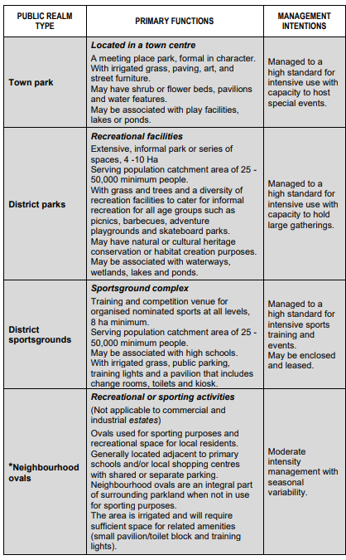
SPACE

