Australian Capital Territory

**Work Health and Safety (Managing the Risks of Airborne Crystalline Silica (Silica Dust) in the Workplace Code of Practice) Approval 2023\***

**Notifiable instrument NI2023–589**

made under the

***Work Health and Safety Act 2011*, section 274 (Approved Codes of Practice)**

**1 Name of instrument**

This instrument is the *Work Health and Safety (Managing the Risks of Airborne Crystalline Silica (Silica Dust) in the Workplace Code of Practice) Approval 2023.*

**2 Commencement**

This instrument commences on 15 November 2023.

**3 Code of Practice Approval**

Under section 274 of the *Work Health and Safety Act 2011* (the Act) and being satisfied that this code of practice was developed by a process described in s274 (2) of the Act, I approve the attached Managing the risks of airborne crystalline silica (silica dust) at the workplace.

Mick Gentleman

Minister for Industrial Relations and Workplace Safety

18/09/2023

Managing the risks of airborne crystalline silica (silica dust) in the workplace

Code of Practice

September 2023

**Disclaimer**

This code is based on a national model code of practice developed by Safe Work Australia under the national harmonisation of work health and safety legislation and material developed by WorkSafe QLD including the Managing respirable crystalline silica dust exposure in construction and manufacturing of construction [elements](https://www.worksafe.qld.gov.au/__data/assets/pdf_file/0025/106486/rcs-construction-manufacturing-construction-elements-cop-2022.pdf) Code of Practice 2022, and has been approved under section 274 of the *Work Health and Safety Act 2011* (ACT), following the legislated consultation.

This code of practice commenced in the Australian Capital Territory on the date it was published on the ACT Legislation Register.

Safe Work Australia is an Australian Government statutory agency established in 2009. Safe Work Australia includes Members from the Commonwealth, and each state and territory, Members representing the interests of workers and Members representing the interests of employers.

Safe Work Australia works with the Commonwealth, state and territory governments to improve work health and safety and workers’ compensation arrangements. Safe Work Australia is a national policy body, not a regulator of work health and safety. The Commonwealth, states and territories have responsibility for regulating and enforcing work health and safety laws in their jurisdiction.

ISBN 978-0-642-33299-8 (PDF)

ISBN 978-0-642-33300-1 (DOCX)

**Creative Commons**

This copyright work is licensed under a Creative Commons Attribution-Non-commercial 4.0 International licence. To view a copy of this licence, visit creativecommons.org/licenses In essence, you are free to copy, communicate and adapt the work for non- commercial purposes, as long as you attribute the work to Safe Work Australia and abide by the other licence terms.

**Contact information** Safe Work Australia | [info@swa.gov.au](mailto:info@swa.gov.au) | [www.swa.gov.au](http://www.swa.gov.au/)

**Contents**

Foreword 4

1. Introduction 6

1.1 What is crystalline silica material? 6

1.2 What is airborne crystalline silica? 7

1.3 Health effects of airborne crystalline silica (silica dust) 10

1.4 Who has health and safety duties in relation to working with crystalline silica material? 12

1.5 Other relevant duties 18

1.6 Safe Work Method Statements (SWMS) 22

2. Specific duties for working with crystalline silica material 26

2.1 Choosing controls when mechanically cutting crystalline silica material 26

2.2 Workplace exposure standard for respirable crystalline silica 29

2.3 Air monitoring 30

2.4 Health monitoring 35

3. How to manage and control the risks from working with crystalline silica material 40

3.1 Identifying the hazard 40

3.2 Assessing the risks 41

3.3 Controlling the risks 42

3.4 Use a Combination of Control Measures 48

4. Maintaining and reviewing control measures 63

4.1 Maintenance of control measures 63

4.2 Review of control measures 64

5. Clean-up and disposal of silica dust 66

5.1 Cleaning and housekeeping 66

5.2 Management of water and waste 67

6. Post-installation 69

6.1 Maintenance or refurbishment of crystalline silica material, such as engineered stone 69

6.2 Removal 69

Appendix A – Glossary 70

Appendix B - Example of matters for inclusion in a SWMS for silica dust control 74

Appendix C - Example Task Risk Assessment: Crystalline Silica Material 77

# Foreword

This code of practice on managing the risks of airborne crystalline silica (silica dust) in the workplace (hereafter referred to as the Code) is an approved code of practice under section 274 of the *Work Health and Safety Act 2011* (the WHS Act).

An approved code of practice provides practical guidance on how to achieve the standards of work health and safety required under the WHS Act and the *Work Health and Safety Regulation 2011* (the WHS Regulation) and effective ways to identify and manage risks.

A code of practice can assist anyone who has a duty of care in the circumstances described in the code of practice to achieve compliance with the health and safety duties in the WHS Act and WHS Regulation, in relation to the subject matter of the code of practice. Like regulations, codes of practice deal with particular issues and may not cover all hazards or risks in the workplace. The health and safety duties require duty holders to consider all risks associated with work, not only those for which regulations and codes of practice exist.

Codes of practice are admissible in court proceedings under the WHS Act and WHS Regulation. Courts may regard a code of practice as evidence of what is known about a hazard, risk, risk assessment or risk control and may rely on the code in determining what is reasonably practicable in the circumstances to which the code of practice relates. For further information see the [Interpretive Guideline: The meaning of ‘reasonably practicable’](https://www.bing.com/ck/a?!&&p=fa3d2d9c1cef8ae9JmltdHM9MTY3NzcxNTIwMCZpZ3VpZD0zODA4ZmJmYS1mYzFmLTY3MmMtMDc0Mi1mNDQ2ZmQ5NjY2ZWUmaW5zaWQ9NTE3OA&ptn=3&hsh=3&fclid=3808fbfa-fc1f-672c-0742-f446fd9666ee&psq=Interpretive+Guideline%3a+The+meaning+of+%e2%80%98reasonably+practicable%e2%80%99&u=a1aHR0cHM6Ly93d3cuc2FmZXdvcmthdXN0cmFsaWEuZ292LmF1L2RvYy9pbnRlcnByZXRpdmUtZ3VpZGVsaW5lLW1vZGVsLXdvcmstaGVhbHRoLWFuZC1zYWZldHktYWN0LW1lYW5pbmctcmVhc29uYWJseS1wcmFjdGljYWJsZQ&ntb=1).

Compliance with the WHS Act and WHS Regulation may be achieved by following another method if it provides an equivalent or higher standard of work health and safety than the code of practice.

An inspector may refer to an approved code of practice when issuing an improvement or prohibition notice.

In circumstances where equipment, or methods, for managing work health and safety (WHS) risks are used in the workplace, it is recommended that current Australian standards or recognised international standards are applied, where available.

**Scope and application**

This Code is intended to be used by a range of duty holders to assist them in complying with the WHS Act and WHS Regulation. Duty holders include persons conducting a business or undertaking (PCBUs), workers and their health and safety representatives (HSRs), manufacturers, importers and suppliers.

In the ACT, this Code provides practical guidance on how to effectively manage risks of exposure to any airborne contaminant containing respirable crystalline silica (airborne crystalline silica) which can be generated when with working with materials or products that contain crystalline silica.

It provides information on how to implement a combination of control measures to eliminate or minimise as far as is reasonably practicable the risks of exposure to airborne crystalline silica, and its related diseases, such as silicosis.

This Code supports PCUBs implement the regulatory arrangements set out by the [WHS Regulation](https://www.legislation.act.gov.au/View/sl/2011-36/current/html/2011-36.html) and applies to crystalline silica material defined as:

* Crystalline *silica material* –
* engineered stone
* any cement, concrete, masonry, mortar or brick product containing crystalline silica; and
* natural stone containing crystalline silica.

In this Code *airborne crystalline silica* – defined by the WHS Regulation as an airborne contaminant containing respirable crystalline silica - includes references to ‘silica dust’.

In the ACT, this Code provides guidance for managing the risks of exposure to any airborne contaminant containing airborne crystalline silica when:

* using
* cutting - cut (cutting) - includes crush, drill, grind, polish, sand and trim
* fabricating
* installing
* modifying
* maintaining
* removing; or
* disposing of crystalline silica material.

Working with crystalline silica material carries a range of risks beyond those covered in this Code. Other relevant Codes of Practice that apply in the ACT to help manage these risks include:

* [Managing the work environment and facilities](https://www.legislation.act.gov.au/ni/2020-551/)
* [Construction work](https://www.legislation.act.gov.au/ni/2018-733/)
* [Hazardous manual tasks](https://www.legislation.act.gov.au/ni/2020-544/)
* [Demolition work](https://www.legislation.act.gov.au/ni/2020-541/)
* [Excavation work](https://www.legislation.act.gov.au/ni/2020-542/)
* [Managing electrical risks in the workplace](https://www.legislation.act.gov.au/ni/2020-556/)
* [Managing noise and preventing hearing loss at work](https://www.legislation.act.gov.au/ni/2022-688/); and
* [Managing the risks of plat in the workplace](https://www.legislation.act.gov.au/ni/2022-356/).

**How to use this Code of Practice**

This Code includes references to legal requirements under the model WHS Act and WHS Regulation. These are included for convenience only and should not be relied upon in place of the full text of the WHS Act or WHS Regulation. The words ‘must’, ‘requires’ or ‘mandatory’ indicate a legal requirement exists that must be complied with.

The word ‘should’ is used in this Code to indicate a recommended course of action, while ‘may’ is used to indicate an optional course of action.

1. Introduction

Airborne crystalline silica (silica dust) is a hazardous material to which legal requirements and workplace exposure standards apply under work health and safety laws.

Working with materials that contain crystalline silica can expose workers, and other persons, to silica dust.

Exposure to silica dust can have serious health effects, including fatal lung disease.

This Code applies to any work environment that uses or engages with, or potentially uses or engage with, crystalline silica material on the basis that any work with crystalline silica material has the potential to generate and release particles of crystalline silica into the air.

This includes, but is not limited to:

* commercial, civil or housing construction work
* the manufacturing of material for use in construction work, regardless of where the manufacturing is undertaken
* the prefabrication, assembly or testing of elements or materials for use in construction work
* work in connection with an excavation or site preparation; and
* work that is carried out for renovation, repair and maintenance.  
  1. What is crystalline silica material?

For the purposes of this Code, examples of crystalline silica material include, but are not limited to:

* cement, concrete and aggregates, including precast concrete products such as fibre-cement sheeting
* bricks, tiles, blocks, pylons and pavers
* grout mortar, asphalt, sand and stone
* wall and floor panels (interior and exterior)
* geosynthetics
* construction elements that contain crystalline silica
* engineered stone; and
* natural stone.

The risk of exposure to silica dust occurs over the entire lifecycle of these products, from design and manufacture, supply to a workplace, fabrication, installation, and through to post-installation (maintenance, remodelling and removal).

This Code is concerned with crystalline silica material that contain 1 per cent or more crystalline silica. If the PCBU is unsure if the material(s) contain 1 per cent of more crystalline silica they should check the information provided by the manufacturer, supplier or importer – such as a technical or safety data sheet. If the PCBU is unable to find out whether a material does contain 1 per cent or more crystalline silica, the PCBU should proceed on the presumption that it does contain 1 per cent or more crystalline silica and must implement the required controls.

Table 1 provides examples of the types of material that contains crystalline silica – it also shows that for some material, such as concrete, there can be a variation in silica content that can exist in different types.

**Table 1: Types of stone and the approximate amount of silica they contain.**

##### 

|  |  |
| --- | --- |
| **Type** | **Amount of silica (%)** |
| Marble | 2 |
| Limestone | 2 |
| Slate | 20 to 40 |
| Autoclaved-aerated concrete panels, concrete bricks and pavers | 20 to 40[1] |
| Shale | 22 |
| Concrete | May contain between 25 – 70 (typically up to 30) |
| Ceramic tiles | 5 to 45 |
| Fibre-cement sheeting | 5 to 40 |
| Granite | 20 to 45 (typically 30) |
| Natural sandstone | 0 to 95 |
| Engineered stone | Up to 97 |

**Note**: Engineered stone is also known as composite stone, manufactured stone, artificial stone, reconstituted stone or quartz conglomerate. The crystalline silica content in engineered stone varies widely but it can contain greater than 90 per cent crystalline silica, which is significantly greater than that found in natural stones.

For the purposes of this Code, engineered stone is an artificial product that:

1. is created by combining and heat curing natural stone materials that contain crystalline silica (such as quartz or stone aggregate) with chemical constituents (such as water, resins or pigments); and
2. can be manipulated through mechanical processes to manufacture other products (such as kitchen benchtops).  
   1. What is airborne crystalline silica?

Crystalline silica is the crystalline form of silicon dioxide, a naturally occurring mineral that forms a major component of most rocks. It is found in natural stones like granite and sandstone and is used to create artificial products like engineered stone and tiles.

Crystalline silica is found in materials such as concrete, mortar, cement, and bricks, because sand (silica quartz) is a primary component of these materials.

Work processes can release dusts, gases, fumes, vapors, or mists into the air. These are known as airborne contaminants.

Airborne crystalline silica is the airborne contaminant containing respirable – able to be breathed in - crystalline silica. When breathed in crystalline silica can cause fatal lung disease and other illnesses. The risks are much greater where the product contains high levels of crystalline silica.

When dust is created when working with crystalline silica material, through natural or artificial means, it comes in a range of sizes, from very small (less than 10 micrometres [µm] in diameter) to larger particles that can be seen with the naked eye.

Dust that is less than 10 µm in diameter (Figure 1) is known as **respirable dust** as, when inhaled, it can travel deep into the lungs.

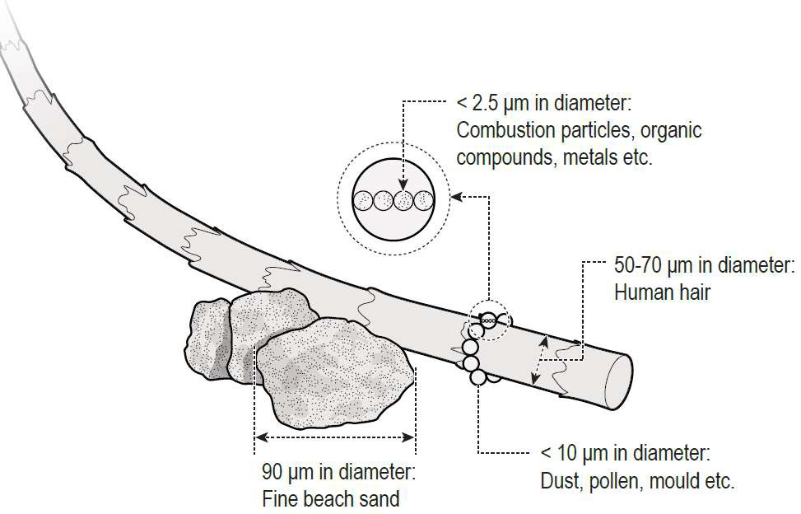

**Figure 1: Dust particle sizes (original image from Mining and Quarrying Occupational Health and Safety Committee).**

In its solid form, such as the slab of engineered stone supplied to a workplace for fabrication or a slab of concrete, products that contain crystalline silica are unlikely to present the respirable hazardous properties as silica dust.

The dust that is generated from crystalline silica material, such as when cutting crystalline silica material using a power tool or other mechanical process, has the potential to cause harm when it is breathed in[2].

Processes such as cutting, which under the WHS Regulation includes grinding, trimming, drilling, sanding, crushing and polishing, may be used to create a specific product to be supplied for installation. For example, creating a kitchen benchtop to size and cutting holes for positioning a sink and tap or cutting tiles to fit into place or to accommodate services.

Once the fabricated product is installed, further mechanical processes may be required, for example, minor cutting to enable a custom fit, or for maintenance purposes. These further mechanical processes are also likely to generate airborne crystalline silica (respirable dust).

For the purposes of this Code, mechanical processes are not considered to be the operation of tools or devices or processes that:

1. rely exclusively on manual power for operation; and
2. are designed to be primarily supported by hand.

For example, this might include the use of hand trowels to help smooth concrete surfaces for finishing, hand held tools to score fibre cement products, or the use of a brick jointer in masonry construction.

Construction work that involves activities such as digging trenches or tunneling, could involve materials containing crystalline silica. This is because common materials found in the ground may contain crystalline silica, and can be found in:

* most rocks, sands, and clays
* granite; and
* sandstone.

If the task involves high-energy earthmoving processes, such as rock ripping, it will likely result in a risk of exposure to respirable crystalline silica and controls to manage those risks must be in place.

If a PCBU is unsure if the earth involved in the task or project includes material(s) containing 1 per cent or more crystalline silica, they could get a geotechnical report, petrographic test, or bulk material analysis to confirm the materials present in the earth that will be moved, processed or disturbed.

Any testing should be representative of the material that will be disturbed by the task – including whether the material will be disturbed by driving or transport.

If a PCBU is unable to find out whether the earth involved in the task or project includes material(s) containing 1 per cent or more crystalline silica, the PCBU should go ahead with the presumption that it does.

Workers fabricating, processing, installing, maintaining or removing crystalline silica material without appropriate control measures in place may be exposed to high levels of silica dust (for example through dust clouds).

Workers can also be exposed to silica dust from poor housekeeping methods that disturb accumulated dust, including dry sweeping, using compressed air or high-pressure water cleaners and general-purpose vacuum cleaners not designed for use with hazardous dusts.

* 1. Health effects of airborne crystalline silica (silica dust)

Silica dust poses a significant health hazard to workers. Very small particles of silica dust cannot be seen under normal lighting or with the naked eye and can stay airborne for long periods of time. When airborne, workers can easily inhale the small silica dust particles deep into their lungs where it can lead to a range of respiratory diseases, including:

* silicosis
* progressive massive fibrosis
* chronic obstructive pulmonary disease
* chronic bronchitis; and
* lung cancer.

Silica dust also increases the risk of developing chronic kidney disease, autoimmune disorders (such as scleroderma and systemic lupus erythematosus) and other adverse health effects, including an increased risk of activating latent tuberculosis, eye irritation and eye damage.

### SILICOSIS

Silicosis is a serious, irreversible lung disease that causes permanent disability and can be fatal. Silica dust can be inhaled deep into the lungs and, when silica dust comes into prolonged contact with the lung tissue, it causes inflammation and scarring and reduces the lungs’ ability to take in oxygen. Silicosis may continue to progress even after a worker is removed from exposure to silica dust. As the disease progresses, a worker may experience shortness of breath, a severe cough or general weakness. There are three types of silicosis (Table 2).

**Table 2. Types of silicosis.**

|  |  |  |
| --- | --- | --- |
| **Silicosis type** | **Exposure type** | **Respiratory impact of exposure** |
| Acute | Can develop after short-term and very high levels of silica dust (for example less than one year, and after a few weeks). | Causes severe inflammation and protein in the lung. |
| Accelerated | Results from short term exposure to large amounts of silica dust (1 to 10 years of exposure). | Causes inflammation, and protein and scarring in the lung (fibrotic nodules). |
| Chronic | Results from long term exposure (over 10 years of exposure) to low levels of silica dust. | Causes scarring of the lung and shortness of breath. |

Damage to the lungs from silica dust and symptoms of disease may not appear for many years. Workers may not show any symptoms, even at the point of initial diagnosis, which is why prevention and health monitoring are critical. Health monitoring requirements for workers who work with crystalline silica material are detailed in Part 3.4 of this Code.

There is no cure for silicosis. However, all silica dust-related diseases are preventable through using effective controls throughout the lifecycle of the product to eliminate or minimise exposure to silica dust at the workplace.

Activities that release silica dust into the air include:

1. excavation, earth moving and drilling plant operations
2. clay and stone processing machine operations
3. cutting and laying pavers and surfacing
4. mining, quarrying and mineral ore treating processes
5. road construction and tunnelling
6. construction, building and demolition
7. brick, concrete or stone cutting
8. abrasive blasting (blasting agent must not contain greater than 1 per cent of crystalline silica)
9. foundry casting
10. angle grinding, jack hammering and chiseling of concrete or masonry
11. hydraulic fracturing of gas and oil wells
12. pottery
13. crushing, loading, hauling and dumping of rock, or muck from tunnelling; and
14. clean-up activities such as sweeping or pressurised air blowing of dust.

When identifying activities that might lead to a risk of exposure to silica dust PCBUs should consider the right controls to prevent or minimise the release of silica dust into the air.

Risks of exposure to silica dust are increased when performing an activity that involves the generation of dust.

However, workers in nearby work areas, or in areas where dust generation activities are being or have recently been undertaken are also at risk of exposure to silica dust. This can include workers carrying out tasks such as supervision, maintenance, cleaning, general labouring and associated trades such as electrical work.

The most effective way to prevent workers from exposure to silica dust is to implement the right combination of controls to prevent or minimise the release of silica dust into the air.

The aim of using controls must be to:

* ensure nobody in the workplace is exposed to a level of respirable crystalline silica higher than the workplace exposure standard; and
* remove or reduce the risk of silica dust generation so far as is reasonably practicable.

**EXAMPLES OF WORK WITH POTENTIALLY HARMFUL EXPOSURES TO SILICA DUST**

|  |
| --- |
| **Fabricating, installing, maintaining and removing silica containing products**  Silica dust can be made when crushing, cutting, grinding, trimming, polishing, removing or blasting silica containing products or from storing or disposing of dusty waste from these processes.  **Mining, quarrying, tunnelling and extractive minerals**  Exposure to silica dust is a known issue, with high risks of worker exposure during rock crushing and tunnelling activities  **Construction, building and demolition**  Silica dust can be formed on site from brick, stone and concrete cutting using power tools.  **Other tasks** like dry sweeping or using compressed air can disturb settled dust containing respirable crystalline silica and make it airborne. |

* 1. Who has health and safety duties in relation to working with crystalline silica material?

Duty holders with a role in managing the risks of silica dust when working with materials containing crystalline silica include:

* persons conducting businesses or undertakings (PCBUs)
* officers
* designers, manufacturers, importers, suppliers
* workers; and
* other persons in the workplace.

A person can have more than one duty and more than one person can have the same duty at the same time. Each PCBU in the supply or contractual chain must ensure, so far as is reasonably practicable, the health and safety of all workers that they engage, cause to engage, influence or direct; and must consult all workers that carry out work for them on health and safety issues.

Safe Work Australia provides additional information for PCBUs who are working as part of a contractual chain – [WHS duties in a contractual chain: Factsheet](https://www.safeworkaustralia.gov.au/doc/whs-duties-contractual-chain-factsheet). This provides guidance on duties under the WHS laws and examples of how contractual relationships fit within the WHS framework. This information may assist duty holders understand how individual contractors, including principal contractors, and self-employed persons may have the same duty at the same time or may be both a PCBU and a worker.

### PERSON CONDUCTING A BUSINESS OR UNDERTAKING (PCBU)

**WHS Act, section 19**

Primary duty of care

When working with crystalline silica material a PCBU must eliminate risks arising from exposure to silica dust or, if that is not reasonably practicable, minimise the risks so far as is reasonably practicable to workers and other persons at their workplace.

The WHS Regulation includes specific requirements for a PCBU when implementing a combination of control measures to manage the risks associated with silica dust including:

* ensuring workers are trained about a course in crystalline silica awareness[3]
* ensuring workers do not dry cut engineered stone
* ensuring workers do not undertake uncontrolled dry cutting of other crystalline silica material; and
* monitoring airborne contaminant levels and undertaking health monitoring[4] (see Part 3 of this Code).

Respirable crystalline silica is classified as a hazardous substance according to the Globally Harmonized System of Classification and Labelling of Chemicals (GHS) and has a workplace exposure standard.

More information about the classification of respirable crystalline silica can be found in the [Hazardous Chemicals Information System (HCIS](https://www.bing.com/ck/a?!&&p=2b07e37eda7d7d4cJmltdHM9MTY3NzcxNTIwMCZpZ3VpZD0zODA4ZmJmYS1mYzFmLTY3MmMtMDc0Mi1mNDQ2ZmQ5NjY2ZWUmaW5zaWQ9NTE3Ng&ptn=3&hsh=3&fclid=3808fbfa-fc1f-672c-0742-f446fd9666ee&psq=Hazardous+Chemicals+Information+System+(HCIS&u=a1aHR0cDovL2hjaXMuc2FmZXdvcmthdXN0cmFsaWEuZ292LmF1Lw&ntb=1)).

**FURTHER DUTIES OF PERSONS CONDUCTING BUSINESSES OR UNDERTAKINGS**

**WHS Act, section 20**

Duty of persons conducting businesses or undertakings involving management or control

The person with management or control of a workplace must ensure, so far as is reasonably practicable, that the workplace, the means of entering and exiting the workplace and anything arising from the workplace are without risks to the health and safety of any person.

For example, the person with management or control of the workplace must take reasonable steps to ensure that information about how much silica is present in a product is shared with other persons entering the workplace, such as through a visible safety data sheet and that the controls for the risks of exposure are also available.

The person with management or control of fixtures, fittings or plant at a workplace, must ensure, so far as is reasonably practicable, that the fixtures, fittings and plant are without risks to the health and safety of any person.

**WHS Act, section 21**

Duty of persons conducting businesses or undertakings involving management or control of fixtures, fittings or plant at workplaces

For example, silica dust is abrasive and can damage equipment, including equipment used for controls. It is important to have and maintain a maintenance schedule in place to keep equipment in good working order.

### PCBU DUTIES – WHAT IS REASONABLY PRACTICABLE?

**WHS Act, section 18**

The factors to be considered in determining what is reasonably practicable in relation to a PCBUs duty to ensure the health and safety of persons.

The standard of ‘reasonably practicable’ in health and safety duties applies to a PCBU. Other duty holders are required to meet different standards, for example officers must exercise ‘due diligence’ and workers and others at a workplace must take ‘reasonable care’.

‘Reasonably practicable’, in relation to a duty to ensure health and safety, means that which is, or was at a particular time, reasonably able to be done to ensure health and safety, taking into account and weighing up all relevant matters including:

* the likelihood of the hazard or the risk concerned occurring
* the degree of harm that might result from the hazard or the risk
* the availability and suitability of ways to eliminate or minimise the risk
* what the person concerned knows, or ought reasonably to know, about the hazard or risk, and about the ways of eliminating or minimising the risk; and
* after assessing the extent of the risk and the available ways of eliminating or minimising the risk, the cost associated with available ways of eliminating or minimising the risk, including whether the cost is grossly disproportionate to the risk.

The question of what is reasonably practicable is determined objectively (that is, by what a reasonable person in the position of the PCBU would do in the circumstances) - not by reference to a PCBU’s capacity to pay or other individual circumstances. A PCBU cannot expose people to a lower level of protection simply because it is in a lesser financial position than another PCBU facing the same hazard or risk in similar circumstances.

In the ACT, specific requirements are in place for the control of exposure risks to silica dust. These are set out in the WHS Regulation. Additional information relevant to determining what is reasonably practicable specific to controlling the risk of silica dust is outlined in Part 3 of this Code.

For further information see [the Interpretive Guideline: The meaning of ‘reasonably practicable’.](https://www.bing.com/ck/a?!&&p=ebb92aebd18a8da5JmltdHM9MTY3NzcxNTIwMCZpZ3VpZD0zODA4ZmJmYS1mYzFmLTY3MmMtMDc0Mi1mNDQ2ZmQ5NjY2ZWUmaW5zaWQ9NTE3OA&ptn=3&hsh=3&fclid=3808fbfa-fc1f-672c-0742-f446fd9666ee&psq=the+Interpretive+Guideline%3a+The+meaning+of+%e2%80%98reasonably+practicable%e2%80%99.&u=a1aHR0cHM6Ly93d3cuc2FmZXdvcmthdXN0cmFsaWEuZ292LmF1L2RvYy9pbnRlcnByZXRpdmUtZ3VpZGVsaW5lLW1vZGVsLXdvcmstaGVhbHRoLWFuZC1zYWZldHktYWN0LW1lYW5pbmctcmVhc29uYWJseS1wcmFjdGljYWJsZQ&ntb=1)

### OFFICERS

**WHS Act, section 27**

Duty of officers

Officers, for example company directors, have a duty to exercise due diligence to ensure the PCBU complies with the WHS Act and WHS Regulation. This includes taking reasonable steps to ensure that the PCBU has and uses appropriate resources and processes to eliminate or minimise risks that arise from working with materials or products containing crystalline silica; namely exposure to silica dust. More information on who is an officer and their duties is in the [Interpretive Guideline: *The health and safety duty of an officer under section 27*.](https://www.bing.com/ck/a?!&&p=d86b699f013410cbJmltdHM9MTY3NzcxNTIwMCZpZ3VpZD0zODA4ZmJmYS1mYzFmLTY3MmMtMDc0Mi1mNDQ2ZmQ5NjY2ZWUmaW5zaWQ9NTIwMw&ptn=3&hsh=3&fclid=3808fbfa-fc1f-672c-0742-f446fd9666ee&psq=Interpretive+Guideline%3a+The+health+and+safety+duty+of+an+officer+under+section+27.&u=a1aHR0cHM6Ly93d3cuc2FmZXdvcmthdXN0cmFsaWEuZ292LmF1L3N5c3RlbS9maWxlcy9kb2N1bWVudHMvMTgxMi9vZmZpY2VyLWR1dHktaW50ZXJwcmV0aXZlLWd1aWRlLmRvY3g&ntb=1)

### PRINCIPAL CONTRACTORS

**WHS Regulation, part 6.4**

Duties of principal contractors

Projects involving construction work that costs $250,000 or more are classified as ‘construction projects’ under the WHS Act. Each construction project has a ‘principal contractor’. A principal contractor is also a PCBU. The principal contractor for a construction project is:

* the PCBU that commissions a construction project
* if the PCBU that commissions the project engages another PCBU to be the principal contractor and authorises that second PCBU to have management or control of the workplace and to discharge the duties of the principal contractor, the second PCBU; or
* if the owner of residential premises is an individual who directly or indirectly engaged a PCBU to undertake a construction project in relation to the premises, the PCBU so engaged if the PCBU has management or control of the workplace.

A construction project only has one principal contractor at any specific time.

In addition to the primary duties imposed on a principal contractor as a PCBU, the principal contractor has duties relating to WHS management plans, ensuring general compliance, and managing specific risks.

In a contractual chain there may be multiple PCBUs who share the same WHS duties. PCBUs, including the principal contractor, must each discharge their duty to the extent to which they have the capacity to influence and control the matter. The PCBU with the most influence and control over a matter will be in the best position to manage the associated risk. The Safe Work Australia [WHS duties in a contractual chain Factsheet](https://www.safeworkaustralia.gov.au/doc/whs-duties-contractual-chain-factsheet) provides further guidance about shared WHS duties.

**DESIGNERS, MANUFACTURERS, IMPORTERS AND SUPPLIERS OF PLANT, SUBSTANCES OR STRUCTURES**

**WHS Act, Part 2, Division 2.3**

Further duties of persons conducting businesses or undertakings

**WHS Act, section 22**

Duties of persons conducting businesses or undertakings that design plant, substances or structures

**WHS Act, section 23**

Duties of persons conducting businesses or undertakings that manufacture plant, substances or structures

**WHS Act, section 24**

Duties of persons conducting businesses or undertakings that import plant, substances or structures

**WHS Act, section 25**

Duties of persons conducting businesses or undertakings that supply plant, substances or structures

Designers, manufacturers, importers and suppliers of materials or products that contain crystalline silica used at the workplace must ensure, so far as is reasonably practicable, the material they design, manufacture, import or supply is without risks to health and safety.

This is because in these early phases of the product lifecycle there is greater scope to:

* minimise risks through design
  + for example, reduce the amount of crystalline silica in the product and therefore reduce the risk of exposure to silica dust; and
* incorporate risk control measures that are compatible with the original design concept and functional requirements of the product
  + for example, manufacturing a made-to-size product that can be installed with little to no need for cutting or grinding.

Providing information to downstream duty holders (such as PCBUs who fabricate or install crystalline silica material) is a key factor in assisting them to meet their duty to manage health and safety risks. Information should be passed on from the designer and/or manufacturer to the importer, supplier and ultimately the end user.

Designers, manufacturers, importers and suppliers must ensure, so far as is reasonably practicable, that material containing crystalline silica they design and manufacture, is without risks to the health and safety of persons at the workplace or within the vicinity of the workplace. Manufactures must provide adequate information about construction materials/elements to make sure that they can be used safely.

This should include information on whether the construction material/element contains 1per cent or more crystalline silica (crystalline silica material). If the material/element does contain 1per cent or more crystalline silica, manufacturers should also make sure the following information is included:

* information on the hazardous properties of respirable crystalline silica
* information on the health risk of respirable crystalline silica
* information on how to manage these risks in the workplace when undertaking activities with the construction material/element, including:
  + - * a statement that users should consider any relevant Codes of Practice for working with respirable crystalline silica to manage the risks.

Designers, manufacturers, importers and suppliers must carry out, or arrange the carrying out of, any calculations, analysis, testing or examination that may be necessary to meet their duties. This includes where manufacturers are unsure whether the material/element contains 1 per cent or more crystalline silica.

Designers, manufacturers, importers and suppliers must give adequate information to downstream users of:

* the intended purpose of the product
* the results of any calculations, analysis, testing or examination in relation to the product, including any hazardous properties
  + - * for example, the amount of crystalline silica contained in the product, expressed as a percentage
* any conditions necessary to ensure the product is without risks to health and safety when used correctly for its intended purpose
  + - * for example, appropriate controls for fabrication, installation, maintenance or removal of the product.

This information can be provided in the form of a label, product information sheet or a safety data sheet (SDS).

Importers and suppliers can obtain information about the material they are importing or supplying from the designer or manufacturer.

Designers, manufacturers, importers and suppliers do not have a duty to provide this information as a SDS for solid products that contain crystalline silica, such as engineered stone. However, SDS are an effective way to communicate information downstream about the risks when working with material containing crystalline silica. It is considered good practice to make them available.

If requested, designers, manufacturers, importers and suppliers must, so far as is reasonably practicable, give relevant information to users, and provide any amendments or updates to this information.

More information about safety data sheets can be found on the Safe Work Australia [website,](https://www.safeworkaustralia.gov.au/safety-topic/hazards/chemicals/safety-data-sheets/preparing-safety-data-sheets) [Schedule 6 of the WHS Regulation](https://www.legislation.act.gov.au/View/sl/2011-36/current/html/2011-36.html), or in the [Safety Data Sheet Code of Practice](https://www.legislation.act.gov.au/View/ni/2022-686/current/html/2022-686.html).

### WORKERS

##### WHS Act, section 28

Duties of workers

As defined in the WHS Act, workers include employees, contractors and subcontractors and their employees, labour hire workers, outworkers, apprentices, trainees, work experience students and volunteers. Workers have a duty to take reasonable care for their own health and safety and they must take reasonable care that their acts or omissions do not adversely affect the health and safety of other persons. Workers must:

* comply with reasonable instructions including training, as far as they are reasonably able; and
* cooperate with reasonable health and safety policies that have been notified to workers, including health monitoring, if they have been told about it beforehand.

### OTHER PERSONS IN THE WORKPLACE

##### WHS Act, section 29

Duties of other persons at the workplace

Other persons at the workplace, like visitors, must take reasonable care for their own health and safety and must take care not to adversely affect other people’s health and safety. They must comply, so far as they are reasonably able, with reasonable instructions given by the PCBU to allow that person to comply with the WHS Act. For example, if a crystalline silica material is being installed at a customer’s home by a PCBU, that home becomes a workplace. The homeowner and other people who enter the home while it is a workplace are other persons for the purposes of the WHS Act.

* 1. Other relevant duties

### CONSULTATION

##### WHS Act, section 47

Duty to consult workers

**WHS Act, section 48**

Nature of consultation

A PCBU must consult, so far as is reasonably practicable, with workers who carry out work for the business or undertaking and the HSR (if any), who are (or are likely to be) directly affected by a work health and safety matter. This includes consulting about the PCBUs risk management process such as identifying risks and choosing appropriate controls.

Worker input and participation improves decision-making about health and safety matters and assists in reducing work-related injuries and disease.

Workers are entitled to be represented in consultations by a HSR who has been elected to represent their work group.

Workers who work with crystalline silica material, workers who may be exposed to silica dust, and the HSR (if any) must be consulted on health and safety matters, including, but not limited to:

* identifying the tasks and processes that may result in exposure to silica dust
* developing a risk control plan including a Safe Work Method Statement if applicable to the work activity
* making changes to processes or procedures that generate silica dust
* making changes to controls to protect workers from silica dust
* proposing changes that may affect worker health and safety
  + - * for example, positioning of work spaces, non-fabrication areas and ventilation systems
* monitoring the health of workers exposed to silica dust, including the engagement of a medical practitioner to carry out health monitoring
* monitoring the conditions at the workplace
* resolving health and safety issues; and
* providing information and training for workers.

When discussing health and safety matters with workers, workers must be provided with reasonable opportunity to express views before any decisions are made.

### CONSULTING, COOPERATING AND COORDINATING ACTIVITIES WITH OTHER DUTY HOLDERS

##### WHS Act, section 46

Duty to consult with other duty holders

A PCBU must consult, cooperate and coordinate activities with all other persons who have a work health or safety duty in relation to the same matter, so far as is reasonably practicable.

Where there is more than one PCBU involved in work being carried out at the same location, each duty holder should exchange information to find out who is doing what task and work together in a cooperative and coordinated way, so risks are eliminated or minimised so far as is reasonably practicable.

An example of when multiple duty holders may need to consult, cooperate and coordinate is during installation of an engineered stone kitchen bench top in a home. During the installation, multiple PCBUs may carry out activities on the same site, such as electricians, plumbers, or cabinetmakers. They each have a duty to protect the health and safety of workers and other persons at the workplace and must therefore consult, cooperate and coordinate activities to ensure each person is made aware of what the others are doing, to identify the hazards and risks and decide who is best placed to take action to control the risks.

Duty holders’ work activities may overlap and interact at times. When they share a duty, for example a duty in relation to the health and safety of the same worker or workers, or are involved in the same work, they will be required to consult, cooperate and coordinate activities with each other so far as is reasonably practicable.

See the [Code of Practice: *Work health and safety consultation, cooperation and coordination* for guidance on consultation](https://www.legislation.act.gov.au/ni/2022-355/).

### PROVIDING INFORMATION, TRAINING, INSTRUCTION AND SUPERVISION

##### WHS Act, section 19

Primary duty of care

**WHS Regulation, section 39**

Provision of information, training and instruction

**WHS Regulation, section 418D**

Mandatory silica awareness training

The WHS Act requires that a PCBU ensures, so far as is reasonably practicable, the provision of any information, training, instruction and supervision that is necessary to protect all persons from risks to their health and safety arising from work with crystalline silica material that is carried out as part of the conduct of the business or undertaking.

A PCBU must ensure that information, training and instruction provided to a worker are suitable and adequate and have regard to:

* the nature of the work carried out by the worker
* the nature of the risks associated with the work at the time the information, training and instruction is provided; and
* the control measures implemented.

A PCBU must also ensure, so far as is reasonably practicable, that information, training and instruction are provided in a way that is readily understandable by any person to whom it is provided. A PCBU should consider any special requirements of the workers, for example, information, training and instruction may need to be provided in a language other than English. Other considerations include the specific skills or experience, disability, literacy or age of the worker.

Workers must be trained and have the appropriate skills to carry out tasks safely. Training should be provided to workers by a competent person. A competent person is a person who has acquired through training, qualification or experience the knowledge and skills to carry out the task.

A PCBU should obtain any information related to the health hazards of crystalline silica material and any instructions on safe work practices available from the suppliers of the materials or products for use in instruction and training activities.

Training should be practical, and where relevant, include hands-on sessions, for example:

* correctly setting up local exhaust ventilation (LEV), or
* demonstrating to workers how to safely use tools, such as angle grinders, when working with crystalline silica material.

Information, training and instruction provided to workers who carry out work crystalline silica material including engineered stone must include the proper use, wearing, storage and maintenance of personal protective equipment (PPE), and should also include information about, but not limited to:

* the risk management process
* when working with crystalline silica material, the information provided by the manufacturer or supplier about the type of product being used in the workplace
* the hazards and risks associated with exposure to silica dust
* the work practices and procedures that must be followed when working with crystalline silica material
* the control measures implemented, including information on the correct use and maintenance of the controls, working off-site, waste collection and disposal
* emergency procedures, including any special decontamination procedures
* first aid and incident reporting procedures in case of injury or illness
* the purpose and results of air monitoring; and
* any health monitoring that may be required.

A PCBU should review training regularly, particularly if there has been a change to the way in which work is performed, or a request is made by the HSR. For example:

* when there is a change to work processes, plant or equipment
* when there is an incident; and
* if new control measures are implemented.

In the ACT, a PCBU must ensure that a worker engaged by the person who the person reasonably believes will carry out high risk crystalline silica work is trained in crystalline silica awareness.

High risk crystalline silica work means work carried out in a workplace in relation to a crystalline silica process that is reasonably likely to result in a risk to the health of a person at the workplace.

This includes workers who may be exposed to risks of silica dust intermittently, such as when loading dry components that may contain crystalline silica for mixing or combining with water in containers or plant (such as concrete mixer trucks).

It is also mandatory for workers in prescribed occupations to complete mandatory silica dust awareness training.[5]

PCBUs must ensure their workers have completed a mandatory silica dust awareness training course that is declared by the Minister.

For more information about the declared occupations and training course see the ACT Legislation [Register](https://www.legislation.act.gov.au/ni/2022-355/) to access the relevant instruments.

Examples of the types of occupations required to undertake mandatory training in addition to any site or job-specific training may include:

* bricklayer
* builder’s labourer
* glazier or glass and stone processing machine operator
* concreter
* floor finisher
* handyperson
* home improvement installer
* landscape architect
* stonemason; and
* wall and floor tiler[6].

* 1. Safe Work Method Statements (SWMS)

##### WHS Regulation, Chapter 6, Part 6.3, Division 6.3.2

High-risk construction work – safe work method statements

### HIGH RISK CONSTRUCTION WORK

‘Construction work’ is defined in the WHS Regulation as any work carried out in connection with the construction, alteration, conversion, fitting-out, commissioning, renovation, repair, maintenance, refurbishment, demolition, decommissioning or dismantling of a structure.

A structure means anything that is constructed, whether fixed or moveable, temporary or permanent, and includes any component or part of a structure.

Section 291 of the WHS Regulation sets out a list of construction work that is high risk for the purposes of the Regulations, and for which a safe work method statement (SWMS) is required.

For the purposes of managing exposure risks of respirable crystalline silica, the WHS Regulation sets out that high risk construction work includes work that:

* is carried out in an area that may have a contaminated or flammable atmosphere; or
* involves the cutting (noting the expanded definition of cutting for the purposes of crystalline silica material) of crystalline silica material using a power tool or another mechanical process.

This means that in the ACT a SWMS must be prepared prior to carrying out work that involves the cutting of crystalline silica material using a power tool or another mechanical process is high risk construction work.

This includes work undertaken during fabrication, installation, maintenance and removal of crystalline silica material and recognises that these activities have a high likelihood of releasing or generating respirable silica dust into the air, resulting in an airborne contaminant to which a SWMS requirement applies.

For example, work that involves dry material or products that contain crystalline silica may pose a risk to exposure of airborne contaminates – as such, these activities may also require the preparation of a SWMS.

A SWMS must be prepared before carrying out work that includes a risk of exposure to silica dust. If a SWMS has been prepared because the work area has a risk of a contaminated atmosphere from silica dust and the work being carried out that creates the contaminated atmosphere involves the mechanical cutting of crystalline silica material, only one SWMS needs to be prepared for the work. However, you may need to another SWMS if the work is not covered.

A SWMS is required because it enables a PCBU clearly communicate to all workers and other duty holders at the workplace any health and safety risks and how they will be managed. A SWMS required for all work that involves the cutting of crystalline silica material using a power tool or another mechanical process.

### WHO IS RESPONSIBLE FOR PREPARING A SWMS?

A PCBU must prepare a SWMS, or ensure a SWMS has been prepared, before carrying out work that includes a risk of exposure to silica dust.

The person responsible for carrying out the activity, such as on-site installation of crystalline silica material or high-risk construction work is often best placed to prepare the SWMS.

Workers and their health and safety representatives must be consulted when preparing SWMS. If there are no workers engaged at the planning stage, consultation must occur with workers when the SWMS is first made available to workers – such as during workplace- specific training or a toolbox talk.

If more than one PCBU has the duty to ensure a SWMS is or has been prepared, they must consult and cooperate with each other to coordinate who will be responsible for preparing it.

There may be situations when different types of high-risk construction work occur at the same time at the same workplace. In this situation, one SWMS may be prepared to cover any high-risk construction work activities being carried out at the workplace.

Alternatively, a separate SWMS can be prepared for each type of high-risk construction work. If separate SWMS are prepared, consider how the different types of work activities may impact on each other and whether this may lead to inconsistencies between control measures.

If the work is being carried out is in connection with a construction project, the SWMS must consider the WHS management plan prepared by the principal contractor of the construction project.

A PCBU must provide the principal contractor with a copy of the SWMS before high-risk construction work starts. If not made available, the principal contractor would need to take reasonable steps to obtain a copy of the SWMS before construction work commences.

More information on multiple and shared duties can be found in the [Code of Practice: Construction work.](https://www.legislation.act.gov.au/ni/2018-733/)

### WHAT SHOULD A SWMS INCLUDE?

The content of a SWMS should provide clear direction on the control measures to be implemented. There should be no statements that require a decision to be made by supervisors or workers. For example, the statement ‘use appropriate PPE’ does not detail the specific types of PPE that should be used. The control measures should be clearly specified.

The SWMS must be accessible and understandable to any individual who needs to use it. It is important that those who need to carry out work in accordance with the SWMS understand the detail of the SWMS and what they are required to do to implement and maintain risk controls. For example, it should consider the literacy needs and the cultural or linguistically diverse backgrounds of the workers.

A SWMS must include the following information:

* identify the high-risk construction work activities to be carried out on-site
* the hazards and risks to health and safety arising from these activities
* the measures to be implemented to control the risks; and
* how the control measures are to be implemented, monitored and reviewed.

For the purposes of crystalline silica material, a SWMS will include specific provisions for control measures for silica dust – this can be known as a silica dust control plan, or the component of the SWMS that is specific to silica dust control.

This will help a PCBU identify all potential tasks that may result in exposure, or possible exposure, to silica dust and the control measures to eliminate or minimise that exposure.

The specific provisions relating to crystalline silica material should consider ways to:

* eliminate or minimise the amount of silica dust being generated and released into the air
* prevent silica dust being breathed in by workers
* clean up any silica dust, slurry or other waste produced; and
* decontaminate workers’ clothing, footwear and protective equipment. A silica dust component of a SWMS should include details on:
* the percentage of crystalline silica in the product being used, as the higher the percentage the higher the level of silica in the dust and the greater the risk
* all sources of silica dust in the workplace
* the dust control measures implemented for each activity
* how dust control measures are integrated into daily shift routines, for example, tool box talks, pre-start checks and daily cleaning of work areas
* how air monitoring is used to assess whether the controls are working
* the systems in place to routinely inspect, maintain and monitor controls and equipment to ensure they are clean and functioning effectively
* ongoing monitoring and review strategies, particularly in response to incidents, control failure or where the workplace exposure standard is exceeded; and
* how risks, controls and any control failures, and where the workplace exposure standard is exceeded, are communicated and reported.

An example of the inclusions for silica dust control plan that may form part of a SWMS is provided at Attachment B. WorkSafe ACT provides additional information about [how to develop a SWMS](https://www.worksafe.act.gov.au/health-and-safety-portal/managing-safety/safe-work-method-statements).

**Note**: PCBUs that carry out work involving the cutting of crystalline silica material with a power tool, or another mechanical process have specific requirements that apply under chapter 7A of the WHS Regulation. These include crystalline silica control measures that must be included in a SWMS according to the type of crystalline silica material used, the work activity and process, and the effectiveness of the control measure used where it is not reasonably practicable to eliminate the risk.

### COMPLYING WITH A SWMS

##### WHS Regulation, section 300

Compliance with safe work method statement

If high risk construction work is not carried out in accordance with the SWMS for the work, the PCBU must ensure that the work is:

* stopped immediately or as soon as it is safe to do so; and
* resumed only in accordance with the statement.

More information about a SWMS for high-risk construction work and a SWMS template can be found in the [Code of Practice: *Construction work*](https://www.legislation.act.gov.au/ni/2018-733/).

1. Specific duties for working with crystalline silica material

* 1. Choosing controls when mechanically cutting crystalline silica material

##### WHS Regulation, chapter 7A

##### Prohibits the:

##### Dry-cutting of engineered stone using a power tool or another mechanical process

##### Uncontrolled dry-cutting of crystalline silica material, other than engineered stone, when using a power tool or another mechanical process.

In the ACT, there are specific requirements for working with crystalline silica material including when working with engineered stone. These specific requirements operate concurrently with a range of WHS duties provided by the WHS laws, including:

* a PCBU’s general duty to manage risks to health and safety so far as reasonably practicable utilising the hierarchy of controls where it is not reasonably practicable to eliminate risks (section 36 WHS Regulation)
* ensuring that no person at the workplace is exposure to crystalline silica that exceeds the workplace exposure standard; and
* the provision of personal protective equipment to workers as part of the hierarchy of control measures.

It is important to remember that in the ACT the use of a power tool or other mechanical process when using crystalline silica material includes processes that may mechanically alter the crystalline silica material beyond cutting, including: crushing, drilling, grinding, polishing, sanding and trimming.

### CRYSTALLINE SILICA CONTROL MEASURES

The [WHS Regulation](https://www.legislation.act.gov.au/View/sl/2011-36/current/html/2011-36.html) defines crystalline silica control measure in relation to the cutting of engineered stone or other crystalline silica material as:

* a water delivery system supplying a continuous feed of water over the cutting area is used to suppress airborne crystalline silica produced by the cutting
* a wet dust suppression method
* the attachment of a Class H vacuum to the tool used for cutting
* for other crystalline silica material containing less than 25 per cent crystalline silica—the attachment of a Class M vacuum to the tool used for cutting
* the use of a local exhaust ventilation system; and
* the isolation of the place where the cutting occurs from other workers.

The WHS Regulation sets out the circumstances where crystalline silica control measures are to be implemented, with the primary purpose to ensure the health and safety of workplaces.

### SPECIFIC CONTROLS – ENGINEERED STONE

A PCBU must ensure that the risks of exposure to silica dust are effectively controlled and when using a power tool or other mechanical process to cut engineered stone is required to use:

* a continuous feed of water over the cutting area
* at least one other crystalline silica control measure; and
* suitable respiratory protective equipment.

### SPECIFIC CONTROLS – CRYSTALLINE SILICA MATERIAL (OTHER THAN ENGINEERED STONE)

A PCBU must ensure that the risks of exposure to silica dust are effectively controlled when using a power tool or other mechanical process to cut crystalline silica material. When using a power tool or other mechanical process to cut crystalline silica material other than engineered stone PCBUs are required to ensure:

* a continuous feed of water over the cutting area and at least one other crystalline silica control measure if it is reasonably practicable to do so
* **if that is not reasonably practicable**, a wet dust suppression method and at least one other crystalline silica control measure
* **if that is not reasonably practicable**, an approved vacuum attached to the tool and at least one other crystalline silica control measure
* **if that is not reasonably practicable**, a wet dust suppression method or an approved vacuum attached to the tool or a fully enclosed operator cabin fitted with a high efficiency air filtration system; and
* **if that is not reasonably practicable**, at least one crystalline silica control measure and suitable respiratory protective equipment.

There may be certain crystalline silica material or processes where it is not reasonably practicable to use a continuous feed of water over the cutting area when cutting. In these cases, PCBUs are required to work through the controls set out in chapter 7A of the WHS Regulation (included above) to determine through a documented and evidence-based process what combination of controls are reasonably practicable for the work and the most effective in managing the risks of exposure to silica dust.

Depending on the workplace and nature of the work activities, a PCBU may need to implement more than the minimum controls required in chapter 7A of the WHS Regulation to manage the risks of exposure to silica dust –including the hierarchy of controls. The diagram below provides a quick reference guide to assist PCBUs understand the control measures that must be used for crystalline silica materials other than engineered stone.

For more information about these control measures refer to chapter 3 in this Code.

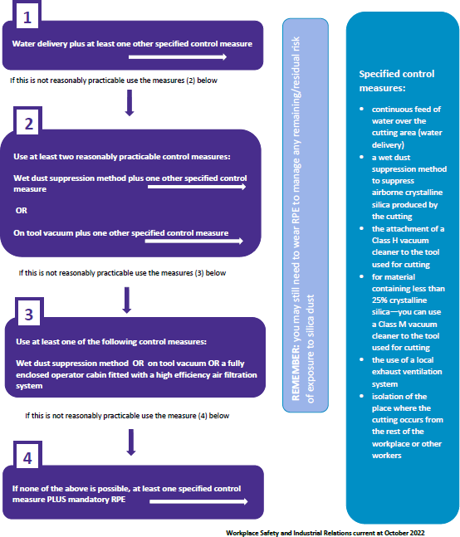

* 1. Workplace exposure standard for respirable crystalline silica

##### WHS Regulation, section 49

Ensuring exposure standards for substances and mixtures not exceeded

A workplace exposure standard is a legal requirement for workplaces to limit how much people can be exposed to dangerous materials, like respirable crystalline silica.

An exposure standard represents the airborne concentration of a particular substance or mixture that must not be exceeded. It does not represent a line between a ‘safe’ and ‘unsafe’ concentration of an airborne substance or mixture. The exposure standard does not eliminate risk of disease and some people might experience adverse health effects below the exposure standard.

A PCBU at a workplace must ensure that no person at the workplace is exposed to a substance or mixture in an airborne concentration that exceeds the exposure standard for the substance or mixture. The duty to ensure the workplace exposure standard is not exceeded is absolute and not qualified by ‘so far as is reasonably practicable’.

This means that a PCBU must ensure that no person at the workplace is exposed to a hazardous chemical, such as respirable crystalline silica, at a concentration above the workplace exposure standard. There are three substances classified as respirable crystalline silica by the workplace exposure standard for airborne contaminants: Cristobalite, Quartz and Tridymite.

The workplace exposure standard for respirable crystalline silica is an eight-hour time weighted average (TWA) of 0.05 milligrams per cubic metre (mg/m3).

**Note:** when selecting control measures to comply with other health and safety duties PCBUs should consider the health based exposure standard for respirable crystalline silica of 0.02 mg/m3 over an eight-hour time weighted average[7] as this is recognised to be the level at which a risk to workers’ health is present.

### ADJUSTMENT OF EXPOSURE STANDARDS FOR EXTENDED WORK SHIFTS

A TWA is based on exposure that happens over an eight-hour working day followed by 16 hours of no exposure, over a five day working week.

To comply with the WHS Regulation, it may be necessary to adjust the TWA to compensate for greater exposure during longer work shifts and decreased time between shifts. Situations where the TWA may need to be adjusted include where workers have:

* a working day longer than eight hours
  + for example, a worker’s daily hours are 7 am to 5 pm with a one-hour lunch break Monday to Friday
* a working week longer than 40 hours
  + for example, a worker’s weekly hours are 8 am to 3 pm Monday and Tuesday and 7 am to 6 pm Wednesday to Thursday with a one hour lunch break, or
* work shift rotations in excess of either eight hours a day or 40 hours a week.

A competent person, such as a certified occupational hygienist, should be engaged to adjust the workplace exposure standard to account for shift variations or longer working weeks.

The workplace exposure standard must not be adjusted upwards, even for shifts less than eight hours.

More information can be found in the [*Guidance on interpretation of Workplace exposure standards for airborne contaminants*](https://www.safeworkaustralia.gov.au/system/files/documents/1705/guidance-interpretation-workplace-exposure-standards-airborne-contaminants-v2.pdf).

* 1. Air monitoring

##### WHS Regulation, section 50

Monitoring airborne contaminant levels

Air monitoring involves testing the air to find out how much of a harmful substance is in the air – it is a proactive measure to determine how effective controls are and if a worker is adequately protected.

A PCBU must ensure that air monitoring is carried out to determine the airborne concentration of silica dust in a worker’s breathing zone, if necessary, to determine:

* whether there is a risk to a worker’s health, or
* if the PCBU is not certain whether silica dust levels exceed the workplace exposure standard.

Air monitoring can also be used to:

* check the effectiveness of control measures, including any new control measures
* inform workers of their pattern of exposure
* determine the right level of respiratory protection; and
* inform health monitoring requirements.

Air monitoring does not prevent disease and is not an alternative to implementing effective control measures.

A PCBU should ensure air monitoring is conducted by an independent, competent person. For example, a certified occupational hygienist or a person with recognised equivalent competency under an international certification scheme.

Air monitoring to determine a worker’s exposure involves measuring the level of contaminants, such as silica dust, in the breathing zone of workers using a personal sampler during their usual shift activities, including routine breaks. Figure 2 shows an approximation of a worker’s breathing zone.

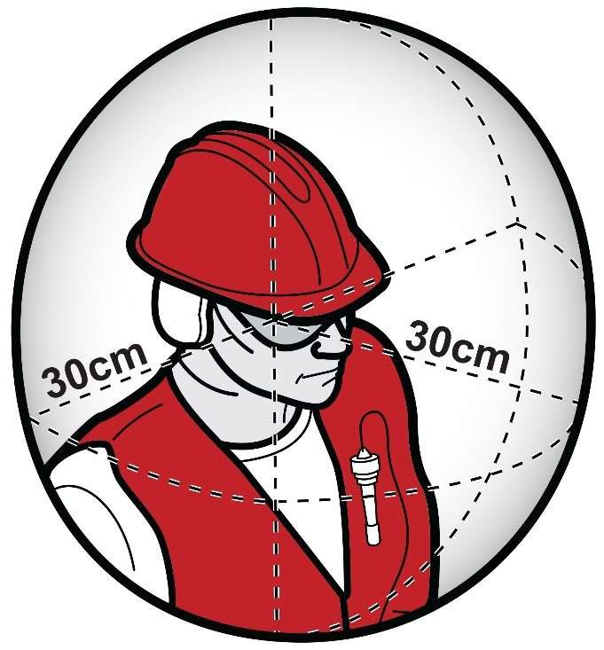

**Figure 2: Worker’s breathing zone.**

### WHEN AIR MONITORING IS REQUIRED

A PCBU must ensure that air monitoring is carried out to determine the airborne concentration of a substance or mixture at the workplace to which an exposure standard applies if:

1. the person is not certain on reasonable grounds whether or not the airborne concentration of the substance or mixture at the workplace exceeds the relevant exposure standard, or
2. monitoring is necessary to determine whether there is a risk to health.

When commencing work with crystalline silica material, a PCBU should undertake baseline air monitoring to ensure that silica dust levels do not exceed the workplace exposure standard and that any risks to workers’ health are minimised as far as is reasonably practicable. Air monitoring should be repeated to ensure the air monitoring results are accurate and representative of the work being undertaken.

After a baseline is established, air monitoring should be undertaken:

* at least every 12 months, or
* in response to a trigger event.

Examples of triggers for undertaking additional air monitoring include:

* changes to work practices (for example, new equipment being commissioned), production, processes (for example, redesign of a work process), procedures or control measures or work environment which may reasonably be expected to result in new or additional exposure risks
* a health monitoring report indicating an adverse result in circumstances where the baseline or previous monitoring reports for that worker did not indicate any abnormality
* a HSR requests a review of control measures; or
* the results of worker consultation indicate monitoring is required
  + - * for example, when a worker or their representative’s concern is confirmed, or
      * lowering of the workplace exposure standard where previous air monitoring results indicate levels above the new workplace exposure standard.

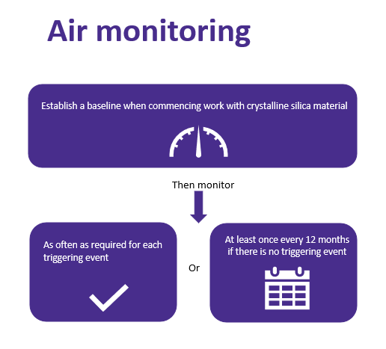

AIR MONITORING FREQUENCY

There are certain roles that are likely to have a high exposure to silica dust. These include (but are not limited to):

* shapers
* saw operators
* finishers
* machine operators
* polishers; and
* labourers/supervisors.

Air monitoring should also be considered for other tasks and occupations, as research shows that workers in the vicinity of dust generation, including those who may work in administrative areas, have a risk of exposure and health effects.

A PCBU is required to conduct air monitoring for silica dust if they are not certain on reasonable grounds if the exposure standard has been exceeded. There are a number of ways that a PCBU can be certain on reasonable grounds including:

1. by using all specified (if applicable) and recommended controls as outlined in this Code, including higher order controls such as ensuring that a water delivery system supplying a continuous feed of water is used to at the site of dust generation, in addition to at least one other control **and** the use of Respiratory Protective Equipment (RPE) (if required); and
2. where statistically valid exposure data demonstrates the higher order controls that are in place are minimising workers’ exposure to respirable crystalline silica below the relevant workplace exposure standard.

**Statistically valid exposure data does not remove the requirement for a PCBU to conduct air monitoring in response to any of the triggers outlined above, or at least once every 12 months.**

### AIR MONITORING REPORT

An air monitoring report is prepared by a competent person, such as a certified occupational hygienist or a person with recognised equivalent competency under an international certification scheme (such as a certified industrial hygienist) and should include:

* the background and purpose of the air monitoring including the current workplace exposure standard for silica dust
* the task to be measured including work patterns and hazards involved with this task
* the control measures in place and their performance
* what sampling and measurements were taken (long and short-term) including information on the calibration of the sampling equipment
* specifics of how sampling was taken
* how and where the samples were analysed including information on the calibration of the analysis equipment
* details of the persons, or similarly exposed groups sampled
* any similar exposure groups that may potentially be exposed but were not sampled
* an interpretation of the results including:
  + - sources of exposure
    - adequacy of current control measures
    - an assessment of risk including identification of tasks not measured that are likely to be an exposure source and any workers that could be exposed but were not measured; and
    - compliance with WHS laws
* recommendations, for example:
  + - a dust control action plan
    - changing control measures and work practices
    - increased worker training
    - health monitoring; and
    - further air monitoring.

The air monitoring report must be made available to a WHS inspector on request and to a registered medical practitioner carrying out or supervising health monitoring.

Additionally, a PCBU must ensure that the results of air monitoring carried out are:

* recorded in writing or electronically
* kept for 30 years after the date the record is made; and
* readily accessible to workers who may be exposed to silica dust and their representatives.

### STATISTICALLY VALID EXPOSURE DATA

The information in this section provides guidance to PCBUs on how air monitoring could be conducted for the purposes of obtaining statistically valid exposure data. Following these guidelines will help PCBUs determine the exposure data is statistically valid.

Statistically valid exposure data can be used to demonstrates that the higher order controls that are in place are minimising workers’ exposure to respirable crystalline silica below the workplace exposure standard.

**Note**: This section references technical information related to air monitoring for silica dust for information purposes only and should be given to the person who will be undertaking the air monitoring at your workplace – the data must be related to your workplace.

Air monitoring for respirable crystalline silica should include:

* Establishment of similar exposure groups (SEGs) and the development of a personal exposure sampling plan (in accordance with EN689:2018 Workplace Exposure - Measurement Of Exposure By Inhalation To Chemical Agents - Strategy For Testing Compliance With Occupational Exposure Limit Values or another statistically valid method outlined in the AIOH Occupational Hygiene Monitoring & Compliance Strategies) that is representative of worker numbers, shifts worked, tasks performed and conditions at the workplace.
* Undertaking baseline personal exposure monitoring (sampling) of workers in each relevant SEG (identified in the respirable dust sampling plan) and assessing the results using either the Preliminary or Statistical test methods described in EN689:2018 to determine if the WES is being exceeded.
* Undertaking periodic personal exposure monitoring (sampling) as per 1 & 2 (above), at the recommended intervals in Annex I of EN689:2018, to ensure workers ongoing exposure to RCS continues to remain below the WES.
* All personal sampling should be undertaken in accordance with AS2985:2009 Workplace atmospheres - Method for sampling and gravimetric determination of respirable dust, with samples analysed by a NATA (or equivalent) accredited laboratory using validated analysis methods, such as FTIR or XRD.

The [Australian Institute of Occupational Hygienists](https://www.aioh.org.au/) and the [EU Standard](https://uk-air.defra.gov.uk/networks/monitoring-methods?view=eu-standards) framework for air monitoring provides additional guidance about air monitoring.

### Static air monitoring

Static or fixed position monitoring may be undertaken at workplaces, such as fabrication workshops, to determine background levels of respirable crystalline silica outside of a worker’s breathing zone.

Static monitoring involves taking samples of air from fixed locations outside the area where the engineered stone is being processed.

Static monitoring can help in determining the design of risk controls or the effectiveness of existing risk controls, however it should not be used as an indicator of actual worker exposure to respirable crystalline silica.

* 1. Health monitoring

##### WHS Regulation, Chapter 7, Part 7.1, Division 7.1.6

Health Monitoring

Health monitoring is the monitoring of a person’s health to identify changes in their health status as a result of exposure to certain substances. Health monitoring is important for workers who work with materials containing crystalline silica because exposure poses a significant risk to their health.

Health monitoring for workers exposed to crystalline silica material primarily involves screening the changes in a worker’s body that may indicate the development of silica related-injury, illness or disease. Health monitoring is necessary to:

* detect the early signs of adverse health effects
* help identify control measures that are not working effectively; and
* assist in protecting workers from the risk of exposure to silica dust.

More information about what ‘significant risk’ means can be found in the [Health monitoring for persons conducting a business or undertaking guide.](https://view.officeapps.live.com/op/view.aspx?src=https%3A%2F%2Fwww.safeworkaustralia.gov.au%2Fsites%2Fdefault%2Ffiles%2F2020-10%2FHealth%2520Monitoring%2520Guidance%2520-%2520PCBUs%2520-%2520Final.docx&wdOrigin=BROWSELINK)

### WHEN TO PROVIDE HEALTH MONITORING

The WHS Regulation provide that a PCBU must organise and pay for health monitoring where there is a significant risk to the health of their workers because the worker is carrying out ongoing work at a workplace and exposed to hazardous chemicals because of that work. Crystalline silica is an identified hazardous chemical for the purposes of health monitoring and poses a significant risk to the health of workers.

A significant risk to the health will exist for any worker who is regularly or repeatedly present in a workplace where work with material or product containing crystalline silica is performed that produces silica dust. As such, a PCBU must provide and pay for health monitoring for all workers involved in work with crystalline silica material.

Examples of workers that the PCBU should provide health monitoring for include:

* shapers
* machine operators including saw operators
* finishers
* polishers; and
* labourers and supervisors involved in the fabrication or installation of crystalline silica material.

In addition to when a PCBU must provide and pay for health monitoring, a PCBU should also consider providing health monitoring to other workers who might be exposed to silica dust. This includes workers who are exposed to dust while cleaning work areas or equipment, maintenance workers, salespeople, or those who perform administrative work in the vicinity of work involving crystalline silica material. The health based recommended standard for respirable crystalline silica is 0.02 mg/m3 over an eight-hour time weighted average[8]. Unless a PCBU undertakes consistent and regular air monitoring to ensure that the health based recommended standard for respirable crystalline silica is not exceed for all workers it is likely that there is a significant risk to health.

A PCBU should provide health monitoring before a worker starts work to establish a baseline from which changes can be detected (unless the worker has participated in health monitoring within the previous two years and the results of the tests are available). From the initial health monitoring date, a worker’s health should then be monitored at least annually.

At the end of a worker’s time working with material containing crystalline silica, for example, before retirement or before the worker’s duties change permanently, a final medical examination should be carried out by the registered medical practitioner carrying out or supervising the health monitoring.

If two or more PCBUs have a duty to provide health monitoring for a worker, they should consult with each other to ensure that arrangements are made to commission the health monitoring and agree on the costs of the health monitoring.

**Note**: As workers may work for multiple PCBUs it is important to consider when they last participated in workplace health monitoring and consult with a registered medical practitioner with experience in health monitoring to avoid them being exposed to excessive radiation.

### PARTICIPATION IN HEALTH MONITORING

Some workers may be reluctant to participate in health monitoring. This may be due to anxiety about the testing and medical results or the impact the results may have on their job, or both.

Under the WHS Regulation, a PCBU has a duty to provide health monitoring to workers where they conduct ongoing work at a workplace generating silica dust and there is a significant risk to their health because of exposure to that dust. If a worker refuses to participate in health monitoring, a PCBU should first try the steps outlined below. If the worker still refuses health monitoring, a PCBU may take action to meet their duties under the WHS laws by removing the worker from the task or role that involves exposure to silica dust.

When considering the removal of a worker from the task or role, the PCBU should seek appropriate advice to ensure any action taken is consistent with other workplace laws.

A PCBU should encourage workers to participate and provide them with information and training on the purpose of health monitoring. Early detection of health effects can lead to an early diagnosis or treatment and prevent more serious and life-threatening conditions from developing.

Supporting a worker in these circumstances can be achieved by:

* ensuring they know how health monitoring will benefit them
* making the process easy for them to follow
* providing interpreters for workers where English is not their first language; and
* reminding them that their workplace, family and community want them to be as safe and healthy as possible.

Conversations with workers about their individual health monitoring should be held privately to maintain confidentiality.

A PCBU must also consult with their HSRs about health monitoring. They may also assist in this process and encourage workers to participate in health monitoring.

### PROVIDING A HEALTH MONITORING PROGRAM

When providing health monitoring, a PCBU must:

* give information to workers prior to the commencement of work and to prospective workers about health monitoring requirements
  + - * ensuring that this information is understandable by the worker, for example, consider literacy needs and cultural or linguistically diverse backgrounds
* ensure health monitoring is carried out by or under the supervision of a registered medical practitioner with experience in health monitoring
* consult workers about the selection of the registered medical practitioner
* pay all expenses relating to health monitoring including time to attend appointments, tests and appointment fees
* provide information about a worker to the registered medical practitioner as specified in the WHS Regulation
* take all reasonable steps to obtain a report from the registered medical practitioner as soon as practicable after health monitoring has been carried out
* provide a copy of the report to the worker and to all other PCBUs who have a duty to provide health monitoring for that worker, for example, where labour hire is used
* provide the WHS regulator with a copy of the report if it contains adverse test results or recommendations that remedial measures should be taken
* keep reports as confidential records for at least 30 years after the record is made; and
* not disclose the report to anyone without the worker’s written consent unless required or permitted by law, for example, WHS laws.

### REQUIREMENTS FOR HEALTH MONITORING

Under WHS laws, the minimum requirements for health monitoring for crystalline silica through exposure to silica dust are:

* collection of demographic, medical and occupational history
* records of personal exposure
* standardised respiratory questionnaire
* standardised respiratory function tests, for example, FEV1 (forced expiratory volume in one second), FVC (forced vital capacity) and FEV1/FVC (respiratory ratio, or Tiffeneau index); and
* chest X-Ray full posterior-anterior (PA) view.

All full-size PA chest X-rays should be taken in a specialist radiology practice or hospital department. The X-rays should be read by a radiologist who meets the reporting requirements and competencies of the Royal Australian and New Zealand College of Radiologists or is qualified as a ‘B reader’. A B reader is a radiologist who has undertaken specialised training to detect dust linked lung diseases such as silicosis, coal workers pneumoconiosis, mixed dust pneumoconiosis and progressive massive fibrosis (PMF).

High-resolution computed tomography (HRCT) is more sensitive and effective than X-rays in the early detection of silicosis. A low dose HRCT scan of the chest (non-contrast) may be used by the registered medical practitioner supervising or carrying out the health monitoring, depending on the worker’s history and levels of silica exposure. Given the high risks posed by working with engineered stone, low dose HRCT may be used instead of, or as an adjunct to, X-ray. Alternative imaging methods are being developed and may also be considered.

More information on health monitoring workers for exposure to crystalline silica can be found in the [Health monitoring guide – crystalline silica](https://www.safeworkaustralia.gov.au/sites/default/files/2021-09/health-monitoring-guidance-crystalline-silica.pdf/).

A registered medical practitioner with experience in health monitoring must undertake or supervise the health monitoring. [The Royal Australasian College of Physicians](https://www.racp.edu.au/) website has a list of suitable practitioners. However, a PCBU may decide other doctors may have the necessary experience required to carry out or supervise health monitoring for their workers. A PCBU must consult their workers when selecting a registered medical practitioner and their preference should be considered if they request a particular doctor.

The following information must be supplied by the PCBU to the registered medical practitioner carrying out or supervising the health monitoring:

* the name and address of the PCBU
* the name and date of birth of the worker
* a description of any of the worker’s tasks that relate to exposure to silica dust; and
* if the worker has started that work, how long the worker has been carrying out that work.

A PCBU should also provide the registered medical practitioner with any available air monitoring reports and risk assessments to assist them with carrying out health monitoring.

### HEALTH MONITORING REPORT

A PCBU must take all reasonable steps to obtain a health monitoring report from the registered medical practitioner who carried out or supervised the health monitoring. The health monitoring report should only contain information relating to the health monitoring that was commissioned by the PCBU.

The health monitoring report must include:

* the name and date of birth of the worker
* the name and registration number of the registered medical practitioner
* the name and address of the PCBU who commissioned the health monitoring
* the date of the health monitoring
* any test results that indicate whether the worker has been exposed to silica dust
* any advice that test results indicate that the worker may have contracted an injury, illness or disease as a result of carrying out the work with materials or products containing crystalline silica
* any recommendation that the PCBU takes remedial measures, including whether the worker can continue to carry out the work with materials or products containing crystalline silica; and
* whether medical counselling is required for the worker.

After a PCBU has received the health monitoring report from the registered medical practitioner, they should act on the results, recommendations and advice contained in it.

After receiving the report, a PCBU must provide copies as soon as practicable to:

* the worker, even if they have left employment at the workplace
* all other PCBUs who have a duty to provide health monitoring for the worker
  + - * for example, where labour hire is used; and
* the WHS regulator, if the report contains:
  + - * any advice that test results indicate the worker may have contracted an injury, illness or disease as a result of carrying out the work using, handling, generating or storing material containing crystalline silica, or
      * any recommendation that a PCBU takes remedial measures, including whether the worker can continue to carry out the work with engineered stone.

Workers should provide their personal general practitioner (GP) with a copy of the health monitoring report and retain a personal copy along with any exposure history, particularly when the worker moves to other employment. This will assist a registered medical practitioner carrying out or supervising any further health monitoring to compare any previous results with new test and examination results.

The health monitoring report must not be disclosed to any person without the worker’s written consent, unless disclosure is required under the WHS laws.

The control measures at the workplace must be reviewed and revised (if necessary) if the report indicates that a worker is experiencing adverse health effects or signs of illness as a result of exposure to silica dust.

A PCBU must ensure that health monitoring reports for a worker are:

* kept as a confidential record
* identified as a record for that worker; and
* retained for at least 30 years after the record is made.

Treatment programs for adverse health effects should only be discussed between the worker and the registered medical practitioner and should not be included in the health monitoring report that is provided to the PCBU. If the health monitoring report includes health information other than what is required to fulfil the duties, or for which consent has not been given by the worker, the PCBU should return the report to the registered medical practitioner, informing them of the error.

More information about health monitoring reports can be found in the Health monitoring for PCBUs guide.

1. How to manage and control the risks from working with crystalline silica material

Risks arising from working with crystalline silica material must be eliminated or minimised so far as is reasonably practicable to protect workers and other persons against harm.

##### WHS Act

Management of risks

Risk management is a proactive, systematic process that helps a PCBU plan and respond to potential hazards and their associated risks in the workplace. It involves four steps:

* identifying the hazard
* assessing the risk
* controlling the risk; and
* reviewing control measures.  
  1. Identifying the hazard

A hazard is a situation or thing that has the potential to harm a person. A duty holder, in managing risks to health and safety, must:

* + - eliminate risks to health and safety so far as is reasonably practicable; and
    - if it is not reasonably practical to eliminate risks to health and safety – minimise those risks so far as is reasonably practicable.

For crystalline silica material, the hazard is the silica dust generated through work processes and activities including the construction and manufacturing of construction elements.

To identify the likely sources of silica dust, it is important for a PCBU to consider the following aspects of the workplace and their interactions:

* the design and manufacture of the material including the percentage of crystalline silica
* the physical work environment
  + - * for example, the layout of a workshop
* the equipment, materials and substances used
  + - * for example, using power tools or another mechanical process to cut crystalline silica material
* the work tasks and how they are performed
  + - * for example, grinding engineered stone or other material or products containing crystalline silica which generates silica dust
* work design and management
  + - * for example, a lack of consideration of the product supply chain and lifecycle when designing good work practices and product risk management; and
* worker experience, knowledge and behaviours.

This may be achieved by:

* conducting a walk-through assessment of the workplace
* observing the work and talking to workers and/or HSRs about how work is carried out
* inspecting the plant and equipment that is used as part of the fabrication and other relevant processes
  + - * for example, hand-held tools may generate more silica dust than automated machinery
* undertaking air monitoring at the workplace
* inspecting workplace surfaces for build-up of settled dust; and
* reading product labels, safety data sheets and manufacturer’s instruction manuals.  
  1. Assessing the risks

A risk assessment involves considering what could happen if a worker is exposed to a hazard and the likelihood of it happening.

Hazards have the potential to cause different types and severities of harm, ranging from minor discomfort to a serious injury, illness, disease or death. Exposure to silica dust can adversely affect a worker’s health, including developing silicosis, progressive massive fibrosis, chronic obstructive pulmonary disease, chronic bronchitis and lung cancer.

Assessing the risks will help to:

* identify which workers are at risk of exposure to silica dust
* determine what sources and processes are causing that risk
* identify what kind of control measures should be implemented to control the risk
* check the effectiveness of existing control measures to control the risk
* determine the severity of the risk; and
* determine how urgently action may need to be taken.

The nature and severity of risks will depend on various factors, including the:

* percentage of crystalline silica in the material
  + - * for example, concrete on average has 30 per cent crystalline silica and bricks typically have between 5 and 15 per cent crystalline silica content
* task(s) being undertaken
  + - * for example, angle grinding can generate more silica dust than other tasks
* equipment being used
  + - * for example, hand-held tools may generate more silica dust closer to the worker’s breathing zone than automated machinery
* conditions under which the work with material containing crystalline silica is carried out
  + - * for example, work undertaken in an isolation booth or in an open plan workshop; and
* skills, competence and experience of the worker.

The potential of exposure of administrative workers to silica dust at fabrication workplaces should also be considered. These workers may be exposed if:

* adequate controls are not implemented, and subsequent background levels of silica dust are high, or
* their roles mean they frequently access processing areas
  + - * for example, administrative workers that frequently walk through or perform tasks in areas near where the processing of material containing crystalline silica is undertaken may be exposed to high levels of silica dust.

A PCBU should review the information on the product labels, and any available safety data sheets, to assist in determining the type and severity of the harm. The following questions may help a PCBU to assess the risk:

* How much silica is in the products at the workplace?
* How often, and for how long, might a worker be exposed to silica dust?
* What are the scenarios that may cause workers to be exposed to silica dust?
  + - * for example, are they exposed to silica dust when it is freshly generated or during housekeeping tasks after dust has accumulated?
* Is there evidence of exposure to silica dust?
  + - * for example, are dust clouds evident near workers when material containing crystalline silica is cut?
* What are the conditions under which the work is carried out?
  + - * for example, is work on material containing crystalline silica carried out in an enclosed space that is isolated from workers?
* What are the skills, level of competence and experience of workers?  
  1. Controlling the risks

### HIERARCHY OF CONTROL MEASURES

##### WHS Regulation, section 36

Hierarchy of control measures

The WHS Regulation specify *crystalline silica control measures* that must be used when cutting crystalline silica material.

However, PCBUs must also consider the hierarchy of controls to eliminate risks arising from any exposure to silica dust. Where it is not reasonably practicable to eliminate risks arising from exposure to silica dust PCBUs must minimise the risks so far as is reasonably practicable to workers and other persons at their workplace.

To meet this duty, a PCBU must apply the hierarchy of control measures (Figure 3). Some controls are more effective than others and can be ranked from the highest level of protection and reliability, to the lowest. Effectiveness of controls can be increased by using a combination approach as outlined in this code and in applying the hierarchy of control measures.

Further information about the required combination of control measures when working with crystalline silica material is in Part 4.4 Use a Combination of Control Measures

The hierarchy ranks control measures from the highest level of protection and reliability to the lowest.

Dry cutting when using a power tool or another mechanical process, which includes trimming, drilling, sanding, crushing, grinding or polishing materials containing crystalline silica without effective controls generates high levels of silica dust. It is highly likely that the workplace exposure standard for respirable crystalline silica would be exceeded when carrying out these activities if no controls are in place to manage the risks of respirable crystalline silica exposure. For this reason, PCBUs must not allow workers to undertake uncontrolled dry cutting or processing of crystalline silica materials.

**Dry-cutting prohibition:** A PCBU must not direct or allow workers to undertake:

* dry cutting of engineered stone – this will expose workers and others to levels of silica dust that pose a significant risk to health; and
* uncontrolled dry cutting of crystalline silica material, other than engineered stone.

Effective control measures must be used when cutting, crushing, drilling, grinding, sanding or trimming engineered stone or other material containing crystalline silica using a power tool or mechanical process. For engineered stone, one of those control measures must be a water delivery system in addition to another specified crystalline silica control measure in chapter 7A of the WHS Regulation.

For other crystalline silica material, where it is not reasonably practicable to use a continuous feed of water PCBUs must use an alternative wet dust suppression method if it is reasonably practicable in combination with another specified crystalline silica control measure.

The most common form of wet dust suppression systems uses water spray technologies – such as ‘misting’ or fogging however, alternative products such as liquid polymers (such as wallpaper paste) may be considered on the basis that the suppression is achieved to the same standard as that would be achieved with the use of water.

Under the hierarchy of specified control measures when mechanically cutting crystalline silica material (other than engineered stone), if a wet dust suppression method is not reasonably practicable then other specified effective control measures may be used as set out in the hierarchy. Refer above to section 3.1 in this Code.

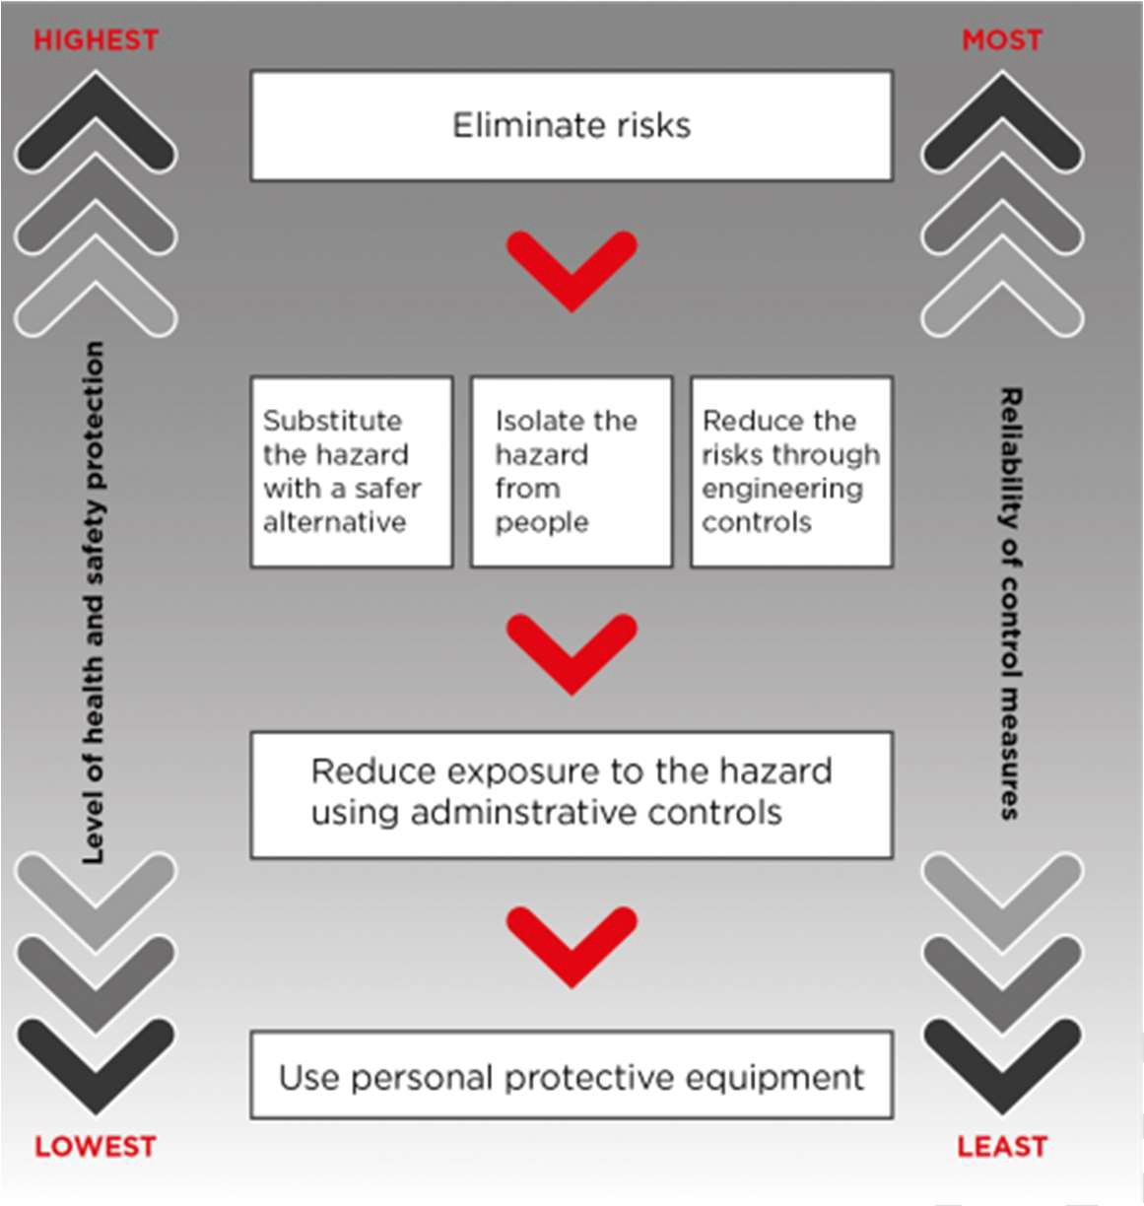

**Figure 3: The hierarchy of control measures.**

**Note:** It is also likely that when using a power tool or another mechanical process to cut materials that contain 1 per cent or more crystalline silica that there is a there is a risk to workers’ health from exposure to respirable crystalline silica and PCBUs should implement appropriate control measures when undertaking these activities.

In addition to ensuring effective control measures are used, a PCBU must ensure that each worker at the workplace who may still be exposed to airborne contaminants produced by the cutting of material containing crystalline silica is wearing suitable personal protective equipment – such as respiratory protective equipment.

### ELIMINATION

For the purposes of this Code, elimination means completely removing all risks of exposure to silica dust at the workplace.

A PCBU can:

* not use engineered stone or other crystalline silica material, or
* eliminate the need to cut, grind, trim, drill, sand or polish crystalline silica material during installation or work.

For example, silica dust will not be generated on-site if an engineered stone installation is completed without further cutting, grinding, trimming, drilling, sanding, crushing or polishing on-site.

For assessment purposes, engineered stone that has been completely fabricated in a workshop, with no additional cutting or fabrication required on-site, poses a minimal risk of exposure to silica dust. Similarly, the risk of exposure to silica dust is lessened where installation of fibre cement products, or cement composite products which contain crystalline silica, does not require any additional cutting, trimming, or drilling on site.

Similarly, where brickwork does not require any additional cutting, trimming or drilling on-site, the risk of exposure to silica dust is likely to be lessened.

Eliminate the need for cutting, grinding, trimming, drilling, sanding, crushing or polishing of crystalline silica material during installation by:

* accurately measuring – whether by templates, diagrams or infrared measuring devices, eliminating measuring errors will eliminate the need for alterations
* cutting sink, tap and stove top holes at the fabrication workshop – mark and cut the location and size of holes during the fabrication stage or obtain the sink to ensure it fits before installation
* returning solid materials to the fabrication workshop when alterations, other than minor modifications, are required; and
* consulting and communicating with principal contractors and clients to prevent alterations on-site.

If elimination is not reasonably practicable, a PCBU must consider the controls set out in the WHS Regulation in conjunction with the hierarchy of controls as set out below:

* **substitute** (wholly or partially) hazards with something safer, **isolate** hazards from people and/or use **engineering controls** to minimise any risks that have not been eliminated
* then, use **administrative controls** to minimise any remaining risks; and
* then, use **PPE** to minimise any risks that still remain.

The control measures a PCBU applies may change the way work is carried out. In these situations, a PCBU must consult the workers and, where applicable their HSR, to develop safe work procedures and provide the workers with training, instruction, information and supervision on the changes.

Further guidance on the risk management process and the hierarchy of control measures is in the [Code of Practice*: How to manage work health and safety risks*](https://www.legislation.act.gov.au/ni/2020-547/).

### SUBSTITUTION

Substitution is where a different product, material, chemical or work process is used that is less hazardous and therefore has a lower risk than the crystalline silica material that was previously used.

Substitution can be an effective way of managing the risk of silica dust. For example:

* engineered stone could be substituted with a product that contains a lower percentage of crystalline silica such as, wood or laminate
* fibre cement products can be scored and snapped using a score and snap knife rather than a power tool which may generate higher levels of dust.

Care should be taken to ensure any new materials that are substituted do not introduce new hazards such as other hazardous chemicals.

### ISOLATION

Isolation is a way to separate the workers from silica dust. It is an effective control measure that can also be used in combination with engineering controls (see below) to reduce the number of workers potentially exposed to silica dust.

Isolation as a crystalline silica control measures must be used in combination with at least one other crystalline silica control measure such as using a water delivery system supplying a continuous feed of water over the cutting area. Further information about the required combination of control measures is in Part 4.4 Use a Combination of Control Measures.

For example, installing barriers between workers and machines that produce silica dust, both for workers generating the dust and workers nearby, such as those in adjacent offices.

Isolation can be achieved through:

* isolating high dust generation work processes within an enclosed room with restricted access or an isolation booth (Figure 4)
* providing physical barriers between different workers and workstations to prevent dust or water mist from moving into other work areas or towards other workers
* distancing a work process from other workers
  + - * for example, consider exclusion zones where other workers are working when powered hand tools are used
* designating a room or area for other tasks such as changing or eating, away from the work area
* enclosing equipment that generates silica dust.

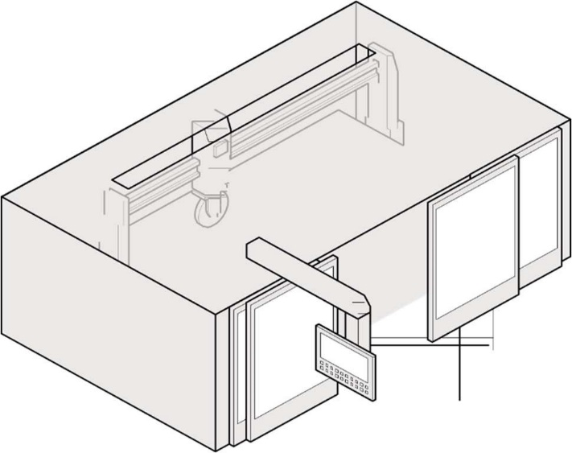

**Figure 4: An example of an isolation booth used for automated wet cutting.**

### Exclusion zones

There may be unique occasions when there is no alternative to use exclusion zones to protect workers and other persons in the area from exposure to respirable dust.

The size of the exclusion zone should be determined by a competent person after assessing the risk to all unprotected people. The prevailing conditions should be taken into account, for example, the exclusion zone may need to be extended down-wind.

Exclusion zones should be used in combination with engineering controls and respiratory protective equipment (RPE), especially indoors for high-dust generating tasks such as grinding.

An exclusion zone should be set up and maintained to exclude workers and other people who are not wearing RPE. Warning signs should be located so that they are clearly visible before entering the area.

Signs should warn that:

* there is a dust hazard present
* access to the area is restricted to authorised persons
* RPE should be worn in the exclusion zone, when advised by the Code or where a risk assessment has determined RPE should be worn.

Where an exclusion zone interferes with other activities at a workplace, other workers should only work within the exclusion zone after being provided with RPE.

**Example:** warning signs

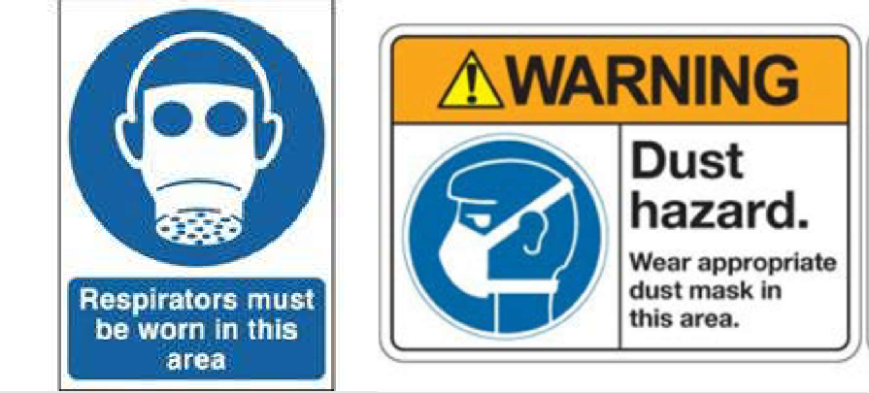

### ENGINEERING CONTROLS

Engineering controls use physical methods to change the characteristics of a task, including mechanical devices or processes that eliminate or minimise the generation of dust and minimise it becoming airborne. For example, a combination of engineering controls like LEV, on-tool extraction and water suppression may be required to minimise exposure from each dust generating process. Further information about the required combination of control measures when working with crystalline silica material is in Part 3.4 Use a Combination of Control Measures.

When considering and using engineering controls, be aware of other hazards that may be introduced. As many engineering controls are motorised, a PCBU should be aware of noise and vibration levels at their workplace and issue personal hearing protection as needed. Further information can be found in the [Managing noise and preventing hearing loss at work](https://www.legislation.act.gov.au/ni/2022-688/) Code of Practice.

The PCBU must ensure that all engineering controls are inspected and maintained according to the manufacturer’s instructions. Where an engineering control fails, and the incident results in the uncontrolled release of silica dust the regulator must be notified. The uncontrolled release of respirable crystalline silica is regarded as a dangerous incident to which incident notification requirements apply.

* 1. Use a Combination of Control Measures

The WHS Regulation sets out the required crystalline silica control measures when working with crystalline silica material including engineered stone. A combination of control measures must always be used to control the risk of silica dust when working with crystalline silica material. The greater number of higher order controls used at a workplace is likely to provide greater certainty for the control of silica dust. The WHS Regulation sets out the minimum requirements that PCBUs must implement.

For example, a PCBU could consider using a LEV system, shift rotation and RPE, in addition to water suppression. Where RPE is provided, it must be worn correctly for the full duration of the task to manage any residual dust.

A PCBU must not rely on one control measure such as PPE or water suppression alone as there may be a significant risk to their workers’ health and they will be breaching the WHS laws. It has been shown that solely relying on PPE or water suppression does not adequately protect workers from the risks of silica dust.

**Note**: Specific requirements apply when choosing a combination of control measures to PCBUs when cutting crystalline silica materials with a power tool or another mechanical process under chapter 7A of the WHS Regulation. Refer to section 3.1 above in this Code.

### WATER SUPPRESSION

Water suppression uses water at the point of dust generation to dampen down or suppress dust before it is released into the air. Powered hand tools and equipment fitted with water feeds are available, including grinders and polishers, and large machinery including bridge saws, routers or polishing machines.

The equipment or machinery used for water suppression must:

* have an appropriate ingress protection (IP) rating for use with water suppression
* have the water feed attached and an adequate number of water feeds directed at the material and/or tool to prevent dust being released during the process
* have a consistent water flow and adequate water pressure during operation (usually at least 0.5 L/min)
* be fitted with guards, plastic flaps or brush guards designed to manage the water spray or mist containing silica dust; and
* be maintained according to manufacturer’s instructions.

Water jet cutting is also a highly effective method for suppressing the generation of airborne silica dust.

**Note**: Only tools and machinery that have been designed for use with water attachments should be used with water suppression. Handheld spray bottles and sponges are inadequate at suppressing silica dust. They are also dangerous if used with power tools that are not designed for use with water. Garden hoses should not be used to separately apply water to power tools and is inadequate to suppress dust and dangerous if used with power tools that are not designed for use with water.

### WET DUST SUPPRESSION – MISTING and other systems

Wet dust suppression techniques and technologies – such as misting or fogging – may be used in certain circumstances where it is not possible or practicable to stop dust at the source, including using a water delivery systems supplying a continuous feed of water.

To effectively control silica dust, water or fine mist suppression needs to be supplied at the right levels for the full duration of time that the work is being done. This means supplying enough water throughout the tasks to prevent the generation of any visible airborne dust.

When considering or designing a water misting system PCBUs should consider:

1. the water droplet size range needs to match the airborne dust particle size; and

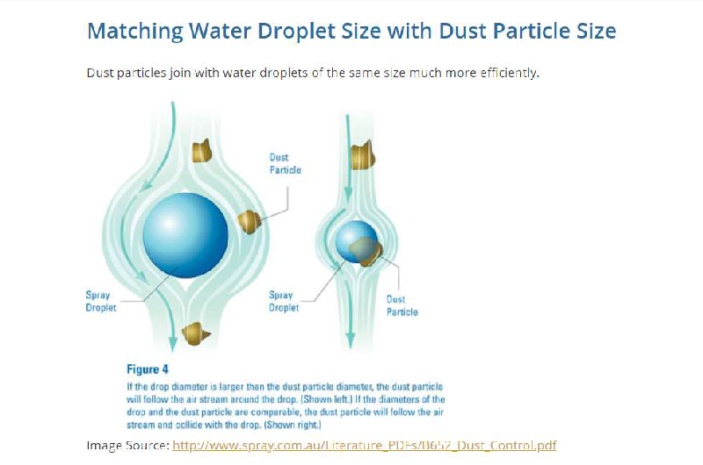

1. water additives should be used to ensure for hydrophobic (water repellent) dust is captured by the water.

Misting and fogging systems can be used:

* On a small scale – for use in enclosed spaces; or
* On a large scale – in open areas.

Large amounts of mist can be effective in suppressing large amounts of dust near the source of generation – in combination with other appropriate control methods such as isolation, LEV and RPE

Wetting crystalline silica material beforehand is not considered to be an adequate method for controlling the risk of respirable crystalline silica in most cases, as to be effective the material needs to constantly monitored for any signs of drying which may in turn allow the generation of dust.

Rock drills, piling rigs, concrete pulverises, crushing and screening plants and other similar heavy plants should have integrated water or wet dust suppression systems.

Integrated water suppression is more effective than using hand-held hoses to reduce exposure to silica dust. It is also important to remember that no single control method is 100 per cent effective on its own without the support of air monitoring data and other controls.

#### Additional hazards when using water suppression

While water suppressed machinery and tools provide an effective means of reducing exposure to silica dust, their use needs to be controlled to ensure other hazards are not created. Potential hazards arising from the use of water suppression are electrical hazards, water mist hazards and recycled water hazards.

#### Electrical hazards

A PCBU must eliminate electrical risks or, if that is not reasonably practicable, minimise the risks so far as is reasonably practicable. When working with water suppression machinery and tools, electrical hazards can be introduced. A PCBU should:

* only use tools and machinery that are specifically designed for use with water attachments
* consider the current electrical equipment’s IP rating if retrofitting or introducing water suppression into an existing process as a new control; and
* thoroughly check electrical equipment, including electrical cords, to ensure safety when undertaking wet cutting or other processing.

#### Slips, trips and falls

Introducing water into the workplace carries with it the risk of slips, trips and falls. The PCBU must implement control measures to protect workers from this risk, for example:

* using non-slip coatings on floors
* constructing water drainage systems around wet areas; and
* providing suitable on-slip footwear.

#### Water mist hazards

As a consequence of applying water to power tools with rotating blades, contaminated water mist can be generated.

This water mist can expose workers to silica dust by:

* breathing in contaminated water mist
* particle laden mist drying in the air and being breathed in; and
* particle laden mist depositing on surfaces, including clothing, and later drying, then becoming airborne again when disturbed.

#### Recycled water hazards

If recycled water is used for water suppression, this may introduce an additional risk for workers. Without an appropriate filtration system, there is a risk that the continual recycling of water will increase the concentration of silica dust in the water over time, and subsequently the level of silica dust in the mist generated from water suppressed activities.

More information on managing the risks of recycled water can be found in section 6.2 of this model Code.

### ADDITIONAL RISKS WHEN COMBINING WATER SUPPRESSION WITH OTHER CONTROLS

Silica dust carried in the air or in water mist generated from water suppression can be further controlled through isolation controls such as guards, enclosures and barriers. In addition to those controls, administrative controls and respiratory protective equipment (RPE) should also be used. These controls include:

* using guards, plastic flaps or brush guards around the rotating blade, tool or equipment to enclose the water spray
* providing distance between the work process and the worker
  + for example, operator positioning when using bridge saws or routers
* providing distance between workers using powered hand tools and other workers in the workplace; and
* providing physical barriers between different workers and workstations to prevent the water mist moving into other work areas or towards other workers, including office workers.

Routine maintenance and cleaning will help to ensure guards continue to work effectively.

When properly designed and used a combination of water suppression and local exhaust ventilation controls can be extremely effective at minimising airborne respirable crystalline silica.

### LOCAL EXHAUST VENTILATION (LEV)

LEV is designed to remove airborne contaminants from the air before they reach the breathing zone of workers. It is the most effective control for large quantities of silica dust when it is applied close to the source of generation. LEV can be used for both wet and dry activities.

For drills, routers, saws and other equipment, an appropriately designed LEV should be fitted. The manufacturer of on-tool extraction and LEV equipment can provide information about how the equipment captures dust to determine its suitability for a particular workplace.

A simple LEV system most commonly comprises of:

* an extraction hood to capture and remove contaminated air near the point of release
* ducting to connect to an air-cleaning system
* a fan to move the air through the system; and
* an exhaust stack outside the building to disperse the cleaned air.

While these controls may reduce background levels of silica dust, they are not as effective in reducing exposure to silica dust for workers performing high exposure tasks. When cutting crystalline silica material, other than engineered stone, water suppression must be used unless it is not reasonably practicable.

If there is too much distance between an extraction unit and the dust generation point, the capture strength or velocity of extraction at the point of dust generation is too low to adequately capture the silica dust generated.

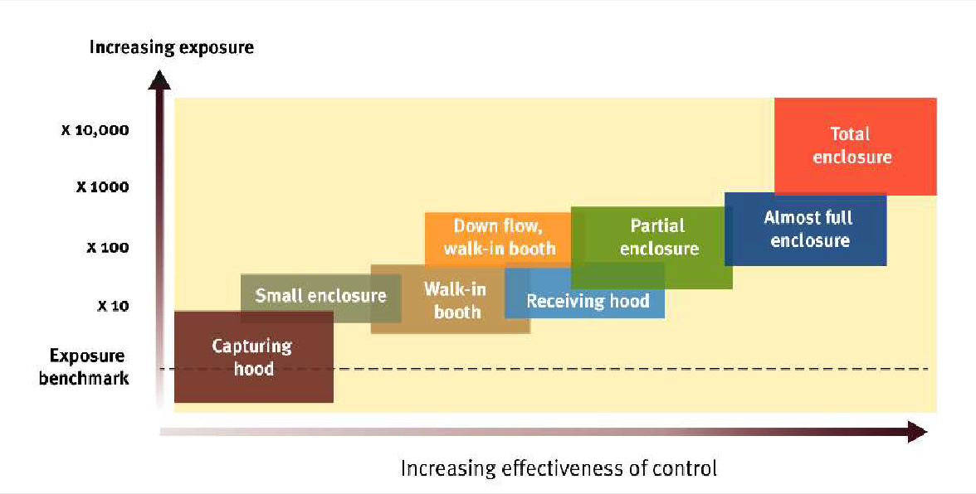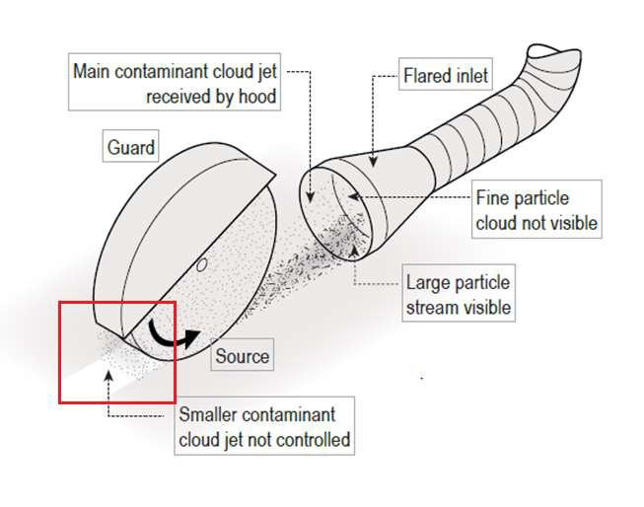

For extraction to be effective, the cutting point needs to be close to the extraction hood. The nature of the work may not allow this, or it may require the worker to constantly reposition the work piece or hood. For example, a stonemason cutting a sink hole into a stone benchtop is regularly moving and turning the tool, which generates dust in a range of directions and angles.

**Figure 5: Operational view of local exhaust ventilation.**

### ON-TOOL LEV

On-tool LEV systems can include a shroud, an on-tool hose attachment and a vacuum extraction system. The dust or mist is collected within the shroud and is then drawn into the hose attachment to the vacuum, where it is extracted, filtered and discharged. When correctly designed and used a LEV system can both capture and contain dust or mist generated from engineered stone (Figure 6).

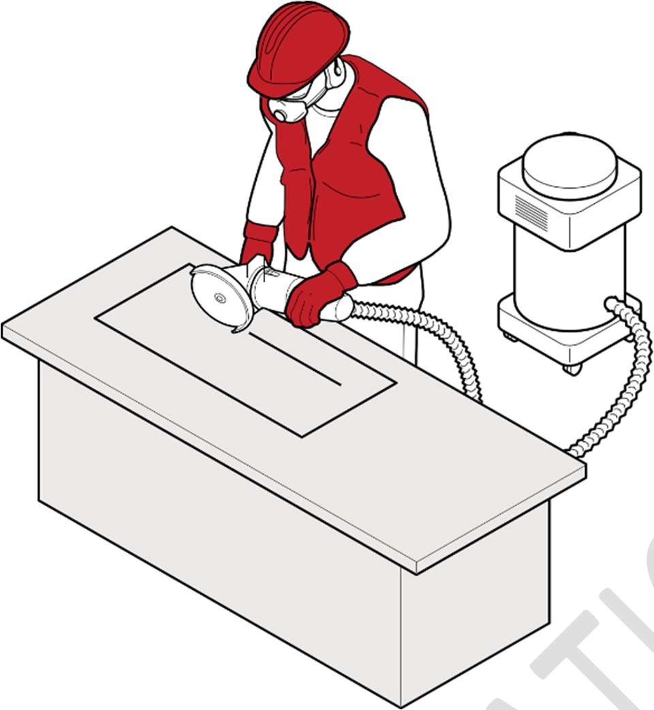

**Figure 6: A worker cutting/grinding with on tool dust extraction.**

For example, when working with engineered stone where the engineered stone slab can be lifted, a sacrificial backer-board or spoil-board should be placed under it during cutting or trimming. This prevents the release of dust below the slab and increases the effectiveness of on-tool dust extraction by LEV. Medium-density fibreboard or particleboard are suitable for this purpose for crystalline silica material with a crystalline silica content of 25 per cent or less. If the crystalline silica content is unknown, a H class vacuum should always be used.

Silica dust is very abrasive to LEV equipment. Regularly inspecting LEV equipment for damage will help ensure it is effective and fit for purpose. For all power tools (with the exception of power drills) the dust extractor or vacuum should meet the requirements of AS/NZS 60335.2.69:2017 Household and similar electrical appliances – Safety – Particular requirements for wet and dry vacuum cleanings, including power brush, for industrial and commercial use (IEC 60335.2.69 ED 5, MOD).

For power drills, the dust extractor should meet the requirements above or use a HEPA fitting tool mounted dust collector.

Where the material can be lifted, placing a sacrificial backer-board or spoil-board under the material during cutting or trimming can prevent dust from being released below, thereby increasing the effectiveness of on-tool extraction.

#### Design and testing of ventilation systems

When using LEV to control RCS, the LEV should be designed to work well for the task. For example, capturing hoods generally work only over small distances. If you are thinking of using a capturing hood, you should consider:

* the capture distance at which a hood will work effectively; and
* the required capture velocity needed to capture different kinds of dusts.

Ventilation systems require regular testing to ensure correct operation, as they can:

* develop leaks
* get filter blockages; and
* have failing fan performance.

If the workplace uses a LEV system to control RCS, one of the two following simple devices can be used for testing both the air flow of the exhaust system and the capture velocity actually being produced with exterior hood:

* Air current tubes – these tubes produce a white aerosol allowing visualisation of air flow; or
* Anemometer – whirling vane or a hot wire anemometer to measure actual air flow rates.

The table below can be used as a guide when testing the velocity at the capture point outside an exterior or capturing hood. Minimum air velocity (ventilation rates) will vary depending on the method in which the dust is being generated. The (air movement) extraction rate has to be measured at or near to the point of dust generation.

|  |  |  |
| --- | --- | --- |
| **Type of contaminant being generated** | **Air speed required m/s at point of capture** | **Inlet velocity if capture point is 1 hood diameter away m/s** |
| Dusts from pouring operations | 0.5 – 1 | 5 – 10 |
| Crusher dusts | 1 – 2.5 | 10 – 25 |
| Grinding, blasting, high speed wheel generated  Dusts | 2.5 – 10 | 25 – 100 |

### NATURAL VENTILATION

Improving the general ventilation to a room or building may help reduce the concentration of contaminants in the air. However, ventilation should not be relied on to ensure silica dust exposure is controlled. Other controls must also be used to prevent the release of silica dust into the air and adequately protect workers and others in the vicinity from exposure to silica dust.

The workplace should have an adequate supply of fresh air. For on-site installation, processes that generate silica dust may be undertaken outside, provided the contaminated dust does not travel in the direction of other workers or premises. When working indoors, windows and doors within a room or building should be open to provide general ventilation. Fans may support the movement of air, but it is important that air streams are directed appropriately. Fans should be arranged so that streams of clean air are drawn past workers and contaminated air streams are drawn away from workers and ensure contaminated air is not directed towards others, for example, workers or adjacent businesses.

Wet slurries should be cleaned up before fans are used to prevent them from drying and creating potential dust hazards.

More information about natural ventilation at the workplace can be found in the [Code](https://www.legislation.act.gov.au/ni/2020-551/) of Practice: Managing the work environment and facilities.

### Tunnelling ventilation

Effective control of exposure to respirable crystalline silica in the underground environment heavily relies on adequate ventilation.

In addition to meeting minimum quantities of air for people in tunnel environments, specific attention is needed on the extraction of airborne contaminants at the source. A key source of exposure is during the maintenance of mechanical ventilations systems, and therefore engineering controls, coupled with safe systems of work and the use of personal protective equipment is necessary to reduce exposure to below the workplace exposure standard.

More information can be found in the Safe Work Australia [Guide for Tunnelling Work](https://www.bing.com/ck/a?!&&p=9ae4c942af23c89bJmltdHM9MTY3NzcxNTIwMCZpZ3VpZD0zODA4ZmJmYS1mYzFmLTY3MmMtMDc0Mi1mNDQ2ZmQ5NjY2ZWUmaW5zaWQ9NTE3Ng&ptn=3&hsh=3&fclid=3808fbfa-fc1f-672c-0742-f446fd9666ee&psq=Guide+for+Tunnelling+Work&u=a1aHR0cHM6Ly93d3cuc2FmZXdvcmthdXN0cmFsaWEuZ292LmF1L2RvYy9ndWlkZS10dW5uZWxsaW5nLXdvcms&ntb=1).

### ADMINISTRATIVE CONTROLS

Administrative controls are used to provide additional protection after implementing higher level controls such as substitution, isolation and engineering.

Administrative controls are work practices or procedures designed to minimise exposure to a hazard. For example, routinely cleaning the work area and vacuuming residual dust from clothing.

Due to the risks of silica dust when working with crystalline silica material, administrative controls on their own will not provide enough protection from exposure to silica dust. They should only be used in combination with and to support higher level control measures.

Administrative control measures rely on human behaviour and supervision to be effective.

#### Workshop layout

The layout of processing workshops for engineered stone and crystalline silica material needs to be designed to minimise exposure to and contamination from silica dust generated in neighbouring work areas. For example, by including enough distance between workstations and positioning work areas for each stage of processing in sequence.

#### Work practices

The way in which work is conducted can influence the generation of silica dust and worker exposure. While the use of higher order controls such as water suppression and LEV are critical to minimising worker exposure to silica dust, the following work practices may assist in reducing exposure:

* organise for all cutting, grinding, trimming, drilling, sanding, or polishing of material or products containing crystalline silica to be completed at the fabrication workshop before on-site installation
* plan cutting of material or products containing crystalline silica to make the minimum number of cuts for each job
* implement policies that describe actions to be taken when working with materials or products containing crystalline silica, for example:
  + wetting the product before cutting, grinding, trimming, drilling, sanding, or polishing to remove dust and aid with water suppression; and
  + washing products prior to and after fabrication to remove any residual dust.
* implement maintenance schedules to ensure routine, or daily checks of critical controls
  + for example, guards, LEV and PPE
* implement shift rotations to make sure workers are not exposed to dust for extended periods of time
* excluding workers and others not involved with the cutting, grinding, trimming, drilling, sanding, or polishing task
* implement good housekeeping policies including regular cleaning of work areas; and
* ensure workers wash their hands and face thoroughly before eating, drinking or leaving the workplace.

#### Safe work procedures

Workers’ use of power tools, equipment and other machinery will influence the amount of silica dust that is generated.

Before plant or equipment is used in the workplace, workers and other persons who are to use it must be provided with the information, training, instruction and supervision necessary to protect them from silica dust and any other risks arising from its use.

Safe work procedures should be developed that include instructions on:

* the correct use of silica dust control equipment
* how to operate the plant and equipment in a manner that reduces the generation of silica dust
* how to carry out inspections, shut-down, cleaning, repair and maintenance of plant and silica dust control equipment
* emergency procedures; and
* the use of PPE, such as protective footwear, eye wear, RPE and aprons.

In addition to safe work procedures, warning signs (Figure 7) must be used to communicate silica dust hazards or the required PPE, if such signs are required to control the risks of silica dust.

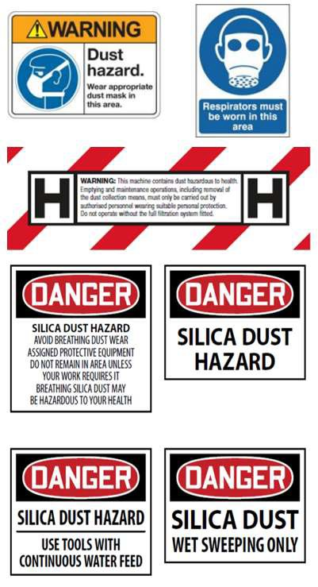

**Figure 7: Dust warning signs.**

### PERSONAL PROTECTIVE EQUIPMENT (PPE)

PPE refers to anything used or worn to minimise risk to workers health and safety, for example, protective footwear, eyewear and RPE such as powered air purifying respirators (PAPR).

If PPE is to be used to minimise the risk of exposure to silica dust, the PCBU must provide the appropriate PPE, and training, to workers at the workplace, unless this PPE has been provided by another PCBU.

PPE must be considered in addition to substitution, isolation, engineering and administrative controls. It must only be used in combination with, and to supplement higher level control measures.

PPE should never be relied on as the sole means to protect workers from silica dust, as it does not control the hazard at the source and is the least effective at minimising risks when used on its own.

Using PPE relies on human behaviour and supervision to be effective.

#### Respiratory protective equipment (RPE)

RPE is used to protect an individual worker for airborne silica dust that may not be captured or removed by higher level controls – it is used for controlling the residual risk that may be present from work activities involving crystalline silica material. It is a good idea to establish a system to manage workers’ use of RPE. The system should include:

* selecting the most suitable RPE for the task
* fit testing
* a use, maintenance, storage and repair program
* a facial hair policy for tight-fitting respirators; and
* providing information, training and supervision for workers.

In the ACT, RPE **must** be worn if only one specified control measure is implemented when cutting crystalline silica material with a power tool or using another mechanical process. However, as outlined above in Part 3.3 Hierarchy of Controls, PCBUs must use **PPE** to minimise any risks that remain after higher order controls are implemented where the risk cannot be eliminated.

#### Selecting suitable RPE for silica dust

A PCBU must ensure RPE is selected to minimise health and safety risks. This includes ensuring the RPE is:

* suitable having regard to the nature of the work and hazards associated with the work
* a suitable size and fit and reasonably comfortable for the worker who is to use and wear it
* maintained, repaired or replaced so that it continues to minimise risk to the worker who uses it, including by ensuring it is clean and hygienic and in good working order; and
* used or worn by the worker, so far as is reasonably practicable.

When determining suitability, the protection factor assigned to the RPE must be sufficient to provide protection. The RPE filter must also be suitable for silica dust.

When using a tight-fitting respirator, it must have an effective face seal to ensure contaminated air does not leak into the respirator and is not breathed in by the worker. This means the worker should be clean-shaven or only have facial hair that does not interfere with the fitting surfaces or the respirator valve. As everyone’s face is a different size and shape, there is no ‘one size fits all’ tight-fitting respirator. Fit testing each worker and their RPE before they commence dust-generating work will help ensure RPE is effective.

For workers who want to keep facial hair that may interfere with the operation or proper fit of a tight-fitting respirator (for example a closely trimmed beard), a PAPR with a loose hood or a positive pressure respirator may be suitable.

Workers using handheld equipment for grinding and polishing tasks, in combination with effective engineering controls, must wear respiratory protection.

The following questions should be considered when choosing RPE:

* Does the RPE provide the required minimum protection factor?
* Is it clean and well maintained?
* Was fit testing successful?
* Is it comfortable for the worker to wear?
* Does the RPE introduce additional hazards such as heat, or obscured vision? More information about PPE can be found on the [Safe Work Australia website](https://www.safeworkaustralia.gov.au/sites/default/files/2021-09/health-monitoring-guidance-crystalline-silica.pdf/).

#### Fit testing

Fit testing is essential to make sure the RPE works correctly and is comfortable to wear with other PPE that may be needed for the task. Fit testing measures the effectiveness of the seal between the respirator and the worker’s face. If there is not a good seal contaminated air, potentially containing silica dust, could leak into the respirator and be inhaled by the worker.

There are two types of fit testing that can be carried out:

* Qualitative
  + a pass/fail test that relies on the wearer’s ability to taste or smell a test agent; and
  + only used on half face respirators.
* Quantitative
  + uses specialised equipment to measure how much air leaks into the respirator; and
  + used on half face respirators, full face respirators and PAPR.

Quantitative fit testing results are more objective than qualitative testing because some workers have difficulty with their ability to taste or smell. This can result in a ‘false pass’ and worker health not being adequately protected. Full face respirators and PAPR should be fit tested using the quantitative method.

Fit testing, including frequency requirements, for half-face respirators must be in accordance with *AS/NZS 1715:2009: Selection, use and maintenance of respiratory protective equipment*.

All fit testing should be carried out by a competent person, manufacturer, supplier or consultant:

* before a worker wears a respirator for the first time
* each time a new make or model of respirator is provided to a worker
* whenever there is a change in the wearer’s facial characteristics or features that may affect the seal
  + for example, large weight loss or gain; and
* be repeated annually.

More information about who a competent person is can be found below.

For PPE to be effective, workers who are required to wear tight-fitting respirators should be clean shaven. If they cannot be clean shaven, ensure:

* there is no hair between their face and the seal of the respirator face piece as it can interfere with a proper fit. This is important as silica dust is smaller than facial hair.
* facial hair does not interfere with the inhalation/exhalation valve operation.

It is also important to ensure clothing, makeup, dental fixtures and jewellery do not interfere with the respirator seal or inhalation/exhalation valve operation.

A written record of fit tests carried out for each worker should be kept and shared with the worker after fit testing is complete. The record should include the:

* type of test performed
* make, model, style and size of respirator tested; and
* date and result of the test.

Hood and head top type PAPRs and positive pressure respirators do not require fit testing as they cover the whole head and do not rely on a tight seal.

#### Competency of fit testers

Fit testers should be properly trained and proficient in the fit test method being used. Relevant competencies of a fit tester may include:

* knowledge of the respirators being fit tested
* knowledge of the fit test method
* ability to set up all applicable equipment and monitor its function
* ability to carry out the test and evaluate the results; and
* ability to identify likely causes of fit test failure.

#### Training workers on the correct use and maintenance of RPE

When issuing RPE, training must be provided to ensure that workers correctly use, maintain and store the RPE. Training can be carried out by:

* a health and safety consultant
* a trained person in-house
* a representative from an RPE manufacturer or supplier
* an occupational hygienist, or
* the holder of recognised qualifications in WHS with expertise or experience in this area.

Training in the use of RPE should cover the following:

* why RPE is required
* when RPE is required to be worn
* how RPE works
* the limitations of RPE
* how to correctly put on and take off RPE
* how to conduct a fit check
* how to clean and maintain RPE
* when and how to replace filters and batteries (including rechargeable batteries); and
* how and where to store RPE when not in use.

Ongoing training and supervision may be required to ensure workers correctly use RPE. Workers must also take reasonable care for their own health and safety, comply with any reasonable instruction, and cooperate with any reasonable policy or procedure of the PCBU relating to health or safety. This means a worker must use and wear RPE in accordance with any workplace policy and information, training or reasonable instruction given.

#### Fit checking

Fit checking enables workers to take reasonable care of their own health and safety while working with engineered stone and other materials or products containing crystalline silica.

A fit check is a quick check to ensure a fit tested respirator is properly positioned on the face and there is a good seal between the respirator and face. Fit checks do not replace the need for a fit test. Workers should follow the respirator manufacturer’s instructions on how to carry out a fit check.

Fit checking is the responsibility of the worker. Workers must be trained on how to carry out a fit check for their RPE. They should undertake a fit check every time they use a respirator to ensure they are using and wearing RPE in a way that will protect their health and safety.

### OTHER PPE

In addition to respirators, workers may need other PPE depending on the work task. A risk assessment should be conducted to decide the PPE required for workers.

The PCBU should assess the conditions likely to affect the health and safety of workers and ensure suitable PPE and appropriate training is provided before any work generating silica dust commences.

Other types of PPE that can be used to minimise exposure to silica dust include:

* eye protection
* gloves
* protective footwear such as rubber boots or gumboots; and
* protective clothing such as waterproof overalls or an apron (Figure 9).

Appropriate protective footwear and clothing will protect workers’ clothing from silica dust, including water and mists containing dusts. Note that the use of gloves could be an entanglement hazard when using high-speed power tools.

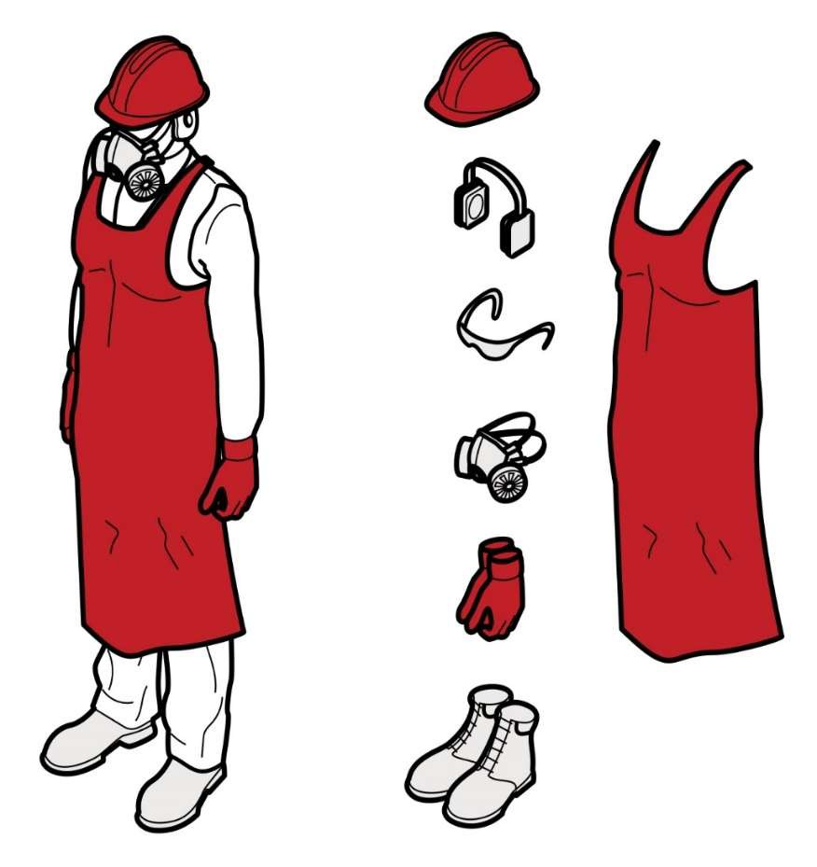A hard hat and hearing protection will provide protection and may be recommended to manage other risks associated with the fabrication process. When selecting other types of PPE, it is important to ensure that the PPE does not interfere with the effectiveness of RPE.

**Figure 9: Personal protective equipment.**

1. Maintaining and reviewing control measures

* 1. Maintenance of control measures

##### WHS Regulation, section 39

Maintenance of control measures

All control measures must be maintained so they remain effective. This includes ensuring control measures are fit for purpose, suitable for the nature and duration of the work, and installed, set up and used correctly.

For example, a PCBU should conduct daily start up checks to ensure that:

* machine and water mist guards and LEV are fitted correctly and are working effectively
* LEV filters are clean and replaced according to the manufacturer’s instructions
* there is an adequate water supply for water suppression; and
* all RPE is in good, working condition and fit checked.

A PCBU should routinely monitor the workplace for signs of visible dust on work surfaces or clothing as that may be an indication that some controls are not working effectively.

### PLANT INSPECTION AND MAINTENANCE

Silica dust is abrasive and can damage and wear plant, including engineering controls.

Plant must be routinely inspected, maintained and repaired according to the manufacturer’s specifications or, in the absence of such specifications, in accordance with a competent person’s recommendations.

Inspection of plant should identify any:

* wear and tear, corrosion, or damaged parts
* air leaks in pneumatic tools
* kinks, holes or leaks in water suppression, exhaust ventilation or dust extraction equipment
* filters in need of replacing; and
* damage to guards and flaps that contain water spray.

For example, hand-held powered tools should be regularly inspected, repaired or replaced when necessary, and any damaged or worn parts (such as grinding wheels) identified should be replaced.

A system of routine daily checks on plant and equipment designed to control dust should be implemented to ensure they are working effectively. Failures or problems identified should be rectified and workers should be encouraged to report concerns to the PCBU.

More information on plant inspection and maintenance can be found in the [Code of Practice: *Managing risks of plant in the workplace*.](https://www.legislation.act.gov.au/ni/2022-356/)

### MAINTENANCE OF RPE

A PCBU must ensure that RPE is maintained, repaired or replaced so that it continues to be effective. A competent person should administer an RPE maintenance program in accordance with the manufacturer’s instructions.

A maintenance program should include procedures for:

* daily cleaning and inspection of RPE by the worker for wear, damage and flat batteries
* appropriate storage:
  + - * each worker should be provided with a dry, clean and sealed container to store their RPE
      * clean, dry RPE should be stored away from dust and out of direct sunlight; and
      * face pieces should be stored so that they are not subject to distortion
* identification and repair or replacement of any worn or defective components of the equipment including filters (including availability of replacement parts)
* regular periodic inspection, maintenance and testing of RPE in accordance with the manufacturer’s instructions
* record keeping, including:
  + - * details of any issues, including the date
      * user records including training provided
      * fit testing records for each worker including:
        + type of test performed
        + make, model, style and size of respirator tested
        + date of the test
        + result of the test
      * maintenance records including filter replacement and RPE maintenance schedules; and
      * RPE program records, including procedures for use and audits or evaluations.

An RPE maintenance program should also consider the environmental conditions the RPE is being used or stored in (for example, hot work vehicles) as the rubber seals may deteriorate and require replacing more frequently.

* 1. Review of control measures

In order to ensure a work environment is without risks to health and safety a PCBU must review and revise, as necessary, the control measures they have put in place to ensure they are effective and protect the health and safety of their workers. Regular and routine review of control measures is likely to ensure that the PCBU is managing risks to health and safety appropriately.

##### WHS Regulation, section 38

Review of control measures

Undertaking air monitoring to measure the airborne concentration of silica dust in the workplace is one way to check the effectiveness of controls.

If control measures are not working effectively, a PCBU must revise them to ensure effective risk control measures are implemented. A PCBU can use the same steps that were taken during the initial hazard identification to check control measures.

A PCBU must consult with their workers and, where applicable, their HSRs. They should consider:

* key triggers that may indicate when controls are not working to their designed specification or operation
* the results of air monitoring, in particular whether the workplace exposure standard is being exceeded (see section 3.1)
* any health monitoring reports that recommend reviewing the control measures (noting that health monitoring results must not be disclosed to any person without the worker’s consent)
* if and when workers have become or have reported feeling unwell
* the outcomes of consultation with workers (or their representatives) and HSRs, or worker complaints
* any new hazards the control measures have introduced
* any new hazards proposed control measures could introduce
* any other respirable dust hazards
* if new work methods or new equipment have made the job safer
* if safety procedures are being followed
* whether the training and instruction provided to workers on how to work safely has been successful
* whether workers are using the supplied PPE during relevant work tasks
* whether there has been a reduction in the frequency and severity of incidents; and
* if new legislation or new information has become available and whether it shows that the current controls may no longer be the most effective.

If problems are identified, a PCBU should go back through the risk management steps, review information and make further decisions about risk control.

More information on the risk management process and the hierarchy of control measures can be found in the [Code of Practice: *How to manage work health and safety risks*](https://www.legislation.act.gov.au/ni/2020-547/).

1. Clean-up and disposal of silica dust

The proper clean-up of the workplace, including the decontamination of clothing and PPE, and the correct disposal of material that might be contaminated with silica dust play an important role in further minimising exposure to silica dust for workers, or others in the vicinity of the workplace.

* 1. Cleaning and housekeeping

### GENERAL CLEANING AND HOUSEKEEPING

Regular cleaning should be undertaken to prevent the build-up of dust on floors, walls, other surfaces and equipment. Cleaning should be conducted at least daily, ideally at the end of the working day. Workers should wear RPE and use good housekeeping practices when cleaning. The wearing of RPE throughout the cleaning process will reduce the risk of workers being exposed to silica dust or contaminated water mist.

To ensure good housekeeping practices:

* implement daily and thorough housekeeping and cleaning procedures for wet slurry and settled dust to prevent dust build up on surfaces, or it becoming airborne, in areas where the stone is processed, for example:
  + - * walls and building support structures such as girders and cross members; and
      * wash engineered stone slabs prior to processing and again before sending out for installation
* use low pressure water, wet sweeping or an M- or H- class rated vacuum cleaner to clean, tools, equipment, floors, walls and other surfaces
* regularly clean vehicle track or high use areas and keep it wet during the day
* prohibit the use of dry sweeping or compressed air to clean surfaces or clothing
* provide low pressure water from hoses for cleaning between tasks; and
* ensure all waste products are disposed of in a manner that minimises the risk of dust being redistributed over the workplace (for example covered, kept wet or bagged).

**Note**: Dry sweeping methods, such as using brooms, or using compressed air to clean up accumulated dust must not be used; these housekeeping methods are likely to increase the risk of exposure to respirable crystalline silica and recirculate silica dust into the air. To avoid the risk of recirculated silica dust dry sweeping methods must not be used. Household vacuum cleaners are not designed for use with hazardous dusts and should never be used where silica dust is or may be present, even if they have a HEPA filter.

### DECONTAMINATION OF WORKERS’ CLOTHING AND PPE

Dusty clothing and PPE can expose workers and others to silica dust. PPE should be cleaned after use to ensure that silica dust does not accumulate. Information about maintaining and cleaning PPE should be sourced from the manufacturer or supplier.

Examples of how exposure to silica dust carried on PPE and work clothes can be minimised include:

* using an industrial M- or H- class rated vacuum cleaner to remove dust from clothes and PPE
  + - * by positioning these units at the exits of engineered stone and other material or products containing crystalline silica processing areas, workers are encouraged to vacuum their clothes and PPE before leaving
* providing workers with access to an area to wash their arms, hands, faces and hair
* a low-pressure hose or tray of water may also be useful for cleaning the bottom of footwear to prevent tracking dust into other areas
* providing a laundry service for dusty work clothes and PPE so they are not taken home for washing
  + - * if a commercial laundry is used, dampen the clothes and place them in a sealed, labelled plastic bag, and inform the laundry that the clothes are contaminated with crystalline silica
* ensuing that the te laundry service has the appropriate equipment and procedures to safely deal with contaminated clothing and disposal of resulting waste
* requiring workers to change dusty clothing after each shift, or if they have just finished a very dusty task to change at their next break; and
* providing workers with rubber boots and aprons.

When working outdoors, the ground can be covered with plastic sheeting and remaining dust can be removed using the above methods.

More information about managing facilities at the workplace can be found in the [Code of Practice: *Managing the work environment and facilities*](https://www.legislation.act.gov.au/ni/2020-551/).

* 1. Management of water and waste

### MANAGEMENT OF WET SLURRY

Wet slurry is the resultant waste from water suppression. This slurry has the potential to build up from continuous processing using water suppression on equipment and machinery. The slurry is not hazardous while wet. However, if it dries, the dust can become airborne when disturbed and expose workers and others.

Wet slurry can be managed by:

* capturing or containing it through floor grading, grates, curbing and channelling
* keeping floors and surfaces wet; and
* regularly cleaning, including at the end of each day, to prevent wet slurry drying overnight.

Any wet slurry that is de-watered so that it is still wet, but of cake-like consistency, should be disposed of in a way that minimises the risk of dust being redistributed over the workplace. This may include covering the slurry, keeping it wet or bagging it before disposal.

### RECYCLED WATER

Water that is recycled on-site for use in water suppression should be effectively filtered to remove silica dust and prevent contaminated water continually passing through the system. Without an appropriate filtration system there is a risk that continual recycling of water will increase the concentration of silica dust in the water over time and subsequently the level of silica dust in the mist arising from the water suppression activities.

Water recycling systems can filter slurry so that silica and other dust particles are removed from the water before it is re-used. These systems can include:

* a pit that collects slurry from drains
* a slurry collection tank and filter press that compacts silica and other particles into a solid block for disposal
* a slurry settlement tank and waste bag, where waste forms into a solid block; and
* a filtered water tank that recirculates clean water back into the water supply.

Some products, such as commercially available flocculants, promote the clumping of particles, and will consolidate silica dust in recycled water more effectively. Water that is recycled needs to be visually assessed to ensure it is clear. If the water has a cloudy or milky appearance this means it is likely to contain a high concentration of silica dust and may increase the risk that airborne particles or contaminated mist will be released in the workplace.

For further information on the management of recycled water, please refer to guidelines in your state or territory.

### DISPOSAL OF CONTAMINATED MATERIAL AND OFFCUTS

The PCBU should have a waste management system in place that eliminates the risk of silica dust being released and becoming airborne.

The PCBU must ensure that containers of waste produced or generated at a workplace from a hazardous substance, including silica dust, are labelled. The label needs to reflect the nature of the waste as closely as possible, for example the label should identify the substance as ‘Silica dust hazard’.

Waste contaminated by silica dust can include any disposable clothing or PPE, rags used to clean the work area or tools or equipment that cannot be decontaminated or are no longer required.

Bags used for containing waste need to be strong enough to ensure they will not tear and release dust. To minimise the risk of a bag tearing or splitting, bags should not be filled more than half-full and excess air gently evacuated from the bag in a way that does not cause the release of dust.

Offcuts of engineered stone and other crystalline silica material may be covered with silica dust. Transferring offcuts can result in accumulated dust becoming airborne. Control measures must be put in place to ensure that this dust is controlled, for example wetting down the offcuts before transferring into larger waste disposal bins or skips.

1. Post-installation
   1. Maintenance or refurbishment of crystalline silica material, such as engineered stone

Crystalline silica material that is already installed in the home or workplace or other area are not a risk to health unless they are disturbed through mechanical processes such as cutting, sanding, grinding, drilling or polishing.

Work activities that might include removing crystalline silica material could include: removing or patching exiting fibre cement sheeting, repairing or refurbishing brick work, or re-polishing concrete flooring.

Workers undertaking maintenance or refurbishment crystalline silica material using mechanical processes may be exposed to silica dust. This type of work should only be carried out by workers who have had suitable training and should occur off-site where possible.

PCBUs must manage risks to health and safety associated with the maintenance or refurbishment of crystalline silica material, including engineered stone.

One effective way to manage the risk is to conduct this work in a controlled exclusion zone with additional controls, such as wet dust suppression as outlined in Part 3 of this Code.

* 1. Removal

When removing crystalline silica material that has been installed in the home or workplace or other area, the PCBU should carefully plan before work commences so it can be carried out safely. Planning involves identifying hazards, assessing risks and determining appropriate control measures in consultation with all persons involved in the work.

The PCBU must consider not only the direct hazards that are associated with this work, but also those hazards related to the work activity and work environment.

When undertaking removal work, a risk assessment is often the best way to determine the measures that should be implemented to control risks. Refer to Part 3 of this Code for information on how to manage and control the risks from working with crystalline silica material.

Appendix A – Glossary

| **Key terms** | **Meaning** |
| --- | --- |
| Airborne crystalline silica | Airborne crystalline silica is an airborne contaminant containing respirable crystalline silica |
| Cut | Cut includes crush, drill, grind, polish, sand and trim |
| Crystalline silica | The crystalline form of the abundant naturally occurring mineral silica or silicon dioxide (SiO2). It is present in almost all types of rocks, sand, clays, shales and gravel and in construction materials such as concrete, tiles and bricks |
| Crystalline silica control measure | Each of the following control measures is a crystalline silica control measure in relation to the cutting of engineered stone or other crystalline silica material:   1. a water delivery system supplying a continuous feed of water over the cutting area is used to suppress airborne crystalline silica produced by the cutting 2. a wet dust suppression method 3. the attachment of a Class H vacuum to the tool used for cutting 4. for other crystalline silica material containing less than 25 per cent crystalline silica – the attachment of a Class M vacuum to the tool used for cutting 5. the use of a local exhaust ventilation system 6. the isolation of the place where the cutting occurs from other workers. |
| Crystalline silica material | Means:   * engineered stone, or * any cement, concrete, masonry, mortar or brick product containing crystalline silica, or * natural stone containing crystalline silica |
| Duty holder | Any person who owes a work health and safety duty under the WHS Act including a person conducting a business or undertaking, a designer, manufacturer, importer, supplier, installer of products or plant used at work (upstream duty holder), officer or a worker |
| Engineered stone | Engineered stone2 is an artificial product that:   1. is created by combining and heat curing natural stone materials that contain crystalline silica (such as quartz or stone aggregate) with chemical constituents (such as water, resins or pigments); and 2. can be manipulated through mechanical processes to manufacture other products (such as kitchen benchtops).   Engineered stone does not include natural stone that has not been combined with other products or heat cured (for example granite and quartz in their natural state).  2 Engineered stone does not include concrete, concrete products, cement products, fibre cement, bricks, blocks, pavers, autoclaved aerated concrete, roof tiles, wall and floor tiles that are ceramic or porcelain, grout, mortar, render and plasterboard. |
| H Class vacuum | Class H vacuum means a vacuum that complies with the requirements of Class H of AS/NZS 60335.2.69:2017 (Household and similar electrical appliances – Safety, Part 2.69: Particular requirements for wet and dry vacuum cleaners, including power brush, for commercial use), or requirements equivalent to the standard |
| Hazard | A situation or thing that has the potential to harm a person. Hazards at work may include, noisy machinery, a moving forklift, chemicals, electricity, working at heights, a repetitive job, bullying and violence at the workplace. |
| Health and Safety Representative (HSR) | A worker who has been elected by their work group under the WHS Act to represent them on health and safety matters. |
| Ingress Protection (IP) | The level of protection offered by an electrical enclosure or casing against the intrusion or accidental contact of solids and/or liquids. |
| M Class vacuum | Class M vacuum means a vacuum that complies with the requirements of Class M of AS/NZS 60335.2.69:2017 (Household and similar electrical appliances – Safety, Part 2.69: Particular requirements for wet and dry vacuum cleaners, including power brush, for commercial use), or requirements equivalent to the standard. |
| May | **‘May’ indicates an optional course of action** |
| Mechanical process | Does not include a process that involves plant or a tool that:   * relies exclusively on manual power for its operation; and * is designed to be primarily supported by hand |
| Must | ‘Must’ indicates a legal requirement exists that must be complied with. |
| Officer | An officer under the WHS Act includes:   * an officer within the meaning of section 9 of the *Corporations Act 2001* (Commonwealth) * an officer of the Crown within the meaning of section 247 of the WHS Act; and * an officer of a public authority within the meaning of section 252 of the WHS Act.   A partner in a partnership or an elected member of a local authority is not an officer while acting in that capacity. |
| Person conducting a business or undertaking (PCBU) | A PCBU is an umbrella concept which intends to capture all types of working arrangements or relationships.  A PCBU includes a:   1. company 2. unincorporated body or association; and 3. sole trader or self-employed person.   Individuals who are in a partnership that is conducting a business will individually and collectively be a PCBU.  A volunteer association or elected members of a local authority will not be a PCBU. |
| Personal protective equipment (PPE) | Anything used or worn by a person to minimise risk to the person’s health and safety. |
| Required minimum protection factor | Minimum reduction in exposure required to reduce the wearer’s exposure below the workplace exposure standard. |
| Respirable crystalline silica | Respirable dust (less than and equal to 10 micrometres (µm)) in diameter of the following CAS numbers:   * Cristobalite 14464-46-1 * Quartz 14808-60-7 * Tridymite 15468-32-3; and * Tripoli 1317-5-9.   Synonyms:  α quartz, crystallized silicon dioxide, silica, calcined diatomaceous earth. |
| Respiratory protective equipment (RPE) | A type of PPE designed to protect the worker from inhaling an airborne hazardous substance. RPE includes masks and respirators. |
| Risk | The possibility of harm (death, injury or illness) might occur when exposed to a hazard |
| Should | ‘Should’ indicates a recommended course of action |
| Wet dust suppression method | Means a method of suppressing airborne crystalline silica that involves the use of water or other suitable liquid, or a wetting agent; and  Includes using a continuous feed of water, or an emulsion, spray, curtain, mist or foam of water or other suitable liquid over the place where airborne crystalline silica is produced |
| Worker | Any person who carries out work for a person conducting a business or undertaking, including work as an employee, contractor or subcontractor (or their employee), self-employed person, outworker, apprentice or trainee, work experience student, employee of a labour hire company placed with a 'host employer' or a volunteer |
| Workplace | Any place where work is carried out for a business or undertaking and includes any place where a worker goes, or is likely to be, while at work. This may include offices, factories, shops, construction sites, vehicles, ships, aircraft or other mobile structures on land or water |
| Workplace exposure standard | A workplace exposure standard published by Safe Work Australia in the *Workplace Exposure Standards for Airborne Contaminants*. |

Appendix B - Example of matters for inclusion in a SWMS for silica dust control

*This template will help you to document the control measures used to manage the risks of exposure to respirable crystalline silica (silica dust) when working with crystalline silica material. This information should be considered and included in a SWMS and form part of your WHS management and compliance framework.*

*You will need to add details regarding the safe systems of work and practices specific to your workplace. The plan should be* developed *in consultation with workers responsible for carrying out the tasks and the relevant Health and Safety Representative of the work group and be readily available. It should also be provided to the registered medical practitioner carrying out or supervising health monitoring.*

This plan was prepared on [ / / ] and will be reviewed on [ / / ].

##### Business Name

Click here to enter text.

##### Address

Click here to enter text.

##### Person conducting a business or undertaking (PCBU)

Click here to enter text.

##### Contact details of PCBU

Click here to enter text.

**Details of the crystalline silica material being used**

|  |  |  |  |
| --- | --- | --- | --- |
| **Product name** | **Product supplier** | **Silica content (sourced from SDS or product information)** | **SDS or product information reference details** |
|  |  |  |  |
|  |  |  |  |
|  |  |  |  |

**Controlling the risk of exposure to silica dust**

|  |  |  |  |  |  |
| --- | --- | --- | --- | --- | --- |
| **Location** | **Task** | **Control measures** | **Work practices** | **Respiratory protection** | **How controls are integrated into daily activities** |
| **EXAMPLE ONLY**  Fabrication workshop – cutting bench | Cutting engineered  stone with a bridge saw | Wet suppression system using  built in blade water feed nozzle  Water spray/mist guards | Ensure:   * cutting area is clearly marked   on workshop floor   * water supply to the saw is turned on and operational before starting the saw * water is flowing to the cutting area prior to blade making contact with the product * spray guards are in place before commencing work, and * regular cleaning of saw table and surrounding areas | Full face powered air purifying  respirators (PAPR) with a P2 class filter | Tool box talks, pre- start checks and  daily cleaning of work areas.  For example, daily checks of:   * water supply & flow * safety and spray guards are in place * equipment (including guards) have no visible damage or build-up of residue, no blockages * work area is kept clean & slurry managed to prevent drying out * PAPR (tight fitting) fit checked each time the respirator is worn * PAPR filter check/replace * PAPR performance check |
|  |  |  |  |  |  |
|  |  |  |  |  |  |
|  |  |  |  |  |  |
|  |  |  |  |  |  |
|  |  |  |  |  |  |

**Respiratory Protective Equipment (RPE) maintenance program**

*So RPE continues to be effective the PCBU must ensure that it is maintained, repaired or replaced. A* competent *person should administer an RPE maintenance program in accordance with the manufacturer’s instructions.*

Supporting documents: [for example clean-shaven policy, user manuals]

|  |  |  |  |  |  |  |
| --- | --- | --- | --- | --- | --- | --- |
| **Worker name** | **Respirator details (make, model, size)** | **RPE**  **supply date** | **Fit test conducted [name & date]** | **Scheduled retest date** | **Training conducted by [name & date]** | **Maintenance schedule (as per**  **manufacturer’s**  **instructions)** |
|  |  |  |  |  |  |  |
|  |  |  |  |  |  |  |

##### Air monitoring

*The PCBU* should *undertake air monitoring at least every 12 months if:*

* *they are uncertain whether the airborne concentration of silica dust exceeds the workplace exposure* standard*, or*
* *monitoring is* necessary *to determine whether there is a risk to the health of workers.*

*Air monitoring should be conducted by an independent, competent person. For example, a certified* occupational *hygienist, or a person with recognised equivalent competency under an international certification scheme.*

|  |  |  |
| --- | --- | --- |
| **Details** | **Task details** | **Actions arising from air monitoring report recommendations** |
| Carried out by: [*insert name of independent competent person*]  On: [*insert date*]  In response to [*insert specific trigger*] |  |  |
|  |  |  |
|  |  |  |

##### Review of control measures

*The* PCBU *should routinely review the control measures that have been put in place to ensure they are effective and protect the health and safety of workers.*

|  |  |  |  |
| --- | --- | --- | --- |
| **Engineering control** | **Date of review** | | **Comments**  ***For example: the review was scheduled, or in response to [insert specific trigger].*** |
| **Scheduled** | **Completed** |
|  |  |  |  |

Appendix C - Example Task Risk Assessment: Crystalline Silica Material

|  |  |  |  |
| --- | --- | --- | --- |
| **Project** |  | **Address** |  |
| **Principal Contractor** |  | **Subcontractor** |  |
| **Trade** |  | **Date:** |  |
| **SILICA ACTIVITY** |  | | |

This Task Risk Assessment must be completed by those undertaking the cutting crystalline silica material activity and in consultation with others who may be adversely affected by the activity. Once completed, this task risk assessment is to be provided to the PC representative and reviewed prior to the commencement of the activity on site. This Task Risk Assessment has been developed as a guide on managing Respirable Crystalline Silica (RCS) on site in accordance with the legislation and relevant codes. This risk assessment can also assist in the development of a Silica Dust Control Plan that explains how you control exposure to silica dust

Cutting of crystalline silica material includes crushing, drilling, grinding, polishing, sanding, and trimming with a power tool or use of another mechanical process. The cutting of crystalline silica material is expressly defined as ‘high risk construction work’ and therefore a Safe Work Method Statement (SWMS) must be provided and approved prior to commencement of works onsite. This risk assessment can be used to assist in the review and/or inclusion of site- specific risk controls within the submitted SWMS.

|  |  |  |  |  |  |  |  |  |
| --- | --- | --- | --- | --- | --- | --- | --- | --- |
| **Section 1 – ENGINEERED STONE** | | | | | | | | |
| **Step** | **Risk Assessment Process** | **If Yes** | | | | **If No** | | **Comments** |
| 1. | Is the product to be cut engineered stone? (e.g., manufactured composite stone bench top)   * Yes ☐ No | DRY CUTTING OF ENGINEERED STONE IS PROHIBITED IN THE ACT  A permit to work must be obtained from Principal Contractor (PC) and this risk assessment undertaken and  supplied. | | | | Proceed to Section 2 - Other Crystalline Silica Material | |  |
| 2. | Is it reasonably practicable to eliminate the use of engineered stone?   * Yes ☐ No | No further risk assessment required. | | | | Effective control measures for cutting engineered stone is a water delivery system supplying a continuous feed of water over the cutting area is to be used to suppress airborne silica and mandatory RPE is provided and worn each worker at the workplace who may be exposed to airborne crystalline silica and;  In comments section identify at least 1 other specified control measure (e.g. Isolation of area, Use of a local exhaust ventilation system or other approved dust extraction devices) | |  |
| **Section 2 – OTHER SILICA CONTAINING MATERIALS** | | | | | | | | |
| **Step** | **Risk Assessment Process** | **If Yes** | | | | **If No** | | **Comments** |
| 1. | Does the product to be cut contain crystalline silica greater than 1% (as indicated in Safety Data Sheet) (SDS)?   * Yes ☐ No | Proceed to next step. | | | | No further risk assessment required | |  |
| 2. | Is it reasonably practicable to eliminate the use of crystalline silica material?   * Yes ☐ No | Eliminate material and use safer alternative and provide details of the alternative in the comments section. | | | | Proceed with next step | |  |
| 3. | Will the crystalline silica material be cut with a power tool or using another mechanical process?   * Yes ☐ No | Identify power tool or mechanical process in comments section and proceed to next step. | | | | Nominate hand tools to be used for the task in the comments section.  No further risk assessment required | |  |
| 4. | Can a continuous feed of water over the cutting area be used for the task as far as reasonably practical?   * Yes ☐ No | Identify the water delivery system supplying a continuous feed of water over the cutting area and at least 1 other specified control measure (e.g. Isolation of area, use of a local exhaust ventilation system or other approved dust extraction devices) within the comments section. | | | | Detail justification why water cannot be used within the comments section (e.g. electrical hazard, water damage to product etc) and:  Proceed with next step | |  |
| 5. | Can a wet dust suppression method (oil, foam, water spray) be used for the task?   * Yes ☐ No | Identify the wet dust suppression method and at least 1 other specified control measure (e.g., Isolation of area, use of a local exhaust ventilation system or other approved dust extraction devices) within the comments section. | | | Detail justification why wet dust suppression method cannot be used within the comments section (e.g., electrical hazard, water damage to product etc) and:  Proceed with next step | | |  |
| 6. | Can you attach an approved vacuum to the tool to be used for the task?   * Yes ☐ No | Identify the vacuum to tool type and at least 1 other specified control measure (e.g. Isolation of area, use of a local exhaust ventilation system) within the comments section:  NOTE: Class H Vacuum is to be used for SCM > 25% and Class M for < 25% (content % is defined within the SDS) (if in doubt use Class H). | | | Detail justification why Class H or M vacuum to tool cannot be used within the comments section and:  Proceed with next step | | |  |
| 7. | Can a fully enclosed area with a high efficiency air filtration system be used during this task?   * Yes ☐ No | Identify the filtration system including the filter type and maintenance requirements in the comments section. | | | Detail justification why high efficiency air filtration system cannot be used within the comments section and:  Proceed with next step | | |  |
| 8. | Can a local exhaust ventilation system be used for the task?   * Yes ☐ No | Identify the exhaust ventilation system, including the filter type and maintenance requirements in the comments section.  NOTE: Mandatory Respiratory Protective Equipment (RPE) and type is required to be detailed in comments section. | | | Detail justification why exhaust ventilation system cannot be used within the comments section and:  Proceed with next step | | |  |
| 9. | Can isolation of the place where the cutting occurs from the rest of the workplace or other workers?   * Yes ☐ No | Identify the isolation type in the comments section.  NOTE: Mandatory RPE and type is required to be detailed in comments section and warning signs should be located so that they are clearly visible before entering the area | | | Detail justification why exhaust ventilation system cannot be used within the comments section and:  Proceed with next section | | |  |
| **Section 3 – FURTHER CONTROL MEASURES** | | | | | | | | |
| **Step** | **Risk Assessment Process** | **If yes** | | | **If No** | | | **Comments** |
| 1. | Is RPE being used as a proposed control measure?   * Yes ☐ No | Details in comments section of RPE to be used including filter type and respirator type (e.g.P2 / P3 Filters - Disposable / Half Face Respirators) and evidence of fit testing of individual provided.  Proceed with next step | | | Detail justification why RPE is not being used within the comments section and:  Proceed with next step | | |  |
| 2. | Has previous RCS air monitoring been carried out for this task?   * Yes ☐ No | Provide records of air monitoring of RCS to the PC representative.  NOTE: Further air monitoring may be required.  Proceed with next step | | | Detail justification why air-monitoring has not been undertaken, and why it is believed the task is not likely to exceed the Workplace Exposure Standard (WES) of 0.05mg/m3 over 8- hour Time Weighted Average (TWA)? in the comments section.  Proceed with next step | | |  |
| 3. | Has 10830NAT Course in Crystalline Silica Exposure Prevention been undertaken for each of the workers?   * Yes ☐ No | Attach evidence of this to this risk assessment  Proceed with next step | | | NOTE: This training will be mandatory in the ACT by 1 October 2023 for all at risk workers. Further information can be found on the WorkSafe ACT website.  Proceed with next step | | |  |
| 4. | Has health monitoring been undertaken for all workers who are at significant risk of exposure to RCS?   * Yes ☐ No | Provide a register outlining health monitoring program for workers to the PC Representative.  Proceed with next step | | | NOTE: Baseline health monitoring is required for all workers who may be exposed to RCS and where RPE is required to be worn for 30 or more shifts per year. Further health monitoring should be undertaken annually thereafter.  Proceed with next section | | |  |
| **Section 4 – REVIEW AND MONITOR** | | | | | | | | |
| **Name of worker involved in activity** | | | **Company** | **Name of worker involved in activity** | | | **Company** | |
|  | | |  |  | | |  | |
|  | | |  |  | | |  | |
|  | | |  |  | | |  | |
|  | | |  |  | | |  | |
|  | | |  |  | | |  | |

The purpose of identifying each worker in the activity is to enable fit-test and health monitoring is reviewed for each provided and reviewed for each applicable worker.

|  |  |  |  |  |  |  |  |
| --- | --- | --- | --- | --- | --- | --- | --- |
| **RISK ASSESSMENT UNDERTAKEN BY** | | | | | | | |
| PC Rep (Name) |  | Sign |  | Position |  | Date |  |
| Contractor (Name) |  | Sign |  | Position |  | Date |  |

This risk assessment is valid for the duration of the specified activity. If the process or activity changes then a review of this task risk assessment must be completed.

|  |  |  |  |
| --- | --- | --- | --- |
| **MONITORING OF ACTIVITY** | | | |
| Name of reviewer |  | | |
| Date |  | Time |  |
| **Observations** |  | | |
| Name of PC reviewer |  | | |
| Date |  | Time |  |
| **Observations** |  | | |
| Name of PC reviewer |  | | |
| Date |  | Time |  |
| **Observations** |  | | |
| Name of PC reviewer |  | | |
| Date |  | Time |  |
| **Observations** |  | | |

1. it is noted that bricks generally contain between 5 and 15 percent
2. WHS duties apply to a range of materials, products and work processes including when working with crystalline silica materials in solid form – PCBUs and workers should refer guidance material, codes of practices, and WHS laws when undertaking work with these materials to ensure they meet their WHS duties
3. In the ACT, mandatory training in a course in crystalline silica awareness commences on 1 October 2023
4. Health monitoring is required as per schedule 14, table 14.1, item 7 for the purposes of crystalline silica of the WHS Regulation
5. The mandatory silica dust awareness training requirement comes into effect from 1 October 2023.
6. These occupations are provided for information purposes only and are indicative of the occupations that may be included in a declaration for the purposes of the WHS Regulation. PCBUs must ensure that they consider any declared occupations for the purposes of mandatory training. Information about declared occupations is available through the ACT’s Legislation Register [www.legislation.act.gov.au](http://www.legislation.act.gov.au/)
7. SafeWork Australia provides further information about the health based standard for respirable crystalline silica, including its 2020 report [Measuring respirable crystalline silica](https://www.safeworkaustralia.gov.au/sites/default/files/2022-06/report_measuring_respirable_crystalline_silica.pdf).
8. SafeWork Australia provides further information about the health based standard for respirable crystalline silica, including its 2020 report [Measuring respirable crystalline silica](https://www.safeworkaustralia.gov.au/sites/default/files/2022-06/report_measuring_respirable_crystalline_silica.pdf).