Australian Capital Territory

Nature Conservation (Closed Reserves) Declaration 2023 (No 5)

Notifiable instrument NI2023–642
made under the
Nature Conservation Act 2014, s 259 (Conservator may close reserve)

1 Name of instrument
This instrument is the Nature Conservation (Closed Reserves) Declaration 2023 (No 5).

2 Commencement
This instrument commences on 24 October 2023.

3 Declaration
I declare that public access to:
- the reserves listed in schedule 1;
- the parts of Mt Ainslie Nature Reserve and Red Hill Nature Reserve indicated in the maps at schedule 2; and
(c) is prohibited during the periods specified in schedule 3 (closure periods).

4 Exceptions
Section 3 does not apply to:
- a conservation officer exercising a function under the Act; or
- a person accompanied by a conservation officer exercising a function under the Act; or
- a contractor undertaking rabbit control work within the closed reserves and engaged by the ACT Government to do so.

5 Definitions
Closed reserves means the reserves mentioned in schedule 1 and schedule 2.

6 Expiry
This instrument expires on 15 December 2023.
Bren Burkevics
Conservator of Flora and Fauna

17 October 2023
Schedule 1 Reserves fully closed
(see s 3)

Mount Majura Nature Reserve
Mount Pleasant Nature Reserve
Percival Hill Nature Reserve

Schedule 2 Reserves partially closed
(see s 3)

Red Hill Nature Reserve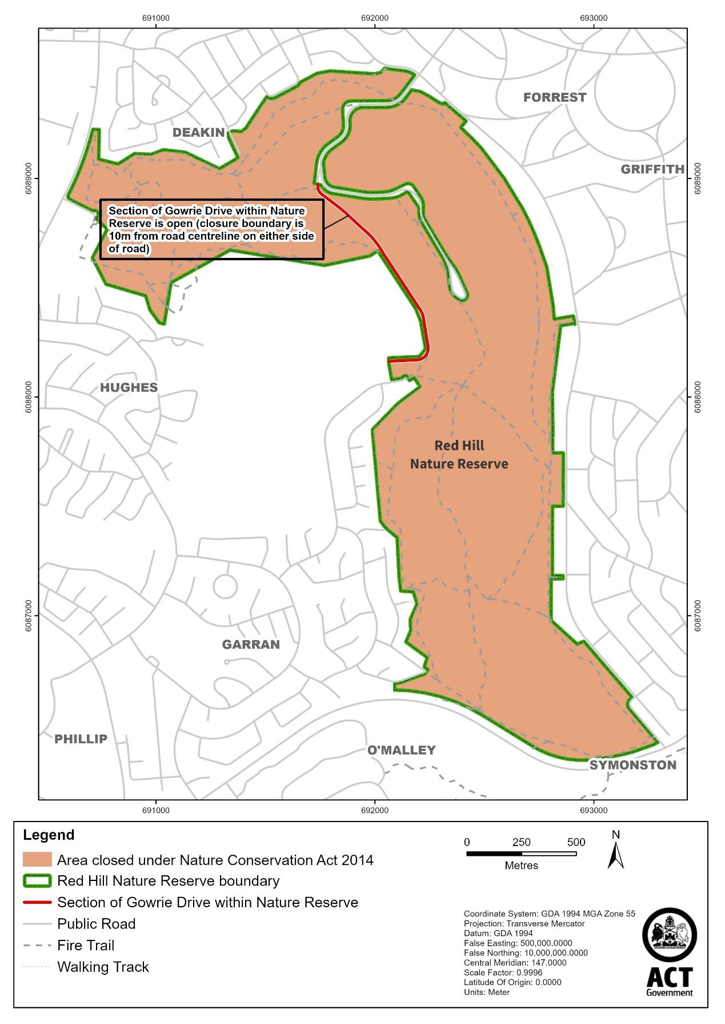

Mount Ainslie Nature Reserve
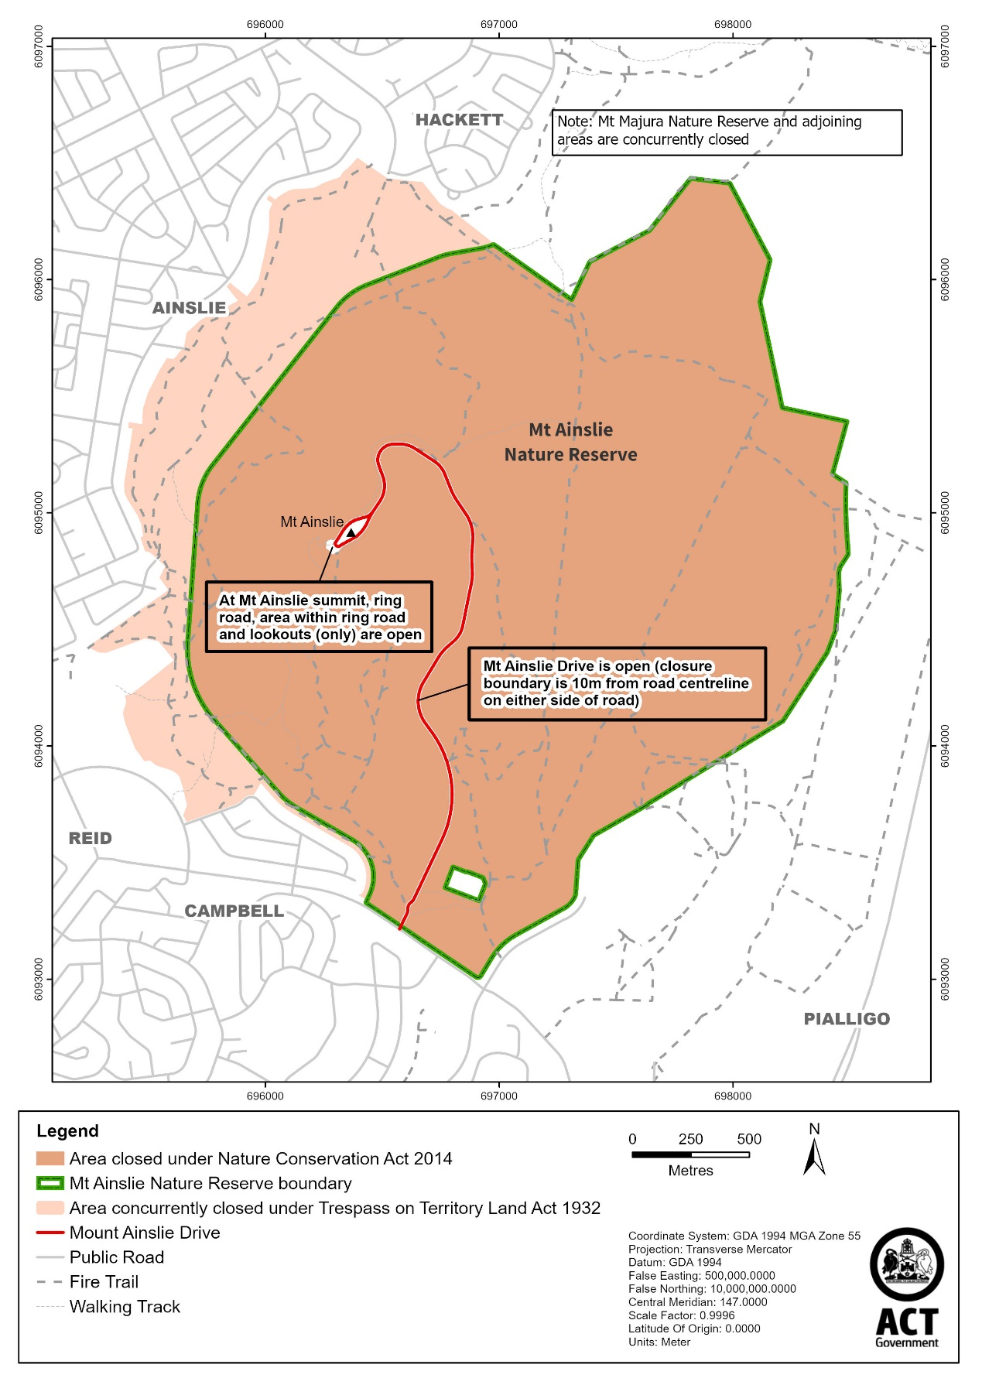

Schedule 3 Closure periods
(see s 3)

column 1  closed reserve | column 2  times when public access is prohibited
Red Hill | Beginning at 8:00 pm every Tuesday and Thursday and ending on the following day at 4:00 am
Mount Ainslie  Mount Majura Nature Reserve  Mount Pleasant Nature Reserve  Percival Hill Nature Reserve | Beginning at 8:00 pm every Tuesday and ending the following day at 4.00am

