Australian Capital Territory
Planning and Development (Technical Amendment—Changes to public land overlay boundaries) Plan Variation 2023

Notifiable instrument NI2023—659
Technical Amendment No 2023-06
made under the
Planning and Development Act 2007, s 89 (Making technical amendments)

- Name of instrument
This instrument is the Planning and Development (Technical Amendment—Changes to public land overlay boundaries) Plan Variation 2023.
2 Commencement
This instrument commences on the day after its notification day.
3 Technical amendment
I am satisfied under section 89 (1) (a) of the Planning and Development Act 2007, that the changes to public land overlay boundaries plan variation is a technical amendment to the Territory Plan.
4 Dictionary
In this instrument:
Changes to public land overlay boundaries plan variation means the technical amendment to the Territory Plan, variation 2023-06, in the schedule.
Note No consultation was required in relation to this plan variation under the Act, s 87.

Freya O’Brien
Delegate of the planning and land authority
25 October 2023

Planning & Development Act 2007

Technical Amendment
to the Territory Plan
Variation 2023-06

Changes to public land
overlay boundaries

October 2023

Table of Contents
1. INTRODUCTION 1
1.1 Purpose 1
1.2 Public consultation 1
1.3 National Capital Authority 1
1.4 Process 1
1.5 Types of technical amendments under the Act 2
2. EXPLANATION 3
2.1 Background 3
2.2 Variation to the Territory Plan Map 3
3. TECHNICAL AMENDMENT 9
3.1 Territory Plan Map 9

- INTRODUCTION
  - Purpose
This technical amendment makes the following changes to the Territory Plan:
Territory Plan Map
Casey:
- re-align the public land ‘Pc – a nature reserve’ overlay to exclude Casey section 2 blocks 1 and 2
- separate the public land ‘Pc – a nature reserve’ overlay to align with the division boundary of Casey
Rendezvous Creek:
- re-align the public land ‘Pa – Wilderness Area’ and ‘Pb – National Park’ overlays at Rendezvous Creek rural block 3

  - Public consultation
Under section 87(1)(b) of the Planning and Development Act 2007 (the Act) this type of technical amendment is not subject to public consultation.

  - National Capital Authority
The National Capital Authority does not need to be advised of this technical amendment as per 1.2.

  - Process
This technical amendment has been prepared in accordance with section 87 and made in accordance with section 89 of the Act.
  - Types of technical amendments under the Act
The following categories of technical amendments are provided under section 87 of the Act:
- Each of the following territory plan variations is a technical amendment for which no consultation is needed before it is made under section 89:
(a) a variation (an error variation) that –
- would not adversely affect anyone’s rights if approved; and
- has as its only object the correction of a formal error in the plan;
(b) a variation to change the boundary of a zone or overlay under section 90A (Rezoning – boundary changes);
(c) a variation, other than one to which subsection (2)(d) applies, in relation to an estate development plan under section 96 (Effect of approval of estate development plan);
(d) a variation required to bring the territory plan into line with the national capital plan;
(e) a variation to omit something that is obsolete or redundant in the territory plan.
- Each of the following territory plan variations is a technical amendment for which only limited public consultation is needed under section 90:
- a variation (a code variation) that –
- would only change a code; and
- is consistent with the policy purpose and policy framework of the code; and
- is not an error variation;
- a variation to change the boundary of a zone under section 90B (Rezoning – development encroaching on adjoining territory land);
- a variation in relation to a future urban area under section 90C (Technical amendments – future urban areas);
- a variation in relation to an estate development plan under section 96 (Effect of approval of estate development plan) if it incorporates an ongoing provision that was not included in the plan under
section 94(3)(g);
- a variation to clarify the language in the territory plan if it does not change the substance of the plan;
- a variation to relocate a provision within the territory plan if the substance of the provision is not changed.
TA2023-06 has been prepared in accordance with section 87(1)(b) of the Act.
- EXPLANATION
This part of the technical amendment document explains the changes to be made to the Territory Plan, the reasons for the change, and a statement of compliance against the relevant section of the Act.
  - Background
Casey
The boundary of the public land ‘Pc – a nature reserve’ overlay (Kinlyside Nature Reserve) is being re-aligned to excise Casey section 2 blocks 1 and 2. These blocks contain an Icon Water reservoir and access track which are fenced off from the rest of the reserve and contain no trees or suitable habitat. The overlay is also being separated to align with the division boundary of Casey.
Rendezvous Creek
The boundary of the public land ‘Pa – a wilderness area’ (Bimberi Wilderness) and ‘Pb – a national park’ (Namadgi National Park) reserve overlays are being re-aligned at Rendezvous Creek rural block 3.
As part of the post Orroral Fire re-build of the viewing platform and track to the Yankee Hat Aboriginal rock art site, the opportunity to formalise an additional section of track has been identified. The site of the proposed track is approximately 200m within the wilderness boundary. Making a track or road in a wilderness area is an offence under Section 223 of the Nature Conservation Act 2014. To permit this track extension to be considered and assessed under the Planning and Development Act 2007, approximately 8.5 hectares of land is being excised from the wilderness area and included in national park.
This proposal has been discussed with key stakeholders including the National Parks Association and Representative Aboriginal Organisations, who support the variation to amend the boundaries of the overlays.
  - Variation to the Territory Plan Map
In accordance with section 90A of the Act, this technical amendment makes changes to the public land overlay boundaries as follows:
Casey:
- re-align the public land ‘Pc – a nature reserve’ overlay to excise Casey section 2 blocks 1 and 2
- separate the public land ‘Pc – a nature reserve’ overlay to align with the division boundary of Casey
Rendezvous Creek:
- re-align the public land ‘Pa – a wilderness area’ and ‘Pb – a national park’ overlays at Rendezvous Creek rural block 3

Casey

Existing Territory Plan Map

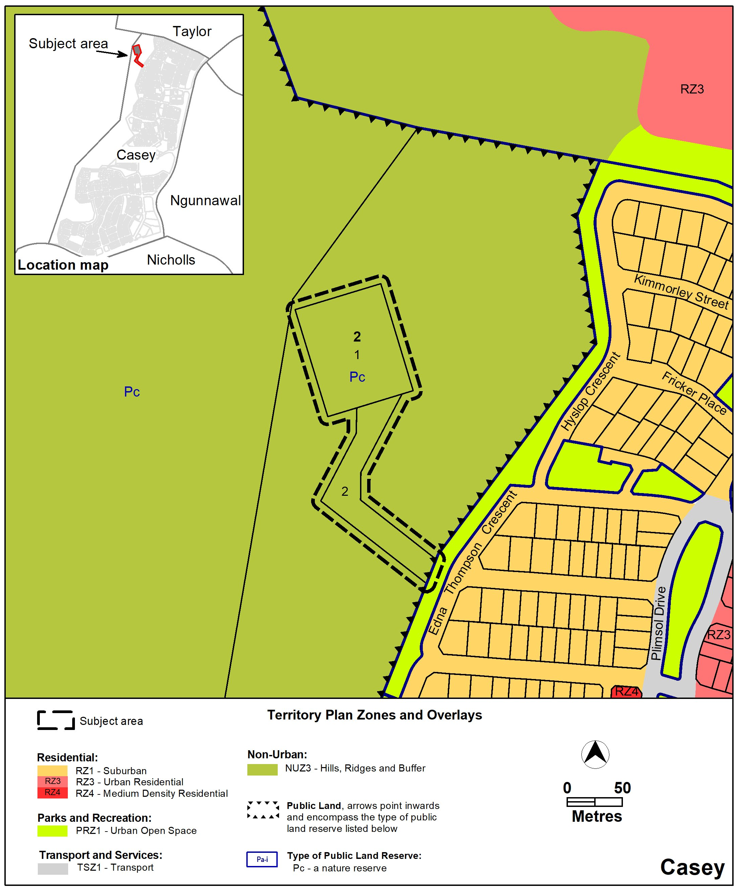

Proposed Territory Plan Map
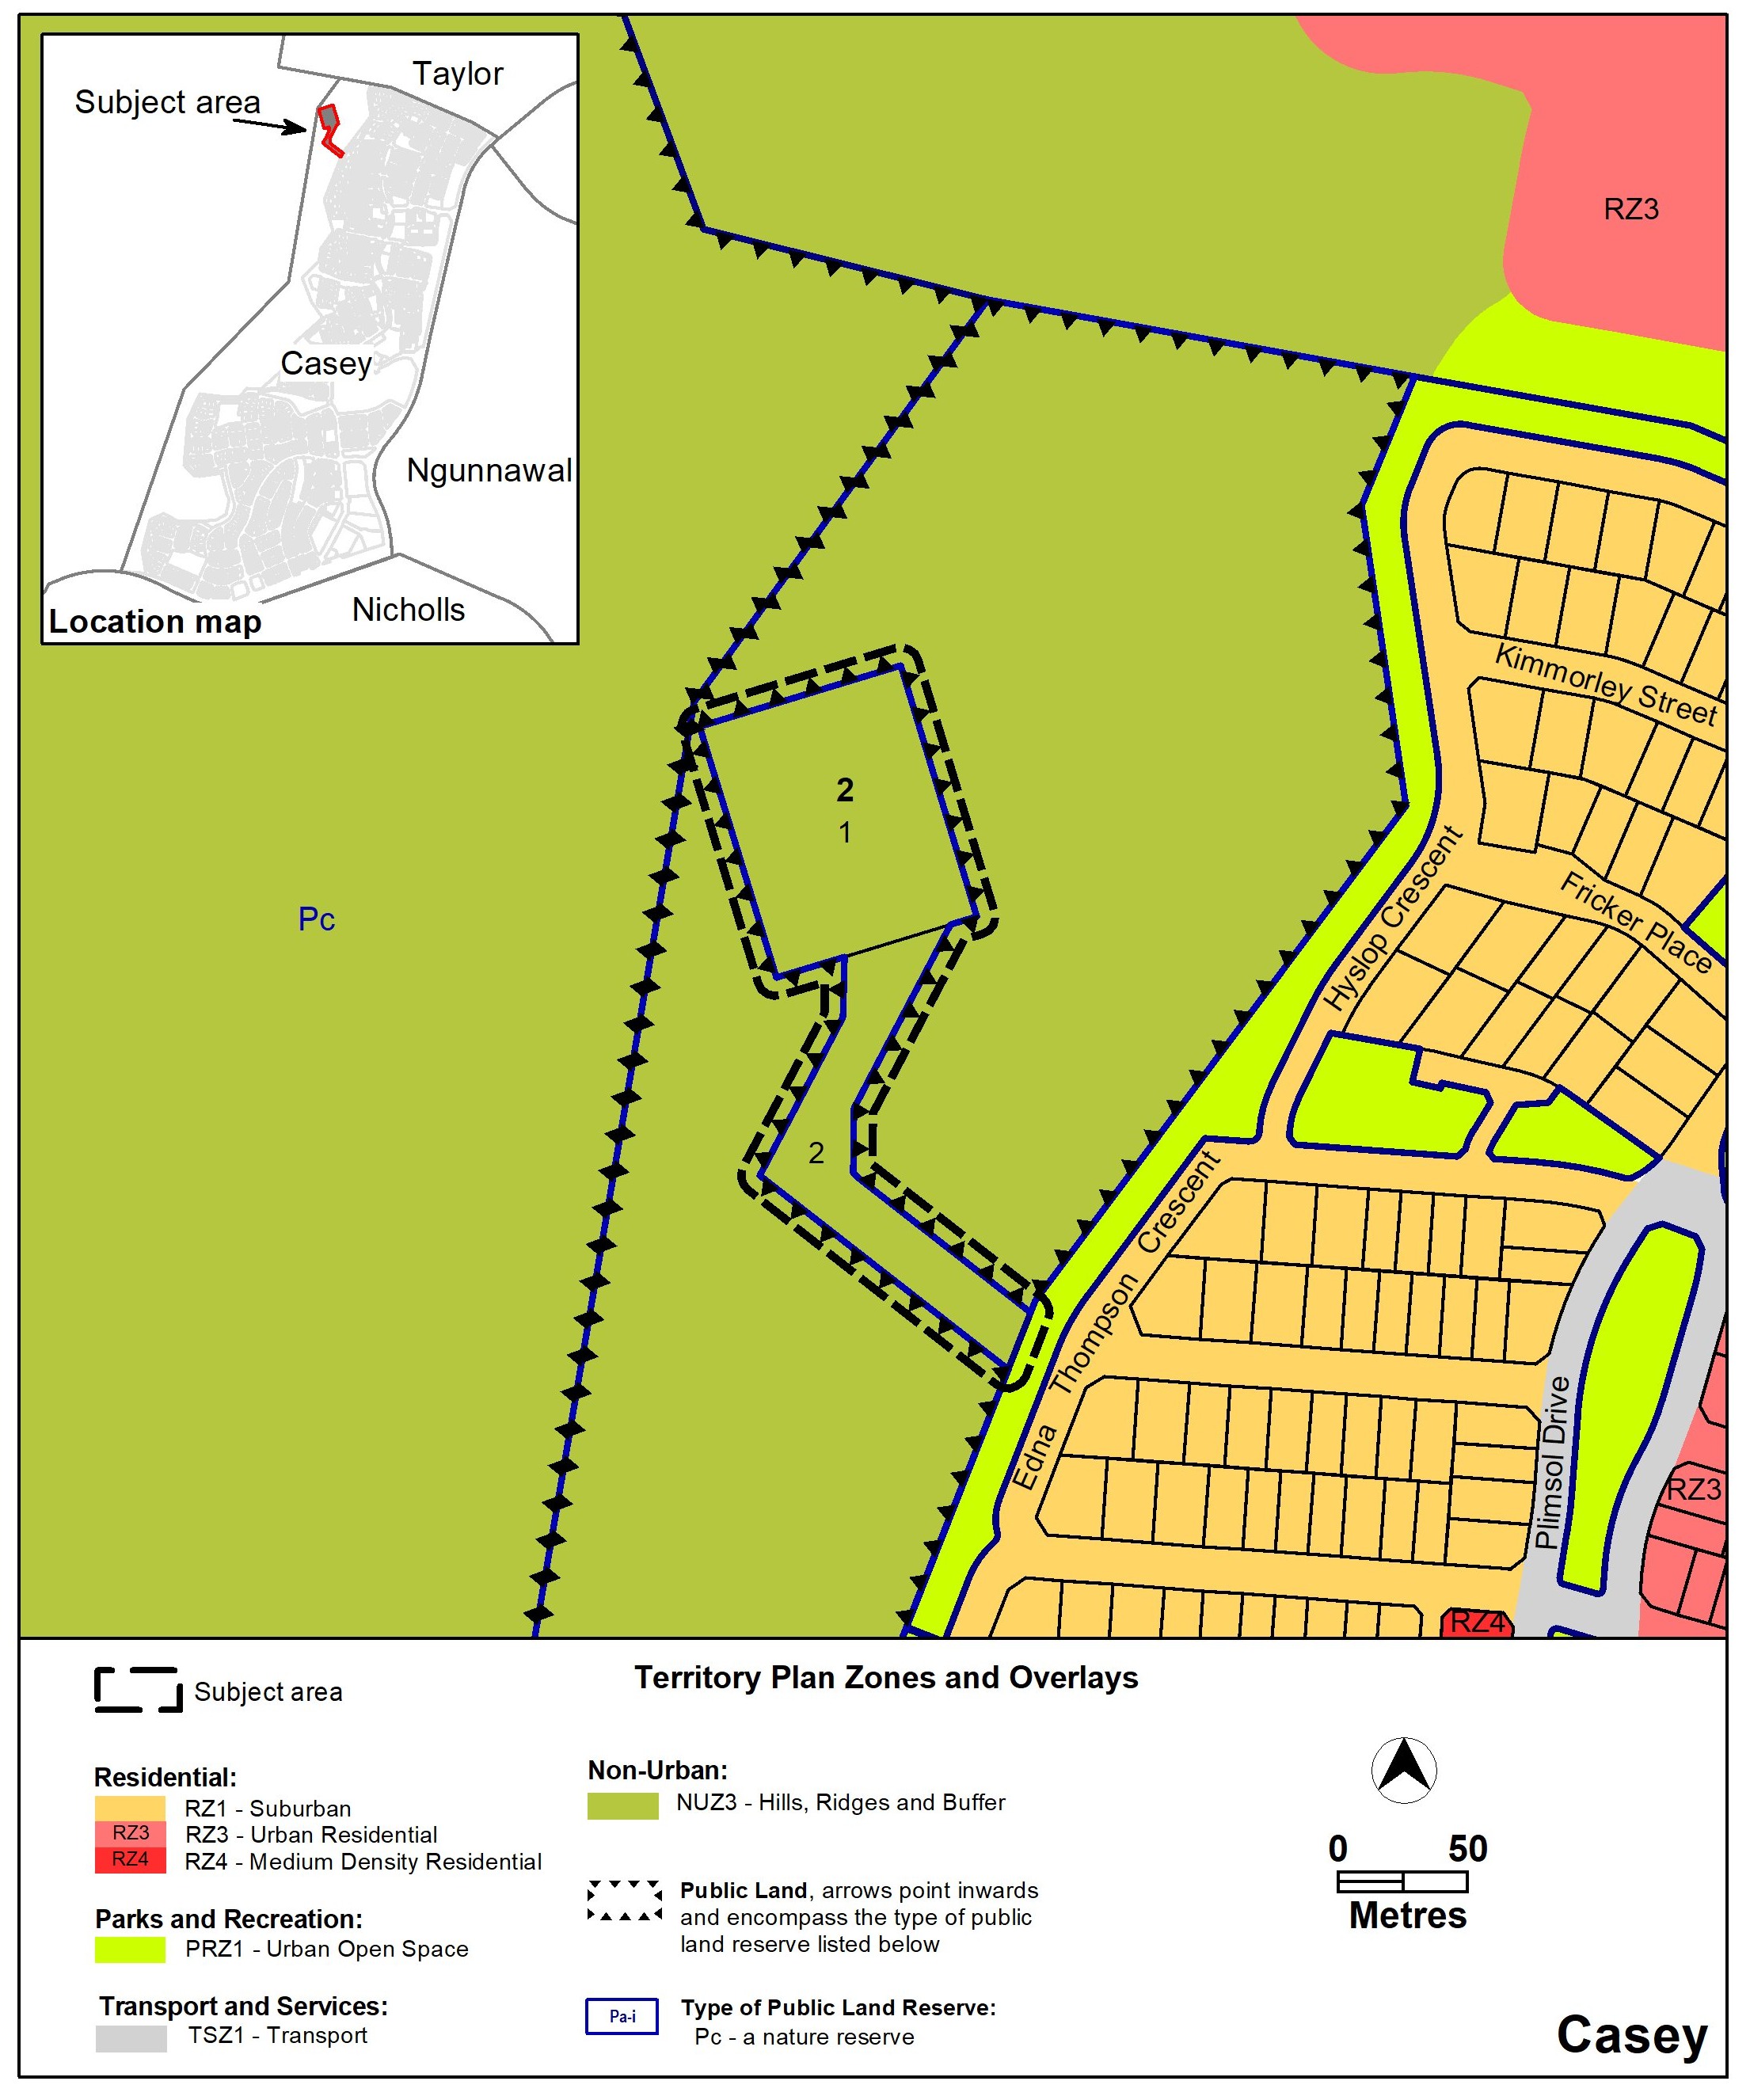

Rendezvous Creek

Existing Territory Plan Map

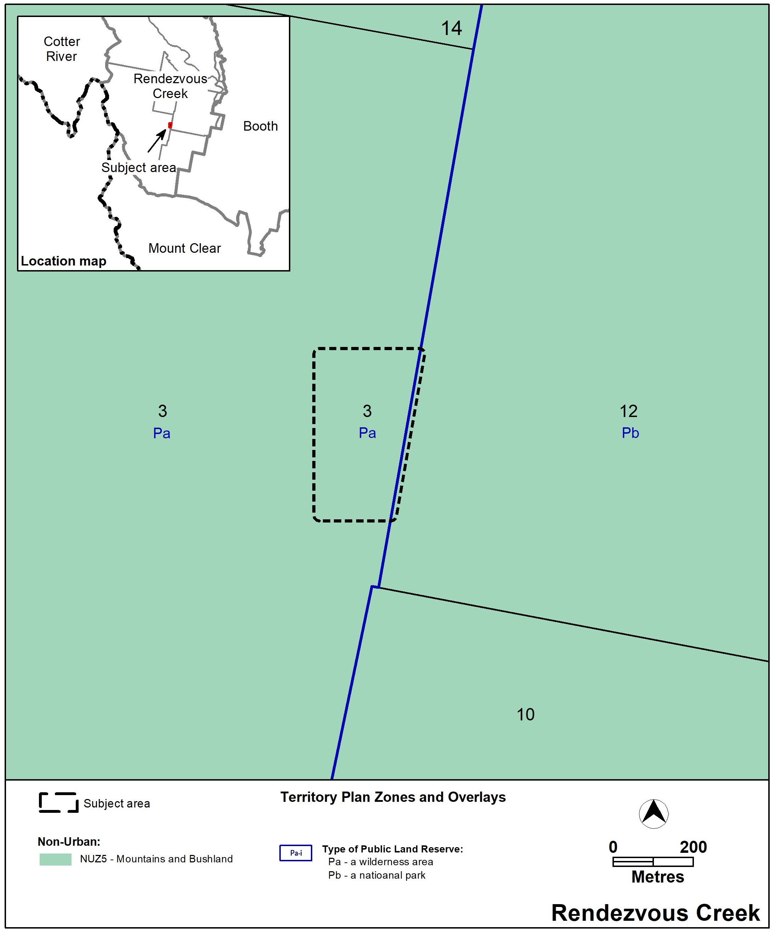

Proposed Territory Plan Map
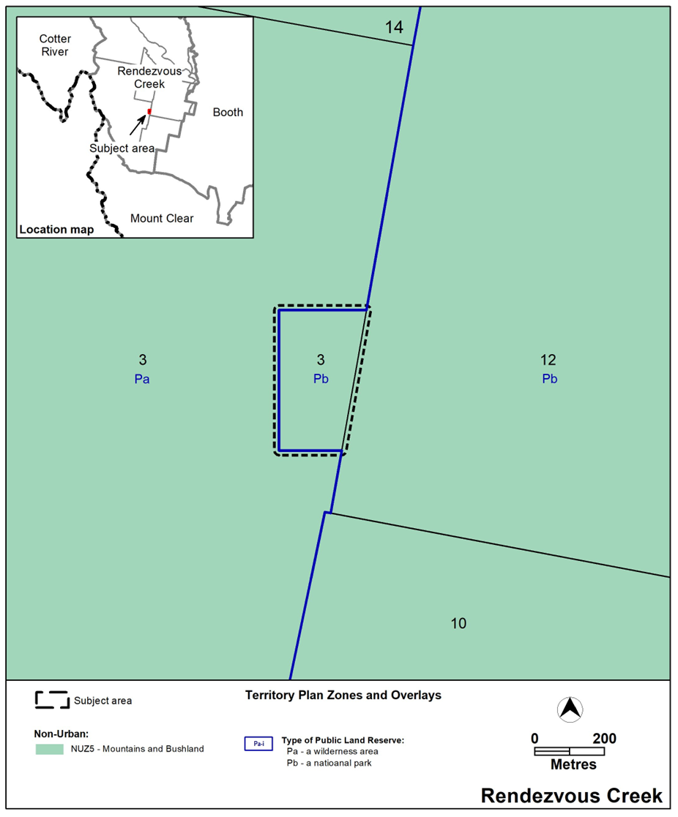

Section | Statement
Section 87 (1) (b) – a variation to change the boundary of a zone or overlay under section 90A (Rezoning boundary changes)
Section 90A  - This section applies to a zone or overlay in relation to land if the land adjoins unleased territory land or land for which the Territory is the registered proprietor (the adjoining territory land). | This technical amendment adjusts the public land ‘Pc – a nature reserve’ overlay boundary at Casey (Kinlyside Nature Reserve) for which the Territory is the registered proprietor. It also adjusts the public land ‘Pa – wilderness area’ and ‘Pb – national park’ overlay boundaries at Rendezvous Creek on land which is unleased.
- The planning and land authority may vary the territory plan under section 89 (Making technical amendments) to change the boundary of the zone or overlay to encroach onto the adjoining territory land if the change is consistent with— (a) the apparent intent of the original boundary line; and (b) the objective for the zone. | This technical amendment adjusts the overlay boundaries at Casey section 2 blocks 1 and 2 in line with existing blocks containing a water reservoir and an access road. It will result in improved management of the infrastructure without adversely affecting the Kinlyside Nature Reserve.  This technical amendment also adjusts the public land ‘Pa – Wilderness Area’ and ‘Pb – National Park’ to allow for creation of a track at Rendezvous Creek rural block 3.  This amendment is considered to be consistent with the apparent intent of the original boundaries of the overlays. This technical amendment facilitates the achievement of the zone objectives.
- The planning and land authority may vary the territory plan under section 89 to change the boundary of an overlay to encroach onto the adjoining territory land if—  (a) the authority is advised to do so by—  (i) the conservator of flora and fauna; or  (ii) the custodian of the land for the overlay; and  (b) the conditions in subsection (2) (a) and (b) are satisfied.  - In this section: overlay means an overlay identified in the territory plan. | The planning and land authority has been advised to make the changes by the Conservator of Flora and Fauna.  The conditions in subsection (2) (a) and (b) are satisfied as explained above.

- TECHNICAL AMENDMENT
This section of the technical amendment document provides the actual instructions for implementing the changes to the Territory Plan.
  - Territory Plan Map
- Casey
The Territory Plan map is varied as indicated below.
- Rendezvous Creek
The Territory Plan map is varied as indicated below.
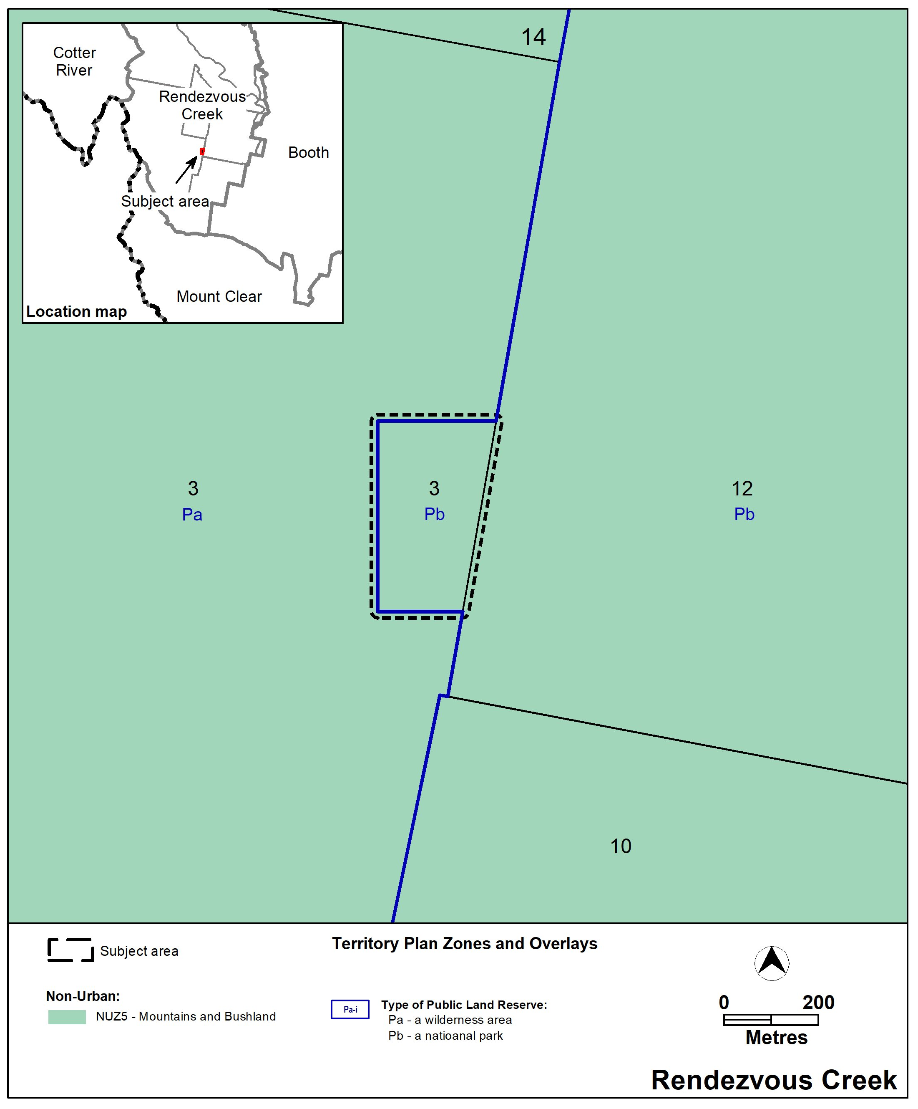

Interpretation service
