Australian Capital Territory
Planning and Development (Technical Amendment—Code Amendments) Plan Variation 2023 (No 4)

Notifiable instrument NI2023–706
Technical amendment No 2023-10
made under the
Planning and Development Act 2007, s 89 (Making technical amendments)

1 Name of instrument
This instrument is the Planning and Development (Technical Amendment–Code Amendments) Plan Variation 2023 (No 4).
2 Commencement
This instrument commences on the day after its notification day.
3 Technical amendment
I am satisfied under the Planning and Development Act 2007, section 89 (1) (a), that the Code amendments plan variation is a technical amendment to the Territory Plan.
4 Dictionary
In this instrument:
Code amendments plan variation means the technical amendment to the Territory Plan, variation 2023-10, as set out in the schedule.
Freya O’Brien
Delegate of the planning and land authority
17 November 2023

Planning and Development Act 2007

Technical Amendment
to the Territory Plan

2023-10

Changes to the Garran
Precinct Map and Code

November 2023

Commencement version
under section 89 of the Planning and Development Act 2007

Table of Contents
1. INTRODUCTION 1
1.1 Purpose 1
1.2 Public consultation 1
1.3 National Capital Authority 1
1.4 Process 1
1.5 Types of technical amendments under the Act 2
2. EXPLANATORY STATEMENT 3
2.1 Background 3
2.2 Garran Precinct Map and Code 3
3. TECHNICAL AMENDMENT 6
3.1 Variation to Garran Precinct Map and Code 6

INTRODUCTION
    - Purpose
This technical amendment proposes to make the following changes to the Territory Plan:
Garran Precinct Map and Code
- amend rule R1 regarding vehicular access off Kitchener Street
- replace the Garran Precinct Map to include revised boundary of RC1
    - Public consultation
Under section 87(2)(a) of the Planning and Development Act 2007 (the Act) this type of technical amendment was subject to limited public consultation.
TA2023-10 was released for public consultation from 13 October 2023 to 10 November 2023.
No submissions were received.
    - National Capital Authority
The Australian Capital Territory (Planning and Land Management) Act 1988 established the National Capital Authority (NCA) with two of its functions being to prepare and administer a National Capital Plan (the Plan) and to keep the NCP under constant review and to propose amendments to it when necessary.
The Plan, which was published in the Commonwealth Gazette on 21 January 1990, is required to ensure Canberra and the Territory are planned and developed in accordance with their national significance. The Australian Capital Territory (Planning and Land Management) Act 1988 also requires the Territory Plan not be inconsistent with the Plan. The areas covered by this technical amendment are within urban areas identified in the Plan.
The National Capital Authority has been advised of this technical amendment.
    - Process
This technical amendment has been prepared in accordance with section 87 of the Planning and Development Act 2007 (the Act).

    - Types of technical amendments under the Act
The following categories of technical amendments are provided under section 87 of the Act:
- Each of the following territory plan variations is a technical amendment for which no consultation is needed before it is made under section 89:
(a) a variation (an error variation) that –
- would not adversely affect anyone’s rights if approved; and
- has as its only object the correction of a formal error in the plan;
(b) a variation to change the boundary of a zone or overlay under section 90A (Rezoning – boundary changes);
(c) a variation, other than one to which subsection (2)(d) applies, in relation to an estate development plan under section 96 (Effect of approval of estate development plan);
(d) a variation required to bring the territory plan into line with the national capital plan;
(e) a variation to omit something that is obsolete or redundant in the territory plan.
- Each of the following territory plan variations is a technical amendment for which only limited public consultation is needed under section 90:
- a variation (a code variation) that –
- would only change a code; and
- is consistent with the policy purpose and policy framework of the code; and
- is not an error variation;
- a variation to change the boundary of a zone under section 90B (Rezoning – development encroaching on adjoining territory land);
- a variation in relation to a future urban area under section 90C (Technical amendments – future urban areas);
- a variation in relation to an estate development plan under section 96 (Effect of approval of estate development plan) if it incorporates an ongoing provision that was not included in the plan under section 94 (3) (g);
- a variation to clarify the language in the territory plan if it does not change the substance of the plan;
- a variation to relocate a provision within the territory plan if the substance of the provision is not changed.
TA2023-10 has been prepared in accordance with section 87(2)(a) of the Act.

EXPLANATORY STATEMENT
    - Background
This part of the technical amendment explains the changes to be made to the Territory Plan, the reasons for the change, and a statement of compliance against the relevant section of the Act.
    - Garran Precinct Map and Code
Rule R1 is being amended to allow some flexibility in the location of the road intersection with Kitchener Street to enable safer vehicular access to the proposed retirement village within the Federal Golf Course. It is also proposed that the northern boundary of RC1 be extended to accommodate the proposed road within section 10 block 76.

Change to rule R1 shown in red text.
R1  Development of a road intended to provide access to a retirement village at Red Hill section 56 part of block 1 complies with all of the following:  - a public road is constructed to provide access to the retirement village at the Federal Golf Course  - the road utilises the existing access to Garran section 10 block 75 of Kitchener Street or the intersection of the road access with Kitchener Street is at a location agreed to by TCCS, having regard to intersection safety and design considerations  - the road is setback a minimum 50 metres from residential blocks  - development of the road does not diminish or inhibit recreational opportunities and maintenance of ecological values on the balance of the site. | This is a mandatory requirement. There is no applicable criterion.

The current boundary of RC1 is shown in the Garran Precinct Map below. The boundary of RC1 is being re-aligned to include the area shaded in grey.
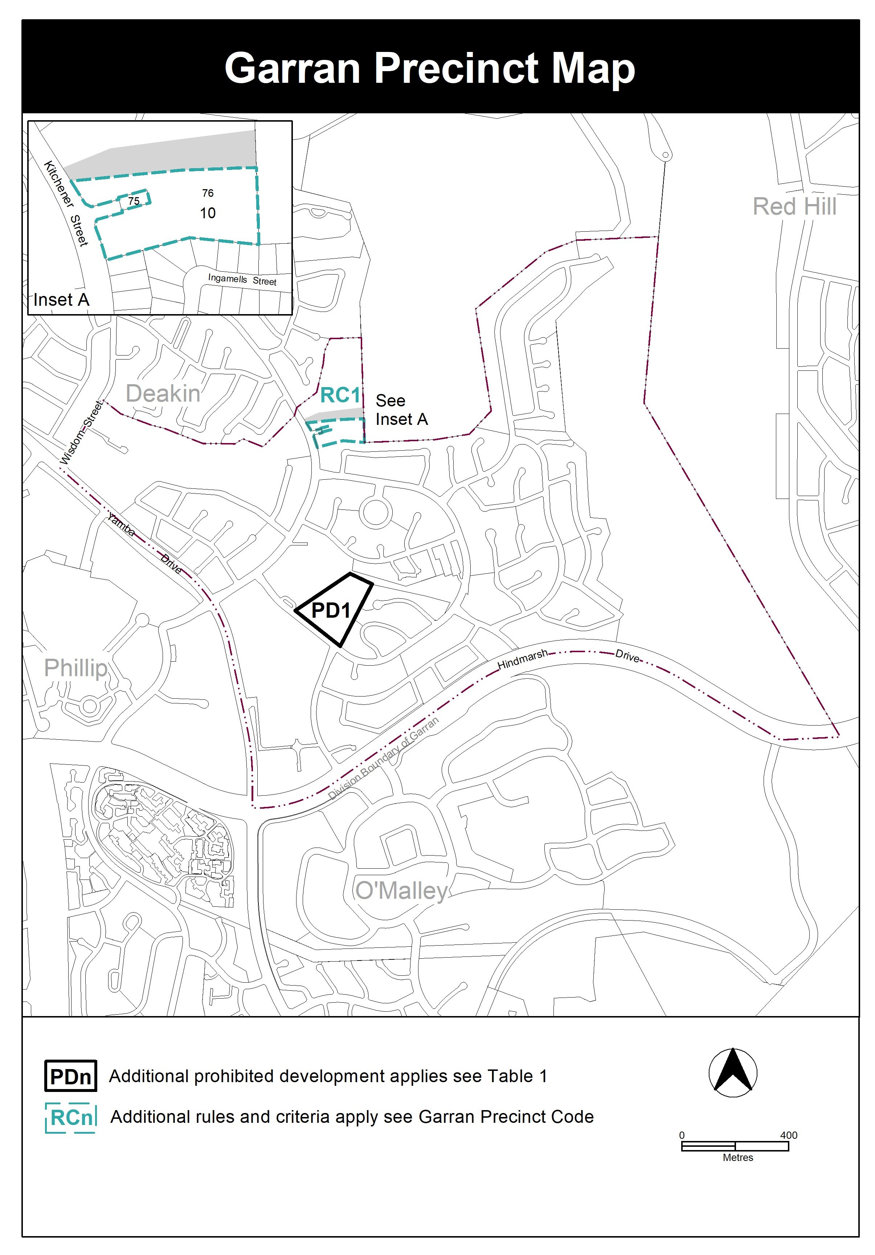
Section | Statement
s87(2)(a)  (a) a variation (a code variation) that—  (i) would only change a code; and  (ii) is consistent with the policy purpose and policy framework of the code; and  (iii) is not an error variation | Compliant.  The changes are proposed to be made to the Garran Precinct Map and Code. The proposed changes are consistent with the policy purpose and policy framework of the code. The proposed change to rule R1 will provide some flexibility in providing safer vehicular access off Kitchener Street, subject to agreement by TCCS. The proposed boundary re-alignment of RC1 reflects the proposed change to rule R1.

TECHNICAL AMENDMENT
This section of the technical amendment document provides the actual instructions for implementing the changes to the Territory Plan.

    - Variation to Garran Precinct Map and Code
- Garran Precinct Map

substitute
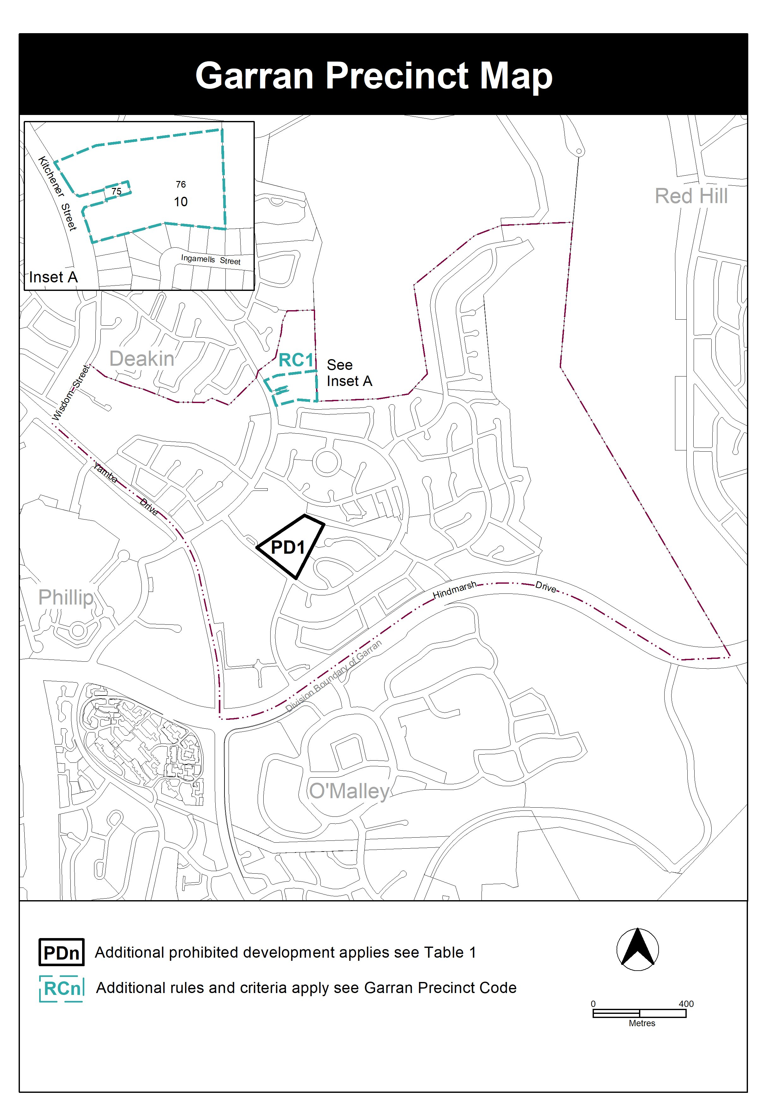

- Additional rules and criteria, RC1 – Kitchener Street Access, Element 1: Site access, rule R1

substitute
R1  Development of a road intended to provide access to a retirement village at Red Hill section 56 part of block 1 complies with all of the following:  - a public road is constructed to provide access to the retirement village at the Federal Golf Course  - the road utilises the existing access to Garran section 10 block 75 of Kitchener Street or the intersection of the road access with Kitchener Street is at a location agreed to by TCCS, having regard to intersection safety and design considerations  - the road is setback a minimum 50 metres from residential blocks  - development of the road does not diminish or inhibit recreational opportunities and maintenance of ecological values on the balance of the site. | This is a mandatory requirement. There is no applicable criterion.

Interpretation service

