Australian Capital Territory
Planning (Inner South District) Technical Specifications 2023 (No 2)
Notifiable instrument NI2023–736
made under the
Planning Act 2023, s 51 (Technical specifications)

1 Name of instrument
This instrument is the Planning (Inner South District) Technical Specifications 2023 (No 2).
2 Commencement
This instrument commences on the commencement of the Planning Act 2023, section 16.
3 Technical specifications
I make the technical specifications at schedule 1.
4 Revocation
I revoke the Planning (Inner South District) Technical Specifications 2023 (NI2023-547).

Ben Ponton
Chief Planner
23 November 2023

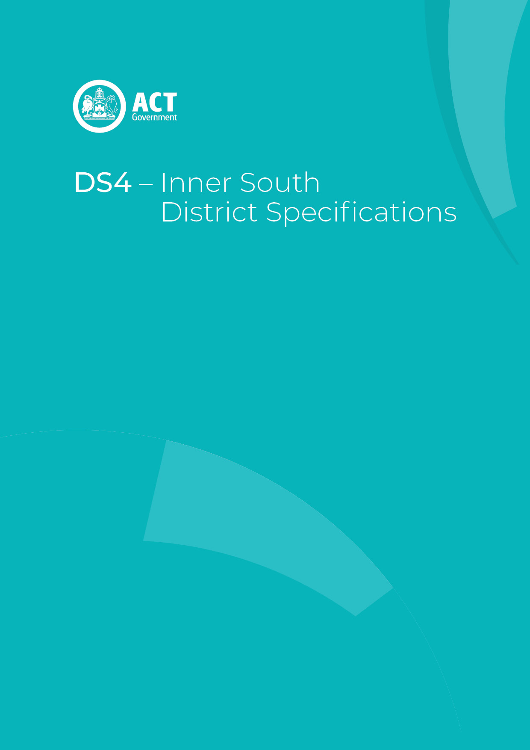

Schedule 1

Contents
Contents 2
Inner South District planning technical specifications 3
1. Barton 4
2. Capital Hill 4
3. Deakin 4
Front Boundary setback 4
Maximum Floor Area 4
4. Forrest 5
Demonstration Housing – Block 5 Section 44 Forrest 5
5. Fyshwick 5
Assessment Outcome 5
Building Height 5
Dairy Road Mixed Use Area – Noise Attenuation 5
Dairy Road Mixed Use Area – Urban Heat 6
6. Griffith 6
Demonstration Housing – Block 6 Section 31 Griffith 6
7. Kingston 6
8. Narrabundah 7
9. Parkes 7
10. Red Hill 7
Federal Golf Course Development – Canopy Coverage 7
11. Yarralumla 7

Inner South District planning technical specifications
The primary assessment consideration for a development application is the assessment outcomes in the Territory Plan. In demonstrating compliance with the assessment outcomes, consideration may be given to the relevant planning technical specifications which may serve as a benchmark. While all assessment outcomes are to be met, not all outcomes are covered by a specification.
Planning technical specifications are used as a possible solution or to provide guidance for identified aspects of a development proposal. The specifications may also be used as a reference or benchmark in the preparation and assessment of development proposals to demonstrate compliance with the assessment outcomes, and the Territory Plan.
Where a proposed development complies with a relevant provision in the planning technical specifications and the development comprehensively addresses the assessment outcome, further assessment regarding those specific provisions will not be required.
The specifications in the Inner South District Specifications can be used to demonstrate compliance with the assessment outcomes in the Inner South District Policy or the relevant zone policy. Where there is a specific assessment outcome in the Inner South District Policy, this takes precedence over the equivalent outcome in the zone policy. Where there is no specific assessment outcome in the Inner South District Policy, the specification can be used to demonstrate compliance with the assessment outcomes in the zone policy.
The Territory Planning Authority may consider advice or written support from a referral entity to demonstrate compliance with a relevant assessment outcome. Where endorsement from an entity is noted as a planning specification, entity referral may be required.
Consistent with the Inner South District Policy, this Inner South District Specifications comprises specifications for specific localities, structured according to the localities.
These specifications will only apply to the specific sites or locations they refer to and should be used in conjunction with the relevant district policy, i.e., Part D4: Inner South District Policy.
- Barton
The following specifications provide possible solutions that should be considered in planning, placing, designing and using buildings and structures for proposed development in Barton:

No applicable specification for this suburb.

- Capital Hill
The following specifications provide possible solutions that should be considered in planning, placing, designing and using buildings and structures for proposed development in Capital Hill:

No applicable specification for this suburb.

- Deakin
The following specifications provide possible solutions that should be considered in planning, placing, designing and using buildings and structures for proposed development in Deakin:
Assessment Outcome 1 | In Sections 5, 6, 7 and 8, front boundary setbacks respect the established building lines of surrounding properties
Front Boundary setback | - The minimum front boundary setback is 10m

Assessment Outcome | Refer to zone assessment outcomes
Specification
Maximum Floor Area | - On Block 89 Section 37 Deakin the maximum gross floor area for a drink establishment, restaurant or shop is 720m²

- Forrest
The following specifications provide possible solutions that should be considered in planning, placing, designing and using buildings and structures for proposed development in Deakin:

Assessment Outcome 2 | In Sections 20, 21, 22, 27 and 28, front boundary setbacks respect the established building lines of surrounding properties
No applicable specification for this assessment outcome. Application must respond to the assessment outcome

Assessment Outcome |  | Refer to zone assessment outcomes
Specification
Demonstration Housing – Block 5 Section 44 Forrest | - Development of multi-unit housing for a Demonstration Housing Project identified on a register published on an ACT Government website complies with all of the following:  - Maximum plot ratio is 50%.  - All dwellings must achieve the Livable Housing Design (Gold Level) accreditation, first published by Livable Housing Australia.  - Only one driveway verge crossings permitted for the block.  - A minimum of 6 car parking spaces are to be provided on the block.

- Fyshwick
The following specifications provide possible solutions that should be considered in planning, placing, designing and using buildings and structures for proposed development in Fyshwick:

Assessment Outcome 3 | Building frontages to Canberra Avenue are consistent with established building lines and achieve a landscaped setting
No applicable specification for this assessment outcome. Application must respond to the assessment outcome

Assessment Outcome |  | Refer to zone assessment outcomes
Specification
Building Height | - On Blocks 15 and 16 Section 6 the maximum number of storeys is 4.
Dairy Road Mixed Use Area – Noise Attenuation | - Noise attenuation for noise from external sources:  - For residential development all dwellings are constructed to comply with the relevant sections of AS/NZS 2107:2016 - Acoustics – Recommended design sound levels and reverberation times for building interiors (the relevant satisfactory recommended interior design sound level).  - Compliance with this specification is demonstrated by an acoustic assessment and noise management plan, prepared by a member of the Australian Acoustical Society with experience in the assessment of rail traffic noise, and endorsed by the ACT Government entity responsible for transport planning.  - Development complies with a noise management plan prepared by a suitably qualified person and endorsed by the Environment Protection Authority (EPA).  Note: The noise management plan will detail the proposed design, siting and construction methods that will be employed to ensure compliance with the Noise Zone Standard as detailed in the Environment Protection Regulation 2005, based on the estimated noise levels when the facility is in use.  Note: A condition of development approval may be imposed to ensure compliance with the endorsed noise management plan.
Dairy Road Mixed Use Area – Urban Heat | - Development demonstrates that there is no net gain of urban heat.  Note: Compliance is demonstrated in a microclimate assessment report by a suitably qualified professional which details building and urban design and proposed use of heat mitigating measures.  A ‘suitably qualified professional’ is a person with qualifications and/or experience in urban climate science, urban modelling or microclimate assessment. This specification does not apply to a development application for the change of use of an existing building or structure

- Griffith
The following specifications provide possible solutions that should be considered in planning, placing, designing and using buildings and structures for proposed development in Griffith:

Assessment Outcome 4 | Building frontages to Canberra Avenue are consistent with established building lines and achieve a landscaped setting
No applicable specification for this assessment outcome. Application must respond to the assessment outcome

Assessment Outcome |  | Refer to zone assessment outcomes
Specification
Demonstration Housing – Block 6 Section 31 Griffith | 6.1 The maximum plot ratio for a manor house is 50%. A Manor house for the purposes of Demonstration Housing is defined as a building containing three or four dwellings, where:  - each dwelling is attached to another dwelling by a common wall or floor  - at least one dwelling is partially or wholly located above another dwelling  - the building contains no more than 2 storeys excluding the basement.  Note: A building is not an apartment if it meets the definition of manor house.

- Kingston
The following specifications provide possible solutions that should be considered in planning, placing, designing and using buildings and structures for proposed development in Kingston:

Assessment Outcome 5 | Appropriate green spaces buffers and other measures are developed to limit impact of future development of East Lake on the Jerrabomberra Wetlands
No applicable specification for this assessment outcome. Application must respond to the assessment outcome

Assessment Outcome 6 | Building frontage to Canberra Avenue are consistent with established building lines and achieve a landscaped setting
No applicable specification for this assessment outcome. Application must respond to the assessment outcome

- Narrabundah
The following specifications provide possible solutions that should be considered in planning, placing, designing and using buildings and structures for proposed development in Narrabundah:

No applicable specification for this suburb.

- Parkes
The following specifications provide possible solutions that should be considered in planning, placing, designing and using buildings and structures for proposed development in Parkes:

No applicable specification for this suburb.

- Red Hill
The following specifications provide possible solutions that should be considered in planning, placing, designing and using buildings and structures for proposed development in Red Hill:
Assessment Outcome |  | Refer to zone assessment outcomes
Specification
Federal Golf Course Development – Canopy Coverage | 10.1 Future development of the land should achieve whichever is the greater of the following:  - not result in a net loss of canopy coverage measured at a mature height or  - provide at least 30% canopy coverage measured at a mature height.

- Yarralumla
The following specifications provide possible solutions that should be considered in planning, placing, designing and using buildings and structures for proposed development in Yarralumla:

No applicable specification for this suburb.

