Australian Capital Territory
Planning (East Canberra District) Technical Specifications 2023 (No 2)
Notifiable instrument NI2023–740
made under the
Planning Act 2023, s 51 (Technical specifications)

1 Name of instrument
This instrument is the Planning (East Canberra District) Technical Specifications 2023 (No 2).
2 Commencement
This instrument commences on the commencement of the Planning Act 2023, section 16.
3 Technical specifications
I make the technical specifications at schedule 1.
4 Revocation
I revoke the Planning (East Canberra District) Technical Specifications 2023 (NI2023-552).

Ben Ponton
Chief Planner
23 November 2023

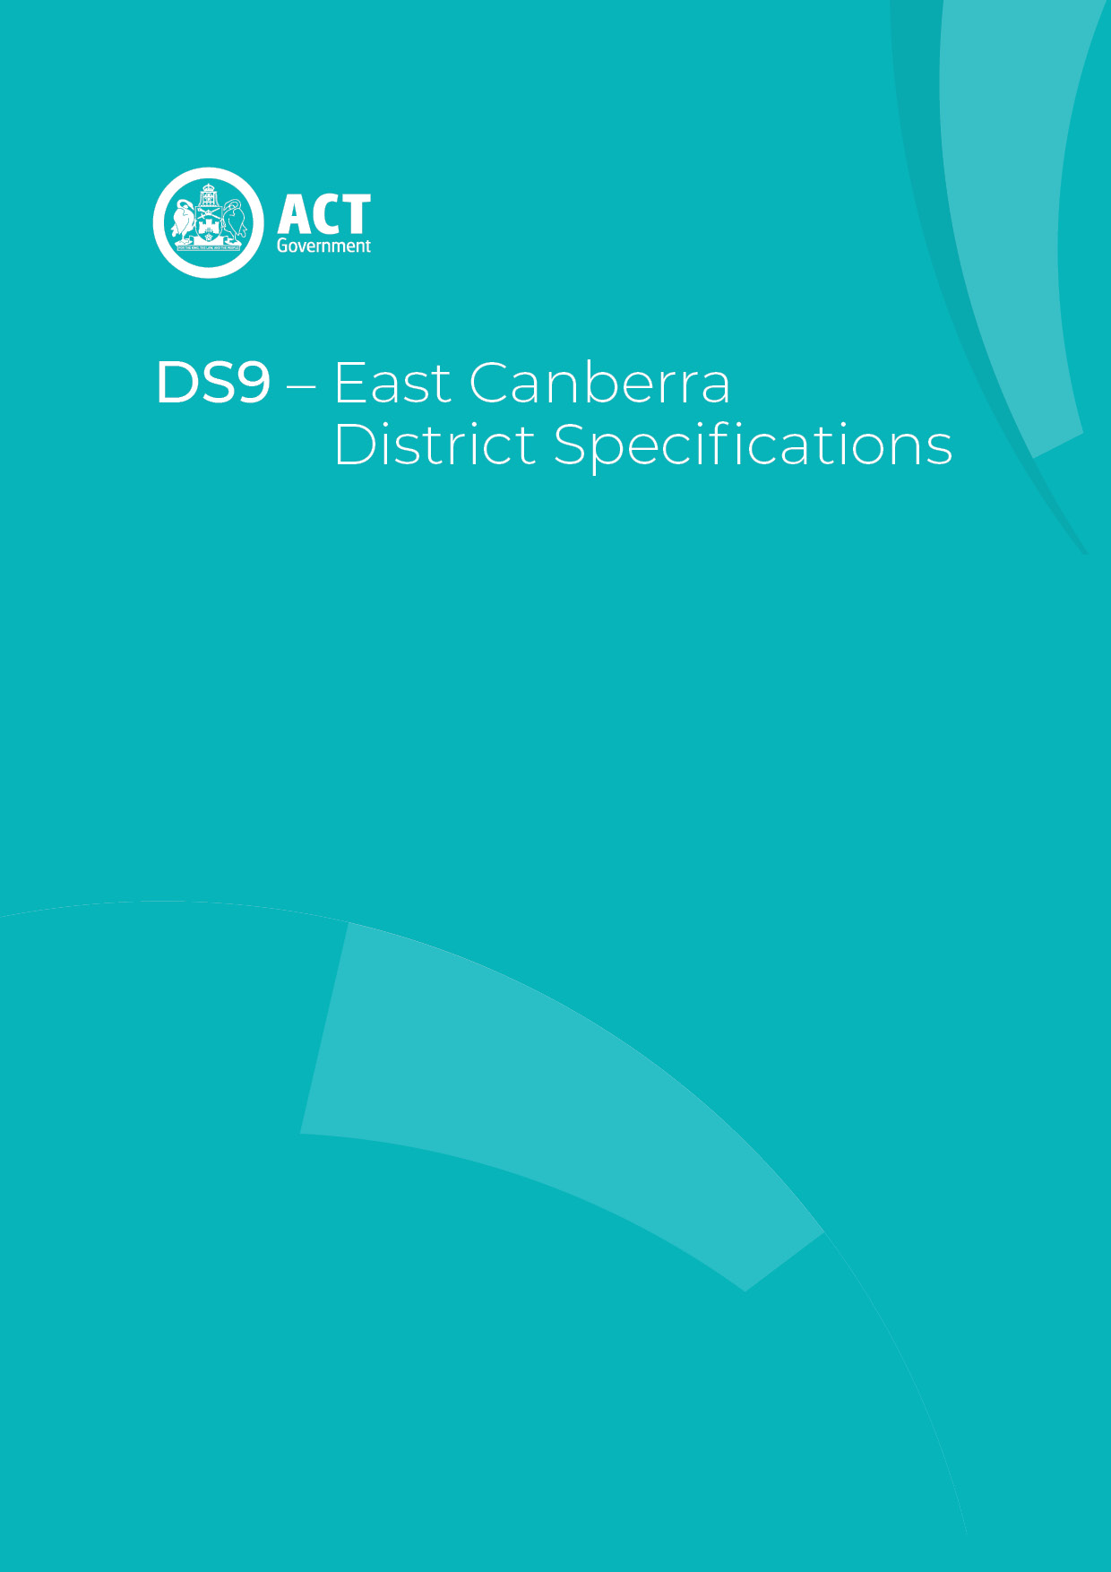
Schedule 1

Contents
Contents 2
East Canberra District planning technical specifications 3
1. Beard 4
Maximum gross floor area for take away shops 4
2. Hume 4
3. Jerrabomberra 4
4. Majura 4
Assessment Outcome 1 4
5. Oaks Estate 5
Assessment Outcome 2: 5
Assessment Outcome 3: 5
Assessment Outcome 4: 5
Front fence 5
Front setback 5
6. Pialligo 5
Assessment Outcome 5: 6
Assessment Outcome 6
Gross floor area 6
Site coverage 7
Figure 1 Pialligo – Agricultural area 8
7. Symonston 9
Gross floor area – Symonston Business Park 9
Urban heat– Symonston Business Park 9
Mugga Lane rural area 9

East Canberra District planning technical specifications
The primary assessment consideration for a development application is the assessment outcomes in the Territory Plan. In demonstrating compliance with the assessment outcomes, consideration may be given to the relevant planning technical specifications which may serve as a benchmark. While all assessment outcomes are to be met, not all outcomes are covered by a specification.
Planning technical specifications are used as a possible solution or to provide guidance for identified aspects of a development proposal. The specifications may also be used as a reference or benchmark in the preparation and assessment of development proposals to demonstrate compliance with the assessment outcomes, and the Territory Plan.
Where a proposed development complies with a relevant provision in the planning technical specifications and the development comprehensively addresses the assessment outcome, further assessment regarding those specific provisions will not be required.
The specifications in the East Canberra District Specifications can be used to demonstrate compliance with the assessment outcomes in the East Canberra District Policy or the relevant zone policy. Where there is a specific assessment outcome in the East Canberra District Policy, this takes precedence over the equivalent outcome in the zone policy. Where there is no specific assessment outcome in the East Canberra District Policy, the specification can be used to demonstrate compliance with the assessment outcomes in the zone policy.
The Territory Planning Authority may consider advice or written support from a referral entity to demonstrate compliance with a relevant assessment outcome. Where endorsement from an entity is noted as a planning specification, entity referral may be required.
Consistent with the East Canberra District Policy, this East Canberra District Specifications comprises specifications for specific localities, structured according to the localities.
These specifications will only apply to the specific sites or locations they refer to and should be used in conjunction with the relevant district policy, i.e., Part D9: East Canberra District Policy.

1. Beard
The following specifications provide possible solutions that should be considered in planning, placing, designing and using buildings and structures for proposed development in Beard:
Assessment Outcome: | Refer to zone assessment outcome
Specification
Maximum gross floor area for take away shops | 1.1. A The maximum gross floor area achieved for each take-away food shop or restaurant is 200m².

2. Hume
The following specifications provide possible solutions that should be considered in planning, placing, designing and using buildings and structures for proposed development in Hume:

No applicable specification for this suburb.

3. Jerrabomberra
The following specifications provide possible solutions that should be considered in planning, placing, designing and using buildings and structures for proposed development in Jerrabomberra:

No applicable specification for this suburb.

4. Majura
The following specifications provide possible solutions that should be considered in planning, placing, designing and using buildings and structures for proposed development in Majura:

Assessment Outcome 1 | Buildings integrate into the landscape and are compatible with surrounding environmentally sensitive areas
No applicable specification for this assessment outcome. Application must respond to the assessment outcome

5. Oaks Estate
The following specifications provide possible solutions that should be considered in planning, placing, designing and using buildings and structures for proposed development in Oaks Estate:
Assessment Outcome 2: | Residential development is designed to mitigate the potential impacts on future residents from the operation of existing commercial uses
No applicable specification for this assessment outcome. Application must respond to the assessment outcome

Assessment Outcome 3: | Development provides an interesting facade to the street compatible with surrounding built form
No applicable specification for this assessment outcome. Application must respond to the assessment outcome

Assessment Outcome 4: | The redevelopment of multi-unit dwelling sites respects the existing east-west orientation of the blocks and provides a built form width compatible with surrounding residential development
No applicable specification for this assessment outcome. Application must respond to the assessment outcome

Assessment Outcome: | Refer to zone assessment outcome
Specification
Front fence | 5.1. Transparent fences achieve a minimum setback of 1m to the front boundary, with a maximum height above datum ground level of 1.2m.  Note: Fences maybe located on the front boundary (0m) where it provides opportunities for passive surveillance of the street from the dwelling and does not obstruct sight lines for vehicles and pedestrians on verge areas in accordance with Australian Standard AS2890.1- Off-Street Parking.
Front setback | 5.2. A minimum front setback to Railway Street, McEwan Avenue and William Street is achieved as follows:  a) 0m for commercial development.  b) 2m for residential development.

6. Pialligo
The following specifications provide possible solutions that should be considered in planning, placing, designing and using buildings and structures for proposed development in Pialligo:
Assessment Outcome 5: | Ancillary residential development in the agricultural area protects environmental and heritage values of the area, does not detrimentally impact on the operation of adjoining agricultural uses, does not significantly impact on the agricultural potential of the block and is compatible with neighbouring dwellings
Specification
Ancillary development | 6.1 Ancillary residential development is limited to 750m² gross floor area per block

Assessment Outcome | Refer to zone assessment outcome
Specification
Verge crossovers to Beltana Road | 6.2 A maximum of two verge crossovers are provided per block frontage to Beltana Road.
Setbacks | 6.3 Development complies with the following:  a) The minimum front setback achieved for buildings to Beltana Road boundary is 40m. This applies for buildings in the hatched areas in Figure 1.  b) The minimum setback achieved for buildings and structures to boundaries adjoining Pialligo Avenue road reservation (except for blocks located at the intersection of Pialligo Avenue and Beltana Road) is 20m.  c) Reduced setbacks up to 10m to Pialligo Avenue may be achieved where development is consistent with any applicable development control plan and incorporates a landscaped area between the building line and the boundary suitable for deep root planting that screens development from Pialligo Avenue and contributes to defining the entrance to the suburb.
Gross floor area | 6.4 Maximum gross floor area is:  a) Shop – 200m².  b) Emergency services facility – 1400m².  c) Ancillary uses in area ‘A’ in Figure 1:  i) craft workshop – maximum 200m² per lease with a maximum 150m² per craft workshop  ii) industrial trades restricted to workshops associated with rural activity – maximum 200m² per lease with a maximum 150m² per industrial trade workshop.  iii) produce market – maximum 300m² per lease with a maximum 100m² per produce market.  d) In the Pialligo agricultural area:  i) restaurant – maximum 250m² per lease with a maximum 150m² per restaurant.  ii) shop restricted to an art, craft or sculpture dealer is 100m².  e) Ancillary uses on blocks with a leased area of 100,000m² or less area in area ‘B’ in Figure 1 are:  i) craft workshop – 100m².  ii) industrial trades restricted to workshops associated with rural activity – 100m².  iii) produce market – 150m².  iv) restaurant – 100m².  f) Each ancillary use on blocks with a leased area more than 100,000m²:  i) craft workshop – 150m².  ii) industrial trades restricted to workshops associated with rural activity – 150m².  iii) produce market – 200m².  iv) restaurant – 150m².  v) Shop restricted to art, craft or sculpture dealer– 50m².
Site coverage | 6.5 The maximum site coverage* for ancillary commercial development in in area ‘B’ shown in Figure 1 is:  a) blocks less than 100,000m²- 8%.  b) blocks equal to or greater than 100,000m²- 6%.  *For the purposes of this provision: site coverage includes surface car parking areas required to accommodate the parking generated by the ancillary uses.

Figure 1 Pialligo – Agricultural area
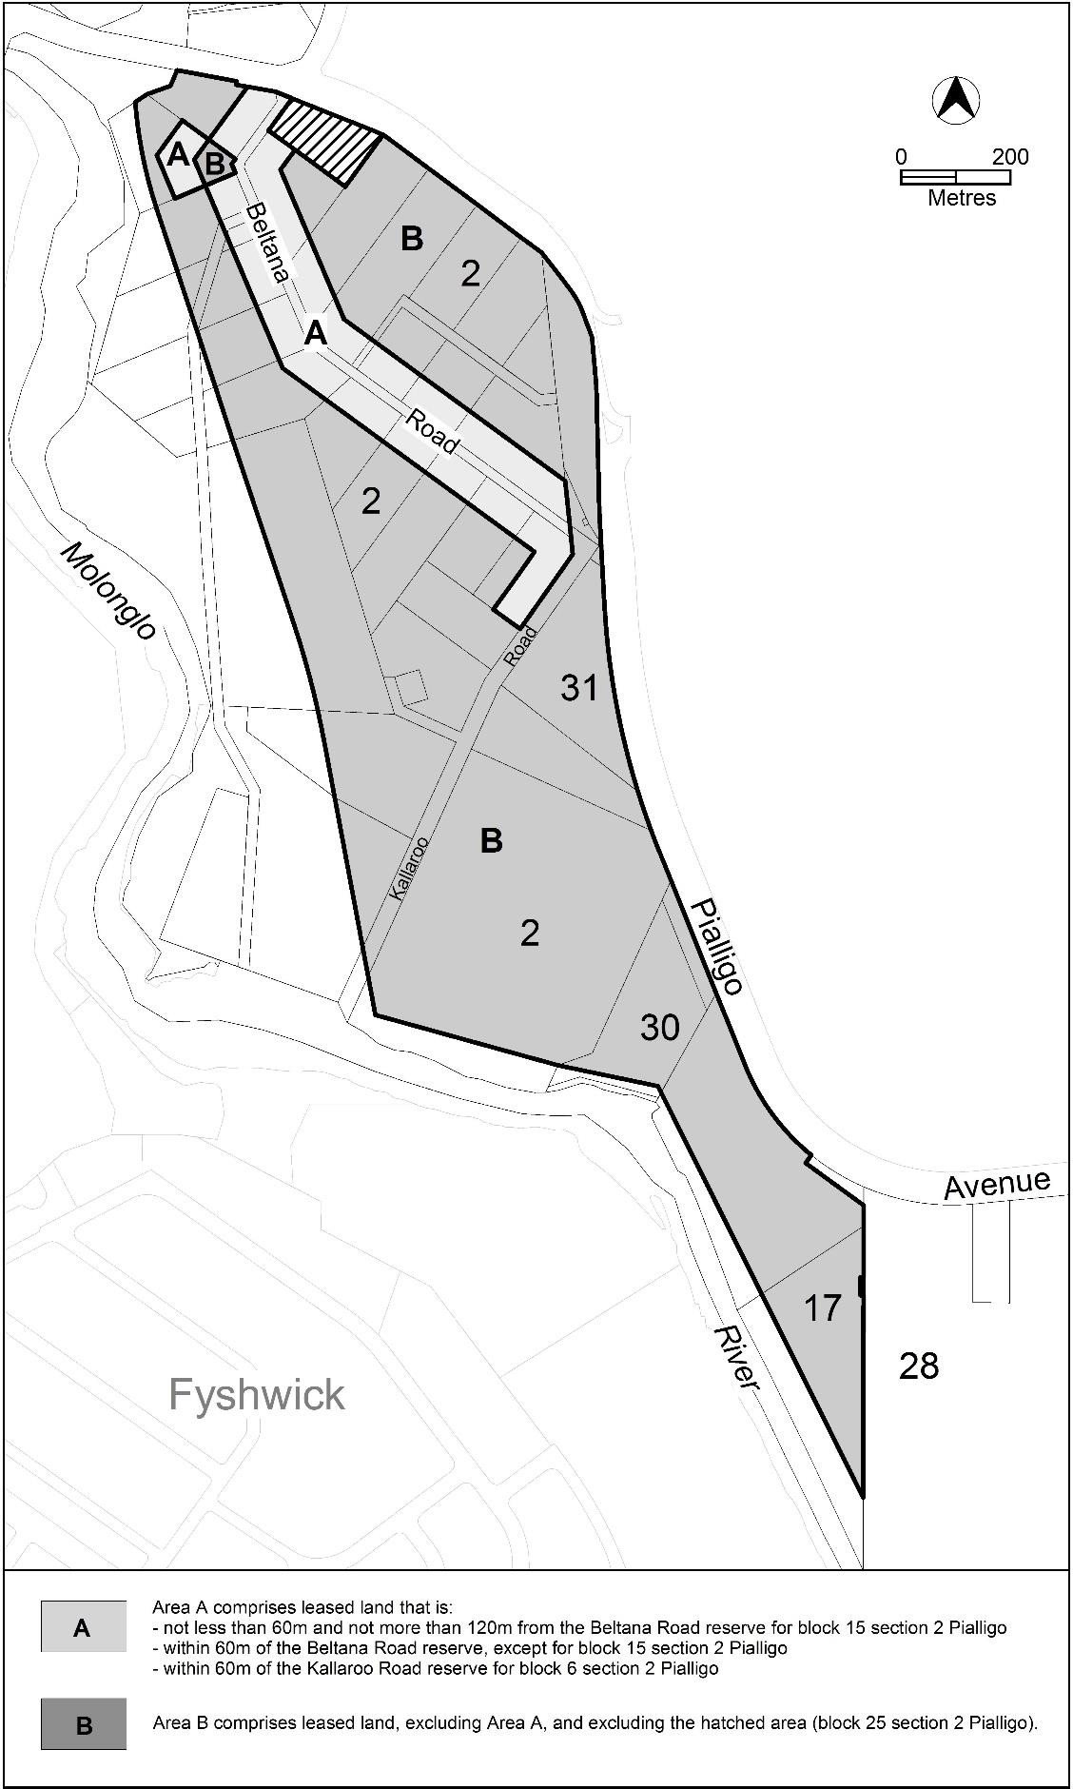

7. Symonston
The following specifications provide possible solutions that should be considered in planning, placing, designing and using buildings and structures for proposed development in Symonston:

Assessment Outcome: | Refer to zone assessment outcome
Specification
Gross floor area – Symonston Business Park | 7.1 Development is to comply with the following:  a) The maximum gross floor area for a restaurant is 300m².  b) The maximum gross floor area for a shop is 50m².
Urban heat– Symonston Business Park | 7.2 Development is to comply with the following:  a) Development achieves no net gain of urban heat to the block on which development is occurring.  b) Compliance is demonstrated in a microclimate assessment report by a suitably qualified professional which details building and urban design and proposed use of heat mitigating measures.  c) A ‘suitably qualified professional’ is a person with qualifications and/or experience in urban climate science, urban modelling or microclimate assessment.
Mugga Lane rural area | 7.3 Subdivision of existing leases is generally not permitted.

