Australian Capital Territory
Planning (Jacka FUA Uplift) Minor Plan Amendment 2024
Notifiable instrument NI2024-108
made under the
Planning Act 2023, s 85 (Making minor plan amendments)

1 Name of instrument
This instrument is the Planning (Jacka FUA Uplift) Minor Plan Amendment 2024.
2 Commencement
This instrument commences on 1 March 2024.
3 Minor plan amendment
I am satisfied under the Planning Act 2023, section 85 (1) (a) that Minor Plan Amendment 2024-b is a minor plan amendment to the territory plan.
4 Dictionary
In this instrument:
Minor Plan Amendment 2024-b means the minor plan amendment in schedule 1.

Freya O’Brien
Delegate of the territory planning authority
28 February 2024

Schedule 1

MINOR PLAN AMENDMENT TO THE TERRITORY PLAN
2024–b
Jacka FUA uplift

This minor plan amendment was prepared
under part 5.3 of the Planning Act 2023
Contents
1.0 INTRODUCTION 1
1.1 Outline of the process 1
1.2 Summary of the proposal 1
2.0 PROPOSED TERRITORY PLAN CHANGES 2
2.1 Part B – Territory Plan Maps 2
3.0 Consequential changes to the Design Guides, Technical Specifications and Exempt Development Declarations. 4
4.0 TERRITORY PLAN AMENDMENT INSTRUCTIONS 5
4.1 Part B – Territory Plan Maps 5
INTERPRETATION SERVICE 6

- INTRODUCTION
  - Outline of the process
Minor plan amendment 2024-b (MA2024-b) to the Territory Plan is minor plan amendment (MA) prepared under section 84 1) c) of the Planning Act 2023 (the Planning Act).

Section 84 of the Planning Act outlines the different types of MAs, some which require limited consultation to be undertaken and some which require no consultation to be undertaken.

Under Section 85 of the Planning Act a MA can only be made where:
- any required limited consultation has taken place and the authority is satisfied that the content of the MA meets the requirements of the Planning Act
- if the MA is not inconsistent with the planning strategy or any relevant district strategy
- any comments received during the consultation period and from the National Capital Authority have been considered.

This MA does not require limited consultation to be undertaken under the Planning Act 2023.

The MA is not inconsistent with the planning strategy or any relevant district strategy. Further details of the changes are contained in section 2 of this document.

The National Capital Authority has received a copy of this MA.

For more information on the content of the Territory Plan and minor plan amendment processes please refer to the Environment, Planning and Sustainable Development (EPSDD) website https://www.planning.act.gov.au/professionals/our-planning-system/the-territory-plan/amendments-to-the-territory-plan.
  - Summary of the proposal
MA2024-b proposes to:
- remove the future urban area overlay from land in the division of Jacka and add ongoing provisions consistent with the approved estate development plan.

- PROPOSED TERRITORY PLAN CHANGES
This section contains details of the proposed changes to be made to the Territory Plan.

MA2024-b proposes changes to parts of the following Territory Plan documents:
- Part B - Territory Plan Maps

  - Part B – Territory Plan Maps
The Territory Plan map is varied to identify the zones and overlays that apply to land ceasing to be in a future urban area.

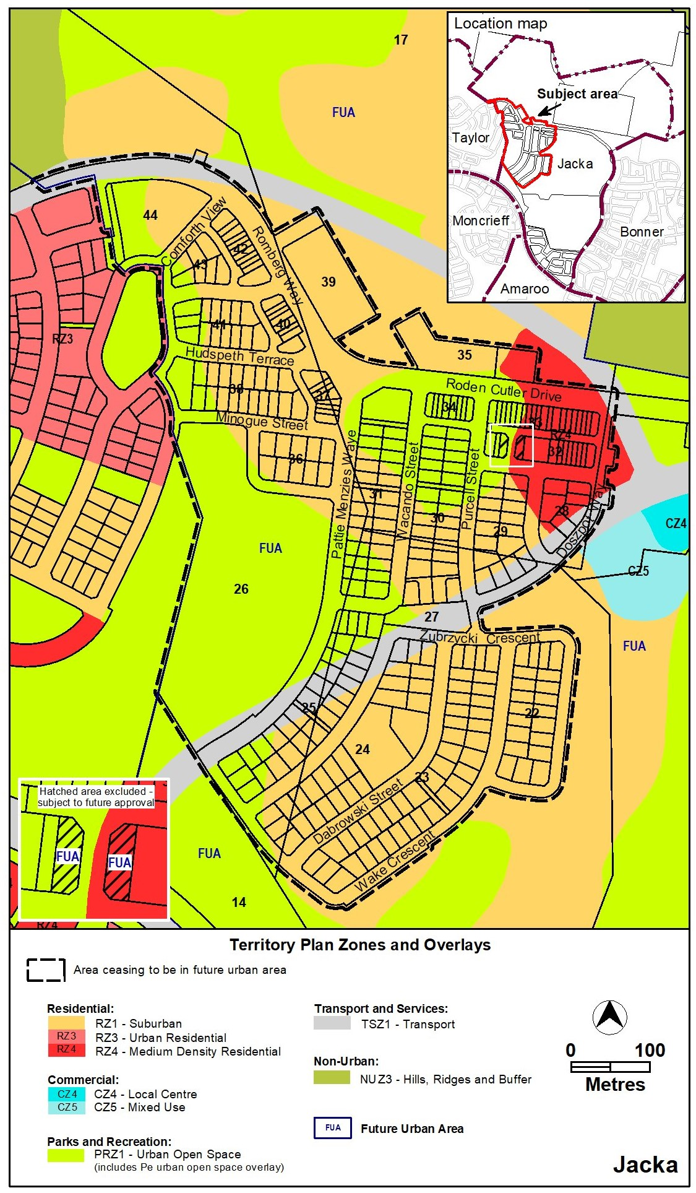
Jacka – Existing Territory Plan map
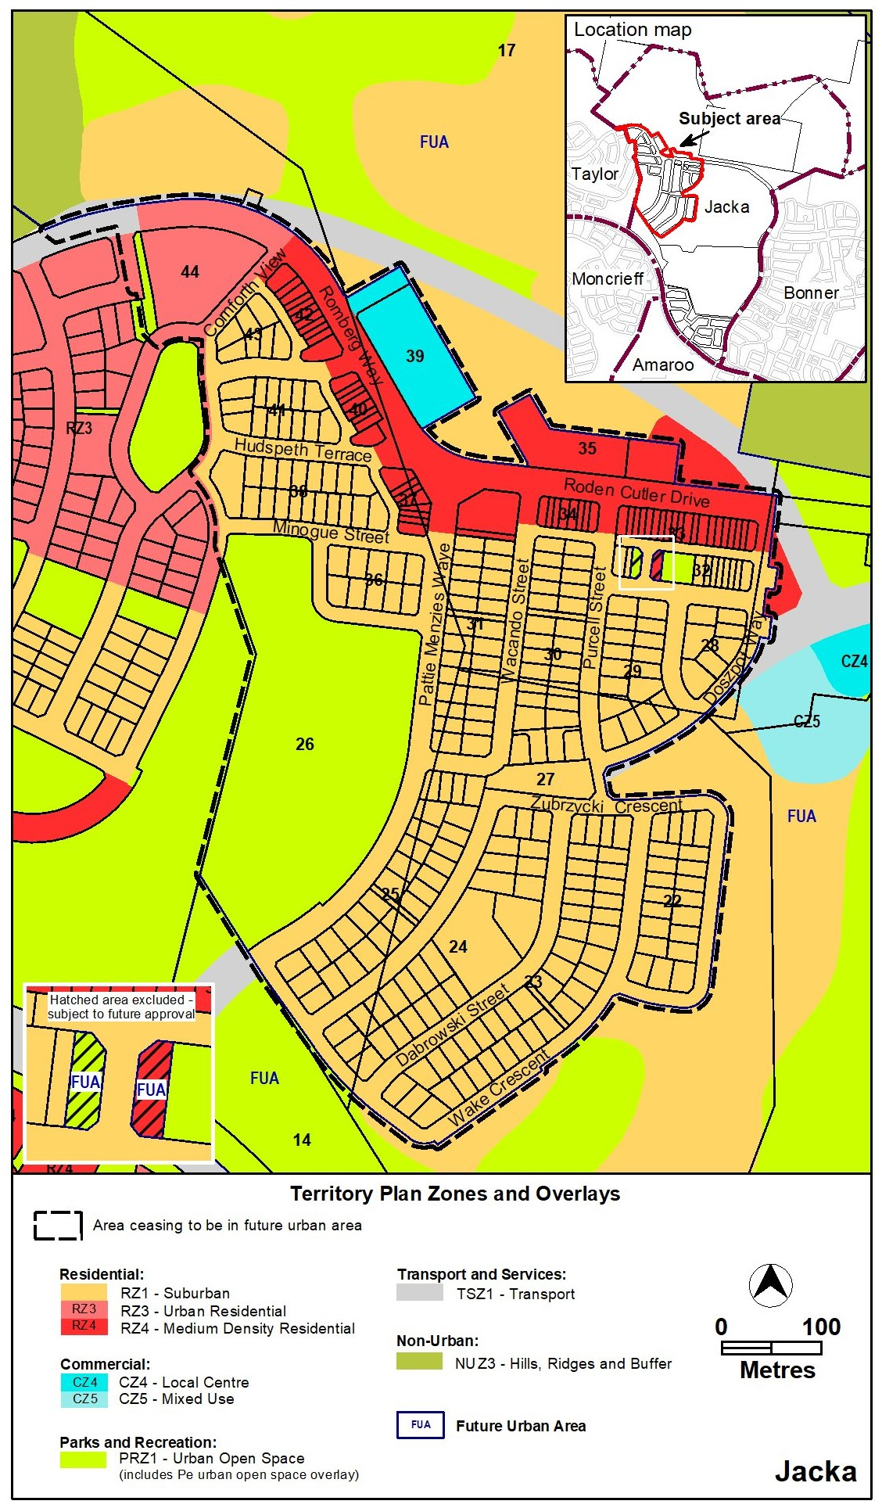
Jacka – Proposed Territory Plan map

- Consequential changes to the Design Guides, Technical Specifications and Exempt Development Declarations.
As the Planning Technical Specifications and Exempt Development Declarations do not form part of the Territory Plan, they cannot be amended through an MA process. However, the following changes are being made to the DS1 – Gungahlin District Specifications and the Planning (Exempt Development) Single Dwelling Housing Development Control – Gungahlin District Declaration to support the changes being undertaken as part of this MA:
- Addition of nine new figures to show ongoing provisions for the uplifted area, as well as a table and two diagrams as supporting information.
- Insertion of new provisions
- Updating figure numbers and references to figures to reflect the above changes.

- TERRITORY PLAN AMENDMENT INSTRUCTIONS
This section provides the legal instructions for how MA2024-b amends the Territory Plan.
  - Part B – Territory Plan Maps
- Jacka

The Territory Plan map is varied as indicated below.

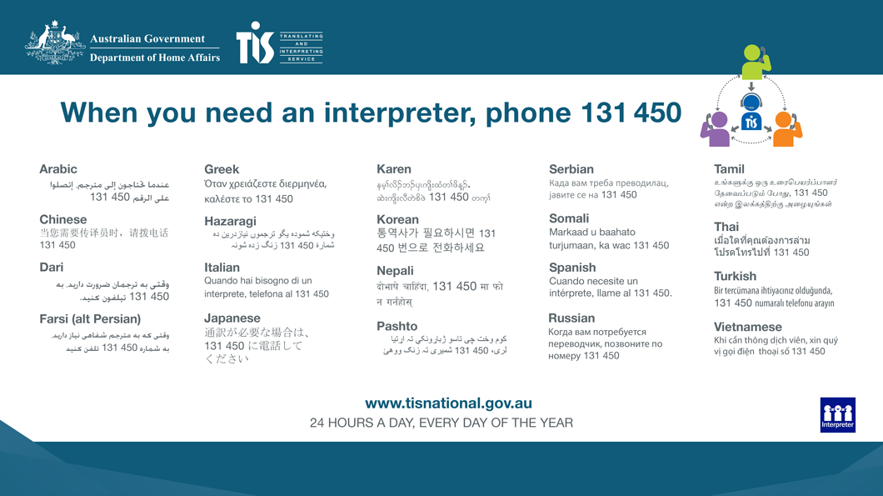
INTERPRETATION SERVICE

