Australian Capital Territory

Nature Conservation (Closed Reserves) Declaration 2024 (No 2)*

Notifiable instrument NI2024–229
made under the
Nature Conservation Act 2014, s 259 (Conservator may close reserve)

1 Name of instrument
This instrument is the Nature Conservation (Closed Reserves) Declaration 2024 (No 2).

2 Commencement
This instrument commences on 13 May 2024.

3 Declaration
I declare that public access to the following areas (closed reserves):
(a) those parts of Namadgi National Park indicated in the map at schedule 1 (Namadgi National Park – Southeast), and
(b) those parts of Namadgi National Park indicated in the map at schedule 2 (Namadgi National Park – Southwest); and
(c) those parts of Bimberi Wilderness Area indicated in the map at schedule 2; and
(d) those parts of Namadgi National Park indicated in the map at schedule 3 (Namadgi National Park – North); and
(e) those parts of Lower Cotter Catchment Reserve indicated in the map at schedule 4,
is prohibited during the closure periods specified at schedule 5.
Note Other sections of Namadgi National Park may also be closed during the period of these closures.

4 Exceptions
Section 3 does not apply to:
(a) a conservation officer exercising a function under the Act; or
(b) a person accompanied by a conservation officer exercising a function under the Act; or
(c) a contractor undertaking vertebrate pest animal control works within a closed reserve and engaged by the ACT Government to do so; or
(d) an employee of Icon Water exercising a function of their position within the defined area.

5 Expiry
This instrument expires on 26 May 2024.

6 Definitions
closure period, for a closed reserve specified in column 1 of schedule 5, means the period:
- commencing on the corresponding date (start date) specified in column 2 of schedule 5; and
- ending on the corresponding date (end date) specified in column 3 of schedule 5.
the defined area means any part of Lower Cotter Catchment Reserve or Namadgi National Park that is within 100 metres of:
- the most direct route by road between Laurel Camp Road and the Bendora Dam wall (following East West Break, Pipeline Rd and Bendora Rd); or
- Corin Road; or
- an Icon Water facility in the immediate vicinity of (a) or (b).
Bren Burkevics
Conservator of Flora and Fauna

6 May 2024
Schedule 1 Area of Namadgi National Park (Namadgi National Park – Southeast) closed to public access

(see s 3)

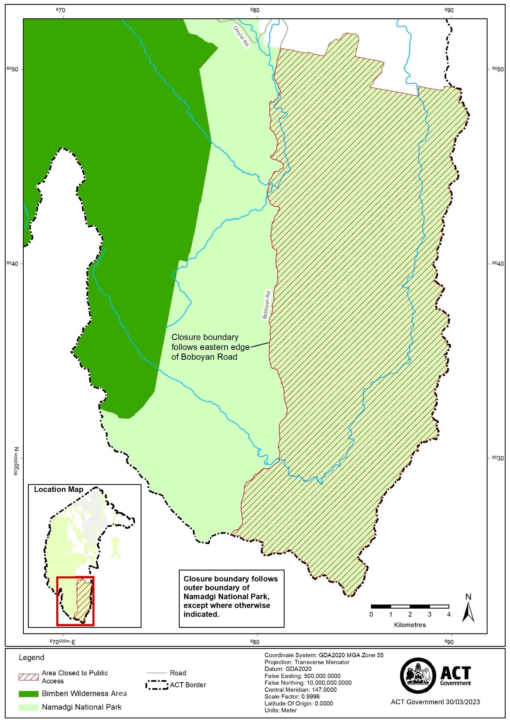
Schedule 2 Area of Namadgi National Park (Namadgi National Park – Southwest) and Bimberi Wilderness Area closed to public access

(see s 3)

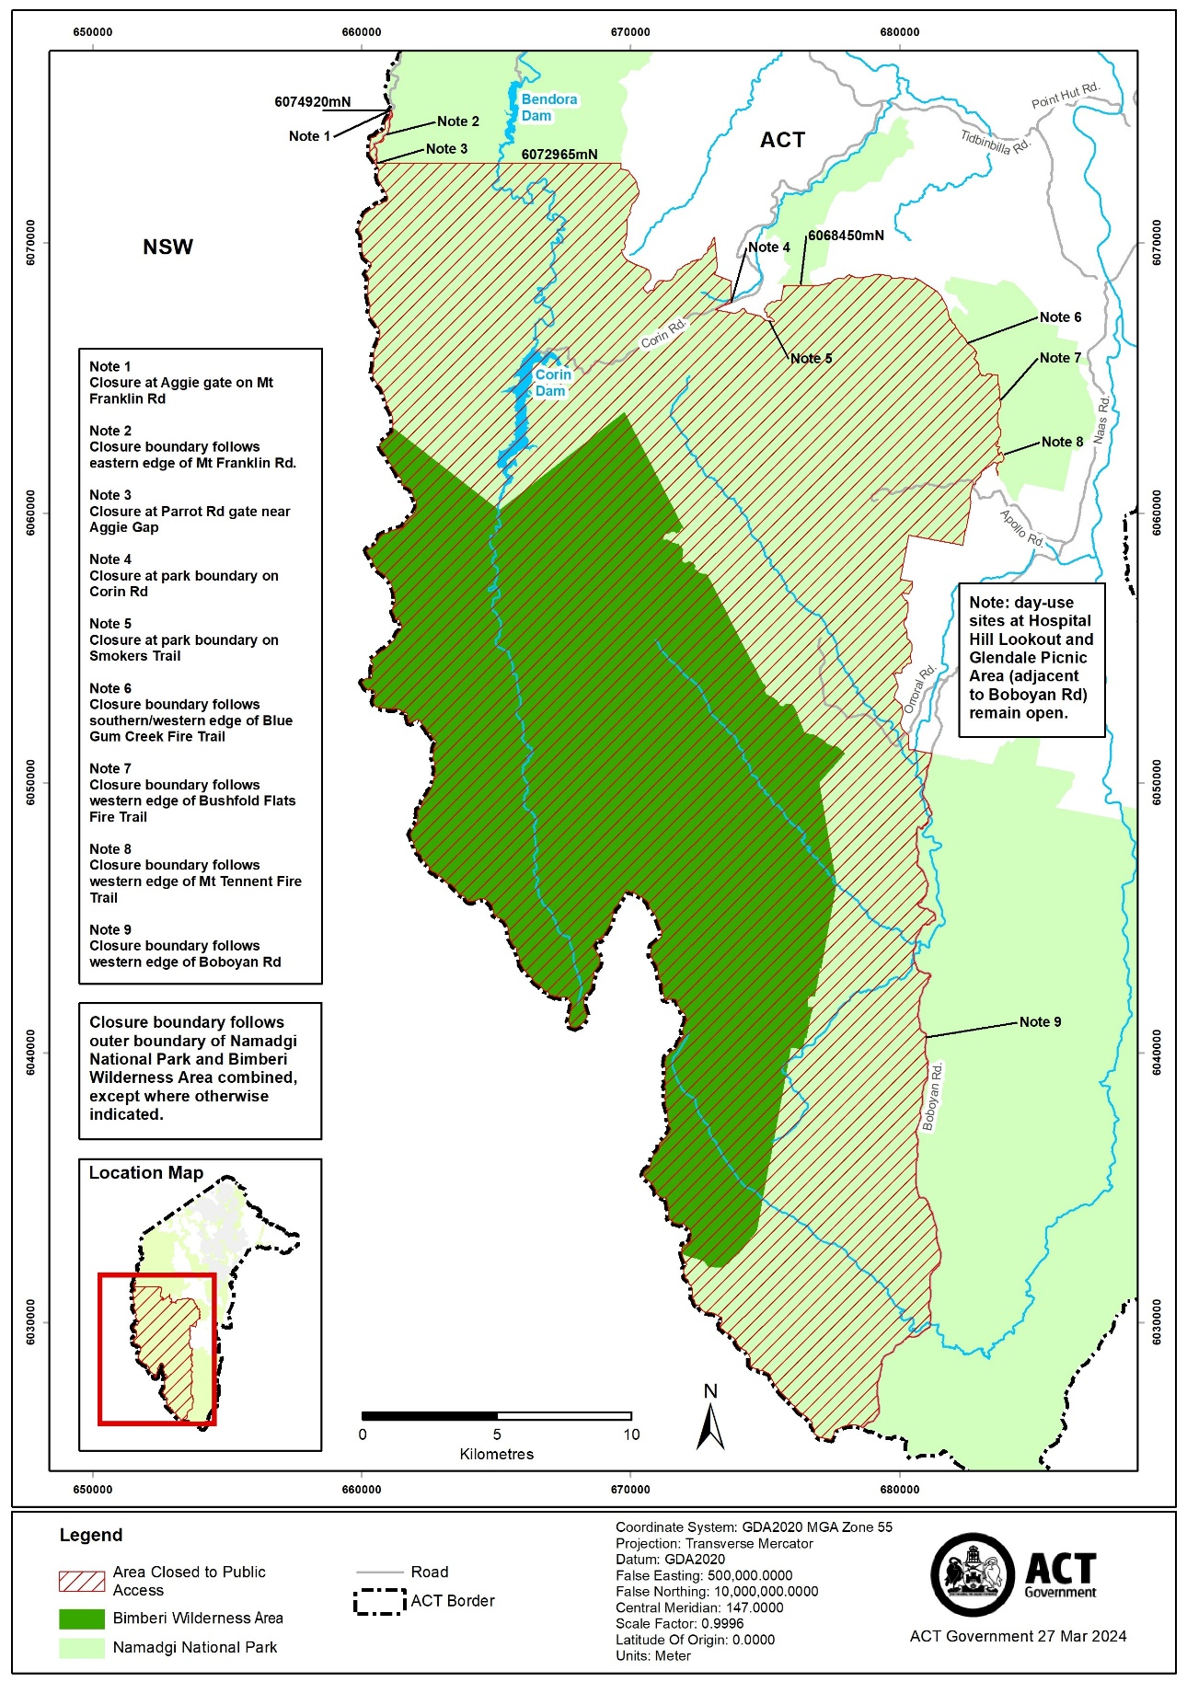
Schedule 3 Area of Namadgi National Park (Namadgi National Park – North) closed to public access

(see s 3)

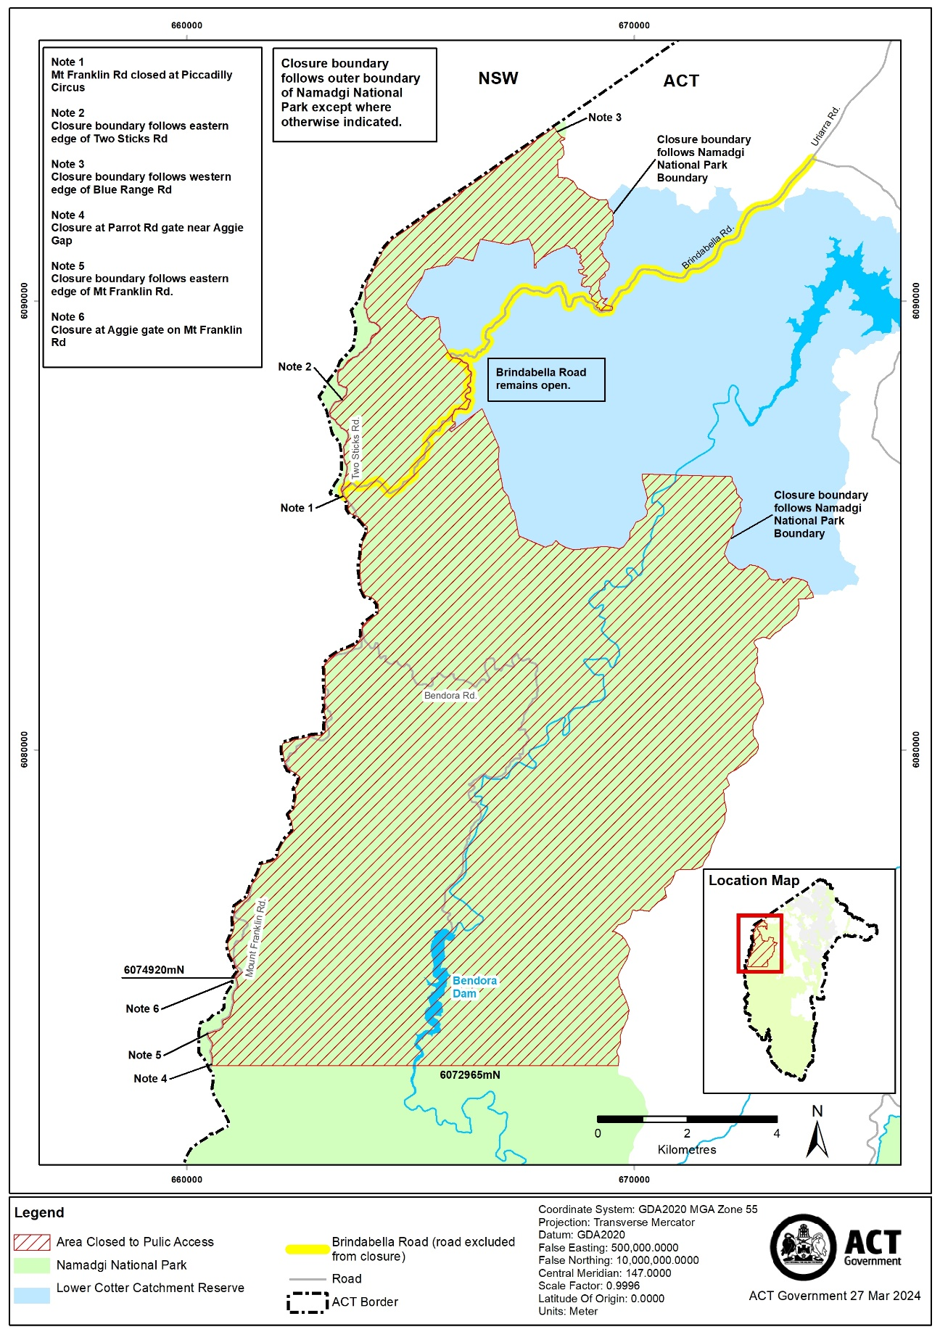
Schedule 4 Area of Lower Cotter Catchment Reserve closed to public access

(see s 3)

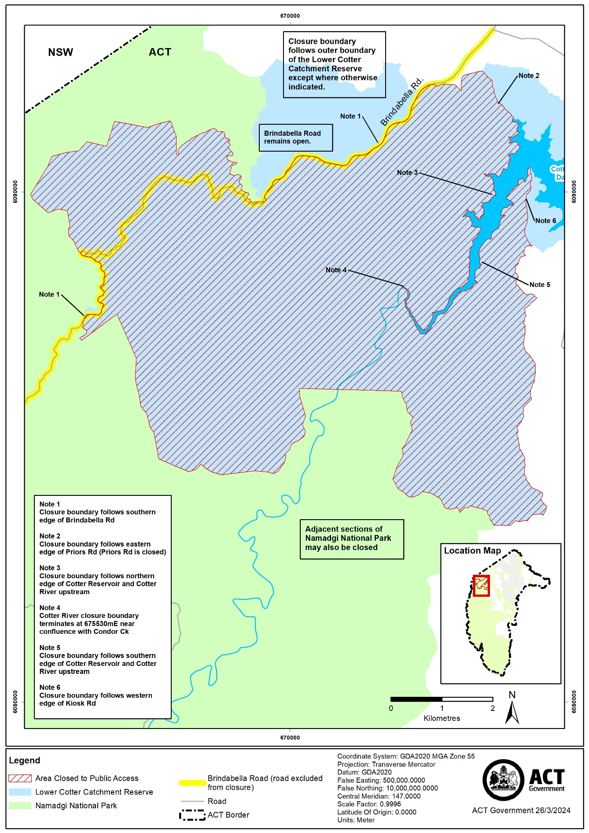
Schedule 5 Closure periods

(see s 3)

column 1 – Closed reserve | column 2 – Start date | column 3 - End date
Namadgi National Park – Southeast  (refer map at schedule 1) | 13 May 2024 | 19 May 2024
Namadgi National Park – Southwest  (refer map at schedule 2) | 14 May 2024 | 24 May 2024
Bimberi Wilderness Area  (refer map at schedule 2) | 14 May 2024 | 24 May 2024
Namadgi National Park – North  (refer map at schedule 3) | 22 May 2024 | 26 May 2024
Lower Cotter Catchment Reserve  (refer map at schedule 4) | 22 May 2024 | 26 May 2024

Note Closure periods are inclusive of the start dates and end dates above and cover 24 hours on every applicable day.

