Australian Capital Territory

Nature Conservation (Brown Treecreeper) Conservation Advice 2024

Notifiable instrument NI2024-250
made under the
Nature Conservation Act 2014, s 90C (Conservation advice)

1 Name of instrument
This instrument is the Nature Conservation (Brown Treecreeper) Conservation Advice 2024.

2 Commencement
This instrument commences on the day after its notification day.

3 Conservation advice for Brown Treecreeper
Schedule 1 sets out the conservation advice for Brown Treecreeper (Climacteris picumnus victoriae).

4 Revocation
The Nature Conservation (Brown Treecreeper) Conservation Advice 2019 (NI2019–247) is revoked.

Arthur Georges
Chair, Scientific Committee
21 May 2024
Schedule 1
(see s 3)

Conservation Advice
Brown Treecreeper (South-eastern)
Climacteris picumnus victoriae

Conservation Status
The Brown Treecreeper Climacteris picumnus victoriae Matthews, 1912 is recognised as threatened in the following jurisdictions:
National Vulnerable, Environment Protection and Biodiversity Conservation Act 1999 (EPBC Act)
Vulnerable, Action Plan for Australian Birds 2020
ACT Vulnerable, Nature Conservation Act 2014
NSW Vulnerable, Biodiversity Conservation Act 2016

ELIGIBILITY
The Brown Treecreeper (South-eastern) is listed as Vulnerable in the ACT Threatened Native Species List under IUCN Criterion A— A2bce+3ce+4bce due to a significant reduction in the national population size (30–50%) over the last three generations (15 years) (Ford et al. 2021 and Attachment A - DCCEEW 2023). The factors contributing to this decline include ongoing threats such as: habitat loss and fragmentation caused by land clearing, habitat degradation caused by domestic livestock grazing and territorial competition by the Noisy Miner (Manorina melanocephala) (Willson and Bignall 2009). Altered fire regimes, increased likelihood of extreme events (i.e., wildfire, heatwave, and drought) and conventional grazing practices also negatively affect the subspecies by preventing regeneration of native woodland habitat (Ford et al. 2021). Most of these threats are greater at habitat edges and so are exacerbated by habitat fragmentation. The effect of these threats, combined with residential and commercial development, and inappropriate firewood collection and tidying of farmland have not ceased and may not be reversible (Ford et al. 2021).

DESCRIPTION AND ECOLOGY
The Brown Treecreeper is the largest species of Australia's treecreepers, measuring about 16–18 cm and weighing (on average) 31.5 g. It is mostly pale brown in plumage. The head, throat and upper breast are pale greyish-brown, while the lower breast and belly are strongly streaked with black and buff. In flight, a buff stripe can be seen in the wing.
The sexes are similar, except females have rufous edges to the feathers of the upper breast, while in the male these edges are black. Juveniles resemble the adults, but are duller, have less obvious stripes on the underparts and the lower belly is a pale rufous colour (Birdlife Australia 2018).
Adult Brown Treecreeper (Tobias Hayashi – Canberra Birds)
The Climacteris picumnus victoriae is the sub-species of the Brown Treecreeper resident in the ACT and is distinguished from C. p. picumnus by colour differences on the face, body and tail markings. The two sub-species grade into each other through central NSW. Individuals are active, noisy and conspicuous, and give a loud ‘pink’ call. This call is often repeated in contact, and sometimes given in a series of five to ten descending notes.
Breeding occurs from July to February across its range (OEH 2017). The nest is a collection of grasses, feathers and other soft material, placed in a suitable tree hollow or similar site. Both sexes build the nest but the female alone incubates the eggs. Pairs often have two broods during each breeding season. Occasionally, other individuals assist the breeding pair with building the nest and feeding young (Birdlife Australia 2018).
The Brown Treecreeper climbs up the trunks and branches of trees in search of food, usually in pairs or small groups. It probes into cavities and under loose bark with its long downward curving bill. In this way it searches for insects and their larvae with the most favoured insects being ants. Feeding can also take place on the ground on fallen logs or by diving on ground-dwelling prey from a perch (Birdlife Australia 2018).

Distribution and Habitat
Three sub-species of Climacteris picumnus are recognised: C. p. melanotus (Cape York Peninsula, Queensland), C. p. picumnus (inland eastern Australia, eastern Queensland) and C. p. victoriae (south-eastern Australia) (Schodde and Mason 1999; Garnett and Crowley 2000).
The south-eastern sub-species C. p. victoriae (hereafter Brown Treecreeper) has an estimated national extent of occurrence of 1.1million km² and area of occupancy of 30,000 km² but contracting (Ford et al. 2021). However, a substantial decline in the distribution is likely to be occurring given the loss and fragmentation of habitat (Garnett et al. 2011). The species is found in sub-coastal environments and the inland slopes of the Great Dividing Range from the Grampians in western Victoria, through central New South Wales (Wagga Wagga, Temora, Forbes, Dubbo, and Inverell) to the Queensland border and north to the Bunya Mountains (Schodde and Mason 1999) as shown in Map 1.
Within its range, the species is described as a common resident, provided habitat is suitable. Blakers et al. (1984) recorded densities of 0.04–0.50 birds/ha, however, large reductions in density have been reported over most parts of its range (Walters et al. 1999, Traill and Duncan 2000). The Brown Treecreeper has declined or disappeared from most remaining habitat fragments under 300 ha, at least partly, because females disperse from these areas or die preferentially and are not replaced (Walters et al. 1999). A decline of 70% was recorded in central New South Wales between 1990 and 2000 (Traill and Duncan 2000).
Map1: Modelled distribution of the Brown Treecreeper (South-eastern) (Source: DCCEEW 2023)
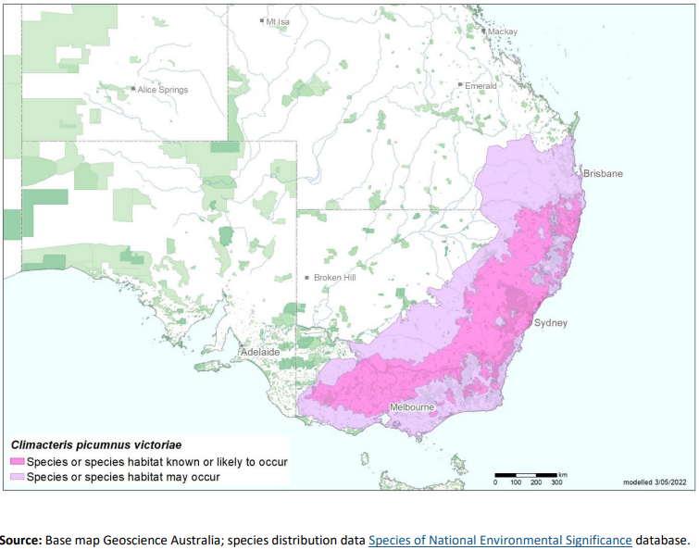
The Brown Treecreeper is likely to exist in isolated family groups in the ACT region in dry eucalypt woodlands and open forest below 1,000 m. It was once described as ‘fairly common from the lowlands to the alpine woodland’ in the ACT in the early 1950s (Cabby 2000). Taylor and COG (1992) reported it as relatively common in the Clear Range and along the Lower Naas River with other populations occurring at Campbell Park, Burbong, former quarries south of the airport, and Castle Hill, north of Tharwa. Surveys by the NSW NPWS in the late 1990s recorded the species at several remnant woodland and dry forest sites between Boorowa, Gunning and the ACT and at one site between Crookwell, Taralga, Collector and Tarago (ACT Government 1999).
There have been few sightings at Mulligans Flat Nature Reserve since 1999, where it was once common. Local extinction (Caswell Drive area on the western slopes of Black Mountain) (Marchant 1973) and decline in the Murrumbidgee River Corridor (Taylor 1987) have been documented. In 2003, the species was found in small numbers at Gooroo, Majura Field Firing Range and Newline quarry woodland (Cunningham 2003).
Brown Treecreepers were recorded nine times in the 2008 Bird Blitz (Allan 2009) but no records were made in the 2018 Bird Blitz (Allan 2019). Sightings were of single birds or groups of up to four birds, comprised two breeding records and were from Namadgi National Park, Castle Hill, Tharwa, Newline and Kama. Sightings of Brown Treecreepers then appeared to stabilise in the ACT region until 2008–2009, after which there was a steady and steep decline. An attempt was made to introduce 43 birds into woodlands inhabited formerly by the Brown Treecreeper. While the attempt appeared to have failed it contributed to the scanty knowledge of reintroduction biology (Bennett et al. 2012,2013). The apparent losses may have been attributable to longer-term effects of translocation stress, lack of familiarity with habitat or insufficient effectiveness of restoration treatments (Bennet et al. 2012). Further results revealed that reintroduced individuals may be more vulnerable due to an increased flight time to reach a refuge area as a result of a significantly lower number of refuge areas in logs and trees and a higher number of shrubs (which may obstruct escape paths and hinder detection of predators) in the reintroduction reserves compared with the source sites (Bennett et al. 2013). This study emphasizes the inherent complexities of species reintroductions and ecosystem restoration, and that further habitat restoration is required within these reserves to achieve more complete restoration (Bennett et al. 2013).
Between 2015 and 2017, the reporting rate levelled off, not far above zero percent (COG 2018) (Figure 1). Most records of sightings in the ACT region (259 total birds (207 in 2015–2016)) were outside the ACT in 2016–2017 (COG 2018) (Figure 2). The decline continued through to 2018–19 (192 total birds (219 in 2017-18) and was reported from only 4.6% of grid cells compared to the 30-year-average of 10.6% of grid cells (COG 2020).
The Brown Treecreeper, along with other woodland species, continues to decline in the ACT despite the creation of reserves and improvements in woodland management (Davey 2019). Analysis of survey data (1998–2019) collected from 142 woodland sites across the ACT (Bounds et al. 2021) confirmed the Brown Treecreeper has disappeared from peri-urban woodland sites and there are no longer resident breeding groups in these ACT woodland sites, it is also rare and uncommon in rural areas.
The habitat critical to the survival of the species is identified in the Commonwealth Conservation Advice (DCCEEW 2023) and corresponds with all known or likely habitat in Map 1 and includes areas that have:
- relatively undisturbed grassy woodland with native understory with:
  - habitat structure that should be quite open at ground level so that birds are able to feed on or near the ground and maintain vigilance against predators
  - the required degree of openness that is mostly likely to be created by moderate levels of disturbance by fire and/or grazing
- large living and dead trees which are essential for roosting and nesting sites and for foraging
- fallen timber which provides essential foraging habitat and
- hollows in standing dead or live trees and tree stumps are also essential for nesting.
Figure 1: Brown Treecreeper records in the ACT region – 1982–2017
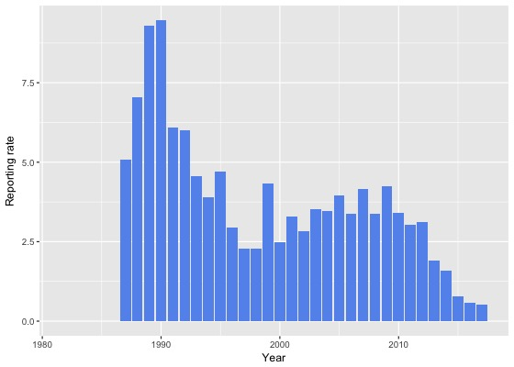
Source: Canberrabirds.org.au. (2018). Note: Reporting rate (%) is the proportion of all surveys in which the species was present. These data were collected by volunteer birdwatchers using various survey methods and on some occasions more than one person may have recorded bird sightings on the same day, which may skew the data.
Figure 2: Brown Treecreeper distribution in the ACT region – 2017 and 1982–2017
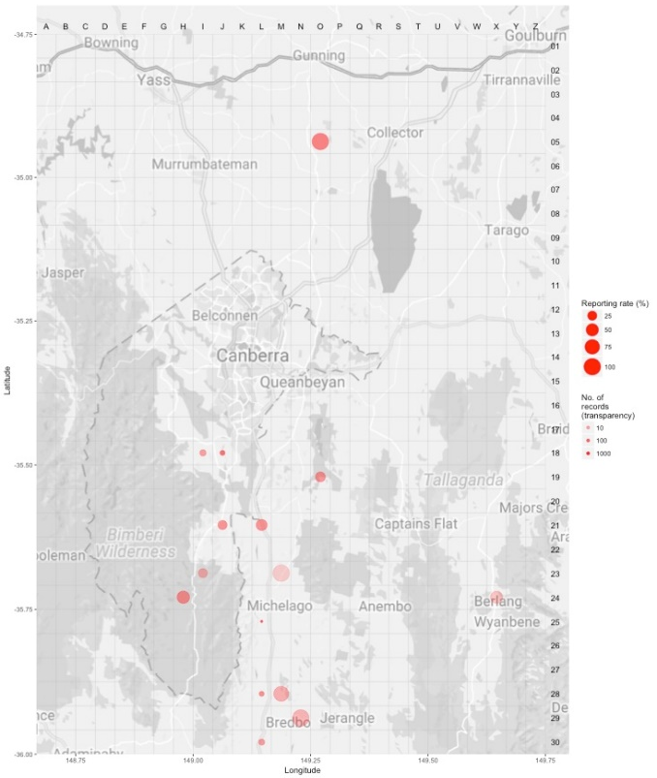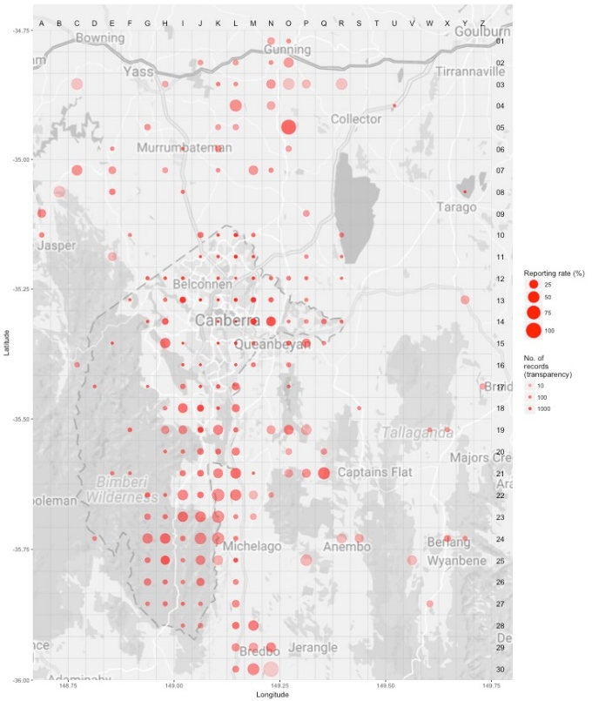
Source: Canberrabirds.org.au. (2018). Note: Reporting rate (%) is the proportion of all surveys in which the species was present. These data were collected by volunteer birdwatchers using various survey methods and on some occasions more than one person may have recorded bird sightings on the same day, which may skew the data.

Threats
In common with many other threatened bird species, the principal threat to the Brown Treecreeper is a severe decline in the quality and quantity of its woodland habitat. In particular, the removal of timber for firewood is likely to result in local reduction of Brown Treecreeper numbers (ACT Government 2004) as hollows in trees or fallen logs are critical refuges in response to predation threats as well as for nesting (Bounds 2019). The fragmented nature of woodlands may present barriers to movement and recolonisation unless measures are taken to connect areas of viable habitat with existing populations Doerr et al. 2011). The Brown Treecreeper displayed reduced dispersal as a response to fragmentation and the genetic impacts of fragmentation are already apparent with the more mobile females being more strongly affected by fragmentation, emphasising the importance of accounting for sex-based responses in conservation planning (Amos et al. 2014). Key features of urban expansion in the ACT (i.e. fragmentation, degradation, change in predatory bird abundance) may have driven declines and today the small pockets of surviving birds are not resilient enough to overcome stochastic events that are hard or impossible to manage (Davey 2019). Bounds et al. (2021) noted the long-term decline of the species was not interrupted by the breaking of the (millennium) drought when it might have been expected to take advantage of and recover with what would typically be considered favourable weather conditions.
Threats to the Brown Treecreeper (ACT Government 2004) include:
- removal of fallen timber and litter and inappropriate fire regimes
- predation by feral and/or uncontrolled domestic animals (foxes, dogs and cats)
- invasion of key habitats by introduced pasture and weeds
- uncontrolled grazing by livestock
- clearing of both living and dead trees
- rural tree dieback.

Major Conservation Objectives
The primary objective in the ACT is to protect Brown Treecreeper habitat through limiting clearance of suitable woodland habitat and prioritising conservation management to woodland patches, particularly those that are large or have complex habitat structure.

Conservation PRIORITIES
Conservation priorities are detailed in the Commonwealth Conservation Advice (DCCEEW 2023). The conservation actions relevant to the Brown Treecreeper in the ACT Lowland Woodland Conservation Strategy (ACT Government 2004) remain relevant including to:
- protect habitat
- maintain and enhance connectivity
- limit removal of live and dead timber
- reduce intensive grazing
- maintain patches of shrubs or eucalypt regrowth
- regenerate habitat
- minimise adverse effects of fire
- minimise nest hollow competition.
Other priorities for the Brown Treecreeper in the ACT should be to:
- monitor long-term trends and the effectiveness of management actions
- identify fire regimes suitable to habitat requirements and highlight the ecological needs of the species in fire management guidelines
- investigate the potential impact of climate change on the subspecies and its habitat
- determine where hollows are limiting and develop strategies to increase hollow availability
- determine the impacts of Noisy Miners and mange as required through re-establishing a structurally complex understory
- actively seek opportunities to involve members of local indigenous communities in on ground activities
- encourage responsible pet ownership
- encourage and support the continuation and further development of community-based conservation activities.

CONSERVATION ISSUES
It is recommended that quantitative targets and resourcing requirements are clearly identified in any Action Plan or other related projects/programs relevant to this species. Broader conservation issues for this and other declining woodland birds need to be considered in developing and implementing actions arising from this advice and the species listing assessment (DCCEEW 2023).

Critical Habitat
The temperate woodlands of the northern ACT and the bordering NSW region have been extensively disturbed by agriculture and urbanization and small patches of woodland are now embedded in a pastoral or suburban matrix. Consequently, birds are threatened by a reduction in habitat area, increased isolation, and declining habitat condition emphasising the importance and need of large, structurally complex, connected, high quality woodland patches to accommodate existing woodland birds (Watson et al. 2002; Watson et al. 2008). Watson et al. (2002) predicted that the decline of woodland bird species will continue unless appropriate habitat conservation strategies are applied as suggested (Watson et al. 2008).
The Commonwealth Conservation Advice (DCCEEW 2023) identifies ‘habitat critical to the survival’ or important habitats of a species refers to areas that are necessary:
- for activities such as foraging, breeding, roosting, or dispersal
- for the long-term maintenance of the species (including the maintenance of species essential to the survival of the species, such as pollinators)
- to maintain genetic diversity and long-term evolutionary development
- for the reintroduction of populations or recovery of the species.
Habitat critical to the survival should not be cleared, fragmented or degraded. Any known or likely habitat (Map 1) should be considered as habitat critical to the survival of the species. Additionally, areas that are not currently occupied by the species due to recent disturbance (e.g fire, grazing or human activity), but should became suitable again in the future, should also be considered habitat critical to the survival of the species. It is essential that the highest level of protection is provided to these areas, across all tenures, and that enhancement and protection measures target these productive sites. No Critical Habitat as defined under section 207A of the EPBC Act has been identified or included in the Register of Critical Habitat under the EPBC Act.

Climate Change
Climate change impacts are inevitable and will affect the likelihood of persistence, within the ACT, of many species. Amongst the most vulnerable in this regard are those species that occupy highly fragmented habitat with highly restricted distributions, such as the Brown Treecreeper. Capacity must be developed to model the impact on this species and its habitat under likely climate change scenarios if we are to anticipate and manage the impacts of climate change. This will require a combination of research and the development of in-house capacity for the collection of relevant data and its application in climate change modelling. New developments in biophysical models can provide a predictive understanding of the habitats required for persistence in the face of climate change and other stressors (see review by Briscoe et al. 2023). Such models integrate physical data on climate and terrain with measures of morphology, behaviour, physiology and life history of the species in question. Ensuring collection of relevant data to provide the necessary information to parameterize models that can explore population persistence and species distributions is critical. Given increases in the frequency and intensity of extreme heat events are widely predicted it will be important to characterise the nature and use of thermal refuges used by birds under such conditions to quantify the importance of refuges for survival, and to preserve/regenerate such habitat.

Population Viability
An understanding of demographic rates, dispersal and behaviour is necessary for assessing responses to environmental changes and to inform population modelling (e.g., PVA, Biophysical Models), which can predict likelihoods of viability over the longer term. This will inform management options which may include assessment of genetic diversity and the possibility of genetic rescue. It is possible for the viability of species/population to be compromised such that they are unable to rebound if conditions improve and/or respond to suitable management. For example, loss of genetic diversity and associated genetic problems, such as inbreeding depression, in small populations can reduce survival and reproductive rates such that the population cannot respond to improved conditions.

Jurisdictional Collaboration
Many woodland birds have large distributions and while the ACT makes up a small component, in terms of area, it can play an important role in informing conservation due to its location, local expertise and community interest. Developing policies and recovery plans across several jurisdictions with many stakeholders requires ongoing discussion/negotiations across many stakeholders and jurisdictional entities.

Ngunnawal Community Engagement
The ACT Government should actively facilitate, the inclusion of the Ngunnawal people in the conservation of this species and its habitat as part of Ngunnawal Country. Reference to the draft Cultural Resource Management Plan (ACT Government in prep.) would be useful to inform culturally appropriate resource management including of native species that aligns with achieving conservation outcomes for the species.

Other Relevant Advice, plans or Prescriptions
- Commonwealth Conservation Advice – Hooded Robin (South-eastern) (DCCEEW 2023)
- ACT Woodland Conservation Strategy (ACT Government 2004)
- ACT Woodland Conservation Strategy (ACT Government 2019)
- ACT Conservation Advice — Loss of Mature Trees (Scientific Committee 2018)

Listing Background
The Brown Treecreeper was initially listed in the ACT as Climacteris picumnus as a Vulnerable species on 30 May 1997 in accordance with section 38 of the Nature Conservation Act 1980.
The Flora and Fauna Committee (now Scientific Committee) concluded that at that time the assessment satisfied the criteria:
2.2 The species is observed, estimated, inferred or suspected to be at risk of premature extinction in the ACT region in the medium-term future, as demonstrated by:
2.2.1 Current serious decline in population or distribution from evidence based on:
2.2.1.1 Direct observation, including comparison of historical and current records; and
2.2.1.3 Serious decline in quality or quantity of habitat.
The Brown Treecreeper (South-eastern) is listed as a Vulnerable sub-species under the Environment Protection and Biodiversity Conservation Act 1999 (EPBC Act), effective 31 March 2023. It is eligible to be listed as Vulnerable under Criterion 1 (A2bce+3ce+4bce) of the EPBC Act.

Action Plan Decision
The ACT Scientific Committee does not recommend that the Minister for the Environment should make the decision to have an individual action plan for the sub-species in the ACT under the Nature Conservation Act 2014 at this time but proposes that an Action Plan for (threatened) Woodland birds (including specific requirements for the Brown Treecreeper) should be developed and implemented by the Conservator. Previous action plans have not addressed key threats or implemented appropriate on-ground actions for the Brown Treecreeper and the last action plan requirement for the sub-species ended in 2019. There are several woodland birds, including the Brown Treecreeper, for which there are actions that are designed to provide for the conservation and management of the habitat of these birds collectively in the Woodland Strategy (ACT Government 2019), however a targeted Action Plan for (threatened) Woodland Birds and their habitat in the ACT is necessary to identify, understand and help address the declines and support recovery.
A National Recovery Plan is required to be prepared for the sub-species (DCCEEW 2023) but there are likely to be ACT specific questions that need to be answered that a National Recovery Plan may not address. For example, as the decline in the ACT is not fully understood and is likely fully attributed to urbanisation we could reduce further losses through better urban planning.

References
ACT Government 1999. Brown Treecreeper (Climacteris picumnus): A vulnerable species. Action Plan No.18. Environment ACT, Canberra.
ACT Government 2004. Woodlands for Wildlife: ACT Lowland Woodland Conservation Strategy. Action Plan No. 27. Environment ACT, Canberra.
ACT Government 2019. ACT Woodland Conservation Strategy and Action Plans. Environment Planning and Sustainable Development Directorate, Canberra.
ACT Government in prep. Draft Cultural Resource Management Plan. Environment Planning and Sustainable Development, ACT Government, Canberra.
Allan B 2009. The Canberra Bird Blitz 2008. Canberra Bird Notes 34(2): 111–125.
Allan B 2019. The Canberra Bird Blitz 2018. Canberra Bird Notes 44(2): 169–187.
Amos JN, Harrisson KA, Radford JQ, White M, Newell G, Nally RM, Sunnucks P & Pavlova A 2014. Species‐and sex‐specific connectivity effects of habitat fragmentation in a suite of woodland birds. Ecology 95(6): 1556–1568.
Bennett VA, Doerr VA, Doerr ED, Manning AD and Lindenmayer DB 2012. The anatomy of a failed reintroduction: a case study with the Brown Treecreeper. Emu 112: 298–312. https://www.tandfonline.com/doi/abs/10.1071/MU11048
Bennett VA, Doerr VA, Doerr ED, Manning AD, Lindenmayer DB, Yoon H-J 2013. Causes of reintroduction failure of the Brown Treecreeper: Implications for ecosystem restoration. Environmental Science Austral Ecology 38(6): 700–712. https://onlinelibrary.wiley.com/doi/epdf/10.1111/aec.12017
BirdLife Australia 2018. Brown Treecreeper Climacteris picumnus Profile. Accessed 21 May 2018 from: http://www.birdlife.org.au/bird-profile/brown-treecreeper
BirdLife International 2016. Climacteris picumnus. The IUCN Red List of Threatened Species 2016. Accessed 21 May 2018 from: http://dx.doi.org/10.2305/IUCN.UK.2016-3.RLTS.T22703577A93928711.en
BirdLife International 2018. Species factsheet: Climacteris picumnus. Accessed 21 May 2018 from: http://datazone.birdlife.org/species/factsheet/brown-treecreeper-climacteris-picumnus
Blakers M, Davies SJJF and Reilly PN 1984. The Atlas of Australian Birds. Melbourne University Press and RAOU, Melbourne.
Bounds J 2019. Brown Treecreeper (Climateris Picumnus) its occurrence and status in the ACT, and dependence on mature, hollow-bearing eucalypts. Canberra Bird Notes 44(2): 109–121.
Bounds J, Davey C, Taws N, Evans MJ, Rayner L 2021. Long-term trends in ACT woodland birds 1998–2019. Canberra Ornithologists Group, Canberra.
Briscoe NJ, Morris SD, Mathewson PD, Buckley LB, Jusup M, Levy O, Maclean IMD, Pincebourde S, Riddell EA, Roberts JA, Schouten R, Sears MW, Kearney MR 2023. Mechanistic forecasts of species responses to climate change: The promise of biophysical ecology. Global Change Biology 29(6): 1451–1470.
Cabby J 2000. List of Birds of the ACT – early 1950s, Canberra Bird Notes 25(1): 1–22.
Canberrabirds.org.au (2018). Brown Treecreeper Climacteris picumnus data sheet. Accessed 22 August 2018 from:
http://canberrabirds.org.au/wp-content/bird_data/555_Brown%20Treecreeper.html
Canberra.naturemapr.org (CNM) 2018. Canberra Nature Map. Accessed 21 May 2018 from: https://canberra.naturemapr.org/Community/Species/15169
COG 2018. Annual Bird Report: 1 July 2016 to 30 June 2017. Canberra Bird Notes 43(1): 1–110.
COG 2020. Annual Bird Report: 1 July 2018 to 30 June 2019. Canberra Bird Notes 45(1): 1–108.
Cunningham R 2003. A statistical analysis of the status and trends of woodland birds in the ACT. COG database, Canberra Ornithologists Group, Canberra.
Davey C 2019. Demise of the Brown Treecreepers in the central Molonglo Valley, ACT. Canberra Bird Notes 44(2): 122–135.
Department of Climate Change, Energy, the Environment and Water (DCCEEW) 2023. Conservation Advice for Climacteris picumnus victoriae (BrownTtreecreeper (South-eastern)). Department of Climate Change, Energy, the Environment and Water (Commonwealth), Canberra.
Doerr VAJ, Doerr E and Davies MJ 2011. Dispersal behaviour of Brown Treecreepers predicts functional connectivity for several other woodland birds. Emu 111(1): 71–83.
Ford HA, Menkhorst P, Loyn RH, Watson DM, Tulloch AIT, Barnes MD and Garnett ST 2021. South‐eastern Brown Treecreeper Climacteris picumnus victoriae. In The Action Plan for Australian Birds 2020. (Eds ST Garnett and GB Baker). CSIRO Publishing, Melbourne.
Freudenberger D 1999. Guidelines for enhancing grassy woodlands for the vegetation investment project. CSIRO Wildlife and Ecology, Canberra.
Garnett ST and Crowley GM 2000. The Action Plan for Australian Birds 2000. Environment Australia, Canberra.
Garnett ST, Szabo JK and Dutson G 2011. The Action Plan for Australian Birds, CSIRO Publishing, Collingwood.
Matthews GM 1912. A reference-list to the birds of Australia. Novitates Zoologicae 18:171–455, 382.
Office of Environment and Heritage (OEH) 2017. Brown Treecreeper (eastern subspecies) Profile. Accessed 21 May 2018 from: https://www.environment.nsw.gov.au/threatenedSpeciesApp/profile.aspx?id=10171
Reid J 1999. Threatened and declining birds in the New South Wales sheep–wheat belt: 1. Diagnosis, characteristics and management. Consultancy report to NSW National Parks and Wildlife Service, CSIRO Sustainable Ecosystems, Canberra.
Schodde R and Mason IJ 1999. The Directory of Australian Birds – Passerines. CSIRO Publishing, Collingwood.
Schodde R and Tidemann SC 1986. Complete Book of Australian Birds. Readers Digest, Sydney.
Scientific Committee 2018. Conservation Advice – Loss of Mature Trees (including Hollow-bearing Trees) and Lack of Recruitment. ACT Government, Canberra.
Taylor M and Canberra Ornithologists Group (COG) 1992. Birds of the Australian Capital Territory – An Atlas. Canberra Ornithologist Group and National Capital Planning Authority, Canberra.
Traill BJ and Duncan S 2000. Status of birds in the New South Wales temperate woodlands region. Report to NSW National Parks and Wildlife Service, Dubbo.
Walters J, Ford HA and Cooper C 1999. The ecological basis of sensitivity to habitat fragmentation: a preliminary assessment. Biological Conservation 90: 13–20.
Willson A and Bignall J 2009. Regional Recovery Plan for Threatened Species and Ecological Communities of Adelaide and the Mount Lofty Ranges, South Australia. Department for Environment and Heritage, Adelaide.

Further Information
Further information can be obtained from the Environment, Planning and Sustainable Development Directorate (EPSDD). EPSDD Website: https://www.environment.act.gov.au/nature-conservation

Attachment A: National Listing Assessment (DCCEEW 2023)
