Australian Capital Territory

**Nature Conservation (Diamond Firetail) Conservation Advice 2024**

**Notifiable instrument NI2024-251**

made under the

**Nature Conservation Act 2014, s 90C (Conservation advice)**

**1 Name of instrument**

This instrument is the *Nature Conservation (Diamond Firetail) Conservation Advice 2024*.

**2 Commencement**

This instrument commences on the day after its notification day.

**3 Conservation advice for Diamond Firetail**

Schedule 1 sets out the conservation advice for Diamond Firetail (*Stagonopleura guttata*).

Arthur Georges

Chair, Scientific Committee

21 May 2024

**Schedule 1**

(see s 3)

Conservation Advice  
DIAMOND FIRETAIL  
*Stagonopleura guttata*

Conservation Status

The Diamond Firetail *Stagonopleura guttata* (Shaw, 1796) is recognised as threatened in the following jurisdictions:

International **Vulnerable**, International Union for the Conservation of Nature (IUCN) Red List

National **Vulnerable**, *Environment Protection and Biodiversity Conservation Act 1999* (EPBC Act)

**Vulnerable***,* Action Plan for Australian Birds 2020

ACT **Vulnerable**, *Nature Conservation Act 2014*

NSW **Vulnerable**, *Biodiversity Conservation Act 2016*

Victoria **Vulnerable**, *Flora and Fauna Guarantee Act 1988*

Queensland **Vulnerable**, *Nature Conservation Act 1992*

SA **Vulnerable**, *National Parks and Wildlife Act 1972*

ELIGIBILITY

The Diamond Firetail is listed as Vulnerable in the ACT Threatened Native Species List under IUCN Criterion A— A2bce+3ce+4bce due to a significant reduction in the national population size (30–50%) over the last ten years with a high probability of declines continuing (Hodder et al. 2021 and Attachment A - DCCEEW) 2023).

DESCRIPTION AND ECOLOGY

[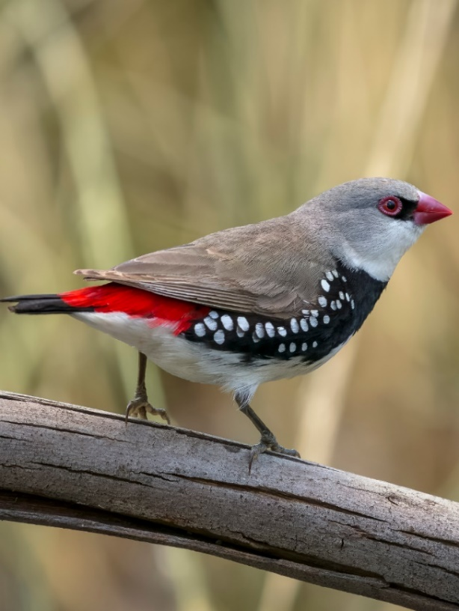](https://canberra.naturemapr.org/sightings/4414207)The Diamond Firetail is a finch, measuring about 12 cm and weighing 17 g on average. The top of its body, wings and head are ash brown to grey and the underparts are white with a crimson rump. There is a black band across its neck which continues down the flank with white dots. The bill and eye ring are coral, and the legs and feet are dark grey. The sexes are similar, except females have a slightly paler bill. Juveniles are duller but plumper versions of adults with grey-black bills and have grey replacing black on the underparts (Birdlife Australia 2023).

Breeding occurs usually from August to January (OEH 2021) and 4–5 eggs are laid in bottle‐shaped nests (Higgins et al. 2007). Nests are built either in the shrubby understorey, or higher up in trees (OEH 2021). The Diamond Firetail roosts in dense shrubs or in smaller nests built especially for roosting.

[Diamond Firetail (Trevor Rix – Canberra Nature Map](https://canberra.naturemapr.org/sightings/4414207))

The species feeds exclusively on the ground, mostly on seeds of grasses and herbs, as well as on insects in the breeding season (OEH 2021).

Distribution and Habitat

The distribution of the Diamond Firetail is across the south‐east mainland of Australia from south‐east Queensland to the Eyre Peninsula, South Australia, as shown in Map 1 (Higgins et al. 2006). The national estimated extent of occurrence (EOO) is 1.5million km2 and area of occupancy (AOO) is 25,000 km2 (Hodder et al. 2021). The species occurs in grassy eucalypt woodlands, including Box-Gum Woodlands and Snow Gum Woodlands, as well as in open forest, mallee, Natural Temperate Grassland, and in secondary grassland derived from other communities (OEH 2021). It is commonly found in riparian areas along rivers and creeks and at times in lightly wooded farmland (OEH 2021).

The Diamond Firetail has disappeared from many of the more settled parts of New South Wales (NSW), the Australian Capital Territory (ACT) and Victoria, and birds in South Australia appear to have been separated into three isolated subpopulations (Higgins et al. 2007).

**Map 1: Modelled distribution of the Diamond Firetail (Source: DCCEEW 2023)**

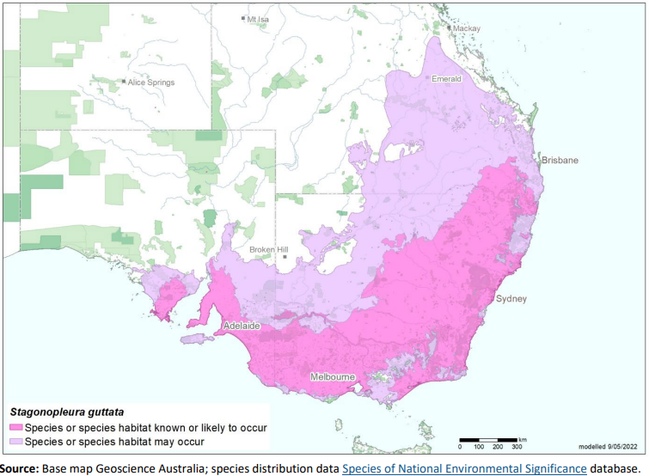

The species is resident in the ACT region (Figure 1 and 2) and is typically recorded in small groups, usually moving around to take advantage of seed sources (Bounds et al. 2021). Taylor and COG (1992) reported it as inhabiting scattered pockets of relatively undisturbed woodland and grassland with patchy shrubs or eucalypt regrowth. The Diamond Firetail can be found in rural/semi-rural areas, on the outer edge of the suburbs and adjoining woodland habitat, avoiding with suburban habitat (Canberra Birds 2023). It was once described as a fairly common breeding species in many localities in the ACT and could usually be found at Naas, along the Murrumbidgee and in other areas in the ACT in the early 1950s (Cabby 2000). It is now known, in the ACT, as an ‘uncommon breeding resident’ with 140 records in 2018–19 (152 in 2017–18; 111 in 2016–17; 154 in 2015–16) with abundance down by 72% on the 30-year average (COG 2018, COG 2020).

The habitat critical to the survival of the species is identified in the Commonwealth Conservation Advice (DCCEEW 2023) and corresponds with all known or likely habitat in Map 1 and includes areas of:

* eucalypt, acacia or casuarina woodlands, open forests and other lightly timbered habitats
* low tree density, few large logs, and little litter cover but high grass cover for foraging, roosting and breeding.

**Figure 1: Diamond Firetail records in the ACT region – 1982–2017**

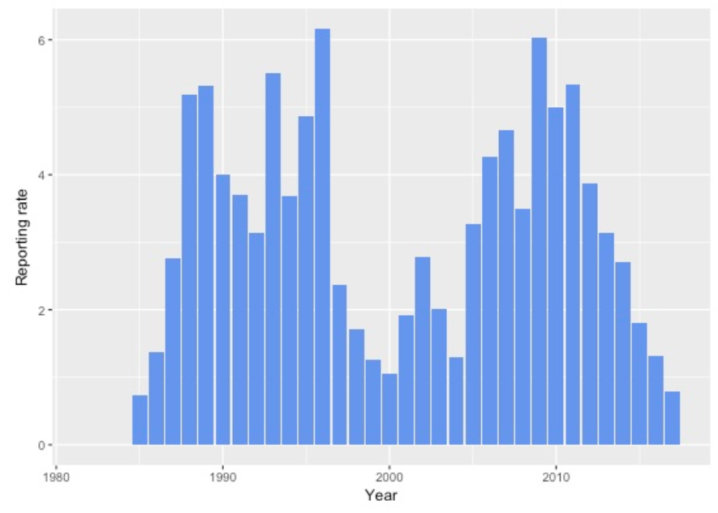

*Source: Canberra Birds (2018). The reporting rate in 2018-19 (0.9%) is down 30% on 2017–18 and down 65% on the 30-year average to be just above the lowest level of 0.8% (COG 2020).   
Note: Reporting rate (%) is the proportion of all surveys in which the species was present. These data were collected by volunteer birdwatchers using various survey methods and on some occasions more than one person may have recorded bird sightings on the same day, which may skew the data.*

**Figure 2: Diamond Firetail distribution in the ACT region – 2017 and 1982–2017**

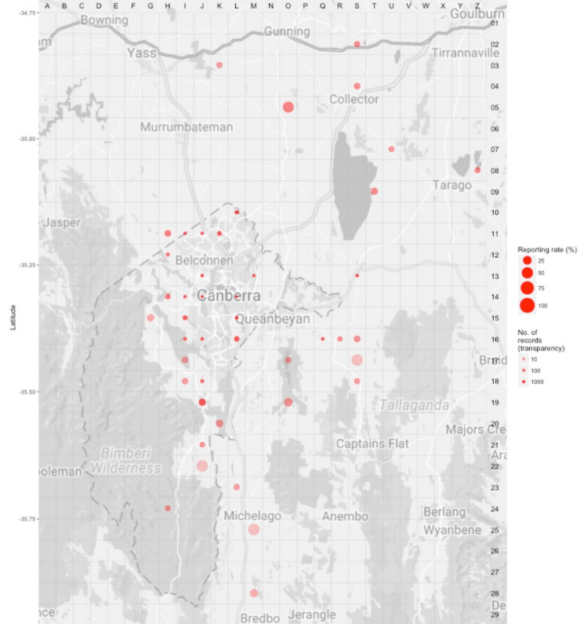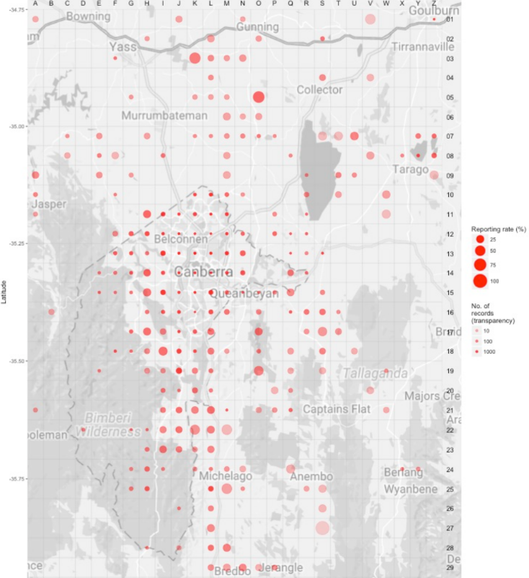

*Source: Canberrabirds.org.au. (2018). Note: Reporting rate (%) is the proportion of all surveys in which the species was present. These data were collected by volunteer birdwatchers using various survey methods and on some occasions more than one person may have recorded bird sightings on the same day, which may skew the data.*

Threats

In common with many other threatened bird species, a principal threat to the Diamond Firetail is a severe decline in the quality and quantity of its native woodland and grassland habitat. In the ACT, weed cover, especially in high rainfall periods, loss of favoured native grasses, or overgrazing by native herbivores may be the influencing factors in the species decline (Bounds et al. 2021).

Threats to the Diamond Firetail (DCCEEW 2023) include:

* over-clearing of native vegetation and subsequent fragmentation and degradation of remnant habitat patches
* overgrazing by stock and rabbits and overabundant kangaroos over-browsing the shrub layer
* invasive weeds, especially exotic annual grasses that replace native perennial grasses
* predation by feral and/or uncontrolled domestic animals (foxes, dogs and cats)
* unknown effects of severe weather events, including heatwaves
* unknown fire regimes
* increased competition with Noisy Miners and predation by Pied Currawongs as fragmented remnants are degraded.

Major Conservation Objectives

The primary objective in the ACT is to protect Diamond Firetail habitat through limiting clearance of suitable woodland habitat and prioritising conservation management to woodland patches, particularly those that are large or have complex habitat structure.

Conservation PRIORITIES

Conservation priorities are detailed in the Commonwealth Conservation Advice (DCCEEW 2023) for the species and rely on engaging with other jurisdictions to support regional and national recovery of the species. Priorities for the Diamond Firetail in the ACT should be to:

* identify and protect woodland and grassland habitat, particularly areas of 200 ha or greater within woody vegetation and maintain areas with a diverse ground layer dominated by a mixture of native perennial grass species that seed at different times of year to provide a year-round food supply and provide scattered shrubs for shelter, as well as areas with access to water, especially riparian areas
* maintain and enhance connectivity through regeneration and revegetation
* target control of invasive weeds that compromise habitat values
* reduce intensive grazing
* monitor long-term trends and the effectiveness of management actions
* investigate the potential impact of climate change on the species and its habitat
* identify fire regimes suitable to habitat requirements and highlight the ecological needs of the species in fire management guidelines
* determine the impacts of Noisy Miners and Pied Currawongs and manage as required
* actively seek opportunities to involve members of local indigenous communities in on ground activities
* encourage responsible pet ownership
* encourage and support the continuation and further development of community-based conservation activities.

CONSERVATION ISSUES

It is recommended that quantitative targets and resourcing requirements are clearly identified in any Action Plan or other related projects/programs relevant to this species. Broader conservation issues for this and other declining woodland birds need to be considered in developing and implementing actions arising from this advice and the species listing assessment (DCCEEW 2023).

### Critical Habitat

The temperate woodlands of the northern ACT and the bordering NSW region have been extensively disturbed by agriculture and urbanization and small patches of woodland are now embedded in a pastoral or suburban matrix. Consequently, birds are threatened by a reduction in habitat area, increased isolation, and declining habitat condition emphasising the importance and need of large, structurally complex, connected, high quality woodland patches to accommodate existing woodland birds (Watson et al. 2002, Watson et al. 2008). Watson et al. (2002) predicted that the decline of woodland bird species will continue unless appropriate habitat conservation strategies are applied as suggested (Watson et al. 2008).

The Commonwealth Conservation Advice (DCCEEW 2023) identifies ‘habitat critical to the survival’ or important habitats of a species refers to areas that are necessary:

* for activities such as foraging, breeding, roosting, or dispersal
* for the long-term maintenance of the species (including the maintenance of species essential to the survival of the species, such as pollinators)
* to maintain genetic diversity and long-term evolutionary development
* for the reintroduction of populations or recovery of the species.

Habitat critical to the survival should not be cleared, fragmented or degraded. Any known or likely habitat (Map 1) should be considered as habitat critical to the survival of the species. Additionally, areas that are not currently occupied by the species due to recent disturbance (e.g fire, grazing or human activity), but should became suitable again in the future, should also be considered habitat critical to the survival of the species. It is essential that the highest level of protection is provided to these areas, across all tenures, and that enhancement and protection measures target these productive sites. No Critical Habitat as defined under section 207A of the EPBC Act has been identified or included in the Register of Critical Habitat under the EPBC Act.

### Climate Change

Climate change impacts are inevitable and will affect the likelihood of persistence, within the ACT, of many species. Indeed, recent work demonstrates the negative effects of heatwaves and consequences for population persistence in bird communities of semi-arid woodlands (Gardner et al. 2022). The ACT is expected to face similar climate conditions in coming decades. Amongst the most vulnerable in this regard are those species that occupy highly fragmented habitat with highly restricted distributions. Capacity must be developed to model the impact on this species and its habitat under likely climate change scenarios if we are to anticipate and manage the impacts of climate change. This will require a combination of research and the development of in-house capacity for the collection of relevant data and its application in climate change modelling. New developments in biophysical models can provide a predictive understanding of the habitats required for persistence in the face of climate change and other stressors (see review by Briscoe et al. 2023). Such models integrate physical data on climate and terrain with measures of morphology, behaviour, physiology and life history of the species in question. Ensuring collection of relevant data to provide the necessary information to parameterize models that can explore population persistence and species distributions is critical.  Given increases in the frequency and intensity of extreme heat events are widely predicted it will be important to characterise the nature and use of thermal refuges used by birds under such conditions to quantify the importance of refuges for survival, and to preserve/regenerate such habitat.

### Population Viability

An understanding of demographic rates, dispersal and behaviour is necessary for assessing responses to environmental changes and to inform population modelling (e.g., PVA, Biophysical Models), which can predict likelihoods of viability over the longer term. This will inform management options which may include assessment of genetic diversity and the possibility of genetic rescue.  It is possible for the viability of species/population to be compromised such that they are unable to rebound if conditions improve and/or respond to suitable management. For example, loss of genetic diversity and associated genetic problems, such as inbreeding depression, in small populations can reduce survival and reproductive rates such that the population cannot respond to improved conditions.

### Jurisdictional Collaboration

Many woodland birds have large distributions and while the ACT makes up a small component, in terms of area, it can play an important role in informing conservation due to its location, local expertise and community interest. Developing policies and recovery plans across several jurisdictions with many stakeholders requires ongoing discussion/negotiations across many stakeholders and jurisdictional entities.

### Ngunnawal Community Engagement

The ACT Government should actively facilitate, the inclusion of the Ngunnawal people in the conservation of this species and its habitat as part of Ngunnawal Country. Reference to the draft Cultural Resource Management Plan (ACT Government in prep.) would be useful to inform culturally appropriate resource management including of native species that aligns with achieving conservation outcomes for the species.

Other Relevant Advice, plans or Prescriptions

* Commonwealth Conservation Advice – Diamond Firetail (DCCEEW 2023)
* [ACT Woodland Conservation Strategy](http://www.environment.act.gov.au/cpr/conservation_and_ecological_communities/threatened_species_action_plans) (ACT Government 2004)
* [ACT Woodland Conservation Strategy](https://www.legislation.act.gov.au/View/ni/2019-184/current/PDF/2019-184.PDF) (ACT Government 2019)
* [ACT Conservation Advice](https://www.legislation.act.gov.au/ni/2018-536/) — Loss of Mature Trees (Scientific Committee 2018)

Listing Background

The Diamond Firetail is listed as a Vulnerable species under the *Environment Protection and Biodiversity Conservation Act 1999* (EPBC Act), effective 31 March 2023. It is eligible to be listed as Vulnerable under Criterion 1 (A2bce+3ce+4bce) of the EPBC Act. In 2023, under the *Nature Conservation Act 2014*, the ACT Scientific Committee recommended the Diamond Firetail be listed in the Vulnerable category in the ACT Threatened Native Species List to align with the EPBC Act listing.

Action Plan Decision

The ACT Scientific Committee does not recommend that the Minister for the Environment should make the decision to have an individual action plan for the species in the ACT under the *Nature Conservation Act 2014* at this time but proposes that an Action Plan for (threatened) Woodland Birds (including specific requirements for the Diamond Firetail) should be developed and implemented by the Conservator. There are several woodland birds, including the Diamond Firetail, for which there are actions that are designed to provide for the conservation and management of the habitat of these birds collectively in the Woodland Strategy (ACT Government 2019), however a targeted Action Plan for (threatened) Woodland Birds and their habitat in the ACT is necessary to identify, understand and help address the declines and support recovery.

A National Recovery Plan is required to be prepared for the species (DCCEEW 2023) but there are likely to be ACT specific questions that need to be answered that a National Recovery Plan may not address. For example, as the decline in the ACT is not fully understood and is likely fully attributed to urbanisation we could reduce further losses through better urban planning.

References

ACT Government 2004. *Woodlands for Wildlife: ACT Lowland Woodland Conservation Strategy. Action Plan No. 27*. Environment ACT, Canberra.

ACT Government 2019. *ACT Woodland Conservation Strategy and Action Plans*. Environment Planning and Sustainable Development Directorate, Canberra.

ACT Government in prep. *Draft Cultural Resource Management Plan*. Environment Planning and Sustainable Development, ACT Government, Canberra.

BirdLife Australia 2023. Diamond Firetail *Stagonopleura guttata* Profile. Accessed 10 May 2023 from: <https://birdlife.org.au/bird-profiles/diamond-firetail/>

BirdLife International 2022. *Stagonopleura guttata*. The IUCN Red List of Threatened Species 2022: e.T22719660A211542365. <https://www.iucnredlist.org/species/22719660/211542365> Accessed on 10 May 2023.

Bounds J, Davey C, Taws N, Evans MJ, Rayner L 2021. *Long-term trends in ACT woodland birds 1998–2019*. Canberra Ornithologists Group, Canberra.

Briscoe NJ, Morris SD, Mathewson PD, Buckley LB, Jusup M, Levy O, Maclean IMD, Pincebourde S, Riddell EA, Roberts JA, Schouten R, Sears MW, Kearney MR 2023. Mechanistic forecasts of species responses to climate change: The promise of biophysical ecology. *Global Change Biology* 29(6): 1451–1470.

Cabby J 2000. List of Birds of the ACT – early 1950s, *Canberra Bird Notes* 25(1): 1–22. <http://canberrabirds.org.au/wp-content/canberra-bird-notes/cbnvol25no1.pdf>

Canberra Birds 2018. Diamond Firetail *Stagonopleura guttata* data sheet. Canberra Ornithologists Group, Canberra. <http://canberrabirds.org.au/birds/diamond-firetail/>

Canberra Birds 2023. Canberra Garden Birds – Diamond Firetail *Stagonopleura guttata* Profile. Canberra Ornithologists Group, Canberra. <https://canberrabirds.org.au/our-birds/canberra-garden-birds/finches/diamond-firetail/>

COG 2018. Annual Bird Report: 1 July 2016 to 30 June 2017. *Canberra Bird Notes* 43(1): 1–110.

COG 2020. Annual Bird Report: 1 July 2018 to 30 June 2019. *Canberra Bird Notes* 45(1): 1–108

Bounds J, Davey C, Taws N, Evans MJ, Rayner L 2021. Long-term Trends in ACT Woodland Birds 1998–2019. Canberra Ornithologists Group, Canberra.

Department of Climate Change, Energy, the Environment and Water (DCCEEW) 2023. *Conservation Advice Stagonopleura guttata (diamond firetail)*. Department of Climate Change, Energy, the Environment and Water (Commonwealth), Canberra.

Gardner JL, Clayton M, Allen R, Stein J, Bonnet T. 2022. The effects of temperature extremes on survival in two semi-arid Australian bird communities over three decades, with projections to 2104. *Global Ecology & Biogeography* 31(12): 2498–2509.

Garnett ST and Baker GB 2021. *The Action Plan for Australian Birds*, CSIRO Publishing, Collingwood.

Higgins PJ, Peter JM, Cowling SJ (Eds) 2007. *Handbook of Australian, New Zealand and Antarctic Birds. Volume 7: Boatbill to Starlings.* Oxford University Press, Melbourne.

Hodder GV, Ford HA, Ehmke G, D Oliver, Tulloch AIT, Barnes MD & Garnett ST 2021. Diamond Firetail *Stagonopleura guttata.* In *The Action Plan for Australian Birds 2020*. (Eds ST Garnett and GB Baker). CSIRO Publishing, Melbourne.

Office of Environment and Heritage (OEH) 2021. Diamond Firetail Profile. <https://www.environment.nsw.gov.au/threatenedSpeciesApp/profile.aspx?id=10768>

Scientific Committee 2018. Conservation Advice – Loss of Mature Trees (including Hollow-bearing Trees) and Lack of Recruitment. ACT Government, Canberra.

Taylor M and Canberra Ornithologists Group (COG) 1992. *Birds of the Australian Capital Territory – An Atlas*. Canberra Ornithologist Group and National Capital Planning Authority, Canberra.

Further Information

Further information can be obtained from the Environment, Planning and Sustainable Development Directorate (EPSDD). EPSDD Website: <https://www.environment.act.gov.au/nature-conservation>

Attachment A: National Listing Assessment ([DCCEEW 2023](https://www.environment.gov.au/cgi-bin/sprat/public/publicspecies.pl?taxon_id=59398))

