Australian Capital Territory

**Nature Conservation (Hoary Sunray) Conservation Advice 2024**

**Notifiable instrument NI2024-254**

made under the

**Nature Conservation Act 2014, s 90C (Conservation advice)**

**1 Name of instrument**

This instrument is the *Nature Conservation ( Hoary Sunray) Conservation Advice 2024*.

**2 Commencement**

This instrument commences on the day after its notification day.

**3 Conservation advice for Hoary Sunray**

Schedule 1 sets out the conservation advice for Hoary Sunray (*Leucochrysum albicans tricolor*).

Arthur Georges

Chair, Scientific Committee

21 May 2024

**Schedule 1**

(see s 3)

Conservation Advice  
HOARY SUNRAY – *Leucochrysum albicans tricolor*

Conservation Status

The Hoary Sunray – *Leucochrysum albicans* subsp. *tricolor* (DC.) N.G. Walsh (2015)– is recognised as threatened in the following jurisdictions:

National **Endangered**, *Environment Protection and Biodiversity Conservation Act 1999*

ACT **Endangered**, *Nature Conservation Act 2014*

NSW **Endangered**, *Biodiversity Conservation Act 2016*

VIC **Endangered**, *The Flora and Fauna Guarantee Act 1988*

TAS **Endangered**, *Threatened Species Protection Act 1995*

ELIGIBILITY

[Close up photo of a couple of flowering Hoary Sunray paper daisy plants at Gossan Hill Nature Reserve, Bruce, taken by Andrew Zelnick in October 2021.
The photo shows the crimson coloured buds opening out to bright yellow "egg-yolk-like" centred flower heads surrounded by layers of white paper petal-like bracts. As flowers age the crimson colouring fades out on the underside of the bracts. Photo on Canberra Nature Map.](https://canberra.naturemapr.org/sightings/4401565)This Hoary Sunray subspecies is listed as Endangered in the ACT Threatened Native Species List under IUCN Criterion A – A2abc due to its severe population reduction at the national level from 2000–2020 (three generations), particularly in Victoria and Tasmania (DAWE 2021; Attachment 1). In south-west Victoria it is estimated to have declined (from no more than 40,000 plants in the early 2000s to 20,000–30,000 plants in 2020) due to unsecure land tenure often on roadsides. In eastern and central Tasmania, it declined, particularly on private land (from 200,000–400,000 plants in 2011 to 30,000–50,000 plants in 2020) due to clearing and poor management (DAWE 2021).

DESCRIPTION AND ECOLOGY

The Hoary Sunray is a perennial everlasting daisy. It has a yellow flowerhead surrounded by papery white, overlapping ovate-oblong bracts which are often coloured in various shades of crimson on the outer/underside that may fade as the flowers mature.

Flowering generally occurs from October to December in the ACT. The Hoary Sunray (*L. a. tricolor* subspecies) can be distinguished from the other subspecies within *L. albicans* by its white involucral bracts and narrow, linear-oblanceolate leaves but can, in rare instances, apparently intergrade with the yellow-flowered *L. albicans* subsp. *albicans* (NSW OEH 2023). After flowering, the plants die-back in summer but survive as a perennial rootstock (Sinclair 2010) and can likely live for 15 years (Gilfedder and Kirkpatrick 1994a) but on average the generation length is likely to be seven years.

Hoary Sunray (subsp. tricolor) (Andrew Zelnik – Canberra Nature Map)

Distribution and Habitat

Hoary Sunray is endemic to south-eastern Australia, where it occurs in three geographically separate areas in NSW/ACT, Victoria and Tasmania (DAWE 2021). Most Hoary Sunray populations occur in NSW and the ACT where the taxon is still locally common (K McDougall pers. comm. in DAWE 2021) although some roadside subpopulations may be declining (FOG pers. comm. in DAWE 2021). Sinclair (2010) estimated the total number of plants in NSW and ACT to be greater than 200,000 plants which likely remains unchanged as most populations appear to be stable. Around 20 of the approximate 30 subpopulations in the ACT occur in nature reserves (Figure 1), with the remainder occurring on roadsides or unsecured private land (DAWE 2021).

**Figure 1: ACT region observations 1998–2023**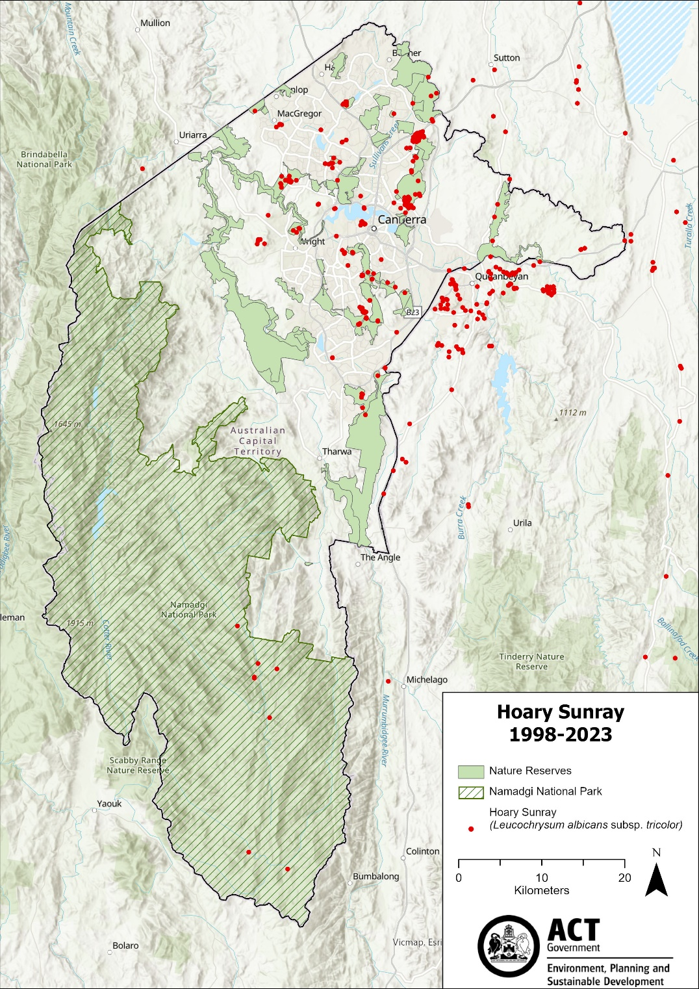

Mount Majura, Mount Ainslie and Percival Hill nature reserves support large populations (thousands of plants) of the Hoary Sunray and smaller populations occur in several other open forest, woodland and grassland reserves, including, Kowen Escarpment, Farrer Ridge and Rob Roy nature reserves (ACT Government 2021). These occur in the suburbs of Watson, Majura, Hackett, Campbell, Nicholls, Farrer, Issacs, Fadden, Tuggeranong. A significant population has also been identified at Booth in Namadgi National Park (NNP) in 2022 (CNM 2023). Other medium sized populations have been recorded in Wanniassa Hills, Stromlo, Molonglo Valley, Gigerline Nature Reserve, Central Canberra, Kowen, Theodore, Latham, Pialligo, Yarralumla, Belconnen, Rendezvous Ck (NNP)and Mount Clear (NNP) (CNM 2023).

In NSW and the ACT, ‘habitat critical to the survival’ of Hoary Sunray includes the critically endangered ecological communities: Natural Temperate Grassland of the South Eastern Highlands; and White Box–Yellow Box–Blakely’s Red Gum Grassy Woodlands and Derived Native Grasslands (DAWE 2021). Hoary Sunray occurs on a variety of soil types including clays, clay loams, stony and gravely soil and relies on bare and/or disturbed ground for germination and establishment (Sinclair 2010).

Threats

In the ACT (and NSW) there is no evidence of a substantial decline of Hoary Sunray (DAWE 2021). In other areas (Victoria and Tasmania), the major threats to Hoary Sunray are:

* the clearing of native grasslands
* a lack of biomass reduction in productive habitat
* weed invasion
* road maintenance works
* climate change - increasing frequency and intensity of drought
* genetic risks associated with small and fragmented populations (DAWE 2021).

Major Conservation Objective

The priority management objective should be to maintain in the long term, viable, wild populations of the species as a component of the indigenous biological resources of the ACT and as a contribution to regional and national conservation of the species. This includes the need to maintain natural evolutionary processes.

Conservation Priorities

The primary way Hoary Sunray populations can be managed in the ACT is through the management of habitat and the long-term conservation of the species depends on protecting its native grassland and grassy woodland habitat.

Conservation actions are detailed in the Commonwealth Conservation Advice (DAWE 2021). Conservation and management priorities for the Hoary Sunray in the ACT should be to:

* identify and record important populations (large populations greater than 10,000 plants) and protect from damage, destruction or decline
* develop and implement a non-onerous population trend/condition monitoring program
* collect seeds from the above identified populations for *ex situ* conservation in the National Seed Bank
* climate change modelling (details in issues section below)
* identify and provide signage for roadside populations
* include specific requirements of the Hoary Sunray (e.g., appropriate biomass reduction of Hoary Sunray grassland habitat (including post-treatment weed control) in late summer to mid-autumn every 2–5 years in Kangaroo Grass-dominated grasslands (McDougall 1989)) in revisions of the ACT Ecological Guidelines (ACT Government 2019c) and ACT Herbage Mass Guidelines (ACT Government 2019b)
* actively seek opportunities to involve members of local indigenous communities in on ground activities
* encourage and support the continuation and further development of community conservation activities.
* engage with other jurisdictions to support regional and national recovery of the species.

Conservation Issues

It is recommended that quantitative targets and resourcing requirements are clearly identified in any Action Plan or other related projects/programs relevant to this species. Broader conservation issues need to be considered in developing and implementing actions arising from this advice and the listing assessment (DAWE 2021).

### Critical Habitat

The Commonwealth Conservation Advice (DAWE 2021) identifies ‘habitat critical to the survival’ of the Hoary Sunray as habitats that are likely necessary for dispersal activities, the maintenance of genetic diversity and the long-term evolutionary trajectory of Hoary Sunray. These include the Yellow Box–Blakely’s Red Gum Grassy Woodland and Natural Temperate Grassland ecological communities. No Critical Habitat as defined under section 207A of the EPBC Act has been identified or included in the Register of Critical Habitat under the EPBC Act.

### Population Viability

If other measures are not effective in restoring populations in other jurisdictions, then *ex situ* seed banking and propagation of the existing subpopulations across the species distribution and cross pollination experiments to increase genetic diversity may be necessary for this species to recover in other jurisdictions.

### Climate Change

Climate change impacts are inevitable and will affect the likelihood of persistence, within the ACT, of many species. Capacity must be developed to model the impact on the Hoary Sunray and its habitat under likely climate change scenarios if we are to anticipate and manage the impacts of climate change. This will require a combination of research and the development of in-house capacity for the collection of relevant data and its application in climate change modelling for threatened species.

### Ngunnawal Community Engagement

The ACT Government should actively facilitate, the inclusion of the Ngunnawal people in the conservation of this species and its habitat as part of Ngunnawal Country. Reference to the draft Cultural Resource Management Plan (ACT Government in prep.) would be useful to inform culturally appropriate resource management including of native species that aligns with achieving conservation outcomes for the species.

Other Relevant Advice, plans or Prescriptions

* Commonwealth Conservation Advice – Hoary Sunray (DAWE 2021)
* National Recovery Pan – Hoary Sunray (Sinclair 2010)
* ACT Native Woodland Strategy (ACT Government 2019a)
* ACT Native Grassland Strategy (ACT Government 2017)
* Canberra Nature Park Reserve Management Plan (ACT Government 2021)
* Namadgi National Park Plan of Management (ACT Government 2010)

Listing Background

The Hoary Sunray was eligible for listing under the *Environment Protection and Biodiversity Conservation Act 1999* (EPBC Act) as *Leucochrysum albicans* var. *tricolor* (DC.) Paul G. Wilson on 16 July 2000. Following the elevation of rank by Walsh (2015), the name of this taxon is now conventionally accepted as *Leucochrysum albicans* subsp*. tricolor* (DC.) N.G. Walsh.

The Hoary Sunray was reassessed in 2021 and remains listed as an Endangered species under the EPBC Act. It is assessed as Endangered under Criterion 1 – A2abc of the EPBC Act. In 2023, under the *Nature Conservation Act 2014*, the ACT Scientific Committee recommended the Hoary Sunray be listed in the Endangered category in the ACT Threatened Native Species List to align with the EPBC Act listing.

Action Plan Decision

The ACT Scientific Committee does not recommend that the Minister for the Environment should make the decision to have an action plan for the species in the ACT under the *Nature Conservation Act 2014*. The key populations of Hoary Sunray appear stable in ACT nature reserves and in Namadgi National Park where habitat is protected. The critically endangered ecologically communities in which the Hoary Sunray occurs are managed under the ACT Native Woodland Conservation Strategy (ACT Government 2019a) and ACT Native Grassland Conservation Strategy (ACT Government 2017) as well as the Canberra Nature Park Reserve Management Plan (ACT 2021) and the Namadgi National Park Plan of Management (ACT Government 2010) that is currently under review. Specific Requirements for the Hoary Sunray should be included in revisions of the ACT Ecological Guidelines (ACT Government 2019c) and ACT Herbage Mass Guidelines (ACT Government 2019b).

A National Recovery Plan is in place for the Hoary Sunray (Sinclair 2010), mostly to guide management and recovery in Victoria and Tasmania.

References

ACT Government 2010. Namadgi National Park Plan of Management 2010. Land Management and Planning Division, Department of Territory and Municipal Services. ACT Government, Canberra.

ACT Government 2017. *ACT Native Grassland Conservation Strategy and Action Plans*. Environment, Planning and Sustainable Development Directorate, ACT Government, Canberra.

ACT Government 2019a. *ACT Native Woodland Conservation Strategy and Action Plans*. Environment Planning and Sustainable Development Directorate, Canberra.

ACT Government 2019b. *Draft Herbage Mass Management Guidelines for Lowland Grassy Ecosystems of the ACT*. Environment, Planning and Sustainable Development Directorate, ACT Government, Canberra.

ACT Government 2019c. *Ecological Guidelines for Fire, Fuel and Access Management Operations*. Environment Planning and Sustainable Development Directorate, ACT Government, Canberra. <https://www.environment.act.gov.au/__data/assets/pdf_file/0009/1483830/Ecological-Guidelines-2019-ver-1.3.pdf>

ACT Government 2021. *Canberra Nature Park Reserve Management Plan 2021*. Environment, Planning and Sustainable Development Directorate, ACT Government, Canberra.

ACT Government in prep. *Draft Cultural Resource Management Plan*. Environment, Planning and Sustainable Development Directorate, ACT Government, Canberra.

Canberra Nature Map 2023. *Leucochrysum albicans* subsp. *tricolor* sightings - Canberra Nature Map (naturemapr.org) Available at: <https://canberra.naturemapr.org/species/7626> Accessed 25 July 2023.

Department of Agriculture Water and the Environment (DAWE) 2021. *Conservation Advice for Leucochrysum albicans subsp. tricolor (Hoary Sunray)*. Canberra: Department of Agriculture, Water and the Environment (Commonwealth), Canberra.

Sinclair SJ 2010. *National Recovery Plan for the Hoary Sunray Leucochrysum albicans* var. *tricolor.*  Department of Sustainability and Environment, Victorian Government, Melbourne.

Walsh NG 2015. Elevation of rank for *Leucochrysum albicans* var. *tricolor* (Asterace: Gnaphalieae). *Muelleria* 34: 11–13.

Further Information

Further information on the related Action Plan or other threatened species and ecological communities can be obtained from: Environment, Planning and Sustainable Development Directorate (EPSDD).  
Phone: (02) 132281, EPSDD Website: <https://www.environment.act.gov.au/nature-conservation>

Attachment A: Listing Assessment ([DAWE 2021](https://www.environment.gov.au/cgi-bin/sprat/public/publicspecies.pl?taxon_id=89104))

