Australian Capital Territory

Nature Conservation (Hooded Robin) Conservation Advice 2024

Notifiable instrument NI2024-255
made under the
Nature Conservation Act 2014, s 90C (Conservation advice)

1 Name of instrument
This instrument is the Nature Conservation (Hooded Robin) Conservation Advice 2024.

2 Commencement
This instrument commences on the day after its notification day.

3 Conservation advice for Hooded Robin
Schedule 1 sets out the conservation advice for Hooded Robin (Melanodryas cucullata cucullata).

4 Revocation
The Nature Conservation (Hooded Robin) Conservation Advice 2019 (NI2019-249) is revoked.

Arthur Georges
Chair, Scientific Committee
21 May 2024
Schedule 1
(see s 3)

Conservation Advice
Hooded RObin (South-eastern)
Melanodryas cucullata cucullata

Conservation Status
The Hooded Robin Melanodryas cucullata cucullata (Latham, 1801) is recognised as threatened in the following jurisdictions:
National Endangered, Environment Protection and Biodiversity Conservation Act 1999 (EPBC Act)
Vulnerable, Action Plan for Australian Birds 2010
ACT Endangered, Nature Conservation Act 2014
NSW Endangered, Biodiversity Conservation Act 2016
Victoria Vulnerable, Flora and Fauna Guarantee Act 1988
SA Rare, National Parks and Wildlife Act 1972

ELIGIBILITY
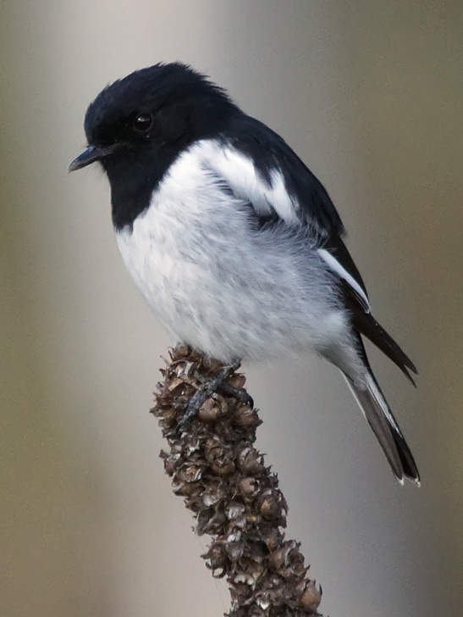
The Hooded Robin (South-eastern) is listed as Endangered in the ACT Threatened Native Species List under IUCN Criterion A— A2bce due to a greater than 50% reduction in the national population size over the last 10 years (Ford et al. 2021 and Attachment A - DCCEEW 2023). Decline of Hooded Robins (South-eastern) is due to the combined threats such as: ongoing increased predation from introduced mammals (cats and foxes), invasive weeds, and competition with Noisy Miners (Manorina melanocephala); over-grazing by domestic stock, rabbits and overabundant kangaroos preventing regeneration of native vegetation; combined with habitat loss and fragmentation, climate change, inappropriate fire regimes, and inappropriate firewood collection and tidying of farmland that have not ceased and may not be reversible (DCCEEW 2023).

DESCRIPTION AND ECOLOGY
Melanodryas cucullata cucullata is the sub-species of the Hooded Robin resident in the ACT. It is a medium-large robin, measuring 14–17 cm in length, with a rather short slender bill and a moderately long tail which is square-tipped. Adult males are pied (black and white) with a black hood and back, white underparts, black wings, white shoulder bar and wing stripe. Females are similar to males but greyer with a brown-grey head and a dark brown wing with a white stripe. Juveniles are dark brown with off-white speckling, white markings on the upper body and white underneath (Birdlife Australia 2018).
Adult male Hooded Robin (David Cook – Canberra Birds)
Flight is short and swiftly undulating. The adult male is unmistakable but the female and young males may be confused with other species, such as the Jacky Winter (Microeca fascinans). Hooded Robins are distinguished from aesthetically similar species by their larger size, distinctive white wing bar and different 'hourglass' shaped tail markings (OEH 2017).
The Hooded Robin is a shy and largely sedentary bird. Hooded Robins are often quiet during the day, especially in the afternoon, but are one of the first birds to call in the morning, when they vigorously add their far-carrying song to the dawn chorus (Birdlife Australia 2018). The call is a series of descending, fading, mellow notes. They are never numerous, do not flock but are frequently observed in pairs or small groups. They hunt for invertebrates by ‘perch and pounce’ in grassy clearings where rocks and fallen timber litter the ground (Sullivan 1993).
Hooded Robins breed in monogamous pairs, prefer a particular breeding site and the female incubates the eggs. Pairs occupy territories of between five and fifty hectares. Small territories are defended in the breeding season (August to December) and the species occupy larger home ranges in the non-breeding season (Bell 1984; Blakers et al. 1984; Schodde and Tidemann 1986; Fitri 1993; Graham 1995). The species builds open cup nests from bark strips, leaves, grass and spiders’ web placed on stumps or in a cavity in a broken trunk or horizontal fork or branch 1–6 m above ground (Pizzey and Knight 1998). Generation length is estimated as 5.3 years (Garnett et al. 2011).

Distribution and Habitat
Four intraspecific taxa of the Hooded Robin (Melanodryas cucullata) are recognized, together distributed across most of mainland Australia: M. c. melvillensis (Tiwi Islands, NT); M. c. westralensis (South-western arid zone); M. c. picata (Northern inland); and M. c. cucullata (South-eastern) (Schodde and Mason 1999; Garnett and Crowley 2000).
The south-eastern sub-species M. c. cucullata occurs (hereafter Hooded Robin) from Mundubbera in Queensland to the Spencer Gulf in South Australia, intergrading with the other sub-species through the northern Murray-Darling basin as shown in Map 1. This is the sub-species that is the breeding resident of the ACT and it has a total estimated extent of occurrence of 1.2 million km² and area of occupancy of 30,000 km² (Ford et al. 2021). The sub-species, however, is either declining or has vanished entirely from many habitat fragments and regions across its range, particularly in eucalypt-dominated woodlands and wetter areas of the south and east (Robinson 1993; Barrett et al. 1994; Paton et al. 1994; Fitri and Ford 1996; Robinson and Traill 1996; Olsen et al. 2005; Priday 2010; Ford 2011; Garnett et al. 2011).
In the ACT, small groups have been observed in grassy woodlands in the north and open areas in valleys in the south (ACT Government 1999). Taylor and Canberra Ornithologists Group (COG) (1992) stated that Hooded Robins were once common close to the city, however, local disappearances have been documented at a number of sites including Black Mountain, Campbell Park, Mt Ainslie and Tuggeranong Homestead. There were 40 active territories (or pairs) estimated in the ACT in 1991 (Graham 1995).

Map 1: Modelled distribution of the Hooded Robin (South-eastern) (Source: DCCEEW 2023)
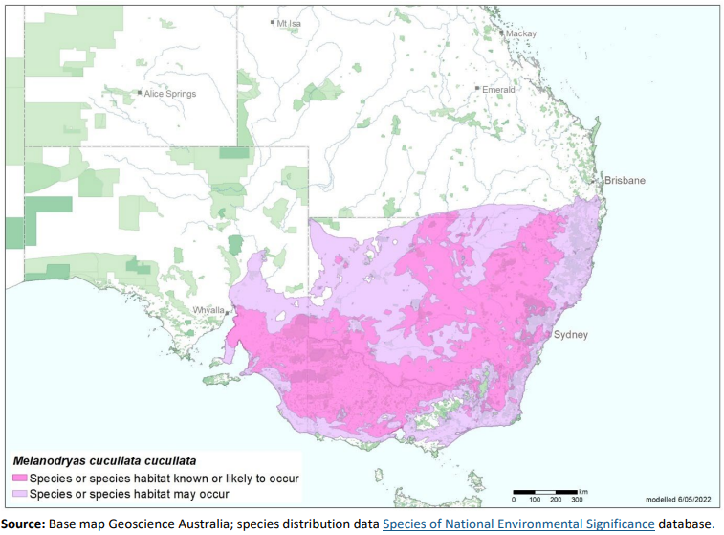
In a study on the largest woodland corridor in the ACT from Hall to Newline, Bounds (2006) estimated there were only four to six Hooded Robin territories in the Mulligans Flat/Goorooyarroo Nature Reserve complex of around 1500 hectares including two territories in Mulligans Flat on the eastern side of the reserve and two to three territories in Goorooyarroo, in the northern part of the reserve. It was also thought that there were only one or two territories in the Kinlyside woodlands near Hall (three records of one to two birds, 2002–2003) and possibly 2–3 territories in the Majura Field Range (11 records of one to five birds, 1998–2006) (N Taws, A Rowell pers comm, in Bounds 2006).
Data analysis of COG’s woodland surveys between 1995 and 2003 at eleven key woodland sites indicated a decline in abundance of the Hooded Robin, including Mulligans Flat Nature Reserve. The species was also recorded at: the Newline quarry; the southern part of Majura Field firing range; and north of Tharwa (Cunningham 2003 in ACT Government 2004). Analysis from surveys conducted between 1998 and 2005 as part of the COG Woodland Project, indicated that the Hooded Robin decreased in occupancy rate (detection rate) across the project's fourteen locations by 24% (Bounds et al. 2007). In further analyses in 2008 (Bounds et al. 2010) and 2010, the rate of Hooded Robin occupancy was too low for meaningful statistical analysis. Further analysis of reporting in this study at selected grassy woodland locations in the ACT showed a significant steady decline 1998–2014 after which there were no longer resident breeding groups and no records at these sites (Bounds et al. 2021).
There have been further fluctuations and continuing declines in sightings of Hooded Robins in the ACT (COG 2018) (Figure 1 and 2). Sightings of 42 birds were recorded in 2016–2017 (82 in 2015–2016) in the ACT region with most occurring in open woodland in nearby NSW to the east of the ACT (Figure 2) (COG 2018). The numbers reported remained very low through to 2018–19 (43 total birds) and the reporting rate (0.2%) was much less than 2017–18 (0.5%), and closer to the 2016–17 lowest ever (0.1%) (COG 2020).
The habitat critical to the survival of the species is identified in the Commonwealth Conservation Advice (DCCEEW 2023) and corresponds with all known or likely habitat in Map 1 and includes areas of:
- dry eucalypt and acacia woodland and shrubland remnants with an open understorey,
some grassy areas and a complex ground layer, often in or near clearings or open areas
- structurally diverse habitats featuring mature eucalypts, saplings, some small shrubs and a
ground layer of moderately tall native grasses
- standing dead or live trees and tree stumps are also essential for nesting, roosting and
foraging
- moderately deep to deep soils, rocks and fallen timber which provides essential foraging
habitat.

Figure 1: Hooded Robin records in the ACT region – 1982–2017
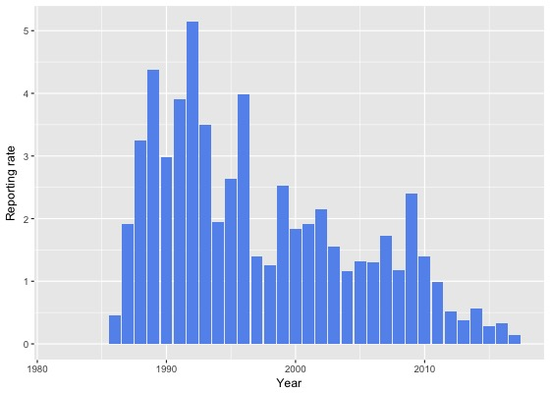
Source: Canberrabirds.org.au. (2018). The 2018-19 reporting rate (0.2%) was much less than 2017–18 (0.5%), and closer to the 2016–17 lowest ever (0.1%) (COG 2020).
Note: Reporting rate (%) is the proportion of all surveys in which the species was present. These data were collected by volunteer birdwatchers using various survey methods and, on some occasions, more than one person may have recorded bird sightings on the same day, which may skew the data.

Figure 2: Hooded Robin distribution in the ACT region – 2017 and 1982–2017
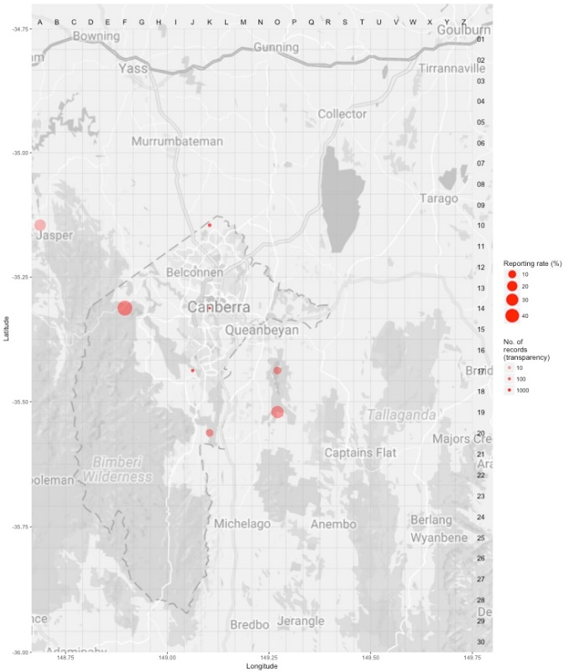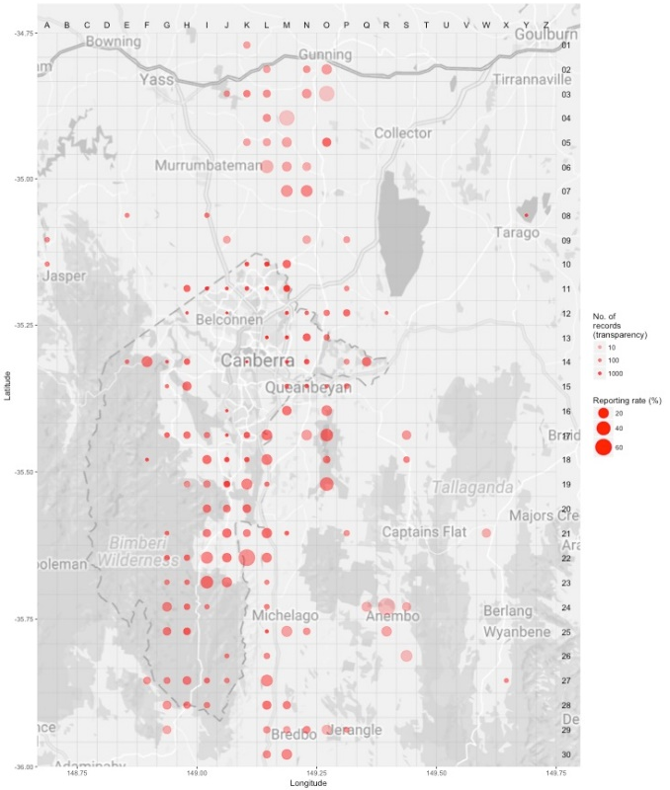
Source: Canberrabirds.org.au. (2018). Note: Reporting rate (%) is the proportion of all surveys in which the species was present. These data were collected by volunteer birdwatchers using various survey methods and, on some occasions, more than one person may have recorded bird sightings on the same day, day, which may skew the data.
Hooded Robin territories usually have some patches of eucalypt regrowth. The species requires more vegetation cover in the breeding season, as nests are typically built in saplings and small trees. The results of research on the species near Armidale suggested that nesting habitat, including small patches of eucalypt regrowth, may be in shorter supply than foraging areas (Fitri 1993). The distribution of the Hooded Robin in the ACT is restricted to habitats that contain a mixture of woodland and native grassland away from urban areas (Graham 1990).

Threats
In common with many other threatened bird species, the principal threat to the Hooded Robin is loss of its woodland habitat. The modification of the structure of grassy woodland habitat has contributed to the decline of the Hooded Robin. The loss of perching sites essential for foraging may alone be sufficient to make otherwise suitable habitat unsuitable (Graham 1990). Therefore, the removal of timber for firewood is likely to result in local reduction of Hooded Robin numbers.
Nevertheless, nesting habitat, including small patches of eucalypt regrowth, may be in shorter supply than in foraging areas (Fitri 1993; ACT Government 1999). The species requires more vegetation cover in the breeding season as nests are typically built in saplings and small trees. High levels of nest predation leading to poor recruitment was suggested to be the likely cause of decline in Hooded Robins (Ford 2011) and it is possible that habitat degradation such as the removal of understory species and tree cover has exposed the Hooded Robin to higher rates of predation.
Ongoing climate change, including predicted increases in the frequency and intensity of extreme heat events are a threat, especially given evidence of heatwave-related reproductive failure and adult mortality in the closely related Jacky Winter (Sharpe et al. 2019, 2021, 2022). The negative effects of heat-related mortality appear widespread across bird communities in semi-arid woodlands and threaten population persistence (Gardner et al. 2022). The ACT is expected to face similar climate conditions in coming decades.
Threats to the Hooded Robin (ACT Government 2004) include:
- removal of fallen timber and litter and inappropriate fire regimes
- predation by feral and/or uncontrolled domestic animals (foxes, dogs and cats)
- invasion of key habitats by introduced pasture and weeds
- uncontrolled grazing by livestock
- clearing of both living and dead trees
- rural tree dieback
- inappropriate fire regimes.

Major Conservation Objectives
The primary objective in the ACT is to protect Hooded Robin habitat through limiting clearance of suitable woodland habitat and prioritising conservation management to woodland patches, particularly those that are large or have complex habitat structure.

Conservation Priorities
Conservation priorities are detailed in the Commonwealth Conservation Advice (DCCEEW 2023). The conservation actions relevant to the Hooded Robin in the ACT Lowland Woodland Conservation Strategy (ACT Government 2004) remain relevant including to:
- protect habitat
- maintain and enhance connectivity
- limit removal of live and dead timber
- reduce intensive grazing
- maintain patches of shrubs or eucalypt regrowth
- regenerate habitat
- minimise adverse effects of fire.
Other priorities for the Hooded Robin in the ACT should be to:
- monitor long-term trends and the effectiveness of management actions
- identify fire regimes suitable to habitat requirements and highlight the ecological needs of the species in fire management guidelines
- investigate the potential impact of climate change on the subspecies and its habitat
- characterise the nature and use of thermal refuges used during heatwaves
- target removal of invasive perennial grasses and careful replacement of beneficial exotic woody vegetation
- determine the impacts of Noisy Miners and mange as required through re-establishing a structurally complex understory
- actively seek opportunities to involve members of local indigenous communities in on ground activities
- encourage responsible pet ownership
- encourage and support the continuation and further development of community-based conservation activities.

CONSERVATION ISSUES
It is recommended that quantitative targets and resourcing requirements are clearly identified in any Action Plan or other related projects/programs relevant to this species. Broader conservation issues for this and other declining woodland birds need to be considered in developing and implementing actions arising from this advice and the species listing assessment (DCCEEW 2023).

Critical Habitat
The temperate woodlands of the northern ACT and the bordering NSW region have been extensively disturbed by agriculture and urbanization and small patches of woodland are now embedded in a pastoral or suburban matrix. Consequently, birds are threatened by a reduction in habitat area, increased isolation, and declining habitat condition emphasising the importance and need of large, structurally complex, connected, high quality woodland patches to accommodate existing woodland birds (Watson et al. 2002, Watson et al. 2008). Watson et al. (2002) predicted that the decline of woodland bird species will continue unless appropriate habitat conservation strategies are applied as suggested (Watson et al. 2008).
The Commonwealth Conservation Advice (DCCEEW 2023) identifies ‘habitat critical to the survival’ or important habitats of a species refers to areas that are necessary:
- for activities such as foraging, breeding, roosting, or dispersal
- for the long-term maintenance of the species (including the maintenance of species essential to the survival of the species, such as pollinators)
- to maintain genetic diversity and long-term evolutionary development
- for the reintroduction of populations or recovery of the species.
Habitat critical to the survival should not be cleared, fragmented or degraded. Any known or likely habitat (Map 1) should be considered as habitat critical to the survival of the species. Additionally, areas that are not currently occupied by the species due to recent disturbance (e.g fire, grazing or human activity), but should became suitable again in the future, should also be considered habitat critical to the survival of the species. It is essential that the highest level of protection is provided to these areas, across all tenures, and that enhancement and protection measures target these productive sites. No Critical Habitat as defined under section 207A of the EPBC Act has been identified or included in the Register of Critical Habitat under the EPBC Act.

Climate Change
Climate change impacts are inevitable and will affect the likelihood of persistence, within the ACT, of many species. Amongst the most vulnerable in this regard are those species that occupy highly fragmented habitat with highly restricted distributions. Capacity must be developed to model the impact on this species and its habitat under likely climate change scenarios if we are to anticipate and manage the impacts of climate change. This will require a combination of research and the development of in-house capacity for the collection of relevant data and its application in climate change modelling. New developments in biophysical models can provide a predictive understanding of the habitats required for persistence in the face of climate change and other stressors (see review by Briscoe et al. 2023). Such models integrate physical data on climate and terrain with measures of morphology, behaviour, physiology and life history of the species in question. Ensuring collection of relevant data to provide the necessary information to parameterize models that can explore population persistence and species distributions is critical. Given increases in the frequency and intensity of extreme heat events are widely predicted it will be important to characterise the nature and use of thermal refuges used by birds under such conditions to quantify the importance of refuges for survival, and to preserve/regenerate such habitat.

Population Viability
An understanding of demographic rates, dispersal and behaviour is necessary for assessing responses to environmental changes and to inform population modelling (e.g., PVA, Biophysical Models), which can predict likelihoods of viability over the longer term. This will inform management options which may include assessment of genetic diversity and the possibility of genetic rescue. It is possible for the viability of species/population to be compromised such that they are unable to rebound if conditions improve and/or respond to suitable management. For example, loss of genetic diversity and associated genetic problems, such as inbreeding depression, in small populations can reduce survival and reproductive rates such that the population cannot respond to improved conditions.

Jurisdictional Collaboration
Many woodland birds have large distributions and while the ACT makes up a small component, in terms of area, it can play an important role in informing conservation due to its location, local expertise and community interest. Developing policies and recovery plans across several jurisdictions with many stakeholders requires ongoing discussion/negotiations across many stakeholders and jurisdictional entities.

Ngunnawal Community Engagement
The ACT Government should actively facilitate, the inclusion of the Ngunnawal people in the conservation of this species and its habitat as part of Ngunnawal Country. Reference to the draft Cultural Resource Management Plan (ACT Government in prep.) would be useful to inform culturally appropriate resource management including of native species that aligns with achieving conservation outcomes for the species.

Other Relevant Advice, plans or Prescriptions
- Commonwealth Conservation Advice (DCCEEW 2023)
- ACT Woodland Conservation Strategy (ACT Government 2004)
- ACT Woodland Conservation Strategy (ACT Government 2019)

Listing Background
The Hooded Robin was initially listed in the ACT as Melanodryas cucullata as a Vulnerable species on 30 May 1997 in accordance with section 38 of the Nature Conservation Act 1980.
The Flora and Fauna Committee (now Scientific Committee) concluded that at that time the assessment satisfied the criteria:
2.2 The species is observed, estimated, inferred or suspected to be at risk of premature extinction in the ACT region in the medium-term future, as demonstrated by:
2.2.1 Current serious decline in population or distribution from evidence based on:
2.2.1.1 Direct observation, including comparison of historical and current records; and
2.2.1.3 Serious decline in quality or quantity of habitat.
2.2.5 Continuing decline or serious fragmentation in population, for species with a moderately small current population.
The Hooded Robin (South-eastern) is listed as an Endangered sub-species under the Environment Protection and Biodiversity Conservation Act 1999 (EPBC Act), effective 31 March 2023. It is eligible to be listed as Endangered under Criterion 1 (A2bce) of the EPBC Act. In response, the ACT Scientific Committee recommended the Hooded Robin (South-eastern) be transferred to the Endangered category in the ACT Threatened Native Species List under the Nature Conservation Act 2014, to align with the EPBC Act listing.

Action Plan Decision
The ACT Scientific Committee does not recommend that the Minister for the Environment should make the decision to have an individual action plan for the sub-species in the ACT under the Nature Conservation Act 2014 at this time but proposes that an Action Plan for (threatened) Woodland birds (including specific requirements for the Hooded Robin) should be developed and implemented by the Conservator. Previous action plans have not addressed key threats or implemented appropriate on-ground actions for the Hooded Robin and the last action plan requirement for the sub-species ended in 2019. There are several woodland birds, including the Hooded Robin, for which there are actions that are designed to provide for the conservation and management of the habitat of these birds collectively in the Woodland Strategy (ACT Government 2019), however a targeted Action Plan for (threatened) Woodland Birds and their habitat in the ACT is necessary to understand and help address the declines and support recovery.
A National Recovery Plan is required to be prepared for the sub-species (DCCEEW 2023) but there are likely to be ACT specific questions that need to be answered that a National Recovery Plan may not address. For example, as the decline in the ACT is not fully understood and is likely fully attributed to urbanisation we could reduce further losses through better urban planning.

References
ACT Government 1999. Hooded Robin (Melanodryas cucullata): A Vulnerable Species. Action Plan No.15. Environment ACT, Canberra.
ACT Government 2004. Woodlands for Wildlife: ACT Lowland Woodland Conservation Strategy. Action Plan No. 27. Environment ACT, Canberra.
ACT Government 2019. ACT Woodland Conservation Strategy and Action Plans. Environment Planning and Sustainable Development Directorate, Canberra.
ACT Government in prep. Draft Cultural Resource Management Plan. Environment Planning and Sustainable Development, ACT Government, Canberra.
Allan B 2009. The Canberra Bird Blitz 2008, Canberra Bird Notes 34(2): 111–125.
Bell HL 1984. A note on communal breeding and dispersal of young of the Hooded Robin Petroica cucullata. Emu 84: 243–244.
BirdLife Australia 2018. Hooded Robin Profile. Birdlife.org.au. Accessed 21 May 2018 from: http://www.birdlife.org.au/bird-profile/hooded-robin.
BirdLife International 2017. Melanodryas cucullata (amended version of assessment). The IUCN Red List of Threatened Species 2017. Accessed 21 May 2018 from: http://dx.doi.org/10.2305/IUCN.UK.2017-3.RLTS.T22704837A118832667.en.
Blakers M, Davies SJJF and Reilly PN 1984. The Atlas of Australian Birds. Melbourne University Press and RAOU, Melbourne.
Bounds J 2006. The status of Hooded Robins in the Hall to Newline woodland corridor. Canberra Bird Notes 31(4): 169–177.
Bounds J, Cunningham R and Taws N 2007. A statistical analysis of trends in occupancy rates of woodland birds in the ACT, December 1998 to December 2005. Canberra Bird Notes 32(2): 73–98.
Bounds J, Taws N and Cunningham R 2010. A statistical analysis of trends in occupancy rates of woodland birds in the ACT, December 1998 to December 2008: the ten-year data analysis. Canberra Bird Notes 35(3): 158–191.
Bounds J, Davey C, Taws N, Evans MJ, Rayner L 2021. Long-term trends in ACT woodland birds 1998–2019. Canberra Ornithologists Group, Canberra.
Briscoe NJ, Morris SD, Mathewson PD, Buckley LB, Jusup M, Levy O, Maclean IMD, Pincebourde S, Riddell EA, Roberts JA, Schouten R, Sears MW, Kearney MR 2023. Mechanistic forecasts of species responses to climate change: The promise of biophysical ecology. Global Change Biology 29(6): 1451–1470. https://onlinelibrary.wiley.com/doi/10.1111/gcb.16557
Canberrabirds.org.au (2018). Hooded Robin Melanodryas cucullata data sheet. Accessed 22 August 2018 from: http://canberrabirds.org.au/wp-content/bird_data/385_Hooded%20Robin.html
Canberra.naturemapr.org (CNM) 2018. Canberra Nature Map. Accessed 22 August 2018 from: https://canberra.naturemapr.org/Community/Species/15146.
COG 2013. Bird Report – Hooded Robin Melanodryas cucullata – 1 July 1981 – 30 June 2013. Canberra Ornithologists Group, Canberra.
COG 2018. Annual Bird Report: 1 July 2016 to 30 June 2017. Canberra Bird Notes 43(1): 1–110.
COG 2020. Annual Bird Report: 1 July 2018 to 30 June 2019. Canberra Bird Notes 45(1): 1–108.
Cunningham R 2003. A statistical analysis of the status and trends of woodland birds in the ACT. COG database, Canberra Ornithologists Group, Canberra.
Department of Climate Change, Energy, the Environment and Water (DCCEEW) 2023. Conservation Advice for Melanodryas cucullata cucullata (Hooded Robin (South-eastern)). Department of Climate Change, Energy, the Environment and Water (Commonwealth), Canberra.
Fitri LL 1993. Ecology and behaviour of Hooded Robins Melanodryas cucullata in the Northern Tablelands of New South Wales. Unpublished MSc thesis, University of New England, Armidale.
Fitri L and Ford HA 1996. Status, habitat and social organisation of the Hooded Robin Melandoryas cucullata in the New England Region of New South Wales. Australian Bird Watcher 17: 142–155.
Ford HA 2011. The causes of decline of birds of eucalypt woodlands: advances in our knowledge over the last 10 years. Emu 111: 1–9.
Ford HA, Oliver D, Loyn RH, Barnes MD, Tulloch AIT & Garnett ST 2021. South-eastern Hooded Robin Melanodryas cucullata cucullata. In The Action Plan for Australian Birds 2020. (Eds ST Garnett and GB Baker). CSIRO Publishing, Melbourne.
Freudenberger D 1999. Guidelines for enhancing grassy woodlands for the vegetation investment project. CSIRO Wildlife and Ecology, Canberra.
Gardner JL, Clayton M, Allen R, Stein J, Bonnet T. 2022. The effects of temperature extremes on survival in two semi-arid Australian bird communities over three decades, with projections to 2104. Global Ecology & Biogeography 31(12): 2498–2509.
Garnett ST and Crowley GM 2000. The Action Plan for Australian Birds 2000. Environment Australia, Canberra.
Garnett ST, Szabo JK and Dutson G 2011. The Action Plan for Australian Birds. CSIRO Publishing, Collingwood, Victoria.
Graham B 1990. Habitat requirements of two pairs of Hooded Robins near Canberra – a preliminary report. Canberra Bird Notes 15(2): 22– 27.
Graham B. 1995 Hooded Robin: Bird of the year for 1991, Canberra Bird Notes 20(3): 49–58.
Latham J 1801. Supplementum Indicis, Sive Systematis Ornithologiae. G. Leigh and J. and S. Sotherby, London, 51.
Office of Environment and Heritage (OEH) 2017. Hooded Robin (South-eastern form) – Profile. Accessed 21 May 2018 from: https://www.environment.nsw.gov.au/threatenedSpeciesApp/profile.aspx?id=10519
Olsen P, Weston M, Tzaros C and Silcocks A 2005. The state of Australia’s birds 2005. Woodlands and birds. Supplement to Wingspan 15: 1–32.
Paton DC, Carpenter G and Sinclair RG 1994. A second bird atlas of the Adelaide region. Part 1: changes in the distribution of birds 1974–75 vs 1984–85. South Australian Ornithologist 31: 151–193.
Pizzey G and Knight F 1998. Field Guide to the Birds of Australia. Angus and Robertson (Harper Collins), Sydney.
Priday SD 2010. Beyond the woody remnant paradigm in conservation of woodland birds: habitat requirements of the Hooded Robin (Melanodryas cucullata cucullata). Emu 110: 118–124
Reid J 1999. Threatened and declining birds in the New South Wales sheep–wheat belt: 1. Diagnosis, characteristics and management. Consultancy report to NSW National Parks and Wildlife Service, CSIRO Sustainable Ecosystems, Canberra.
Robinson D 1993. Vale Toolern Vale: the loss of our woodland birds. Wingspan 9: 1–4.
Robinson D and Traill BJ 1996. Conserving Woodland Birds in the Wheat and Sheep Belts of Southern Australia. RAOU (Birds Australia), Melbourne.
Schodde R and Tidemann SC 1986. Complete Book of Australian Birds. Readers Digest, Sydney.
Sharpe LL, Bayter C, Gardner JL. 2021. Too hot to handle? Behavioural plasticity during incubation in a small, Australian passerine. Journal of Thermal Biology 98: 102921.
Sharpe LL, Cale B, Gardner JL 2019. Weighing the cost: the impact of serial heatwaves on body mass in a small Australian passerine. Journal of Avian Biology 50(11): 1–9.
Sharpe LL, Prober SM, Gardner JL. 2022. In the hot seat: cooling behaviours and old-growth trees underpin an Australian songbird’s response to extreme heat. Frontiers in Ecology and Evolution, 10: 813567.
Sullivan D 1993. The breeding and non–breeding behaviour of the Hooded Robin Melanodryas cucullata in Canberra, 1990–1991. Australian Bird Watcher 15: 99–107.
Taylor M and Canberra Ornithologists Group (COG) 1992. Birds of the Australian Capital Territory – An Atlas. Canberra Ornithologist Group and National Capital Planning Authority, Canberra.

Further Information
Further information on the related Woodland Strategy or other threatened species and ecological communities can be obtained from the Environment, Planning and Sustainable Development Directorate (EPSDD). EPSDD Website: https://www.environment.act.gov.au/nature-conservation

Attachment A: National Listing Assessment (DCCEEW 2023)
