Australian Capital Territory

**Nature Conservation (Riek’s Crayfish) Conservation Advice 2024**

**Notifiable instrument NI2024-256**

made under the

**Nature Conservation Act 2014, s 90C (Conservation advice)**

**1 Name of instrument**

This instrument is the *Nature Conservation (Riek’s Crayfish) Conservation Advice 2024*.

**2 Commencement**

This instrument commences on the day after its notification day.

**3 Conservation advice for Riek’s Crayfish**

Schedule 1 sets out the conservation advice for Riek’s Crayfish (*Euastacus rieki*).

Arthur Georges

Chair, Scientific Committee

21 May 2024

**Schedule 1**

(see s 3)

Conservation Advice  
Riek’s crayfish – *Euastacus rieki*

Conservation Status

The Riek’s Crayfish – *Euastacus rieki* Morgan, 1997 – is recognised as threatened in the following jurisdictions:

National **Endangered**, *Environment Protection and Biodiversity Conservation Act 1999* (EPBC Act)

ACT **Endangered**, *Nature Conservation Act 2014*

ELIGIBILITY

The Riek’s Crayfish is listed as Endangered in the ACT Threatened Native Species List under IUCN Criterion B: B2ab(iii,v) at the national level (Attachment A). The main contributing factors are a restricted distribution (area of occupancy (AOO) of 180 km2) and number of locations (not greater than five (5)) with continuing decline inferred in area, extent and/or quality of habitat, and number of mature individuals due to climate change (increasing temperature and increasing bushfire frequency) and other threats including predation by foxes (particularly after fire) and habitat degradation by horses (DCCEEW 2023).

DESCRIPTION AND ECOLOGY

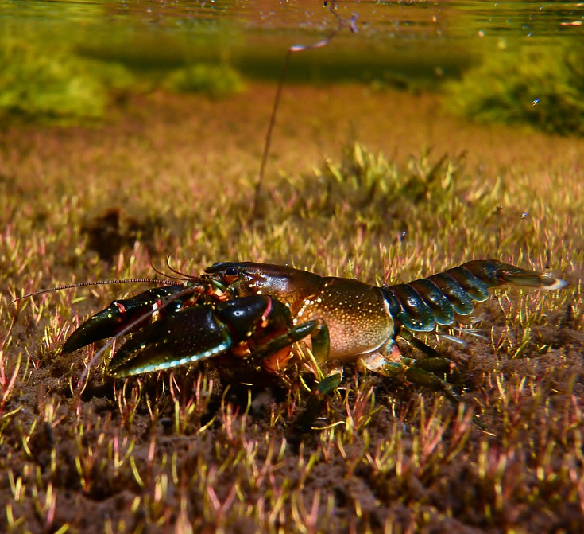Riek’s Crayfish is a small and spiny crayfish (Coughran 2008), recorded as reaching 53 mm occipital carapace length (OCL (‘head length’)) (Morgan 1997). The body is usually chocolate brownish to olive green dorsally, grading to a paler brown or orangish on the sides and paler brown and cream ventrally. Joints are orange-red with claws green-blue-brown and pale spines on the claws and body (Morgan 1997; McCormack 2012). Internal features are generally required to distinguish this species.

Knowledge on the biology and ecology of Riek’s Crayfish is limited; however, it is recognised that *Euastacus* species have a suite of common biological characteristics as summarised in Furse and Coughran (2011a), which also apply to Riek’s Crayfish. Various studies have established that *Euastacus* are very slow-growing (growth increments of a few millimetres OCL per year) and very long-lived, (Honan and Mitchell 1995a, 1995b; Turvey and Merrick 1997; Morey 1998; Furse and Wild 2004; Coughran 2013).

Riek’s Crayfish (Mark Jekabsons – EPSDD)

There are no published studies or information on reproduction in Riek’s Crayfish.

The first record of berried females occurred in the ACT and was reported in April 2014 with two female specimens of 42 mm and 53 mm OCL, carrying an estimated 70 and 100, 3.5 mm diameter orange eggs, respectively (ACT Government 2021). Both females were collected in a subalpine bog at around 1,600 m above sea level (asl) in Namadgi National Park. A further berried female of 43 mm OCL was recorded in a small stream in Kosciuszko National Park (at 1,254 m asl) in early November 2020, with an estimated 70 orange eggs in late developmental stage with developing embryos visible (Lintermans 2021). The records of berried females from April to November appear to confirm a prolonged breeding season with mating occurring in autumn and eggs held over the winter-spring months when the species’ habitat is largely snow-covered (DCCEEW 2023).

During the post 2019–20 bushfire surveys, an examination of around 30 specimens indicated that females are immature below 40 mm OCL but very few crayfish greater than 40 mm OCL were captured (Lintermans 2021). The growth rate, population size and generation length of Riek’s Crayfish are not known.

The diet of the Riek’s Crayfish is not well understood, but the species may be omnivorous. Little is also known about this species’ general biological characteristics, although given its alpine distribution and its close association with cool conditions and specific vegetation types it is anticipated to be intolerant of high temperatures (Bone et al. 2014).

Distribution and Habitat

Riek’s Crayfish is endemic to the high country of the Australian Capital Territory (ACT) and southern New South Wales (NSW) (Morgan 1997; Coughran and Furse 2010). It was also formerly considered to occur in north-eastern Victoria, but Austin et al. (2022) identified a number of specimens from that region as belonging to a different lineage. It has been recorded as low as 560 m asl but is more commonly found above 1,000 m asl, with records up to 1,600 m asl and may occur at higher altitudes (Morgan 1997; Furse and Coughran 2011b; McCormack 2012; ACT Government 2021; Lintermans 2021).

Part of the range of this species occurs in protected areas (Namadgi National Park (ACT); Kosciuszko National Park and Bimberi Nature Reserve (NSW)), but these areas have not been actively managed for the conservation of Riek’s Crayfish.

Riek’s Crayfishis restricted to small-to moderate-sized streams and stream margins, often fringed by snow gums, tussock grasses and heath, as well as bog wetlands often containing rushes, sedges and sphagnum (Morgan 1997; Lintermans 2021). The species can be found in aquatic environments in native ecosystems such as open grassy plains and eucalypt forests and woodlands, as well as modified environments such as grazing land and pine plantations (Morgan 1997). Most of its habitat is covered by snow or ice in winter (Morgan 1997). The species may create deep and complex burrows at the edge of creeks that extend down to the water table but can also reportedly extend horizontally below the fringing heath and tussock grass (McCormack 2012) and can also make temporary burrows under rocks.

**Figure 1: Modeled distribution of the Riek’s Crayfish (Source: DCCEEW 2023)**

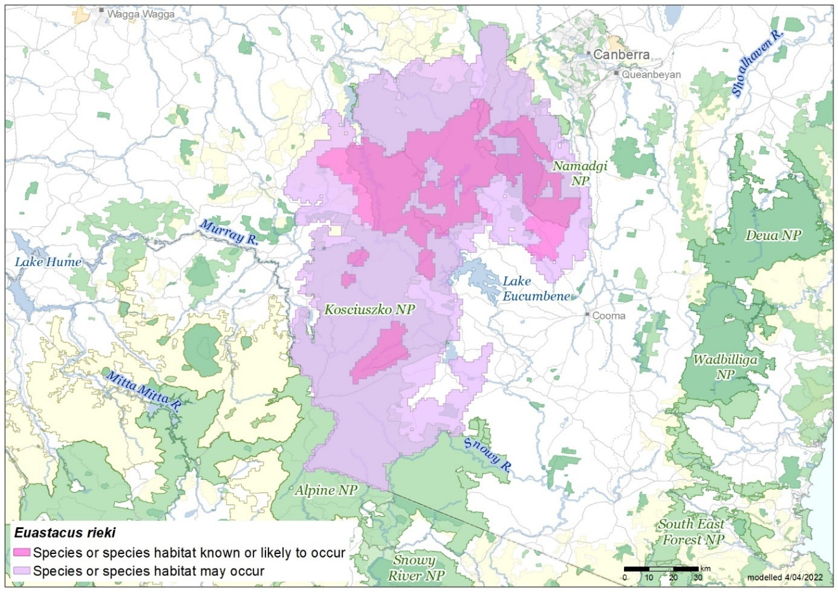

**Source:** Base map Geoscience Australia; species distribution data [Species of National Environmental Significance](http://www.environment.gov.au/science/erin/databases-maps/snes) database.

Threats

Climate change is a key threat to the Riek’s Crayfish, with the species restricted to higher, cooler altitudes and dependent upon available surface or ground water. Predicted increases in temperature in the region will impact this species across its range. Increased water temperature may result in sub-lethal impacts such as changed habitat availability, crayfish activity patterns and reproductive capacity, and ultimately survival of Riek’s Crayfish (DCCEEW 2023).

The frequency and magnitude of bushfires is predicted to increase under climate change scenarios (Di Virgilio et al. 2019). Fire removes vegetation which provides cover to crayfish when emerging from burrows or traversing, particularly in bogs. Dramatic increases in predated crayfish remains have been observed following fires (Carey et al. 2003) and recent evidence from the 2019–20 fires has documented greater than 90% of predator scats collected around upland bogs in the ACT contained crayfish remains (ACT Government 2021).

Storm events following fire usually result in significant inputs of ash and sediment to streams which severely impact aquatic habitats. Ash and sediment inputs smother stream substrates, alter water chemistry, alters riparian shading and organic inputs. Post-fire rainfall impacts on aquatic habitats from high severity fire can significantly alter crayfish habitat and severely reduce local crayfish subpopulations within a single generation (DCCEEW 2023).

Other potential threats that could impact Riek’s Crayfish but are not currently evident in the ACT include *Aphanomyces astaci* (crayfish plague), *Cherax destructor* (common yabby) invasion and horse damage to high country aquatic environments (Unestam 1975; Lowe et al. 2000; TSSC 2008; Coughran et al. 2009; Coughran and Furse 2010; Tolsma and Shannon 2018; Robertson et al. 2019; Lintermans 2021).

Major Conservation Objective

The priority management objective should be to increase in the long term, viable, wild populations of the species as a component of the indigenous biological resources of the ACT and as a contribution to regional and national conservation of the species. This includes the need to maintain natural evolutionary processes and resilience to major impact.

Conservation Priorities

Conservation actions are detailed in the Commonwealth Conservation Advice (DCCEEW 2023). Conservation and management priorities for the Riek’s Crayfish in the ACT should be to:

* protect the species from harvest
* protect sites in the ACT where the species occurs
* identify and include the species and habitat location and requirements specifically in the ACT Ecological Guidelines (ACT Government 2019a) and on-ground management applications
* manage habitat to conserve populations by implementing post fire recovery actions and protecting waterways from tracks and road runoff
* actively control foxes around known habitats, especially immediately following fire
* enhance the long-term viability of populations
* improve understanding of the species’ ecology, habitat and functional role in its ecosystem
* identify options for management of threats including drought, fire and pest species improve community awareness and support for the species and freshwater fish conservation
* actively seek opportunities to involve members of local indigenous communities in on ground activities.

Conservation Issues

It is recommended that quantitative targets and resourcing requirements are clearly identified in any Action Plan or other related projects/programs relevant to this species. Broader conservation issues need to be considered in developing and implementing actions arising from this advice and the listing assessment (DCCEEW 2023).

### Critical Habitat

The Riek’s Crayfish is restricted to high country streams and bogs and has not been found in the absence of permanent surface water (Lintermans 2021). Despite this, burrows can be found 30 m or more from surface water, particularly in bogs presumably accessing near surface ground water. Beyond this, it is not possible to define habitat critical to the survival of Riek’s Crayfish as there are insufficient data. Therefore, all its known, peripheral, and likely habitat in the highlands of the Australian Alps is critical to the survival of this species (Morgan 1997).

Habitat critical to the survival should not be cleared, fragmented or degraded. Any known or likely habitat (Map 1) should be considered as habitat critical to the survival of the species. Additionally, areas that are not currently known to be occupied by the species due to recent disturbance (e.g. fire, grazing or human activity), but should become suitable again in the future, should also be considered habitat critical to the survival of the species. It is essential that the highest level of protection is provided to these areas, across all tenures, and that enhancement and protection measures target these productive sites.

No Critical Habitat as defined under section 207A of the EPBC Act has been identified or included in the Register of Critical Habitat under the EPBC Act.

### Climate Change

Climate change impacts are inevitable and will affect the likelihood of persistence, within the ACT, of many species. Most vulnerable in this regard are those species that occupy highly fragmented habitat with highly restricted distributions, such as the Riek’s Crayfish. Capacity must be developed to model the impact on the Riek’s Crayfish and its habitat under likely climate change scenarios if we are to anticipate and manage the impacts of climate change. This will require a combination of research and the development of in-house capacity for the collection of relevant data and its application in climate change modelling.

### Population Viability

With a threatened species, such as the Riek’s Crayfish, the question often raised is whether the remaining population is viable into the future. That is, have the populations declined in abundance and become fragmented to such an extent, and has the genetic diversity of the species declined to such an extent, that the species no longer has the capacity to rebound should conditions improve or to respond to management intervention. Such an assessment may need to be undertaken in the case of the Riek’s Crayfish, and if it is determined that the species population is not viable, to explore more intensive options for bringing the species to a position where it has the potential to recover, such as genetic rescue.

### Jurisdictional Collaboration

The location of the species habitat in the ACT high country along the NSW border requires the development of any policies and action/recovery plans to be discussed between relevant jurisdictional entities.

### Ngunnawal Community Engagement

The ACT Government should actively facilitate, the inclusion of the Ngunnawal people in the conservation of this species and its habitat as part of Ngunnawal Country. Reference to the draft Cultural Resource Management Plan (ACT Government in prep.) would be useful to inform culturally appropriate resource management including of native species that aligns with achieving conservation outcomes for the species.

Other Relevant Advice, plans or Prescriptions

* ACT Aquatic and Riparian Conservation Strategy (ACT Government 2018)
* ACT Conservation Advice – High Country Bogs and Associated Fens (ACT Government 2019b)
* ACT High Country Bogs and Associated Fens Ecological Community – Draft Action Plan (ACT Government 2023)
* Commonwealth Conservation Advice – Riek’s Crayfish (DCCEEW 2023)
* Namadgi National Park Plan of Management (ACT Government 2010)

Listing Background

The Riek’s Crayfish is listed as an Endangered species under the EPBC Act, effective 7 September 2023. It is assessed as Endangered under Criterion 2 (B2ab(iii,v)) of the EPBC Act. In 2024, under the *Nature Conservation Act 2014*, the ACT Scientific Committee recommended the Riek’s Crayfish be listed in the Endangered category in the ACT Threatened Native Species List to align with the EPBC Act listing.

Action Plan Decision

The ACT Scientific Committee does recommend that the Minister for the Environment should make the decision to have an action plan for the species in the ACT under the *Nature Conservation Act 2014*. The key habitat areas of the species in the ACT are in Namadgi National Park (most commonly above 1000 m asl) and its habitat is protected there but has not been actively managed for the conservation of Riek’s Crayfish. The Commonwealth Conservation Advice (DEECCW 2023) and this Conservation Advice should be used to inform and support the priorities identified above. This especially includes the need for monitoring, and identifying and including the species and its habitat’s needs in ecological guidelines for on-ground management.

A National Recovery Plan is not required to be prepared for the species (DCCEEW 2023).

References

ACT Government (in prep). *Draft Cultural Resource Management Plan*. Environment, Planning and Sustainable Development Directorate, ACT Government, Canberra.

ACT Government (2010). *Namadgi National Park Plan of Management*. Environment, Planning and Sustainable Development Directorate, Canberra. Accessed 14 August 2023 from: <https://www.legislation.act.gov.au/di/2010-192/>

ACT Government (2018). *ACT Aquatic and Riparian Conservation Strategy and Action Plans*. Environment, Planning and Sustainable Development Directorate, Canberra. Accessed 14 August 2023 from: <https://www.legislation.act.gov.au/di/2018-240/>

ACT Government (2019a). *Ecological Guidelines For Fire, Fuel and Access Management Operations*. Environment, Planning and Sustainable Development Directorate, Canberra. Accessed 24 August 2023 from: <https://www.environment.act.gov.au/__data/assets/pdf_file/0009/1483830/Ecological-Guidelines-2019-ver-1.3.pdf>

ACT Government (2019b). *ACT Conservation Advice – High Country Bogs and Associated Fens*. Accessed 14 August 2023 from: <https://www.legislation.act.gov.au/View/ni/2019-66/current/html/2019-66.html>.

ACT Government (2021). *Bushfire Ecosystem Recovery – Orroral Valley bushfire one year on: our ecosystem recovery programs*. Environment, Planning and Sustainable Development Directorate – Environment, Heritage and Water – ACT Government. Accessed 23 August 2024 from: <https://storymaps.arcgis.com/collections/4849e685478d48d6a6b37e84d144b176?item=2>.

ACT Government (2023). *ACT High Country Bogs and Associated Fens Ecological Community – Draft Action Plan*. Accessed 14 August 2023 from: <https://yoursayconversations.act.gov.au/draft-action-plan-high-country-bogs-and-fens>.

Austin C, Whiterod NS, McCormack R, Raadik TA, Ahyong ST, Lintermans M, Furse JM and Grandjean F (2022). *Molecular taxonomy of Australia’s endemic freshwater crayfish genus Euastacus (Parastacidae), with reference to priority 2019–20 bushfire-impacted species – 2022 update*. A report supported by the Australian Government’s Bushfire Recovery for Wildlife and their Habitats. Deakin University and Aquasave–Nature Glenelg Trust, Victor Harbor.

Bone JWP, Wild CH and Furse JM (2014). Thermal limit of *Euastacus sulcatus* (Decapoda: Parastacidae), a freshwater crayfish from the highlands of central eastern Australia. *Marine and Freshwater Research* 65: 645–651.

Carey A, Evans, M, Hann P, Lintermans M, MacDonald T, Ormay P, Sharp S, Shorthouse D and Webb N (2003). Wildfires in the ACT 2003: Report on Initial Impacts on Natural Ecosystems. Technical Report No. 17, Environment ACT, Canberra.

Coughran J (2008). Distinct groups in the genus *Euastacus? Freshwater Crayfish* 16: 125–132.

Coughran J (2013). Biology of the Mountain Crayfish *Euastacus sulcatus* Riek, 1951 (Crustacea: Parastacidae), in New South Wales, Australia. *Journal of Threatened Taxa* 5: 4840–4853.

Coughran J and Furse JM (2010). An assessment of genus *Euastacus* (49 species) versus IUCN Red List criteria. A report prepared for the global species conservation assessment of crayfishes for the IUCN Red List of Threatened Species. The International Association of Astacology. ISBN: 978-0-9805452-1-0. Auburn, Alabama, USA.

Coughran J, McCormack RB and Daly G (2009). Translocation of the Yabby *Cherax destructor* into eastern drainages of New South Wales, Australia. Australian Zoologist 35: 100–103.

Department of Climate Change, Energy, the Environment and Water (DCCEEW) (2023). Conservation Advice for *Euastacus rieki* (Riek’s Crayfish). Department of Climate Change, Energy, the Environment and Water (Commonwealth), Canberra.

Di Virgilio G, Evans J, Blake S, Armstrong M, Dowdy A, Sharples J and McRae R (2019). Climate change increases the potential for extreme wildfires. *Geophysical Research Letters* 46: 8517–8526.

Furse JM and Coughran J (2011a). An assessment of the distribution, biology, threatening processes and conservation status of the freshwater crayfish, genus *Euastacus* (Decapoda: Parastacidae), in Continental Australia. I. Biological Background and Current Status. Crustaceana Monographs 15 (Special edition: *New Frontiers in Crustacean Biology*): 241–252.

Furse JM and Coughran J (2011b) An assessment of the distribution, biology, threatening processes and conservation status of the freshwater crayfish, genus *Euastacus* (Decapoda: Parastacidae), in Continental Australia. II. Threats, Conservation Assessments and Key Findings. Crustaceana Monographs 15 (Special edition: *New Frontiers in Crustacean Biology*): 253–263.

Furse JM and Wild CH (2004). Laboratory moult increment, frequency, and growth in *Euastacus sulcatus*. *Freshwater Crayfish* 14: 205–211.

Honan JA and Mitchell BD (1995a). Growth of the large freshwater crayfish *Euastacus bispinosus* Clark (Decapoda: Parastacidae). *Freshwater Crayfish* 10: 118–131.

Honan JA and Mitchell BD (1995b). Reproduction of *Euastacus bispinosus* Clark (Decapoda: Parastacidae), and trends in the reproductive characteristics of freshwater crayfish. *Marine and Freshwater Research* 46: 485–499.

Lintermans M (2021). Unpublished post-bushfire survey data for *Euastacus crassus* and *Euastacus rieki* in the High Country of NSW. Report to Aquasave–NGT for Project: 100086 Saving the spinys: urgent actions to conserve the *Euastacus* freshwater crayfish. Centre for Applied Water Science, University of Canberra.

Lowe S, Browne M, Boudjelas S and De-Poorter M (2000). 100 of the world’s worst invasive alien species. A selection from the global invasive species database. *Aliens* 12: 1–12.

McCormack RB (2012). *A Guide to Australia's Spiny Freshwater Crayfish*. CSIRO Publishing. Collingwood, Victoria.

Morey JL (1998). Growth, catch rates and notes on the biology of the Gippsland Spiny Freshwater Crayfish, *Euastacus kershawi* (Decapoda: Parastacidae), in West Gippsland, Victoria. *Proceedings of the Linnean Society of New South Wales* 119: 55–69.

Morgan GJ (1997). Freshwater crayfish of the genus *Euastacus* Clark (Decapoda: Parastacidae) from New South Wales, with a key to all species of the genus. *Records of the Australian Museum Supplement* 23: 1–110.

Robertson G, Wright J, Brown D, Yuen K and Tongway D (2019). An assessment of feral horse impacts on treeless drainage lines in the Australian Alps. *Ecological Management and Restoration* 20: 21–30.

Threatened Species Scientific Committee (TSSC) (2008). *Commonwealth Conservation Advice on Alpine Sphagnum Bogs and Associated Fens*. Department of the Environment, Water, Heritage and the Arts. Canberra, ACT, Australia.

Tolsma A and Shannon J (2018). *Assessing the Impacts of Feral Horses on the Bogong High Plains, Victoria*. Arthur Rylah Institute for Environmental Research. Unpublished client report for Parks Victoria, Department of Environment, Land, Water and Planning, Heidelberg, Victoria.

Turvey P and Merrick JR (1997). Growth with age in the freshwater crayfish, *Euastacus spinifer* (Decapoda: Parastacidae), from the Sydney region, Australia. *Proceedings of the Linnean Society of New South Wales* 118: 205–215.

Unestam T (1975). Defence reactions in and susceptibility of Australian and New Guinean freshwater crayfish to European-crayfish-plague fungus. *Australian Journal of Experimental Biology and Medical Science* 53: 349–359.

Further Information

Further information on related action plans or other threatened species and ecological communities can be obtained from: Environment, Planning and Sustainable Development Directorate (EPSDD).  
Phone: (02) 132281, EPSDD Website: <https://www.environment.act.gov.au/nature-conservation>.

Attachment A: Listing Assessment ([DCCEEW 2023](https://www.environment.gov.au/cgi-bin/sprat/public/publicspecies.pl?taxon_id=83155))

