Australian Capital Territory

**Nature Conservation (Southern Whiteface) Conservation Advice 2024**

**Notifiable instrument NI2024-257**

made under the

**Nature Conservation Act 2014, s 90C (Conservation advice)**

**1 Name of instrument**

This instrument is the *Nature Conservation (Southern Whiteface) Conservation Advice 2024*.

**2 Commencement**

This instrument commences on the day after its notification day.

**3 Conservation advice for Southern Whiteface**

Schedule 1 sets out the conservation advice for Southern Whiteface (*Aphelocephala leucopsis*).

Arthur Georges

Chair, Scientific Committee

21 May 2024

**Schedule 1**

(see s 3)

Conservation Advice  
SOuthern Whiteface  
*Aphelocephala leucopsis*

Conservation Status

The Southern Whiteface *Aphelocephala leucopsis* (Gould, 1841) is recognised as threatened in the following jurisdictions:

International **Vulnerable**, International Union for the Conservation of Nature (IUCN) Red List

National **Vulnerable**, *Environment Protection and Biodiversity Conservation Act 1999* (EPBC Act)

**Vulnerable***,* Action Plan for Australian Birds 2020

ACT **Vulnerable**, *Nature Conservation Act 2014*

NSW **Vulnerable**, *Biodiversity Conservation Act 2016*

Queensland **Vulnerable**, *Nature Conservation Act 1992*

ELIGIBILITY

The Southern Whiteface is listed as Vulnerable in the ACT Threatened Native Species List under IUCN Criterion A— A2bc+3c+4bc due to a substantial decline in the national population size (30–50%) over the past ten years (actually over every ten years since 1999) with no indication that the declines are slowing (Ehmke et al. 2021 and Attachment A - DCCEEW 2023). Habitat loss and fragmentation is likely the cause of the species decline, especially in the parts of the species’ range where there has been complete removal of habitat for intensive agriculture (Ehmke et al. 2021).

[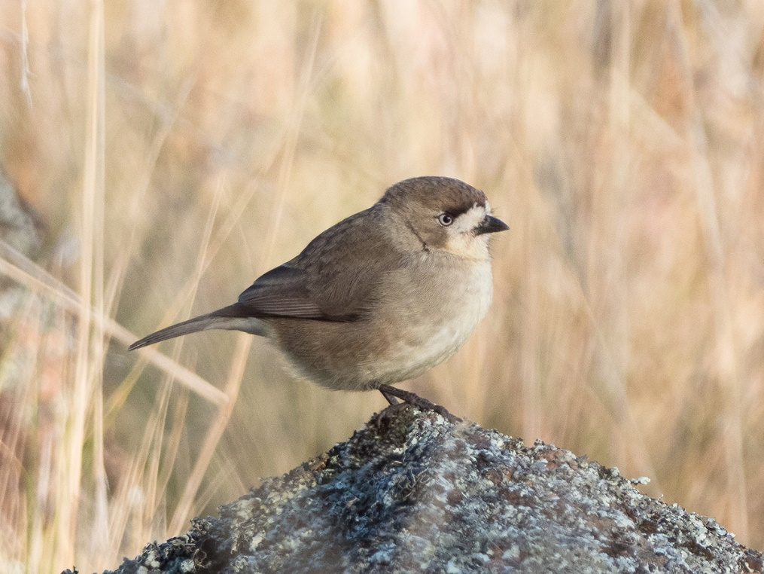](https://canberra.naturemapr.org/sightings/4383618)DESCRIPTION AND ECOLOGY

The Southern Whiteface is a small stocky thornbill like bird, measuring about 11 cm and weighing 12 g on average (Birdlife Australia 2023). The top of its body, wings and head are grey-brown and the underparts are white (Schodde and Mason 1999). Its tail has a broad black tail band with white tips. The forehead is white, edged in black and the bill is dark-grey, stubby and finch-like. The adult sexes are similar and juveniles do not have the black band on the face between the eyes (Hermes 2021).

Breeding occurs usually from July to December but is influenced by rainfall (Taylor and COG 1992, Birdlife Australia 2023). 2–5 eggs are laid in untidy domed nests of grass, rootlets and bark, preferrably built in a hollow tree limb, crevice or stump, or sometimes in dense foliage of shrubs or small trees (Hermes 2021, Birdlife Australia 2023). Talor and COG (1992) reported that standing dead timber provides the ideal nesting sites and is essential for the species’ survival.

[Southern Whiteface (Patrick Cox – Canberra Nature Map](https://canberra.naturemapr.org/sightings/4383618))

Birds busily feed on the ground in small flocks and mainly on insects, spiders, and seeds, largely gleaned from the bare ground or leaf litter (Higgins and Peter 2002, Antos and Bennet 2006, Antos et al. 2008, Hermes 2021, Birdlife Australia 2023).

Distribution and Habitat

The distribution of the Southern Whiteface is across most of the mainland of Australia south of the Tropic of Capricorn as shown in Map 1. Two subspecies are recognised: *A. l. leucopsis* (South‐east Southern Whiteface (found in the ACT)), found throughout south-eastern and central Australia; and *A. l. castaneiventris* (South‐west Southern Whiteface) found in Western Australia with a broad hybrid zone between the two subspecies in the east of Western Australia. The national estimated extent of occurrence (EOO) is 4.9million km2 and the area of occupancy (AOO) is 70,000 km2 and contracting (Ehmke et al. 2021). The species occurs in areas of fallen timber and/or standing dead timber (Hermes 2021) in a wide range of open eucalypt/acacia woodlands and shrublands where there is an understory of grasses and/or shrubs (Higgins & Peter 2002).

**Map1: Modelled distribution of the Southern Whiteface (Source: DCCEEW 2023)**

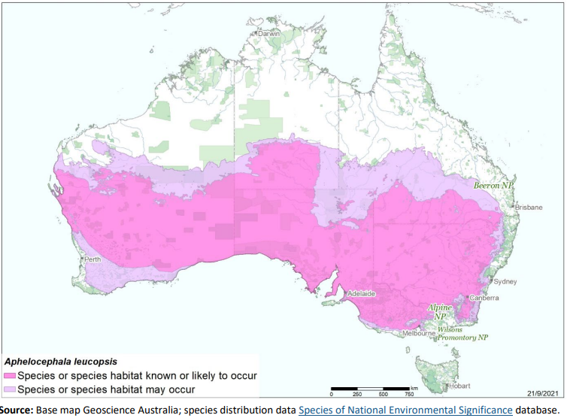

The species is resident in the ACT region (Figure 1 and 2) and was once described in the early 1950s as common on the lowlands, present in all seasons and presumed to nest in the ACT (Cabby 2000). Taylor and COG (1992) reported it as being found where woodland merges with grassland and in dry, rocky paddocks with scattered shrubs, short grass and dead timber, being more common below about 800 m but able to survive the winter up to 1100 m in frost hollows in the Upper Naas catchment.

Wilson (1999) noted that the species was apparently declining due to displacement from its threatened habitat (grasslands/woodlands) by urban and rural development, consequently the Southern Whiteface has been recorded in the Canberra Garden Bird Surveys only eight times (Canberra Birds 2023). Until the mid-1980s the species was regularly reported in the Tuggeranong Valley in areas since developed, and while suburban nature reserves (e.g., Farrer Ridge) may provide a refuge, these scattered remnants are unlikely to be able to support populations in the long-term (Taylor and COG 1992). The species continues to show very low reporting rates with a small but significant decrease in overall trend reflecting very low numbers at woodland sites (Bounds et al. 2021).

Between 2015 and 2017, the reporting rate levelled off to around 0.7% (COG 2018) (Figure 1) representing around 254 total birds (2016-17), 213 (in 2017–18) (COG 2018, COG 2019) (Figure 2). The numbers remained at this low level through to 2018–19 (204 birds) but the reporting rate (0.5%) is at its lowest level ever (COG 2020).

The habitat critical to the survival of the species is identified in the Commonwealth Conservation Advice (DCCEEW 2023) and corresponds with all known or likely habitat in Map 1 and includes areas of:

* relatively undisturbed open woodlands and shrublands with an understorey of grasses or shrubs, or both
* habitat with low tree densities and an herbaceous understory litter cover which provides essential foraging habitat
* living and dead trees with hollows and crevices which are essential for roosting and nesting.

**Figure 1: Southern Whiteface records in the ACT region – 1982–2017**

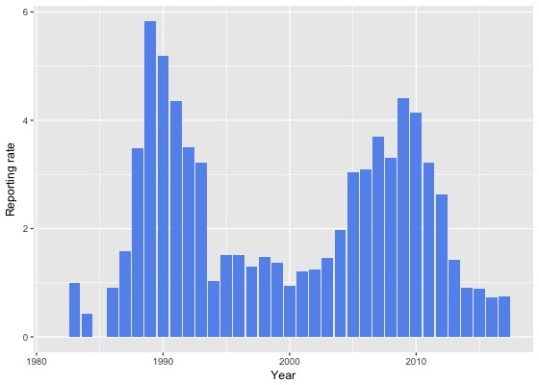

*Source: Canberra Birds (2018). Reporting rate has continued to decline from a 4% peak in 2008, to 0.5% in 2018–19, its lowest level ever (COG 2020).*

*Note: Reporting rate (%) is the proportion of all surveys in which the species was present. These data were collected by volunteer birdwatchers using various survey methods and on some occasions more than one person may have recorded bird sightings on the same day, which may skew the data.*

**Figure 2: Southern Whiteface distribution in the ACT region – 2017 and 1982–2017**

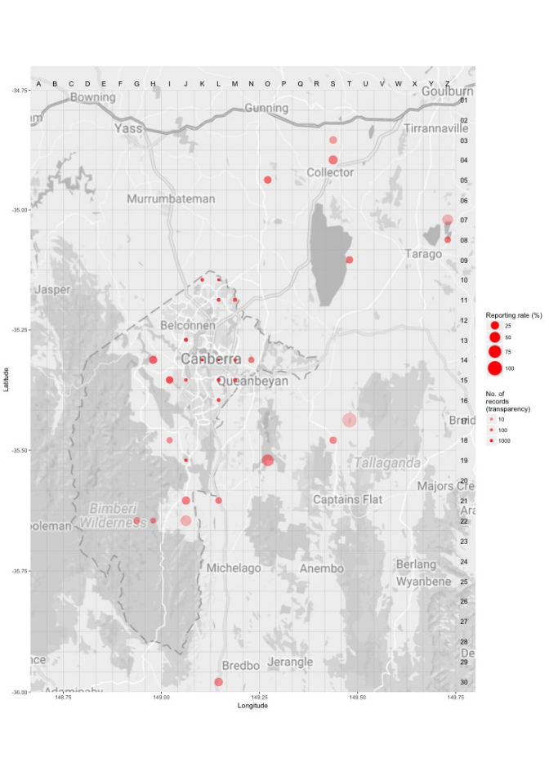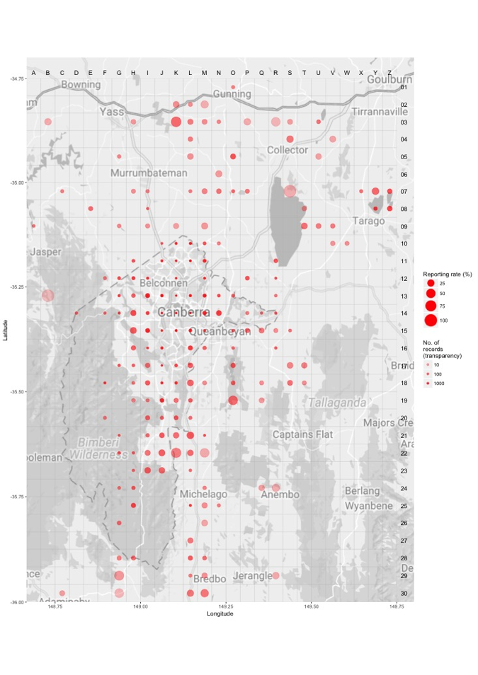

*Source: Canberrabirds.org.au. (2018). Note: Reporting rate (%) is the proportion of all surveys in which the species was present. These data were collected by volunteer birdwatchers using various survey methods and on some occasions more than one person may have recorded bird sightings on the same day, which may skew the data.*

Threats

Apart from the complete removal of its habitat (including for intensive agriculture) no other clear reasons for the continued decline in the species numbers have been confirmed for this species (Ehmke et al. 2021). While the species lives in some of the driest and hottest parts of the country, it has declined in places that are generally far wetter (Ehmke et al. 2021). The species continues to decline in the ACT (in the south-eastern edge of its national distribution) but reporting rates have fluctuated (Bounds et al. 2021), possibly due to oscillating unfavourable herbage mass conditions impacting its preferred habitat, resulting from extreme weather variabilities.

Other possible pressures on the shrinking habitat for the species, identified in the ACT, include the tendency for graziers to tidy-up paddocks of standing dead timber and the demand for firewood by Canberra residents (Taylor and COG 1992). Removal of woody weeds is also likely a cause of decline (e.g., removal of the dense shrub African Box-thorn (*Lycium ferocissimum*)), linked to loss of the species in woodland in the Jerrabomberra West Nature Reserve and elsewhere. The recent COG analysis also suggested removal of woody weeds may explain the observed declines in recent years and highlights the need for land managers to determine the presence of woody weed frequent native species and where present, undertake additional measures (e.g., staged or supplementary habitat plantings) to mitigate the impacts of habitat removal (Bounds et al. 2021).

It is important to determine and understand the residual threats to the Southern Whiteface in the ACT to inform local ecological management for the species. Threats to the Southern Whiteface identified in the Commonwealth Conservation Advice (DCCEEW 2023) include:

* over-clearing of native vegetation and subsequent fragmentation and degradation of remnant habitat patches
* over-grazing by livestock
* increased frequency and length of droughts
* increased likelihood of extreme events (including wildfire, drought and heatwaves).

Major Conservation Objectives

The primary objective in the ACT is to protect Southern Whiteface habitat through limiting clearance of suitable woodland habitat and prioritising conservation management to woodland patches, particularly those that are large or have complex habitat structure.

Conservation PRIORITIES

Conservation priorities are detailed in the Commonwealth Conservation Advice (DCCEEW 2023) for the species and rely on engaging with other jurisdictions to support regional and national recovery of the species. Priorities for the Southern Whiteface in the ACT should be to:

* identify and protect woodland and grassland habitat identified as habitat critical to the survival of the species (especially living and dead trees with hollows and crevices which are essential for roosting and nesting)
* maintain and enhance connectivity of woodland remnants through regeneration and revegetation using a diverse mix of locally appropriate native species, targeting the productive lower parts of the landscape which may provide important drought refuges.
* develop appropriate management interventions preventing intensive over-grazing of habitat and removal of dead timber
* monitor long-term trends and the effectiveness of management actions
* determine all factors contributing to population declines
* understand demography, breeding success and movement ecology with respect to climate variables and use climate modelling techniques to investigate the potential impact of climate change on the species (particularly on abundance and population trends) and its habitat
* actively seek opportunities to involve members of local indigenous communities in on ground activities
* encourage and support the continuation and further development of community-based conservation activities.

CONSERVATION ISSUES

It is recommended that quantitative targets and resourcing requirements are clearly identified in any Action Plan or other related projects/programs relevant to this species. Broader conservation issues for this and other declining woodland birds need to be considered in developing and implementing actions arising from this advice and the species listing assessment (DCCEEW 2023).

### Critical Habitat

The temperate woodlands of the northern ACT and the bordering NSW region have been extensively disturbed by agriculture and urbanization and small patches of woodland are now embedded in a pastoral or suburban matrix. Consequently, birds are threatened by a reduction in habitat area, increased isolation, and declining habitat condition emphasising the importance and need of large, structurally complex, connected, high quality woodland patches to accommodate existing woodland birds (Watson et al. 2002, Watson et al. 2008). Watson et al. (2002) predicted that the decline of woodland bird species will continue unless appropriate habitat conservation strategies are applied as suggested (Watson et al. 2008).

The Commonwealth Conservation Advice (DCCEEW 2023) identifies ‘habitat critical to the survival’ or important habitats of a species refers to areas that are necessary:

* for activities such as foraging, breeding, roosting, or dispersal
* for the long-term maintenance of the species (including the maintenance of species essential to the survival of the species, such as pollinators)
* to maintain genetic diversity and long-term evolutionary development
* for the reintroduction of populations or recovery of the species.

Habitat critical to the survival should not be cleared, fragmented or degraded. Any known or likely habitat (Map 1) should be considered as habitat critical to the survival of the species. Additionally, areas that are not currently occupied by the species due to recent disturbance (e.g., fire, grazing or human activity), but should became suitable again in the future, should also be considered habitat critical to the survival of the species. It is essential that the highest level of protection is provided to these areas, across all tenures, and that enhancement and protection measures target these productive sites. No Critical Habitat as defined under section 207A of the EPBC Act has been identified or included in the Register of Critical Habitat under the EPBC Act.

### Climate Change

Climate change impacts are inevitable and will affect the likelihood of persistence, within the ACT, of many species. Indeed, recent work demonstrates the negative effects of heatwaves and consequences for population persistence in bird communities of semi-arid woodlands (Gardner et al. 2022). The ACT is expected to face similar climate conditions in coming decades. Amongst the most vulnerable in this regard are those species that occupy highly fragmented habitat with highly restricted distributions. Capacity must be developed to model the impact on this species and its habitat under likely climate change scenarios if we are to anticipate and manage the impacts of climate change. This will require a combination of research and the development of in-house capacity for the collection of relevant data and its application in climate change modelling. New developments in biophysical models can provide a predictive understanding of the habitats required for persistence in the face of climate change and other stressors (see review by Briscoe et al. 2023). Such models integrate physical data on climate and terrain with measures of morphology, behaviour, physiology and life history of the species in question. Ensuring collection of relevant data to provide the necessary information to parameterize models that can explore population persistence and species distributions is critical.  Given increases in the frequency and intensity of extreme heat events are widely predicted it will be important to characterise the nature and use of thermal refuges used by birds under such conditions to quantify the importance of refuges for survival, and to preserve/regenerate such habitat.

### Population Viability

An understanding of demographic rates, dispersal and behaviour is necessary for assessing responses to environmental changes and to inform population modelling (e.g., PVA, Biophysical Models), which can predict likelihoods of viability over the longer term. This will inform management options which may include assessment of genetic diversity and the possibility of genetic rescue.  It is possible for the viability of species/population to be compromised such that they are unable to rebound if conditions improve and/or respond to suitable management. For example, loss of genetic diversity and associated genetic problems, such as inbreeding depression, in small populations can reduce survival and reproductive rates such that the population cannot respond to improved conditions.

### Jurisdictional Collaboration

Many woodland birds have large distributions and while the ACT makes up a small component, in terms of area, it can play an important role in informing conservation due to its location, local expertise and community interest. Developing policies and recovery plans across several jurisdictions with many stakeholders requires ongoing discussion/negotiations across many stakeholders and jurisdictional entities.

### Ngunnawal Community Engagement

The ACT Government should actively facilitate, the inclusion of the Ngunnawal people in the conservation of this species and its habitat as part of Ngunnawal Country. Reference to the draft Cultural Resource Management Plan (ACT Government in prep.) would be useful to inform culturally appropriate resource management including of native species that aligns with achieving conservation outcomes for the species.

Other Relevant Advice, plans or Prescriptions

* Commonwealth Conservation Advice – Southern Whiteface (DCCEEW 2023)
* [ACT Woodland Conservation Strategy](http://www.environment.act.gov.au/cpr/conservation_and_ecological_communities/threatened_species_action_plans) (ACT Government 2004)
* [ACT Woodland Conservation Strategy](https://www.legislation.act.gov.au/View/ni/2019-184/current/PDF/2019-184.PDF) (ACT Government 2019)
* [ACT Conservation Advice](https://www.legislation.act.gov.au/ni/2018-536/) — Loss of Mature Trees (Scientific Committee 2018)

Listing Background

The Southern Whiteface is listed as a Vulnerable species under the *Environment Protection and Biodiversity Conservation Act 1999* (EPBC Act), effective 31 March 2023. It is eligible to be listed as Vulnerable under Criterion 1 (A2bc+3c+4bc) of the EPBC Act. In 2023, under the *Nature Conservation Act 2014*, the ACT Scientific Committee recommended the Southern Whiteface be listed in the Vulnerable category in the ACT Threatened Native Species List to align with the EPBC Act listing.

Action Plan Decision

The ACT Scientific Committee does not recommend that the Minister for the Environment should make the decision to have an individual action plan for the species in the ACT under the *Nature Conservation Act 2014* at this time but proposes that an Action Plan for (threatened) Woodland birds (including specific requirements for the Southern Whiteface) should be developed and implemented by the Conservator. There are several woodland birds, including the Southern Whiteface, for which there are actions that are designed to provide for the conservation and management of the habitat of these birds collectively in the Woodland Strategy (ACT Government 2019), however a targeted Action Plan for (threatened) Woodland Birds and their habitat in the ACT is necessary to identify, understand and help address the declines and support recovery.

A National Recovery Plan is required to be prepared for the species (DCCEEW 2023) but there are likely to be ACT specific questions that need to be answered that a National Recovery Plan may not address. For example, as the decline in the ACT is not fully understood and is likely fully attributed to urbanisation we could reduce further losses through better urban planning. Also, The ACT population occurs in the south-eastern edge of the broad national distribution (Map 1) and modelling suggests optimal climatic conditions for the species will retract to the south (Garnett & Franklin 2014).

References

ACT Government 2004. *Woodlands for Wildlife: ACT Lowland Woodland Conservation Strategy. Action Plan No. 27*. Environment ACT, Canberra.

ACT Government 2019. *ACT Woodland Conservation Strategy and Action Plans*. Environment Planning and Sustainable Development Directorate, Canberra.

ACT Government in prep. *Draft Cultural Resource Management Plan*. Environment Planning and Sustainable Development, ACT Government, Canberra.

ACT Scientific Committee 2018. Conservation Advice – Loss of Mature Trees (including Hollow-bearing Trees) and Lack of Recruitment. ACT Government, Canberra.

Antos MJ and Bennett AF 2006. Foraging ecology of ground‐feeding woodland birds in temperate woodlands of southern Australia. *Emu* 106(1): 29–40.

Antos MJ, Bennett AF and White JG 2008. Where exactly do ground‐foraging woodland birds forage? Foraging sites and microhabitat selection in temperate woodlands of southern Australia. *Emu* 108(3): 201–211.

BirdLife Australia 2023. Southern Whiteface *Aphelocephala leucopsis* Profile. Accessed 22 May 2023 from: <https://birdlife.org.au/bird-profiles/southern-whiteface/>

BirdLife International 2022. *Aphelocephala leucopsis*. The IUCN Red List of Threatened Species 2022: e.T22704748A211249958. <https://dx.doi.org/10.2305/IUCN.UK.2022-1.RLTS.T22704748A211249958.en>. Accessed on 22 May 2023.

Bounds J, Davey C, Taws N, Evans MJ, Rayner L 2021. *Long-term trends in ACT woodland birds 1998–2019*. Canberra Ornithologists Group, Canberra. <https://canberrabirds.org.au/conservation/woodland-birds/cog-woodland-bird-monitoring-project/>

Briscoe NJ, Morris SD, Mathewson PD, Buckley LB, Jusup M, Levy O, Maclean IMD, Pincebourde S, Riddell EA, Roberts JA, Schouten R, Sears MW, Kearney MR 2023. Mechanistic forecasts of species responses to climate change: The promise of biophysical ecology. *Global Change Biology* 29(6): 1451–1470.

Cabby J 2000. List of Birds of the ACT – early 1950s, *Canberra Bird Notes* 25(1): 1–22. <http://canberrabirds.org.au/wp-content/canberra-bird-notes/cbnvol25no1.pdf>

Canberra Birds 2018. Southern Whiteface *Aphelocephala leucopsis* data sheet. Canberra Ornithologists Group, Canberra. <http://canberrabirds.org.au/birds/southern-whiteface/>

Canberra Birds 2023. Canberra Garden Birds – Australasian Warblers. Canberra Ornithologists Group, Canberra. <http://canberrabirds.org.au/our-birds/canberra-garden-birds/australasian-warblers/>

COG 2018. Annual Bird Report: 1 July 2016 to 30 June 2017. *Canberra Bird Notes* 43(1): 1–110.

COG 2019. Annual Bird Report: 1 July 2017 to 30 June 2018. *Canberra Bird Notes* 44(1): 1–110.

COG 2020. Annual Bird Report: 1 July 2018 to 30 June 2019. *Canberra Bird Notes* 45(1): 1–108.

Department of Climate Change, Energy, the Environment and Water (DCCEEW) 2023. *Conservation Advice Aphelocephala leucopsis (Southern Whiteface)*. Department of Climate Change, Energy, the Environment and Water (Commonwealth), Canberra.

Ehmke G, Antos MJ, Bennett AF, Ford HA, Barnes MD, Tulloch AIT, Loyn RH & Garnett ST 2021. South‐west Southern Whiteface *Aphelocephala leucopsis castaneiventris* and South‐east Southern Whiteface *Aphelocephala leucopsis leucopsis.* In *The Action Plan for Australian Birds 2020*. (Eds ST Garnett and GB Baker). CSIRO Publishing, Melbourne.

Gardner JL, Clayton M, Allen R, Stein J, Bonnet T. 2022. The effects of temperature extremes on survival in two semi-arid Australian bird communities over three decades, with projections to 2104. *Global Ecology & Biogeography* 31(12): 2498–2509.

Garnett ST and Baker GB 2021. *The Action Plan for Australian Birds*, CSIRO Publishing, Collingwood.

Garnett ST and Franklin DC (Eds) 2014. *Climate Change Adaptation Plan for Australian Birds*. CSIRO Publishing, Melbourne.

Garnett ST, Franklin DC, Ehmke G, VanDerWal JJ, Hodgson L, Pavey C, Reside AE, Welbergen JA, Butchart SHM, Perkins GC & Williams SE 2013. *Climate Change Adaptation Strategies for Australian Birds*. National Climate Change Adaptation Research Facility, Gold Coast.

Hermes N 2021. *Birds of Canberra and the High Country – A photographic field guide*. John Beaufoy Publishing, Oxford.

Higgins PJ and Peter JM (Eds) 2002. *Handbook of Australian, New Zealand and Antarctic Birds. Volume 6: Pardalotes to Shrike‐thrushes.* Oxford University Press, Melbourne.

Schodde R & Mason IJ 1999. *The Directory of Australian Birds: Passerines*. CSIRO Publishing, Melbourne.

Taylor M and Canberra Ornithologists Group (COG) 1992. *Birds of the Australian Capital Territory – An Atlas*. Canberra Ornithologist Group and National Capital Planning Authority, Canberra.

Watson J, Watson A, Paull D and Freudenberger D 2002. Woodland fragmentation is causing the decline of species and functional groups of birds in southeastern Australia. *Pacific Conservation Biology* 8(4): 261–70.

Watson J, Freudenberger D and Paull D 2008. An assessment of the focal‐species approach for conserving birds in variegated landscapes in southeastern Australia. *Conservation Biology* 15(5): 1364–1373.

Wilson S 1999. *Birds of the ACT: Two Centuries of Change*. Canberra Ornithologists Group, Canberra.

Further Information

Further information can be obtained from the Environment, Planning and Sustainable Development Directorate (EPSDD). EPSDD Website: <https://www.environment.act.gov.au/nature-conservation>

Attachment A: National Listing Assessment ([DCCEEW 2023](https://www.environment.gov.au/cgi-bin/sprat/public/publicspecies.pl?taxon_id=529))

