Australian Capital Territory
Planning (Jacka revisions) Minor Plan Amendment 2024
Notifiable instrument NI2024-258
made under the
Planning Act 2023, s 85 (Making minor plan amendments)

1 Name of instrument
This instrument is the Planning (Jacka revisions) Minor Plan Amendment 2024.
2 Commencement
This instrument commences on 24 May 2024.
3 Minor plan amendment
I am satisfied under the Planning Act 2023, section 85 (1) (a) that Minor Plan Amendment 2024-b is a minor plan amendment to the territory plan.
4 Dictionary
In this instrument:
Minor Plan Amendment 2024-g means the minor plan amendment in schedule 1.

Freya O’Brien
Delegate of the territory planning authority
21 May 2024

Schedule 1

MINOR PLAN AMENDMENT TO THE TERRITORY PLAN
2024–g
Jacka revisions

This minor plan amendment was prepared
under part 5.3 of the Planning Act 2023
Contents
1.0 INTRODUCTION 1
1.1 Outline of the process 1
1.2 Summary of the proposal 1
2.0 PROPOSED TERRITORY PLAN CHANGES 2
2.1 Part B – Territory Plan Maps 2
3.0 TERRITORY PLAN AMENDMENT INSTRUCTIONS 5
3.1 Part B – Territory Plan Maps 5
INTERPRETATION SERVICE 6

- INTRODUCTION
  - Outline of the process
Minor plan amendment 2024-g (MA2024-g) to the Territory Plan is minor plan amendment (MA) prepared under section 84 1) a) of the Planning Act 2023 (the Planning Act).

Section 84 of the Planning Act outlines the different types of MAs, some which require limited consultation to be undertaken and some which require no consultation to be undertaken.

Under Section 85 of the Planning Act a MA can only be made where:
- any required limited consultation has taken place and the authority is satisfied that the content of the MA meets the requirements of the Planning Act
- if the MA is not inconsistent with the planning strategy or any relevant district strategy
- any comments received during the consultation period and from the National Capital Authority have been considered.

This MA does not require limited consultation to be undertaken under the Planning Act 2023.

The MA is not inconsistent with the planning strategy or any relevant district strategy. Further details of the changes are contained in section 2 of this document.

The National Capital Authority has received a copy of this MA.

For more information on the content of the Territory Plan and minor plan amendment processes please refer to the Environment, Planning and Sustainable Development (EPSDD) website https://www.planning.act.gov.au/professionals/our-planning-system/the-territory-plan/amendments-to-the-territory-plan.
  - Summary of the proposal
MA2024-g proposes to:
- Change the zone of blocks 2-9 section 32 Jacka from RZ1 to RZ4.
- Change the zone of block 1 section 38 Jacka from RZ1 to RZ3.
- Change the zone of blocks 1 section 27 and block 26 section 24 Jack from RZ1 to PRZ1.
- Place blocks 2 and 3, section 33 Jacka under FUA overlay and revert their zoning to PRZ1.

- PROPOSED TERRITORY PLAN CHANGES
This section contains details of the proposed changes to be made to the Territory Plan.

MA2024-g proposes changes to parts of the following Territory Plan documents:
- Part B - Territory Plan Maps

  - Part B – Territory Plan Maps
The Territory Plan map is varied to correct errors from a recent FUA uplift in Jacka.

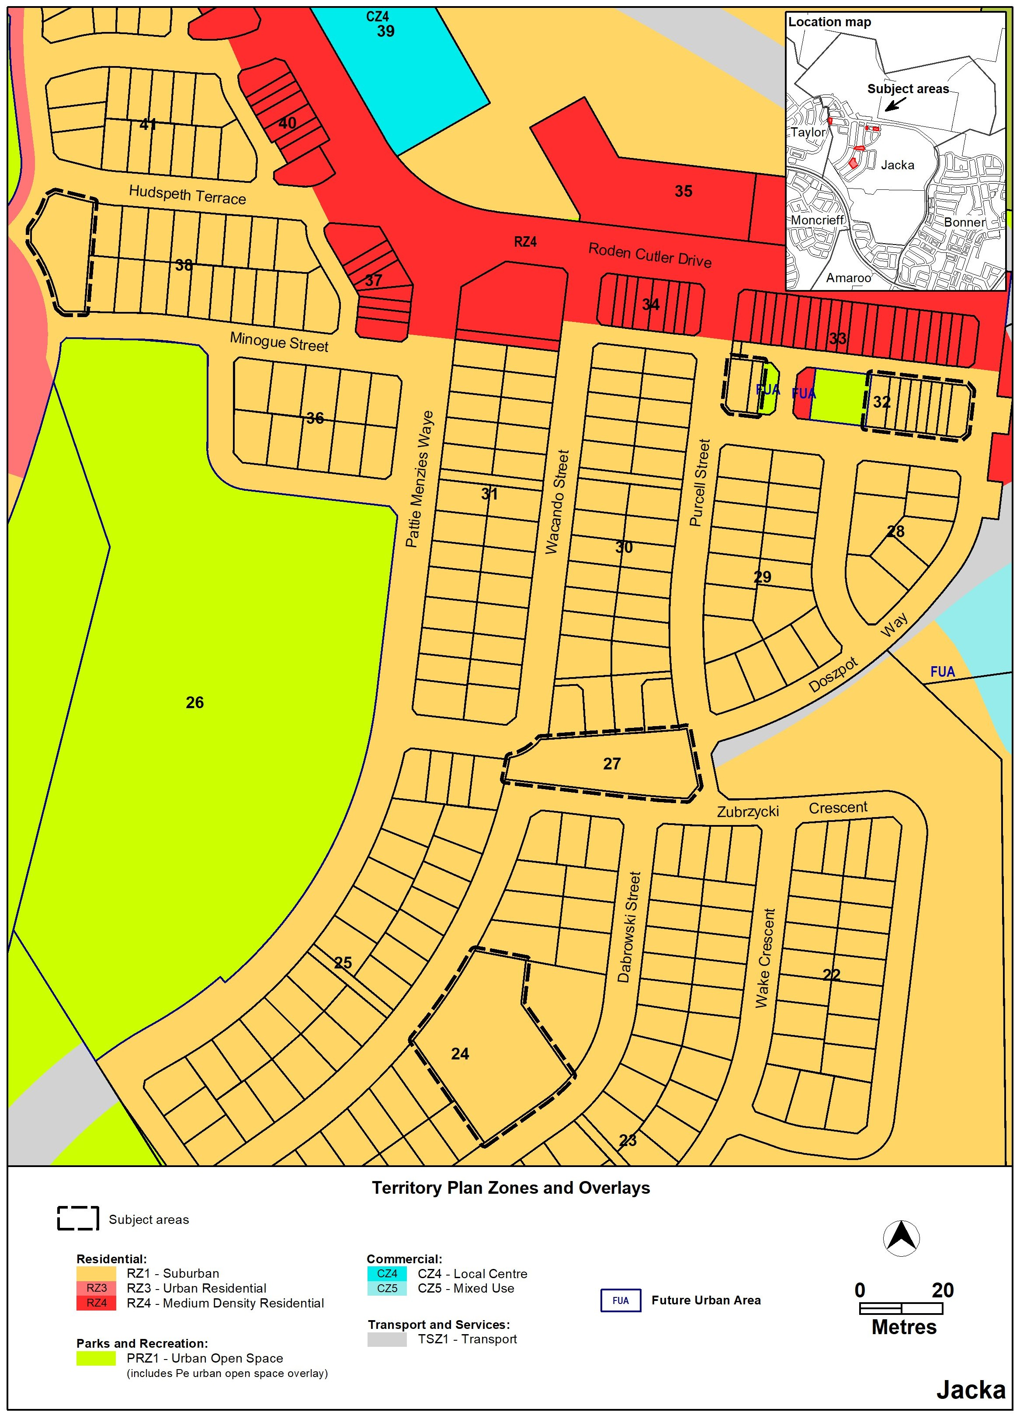
Jacka – Existing Territory Plan map
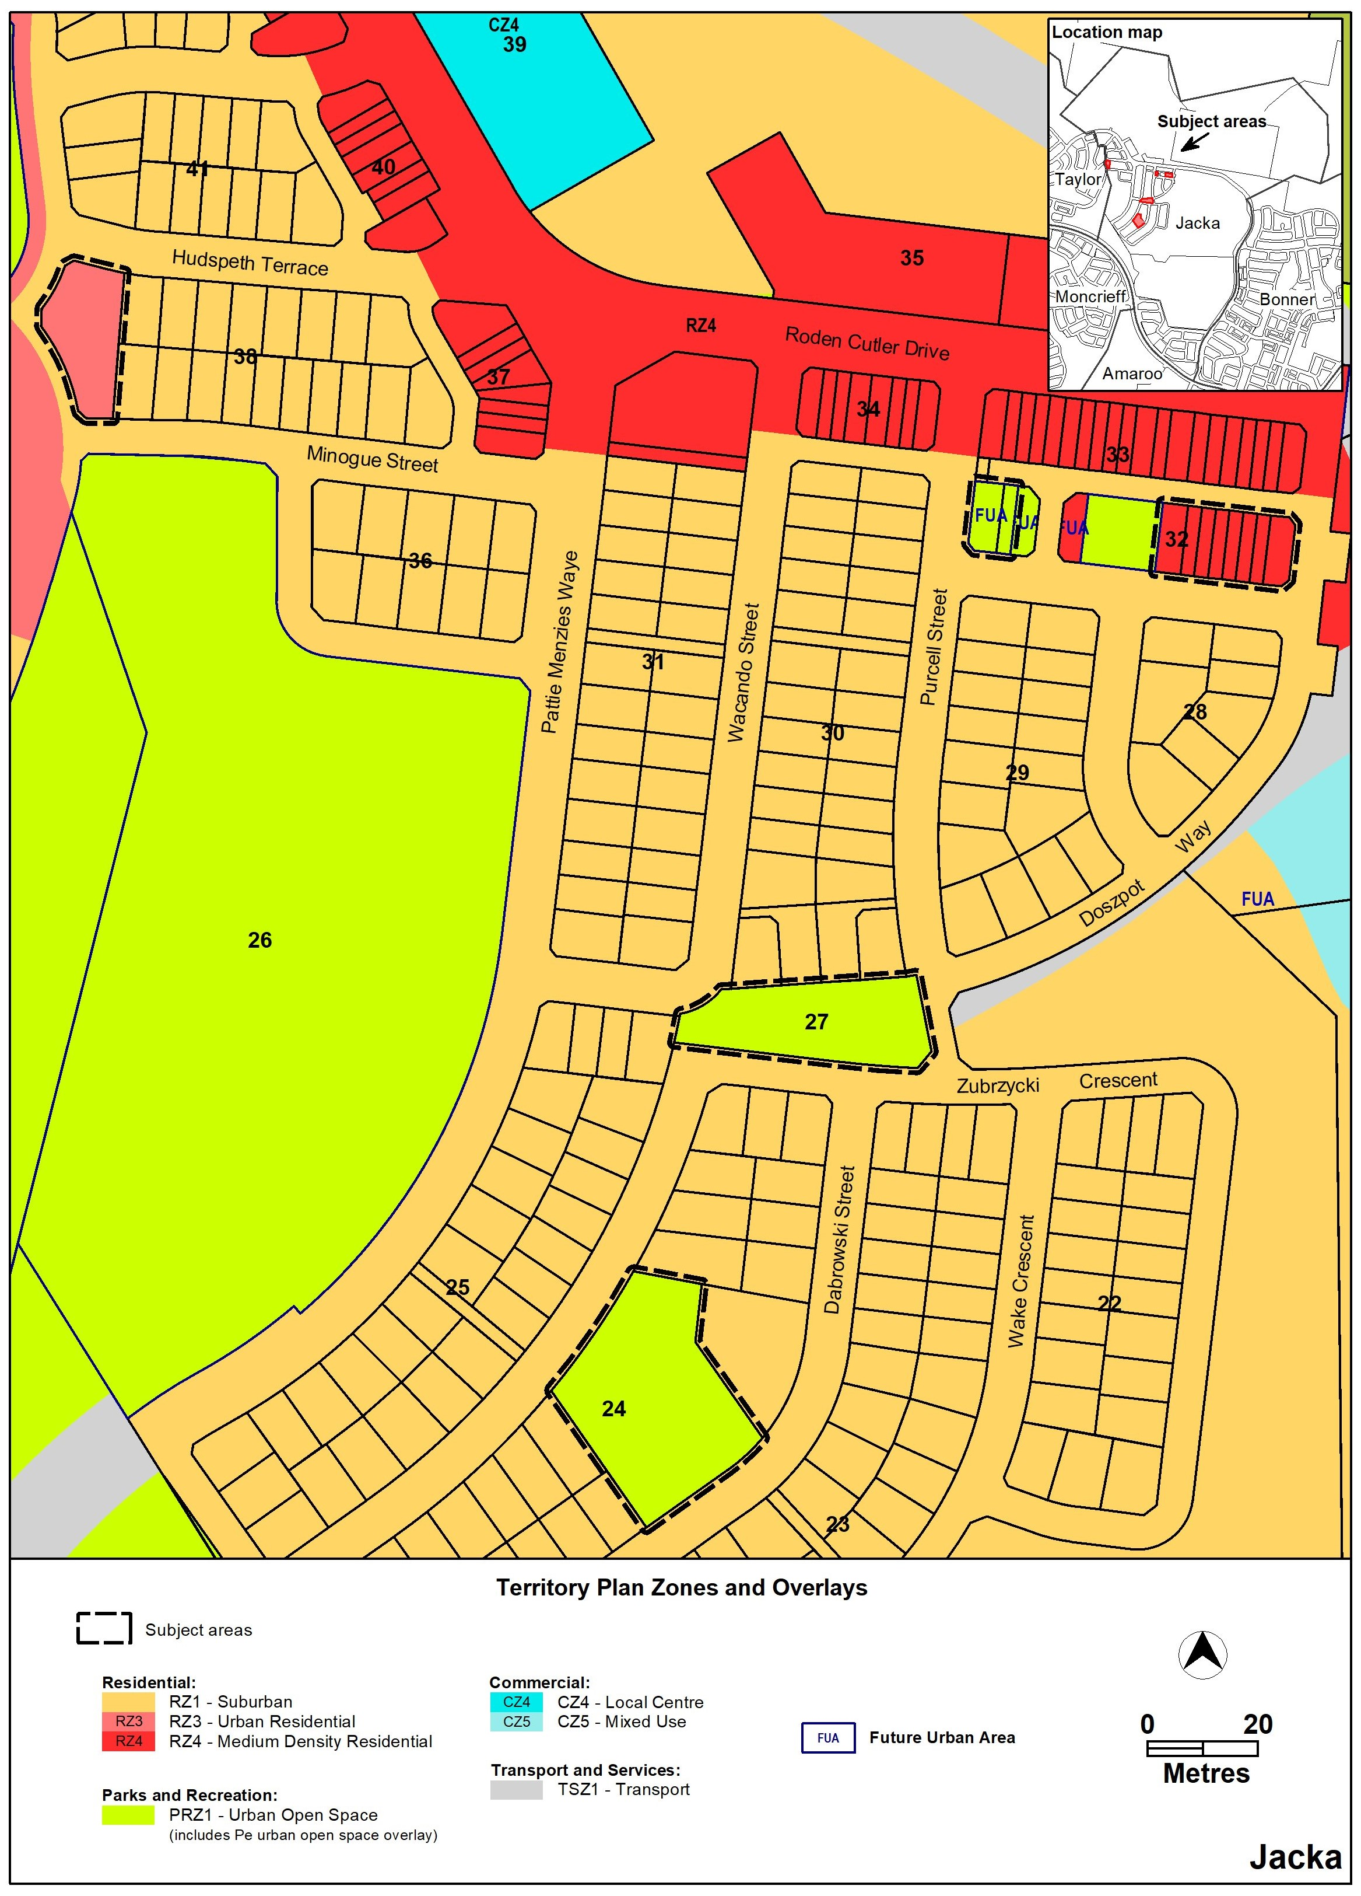
Jacka – Proposed Territory Plan map

TERRITORY PLAN AMENDMENT INSTRUCTIONS
This section provides the legal instructions for how MA2024-g amends the Territory Plan.
  - Part B – Territory Plan Maps
- Jacka

The Territory Plan map is varied as indicated below.
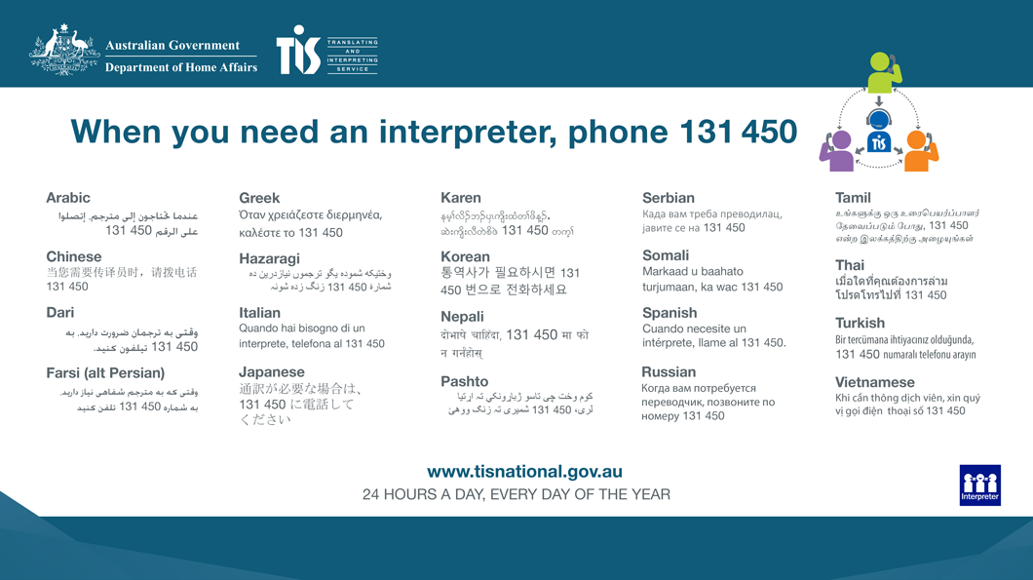
INTERPRETATION SERVICE

