Australian Capital Territory

# Nature Conservation (Closed Reserves) Declaration 2024 (No 3)

## Notifiable instrument NI2024–286

made under the

Nature Conservation Act 2014, s 259 (Conservator may close reserve)

### 1 Name of instrument

This instrument is the *Nature Conservation (Closed Reserves) Declaration 2024 (No 3).*

### 2 Commencement

This instrument commences on 10 June 2024.

### 3 Declaration

I declare that public access to:

1. the reserves mentioned in schedule 1; and
2. those parts of Mount Ainslie Nature Reserve, Red Hill Nature Reserve and Gungaderra Grasslands Nature Reserve indicated in the maps at schedule 2, is prohibited during the closure times mentioned in schedule 3.

### 4 Exceptions

Section 3 does not apply to:

1. a person accompanied by a conservation officer exercising a function under the Act; or
2. a person who is:
   1. contracted by the Territory; or
   2. authorised in writing by the custodian of an area declared in section 3; to
      1. implement the *Nature Conservation (Eastern Grey Kangaroo) Controlled Native Species Management Plan 2017* (DI2017-37); or
      2. control a pest animal species.

### 5 Expiry

This instrument expires on 31 July 2024.



Bren Burkevics  
Conservator of Flora and Fauna

6 June 2024

**Schedule 1 Reserves fully closed**

(see s 3)

|  |
| --- |
| **Reserves** |
| Mount Majura Nature Reserve  Mulanggari Grasslands Nature Reserve |

**Schedule 2 Reserves partially closed**

(see s 3)

Mount Ainslie Nature Reserve

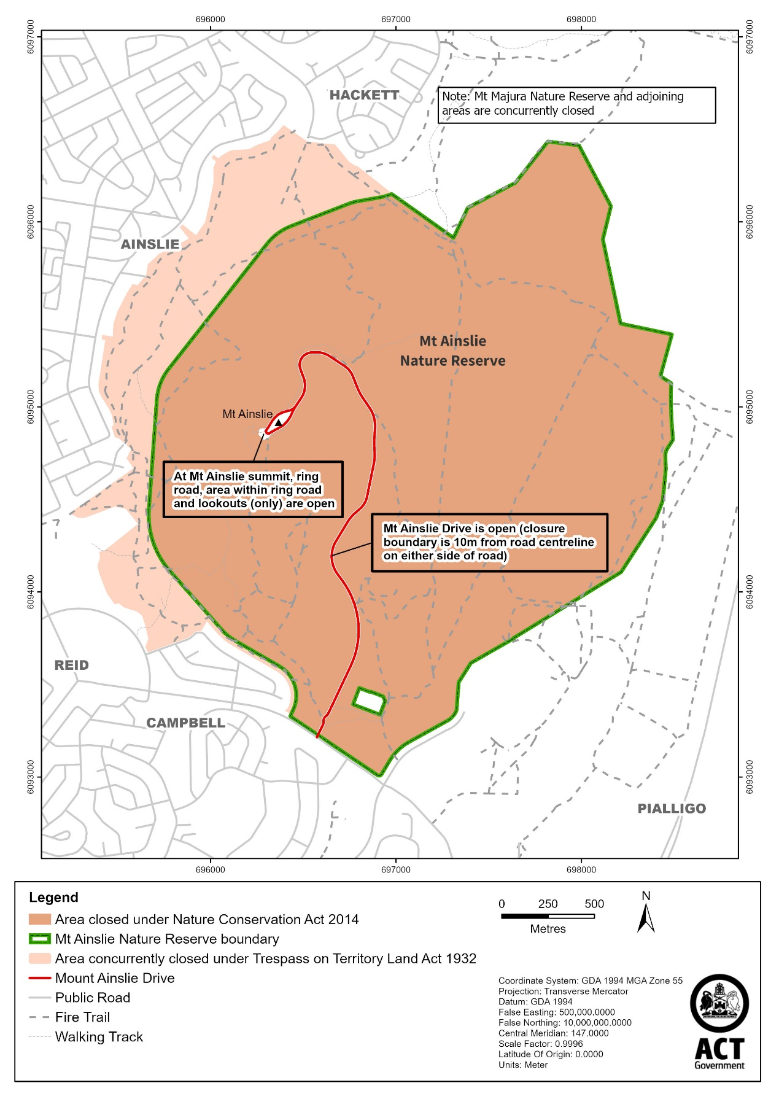

Red Hill Nature Reserve

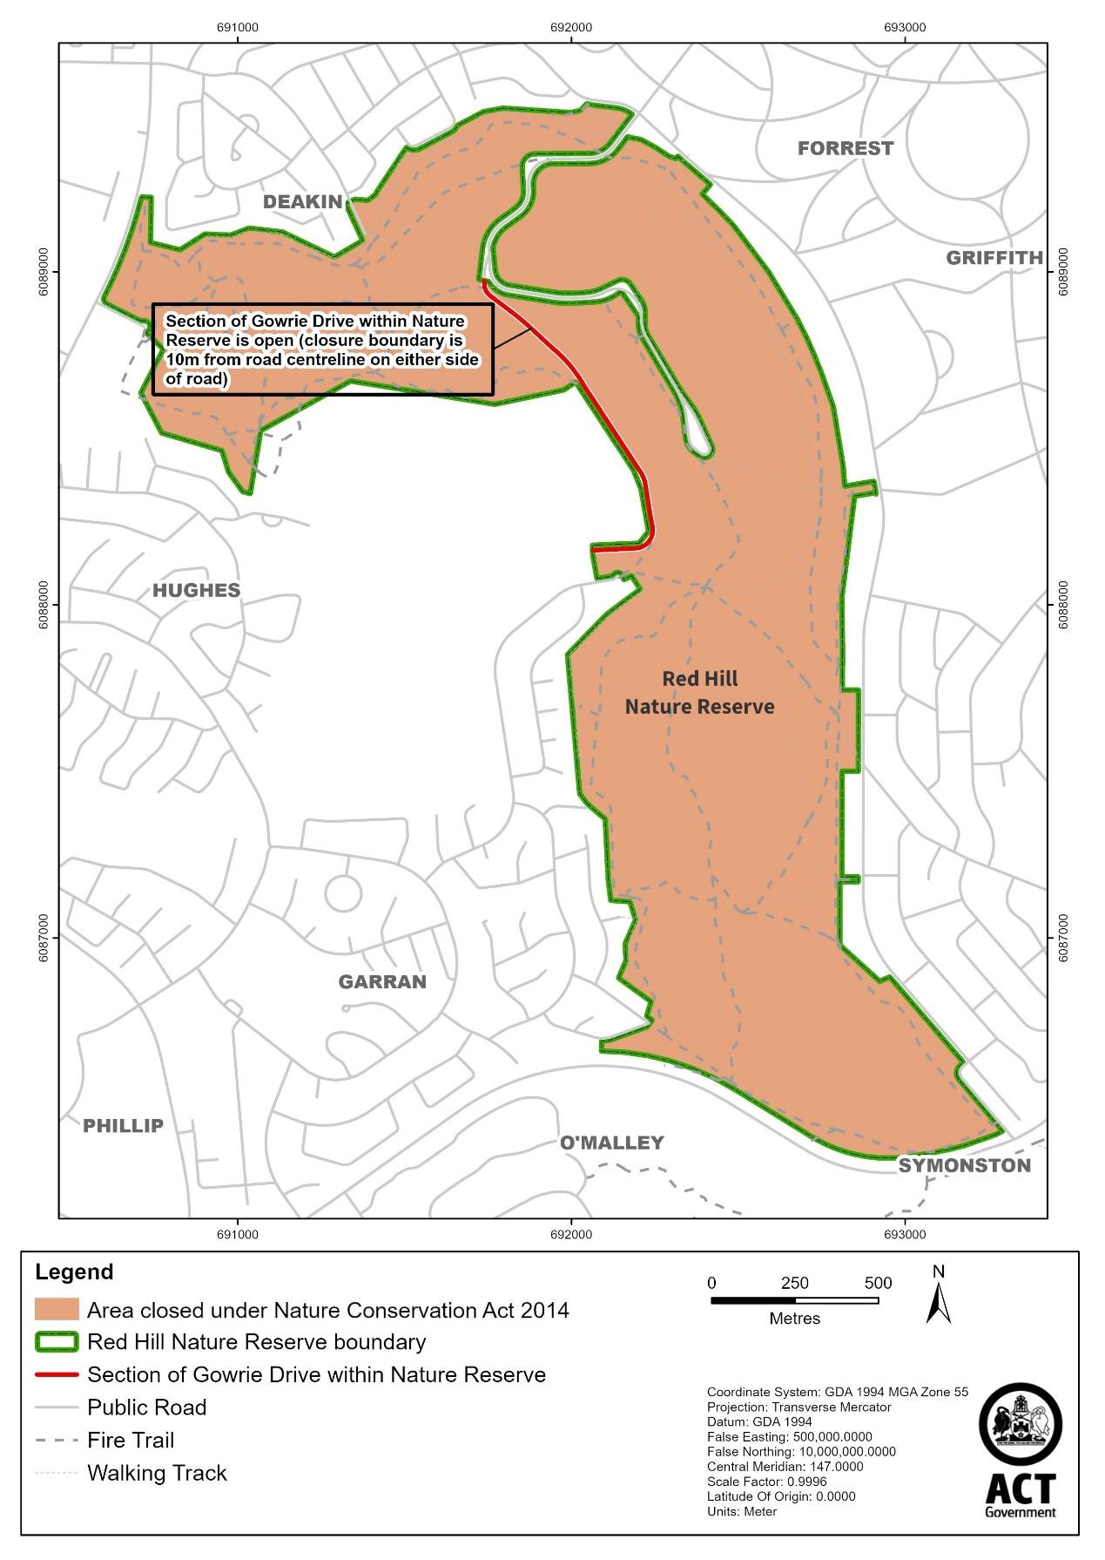

Gungaderra Grasslands Nature Reserve

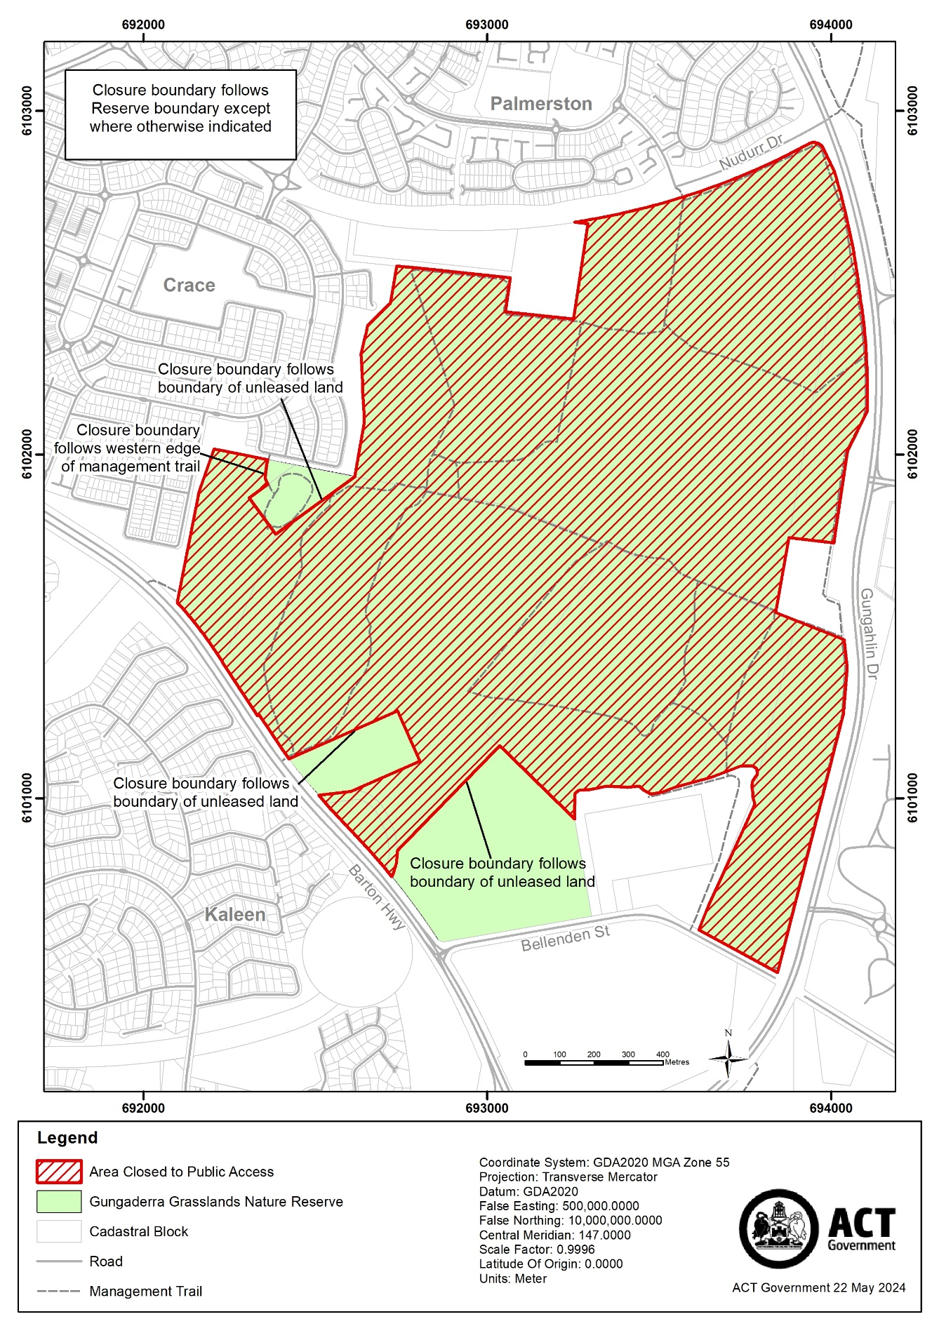

**Schedule 3 Closure times**

(see s 3)

|  |
| --- |
| **Times when public access is prohibited** |
| Beginning at 6:00 pm every Sunday, Monday, Tuesday, Wednesday and Thursday and ending on the following day at 6:00 am. |