Australian Capital Territory

Planning (Inner North and City District Policy) Minor Plan Amendment 2024

**Notifiable instrument NI2024-439**

made under the

Planning Act 2023, s 85 (Making minor plan amendments)

**1 Name of instrument**

This instrument is the *Planning (Inner North and City District Policy) Minor Plan Amendment 2024*.

**2 Commencement**

This instrument commences on 2 August 2024.

**3 Minor plan amendment**

I am satisfied under the *Planning Act 2023*, section 85 (1) (a) that Minor Plan Amendment 2024-e is a minor plan amendment to the Territory Plan.

**4 Dictionary**

In this instrument:

***Minor Plan Amendment 2024-e*** means the minor plan amendment in schedule 1.

Freya O’Brien

Delegate of the territory planning authority

31 July 2024

Schedule 1

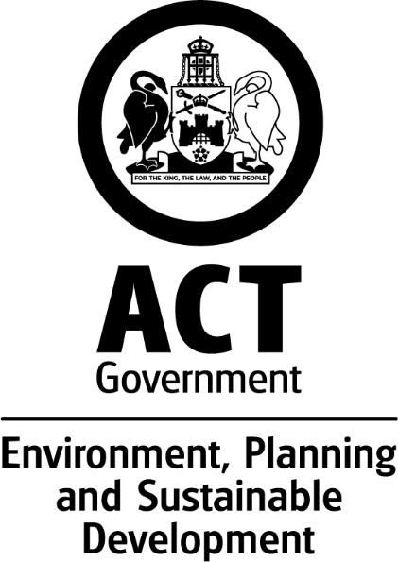

MINOR AMENDMENT

TO THE TERRITORY PLAN

2024-e

Changes to Inner North and

City District Policy

This minor plan amendment was prepared

under part 5.3 of the *Planning Act 2023*

Contents

1.0 INTRODUCTION 1

1.1 Outline of the process 1

1.2 Summary of the changes 2

2.0 CONSULTATION WITH THE PUBLIC 2

2.1 Consultation period 2

2.2 Comments from the public 2

3.0 TERRITORY PLAN CHANGES 3

3.1 Inner North and City District Policy 3

4.0 TERRITORY PLAN AMENDMENT INSTRUCTIONS 6

4.1 Part D – District Policies, Inner North and City District Policy – 3. Policy Outcomes 6

4.2 Part D – District Policies, Inner North and City District Policy – Figure 14 7

INTERPRETATION SERVICE 8

1. INTRODUCTION
   1. Outline of the process

Minor plan amendment 2024-e (MA2024-e) to the Territory Plan is a minor plan amendment (MA) prepared under section 84 2) d) of the *Planning Act 2023* (the Planning Act).

Section 84 of the Planning Act outlines the different types of MAs, some which require limited consultation to be undertaken and some which require no consultation to be undertaken.

Under Section 85 of the Planning Act a MA can only be made where:

* any required limited consultation has taken place, and the authority is satisfied that the content of the MA meets the requirements of the Planning Act
* if the MA is not inconsistent with the planning strategy or any relevant district strategy
* any comments received during the consultation period and from the National Capital Authority have been considered.

This MA required limited consultation to be undertaken and was released for limited public consultation in accordance with the *Planning Act 2023*.

The MA is not inconsistent with the planning strategy or any relevant district strategy. Further details of the changes are contained in section 3 of this document.

The National Capital Authority has received a copy of this MA.

For more information on the content of the Territory Plan and minor plan amendment processes please refer to the Environment, Planning and Sustainable Development (EPSDD) website https://www.planning.act.gov.au/

* 1. Summary of the changes

MA2024–e makes the following changes:

* Amend the Inner North and City District Policy by adding a new policy outcome for the City Centre Entertainment Precinct and replace Figure 14 with a revised figure to show the frame and core areas in the precinct.

1. CONSULTATION WITH THE PUBLIC
   1. Consultation period

Under section 84 (2) (c) of the *Planning Act 2023*, this minor amendment was subject to limited public consultation of at least 20 working days.

* 1. Comments from the public

Written comments were invited on MA2024-e from the public from 4 April 2024 until 3 May 2024.

No submissions were received.

The National Capital Authority has been advised of this minor amendment.

.

1. TERRITORY PLAN CHANGES

This section contains details of the changes made to the Territory Plan.

* 1. Inner North and City District Policy

Changes are being made to add an additional policy outcome for the City Centre Entertainment Precinct (CCEP), and the associated Figure 14 Is being replaced to show the new frame and core areas of the precinct.

An entertainment precinct is an area where existing and future nightlife character and activities, including live music, are prioritised. These precincts give greater certainty to patrons, businesses, residents, the night-time economy industry and building owners.

The City Centre Entertainment Precinct was introduced in the new Territory Plan (Inner North and City District Policy), which came into effect on 27 November 2023. This fulfilled a commitment of the Parliamentary and Governing Agreement (PaGA) of the 10th Legislative Assembly to amend the Territory Plan to create Entertainment Precincts, starting with a city entertainment precinct.

Noise is a key planning consideration in entertainment precincts. Live and amplified music within entertainment precincts typically include bass-heavy beats which travel farther than higher frequency noises. Low frequency (bass) noise also penetrates building facades more readily than high frequency noises, which can impact building occupants. To minimise the risk of harm to human health from noise, complementary reforms to other legislation are being undertaken.

Environmental noise, including noise from amplified music, is regulated under the *Environment Protection Regulation 2005*, made under the *Environment Protection Act 1997*. The ACT is divided into Noise Zones, each with its own noise standard for specified days in the week and hours in the day. While Noise Zones and Noise Zone Standards are specified in the *Environment Protection Regulation 2005*, the boundaries of Noise Zones are defined by maps within the Territory Plan.

The CCEP Core is an area within the CCEP supporting a clustering of higher noise emitting entertainment venues away from any currently constructed residential and commercial accommodation. The Frame makes up the remainder of the CCEP. The Frame contains a variety of venues which contribute to the entertainment scene, with existing residential and commercial accommodation developments within and adjacent to the CCEP Frame. The Frame supports entertainment uses while acting as a transition zone between the Core and the areas adjacent to the City Centre Entertainment Precinct.

Consultation about the night-time economy, which included proposed changes to the City Centre Entertainment Precinct Core and Frame Noise Zone Standards was undertaken in 2023 and early 2024.

The proposed changes are not inconsistent with section 84 (2) (d) of the Planning Act 2023.

The amendment to change the provisions in the Territory Plan does not change the substance of the plan and is consistent with the policy intent of the provision.

*Existing Figure 14*

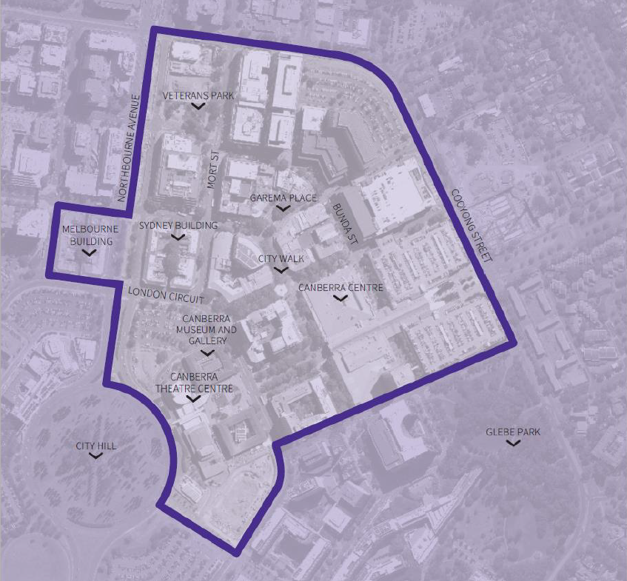

*New Figure 14*

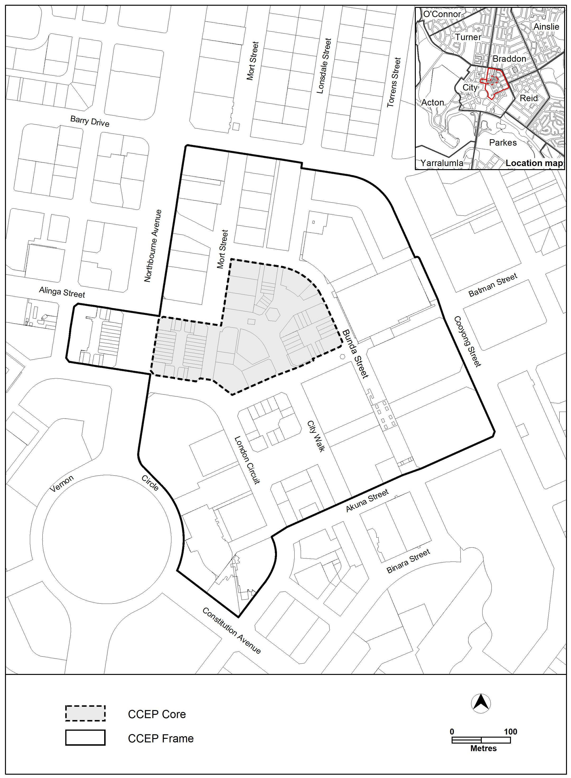

1. TERRITORY PLAN AMENDMENT INSTRUCTIONS

This section provides the legal instructions for how MA2024-e amends the Territory Plan.

* 1. Part D – District Policies, Inner North and City District Policy – 3. Policy Outcomes

After 9.

***Insert***

9A. The City Centre Entertainment Precinct includes a Core and Frame. The City Centre Entertainment Precinct Core supports a clustering of entertainment venues to support the night-time economy. The City Centre Entertainment Precinct Frame contains a variety of venues which contribute to the entertainment and night-time economy scene alongside a variety of other uses.

* 1. Part D – District Policies, Inner North and City District Policy – Figure 14

***Substitute***



INTERPRETATION SERVICE

To speak to someone in a language other than English please telephone the Telephone Interpreter Service (TIS) **13 14 50**

| LANGUAGE | DETAILS |
| --- | --- |
| English | If you need an interpreter please call: **13 14 50** |
| Mandarin (Simplified Chinese) / 简体中文 | 如果您需要翻译，请致电：**13 14 50** |
| Arabic / العربية | إذا كنت بحاجة إلى مترجم شفهي اتصل بالرقم: **50 14 13** |
| Cantonese (Traditional Chinese) / 繁體中文 | 如果你需要傳譯員，請致電：**13 14 50** |
| Vietnamese /  Tiếng Việt | Nếu bạn cần thông dịch viên, xin gọi: **13 14 50** |
| Korean / 한국어 | 통역사가 필요할 경우 다음 번호로 전화하시기 바랍니다: **13 14 50** |
| Spanish / Español | Si necesita un intérprete, llame al **13 14 50** |
| Persian (Farsi) / فارسی | اگر به مترجم نیاز دارید، لطفاً به این شماره تلفن کنید: **50 14 13** |
| Dari / دری | اگر به یک ترجمان شفاهی نیاز دارید لطفاً به شمارۀ **131450** زنگ بزنید. |
| Punjabi / ਪੰਜਾਬੀ | ਜੇਕਰ ਤੁਹਾਨੂੰ ਕਿਸੇ ਦੁਭਾਸ਼ੀਏ ਦੀ ਲੋੜ ਹੈ ਤਾਂ ਕਿਰਪਾ ਕਰਕੇ ਫੋਨ ਕਰੋ: **13 14 50** |
| Tamil / தமிழ் | உங்களுக்கு மொழிபெயர்த்துரைப்பாளர் ஒருவர் தேவைப்பட்டால் **13 14 50** என்ற எண்ணை அழைக்கவும் |
| Greek / Ελληνικά | Αν χρειάζεστε διερμηνέα, τηλεφωνήστε: **13 14 50** |
| Italian / Italiano | Se hai bisogno di un interprete, chiama: **13 14 50** |
| Hazaragi /  هزاره گی | اگه ده ترجمان ضرورت ده رید، لطفاً ده شماره 50 14 13  تماس بگیرید. |
| Thai / ภาษาไทย | หากคุณต้องการล่าม กรุณาโทรไปที่ 13 14 50 |
| Karen / ကညီကျိၥ် | ဖဲနမ့ၢ်လိၣ်ဘၣ်ပှၤကတိၤကျိးထံတၢ်တဂၤအခါ၀ံသးစူၤကိးဘၣ်-၁၃၁ ၄၅၀ တက့ၢ်. |

**Telephone and Interpreter Service 13 14 50 - Canberra and District - 24 hours a day, seven days a week**