Australian Capital Territory

**Planning (Inner South District) Technical Specifications 2024 (No 3)**

**Notifiable instrument NI2024-613**

made under the

**Planning Act 2023, s 51 (Technical specifications)**

**1 Name of instrument**

This instrument is the *Planning (Inner South District) Technical Specifications 2024 (No 3)*.

**2 Commencement**

This instrument commences on the day after notification.

**3 Technical specifications**

I make the technical specifications at schedule 1.

**4 Revocation**

This instrument revokes the *Planning (Inner South District) Technical Specifications 2024 (No 2)* (NI2024-531).

George Cilliers

Chief Planner

14 October 2024



**Schedule 1**

Table of Contents

Table of Contents 2

Inner South District planning technical specifications 4

1. Barton 5

2. Capital Hill 5

3. Deakin 5

Assessment Outcome 1 5

Front Boundary setback 5

Maximum Floor Area 5

Building heights – Deakin office precinct 5

4. Forrest 6

Assessment Outcome 2 6

Demonstration Housing – Block 5 Section 44 Forrest 6

5. Fyshwick 6

Assessment Outcome 3 6

Building Height 6

Dairy Road Mixed Use Area – Noise Attenuation 6

Dairy Road Mixed Use Area – Urban Heat 7

6. Griffith 7

Assessment Outcome 4 7

Demonstration Housing – Block 6 Section 31 Griffith 7

7. Kingston 8

Assessment Outcome 5 8

Assessment Outcome 6 8

Assessment Outcome 7 8

East Lake – The Causeway Area – Light Spill Assessment 8

East Lake – The Causeway Area – Hydrological Assessment 8

East Lake – The Causeway Area – Landscape Plan 8

East Lake – The Causeway Area – Bird Strike 8

Assessment Outcome 8 9

East Lake – The Causeway Area – Subdivision Design 9

Assessment Outcome 9 9

East Lake – The Causeway Area – Subdivision Design 9

Assessment Outcome 10 10

East Lake – The Causeway Area – Climate-wise Measures 10

Assessment Outcome 11 10

East Lake – The Causeway Area – Building Height 10

8. Narrabundah 12

9. Parkes 12

10. Red Hill 12

Federal Golf Course Development – Canopy Coverage 12

11. Yarralumla 12

# Inner South District planning technical specifications

The primary assessment consideration for a development application is the assessment outcomes in the Territory Plan. In demonstrating compliance with the assessment outcomes, consideration may be given to the relevant planning technical specifications which may serve as a benchmark. While all assessment outcomes are to be met, not all outcomes are covered by a specification.

Planning technical specifications are used as a possible solution or to provide guidance for identified aspects of a development proposal. The specifications may also be used as a reference or benchmark in the preparation and assessment of development proposals to demonstrate compliance with the assessment outcomes, and the Territory Plan.

Where a proposed development complies with a relevant provision in the planning technical specifications and the development comprehensively addresses the assessment outcome, further assessment regarding those specific provisions will not be required.

The specifications in the Inner South District Specifications can be used to demonstrate compliance with the assessment outcomes in the Inner South District Policy or the relevant zone policy. Where there is a specific assessment outcome in the Inner South District Policy, this takes precedence over the equivalent outcome in the zone policy. Where there is no specific assessment outcome in the Inner South District Policy, the specification can be used to demonstrate compliance with the assessment outcomes in the zone policy.

The Territory Planning Authority may consider advice or written support from a referral entity to demonstrate compliance with a relevant assessment outcome. Where endorsement from an entity is noted as a planning specification, entity referral may be required.

Consistent with the Inner South District Policy, this Inner South District Specifications comprises specifications for specific localities, structured according to the localities.

These specifications will only apply to the specific sites or locations they refer to and should be used in conjunction with the relevant district policy, i.e., ***Part D4: Inner South District Policy***.

# Barton

The following specifications provide possible solutions that should be considered in planning, placing, designing and using buildings and structures for proposed development in Barton:

| **No applicable specification for this suburb.** |
| --- |

# Capital Hill

The following specifications provide possible solutions that should be considered in planning, placing, designing and using buildings and structures for proposed development in Capital Hill:

| **No applicable specification for this suburb.** |
| --- |

# Deakin

The following specifications provide possible solutions that should be considered in planning, placing, designing and using buildings and structures for proposed development in Deakin:

|  |  |
| --- | --- |
| Assessment Outcome 1 | **In Sections 5, 6, 7 and 8, front boundary setbacks respect the established building lines of surrounding properties** |
| Front Boundary setback | * 1. The minimum front boundary setback is 10m. |

|  |  |
| --- | --- |
| **Assessment Outcome** | **Refer to zone assessment outcomes** |
| **Specification** | |
| Maximum Floor Area | * 1. On Block 89 Section 37 Deakin the maximum gross floor area for a drink establishment, restaurant or shop is 720m2. |

|  |  |
| --- | --- |
| **Assessment Outcome** | **Refer to zone assessment outcomes** |
| **Specification** | |
| Building heights – Deakin office precinct | * 1. The maximum number of storeys is:      1. Section 68 – 3      2. Blocks 2 and 28 Section 35 – 4      3. On all other blocks – 2 |

# Forrest

The following specifications provide possible solutions that should be considered in planning, placing, designing and using buildings and structures for proposed development in Deakin:

|  |  |
| --- | --- |
| Assessment Outcome 2 | **In Sections 20, 21, 22, 27 and 28, front boundary setbacks respect the established building lines of surrounding properties** |
| **No applicable specification for this assessment outcome. Application must respond to the assessment outcome.** | |

|  |  |
| --- | --- |
| **Assessment Outcome** | **Refer to zone assessment outcomes** |
| **Specification** | |
| Demonstration Housing – Block 5 Section 44 Forrest | * 1. Development of multi-unit housing for a Demonstration Housing Project identified on a register published on an ACT Government website complies with all of the following:      1. Maximum plot ratio is 50%.      2. All dwellings must achieve the Livable Housing Design (Gold Level) accreditation, first published by Livable Housing Australia.      3. Only one driveway verge crossings permitted for the block.      4. A minimum of 6 car parking spaces are to be provided on the block. |

# Fyshwick

The following specifications provide possible solutions that should be considered in planning, placing, designing and using buildings and structures for proposed development in Fyshwick:

|  |  |
| --- | --- |
| Assessment Outcome 3 | **Building frontages to Canberra Avenue are consistent with established building lines and achieve a landscaped setting.** |
| **No applicable specification for this assessment outcome. Application must respond to the assessment outcome.** | |

|  |  |
| --- | --- |
| **Assessment Outcome** | **Refer to zone assessment outcomes** |
| **Specification** | |
| Building Height | * 1. On Blocks 15 and 16 Section 6 the maximum number of storeys is 4. |
| Dairy Road Mixed Use Area – Noise Attenuation | * 1. Noise attenuation for noise from external sources:      1. For residential development all dwellings are constructed to comply with the relevant sections of *AS/NZS 2107:2016 – Acoustics – Recommended design sound levels and reverberation times for building interiors* (the relevant satisfactory recommended interior design sound level).      2. Compliance with this specification is demonstrated by an acoustic assessment and noise management plan, prepared by a member of the Australian Acoustical Society with experience in the assessment of rail traffic noise, and endorsed by the ACT Government entity responsible for transport planning.      3. Development complies with a noise management plan prepared by a suitably qualified person and endorsed by the Environment Protection Authority (EPA).   Note: The noise management plan will detail the proposed design, siting and construction methods that will be employed to ensure compliance with the Noise Zone Standard as detailed in the Environment Protection Regulation 2005, based on the estimated noise levels when the facility is in use.  Note: A condition of development approval may be imposed to ensure compliance with the endorsed noise management plan. |
| Dairy Road Mixed Use Area – Urban Heat | * 1. Development demonstrates that there is no net gain of urban heat.   Note: Compliance is demonstrated in a microclimate assessment report by a suitably qualified professional which details building and urban design and proposed use of heat mitigating measures. A ‘suitably qualified professional’ is a person with qualifications and/or experience in urban climate science, urban modelling or microclimate assessment. This specification does not apply to a development application for the change of use of an existing building or structure. |

# Griffith

The following specifications provide possible solutions that should be considered in planning, placing, designing and using buildings and structures for proposed development in Griffith:

|  |  |
| --- | --- |
| Assessment Outcome 4 | **Building frontages to Canberra Avenue are consistent with established building lines and achieve a landscaped setting.** |
| **No applicable specification for this assessment outcome. Application must respond to the assessment outcome.** | |

|  |  |
| --- | --- |
| **Assessment Outcome** | **Refer to zone assessment outcomes** |
| **Specification** | |
| Demonstration Housing – Block 6 Section 31 Griffith | * 1. The maximum plot ratio for a manor house is 50%. A Manor house for the purposes of Demonstration Housing is defined as a building containing three or four dwellings, where:      1. Each dwelling is attached to another dwelling by a common wall or floor.      2. At least one dwelling is partially or wholly located above another dwelling.      3. The building contains no more than 2 storeys excluding the basement.   Note: A building is not an apartment if it meets the definition of manor house. |

# Kingston

The following specifications provide possible solutions that should be considered in planning, placing, designing and using buildings and structures for proposed development in Kingston:

|  |  |
| --- | --- |
| Assessment Outcome 5 | **Appropriate green spaces buffers and other measures are developed to limit impact of future development of East Lake on the Jerrabomberra Wetlands.** |
| **No applicable specification for this assessment outcome. Application must respond to the assessment outcome.** | |

|  |  |
| --- | --- |
| Assessment Outcome 6 | **Building frontage to Canberra Avenue are consistent with established building lines and achieve a landscaped setting.** |
| **No applicable specification for this assessment outcome. Application must respond to the assessment outcome.** | |

|  |  |
| --- | --- |
| Assessment Outcome 7 | Protect the Jerrabomberra Wetlands and Lake Burley Griffin from the impacts of development on flora and fauna. |
| **Specification** | |
| East Lake – The Causeway Area – Light Spill Assessment | * 1. Development within 60 metres of the Jerrabomberra Wetlands block boundary includes a light spill assessment, demonstrating that there will be no adverse impacts from lighting produced by internal luminaires and street lighting on the adjacent wetlands - to the satisfaction of the Conservator of Flora and Fauna.   Note: The light spill assessment must be prepared by a suitably qualified professional. |
| East Lake – The Causeway Area – Hydrological Assessment | * 1. A hydrological assessment is provided to demonstrate that there will be no adverse hydrological impacts on the Jerrabomberra Wetlands and Lake Burley Griffin as a result of development on the site.   Note: The assessment must be prepared by a suitably qualified hydrological professional. |
| East Lake – The Causeway Area – Landscape Plan | * 1. Proposed development is in accordance with a landscape plan for the site demonstrating that species used are appropriately chosen and managed to remove any risk of introduction of incompatible species to the Jerrabomberra Wetlands - to the satisfaction of the Conservator of Flora and Fauna.   Note: The vegetation adjacent to the site boundary with the wetlands is a combination of midlayer shrubs and advanced stock tree planting to provide visual screening of the site from the wetlands. The species are chosen to have minimal impact on the wetlands and to avoid any exotic species entering the reserve. |
| East Lake – The Causeway Area – Bird Strike | * 1. Where a façade is located within 100 metres of the Jerrabomberra Wetlands, 95% of glazing is treated with suitable bird strike protection where the glazed surface is:  1. less than 6 m from another glazed surface such as corners 2. less than 6 m from an internal planted area such as a green wall or planted atrium 3. projecting vertically more than 1 m above the building roof line 4. projecting horizontally more than 1 m beyond the building enclosed façade.   Minimising risk of bird strike can be provided in ways such as:   1. bird strike glazing UV patterning 2. fritted, etched, channelled or translucent glass with an untreated glazing surface area of no larger than 100 mm x 100 mm 3. external treatments such as angled, layers or recessed glazing, shading elements such as louvres, overhangs and awnings or mesh are designed so that they don’t include openings larger than 100mm x 100 mm. |

|  |  |
| --- | --- |
| Assessment Outcome 8 | Subdivision design minimises adverse ecological impacts on the Jerrabomberra Wetlands and Lake Burley Griffin. |
| **Specification** | |
| East Lake – The Causeway Area – Subdivision Design | * 1. The subdivision design demonstrates that:  1. lighting is designed by a suitably qualified professional to avoid light spill into the reserve and is in accordance with Australian Standards for Sports Lighting & Control of the Obtrusive Effects of Outdoor Lighting and the National Light Pollution Guidelines for Wildlife 2023 2. total bioretention basin area of >3% of the total catchment area and a wetland/pond area of 5% of the total catchment area is incorporated 3. public realm design incorporates provision of: 4. alignment and design of driveways along Eyre Street and the eastern edge of The Causeway Area to prevent direct light into the Jerrabomberra Wetlands 5. planting of structurally complex, local native vegetation along the interface with the wetlands to act as a barrier against light and noise 6. pedestrian access into the wetlands in locations which are suitable and capable of dealing with the expected increase in patronage as a result of future residential population in The Causeway Area 7. open space and recreational facilities in suitable and appropriate locations in The Causeway Area to ease pressure on the Jerrabomberra Wetlands as a recreational destination 8. adequate infrastructure to mitigate any potential significant adverse environmental impact on the wetlands from pedestrian/cycling traffic leaving The Causeway Area.   Note: Provision of a ‘well marked’ entry from new development to the Jerrabomberra Wetlands is required in accordance with the relevant Plan of Management for the Jerrabomberra Wetlands. |

|  |  |
| --- | --- |
| Assessment Outcome 9 | Subdivision design makes provision for community and recreation uses within the CFZ Community Facility zone. |
| **Specification** |  |
| East Lake – The Causeway Area – Subdivision Design | * 1. Subdivision design incorporates community and recreation uses within the CFZ Community Facility Zone by incorporating:  1. a site that is approximately 2,500m² for community uses such as community gardens near Cargill’s Cottage and the limestone outcrop. 2. a neighbourhood park that is approximately 2,500m² and is to be centrally located near the Causeway Hall (Block 1 Section 35 Kingston).   Note: The above sites are to be returned to the relevant ACT government agency. |

|  |  |
| --- | --- |
| Assessment Outcome 10 | Promote development which incorporates landscape and urban design climate-wise measures. |
| **Specification** |  |
| East Lake – The Causeway Area – Climate-wise Measures | * 1. Subdivision design incorporates climate-wise landscape and urban design measures such as:  1. increased tree canopy cover and total quantity of green infrastructure to mitigate urban heat effects and contribute to the ACT’s tree canopy cover target 2. reduced heat of ground treatments such as soft fall and tan bark. If required, they are to be co-located with trees and shade and consider lighter colours 3. exploring the opportunity to increase tree canopy on the southern side of the street for east-west oriented streets 4. in north-south oriented streets, prioritise tree canopy on the eastern side of the street 5. supplementing water availability through kerb inlets, permeable paving, irrigation or similar where trees and planted areas do not have access to large, permeable deep soil zones 6. use of deciduous trees for areas near indoor spaces that require light and solar access in winter 7. use of evergreen trees for areas that will benefit from year-round shade 8. use of permeable paving in the public spaces and on block to increase infiltration, where feasible 9. inclusion of a diversity of plant species, such as drought-tolerant plants, that can thrive in different situations and support each other 10. prioritising connections to locally endemic floras and knowledge from Ngunnawal and First Nations people. |
|  |  |
| Assessment Outcome 11 | Building heights vary across the site to create visually and architecturally interesting streetscapes and a building form and scale of development which enhances the heritage significance of the Causeway Hall and its open space setting within and surrounding Section 35 Kingston. |
| **Specification** | |
| East Lake – The Causeway Area – Building Height | * 1. Maximum building heights are indicated in Figure 1.  1. In the area shown on Figure 1 as hatched, up to an additional two storeys are permitted where: 2. the levels above the fourth floor are setback a minimum 3 metres from the floors below 3. buildings are designed to provide a gradual transition in height and scale from the lower development in areas surrounding Section 35 Kingston 4. building design contributes to a safe and interesting streetscape. |

**Figure 1 – Kingston – East Lake – The Causeway Area**

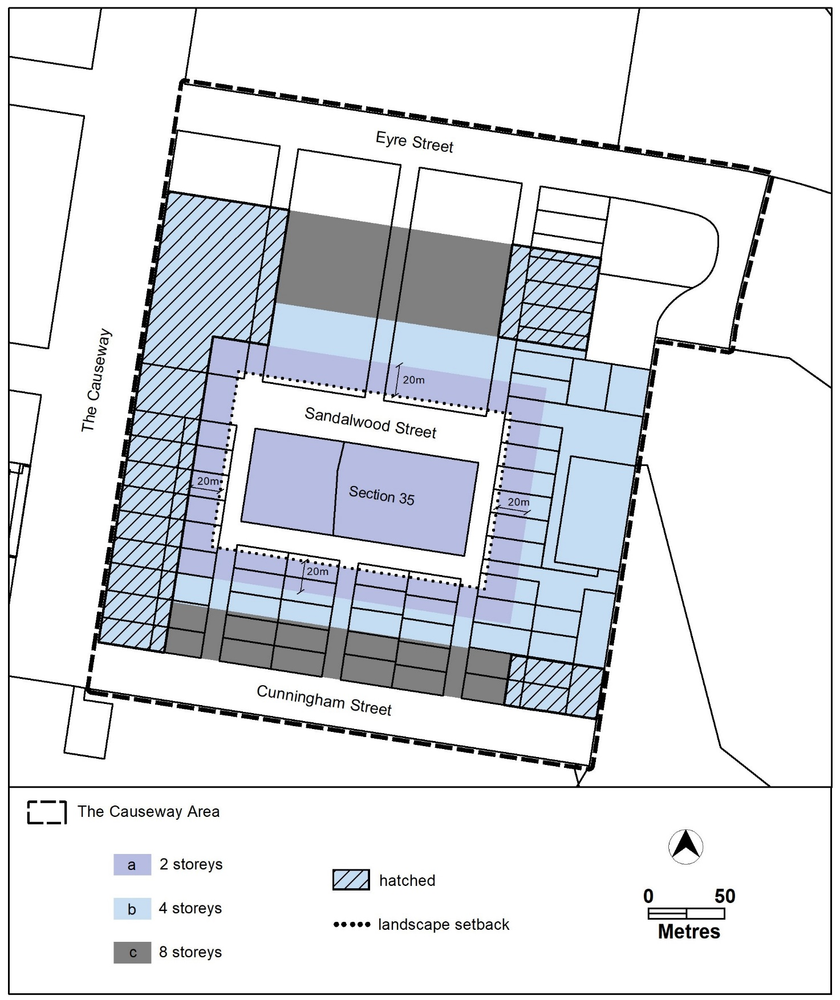

# Narrabundah

The following specifications provide possible solutions that should be considered in planning, placing, designing and using buildings and structures for proposed development in Narrabundah:

| **No applicable specification for this suburb.** |
| --- |

# Parkes

The following specifications provide possible solutions that should be considered in planning, placing, designing and using buildings and structures for proposed development in Parkes:

| **No applicable specification for this suburb.** |
| --- |

# Red Hill

The following specifications provide possible solutions that should be considered in planning, placing, designing and using buildings and structures for proposed development in Red Hill:

|  |  |
| --- | --- |
| **Assessment Outcome** | Refer to zone assessment outcomes |
| **Specification** | |
| Federal Golf Course Development – Canopy Coverage | * 1. Future development of the land should achieve whichever is the greater of the following:  1. Not result in a net loss of canopy coverage measured at a mature height or; 2. Provide at least 30% canopy coverage measured at a mature height. |

# Yarralumla

The following specifications provide possible solutions that should be considered in planning, placing, designing and using buildings and structures for proposed development in Yarralumla:

| **No applicable specification for this suburb.** |
| --- |