Australian Capital Territory
Planning (Exempt Development) Single Dwelling Housing Development Control – Gungahlin District Declaration 2024 (No 3)*
Notifiable instrument NI2024–618
made under the
Planning (Exempt Development) Regulation 2023, s 14 (Territory planning authority may declare development controls)

1 Name of instrument
This instrument is the Planning (Exempt Development) Single Dwelling Housing Development Control – Gungahlin District Declaration 2024 (No 3).
2 Commencement
This instrument commences on the day after notification.
3 Declaration
I declare the development control at schedule 1 for the development of single dwelling housing in residential zones in the Gungahlin District.
4 Revocation
I revoke the Planning (Exempt Development) Single Dwelling Housing Development Control – Gungahlin District Declaration 2024 (No 2) (NI2024-548).

Anthony Burton
Delegate of the territory planning authority
15 October 2024

Residential Zones - Single Dwelling Housing Development Control

Gungahlin District

Application
The Residential Zones - Single Dwelling Housing Development Control enables a single dwelling development, including alterations and extensions, to be exempt from requiring development approval where it meets all the requirements set out in the control declared under section 14 (1) (a) of the Planning (Exempt Development) Regulation 2023 (the Regulation), and where it meets the relevant development exemption criteria as set out in the Regulation. Where a requirement for a specific block is contained within a district specific single dwelling housing development control for exempt development declarations, that requirement supersedes the corresponding requirement in the Residential Zones – Single Dwelling Housing Development Control.
This control is for the district of Gungahlin (as defined in the relevant District Policy of the Territory Plan) and enables single dwelling development to be exempt from requiring development approval where it meets all the requirements set out in this control.
This category of exempt development allows compliant single dwellings to be built without development approval.
An exemption declaration is a minor approval that can be issued by the Territory Planning Authority that allows a single dwelling, which would be exempt from development approval other than for one or more minor encroachments, to continue to be dealt with as exempt development. In all cases, the departures from the requirements in this control must be consistent with the exemptions for minor non-compliance as set out in the Planning (Exempt Development) Regulation 2023 and the Territory Planning Authority is satisfied that the departures are minor and will not cause an adverse effect to neighbours.
Adding a secondary residence is not considered to be exempt development and would require development approval.
Terms used in this development control have the same meaning that they have in the Territory Plan Part G Dictionary and in the Planning (Exempt Development) Regulation 2023.

SINGLE DWELLING DEVELOPMENT CONTROL – GUNGAHLIN DISTRICT
Hall
Item | Control
Development requirements | - Developments in the suburb of Hall are to include materials and colours that are sympathetic with surrounding buildings, consistent with the desired character as expressed in the relevant Assessment Requirements. Where no cohesive built form exists in the immediate neighbourhood, materials are to be consistent with Australian vernacular (timber, brick, metal roofs) and colours are to be predominantly earthy toned.  - Development within the suburb of Hall is to be consistent with the desired character for the Village of Hall as stated in the ‘Hall Village Heritage Precinct’ citation under the provisions of the Heritage Act 2004.  - In accordance with Figure 1:  - In area ‘a’:  - Maximum height of building - 8.5m.  - Maximum plot ratio - 50%.  - Industrial trades are permitted on ground floor.  - Front setback to Victoria Street is nil.  - In area ‘b’ the maximum number of dwellings on each block is 1.

Jacka
Item | Control
Principal Private Open Space (PPOS) | - Upper level PPOS permitted on nominated blocks in Figure 6 and Figure 7.
Building height | - The mandatory number of storeys is nominated in Figure 5, Figure 6, and Figure 7.
Setbacks | - Minimum boundary setbacks to floor levels are identified in Figure 6 and Figure 7.  - Buildings on blocks identified in Figure 6 and Figure 7 must be constructed to nominated boundaries.  - Note: These provisions do not apply to setbacks for garages and/or carports.
Build depth | - Maximum building depth is 16m from front street boundary for nominated blocks in Figure 6 and Figure 7.
Habitable room | - Nominated blocks in Figure 5 must have a habitable room other than a bedroom fronting open space.
Fencing | - This provision applies to nominated boundaries in Figure 2, Figure 3 and Figure 4. Fences are to be constructed in accordance with Table 1.  The following applies to all fences:  - Provide both solid and semi-transparent elements within fencing/courtyard designs.  - Private open space cannot be lower than 1m below the front boundary level for a depth of 3m from the front boundary to the open space.  - Maximum fence/wall height is the cumulative height of retaining wall and fence (see Diagram 2).  - Refer to planning controls for nomination of mandatory gate, street address and letterbox to identified blocks.  The following applies to fencing on corner blocks:  - No fencing permitted within 6m of the corner (refer to Diagram 1).  - Fencing forward of the block line.  - 6m setback to alignment intersection.  - 50% @ 0m setback (total length).  - 50% @ 0.6m setback (total length).  - No maximum fencing length.
Walls | - Maximum length of wall at nominated setback cannot exceed nominated length in Figure 7.
Garages/Carports | - Minimum setback to garage/carport is nominated in Figure 6 and Figure 7.  - Mandatory garage/carport locations are specified in Figure 6 and Figure 7.
Development provisions | - Development complies with the specifications identified in Figure 8, Figure 9 and Figure 10.

Taylor
Item | Control
Principal private open space | - For blocks identified in Figure 13, Figure 14, Figure 15, Figure 16, Figure 17, and Figure 18, at least one area of principal private open space on the block complies with all of the following:  - Minimum area and dimensions specified in the table below.  - At ground level.  - Directly accessible from, and adjacent to, a habitable room other than a bedroom.  - Screened from adjoining public streets and public open space.  - Located behind the building line, except where enclosed by a courtyard wall.  - Is not located to the south, south-east or south-west of the dwelling, unless it achieves not less than 3 hours of direct sunlight onto 50% of the minimum principal private open space area between the hours of 9am and 3pm on the winter solstice (21 June).  Note: Overshadowing from vegetation is not considered when assessing solar access.  * For the purpose of this table, dwelling size is defined as the sum of all floor area measured to the outside face of externals walls including internal walls between the living areas and garage (but excluding the garage).
  Block type | Dwelling Size* | Minimum Area | Minimum Dimension
  Mid sized  Large | up to 105m² | 28m² | 4m
  Mid sized  Large | 105m² or greater | 36m² | 6m
Development provisions | - Development complies with the specifications identified in Figure 11 to Figure 28.
FIGURES
HALL

Figure 1 – Hall development requirements
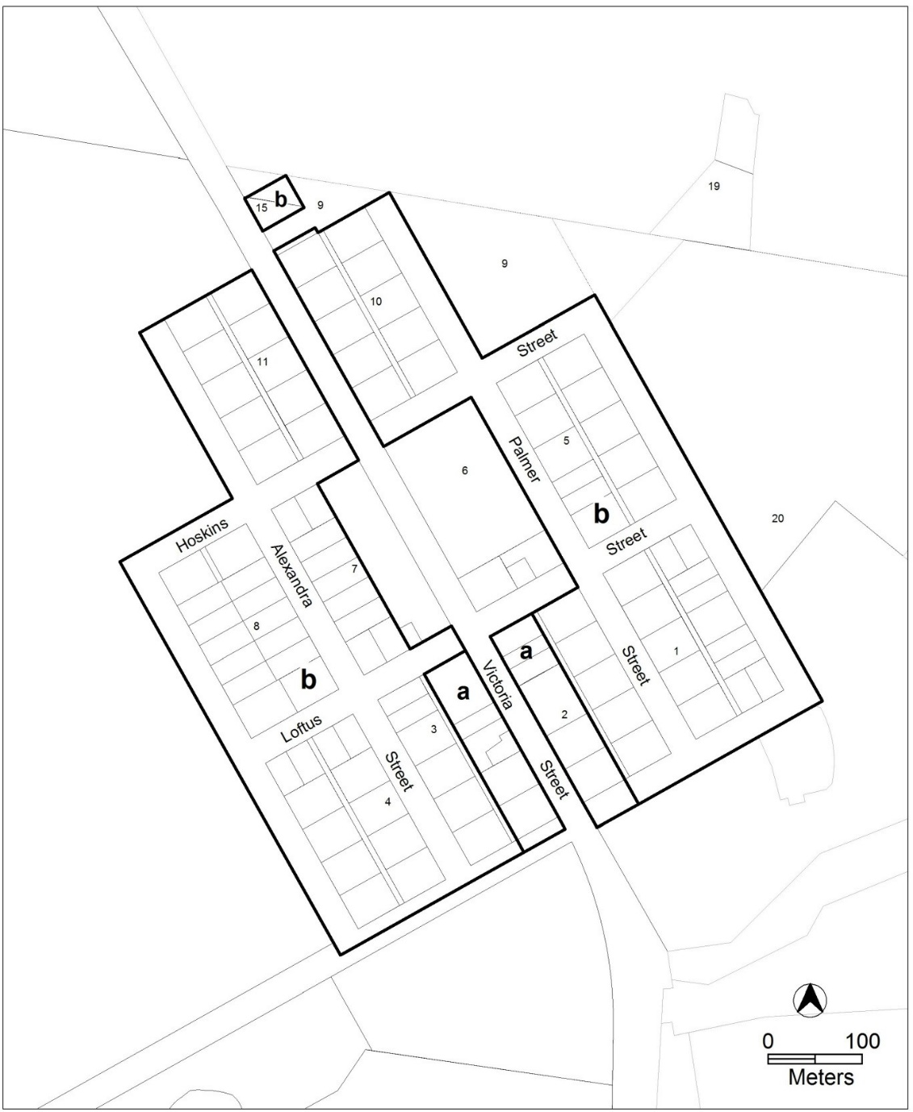

JACKA

Table 1 - Jacka Fencing Controls
 |  |  |  | Minimum setback |  | Maximum height
Location (refer to Figures) |  | Mandatory fencing | Provide Access Gate |  | For screening plants |  | Where located adjacent to the dwellings PPOS
 | Fence to pedestrian link | Yes | Yes | 100% at 0m |  | 1.5m | 1.5m
 | Fence to Boundary A | Yes | No | 100% at 0m |  | 1.5 | 1.5m
 | Fence to Boundary B | Yes | Yes |  | 100% at 0.6m | 1.5m | 1.5m
 | Fence to Section B | Yes | Yes |  | 100% at 0m | 1.8m | 1.8m

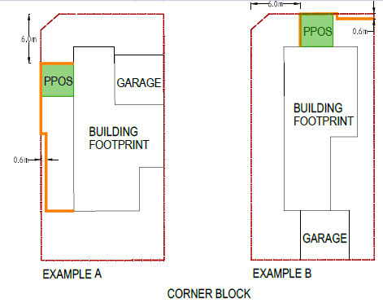
Diagram 1 - Jacka Corner Block Fencing
6.0m
0.6m
6.0m
0.6m

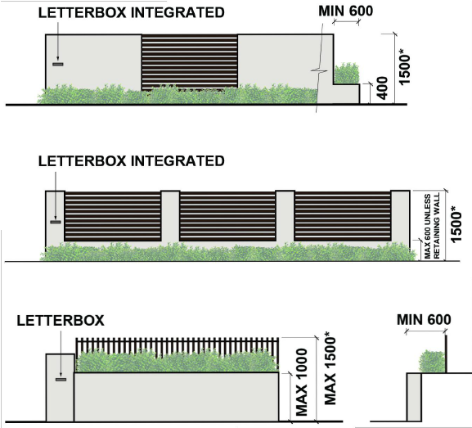
Diagram 2 - Jacka Typical Fencing Treatment

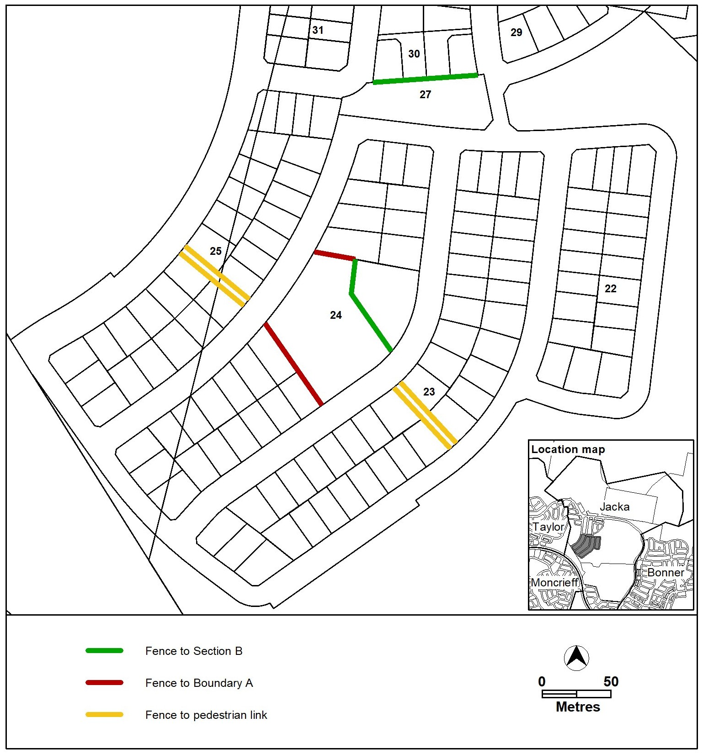
Figure 2 – Jacka development requirements

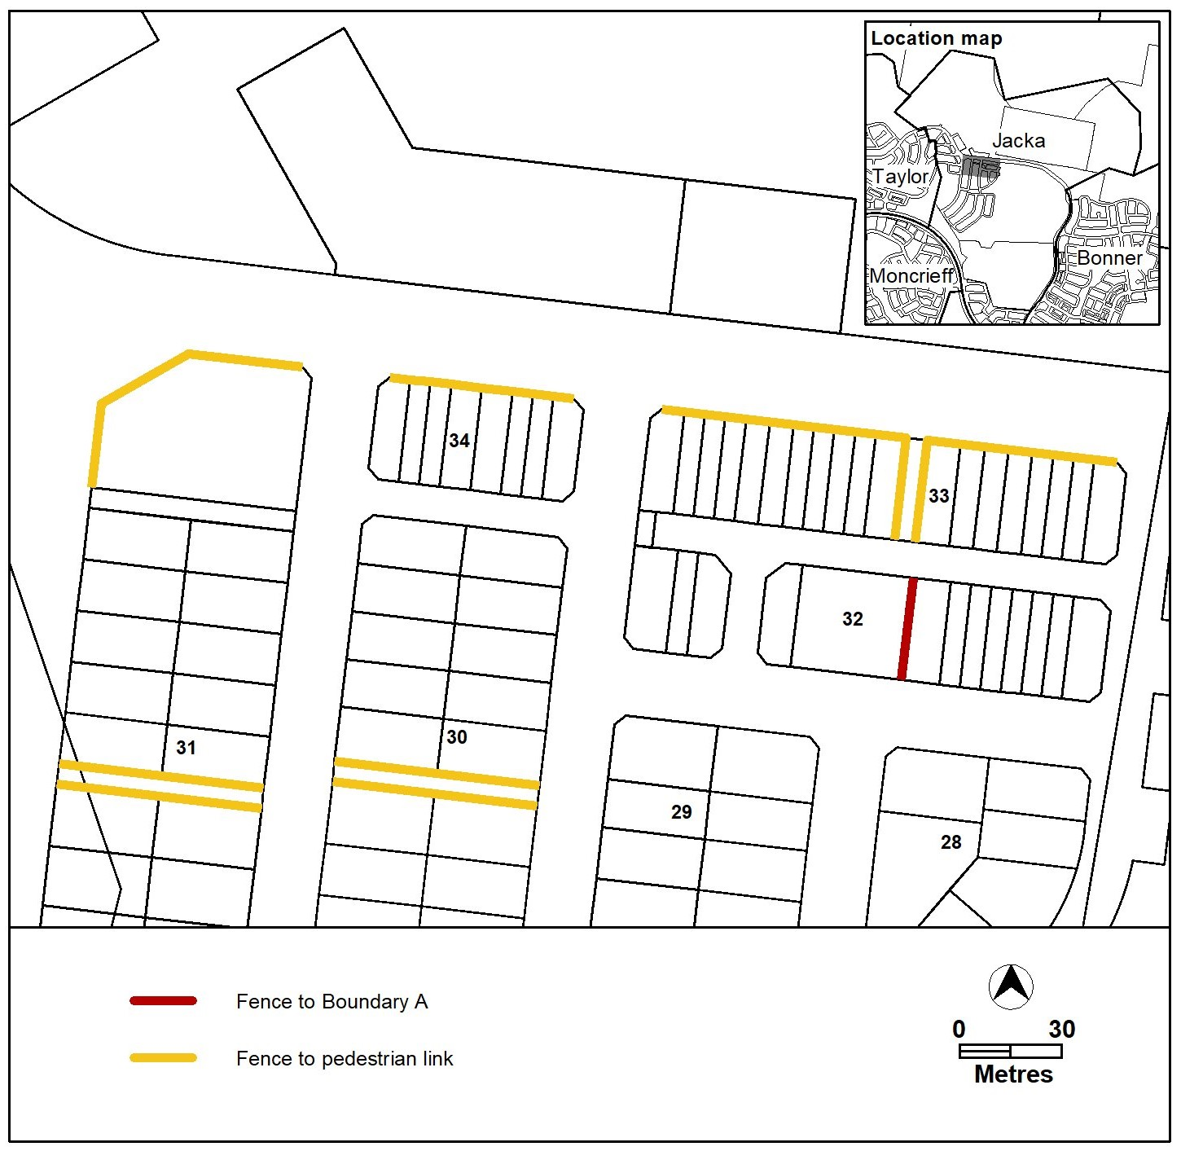
Figure 3 – Jacka development requirements

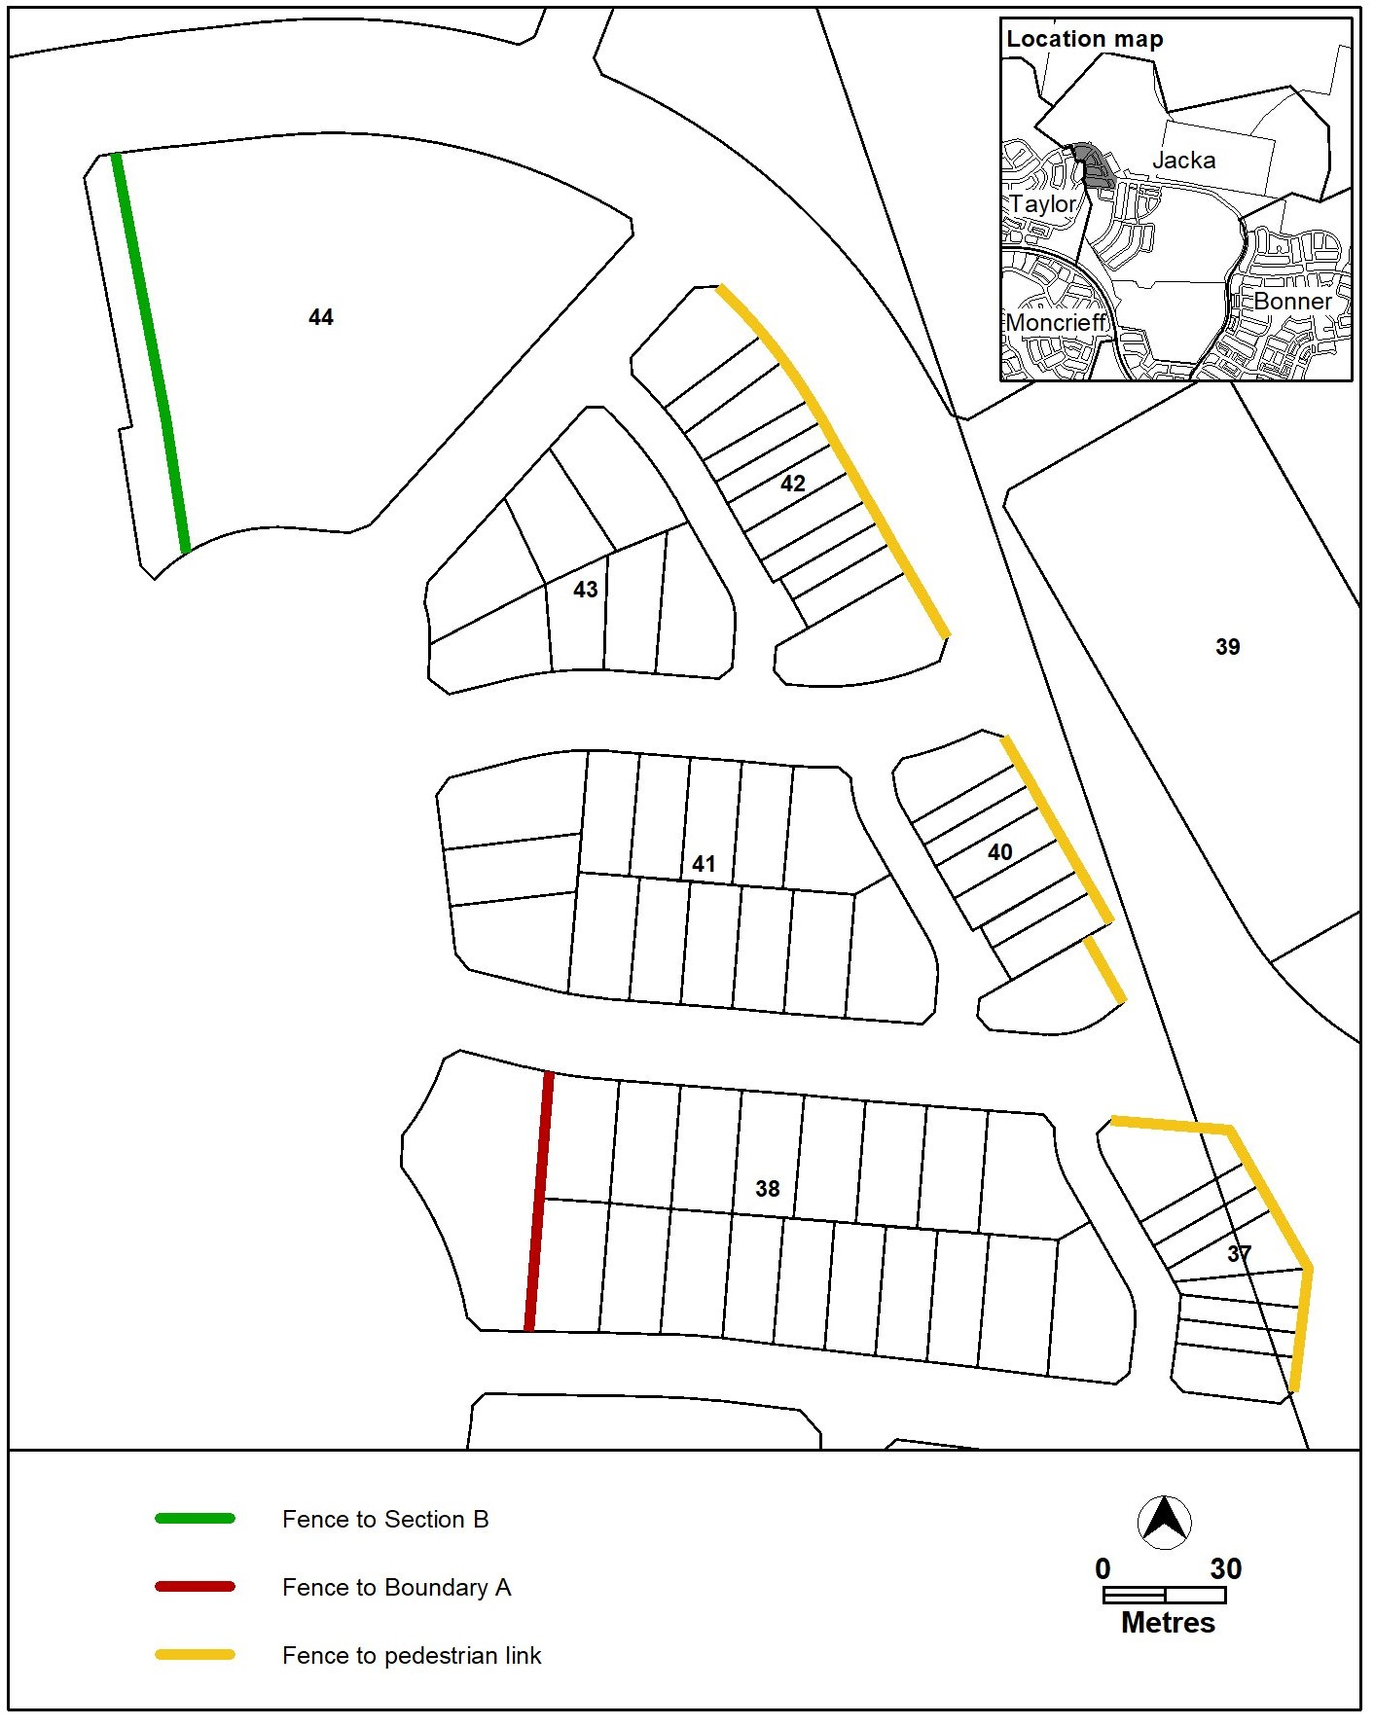
Figure 4 – Jacka development requirements

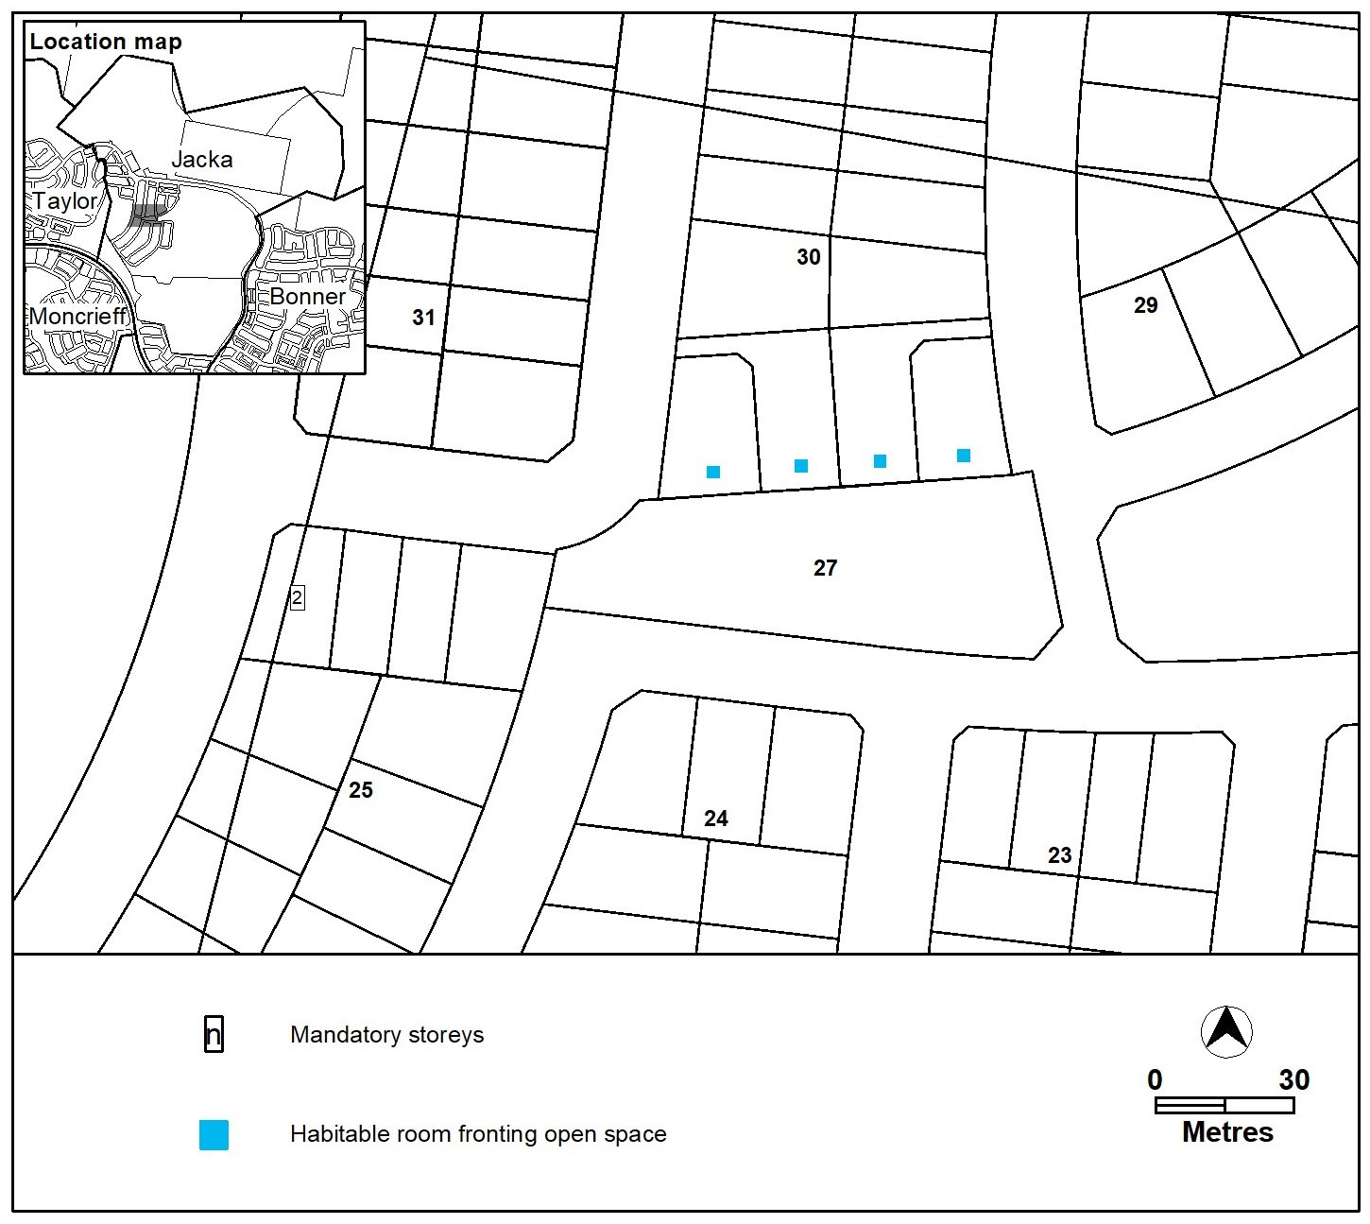
Figure 5 – Jacka development requirements

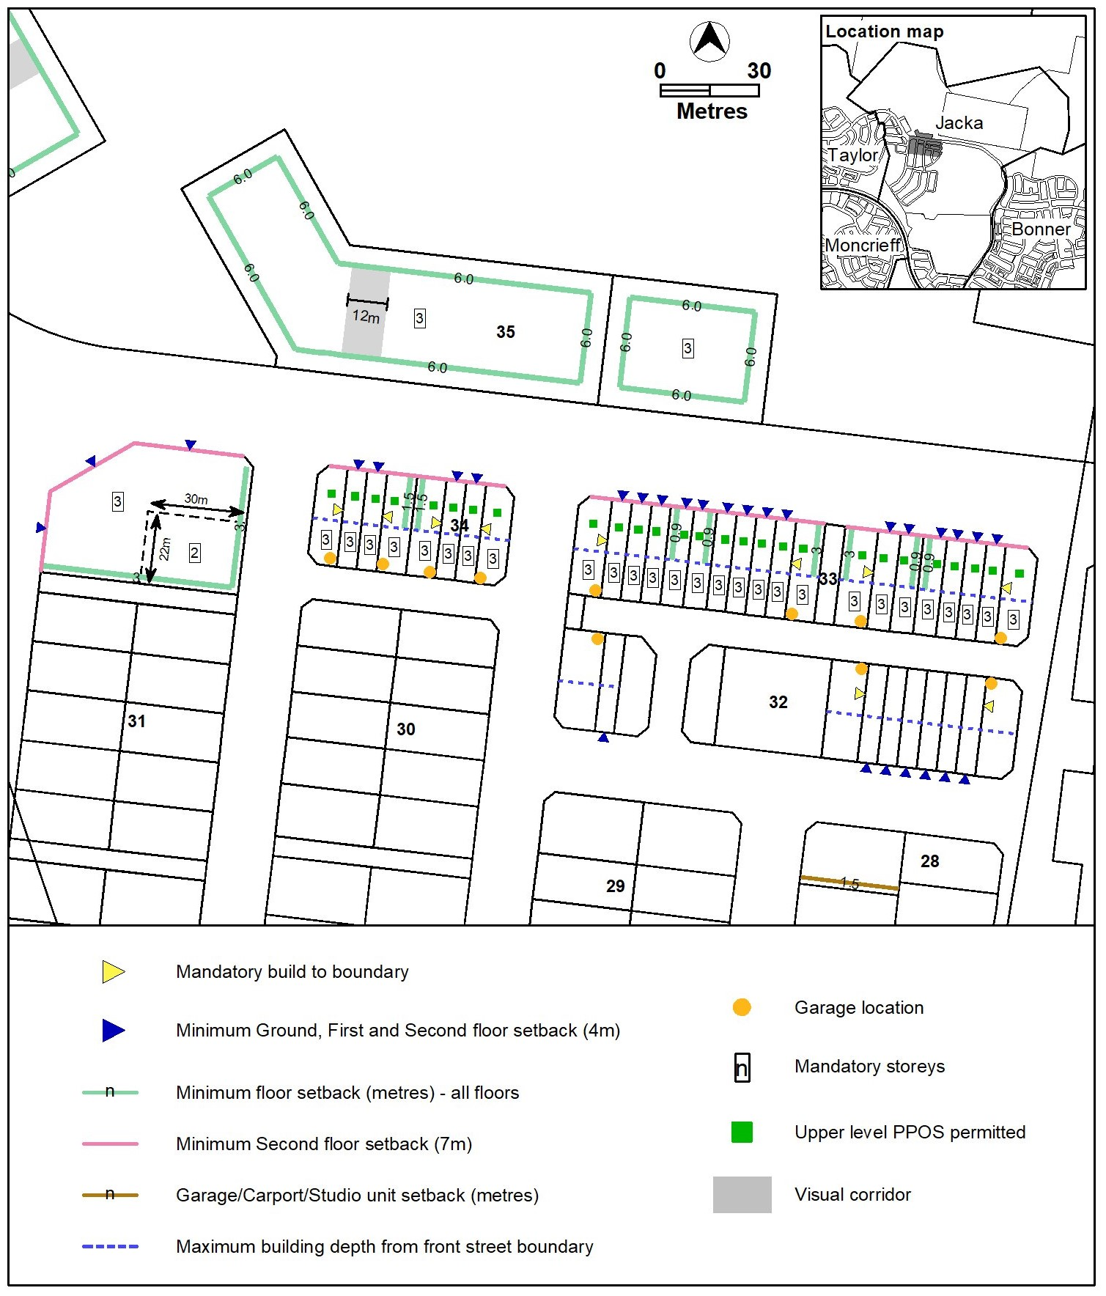
Figure 6 – Jacka development requirements
Minimum ground and first floor setback (4m)

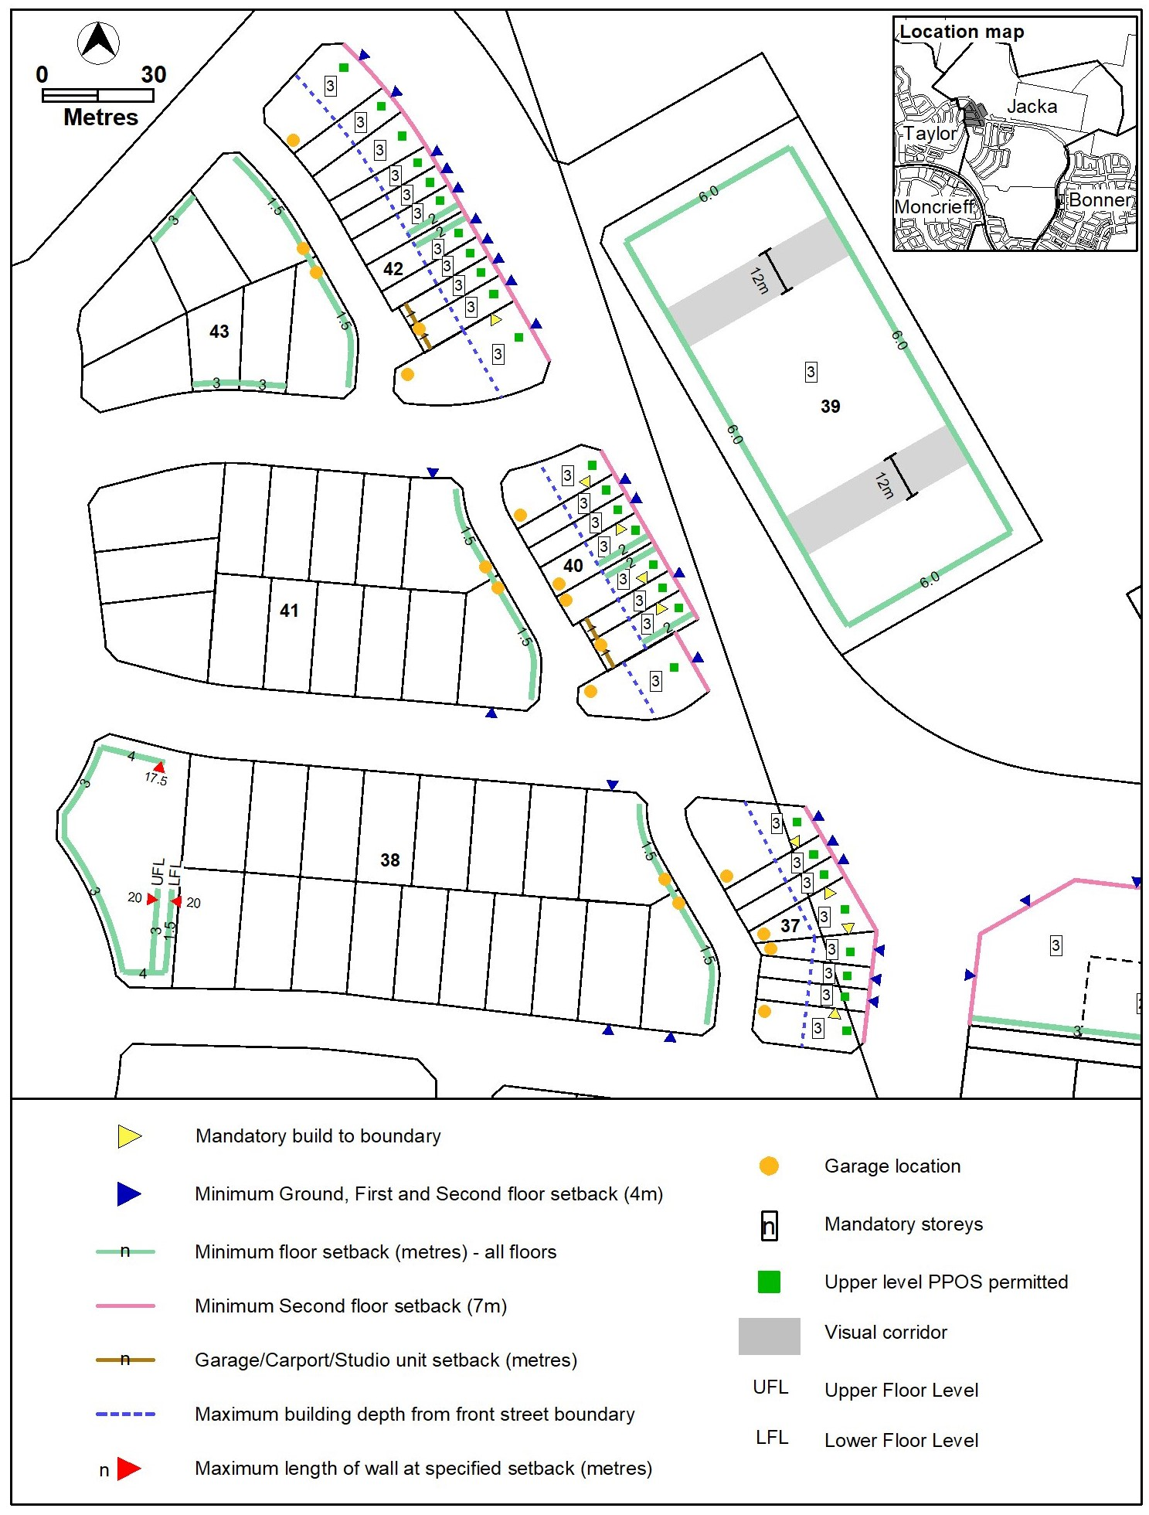
Figure 7 – Jacka development requirements
Minimum ground and first floor setback (4m)

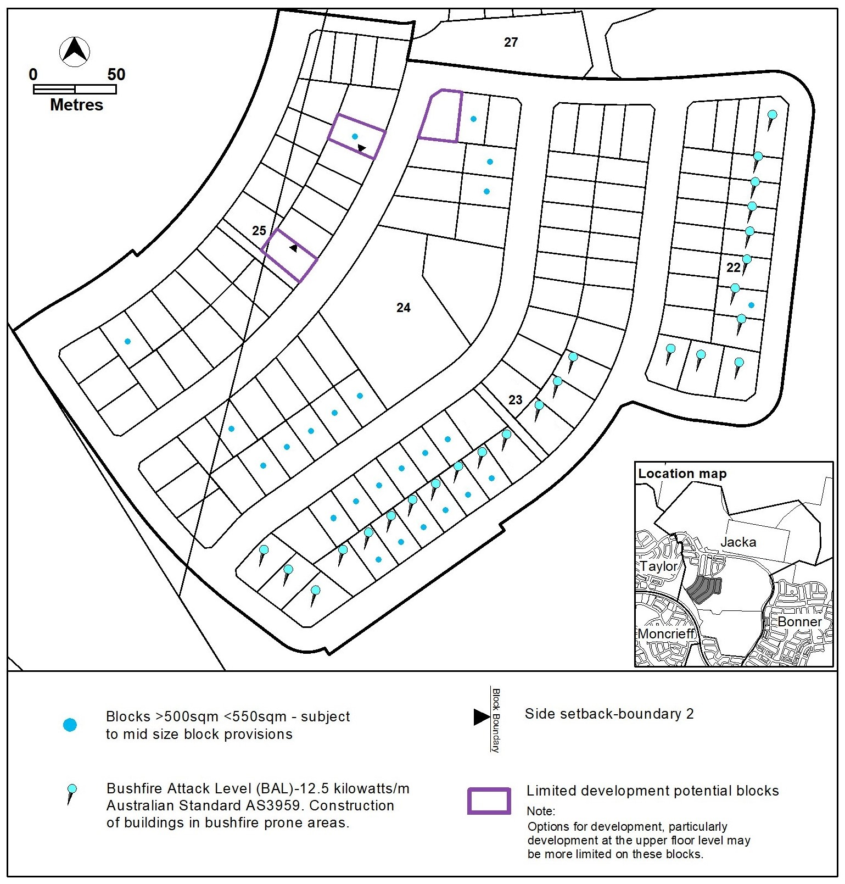
Figure 8 – Jacka development requirements

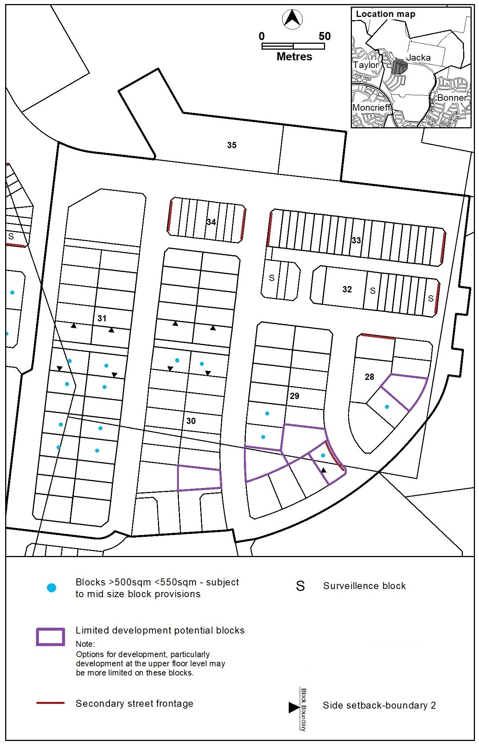
Figure 9 – Jacka development requirements

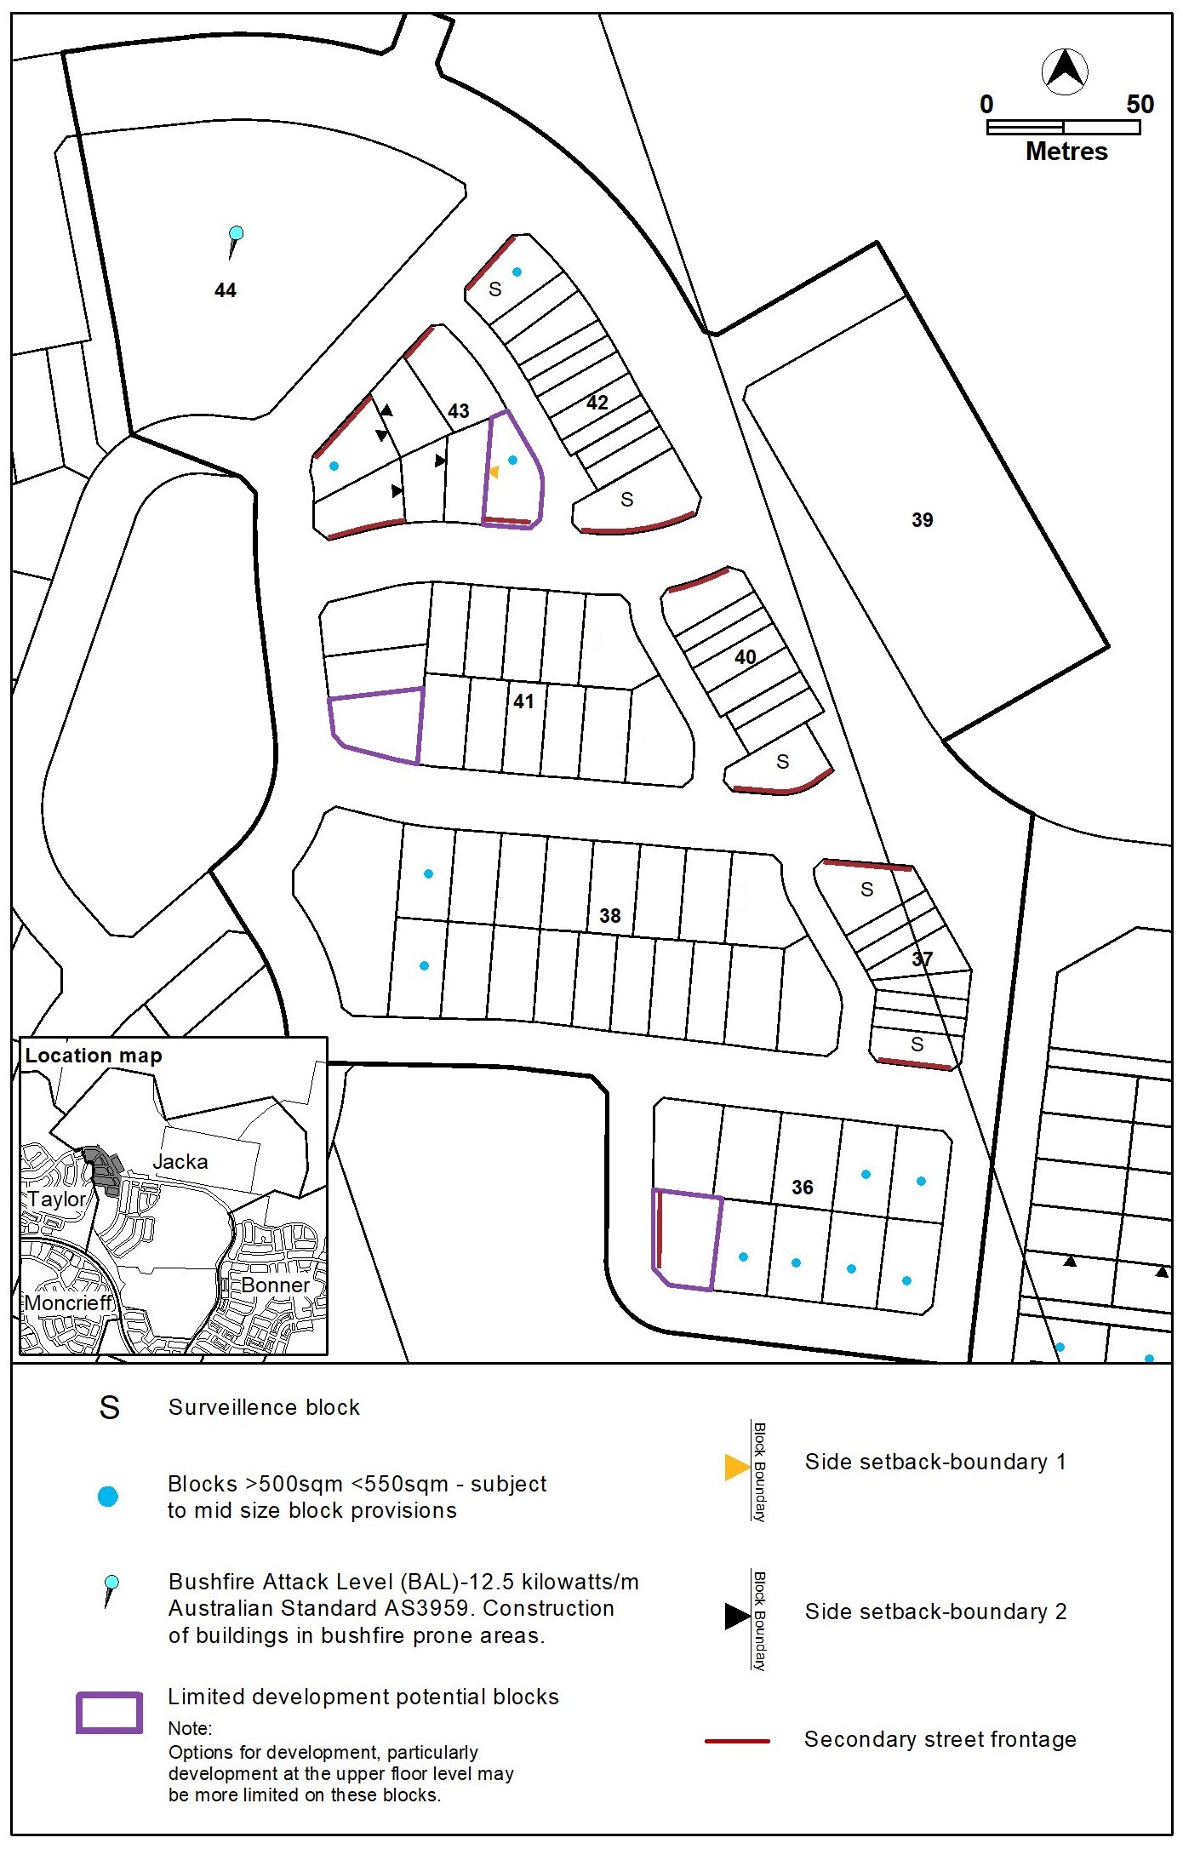
Figure 10 – Jacka development requirements

TAYLOR

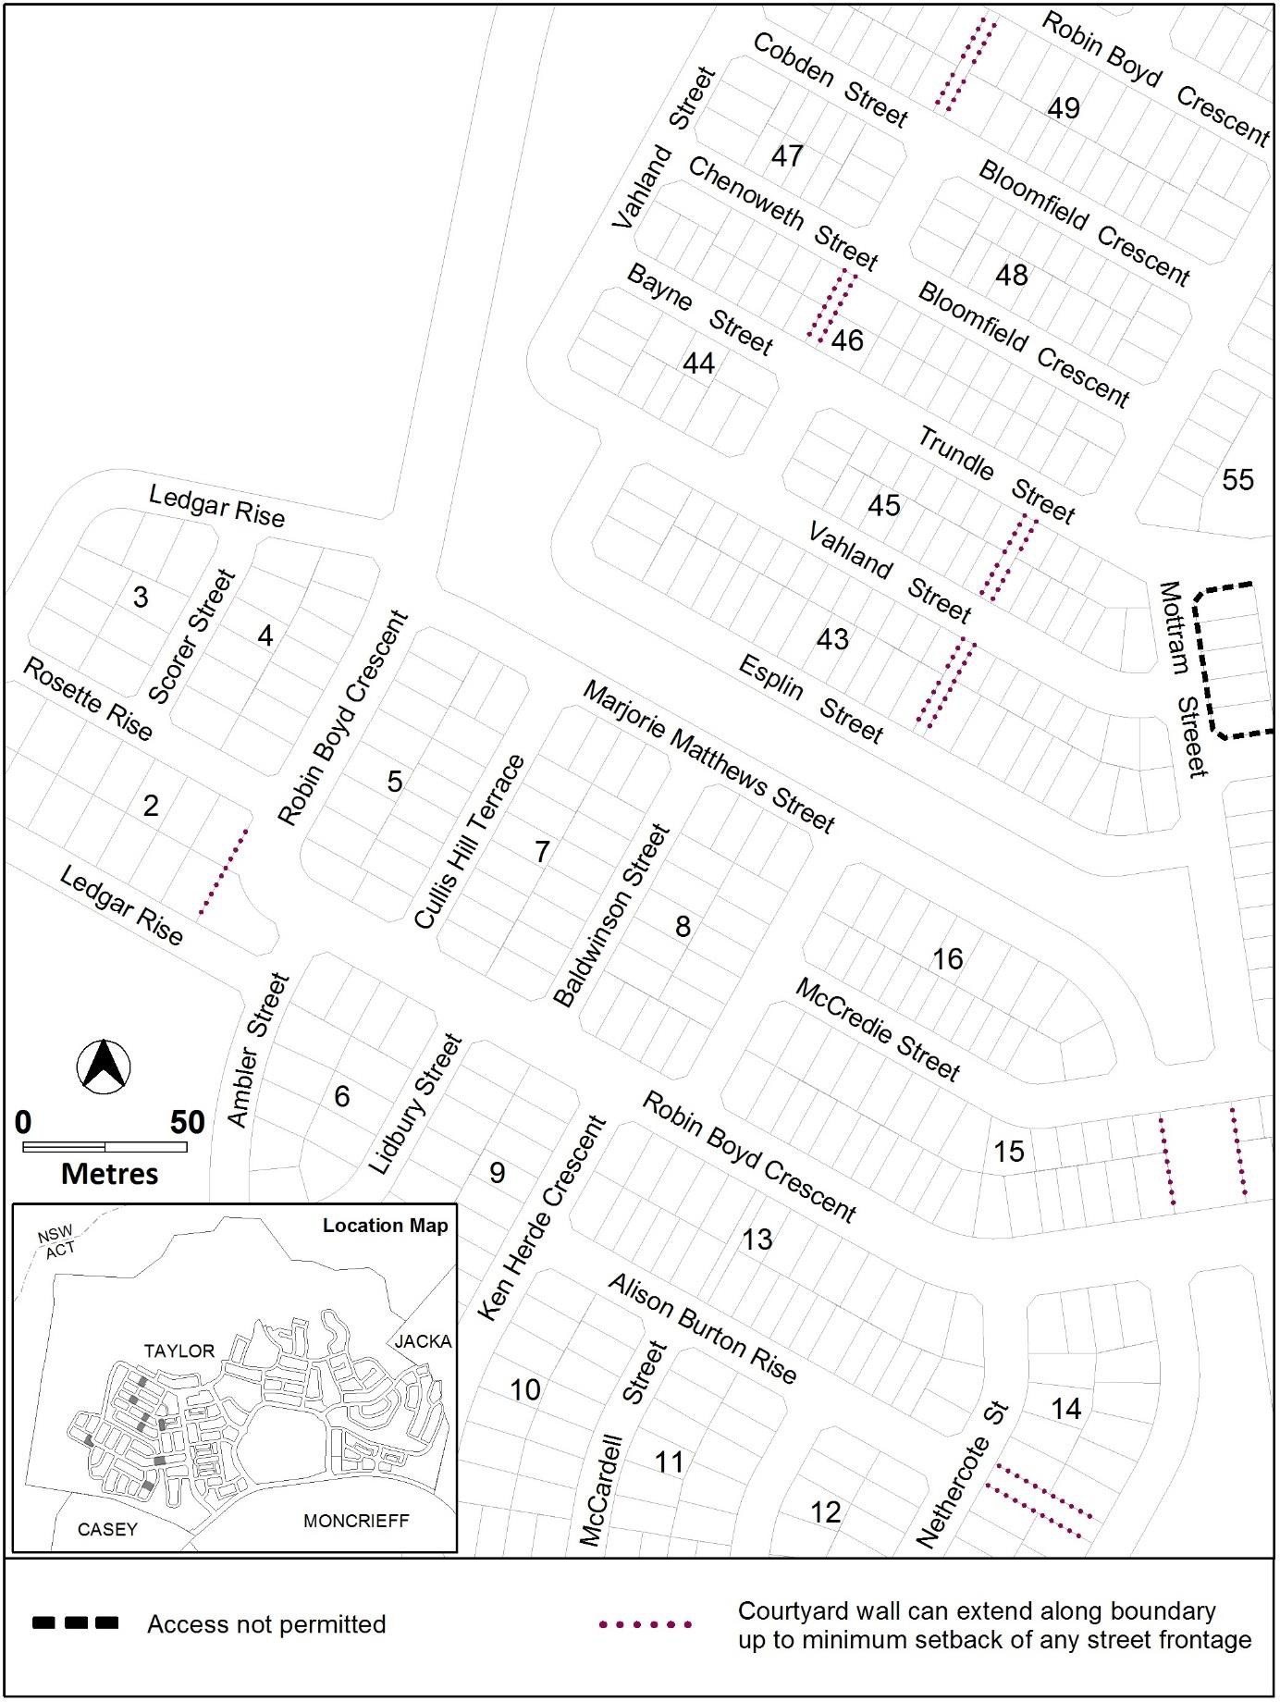
Figure 11 – Taylor development requirements

Figure 12 – Taylor development requirements
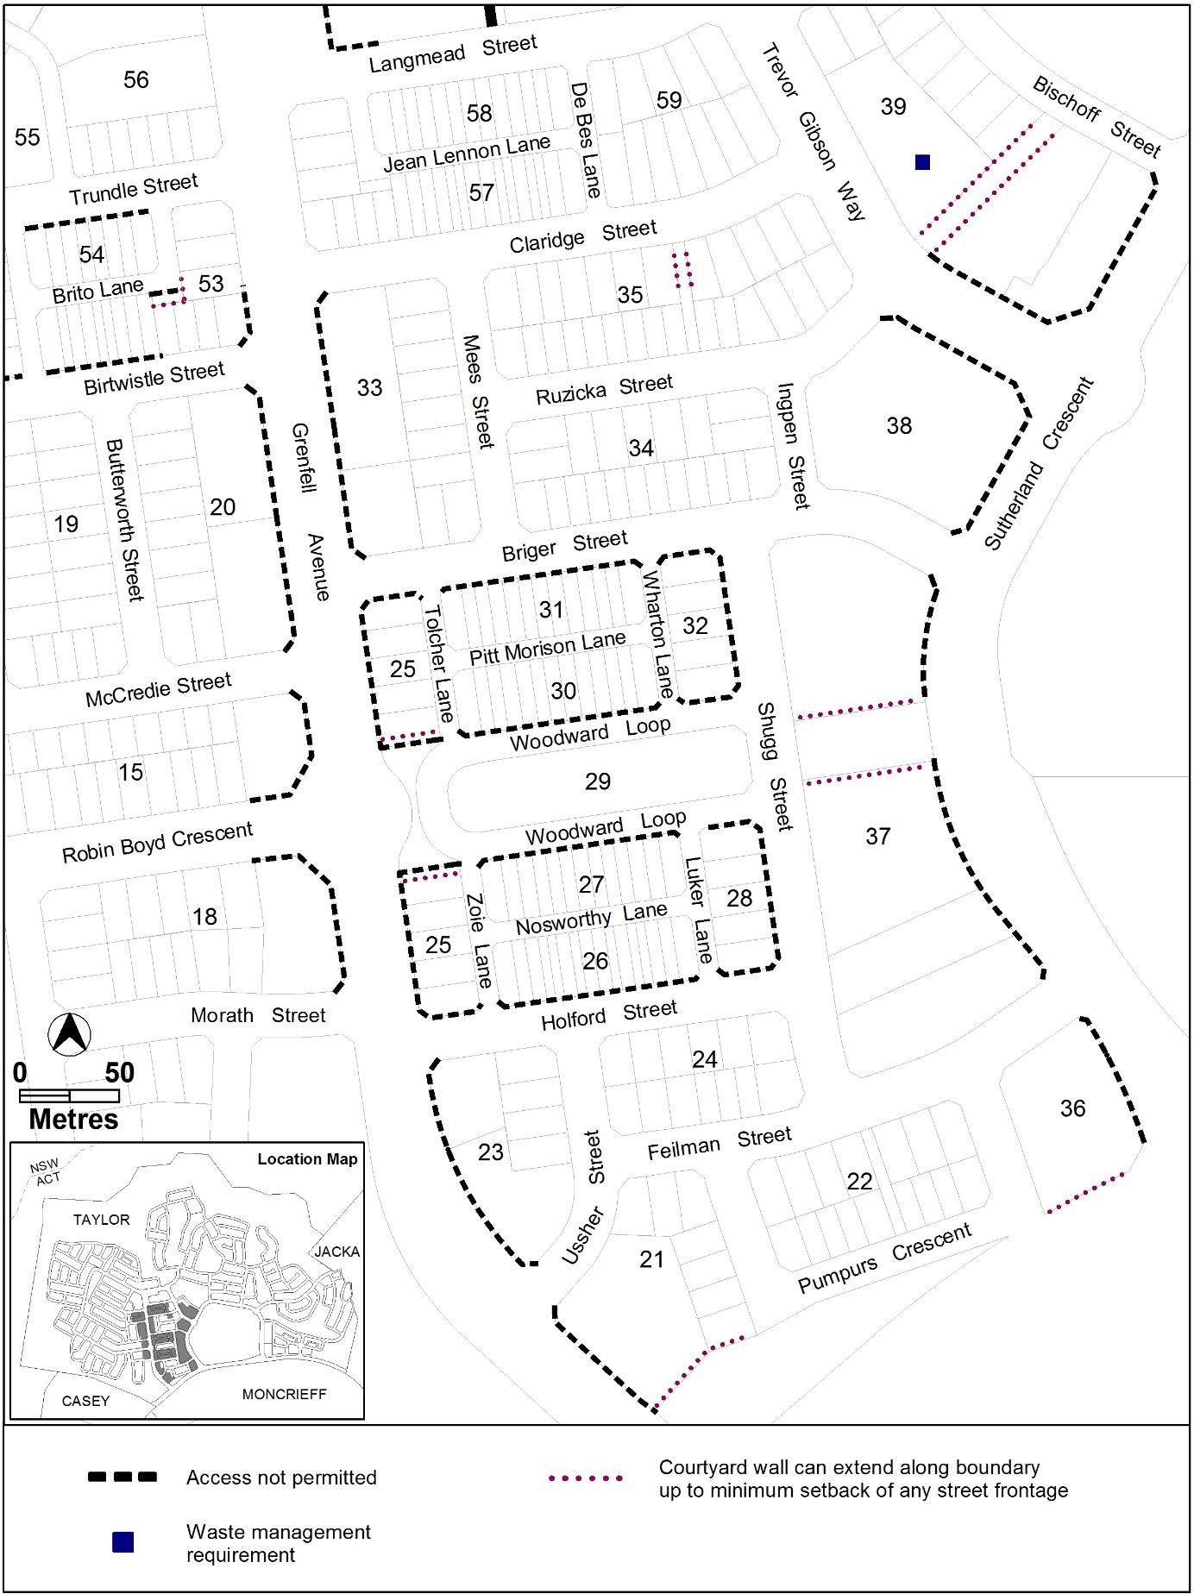

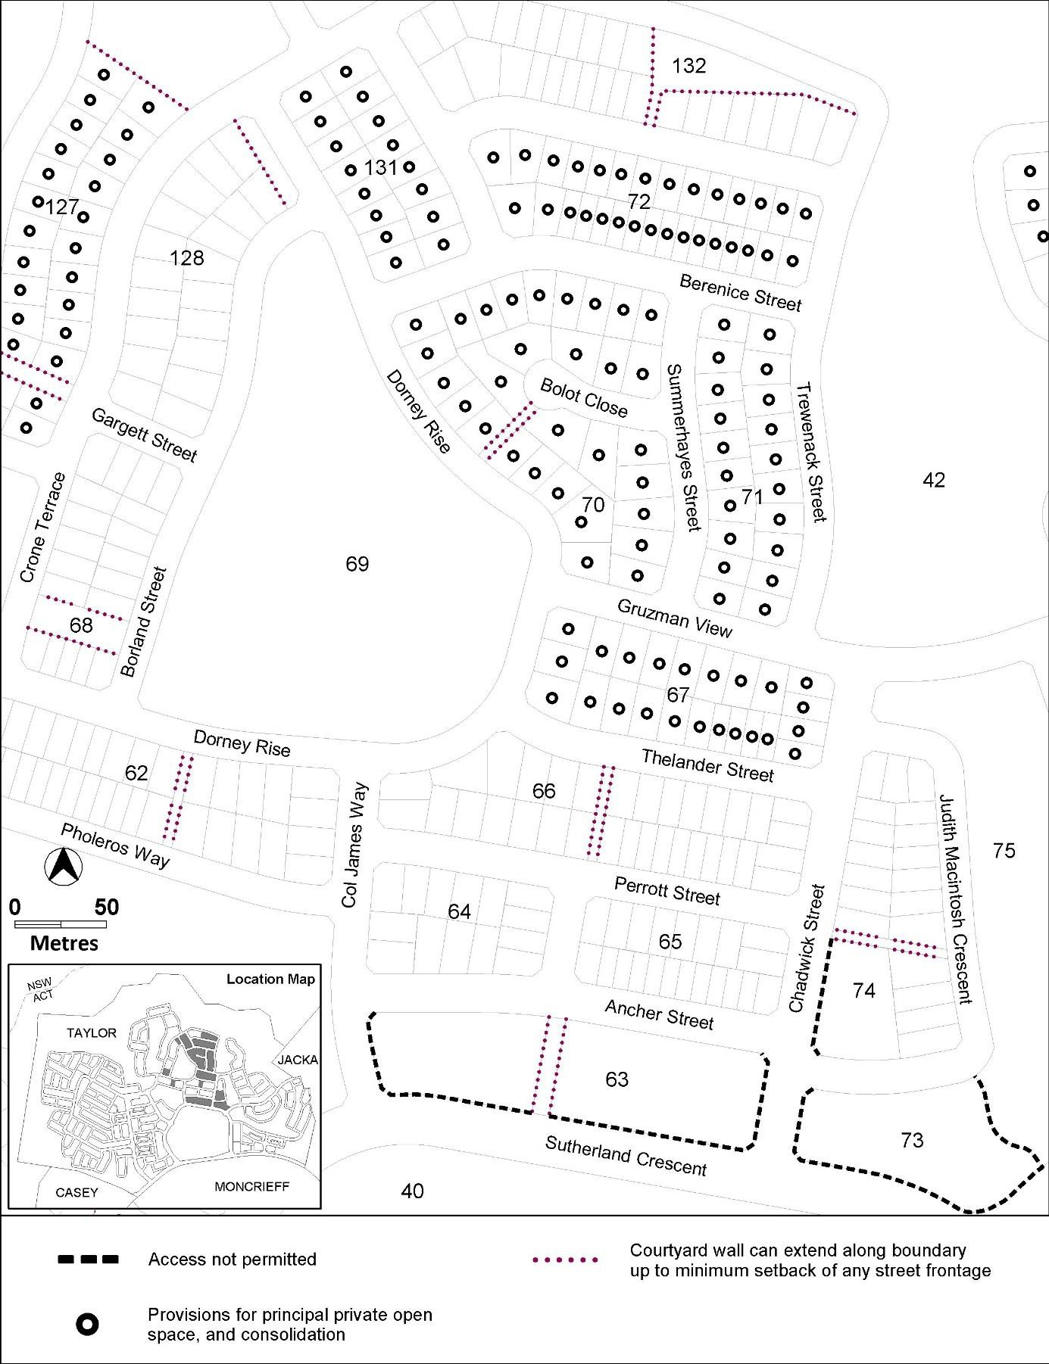
Figure 13 – Taylor development requirements

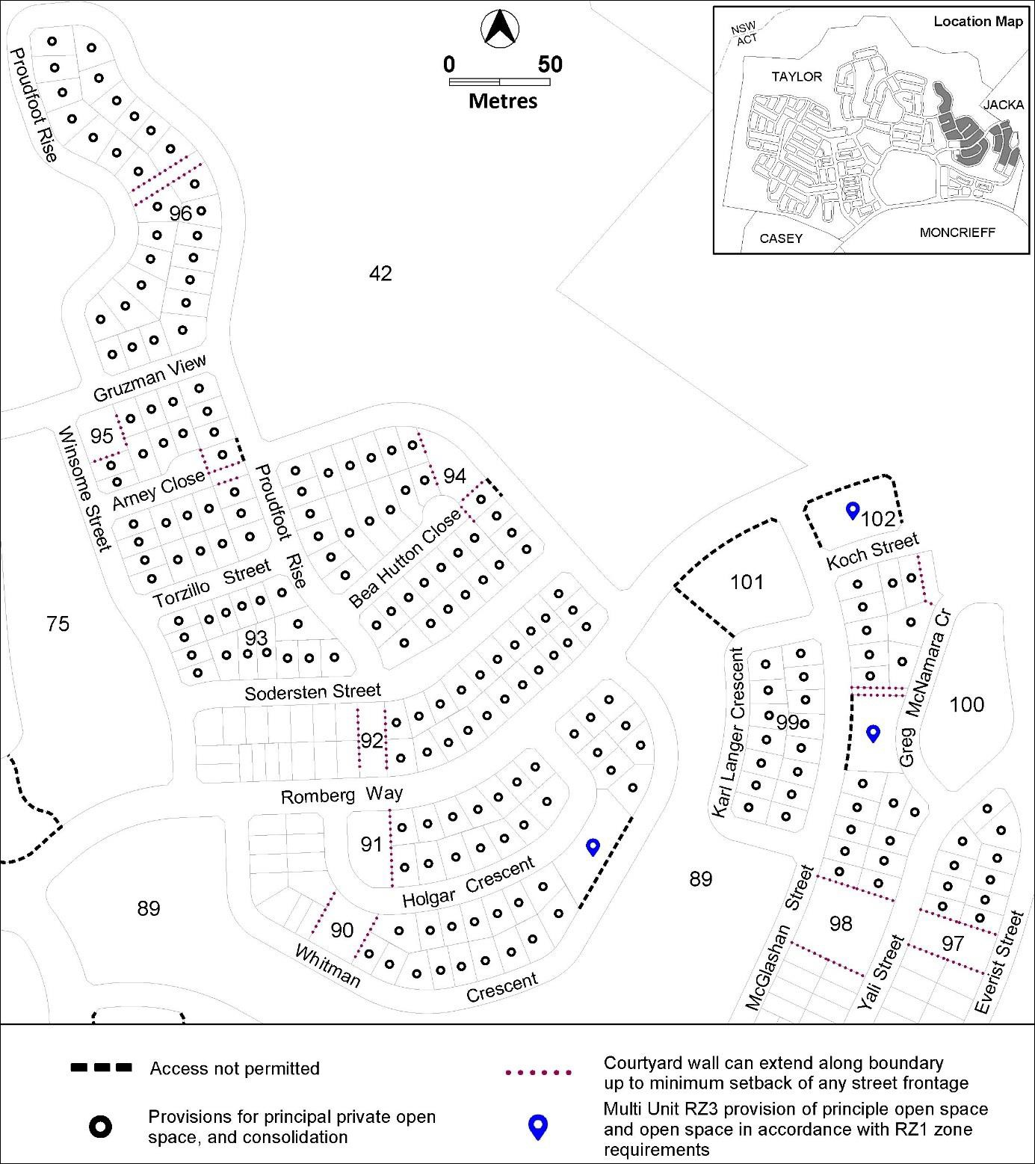
Figure 14 – Taylor development requirements

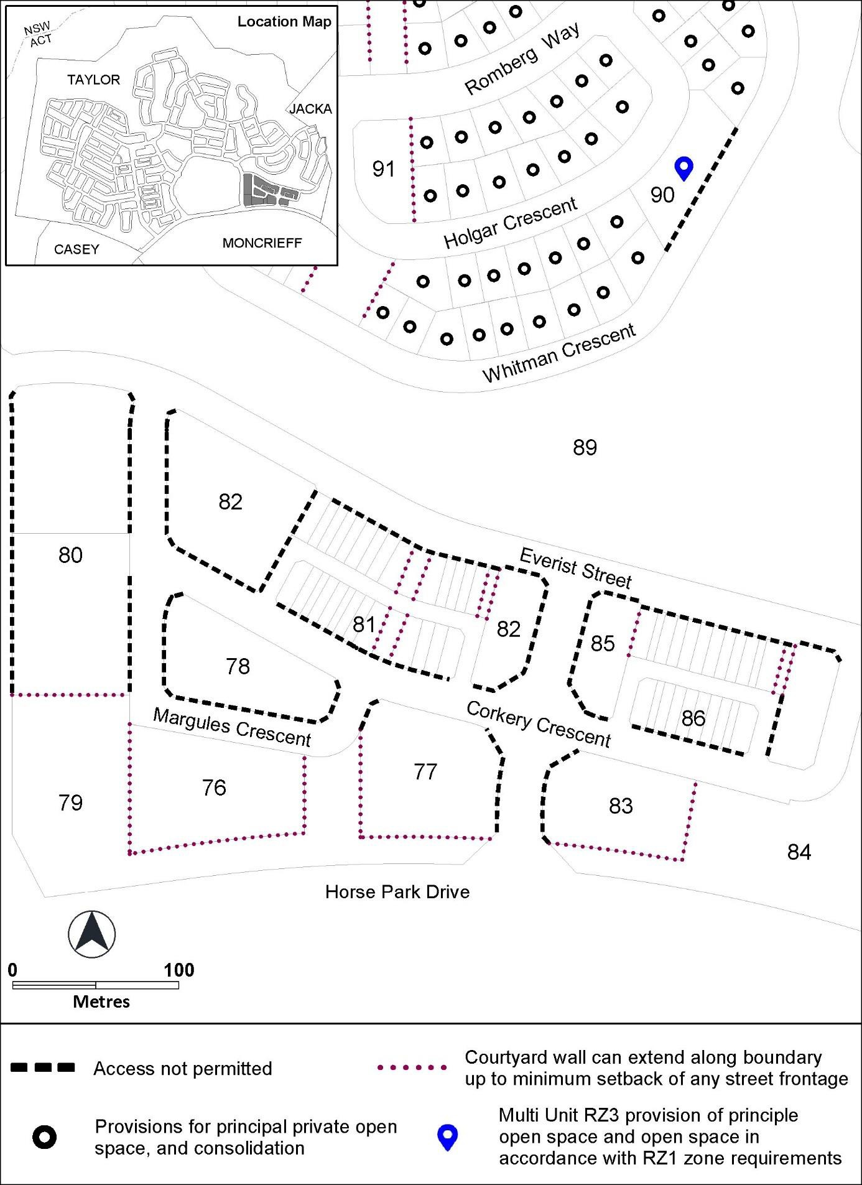
Figure 15 – Taylor development requirements

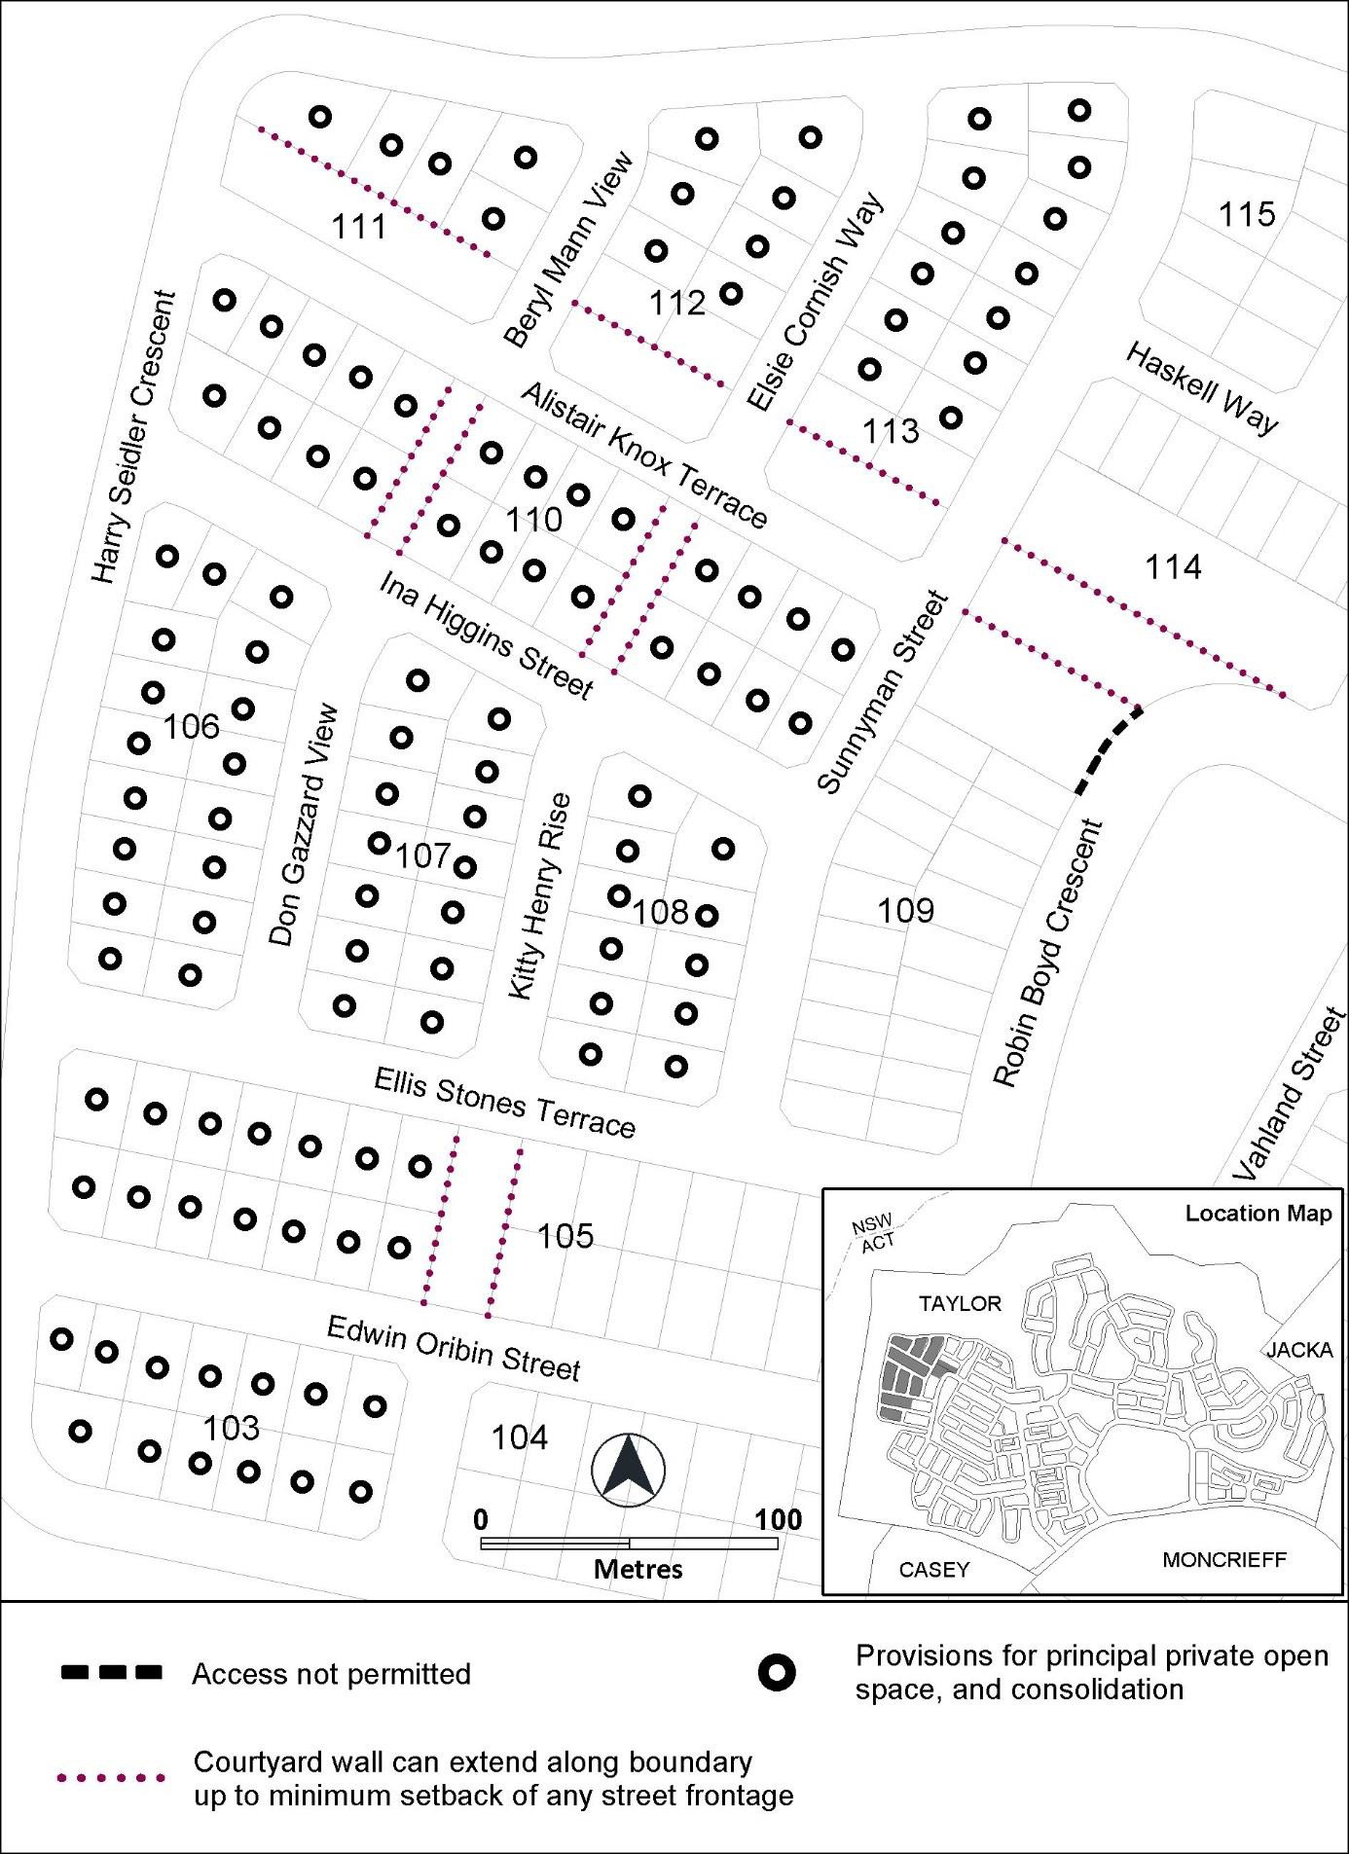
Figure 16 – Taylor development requirements

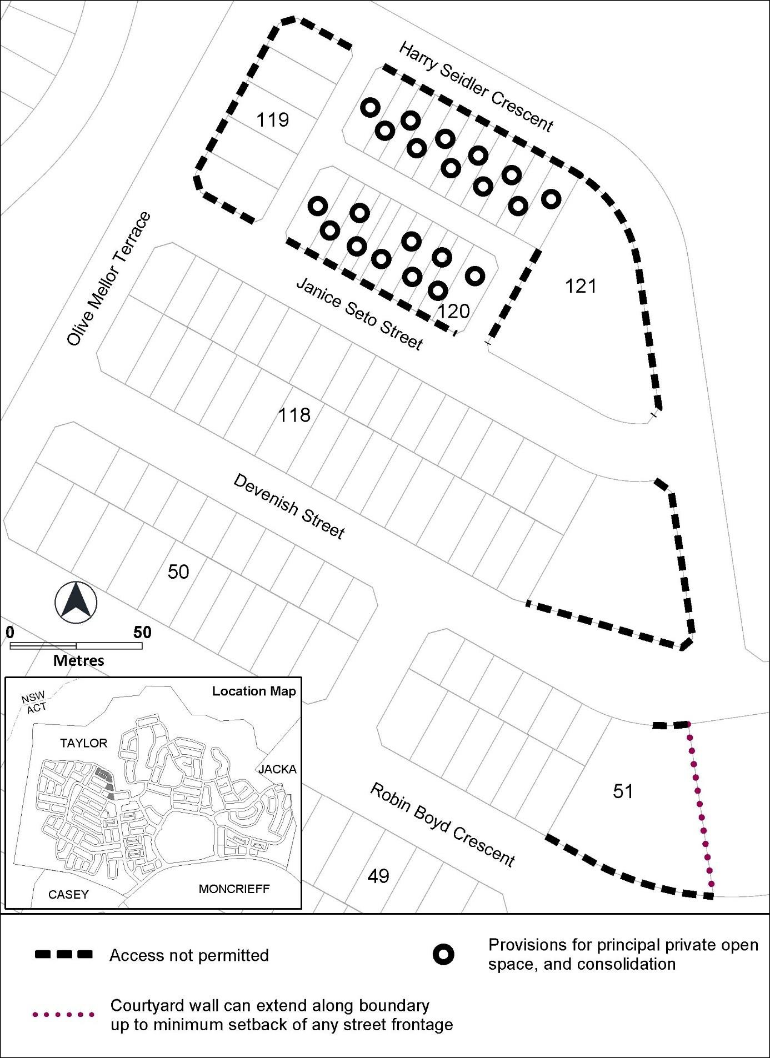
Figure 17 – Taylor development requirements

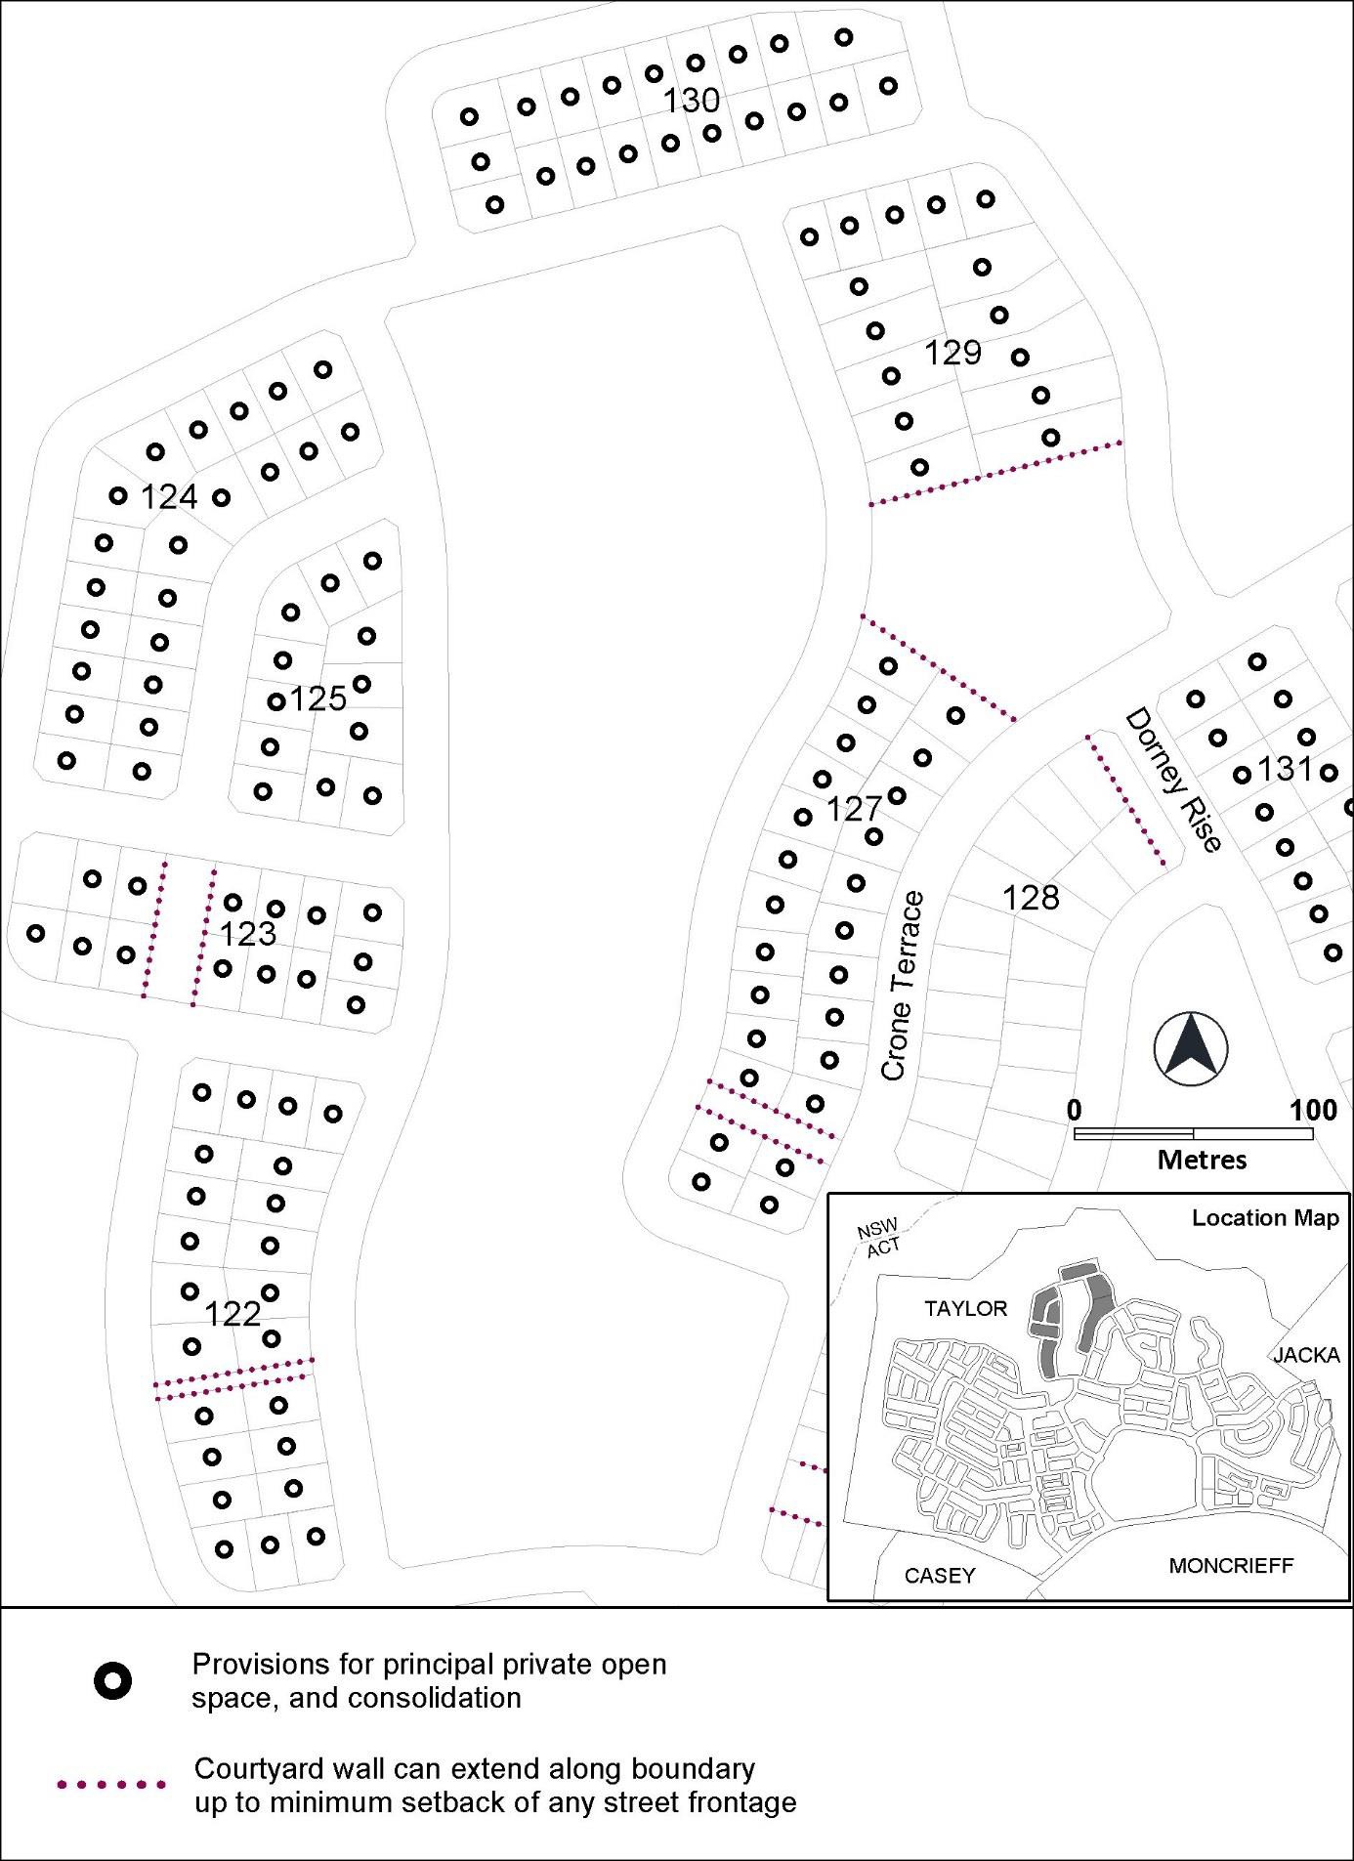
Figure 18 – Taylor development requirements

Figure 19 – Taylor development requirements
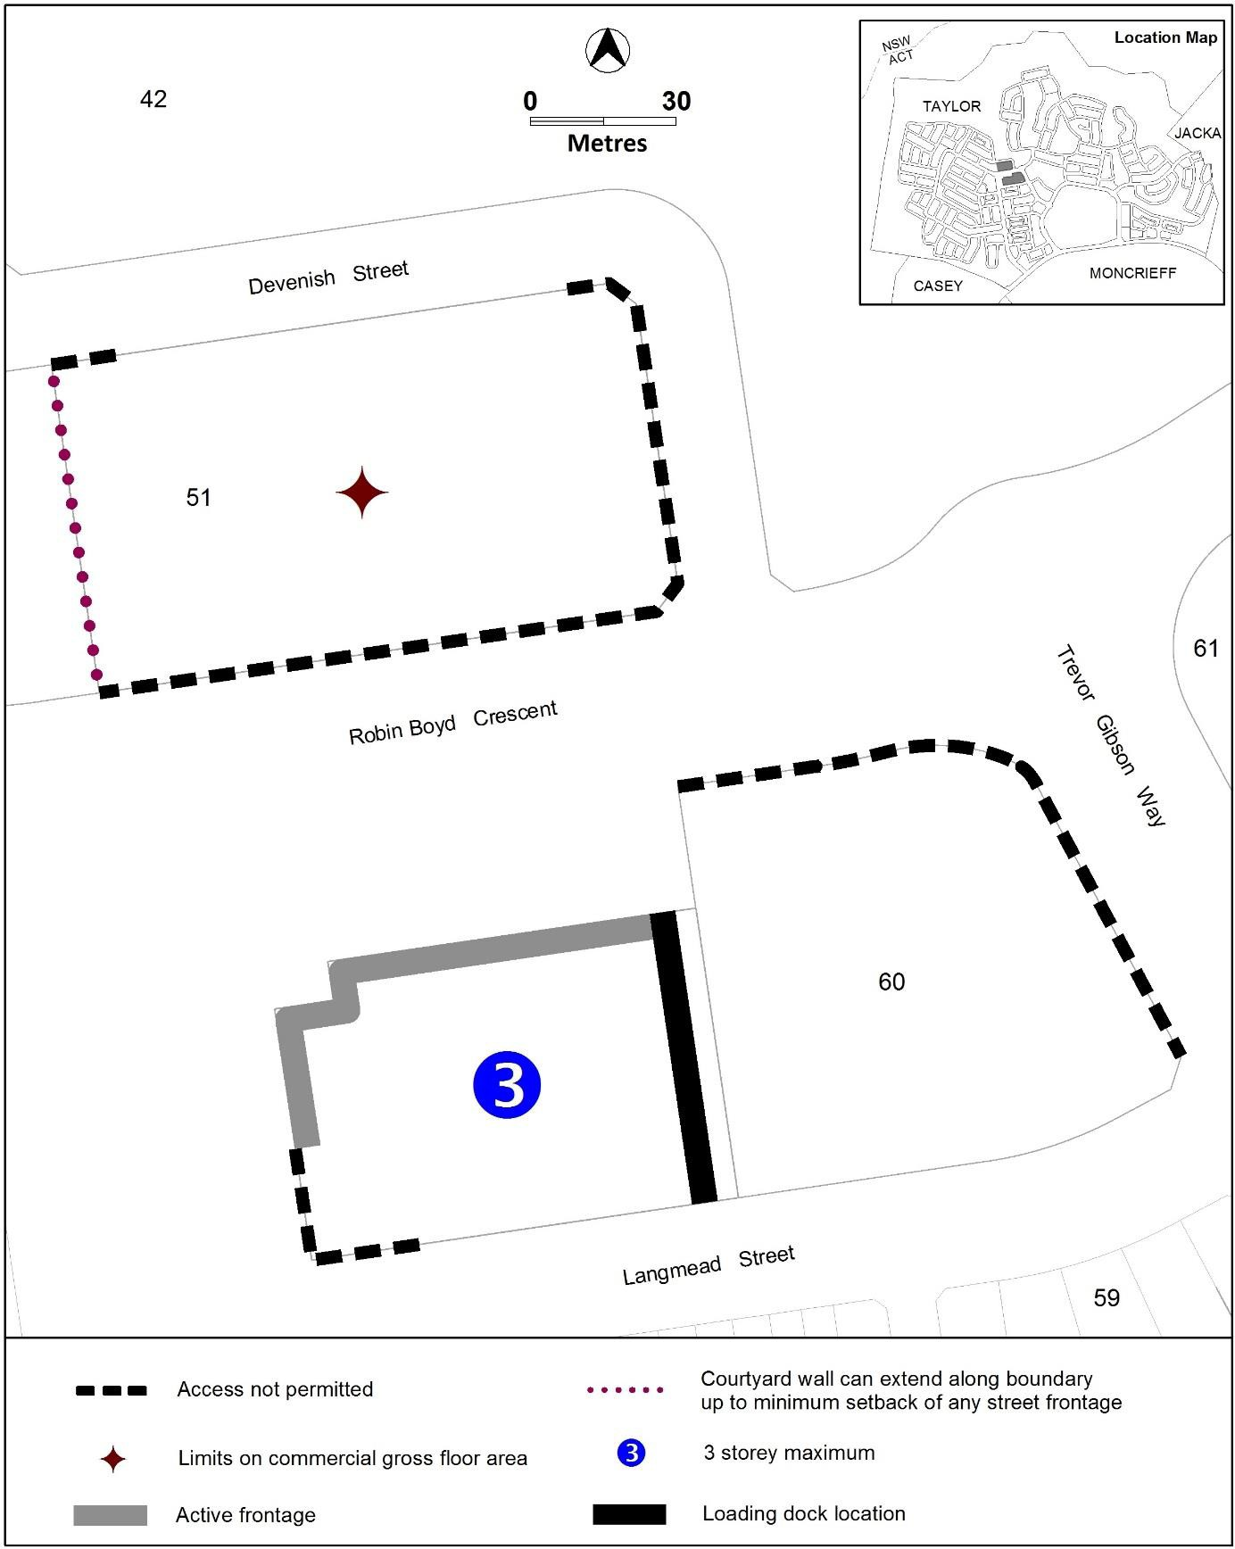

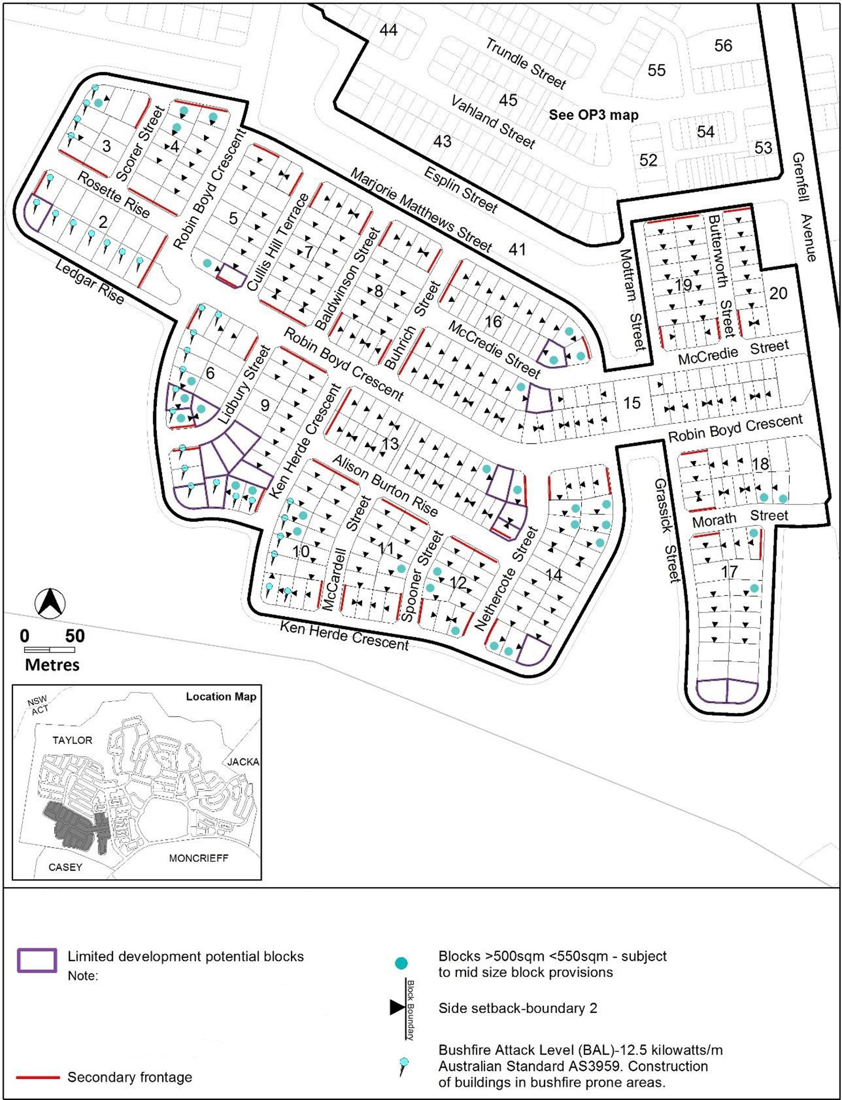
Figure 20 – Taylor development requirements
Options for development, particularly development at the upper floor level, may be more limited on these blocks.

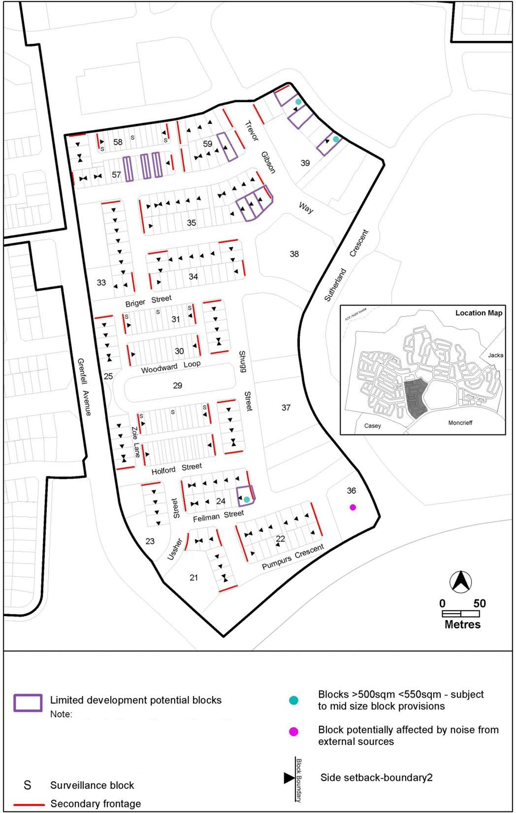
Figure 21 – Taylor development requirements
Options for development particularly, development at the upper floor level, may be more limited on these blocks.

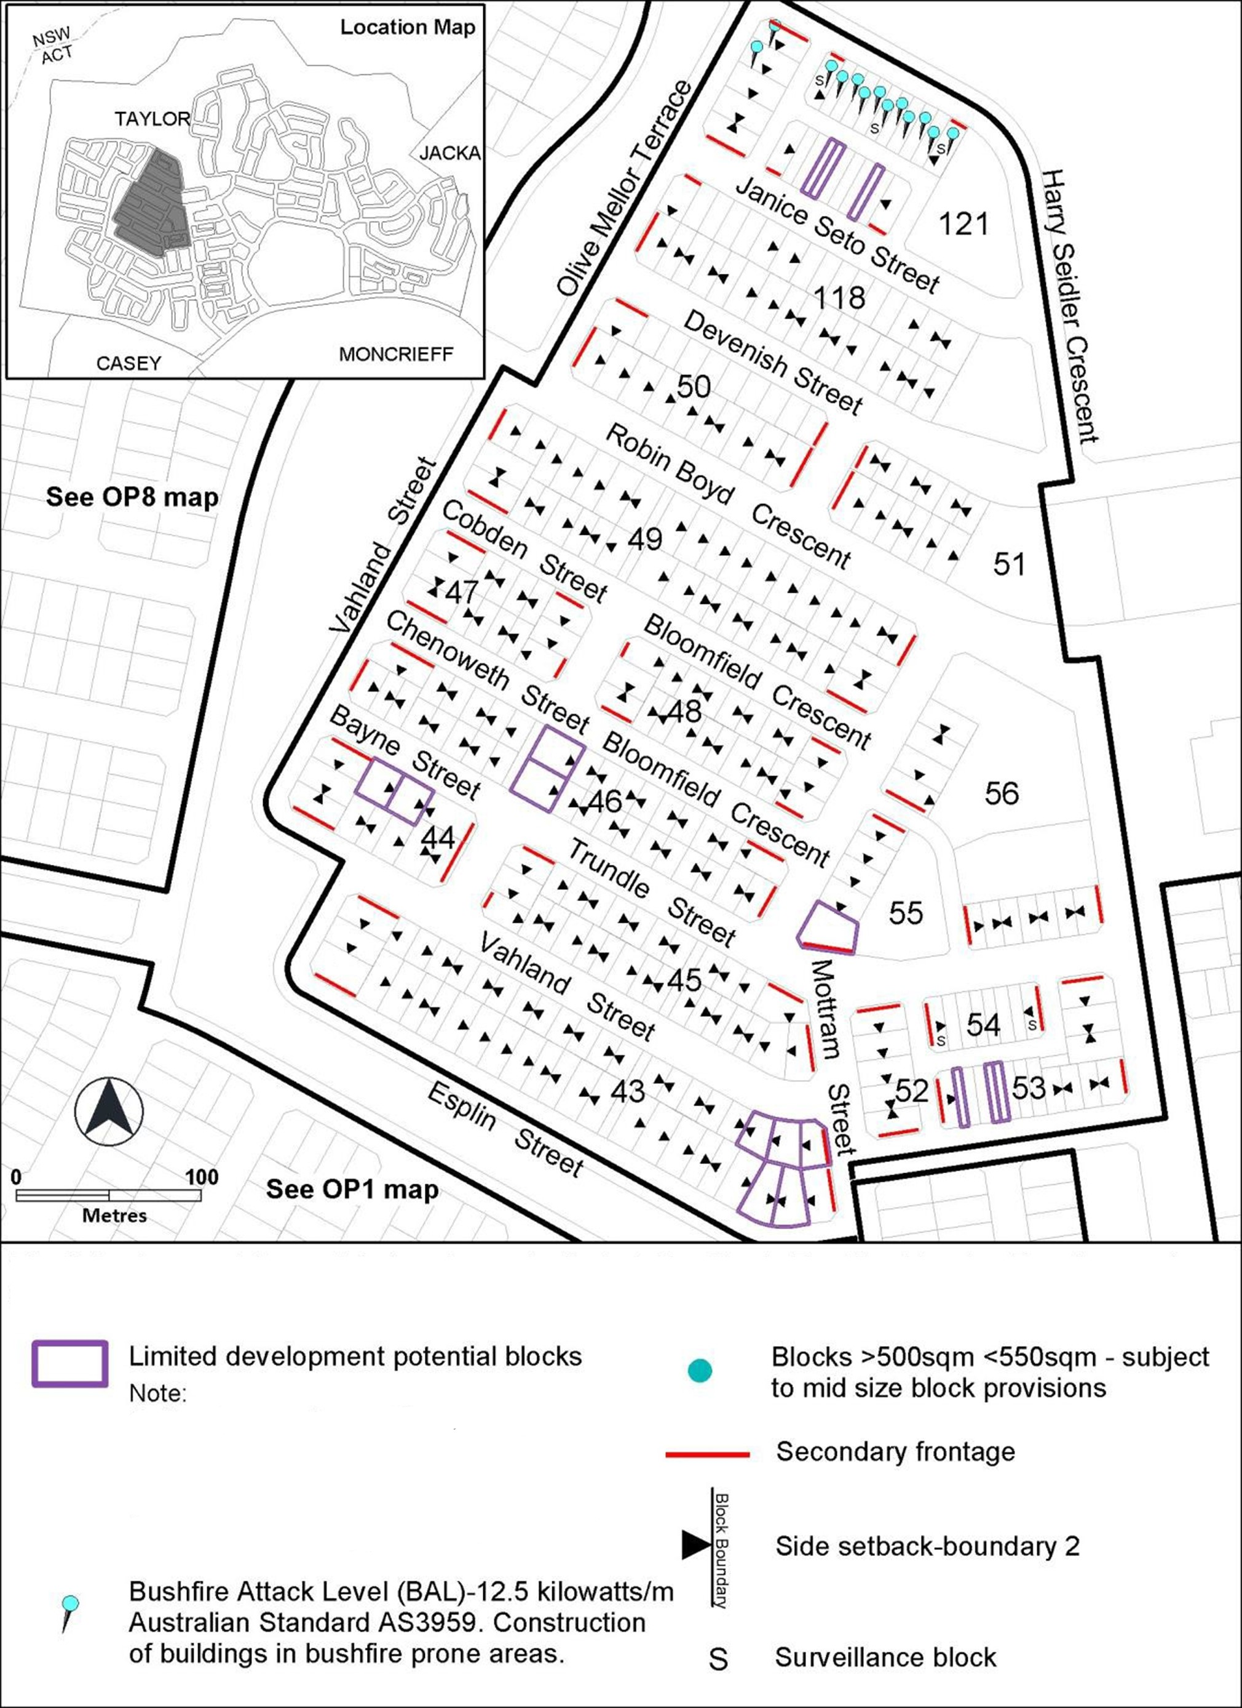
Figure 22 – Taylor development requirements
Options for development, particularly development at the upper floor level, may be more limited on these blocks.

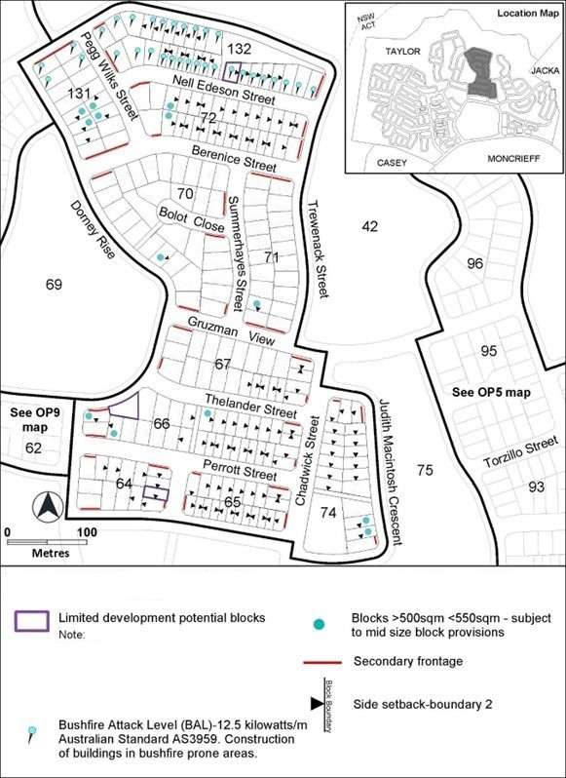
Figure 23 – Taylor development requirements
Options for development, particularly development at the upper floor level, may be more limited on these blocks.

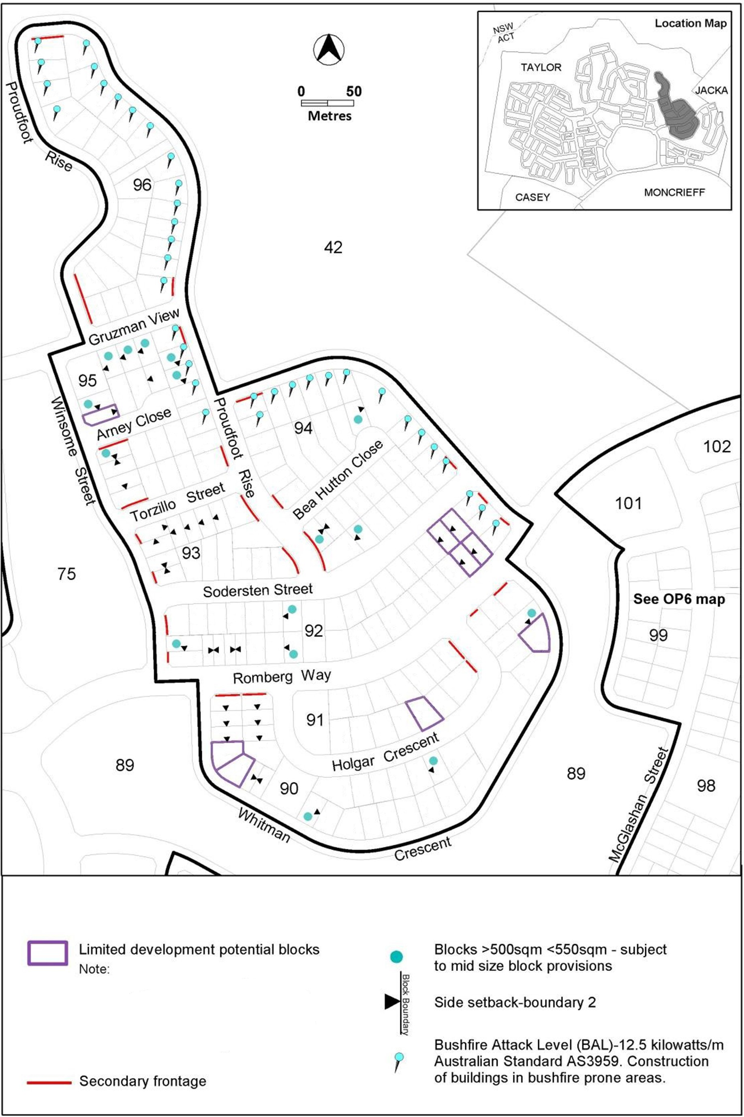
Figure 24 – Taylor development requirements
Options for development, particularly development at the upper floor level, may be more limited on these blocks.

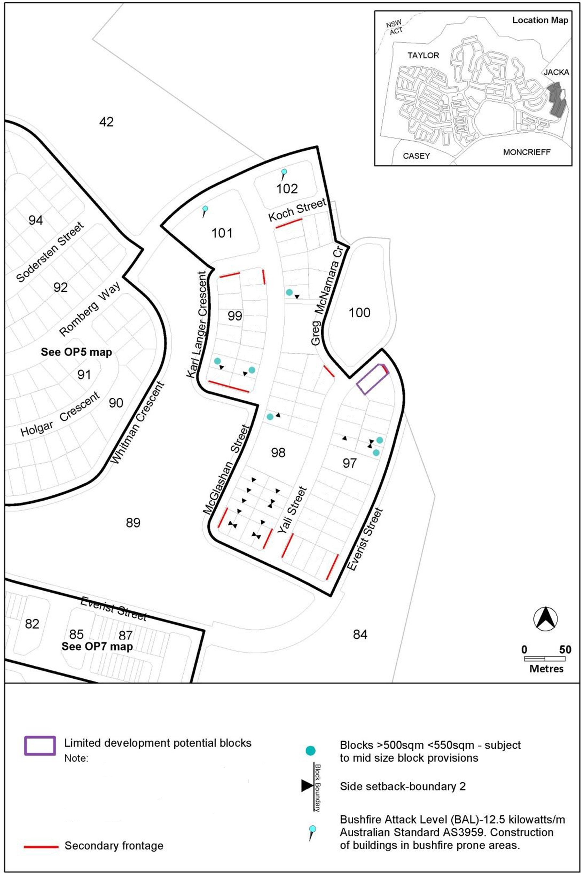
Figure 25 – Taylor development requirements
Options for development, particularly development at the upper floor level, may be more limited on these blocks.

Figure 26 – Taylor development requirements
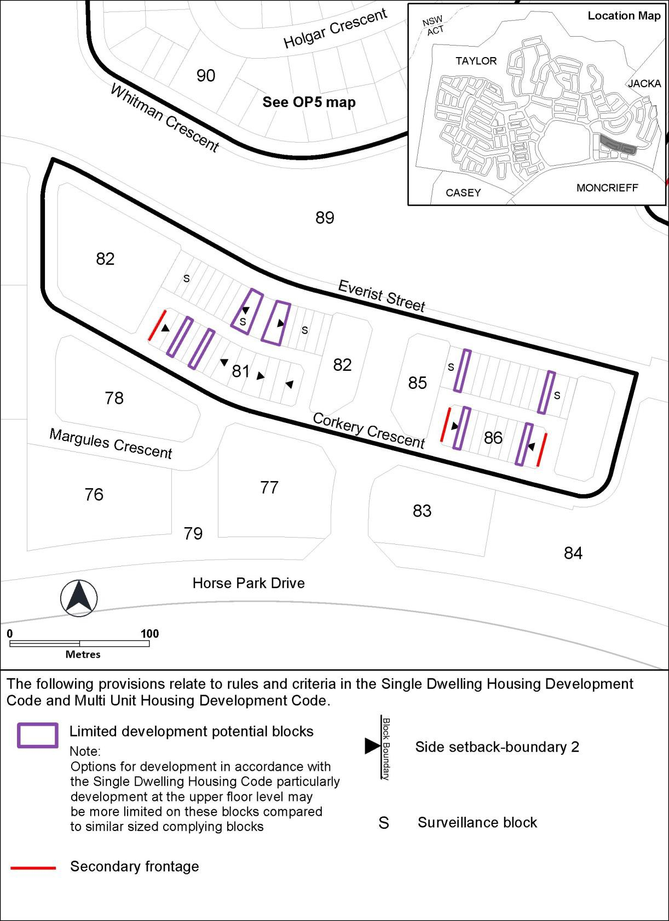
Options for development, particularly development at the upper floor level, may be more limited on these blocks.

Figure 27 – Taylor development requirements
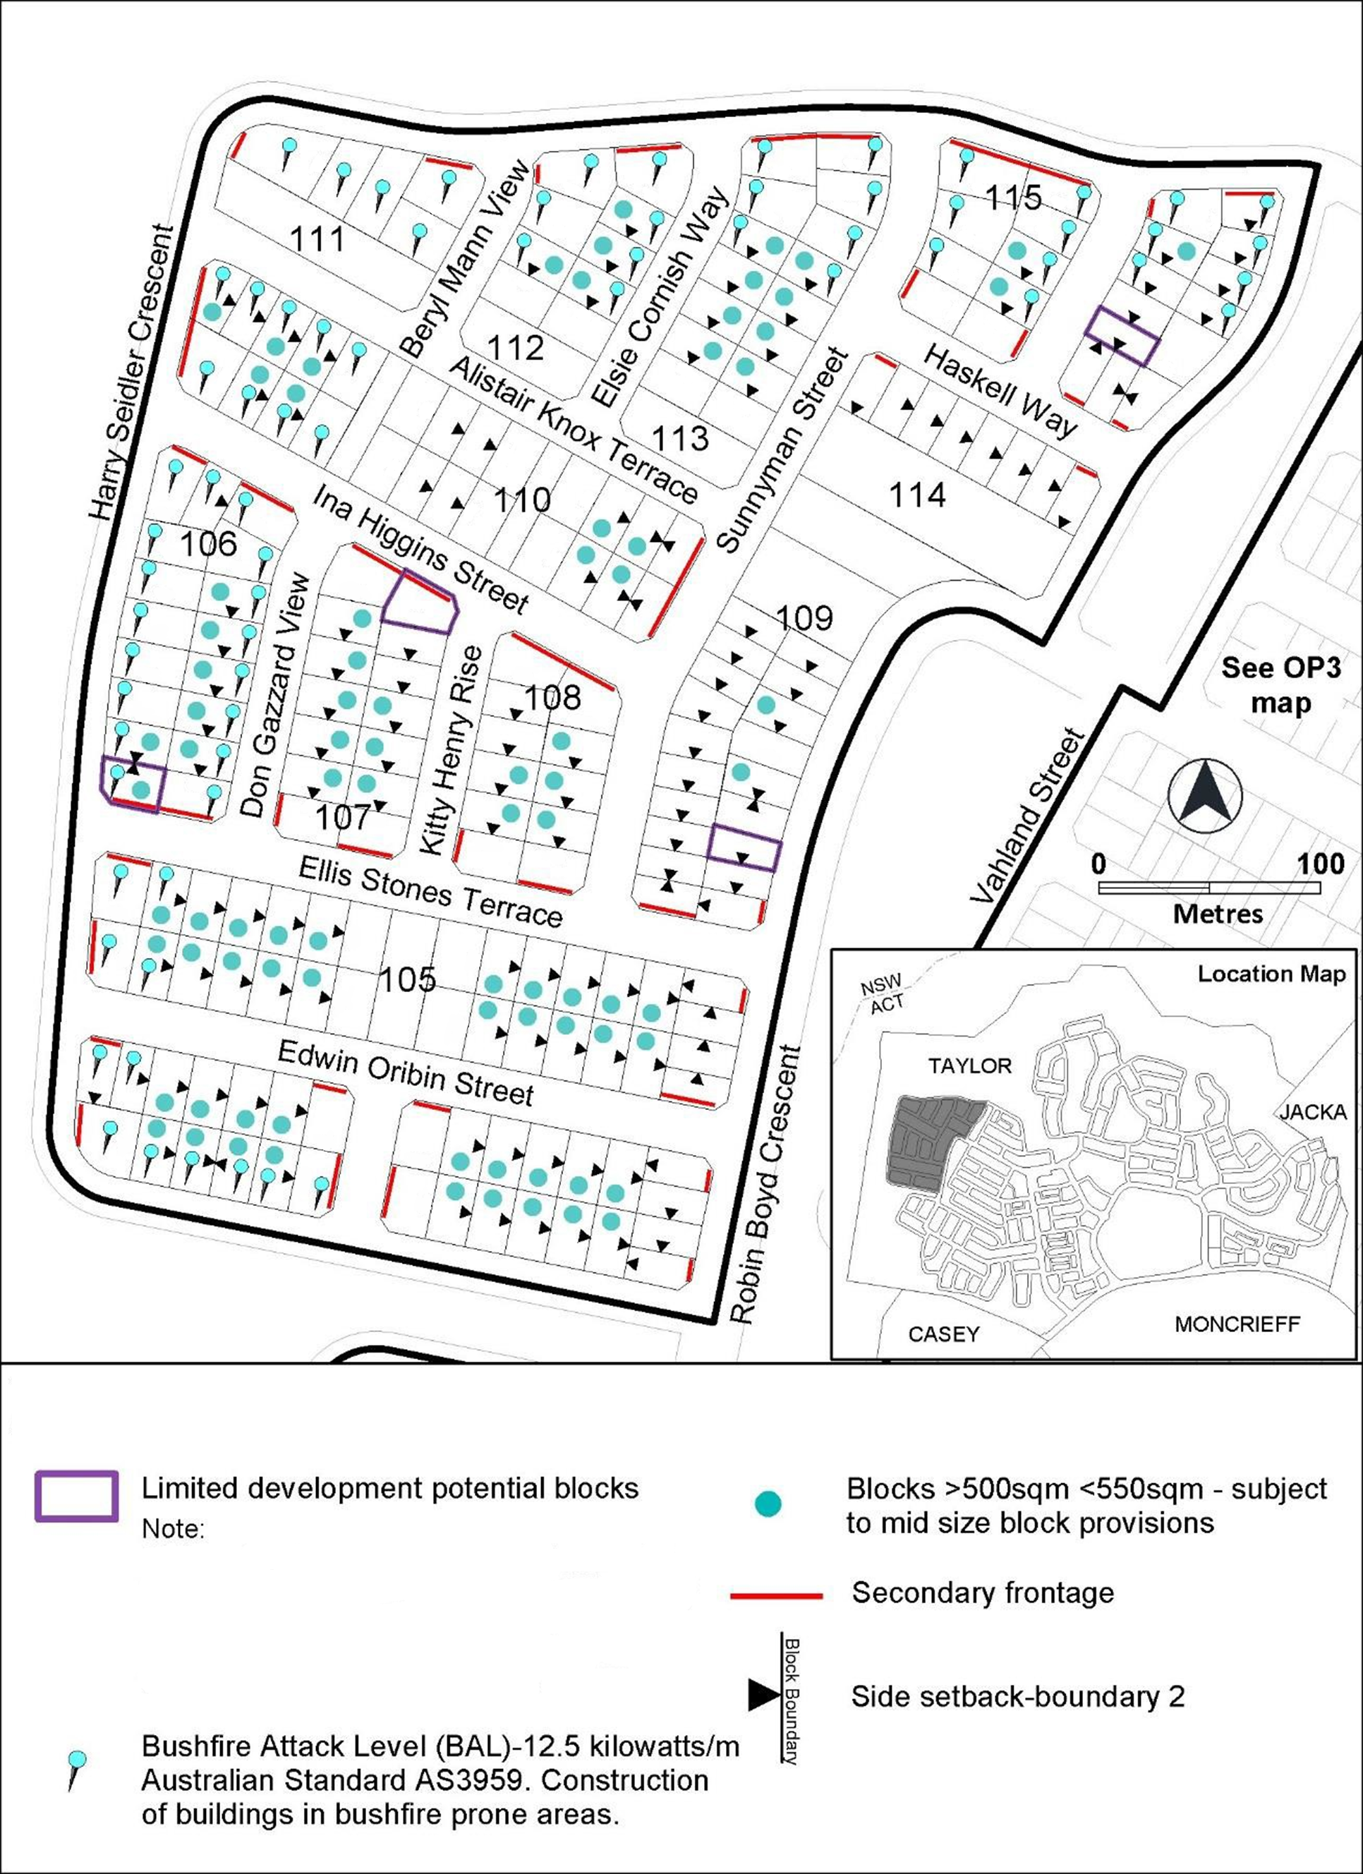
Options for development, particularly development at the upper floor level, may be more limited on these blocks.

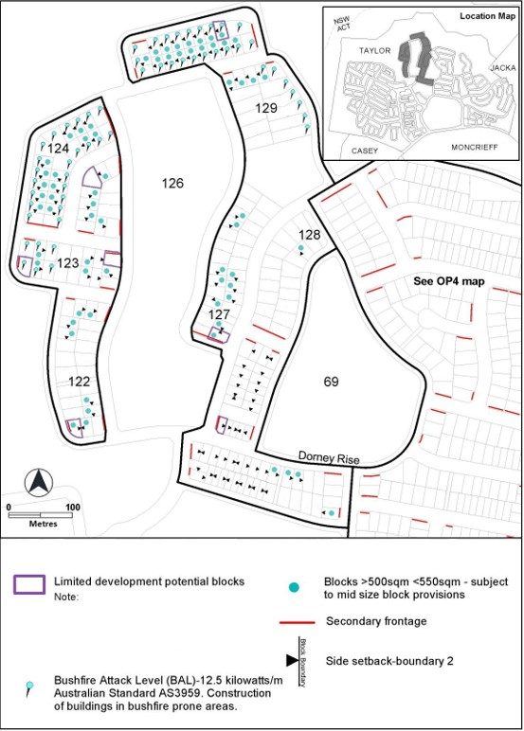
Figure 28 – Taylor development requirements
Options for development, particularly development at the upper floor level, may be more limited on these blocks.

