Australian Capital Territory

Planning (Miscellaneous) Minor Plan Amendment 2024 (No 3)

##### Notifiable instrument NI2024-635

made under the

Planning Act 2023, s 85 (Making minor plan amendments)

**1 Name of instrument**

This instrument is the *Planning (Miscellaneous) Minor Plan Amendment 2024 (No 3)*.

**2 Commencement**

This instrument commences on the day after notification.

**3 Minor plan amendment**

I am satisfied under the *Planning Act 2023*, section 85 (1) (a) that Minor Plan Amendment 2024-05 is a minor plan amendment to the Territory Plan.

**4 Dictionary**

In this section:

***Minor Plan Amendment 2024-05*** means the minor plan amendment to the Territory Planin schedule 1.

Freya O’Brien

Delegate of the territory planning authority

04 November 2024

**Schedule 1**



MINOR PLAN AMENDMENT TO THE TERRITORY PLAN

2024–05

Miscellaneous amendments to various policies and Dictionary definition

This minor plan amendment was prepared

under part 5.3 of the *Planning Act 2023*

Contents

1.0 INTRODUCTION 1

1.1 Outline of the process 1

1.2 Summary of the amendments 1

2.0 Territory Plan changes 2

2.1 Gungahlin District Policy 2

2.2 Belconnen District Policy 2

2.3 Inner North and City District Policy 3

2.4 Inner South District Policy 3

2.5 Woden District Policy 3

2.6 Non-Urban Zones Policy 3

2.7 Dictionary definition 3

3.0 TERRITORY PLAN AMENDMENT INSTRUCTIONS 5

3.1 Part D: D01 – Gungahlin District Policy 5

3.2 Part D: D02 – Belconnen District Policy 5

3.3 Part D: D03 – Inner North and City District Policy 5

3.4 Part D: DO4 – Inner South District Policy 6

3.5 Part D: D07 – Woden District Policy 6

3.6 Part E: E7 – Non-Urban Zones Policy 7

3.7 Part G: Dictionary 7

INTERPRETATION SERVICE 8

1. INTRODUCTION
   1. Outline of the process

Minor plan amendment 2024-05 (MA 2024-05) to the Territory Plan is a minor plan amendment (MA) prepared under section 84 (1) (a) and section 84 (1) (f) of the *Planning Act 2023* (the Act).

Section 84 of the Act outlines the different types of MAs, some which require limited consultation to be undertaken and some which do not require consultation. This MA is consistent with the provisions under section 84 (1) (a) and section 84 (1) (f) of the Act and therefore no consultation is needed.

Under Section 85 of the Act this type of MA can only be made if the MA is not inconsistent with the planning strategy or any relevant district strategy

The MA is not inconsistent with the Planning Strategy and the relevant district strategies.

The National Capital Authority has received a copy of this MA.

For more information on the content of the Territory Plan and minor plan amendment processes please refer to the planning website: [www.planning.act.gov.au/professionals/our-planning-system/the-territory-plan/amendments-to-the-territory-plan](http://www.planning.act.gov.au/professionals/our-planning-system/the-territory-plan/amendments-to-the-territory-plan)

* 1. Summary of the amendments

This MA makes the following changes:

Gungahlin District Policy:

* Rectification of an error that incorrectly prohibited subdivision on certain RZ3 zoned blocks in Taylor.

Belconnen District Policy

* Removes redundant references to the ‘2.45km’ Lower Molonglo Water Quality Control Centre Clearance Zone, which was updated as part of Minor Amendment 2024-h.

Inner North and City District Policy

* Replaces an incorrect version of Figure 18 with the correct figure.

Inner South District Policy

* Removes an incorrect reference that listed ‘service station’ as both an additional permitted and prohibited use on a parcel of land in the IZ2 Zone in Fyshwick.

Woden District Policy

* Corrects typographical errors of ‘Callum’ to ‘Callam’.

Non-Urban District Policy

* Corrects outdated references to ‘transport depot’ opposed to ‘transport facility’.

Dictionary

* Corrects the definition of ‘standard block’ which inadvertently reverted to a previous version.

The changes are detailed in Section 2 of this document and are made under sections 84 (1) (a) and 84 (1) (f) of the Act.

Section 3 contains the instructions for the actual changes to be made to the Territory Plan.

1. Territory Plan changes

This section contains details of the proposed changes to be made to the Territory Plan.

* 1. Gungahlin District Policy

The Gungahlin District Policy land use table contains a restriction on subdivision for certain blocks and sections in the RZ3 Zone for Taylor.

Some blocks were inadvertently included or excluded from the land use table when translated from the Territory Plan 2008 to the Territory Plan 2023. This minor amendment rectifies this issue.

* 1. Belconnen District Policy

The reference to ‘2.45km’ is being removed from Assessment Requirement 91 relating to the Lower Molonglo Water Quality Control Centre Clearance Zone as it is redundant.

The clearance zone boundary was reduced to 2.1km through minor amendment MA2024-h which commenced in June 2024. With this, the reference to a ‘2.45km buffer’ is now redundant.

* 1. Inner North and City District Policy

A redundant version of figure 18 that displays Dickson public car parking areas was inadvertently included with the final Territory Plan, which commenced on 27 September 2024.

This minor amendment replaces figure 18 with the correct figure.

* 1. Inner South District Policy

The Inner South District Policy includes a land use table that outlines additional assessable and prohibited developments in certain areas. In this table, service station appears as an additional assessable use on a select parcel zoned IZ2 in Fyshwick.

As service station is already an assessable use in the IZ2 Zone in the Industrial Zones Policy, its reference as an additional permitted use is redundant. This minor amendment removes this redundant reference.

* 1. Woden District Policy

Assessment Requirements 29 and 34 of the Woden District Policy incorrectly references ‘Callum’ Street and ‘Callum’ Offices rather than ‘Callam’ Street and ‘Callam’ Offices.

This minor amendment rectifies this typographical error.

* 1. Non-Urban Zones Policy

When introducing the Territory Plan 2023, the previous land use of ‘transport depot’ was replaced with ‘transport facility’. However, the Non-Urban Zones Policy land use table still references the redundant term.

This minor amendment corrects this by replacing the references to ‘transport depot’ with ‘transport facility’.

* 1. Dictionary definition

The definition of ‘standard block’ was revised and incorporated into the Territory Plan 2023 via minor amendment MA2024-d in April 2024. In introducing the final Territory Plan 2023, which commenced on 27 September 2024, the old and redundant definition of standard block was inadvertently included.

This MA rectifies this issue by replacing the definition of ‘standard block’ in Part G Dictionary in the Territory Plan, with the correct version as introduced through MA2024-d.

1. TERRITORY PLAN AMENDMENT INSTRUCTIONS
   1. Part D: D01 – Gungahlin District Policy

Land Use Table – Taylor:

In ‘Relevant parcel or figure’ column ***substitute***:

Sections 67, 70, 71, 72, 90, 91, 92, 94, 95, 96, 97, 98 (excluding block 6), 99, 103, 105, 106, 107, 108, 110, 111, 112, 113, 120, 121 (excluding block 12), 122, 123, 124, 125, 127, 129, 130, 131

* 1. Part D: D02 – Belconnen District Policy

Assessment requirement 91:

***Omit***

2.45km

* 1. Part D: D03 – Inner North and City District Policy

Assessment Requirement 29:

***Substitute***

Development on existing car parks (Figure 14) retains or improves the existing level of car parking, accommodates onsite any additional car parking required by the development, ensures that car parking remains available for public access. However, alternative proposals may be considered where it is demonstrated there is enough car parking for the needs of the centre as a whole and the development does not adversely affect the overall function of the centre in terms of economic, social, traffic and parking and urban design impacts.

Figure 18 Dickson – Public car parking areas

***Substitute***

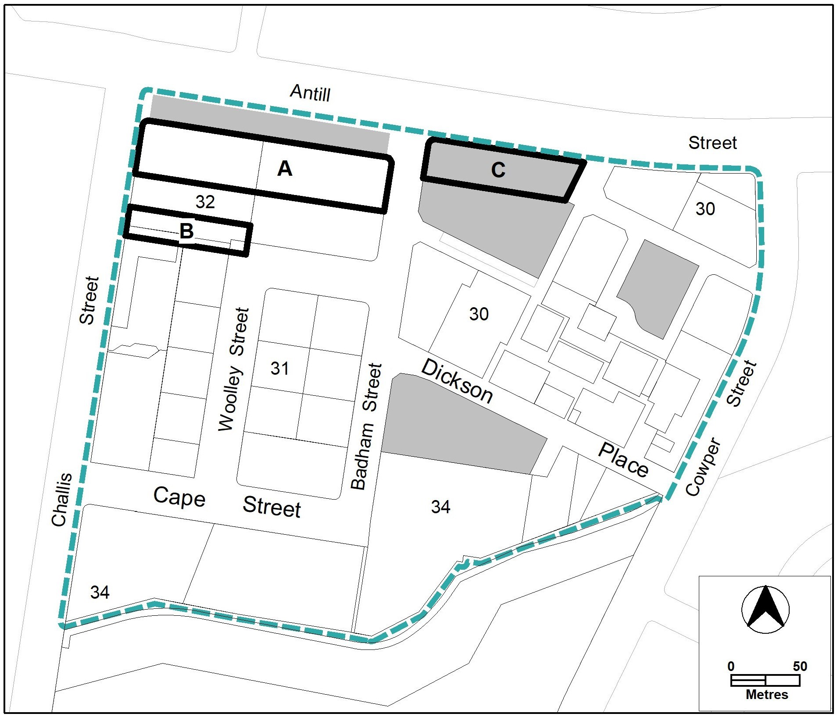

* 1. Part D: DO4 – Inner South District Policy

Land use table:

***Omit*** from Additional assessable development column relating to Fyshwick Locality IZ2 Zone

service station

* 1. Part D: D07 – Woden District Policy

Assessment Requirements:

***Omit***

Callum

***Replace with***

Callam

* 1. Part E: E7 – Non-Urban Zones Policy

Land Use Table:

***Substitute*** Transport depot with

Transport facility

* 1. Part G: Dictionary

Table 2 – terms and concept definitions: *standard block:*

***Substitute***

***standard block*** means a *block* with one of the following characteristics:

1. originally leased or used for the purpose of one or two *dwellings* except where the original *lease* explicitly permits two *dwellings*
2. created by a consolidation of *blocks*, at least one of which is covered by a)

INTERPRETATION SERVICE

To speak to someone in a language other than English please telephone the Telephone Interpreter Service (TIS) **13 14 50**

| LANGUAGE | DETAILS |
| --- | --- |
| English | If you need an interpreter please call: **13 14 50** |
| Mandarin (Simplified Chinese) / 简体中文 | 如果您需要翻译，请致电：**13 14 50** |
| Arabic / العربية | إذا كنت بحاجة إلى مترجم شفهي اتصل بالرقم: **50 14 13** |
| Cantonese (Traditional Chinese) / 繁體中文 | 如果你需要傳譯員，請致電：**13 14 50** |
| Vietnamese /  Tiếng Việt | Nếu bạn cần thông dịch viên, xin gọi: **13 14 50** |
| Korean / 한국어 | 통역사가 필요할 경우 다음 번호로 전화하시기 바랍니다: **13 14 50** |
| Spanish / Español | Si necesita un intérprete, llame al **13 14 50** |
| Persian (Farsi) / فارسی | اگر به مترجم نیاز دارید، لطفاً به این شماره تلفن کنید: **50 14 13** |
| Dari / دری | اگر به یک ترجمان شفاهی نیاز دارید لطفاً به شمارۀ **131450** زنگ بزنید. |
| Punjabi / ਪੰਜਾਬੀ | ਜੇਕਰ ਤੁਹਾਨੂੰ ਕਿਸੇ ਦੁਭਾਸ਼ੀਏ ਦੀ ਲੋੜ ਹੈ ਤਾਂ ਕਿਰਪਾ ਕਰਕੇ ਫੋਨ ਕਰੋ: **13 14 50** |
| Tamil / தமிழ் | உங்களுக்கு மொழிபெயர்த்துரைப்பாளர் ஒருவர் தேவைப்பட்டால் **13 14 50** என்ற எண்ணை அழைக்கவும் |
| Greek / Ελληνικά | Αν χρειάζεστε διερμηνέα, τηλεφωνήστε: **13 14 50** |
| Italian / Italiano | Se hai bisogno di un interprete, chiama: **13 14 50** |
| Hazaragi /  هزاره گی | اگه ده ترجمان ضرورت ده رید، لطفاً ده شماره 50 14 13  تماس بگیرید. |
| Thai / ภาษาไทย | หากคุณต้องการล่าม กรุณาโทรไปที่ 13 14 50 |
| Karen / ကညီကျိၥ် | ဖဲနမ့ၢ်လိၣ်ဘၣ်ပှၤကတိၤကျိးထံတၢ်တဂၤအခါ၀ံသးစူၤကိးဘၣ်-၁၃၁ ၄၅၀ တက့ၢ်. |

**Telephone and Interpreter Service 13 14 50 - Canberra and District - 24 hours a day, seven days a week**