Australian Capital Territory

Heritage (Decision about Provisional Registration of Ainslie Volcanics) Notice 2024

**Notifiable instrument NI2024–668**

made under the

**Heritage Act 2004, s 34 (Notice of decision about provisional registration)**

**1 Name of instrument**

This instrument is the *Heritage (Decision about Provisional Registration of Ainslie Volcanics) Notice 2024*.

**2 Commencement**

This instrument commences on the day after its notification day.

**3 Decision about provisional registration**

On 26 November 2024, the ACT Heritage Council (the ***council***) decided not to provisionally register Ainslie Volcanics, Block 4, Section 63, Campbell, Blocks 2 and 3, Section 60, Ainslie, Wolseley Drive Reserve (the ***place***).

**4 Description of the place**

The description of the place is in the schedule.

**5 Reasons for the decision**

The council is not satisfied on reasonable grounds that the place is likely to have heritage significance as defined by the *Heritage Act 2004*, section 10. A detailed statement of reasons, including an assessment against the heritage significance criteria, is provided in the schedule.26

**6 Date decision takes effect**

The decision not to provisionally register the place takes effect on 27 November 2024 (being the day after the council made its decision in writing as set out in the schedule).

Mary Clare Swete Kelly

A/g Secretary (as delegate for)

ACT Heritage Council

26 November 2024

**Schedule**

**(See sections 3 and 4)**

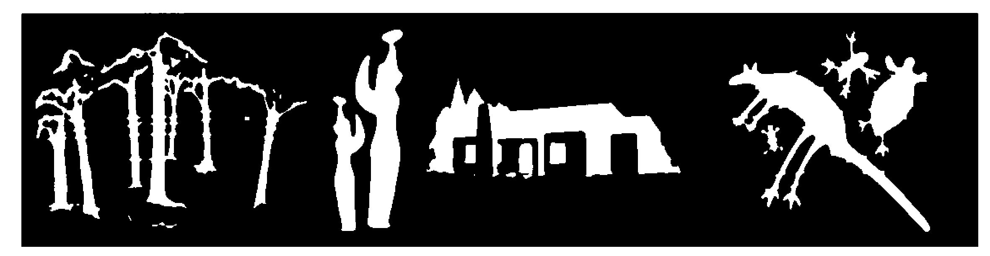

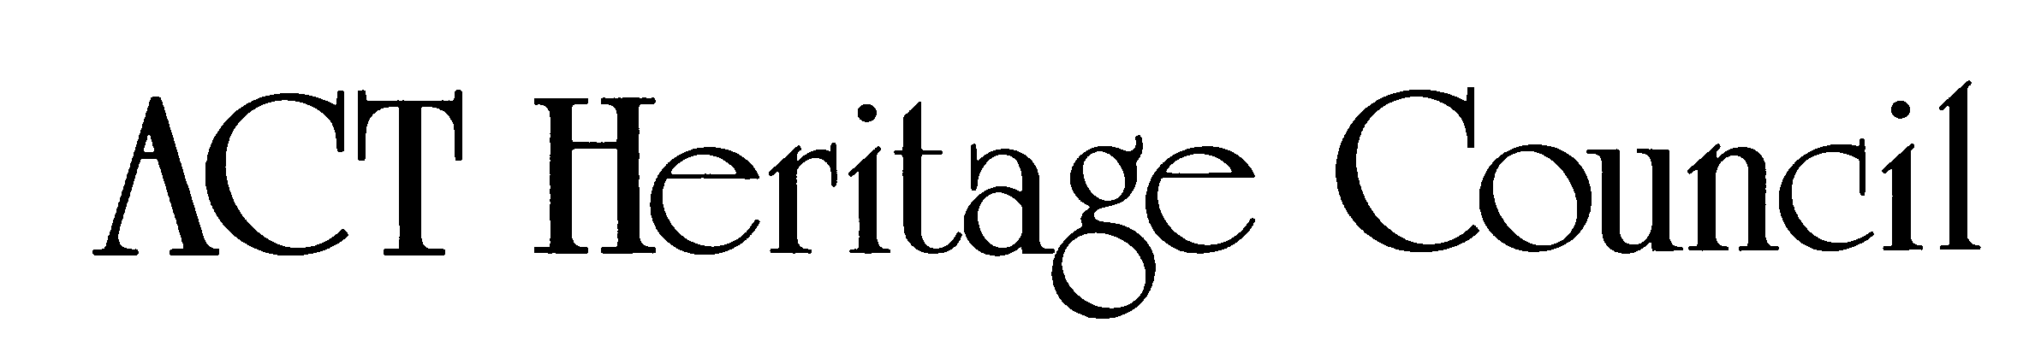

**Statement of Reasons  
Decision Not to Provisionally Register  
Ainslie Volcanics  
Block 4 Section 63, Campbell; Blocks 2 & 3 Section 60, Ainslie; Wolseley Drive Reserve;  
on the ACT Heritage Register**

In accordance with s 32 of the *Heritage Act 2004*, the ACT Heritage Council has decided not to provisionally register the Ainslie Volcanics. This Statement of Reasons provides an assessment of the Ainslie Volcanics and finds that the place does not meet any of the criteria under s10 of the *Heritage Act 2004*.

Background

The original nomination included areas of National Land. The Heritage Act 2004 does not apply to these lands and consequently the Heritage Council is unable to advise on the management of the associated areas. Instead, this assessment applies only to the Territory lands within the stated blocks: Block 4 Section 63, Campbell; Blocks 2 & 3 Section 60 Ainslie; and a portion of the Wolseley Drive Reserve as shown in Image 1. This place also includes biodiversity values but as they are protected under the Nature Conservation Act 2014, they cannot be considered under the provisions of the *Heritage Act 2004*.

Reasons for decision

The Council is not satisfied on reasonable grounds that the place is likely to have heritage significance as defined by s 10 of the *Heritage Act 2004*.

This statement refers to the Council’s reasons for its decision as required in s 34(5)(b)(iv) of the *Heritage Act 2004*.

Location of the place

Ainslie Volcanics, Block 4 Section 63, Campbell; Blocks 2 & 3 Section 60, Ainslie; Wolseley Drive Reserve.

This statement refers to the location of the placeas required in s 34(5)(b)(ii) of the *Heritage Act 2004*.

Description of the place

Whatever features are relevant to the heritage of the place;

Ainslie Volcanics, consisting of an area of land under the management of the ACT Government. The area includes established areas of conservation value and rocky outcrops belonging to the Mount Ainslie Volcanics geological formation.

The site comprises gently undulating landforms with small rocky outcrops and sparse shrubs in a grassland environment, stretching from the south-eastern corner of Quick Street and Limestone Avenue towards Ainslie Village.

This section refers to the description of the placeas required in s 34(5)(b)(iii) of the *Heritage Act 2004*. The boundary of the place and extent of features listed below is illustrated at Figure 1.

Assessment against the heritage significance criteria

This statement refers to the Council’s assessment of the placeagainst the heritage significance criteria as a part of its reasons for its decision as required in s 34(5)(b)(iv) of the *Heritage Act 2004*.

The Council’s assessment against the criteria specified in s 10 of the *Heritage Act 2004* is as follows.

In assessing the heritage significance of Ainslie Volcanics, the Council considered:

* the original nomination and documentary evidence supplied by the nominator
* the Council’s *Heritage Assessment Policy* (March 2018)
* information provided by a site inspection on 10 December 2021, 10 January 2022 and 13 August 2024 by ACT Heritage
* pursuant to s 31 of the Act, information and comments received from consulting with Representative Aboriginal Organisations (RAOs) established under s 14 of the Act
* pursuant to s 31A of the Act, information and comments received from consulting with the scientific committee established under the *Nature Conservation Act 2014*
* the report by ACT Heritage titled, *Background Information Ainslie Volcanics, Ainslie and Campbell, September* 2024, containing photographs and information on history, description, condition and integrity.

Pursuant to s 10 of the *Heritage Act 2004*, a place or object has heritage significance if it satisfies one or more of the following criteria. Future research may alter the findings of this assessment.

(a) importance to the course or pattern of the ACT’s cultural or natural history.

Does not meet criterion.

The Council has assessed Ainslie Volcanics against criterion (a) and is not satisfied that the placemeets this criterion.

At this time, the lack of material evidence together with the fact that there are conflicting views within the Aboriginal community on the cultural heritage significance of this place as a men’s business site, means that the significance of this place cannot be substantiated at the Territory level, as required under the Act. While all areas of land within the ACT hold significance for the Aboriginal peoples of the region, and this was land over which groups likely travelled, the support for its significance is low. Some members of Canberra’s Aboriginal community claim that the significance of Mount Ainslie as a women’s business site runs counter to the claims for this being a men’s business site, because it would be culturally inappropriate to have two such significant locations in such close proximity. Evidence for Aboriginal cultural activity at Pialligo, Black Mountain and along the banks of the Molonglo River is well-established by material remains, cultural memory and historical records. Aboriginal people were travelling through nearby locations, as attested by the background scatter of stone artefacts found throughout the ACT; however, there is insufficient evidence directly related to the assessment area to support claims that it was a focal point for past Aboriginal activity. While the potential petroglyph and pointer rock in the original nomination were located on national lands, and thus outside the jurisdiction of the Heritage Act 2004, in the absence of other nearby features identified as Aboriginal in origin, the conclusion that these features were not of heritage significance means that these cannot be used to establish a broader region of significance based solely on this evidence. Although all locations within the ACT were part of the significant landscape in which the Aboriginal people lived, there is no evidence that this place was of Territory importance to the course or pattern of activity associated with Aboriginal people.

Although there is an association between the early construction of Canberra and quarrying and surveying, the evidence of these activities in the nomination area is not considered significant, nor did the nature of those activities in this place have an influence on the course or pattern of the ACT’s cultural history. The summit of Mount Ainslie was a central point in the Canberra landscape used for trigonometric surveys and also as a central axis in the plans for the city of Canberra. The survey lines for these crossed the assessment area, but the area itself was not a central point influencing the survey and design of Canberra in itself. This was one of a number of locations, and not the primary location, where the rock belonging to the Mount Ainslie Volcanic Formation was quarried, and as such it is of minor interest.

The Mount Ainslie Volcanic Formation is of significance to the geological history of the Canberra Region. However, this is a widespread geological entity that includes other, more prominent, outcrops. The type-site localities for this formation have been variously associated with the quarry behind the Australian War Memorial, the road cuttings alongside the summit road, and the rock faces at the summit lookout. All these localities are within the Mount Ainslie Nature Reserve. Since other outcrops of the Mount Ainslie Volcanic Formation are clearly documented, the geological setting of this is place is neither distinctive nor exceptional within the course or pattern of the ACT’s natural (geological) history.

(b) has uncommon, rare or endangered aspects of the ACT’s cultural or natural history.

Does not meet criterion.

The Council has assessed Ainslie Volcanics against criterion (b) and is not satisfied that the placemeets this criterion.

There is no clear evidence in the broader cultural memory of the contemporary Aboriginal community, historic documents or archaeological investigations to support the claims that this place was of particular significance to Aboriginal people in the past to a level that would demonstrate a notable or influential contribution at the Territory level. There is no physical or documentary evidence relating to the significance of the place. While individual or scattered stone artefacts may be found in the future and the area was likely used in transiting between other localities, these would represent a common activity over the tens of thousands of years that Aboriginal people occupied this region before colonisation. It is unclear if there is oral history related to this place, as some members of the Aboriginal community claim cultural significance related to the place whereas others do not. As such, there is insufficient evidence before Council at this time that the place had a strong, notable or influential contribution to the ACT’s Aboriginal society.

Activities at this place after colonisation, such as use as a temporary survey point or for quarrying of rock, were common and therefore do not satisfy the criterion.

The Mount Ainslie Volcanic Formation extends over a large area of central and northern Canberra from Fyshwick to Hall and beyond the northern border of the territory into New South Wales. Outcrops throughout this area are relatively common. Consequently, the geology of the area does not meet the criterion.

(c) potential to yield important information that will contribute to an understanding of the ACT’s cultural or natural history.

Does not meet criterion.

The Council has assessed Ainslie Volcanics against criterion (c) and is not satisfied that the placemeets this criterion.

Although there is a reasonably high potential for isolated stone artefacts or small scatters to be found in this area through excavation or exposure, these are relatively common and reflect the long-established presence of Aboriginal peoples in the region prior to colonisation. All artefacts are considered important to the Aboriginal people of the ACT because they demonstrate a direct connection to the land, however, such artefacts are not likely to significantly advance the body of knowledge about the history of the ACT, as required under this criterion. Nor is there known potential for any further information regarding the post-Colonial history of the ACT or natural history pertaining to the geology. Therefore, the place does not meet the threshold for this criterion, as it lacks potential to yield important new information relating to the cultural or natural history of the ACT.

(d) importance in demonstrating the principal characteristics of a class of cultural or natural places or objects.

Does not meet criterion.

The Council has assessed Ainslie Volcanics against criterion (d) and is not satisfied that the placemeets this criterion.

There is not sufficient evidence before Council to demonstrate that this place is representative of Men’s business places in the ACT. The contemporary Aboriginal community have conflicting views about its significance as a gathering place for men and some consider it is not significant in this way. Furthermore, to meet the threshold for this criterion the principal characteristics or features of the class of place must be evident in the physical fabric of the place, but there is insufficient physical evidence at this time to establish this association.

By definition, geological type sites are representative of the principal characteristics of a natural place, however, despite its proximity to the mountain, this place is not the type site for the Mount Ainslie Volcanics Formation; the type site is a road cut on the summit road and a quarry on the southern slope, and it is these that would have the greatest potential to meet this criterion.

(e) importance in exhibiting particular aesthetic characteristics valued by the ACT community or a cultural group in the ACT.

Does not meet criterion.

The Council has assessed Ainslie Volcanics against criterion (e) and is not satisfied that the placemeets this criterion.

The rocky outcrops are aesthetically distinct within this place, but there is no evidence to suggest that these are sufficiently valued by the ACT community or a cultural group in the ACT to meet the thresholds for inclusion in this criterion. Some sectors of the contemporary Aboriginal community in the ACT claim that the rocky outcrops were a prominent focal point for the men’s business gatherings that occurred in this area, but these views were contradicted by others in the cultural group. Thus, the aesthetic characteristics are not clearly valued by the cultural group at a Territory level, as required by this criterion.

There is no indication of the place having aesthetic characteristics linked to other non-geological aspects of the Aboriginal or post-colonial history that can be linked to the physical fabric of the place and are clearly valued by the community or a cultural group in the ACT.

(f) importance in demonstrating a high degree of creative or technical achievement for a particular period.

Does not meet criterion.

The Council has assessed Ainslie Volcanics against criterion (f) and is not satisfied that the placemeets this criterion.

There are no known physical features of this place that relate to a high degree of creative or technical achievement.

(g) has a strong or special association with the ACT community, or a cultural group in the ACT for social, cultural or spiritual reasons.

Does not meet criterion.

The Council has assessed Ainslie Volcanics against criterion (g) and is not satisfied that the placemeets this criterion.

The Aboriginal people of the region undoubtably lived in the vicinity of and traversed this site before the NSW colony extended to this area. However, it is not possible to demonstrate that this particular place had a degree of distinctiveness or exceptionality required to meet the thresholds for inclusion under this criterion. Rather this place is part of the continuum of the region as a whole.

(h) has a special association with the life or work of a person, or people, important to the history of the ACT.

Does not meet criterion.

The Council has assessed Ainslie Volcanics against criterion (h) and is not satisfied that the placemeets this criterion.

There are no known or claimed associations between this place and specific achievements of a particular person or people to meet this criterion.

Registration boundary

Image 1: Ainslie Volcanics site boundary