Australian Capital Territory

Planning (Gungahlin and Macgregor FUA) Minor Plan Amendment 2024

**Notifiable instrument NI2024-674**

made under the

Planning Act 2023, s 85 (Making minor plan amendments)

**1 Name of instrument**

This instrument is the *Planning (Gungahlin and Macgregor FUA) Minor Plan Amendment 2024*.

**2 Commencement**

This instrument commences on the day after its notification day.

**3 Minor plan amendment**

I am satisfied under the *Planning Act 2023*, section 85 (1) (a) that Minor Plan Amendment 2024-02 is a minor plan amendment to the Territory Plan.

**4 Dictionary**

In this instrument:

***Minor Plan Amendment 2024-02*** means the minor plan amendment in schedule 1.

Freya O’Brien

Delegate of the Territory Planning Authority

28 November 2024



MINOR AMENDMENT

TO THE TERRITORY PLAN

2024-02

Changes to future urban

area overlay boundary at

Gungahlin section 232 block 2 and Macgregor section 149 block 7

This minor plan amendment was prepared

under part 5.3 of the *Planning Act 2023*

Contents

1.0 INTRODUCTION 1

1.1 Outline of the process 1

1.2 Summary of the amendments 2

2.0 CONSULTATION WITH THE PUBLIC 2

2.1 Consultation period 2

2.2 Changes made after public consultation 2

3.0 TERRITORY PLAN CHANGES 2

3.1 Territory Plan Map 2

4.0 TERRITORY PLAN AMENDMENT INSTRUCTIONS 9

4.1 Amendment to the Territory Plan Maps (Part B) 9

INTERPRETATION SERVICE 11

1. INTRODUCTION
   1. Outline of the process

A minor plan amendment, or minor amendment (MA), is one way that the Territory Plan can be changed.

Section 84 of the *Planning Act 2023* (the Planning Act) outlines the different types of MAs, some of which require limited consultation to be undertaken and some of which require no consultation to be undertaken.

Under Section 85 of the Planning Act a MA can only be made where:

* any required limited consultation has taken place and the authority is satisfied that the content of the MA meets the requirements of the Act
* if the MA is not inconsistent with the planning strategy or any relevant district strategy
* any comments received during the consultation period and from the National Capital Authority have been considered.

This MA to the Territory Plan (MA2024-02) has been prepared under section 84 (2) (e) and section 89 (2) and (3) of the Planning Act.

This MA required limited consultation to be undertaken (section 84 (2) (e) and section 89 (2) and (3) and was released for public consultation in accordance with the Act.

The MA is not inconsistent with the planning strategy or the Gungahlin and Belconnen District Strategies.

The National Capital Authority received a copy of this MA.

For more information on the content of the Territory Plan and minor plan amendment processes please refer to the Environment, Planning and Sustainable Development (EPSDD) website [The Territory Plan - Environment, Planning and Sustainable Development Directorate - Planning (act.gov.au)](https://www.planning.act.gov.au/professionals/our-planning-system/the-territory-plan).

* 1. Summary of the amendments

MA2024–02 changes the Territory Plan Map by:

* amending the boundary of a future urban area overlay in the division of Gungahlin to exclude section 232 block 2 from the overlay; and
* amending the boundary of a future urban area overlay in the division of Macgregor to exclude a portion of section 149 block 7 from the overlay.

1. CONSULTATION WITH THE PUBLIC
   1. Consultation period

Under section 84 (2) (e) of the *Planning Act 2023*, this minor amendment was subject to limited public consultation of at least 20 working days.

Written comments were invited on MA2024-02 from the public from   
4 October 2024 until 4 November 2024. No comments were received.

* 1. Changes made after public consultation

No changes were made following public consultation as no comments were received.

1. TERRITORY PLAN CHANGES
   1. Territory Plan Map

The Territory Plan map is amended by changing the boundary of the future urban area overlay to exclude Gungahlin section 232 block 2 and partially exclude Macgregor section 149 block 7 from the overlay.

The sites are not subject to subdivision design applications and will retain the current zoning of commercial CZ1 core for Gungahlin section 232 block 2 and parks and recreation PRZ1 urban open space for part of Macgregor section 149 block 7.

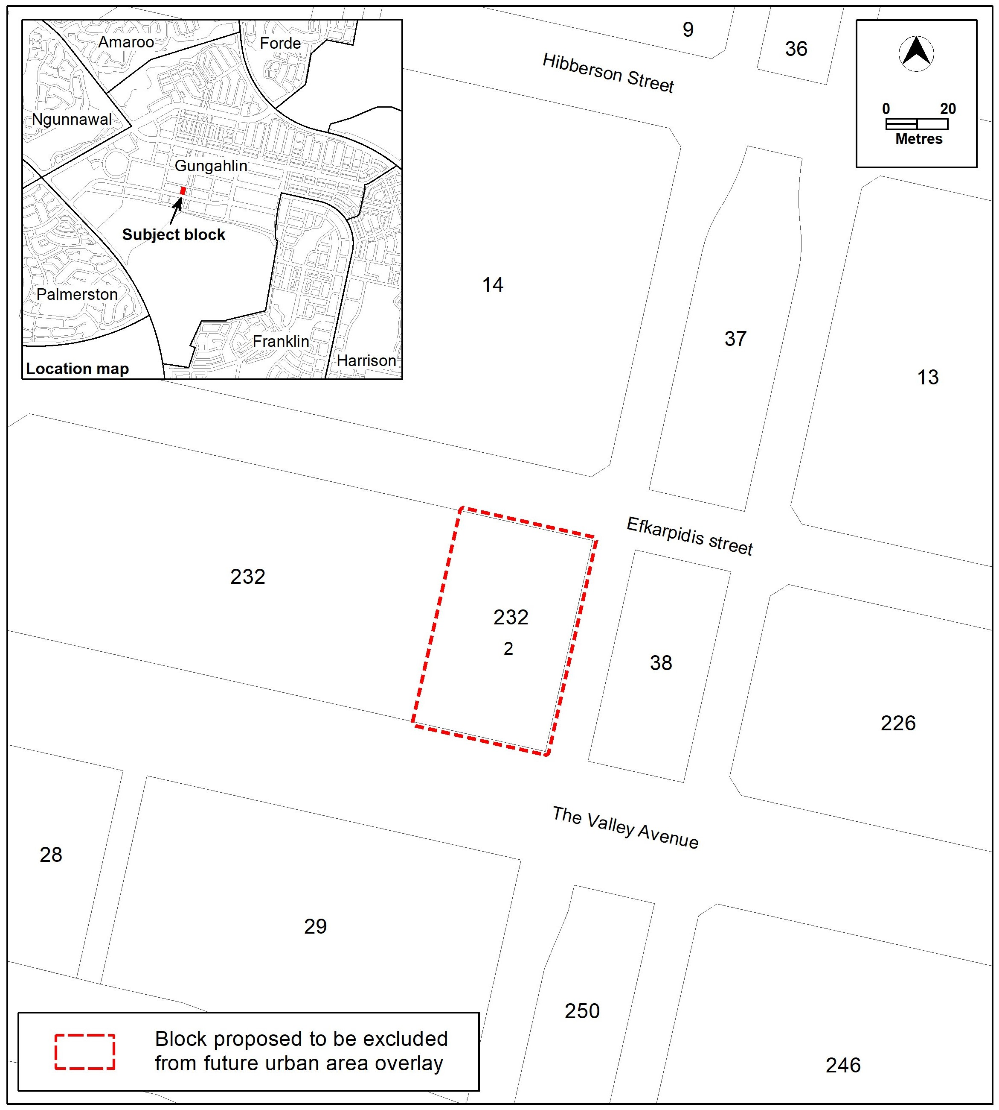Location map – Gungahlin section 232 block 2

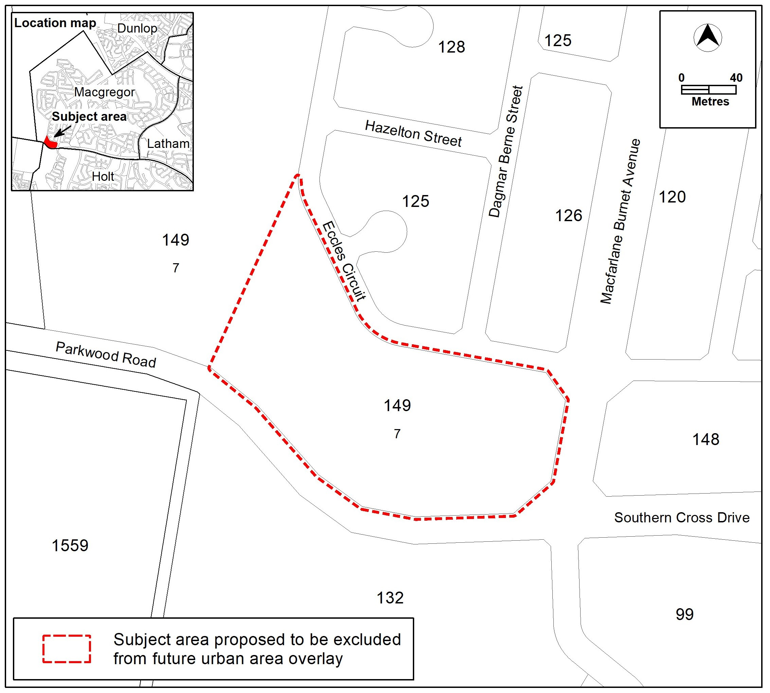Location map – Macgregor section 149 block 7

3.2 Part B **–** Territory Plan Map

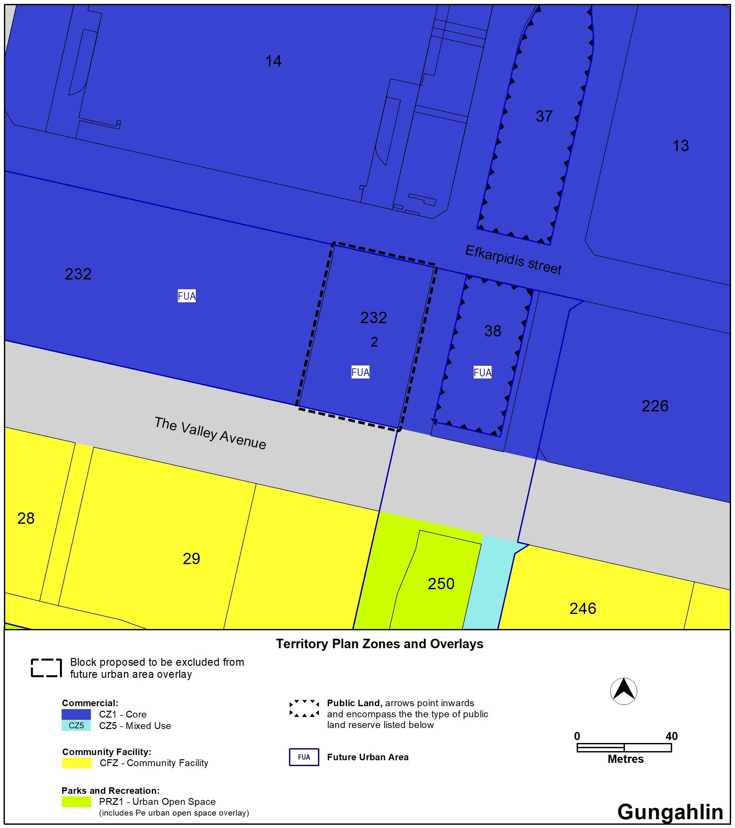Existing Territory Plan Map – Gungahlin section 232 block 2

Proposed Territory Plan Map – Gungahlin section 232 block 2 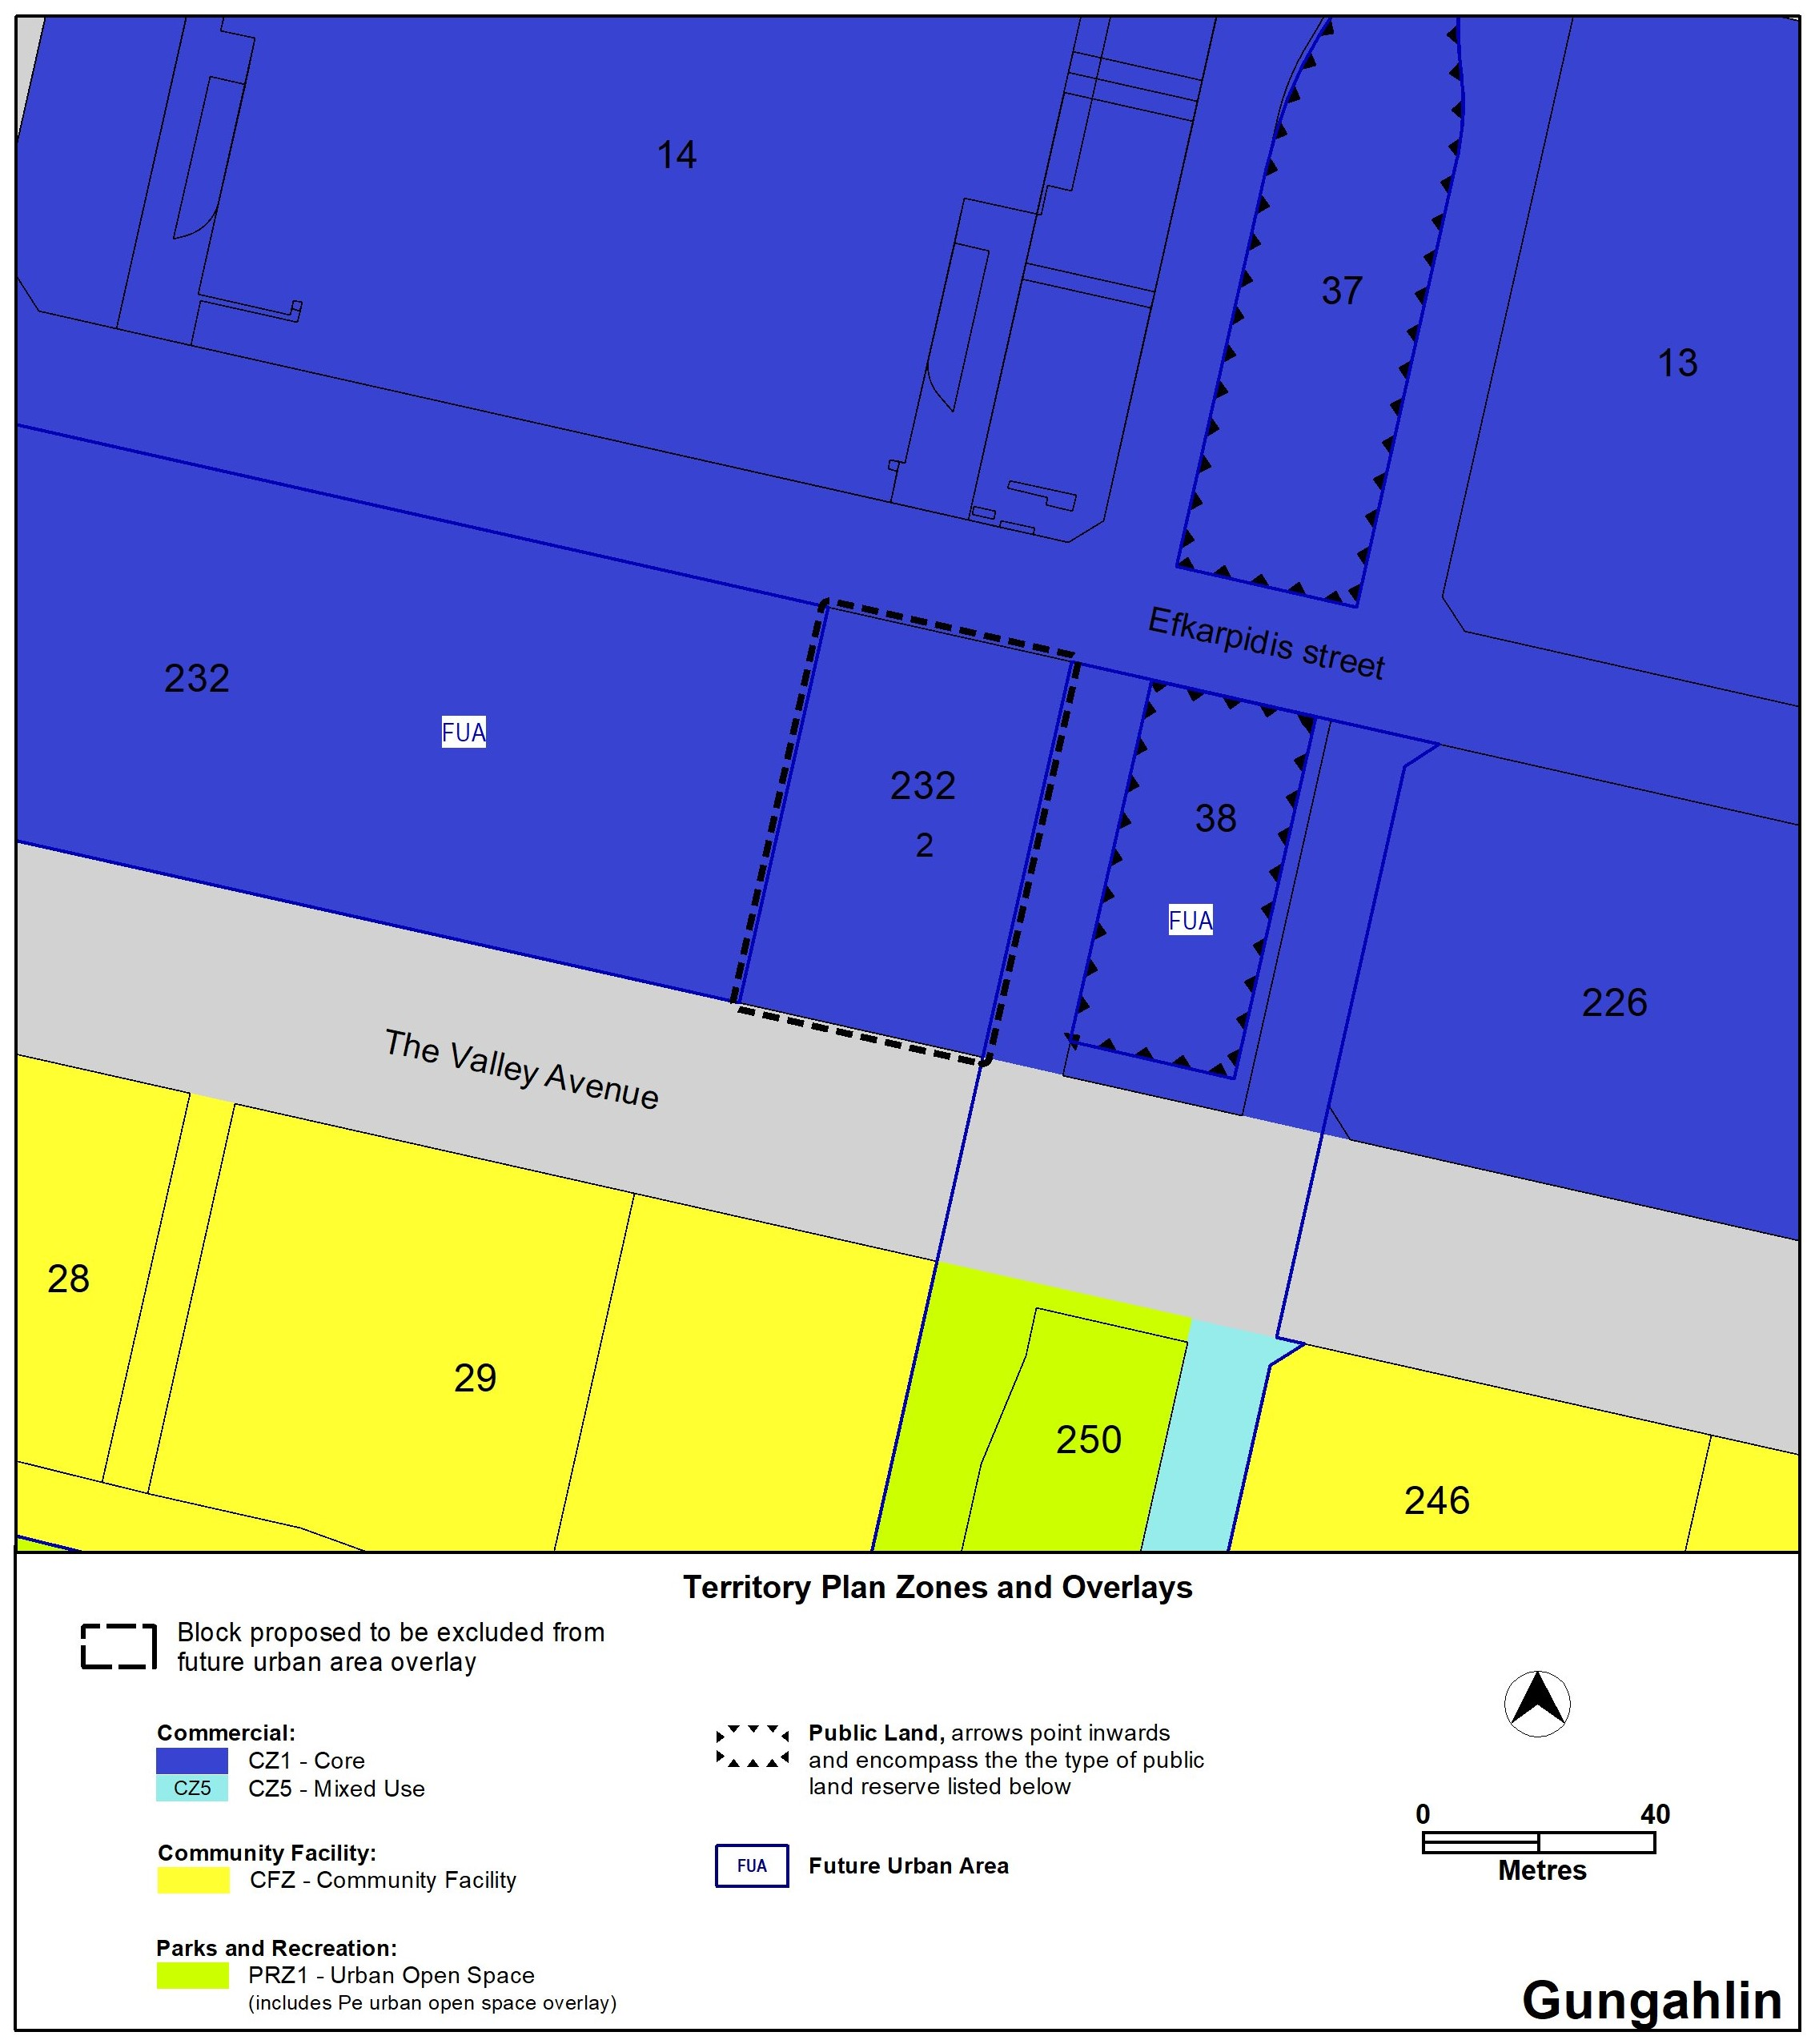

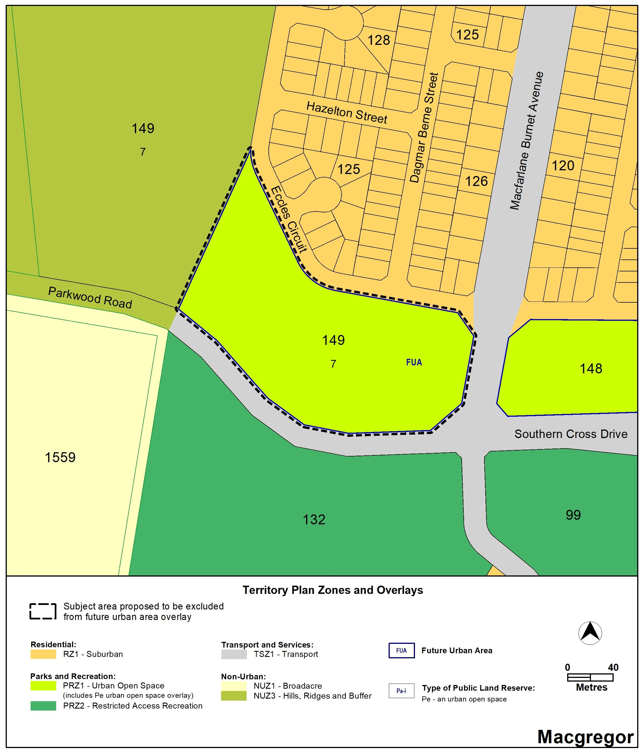Existing Territory Plan Map – Macgregor section 149 block 7

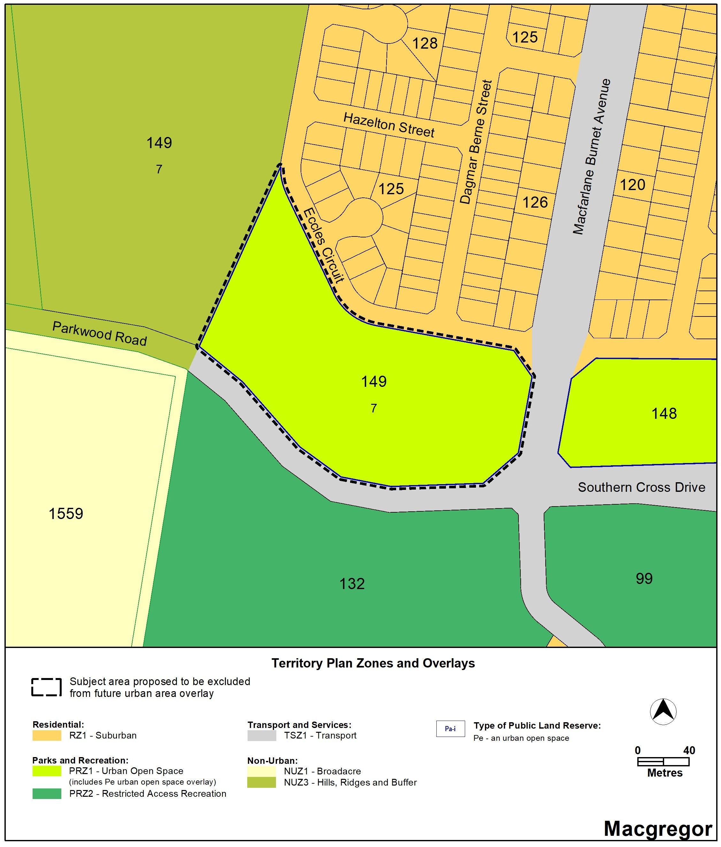Proposed Territory Plan Map – Macgregor section 149 block 7

1. TERRITORY PLAN AMENDMENT INSTRUCTIONS

This section provides the instructions for how MA2024-02 amends the Territory Plan.

* 1. Amendment to the Territory Plan Maps (Part B)

1. Gungahlin

The relevant part of the Territory Plan map is varied as indicated below.

1. Macgregor

The relevant part of the Territory Plan map is varied as indicated below.

INTERPRETATION SERVICE

To speak to someone in a language other than English please telephone the Telephone Interpreter Service (TIS) **13 14 50**

| LANGUAGE | DETAILS |
| --- | --- |
| English | If you need an interpreter please call: **13 14 50** |
| Mandarin (Simplified Chinese) / 简体中文 | 如果您需要翻译，请致电：**13 14 50** |
| Arabic / العربية | إذا كنت بحاجة إلى مترجم شفهي اتصل بالرقم: **50 14 13** |
| Cantonese (Traditional Chinese) / 繁體中文 | 如果你需要傳譯員，請致電：**13 14 50** |
| Vietnamese /  Tiếng Việt | Nếu bạn cần thông dịch viên, xin gọi: **13 14 50** |
| Korean / 한국어 | 통역사가 필요할 경우 다음 번호로 전화하시기 바랍니다: **13 14 50** |
| Spanish / Español | Si necesita un intérprete, llame al **13 14 50** |
| Persian (Farsi) / فارسی | اگر به مترجم نیاز دارید، لطفاً به این شماره تلفن کنید: **50 14 13** |
| Dari / دری | اگر به یک ترجمان شفاهی نیاز دارید لطفاً به شمارۀ **131450** زنگ بزنید. |
| Punjabi / ਪੰਜਾਬੀ | ਜੇਕਰ ਤੁਹਾਨੂੰ ਕਿਸੇ ਦੁਭਾਸ਼ੀਏ ਦੀ ਲੋੜ ਹੈ ਤਾਂ ਕਿਰਪਾ ਕਰਕੇ ਫੋਨ ਕਰੋ: **13 14 50** |
| Tamil / தமிழ் | உங்களுக்கு மொழிபெயர்த்துரைப்பாளர் ஒருவர் தேவைப்பட்டால் **13 14 50** என்ற எண்ணை அழைக்கவும் |
| Greek / Ελληνικά | Αν χρειάζεστε διερμηνέα, τηλεφωνήστε: **13 14 50** |
| Italian / Italiano | Se hai bisogno di un interprete, chiama: **13 14 50** |
| Hazaragi /  هزاره گی | اگه ده ترجمان ضرورت ده رید، لطفاً ده شماره 50 14 13  تماس بگیرید. |
| Thai / ภาษาไทย | หากคุณต้องการล่าม กรุณาโทรไปที่ 13 14 50 |
| Karen / ကညီကျိၥ် | ဖဲနမ့ၢ်လိၣ်ဘၣ်ပှၤကတိၤကျိးထံတၢ်တဂၤအခါ၀ံသးစူၤကိးဘၣ်-၁၃၁ ၄၅၀ တက့ၢ်. |

**Telephone and Interpreter Service 13 14 50 - Canberra and District - 24 hours a day, seven days a week**