Australian Capital Territory

Planning (Changes to public land overlay boundaries) Minor Plan Amendment 2024 (No 1)

##### Notifiable instrument NI2024-687

made under the

Planning Act 2023, s 85 (Making minor plan amendments)

**1 Name of instrument**

This instrument is the *Planning (Changes to public land overlay boundaries) Minor Plan Amendment 2024 (No 1)*.

**2 Commencement**

This instrument commences on the day after its notification day.

**3 Minor plan amendment**

I am satisfied under the *Planning Act 2023*, section 85 (1) (a) that Minor Plan Amendment 2024-04 is a minor plan amendment to the Territory Plan.

**4 Dictionary**

In this section:

***Minor Plan Amendment 2024-04*** means the minor plan amendment to the Territory Planin schedule 1.

Freya O’Brien

Delegate of the territory planning authority

04 December 2024

**Schedule 1**



MINOR PLAN AMENDMENT TO THE TERRITORY PLAN

2024–04

Changes to public land

overlay boundaries

This minor plan amendment was prepared

under part 5.3 of the *Planning Act 2023*

Contents

1.0 INTRODUCTION 1

1.1 Outline of the process 1

1.2 Summary of the proposal 2

2.0 TERRITORY PLAN CHANGES 2

3.0 TERRITORY PLAN AMENDMENT 5

3.1 Amendment to the Territory Plan Map 5

INTERPRETATION SERVICE 6

1. INTRODUCTION
   1. Outline of the process

Minor plan amendment 2024-04 (MA 2024-04) to the Territory Plan is a minor plan amendment (MA) prepared under section 84 (1) (b) and section 87 of the *Planning Act 2023* (the Act).

Section 84 of the Act outlines the different types of MAs, some which require limited consultation to be undertaken and some which do not require consultation. This MA is consistent with the provisions under section 84 (1) (b) and 87 of the Act and therefore no consultation is needed.

Under Section 85 of the Act this type of MA can only be made if the MA is not inconsistent with the planning strategy or any relevant district strategy

The MA is not inconsistent with the Planning Strategy 2018 or the Tuggeranong District Strategy.

The National Capital Authority will receive a copy of this MA.

For more information on the content of the Territory Plan and minor plan amendment processes please refer to the planning website: [www.planning.act.gov.au/professionals/our-planning-system/the-territory-plan/amendments-to-the-territory-plan](http://www.planning.act.gov.au/professionals/our-planning-system/the-territory-plan/amendments-to-the-territory-plan)

* 1. Summary of the proposal

MA2024–04 proposes to amend the Territory Plan Map to change the public land ‘Pd – a special purpose reserve’ (Pd) overlay at Tuggeranong part rural block 1411 and Gordon section 455 part block 1 (the site). This will allow for the proposed use of the site as a formal and enclosed dog park.

The Conservator of Flora and Fauna wrote pursuant to section 384 of the *Planning Act 2023* to recommend that the Territory Plan be amended to remove the Pd overlay from parts of the site.

1. TERRITORY PLAN CHANGES

Changes are being made to the Territory Plan Map to amend the Pd overlay at the site.

The boundary change is consistent with detailed investigations and an Environmental Significance Opinion that revealed the subject site is no longer of significance and, therefore, it no longer needs to be part of the special purpose reserve.

The boundary change is consistent with the apparent intent of the original boundary in that it will continue to protect land of significant environmental values. It also facilitates achievement of desired policy outcomes for the non-urban NUZ4 River Corridor zone by providing opportunities for land based recreational activities and preventing development that would significantly increase the fire hazard. It will also not adversely impact ecological connectivity given the location is on the outer edge of the NUZ4 zoning and the Pd overlay for the site.

Location map

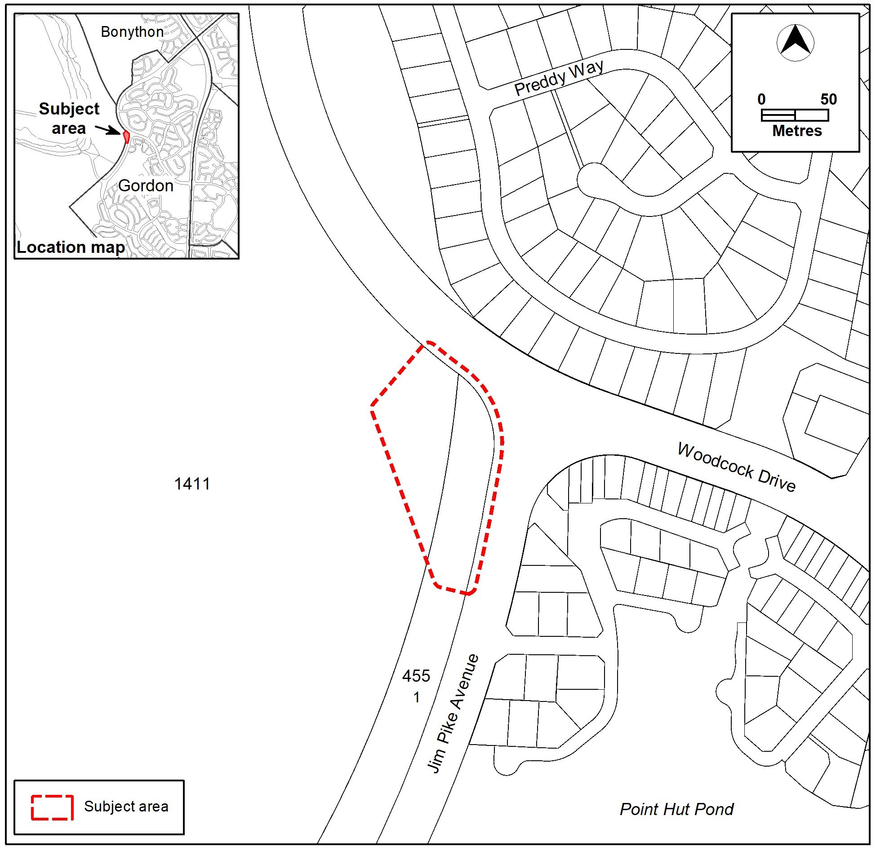

Existing Territory Plan Map

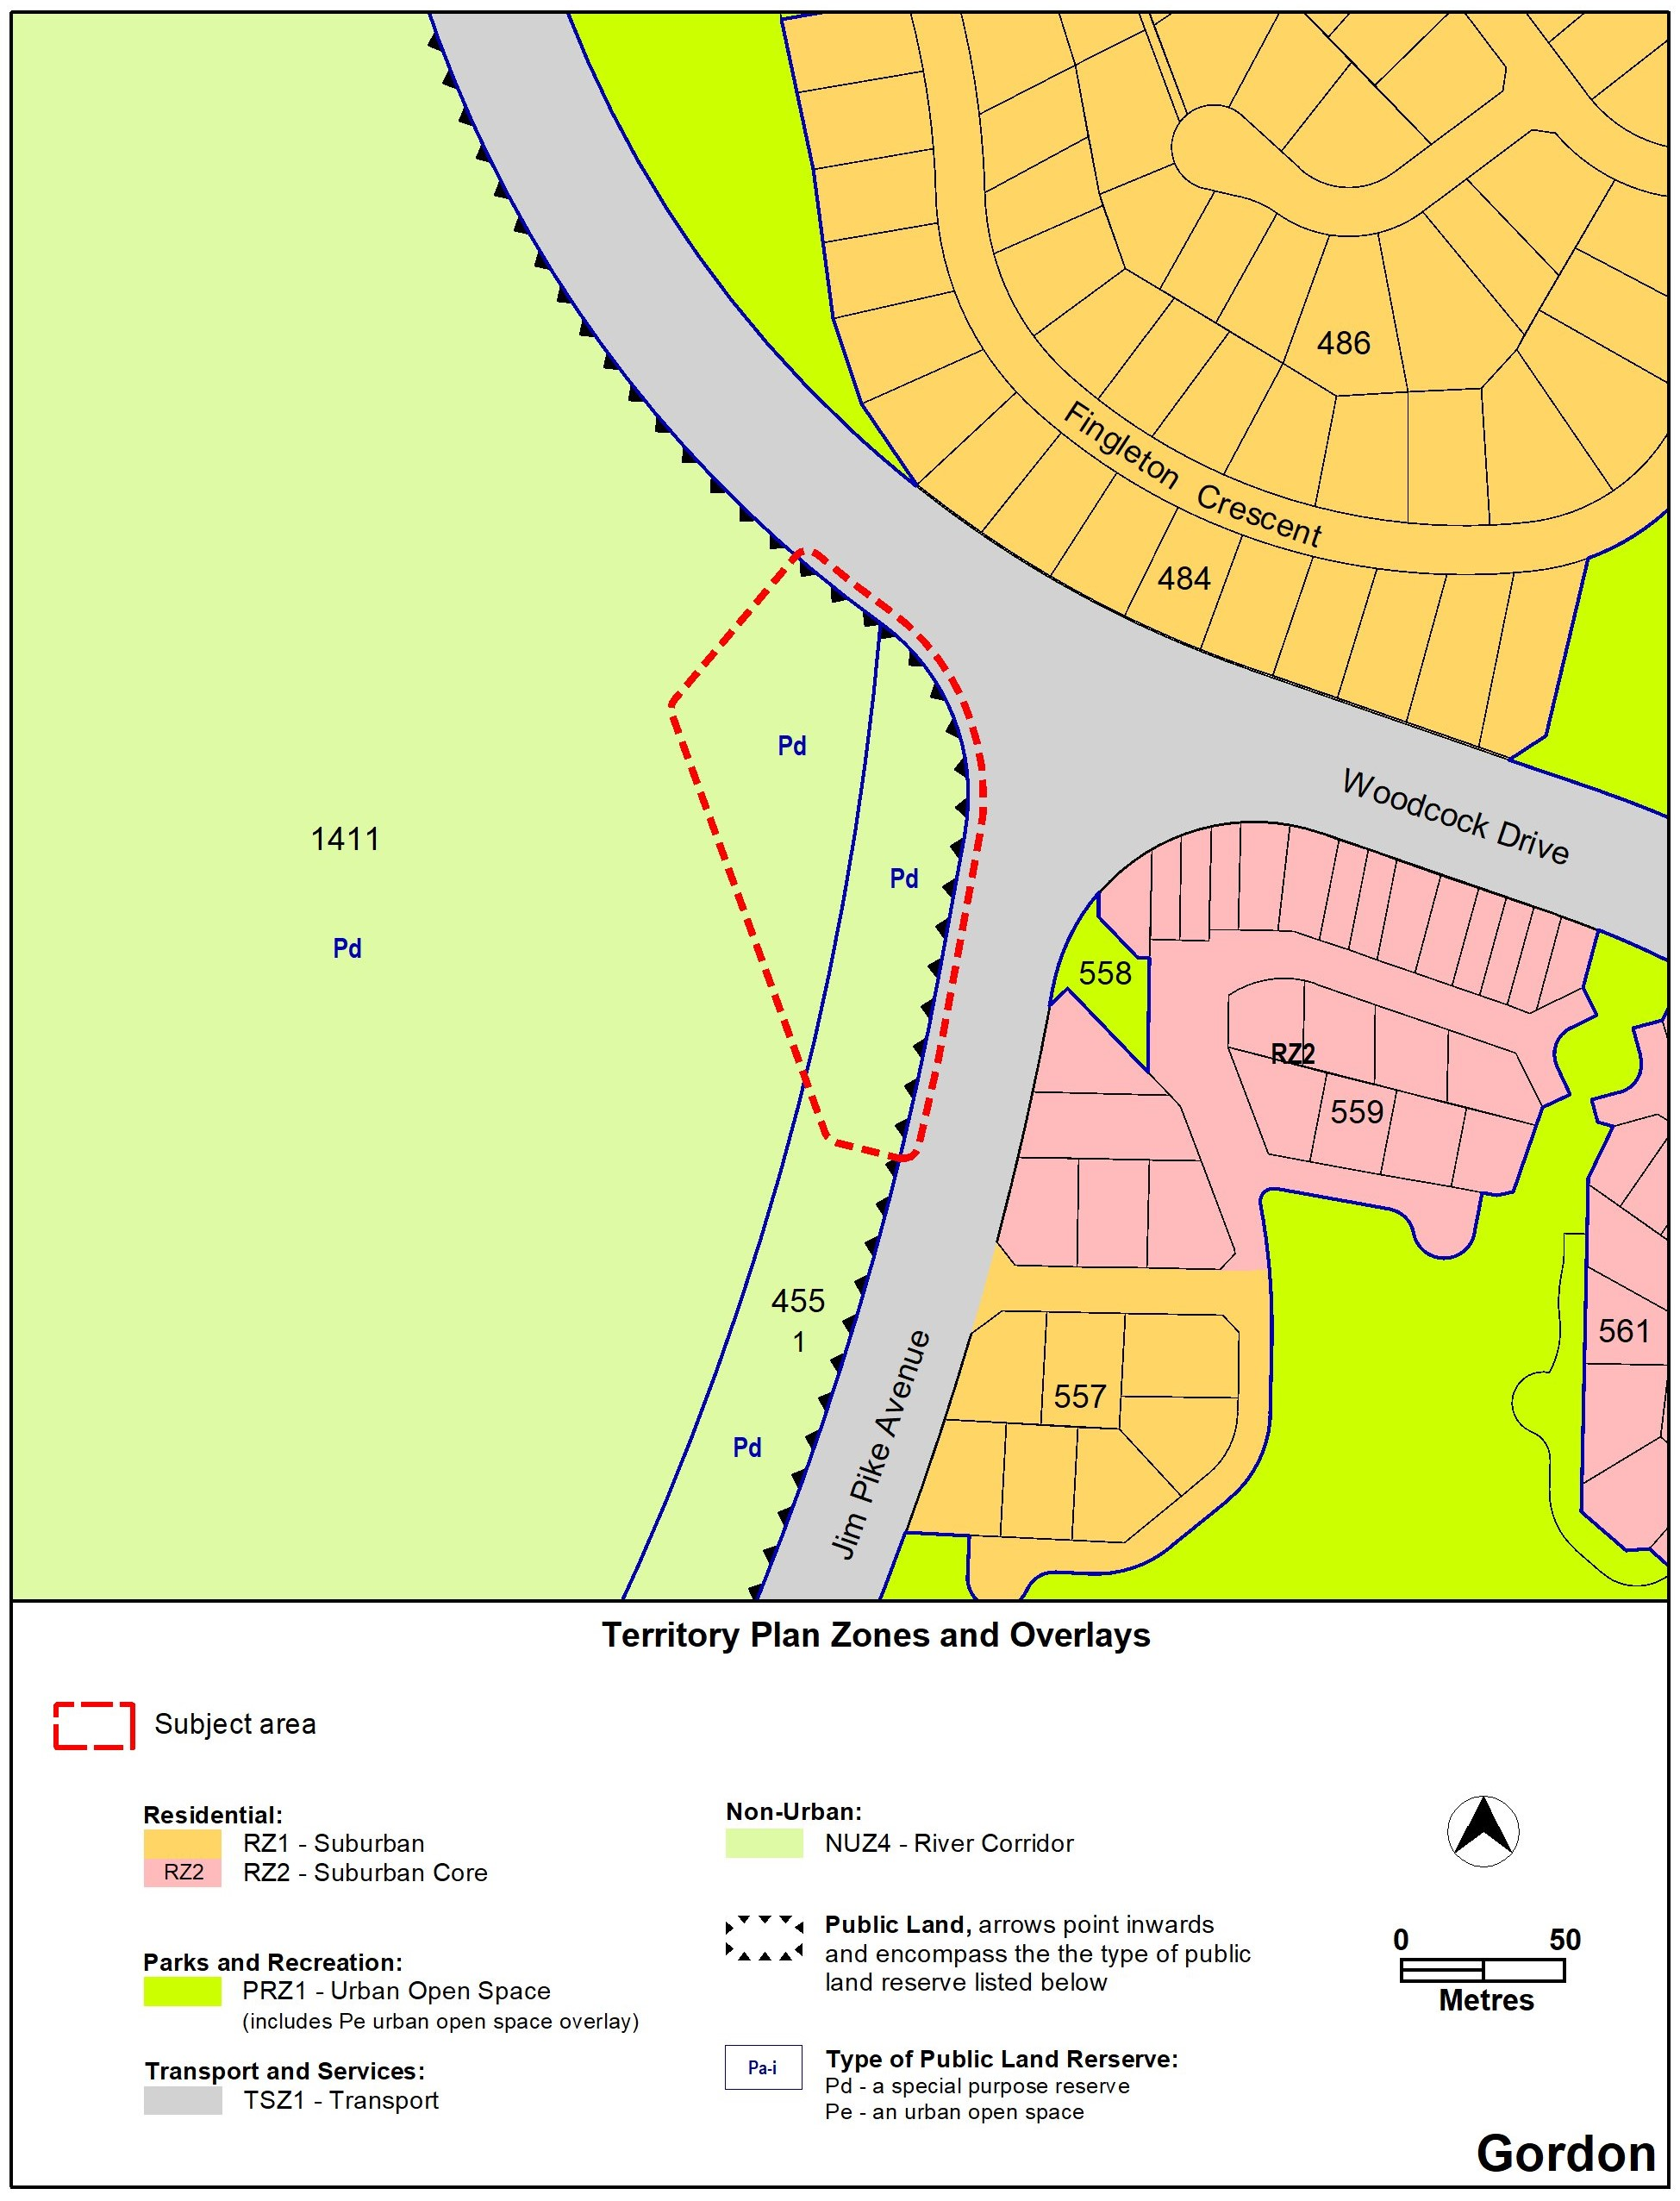

Proposed Territory Plan Map

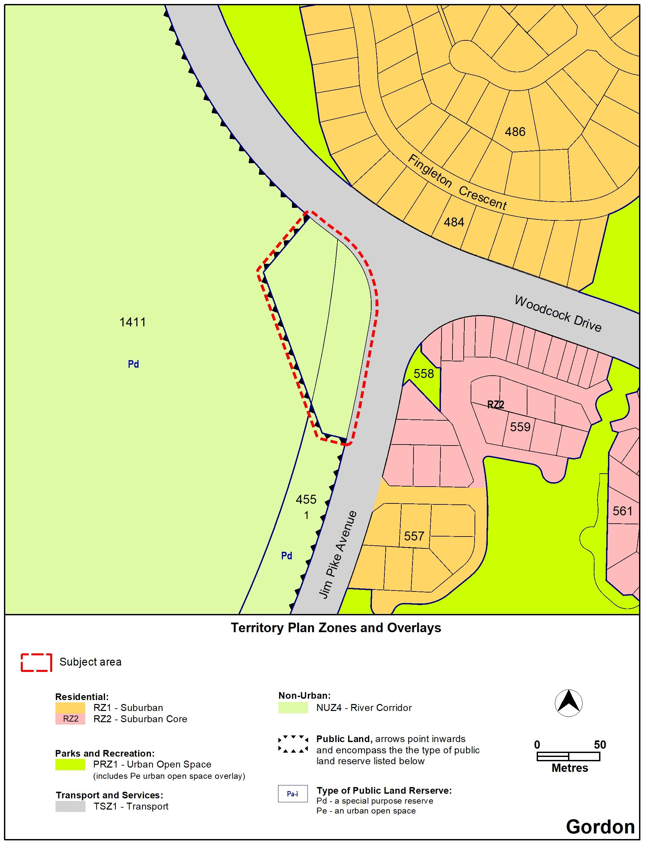

1. TERRITORY PLAN AMENDMENT
   1. Amendment to the Territory Plan Map

1. Territory Plan Map

The relevant part of the Territory Plan map is varied as indicated below.



INTERPRETATION SERVICE

To speak to someone in a language other than English please telephone the Telephone Interpreter Service (TIS) **13 14 50**

| LANGUAGE | DETAILS |
| --- | --- |
| English | If you need an interpreter please call: **13 14 50** |
| Mandarin (Simplified Chinese) / 简体中文 | 如果您需要翻译，请致电：**13 14 50** |
| Arabic / العربية | إذا كنت بحاجة إلى مترجم شفهي اتصل بالرقم: **50 14 13** |
| Cantonese (Traditional Chinese) / 繁體中文 | 如果你需要傳譯員，請致電：**13 14 50** |
| Vietnamese /  Tiếng Việt | Nếu bạn cần thông dịch viên, xin gọi: **13 14 50** |
| Korean / 한국어 | 통역사가 필요할 경우 다음 번호로 전화하시기 바랍니다: **13 14 50** |
| Spanish / Español | Si necesita un intérprete, llame al **13 14 50** |
| Persian (Farsi) / فارسی | اگر به مترجم نیاز دارید، لطفاً به این شماره تلفن کنید: **50 14 13** |
| Dari / دری | اگر به یک ترجمان شفاهی نیاز دارید لطفاً به شمارۀ **131450** زنگ بزنید. |
| Punjabi / ਪੰਜਾਬੀ | ਜੇਕਰ ਤੁਹਾਨੂੰ ਕਿਸੇ ਦੁਭਾਸ਼ੀਏ ਦੀ ਲੋੜ ਹੈ ਤਾਂ ਕਿਰਪਾ ਕਰਕੇ ਫੋਨ ਕਰੋ: **13 14 50** |
| Tamil / தமிழ் | உங்களுக்கு மொழிபெயர்த்துரைப்பாளர் ஒருவர் தேவைப்பட்டால் **13 14 50** என்ற எண்ணை அழைக்கவும் |
| Greek / Ελληνικά | Αν χρειάζεστε διερμηνέα, τηλεφωνήστε: **13 14 50** |
| Italian / Italiano | Se hai bisogno di un interprete, chiama: **13 14 50** |
| Hazaragi /  هزاره گی | اگه ده ترجمان ضرورت ده رید، لطفاً ده شماره 50 14 13  تماس بگیرید. |
| Thai / ภาษาไทย | หากคุณต้องการล่าม กรุณาโทรไปที่ 13 14 50 |
| Karen / ကညီကျိၥ် | ဖဲနမ့ၢ်လိၣ်ဘၣ်ပှၤကတိၤကျိးထံတၢ်တဂၤအခါ၀ံသးစူၤကိးဘၣ်-၁၃၁ ၄၅၀ တက့ၢ်. |

**Telephone and Interpreter Service 13 14 50 - Canberra and District - 24 hours a day, seven days a week**