Australian Capital Territory
Biosecurity (White Spot Disease) Control Declaration 2025
Notifiable instrument NI2025-181
made under the
Biosecurity Act 2023, s 51 (Control declarations)

        - Name of instrument
This instrument is the Biosecurity (White Spot Disease) Control Declaration 2025.
        - Commencement
This instrument commences on the later of—
            - the day after its notification day; and
            - the commencement of the Biosecurity Act 2023, section 51 (Control declarations).
Note The naming and commencement provisions automatically commence on the notification day (see Legislation Act, s 75 (1)).
        - Grounds for declaration—Act s 51 (1)
I am satisfied that this declaration is necessary to manage the biosecurity risk posed by white spot disease because—
            - white spot disease is a highly contagious viral disease that affects farmed and wild crustaceans; and
            - white spot disease is prohibited biosecurity matter throughout the ACT; and
            - the whole of Queensland is established as a white spot biosecurity zone for the white spot syndrome virus which causes white spot disease and Queensland has established regulated movement areas; and
            - white spot disease is present in farmed and wild crustaceans in NSW and NSW has established white spot control zones; and
            - these control measures will minimise the risk of the introduction and spread of white spot disease to crustacean populations in the ACT.
        - Biosecurity matter and biosecurity risk—Act, s 51 (2) (a)
The biosecurity matter that is the subject of this declaration is white spot disease.
The biosecurity risk that is the subject of this declaration is the risk of white spot disease being introduced into the ACT, which would likely have an adverse effect on the ACT environment.
        - Control measures—Act, s 51 (2) (b)
I consider that the control measures in schedule 1 are reasonably necessary to prevent the introduction of white spot disease into the ACT.
        - Control zone—Act, s 51 (2) (c)
The control zone for this declaration is the whole of the ACT.
        - People to whom control measures apply—Act, s 51 (2) (d)
The control measures in this declaration apply to any person who deals with white spot carriers as defined in schedule 1.
        - Expiry—Act, s 51 (2) (e)
This instrument expires 5 years after it commences.

Suzanne Orr MLA
Minister for Climate Change, Energy, Environment and Water
28 March 2025

- Control measures—white spot disease
(see s 5)

Part 1 Important concepts
        - Meaning of white spot carrier

- In this declaration:

White spot carrier means any of the following carriers of white spot disease—
- decapod crustaceans - a crustacean of the Order Decapoda, including but not limited to school, tiger, eastern king and banana prawns, yabbies and pink nippers, shrimp, slipper lobsters, crabs and hermit crabs;
- polychaete worms;
- fittings or equipment that have previously been used in connection with the cultivation or catch of white spot carriers;
- equipment or other things used in water or exposed to water which have been exposed to white spot carriers;
- Water that has held carriers identified at (1) (a) or (b).

        - Meaning of restriction area
          - In this declaration:

import restriction area means an area identified as—
- The Queensland White Spot Disease movement restriction area, as
- the area within the White Spot Biosecurity Zone outside Biosecurity Area 1 defined in the Queensland Department of Agriculture and Fisheries Notice under Section 129 and Regulation 94 of the Biosecurity Act 2014 (QLD), and under Part 12 White spot biosecurity zone regulatory provisions of the Biosecurity Regulation 2016 (QLD) and the Biosecurity (White Spot Syndrome Virus) Amendment Regulation 2017 (QLD) as in force from time to time.
Note Mapping and spatial points are available on the website: www.daf.qld.gov.au
- A control zone for white spot disease identified in
- an emergency order made under the Biosecurity Act 2015 (NSW), section 44, as in force from time to time; or
- a control order made under the Biosecurity Act 2015 (NSW), section 62, as in force from time to time.
Note NSW emergency orders and control orders are available on the website:
www.nsw.gov.au/departments-and-agencies/dpird/our-agencies/agriculture-and-biosecurity

Part 2 Definitions
Act means the Biosecurity Act 2023.
certificate of irradiation means a Certificate that—
- certifies that Gamma irradiation treatment was applied to the product at the Treatment Facility on the date stated in the Certificate; and
- bears an individual lot number assigned by the Treatment Facility; and
- describes the product that was treated including the species and total weight of the product; and
- is signed by an employee of the Treatment Facility who is authorised to sign the Certificate on behalf of the Treatment Facility.
commercial fisher means a person:
- who holds a current commercial fishing licence issued under Division 1 of Part 4 of the New South Wales Fisheries Management Act 1994; or
- who holds a current commercial fisher licence under the Queensland Fisheries Act 1994.
cooked means cooked to a minimum time and temperature standard to ensure that all the protein in the Declared Animals is coagulated and no uncooked meat remains.
decapod crustacean means any crustacean of the Order Decapoda and includes but is not limited to school, tiger and banana prawns, shrimp, slipper lobsters, crabs and hermit crabs.
gamma irradiation treatment means treatment by irradiation at a gamma radiation dose of at least 50 kilo Gray (kGy).
Import restriction area/IRA means the area set out at schedule 2.
polychaete worm means any worm of the Class Polychaeta.
treatment facility means a treatment facility that applies gamma irradiation treatment to the decapod crustaceans.
white spot disease means the disease that is caused by the virus Whispovirus (Family Nimaviridae) (also known as infection with white spot syndrome virus).
Part 3 Control measures
        - Control measure—prohibition on importing white spot carriers
          - A person must not import white spot carriers into the ACT from the import restriction area at section 10.
        - Control measure—prohibition on use of white spot carriers
          - The use in the ACT of white spot carriers is prohibited if the importation of the white spot carrier is prohibited under sections 7 or 8.
Part 4 Control measure exceptions
        - Control measure exception – fittings and other equipment
          - Part 3 does not apply to a person who imports fittings and other equipment into the ACT from the import restriction area if the fittings and equipment have been cleaned and disinfected to remove all traces of white spot carriers in accordance with a protocol outlined on the Queensland Department of Agriculture and Fishing web page Recommended procedure for decontaminating fishing apparatus and vessels | Department of Primary Industries, Queensland.
        - Control measure exception – imported cooked decapod crustaceans
          - Part 3 does not apply to decapod crustaceans if they—
(a) have first been processed for human consumption as cooked product; and
(b) are securely packaged; and
(c) are transported directly to a point of sale in the ACT for human consumption.
        - Control measure exception – imported uncooked decapod crustaceans
          - Part 3 does not apply to uncooked decapod crustaceans moved through (into, within and out of, including the loading and unloading of product into or from vehicles whilst in transit) the import restriction area if—
(a) they originated from outside of the import restriction area; and
(b) any bins or packaging or coverings containing uncooked decapod crustaceans remain intact and secured; and
(c) the name, address, postcode and the State or Territory of both the grower and/or commercial fisher and the packer is clearly displayed on the outer covering of any bins or packaging; and
(d) they are transported directly to a point of sale in the ACT for human consumption.

Example
uncooked decapod crustaceans originating from outside of the control zone may be moved into that area, unloaded from a vehicle and then loaded onto a second vehicle.

        - Control measure exception – treated carriers
          - Part 3 does not apply to decapod crustaceans (cooked or uncooked) that have been subject to gamma irradiation treatment with a dose not less than 50Kgy within the import restriction area, if they have been moved directly from the import restriction area to a destination in the ACT, subject to all of the following conditions—
(a) The following information must be provided to Access Canberra, no less than 48 business hours prior to the planned time of arrival of the product at the destination in the ACT:
(i) the address of the destination of the product; and
(ii) the description of the product including species, weight, type of packaging and number of packages; and
(iii) the estimated date and time of arrival of the product. The date and time of arrival of the product must be on a business day during business hours; and
(b) The product is moved into the ACT:
(i) in refrigerated transport; and
(ii) in the same sealed insulated containers in which the gamma irradiation treatment was applied; and
(iii) accompanied by a copy of the relevant biosecurity certificate or Certificate of Irradiation; and
(iv) in one journey on the same day (they must not be offloaded until they reach their destination); and
(v) subject to an interstate biosecurity permit; and
(vi) the person receiving the product must notify Access Canberra: of the date and time of the arrival of the product at its destination, as soon as possible after its arrival.
          - Further, Part 3 section 11 does not apply where the requirements in Part 4 section 14 have been met and the product is unloaded at the destination from the sealed insulated containers and processed as required, and is then further transported to a point of sale in the ACT if all of the following conditions are met—
(a) it is stored in a separate part of the processing facility to other products being processed; and
(b) it remains identifiable with appropriate marks on containers and boxes with the lot number allocated to the product by the Treatment Facility and with the name of the Treatment Facility; and
(c) a copy of the Certificate of Irradiation is kept with the product at all times prior to it being processed into final packaging; and
(d) each individual container into which the processed product is finally packaged is clearly labelled with:
(i) the name of the Treatment Facility; and
(ii) the relevant lot number; and
(iii) the details of the volume of product that was irradiated in that lot; and
(iv) the symbols “50 kGy” to indicate that the product was irradiated with this dose; and
(e) any waste product produced during processing (for example, water or organic matter) is disposed of to either the sewer (for water) or to general waste as appropriate.

          - Part 3 does not apply to equipment or other things that have been cleaned and disinfected to remove all traces of white spot carriers, in accordance with a protocol outlined on the Queensland Department of Agriculture and Fishing web page - Recommended procedure for decontaminating fishing apparatus and vessels | Department of Primary Industries, Queensland .

- Import Restriction Area
(see section10)

- Queensland restricted area
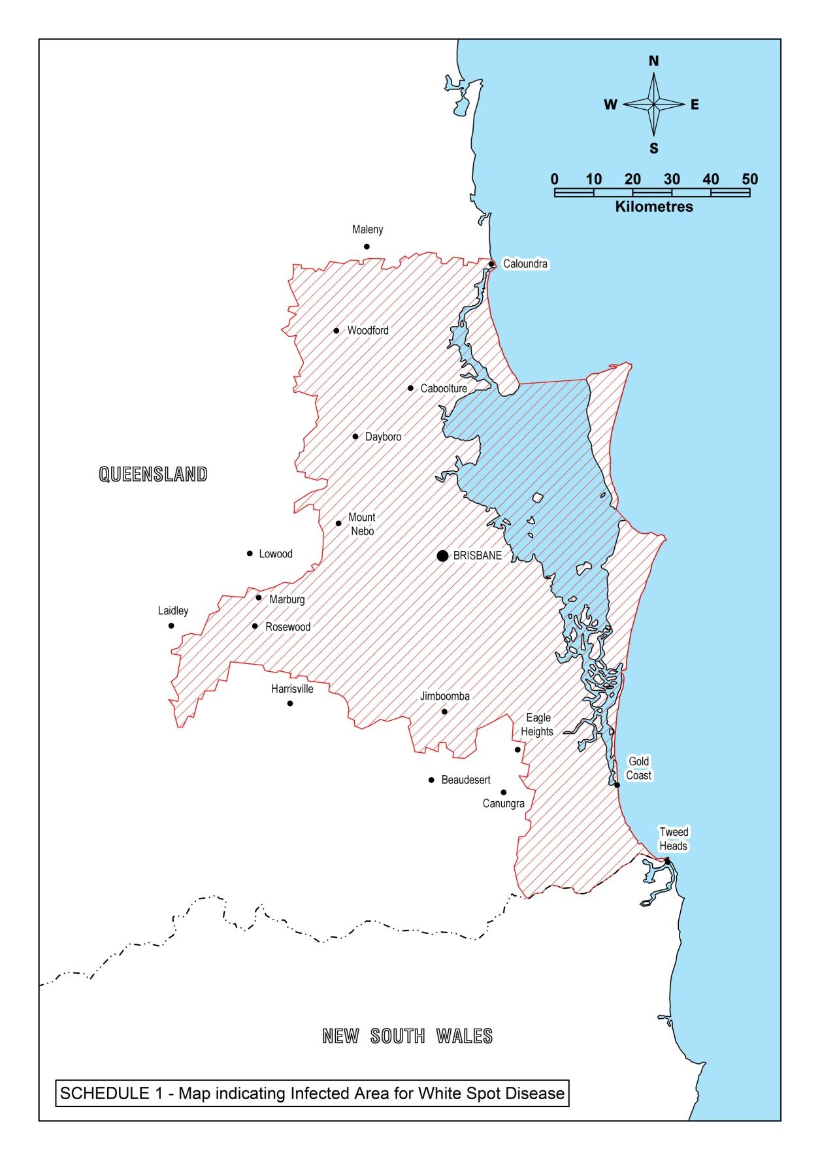

- NSW Control zone

