Australian Capital Territory
Planning (Belconnen) Minor Plan Amendment 2025 (No 1)
Notifiable instrument NI2025–233
made under the
Planning Act 2023, s 85 (Making minor plan amendments)

1 Name of instrument
This instrument is the Planning (Belconnen) Minor Plan Amendment 2025 (No 1).
2 Commencement
This instrument commences on the day after its notification day.
3 Minor plan amendment
I am satisfied under the Planning Act 2023, section 85 (1) that Minor Plan Amendment 2025-06 is a minor plan amendment to the Territory Plan.
4 Dictionary
In this section:
Minor Plan Amendment 2025-06 means the minor plan amendment to the Territory Plan in schedule 1.

Freya O’Brien
Delegate of the territory planning authority
1 May 2025

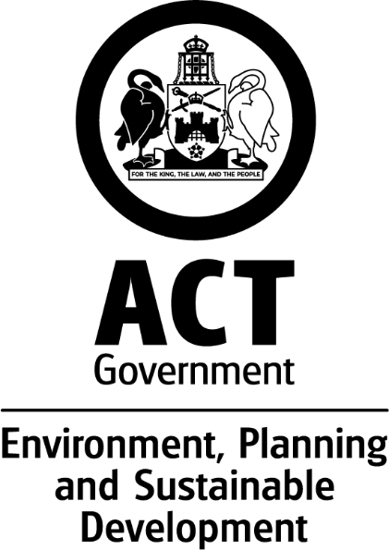

MINOR AMENDMENT
TO THE TERRITORY PLAN
2025-06
Amendments to Belconnen District Policy for Belconnen green waste facility

This minor plan amendment was prepared
under part 5.3 of the Planning Act 2023
Contents
1.0 INTRODUCTION 3
1.1 Outline of the process 3
1.2 Summary of the amendments 3
2.0 CONSULTATION WITH THE PUBLIC 4
2.1 Consultation period 4
2.2 Comments from the public 4
2.3 Changes made following public consultation 4
3.0 TERRITORY PLAN CHANGES 5
3.1 Belconnen District Policy 5
4.0 TERRITORY PLAN AMENDMENT INSTRUCTIONS 7
4.1 Part D: D02 – Belconnen District Policy 7
INTERPRETATION SERVICE 10

- INTRODUCTION
  - Outline of the process

Minor plan amendment 2025-06 (MA2025-06) to the Territory Plan is a minor plan amendment (MA) prepared under section 84 (1) (a) and section 84 (2) (d) of the Planning Act 2023 (the Act).

Section 84 of the Act outlines the different types of MAs, some which require limited consultation to be undertaken and some which require no consultation to be undertaken.

Under Section 85 of the Act an MA can only be made where:
- any required limited consultation has taken place and the authority is satisfied that the content of the MA meets the requirements of the Act.

- the MA is not inconsistent with the planning strategy or any relevant district strategy.

- any comments received during the consultation period and from the National Capital Authority have been considered.

This MA required limited consultation to be undertaken and was released for public consultation in accordance with the Act.

The MA is not inconsistent with the planning strategy or the Belconnen District Strategy.

The National Capital Authority has received a copy of this MA.

For more information on the content of the Territory Plan and minor plan amendment processes please refer to the Environment, Planning and Sustainable Development (EPSDD) website The Territory Plan - Environment, Planning and Sustainable Development Directorate - Planning (act.gov.au).
  - Summary of the amendments

MA2025–06 makes the following changes to the Belconnen District Policy:

- amend wording of provisions to clarify intent of the provisions and rectify incorrect figure references to ensure consistency with the previous concept plan,

- revise Assessment Requirement 92 to include Clearance Zone D for area 3, and

- revise Figure 20 to show the alternate amended clearance zone for the green waste drop off facility.
This reflects current and upcoming relocation of some waste management on the site.
- CONSULTATION WITH THE PUBLIC
  - Consultation period
Under section 84 (2) (d) of the Planning Act 2023, the relevant part of this minor amendment was subject to limited public consultation of at least 20 working days.

Written comments on MA2025-06 were invited from the public from 21 March 2025 to 17 April 2025.
  - Comments from the public
No formal written comments were received from the public on the MA.
  - Changes made following public consultation
The Authority made minor edits and corrections to the MA following consultation. These were made to correct a reference to Figure 21 in Assessment Requirement 90 (and not in Assessment Requirement 91 in the consultation version) and to improve the clarity of the changes to Assessment Requirement 92.
.
- TERRITORY PLAN CHANGES
  - Belconnen District Policy
Changes are made to the Control heading for Assessment Requirements 90-93, Assessment Requirements 90 and 92, and Figure 20. These changes are outlined below.
Control:
- Change ‘Control’ heading for Assessment Requirements 90-93 from “Lower Molonglo Water Quality Control Centre – Clearance Zones” to “Clearance Zones” as the provisions are not only for the LMWQCC requirements, but also Belconnen green waste facility requirements and restricted activities in the vicinity of the sewer vent.

Assessment Requirement 90
- include reference to Figure 21 to correctly align with the intent of the provision as articulated in the previous West Belconnen concept plan.

Assessment Requirement 92:

- Clarify that clearance zones can be adjusted or removed subject to an appropriate audit process and approval from the Environment Protection Authority.
- Add wording to explain that subject to EPA approval, Clearance Zone D (see amended Figure 20) will be operational when green waste delivery, handling, processing or stockpiling operations are occurring in area 3.
- Add wording after d) to clarify that the assessment requirement applies to any of the clearance zones.
- Amend the note to explain that clearance zones will cease or become redundant once functions have been relocated to another area.

Figures
- Amend Figure 20 to include the Clearance Zone D for area 3

Location map – location of green waste facility site in Belconnen
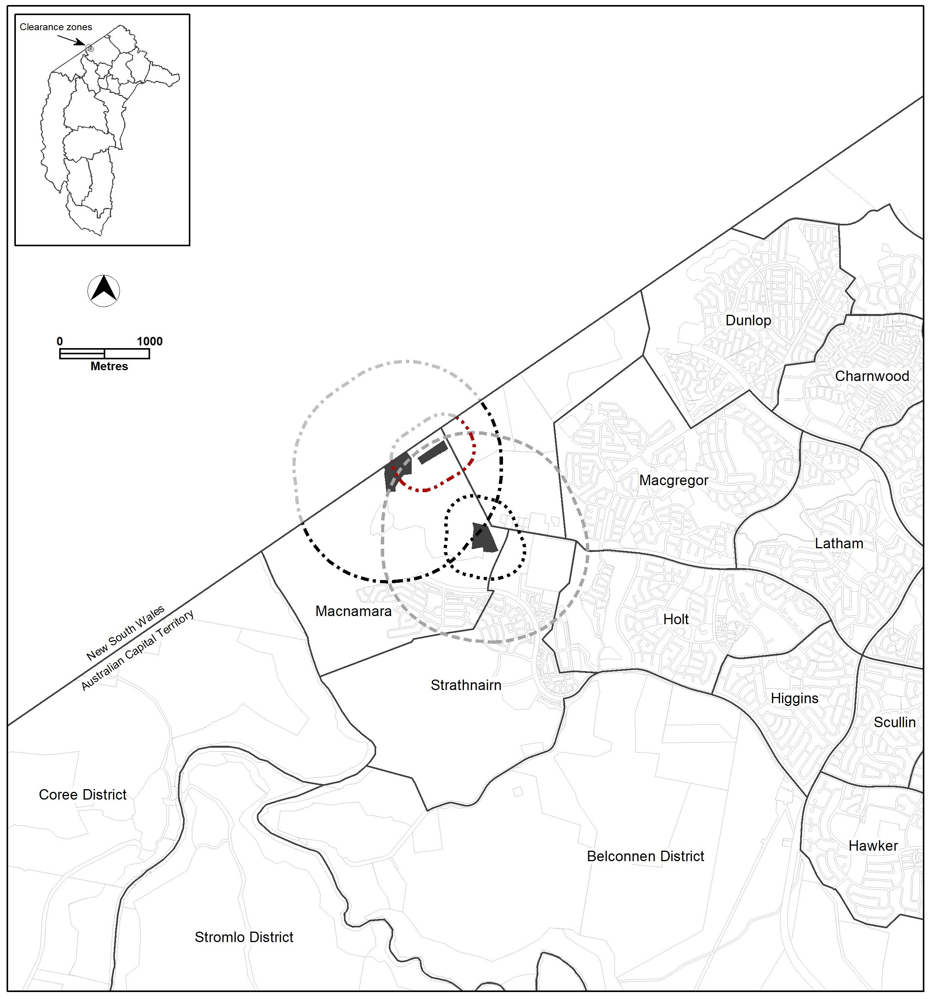

- TERRITORY PLAN AMENDMENT INSTRUCTIONS
  - Part D: D02 – Belconnen District Policy

Control

Delete

Lower Molonglo Water Quality Control Centre – Clearance Zones

Insert

Clearance Zones

Assessment Requirement 90

Substitute

In accordance with Figure 17, Figure 19 and Figure 21, no residential leases may be granted, and no community or sensitive uses are permitted within the clearance zones. Clearance Zones may be adjusted, subject to an appropriate audit process and approval from the Environmental Protection Authority.

Assessment Requirement 90

Hyperlink Figures 17, 19 and Figure 21 in the text with the corresponding figures.

Assessment Requirement 92

Substitute
In accordance with Figure 20, no residential leases may be granted within the clearance zones as per the following:
a) Clearance Zone A when green waste composing operations are occurring in area 1.
b) Clearance Zone B when green waste composting operation are occurring in area 2.
c) Clearance Zone C when waste delivery, handling, processing or stockpiling operations area occurring in area 1. Clearance zones may be adjusted or removed subject to an appropriate audit process and approval from the Environment Protection Authority.
d) Subject to EPA approval, Clearance Zone D when green waste delivery, handling, processing or stockpiling operations are occurring in area 3.

Clearance zones may be adjusted or removed subject to an appropriate audit process and approval from the Environment Protection Authority.

Note 1: Clearance Zone A (for area 1) will cease or become redundant once green waste composting operations have been relocated to area 2.
Note 2.:Clearance Zone C (for area 1) will cease or become redundant once green waste delivery, handling, processing or stockpiling operations have been relocated to area 3.

Assessment Requirement 92

Hyperlink Figure 20 in the text with the corresponding figure.

Figures

Substitute

Figure 20 West Belconnen – Clearance Map D

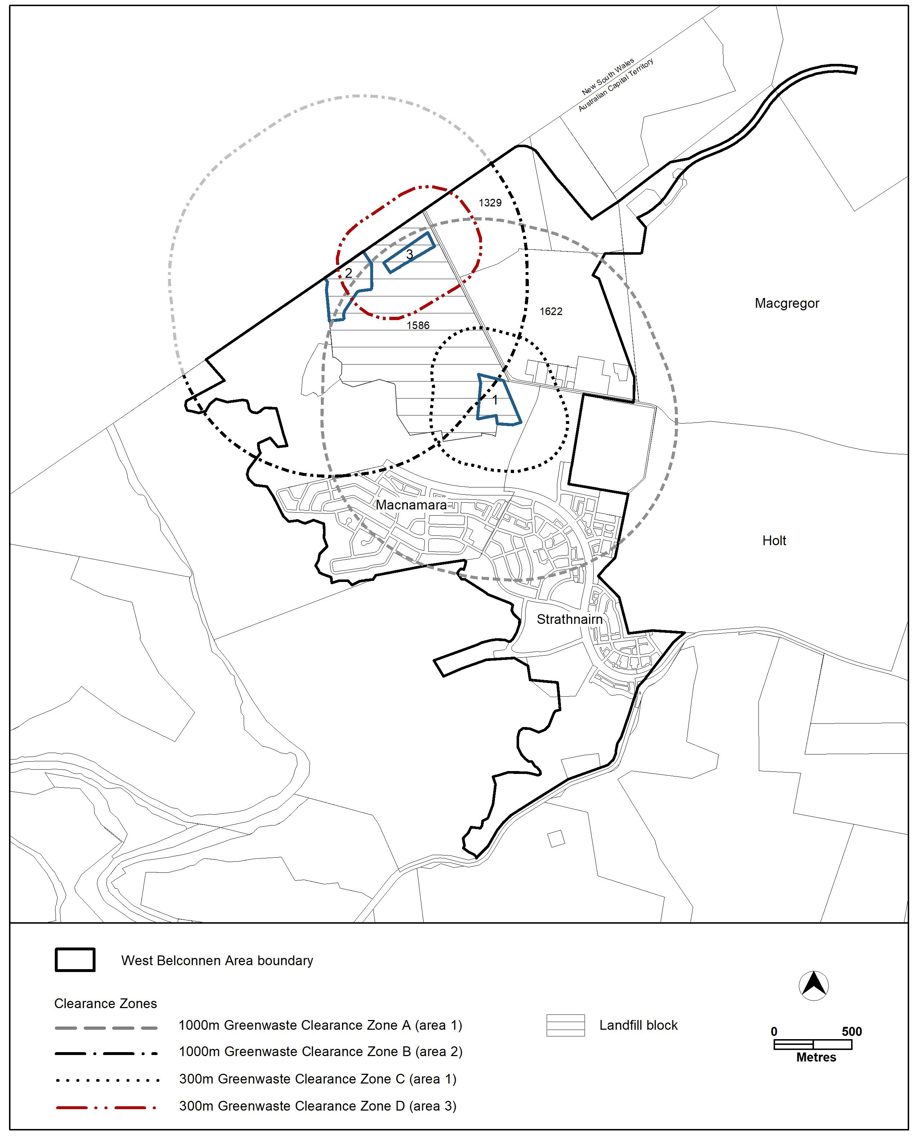
INTERPRETATION SERVICE
To speak to someone in a language other than English please telephone the Telephone Interpreter Service (TIS) 13 14 50
LANGUAGE | DETAILS
English | If you need an interpreter please call: 13 14 50
Mandarin (Simplified Chinese) / 简体中文 | 如果您需要翻译，请致电：13 14 50
Arabic / العربية | إذا كنت بحاجة إلى مترجم شفهي اتصل بالرقم: 50 14 13
Cantonese (Traditional Chinese) / 繁體中文 | 如果你需要傳譯員，請致電：13 14 50
Vietnamese /  Tiếng Việt | Nếu bạn cần thông dịch viên, xin gọi: 13 14 50
Korean / 한국어 | 통역사가 필요할 경우 다음 번호로 전화하시기 바랍니다: 13 14 50
Spanish / Español | Si necesita un intérprete, llame al 13 14 50
Persian (Farsi) / فارسی | اگر به مترجم نیاز دارید، لطفاً به این شماره تلفن کنید: 50 14 13
Dari / دری | اگر به یک ترجمان شفاهی نیاز دارید لطفاً به شمارۀ 131450 زنگ بزنید.
Punjabi / ਪੰਜਾਬੀ | ਜੇਕਰ ਤੁਹਾਨੂੰ ਕਿਸੇ ਦੁਭਾਸ਼ੀਏ ਦੀ ਲੋੜ ਹੈ ਤਾਂ ਕਿਰਪਾ ਕਰਕੇ ਫੋਨ ਕਰੋ: 13 14 50
Tamil / தமிழ் | உங்களுக்கு மொழிபெயர்த்துரைப்பாளர் ஒருவர் தேவைப்பட்டால் 13 14 50 என்ற எண்ணை அழைக்கவும்
Greek / Ελληνικά | Αν χρειάζεστε διερμηνέα, τηλεφωνήστε: 13 14 50
Italian / Italiano | Se hai bisogno di un interprete, chiama: 13 14 50
Hazaragi / هزاره گی | اگه ده ترجمان ضرورت ده رید، لطفاً ده شماره 50 14 13 تماس بگیرید.
Thai / ภาษาไทย | หากคุณต้องการล่าม กรุณาโทรไปที่ 13 14 50
Karen / ကညီကျိၥ် | ဖဲနမ့ၢ်လိၣ်ဘၣ်ပှၤကတိၤကျိးထံတၢ်တဂၤအခါ၀ံသးစူၤကိးဘၣ်-၁၃၁ ၄၅၀ တက့ၢ်.

Telephone and Interpreter Service 13 14 50 - Canberra and District - 24 hours a day, seven days a week

