Australian Capital Territory
Planning (Fraser) Major Plan Amendment 2025*

Notifiable instrument NI2025-286

made under the
Planning Act 2023, s 75 (Minister’s powers in relation to draft plan amendments)

1 Name of instrument
This instrument is the Planning (Fraser) Major Plan Amendment 2025.
2 Major plan amendment
(1) I approve under section 75 (2) (a) of the Planning Act 2023 (the Act) the Major Plan Amendment 01 to the Territory Plan.
(2) In accordance with the Act, section 75 (5) (c), a major plan amendment must be presented to the Legislative Assembly and may only commence by commencement notice under section 80 (2).
3 Dictionary
In this instrument:
Major Plan Amendment 01 to the Territory Plan means the Major Plan Amendment in schedule 1.

Chris Steel MLA
Minister for Planning and Sustainable Development
3 June 2025

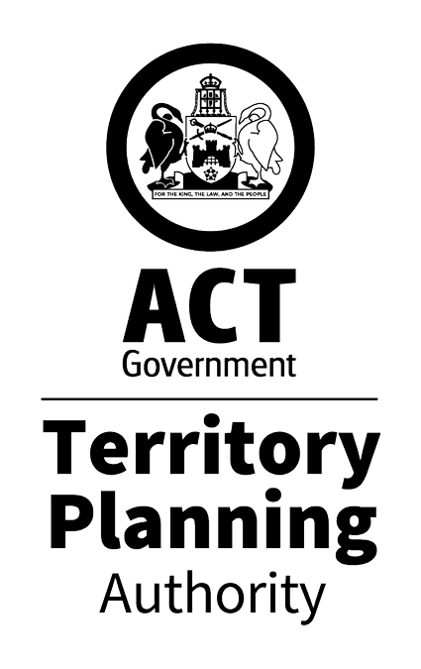

MAJOR PLAN AMENDMENT
to the
TERRITORY PLAN 01

Fraser School
Change of zoning from NUZ3 to CFZ
for
Part Block 6 Section 64 Fraser

May 2025

This draft major plan amendment was prepared
under division 5.2.7 of the Planning Act 2023
Contents
1.0 Introduction 1
1.1 Purpose 1
1.2 Outline of process 1
2.0 Summary of MPA-01 2
2.1 Site description 2
2.2 Summary of amendments to the Territory Plan 4
3.0 REASONS FOR THE MAJOR PLAN AMENDMENT 5
4.0 CONSULTATION 6
4.1 Consultation with entities 6
4.2 Consultation with the public 6
5.0 MAJOR PLAN AMENDMENT 01 7
5.1 Amendment to the Territory Plan Map 7
5.2 Amendment to the Belconnen District Policy 8
INTERPRETATION SERVICE 9

- Introduction
  - Purpose
This document is major plan amendment 01 – Fraser School (MPA-01) to the Territory Plan.

Key parts of this document are:
- section 2 – summarises the MPA, including amendments to the Territory Plan and associated documents
- section 3 – why this MPA was undertaken
- section 5 – detailed amendment instructions to the Territory plan proposed by this MPA.

  - Outline of process
A major plan amendment (MPA) is a statutory process under the Planning Act that enables the Territory Plan to be amended. The three types of MPAs are:
- Proponent-initiated
- Authority-initiated
- Minister-initiated

MPA-01 was an authority-initiated MPA.

Under section 63 of the Planning Act, the Authority made MPA-01 available for public comment from 9 December 2024 to 21 February 2025. Following consultation, the Authority considered whether to revise or withdraw a DPA.

After consultation concluded, the Authority considered the comments and gave DPA-01 to the Minister for referral to the relevant Legislative Assembly Standing committee (the Standing Committee). The Standing Committee did not prepare a report in relation to DPA-01.

With the above complete, and in considering the background papers, the ACT Planning Strategy 2018 and the Belconnen District Policy, the Minister for Planning and Sustainable Development approved MPA-01.

The Minister must now present MPA-01 to the Legislative Assembly who may reject it completely or partly. If passed by the Legislative Assembly, the MPA may commence and become part of the Territory Plan.

A commencement notice or rejection notice will be published on the major plan amendment webpage.

For more information about the content of the Territory Plan and the major plan amendment processes please refer to the Environment, Planning and Sustainable Development (EPSDD) website.

- Summary of MPA-01
This section summarises:
- the amendments MPA-01 made to the Territory Plan and supporting documents
- outlines the relevant subject area

Amendments to the Territory Plan by this MPA are summarised in section 2.2 and shown in detail at section 5 of this document.
  - Site description
The subject site is located at part Block 6 Section 64 Fraser in the Belconnen District (figure 1). The site is currently zoned NUZ3 Hills, Ridges and Buffer (figure 2).

The site adjoins the Fraser Primary School and comprises part Block 2 Section 40 Fraser (see figure 1). The block is a large open space (64.29 hectares) which extends across the northern parts of Fraser and Dunlop and includes peripheral open space, near Tillyard Drive and Shakespeare Crescent, and parts of the Dunlop Grasslands Nature Reserve, to the northwest of Fraser.

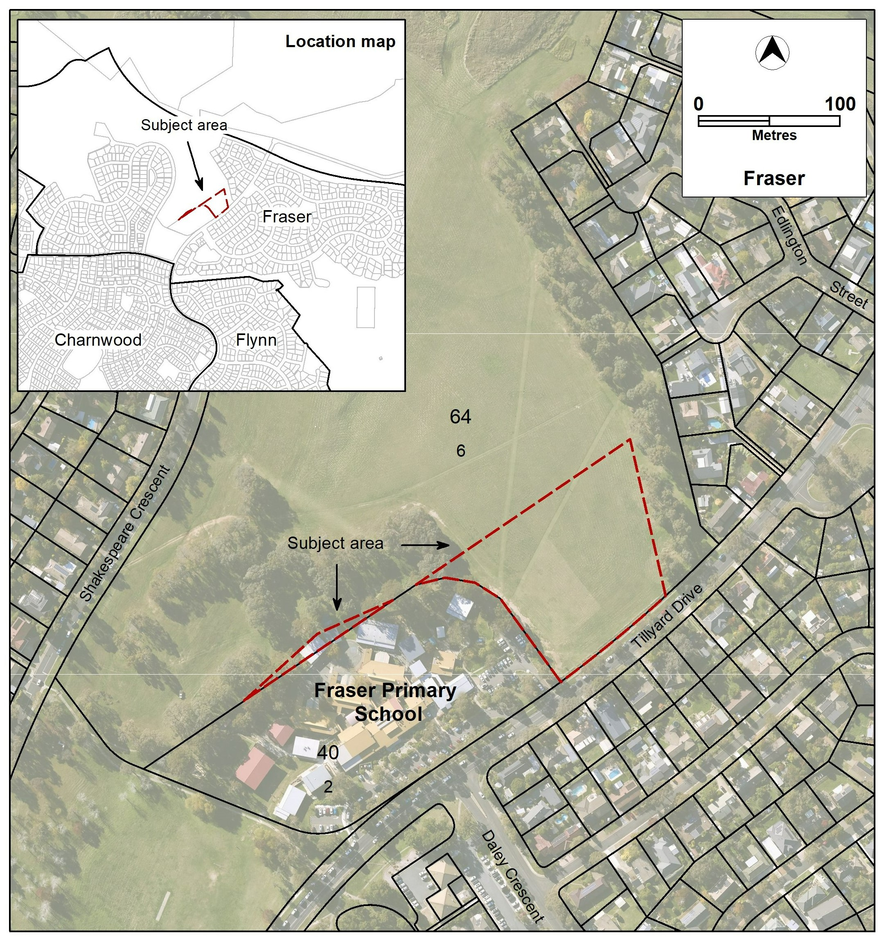
Figure 1 – Location Map
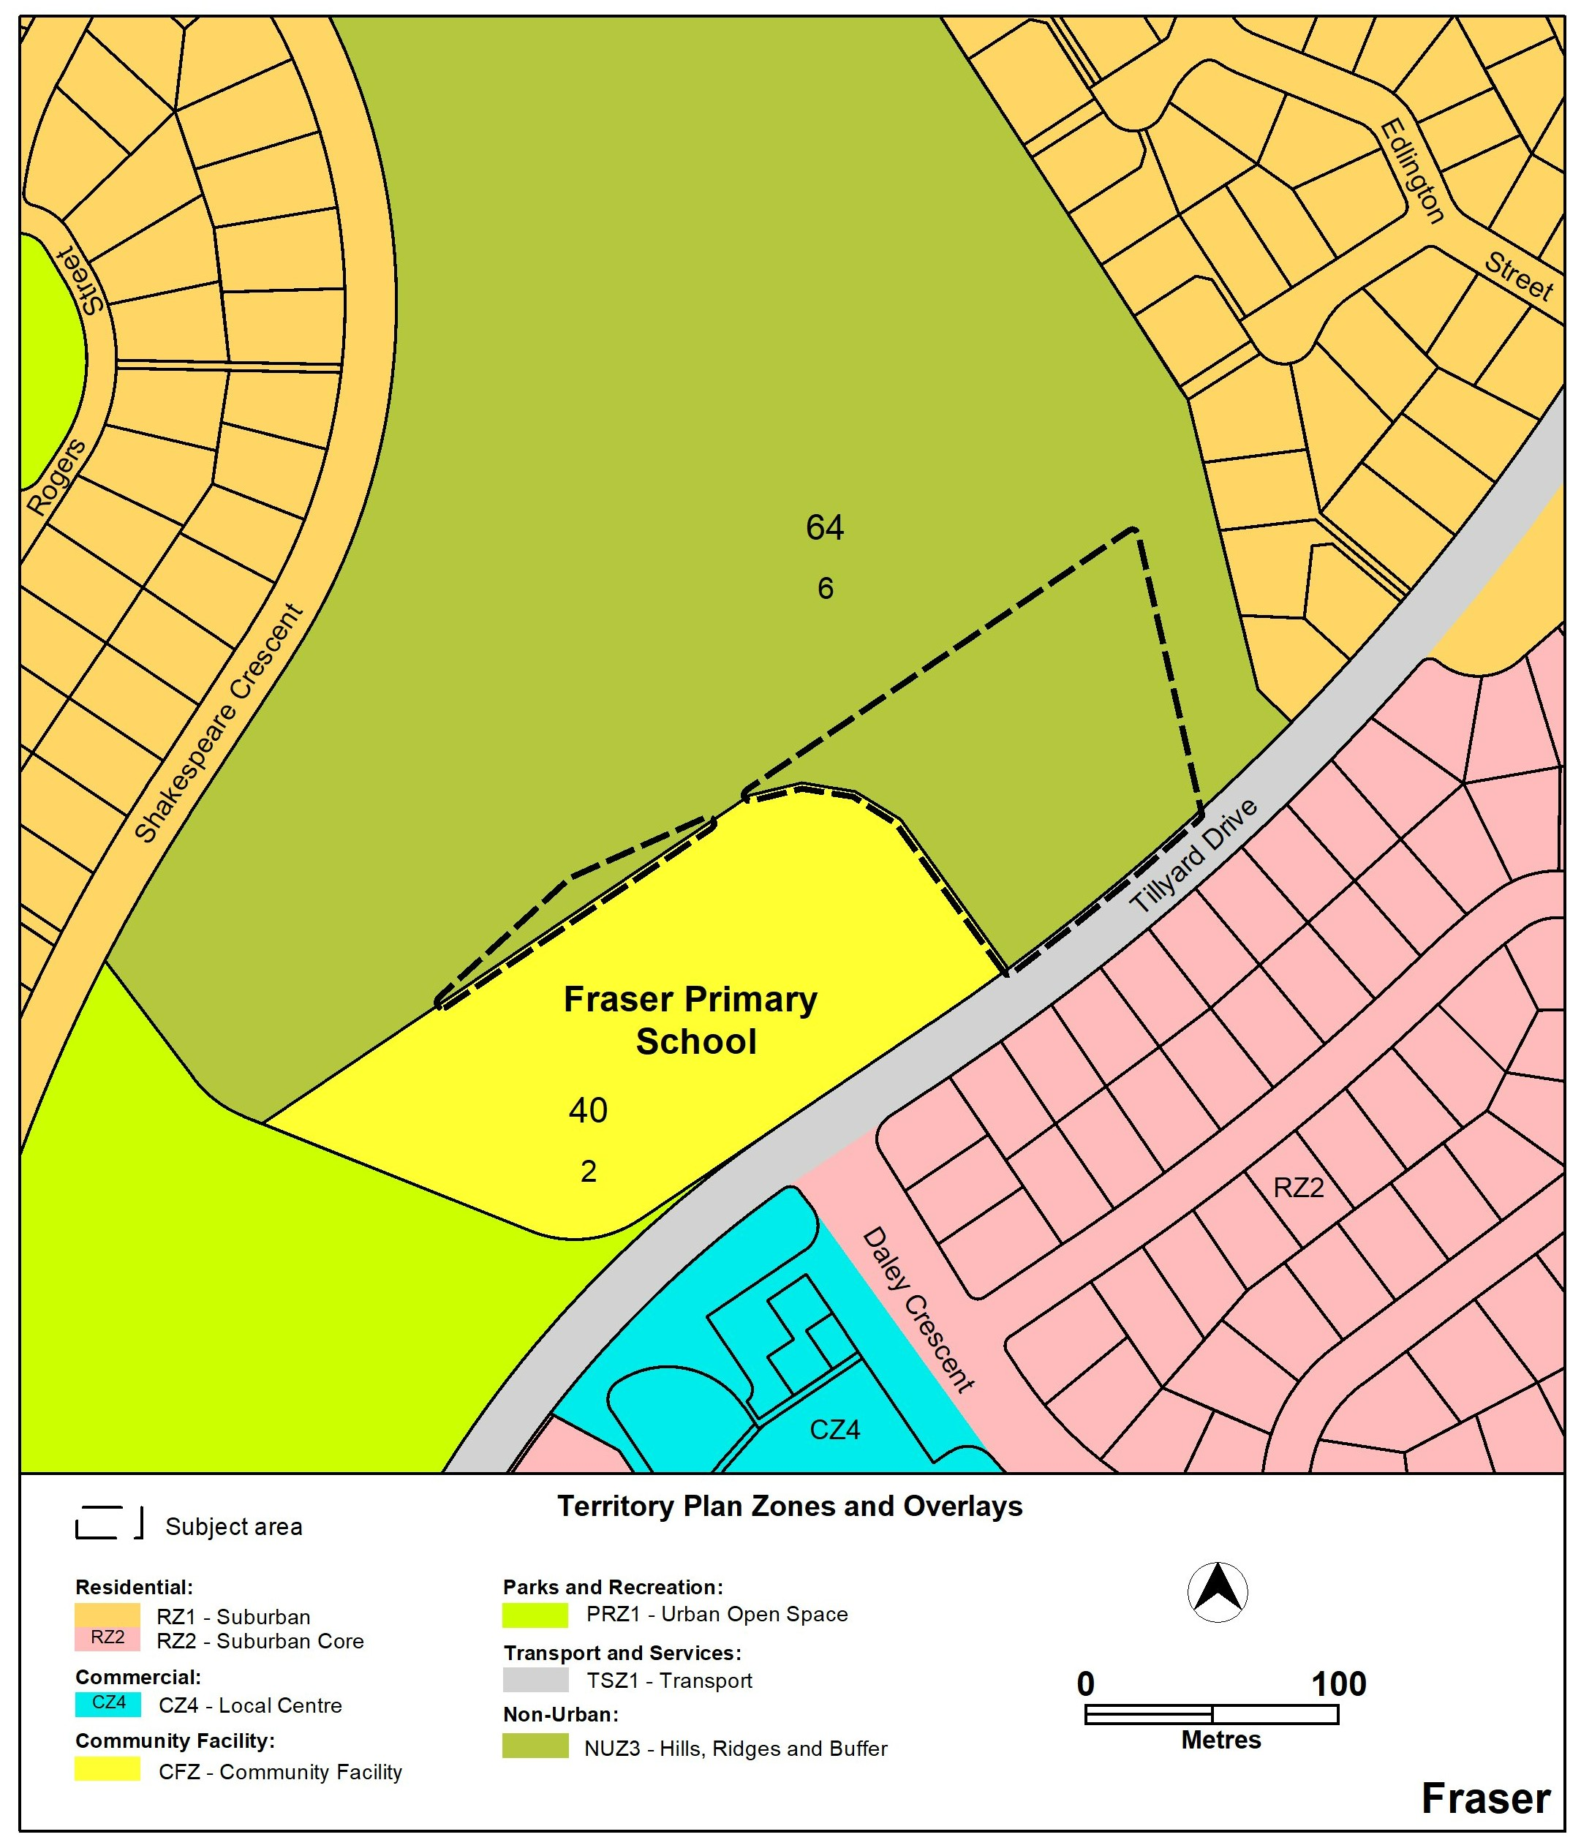
Figure 2 – Existing Territory Plan Zoning

  - Summary of amendments to the Territory Plan
MPA-01 amends the Territory Plan by rezoning part Block 6 Section 64 Fraser from NUZ3 Hills, Ridges and Buffer to Community Facility to enable the site to be used to expand the Fraser Primary School (see figure 3 below). The area being rezoned is mostly on the north-eastern side of the school, but also a small area on the north-western side to regularise the zoning of the buildings located on that boundary.

MPA-01 amends the Belconnen District Policy to prohibit retirement village and supportive housing on the area rezoned to Community Facility. These uses are prohibited on the current school site. The change incorporates the prohibition of these uses both for the existing school site and the areas to be rezoned into the school site into a map, rather than referring to block and section numbers (see figure 24A below).

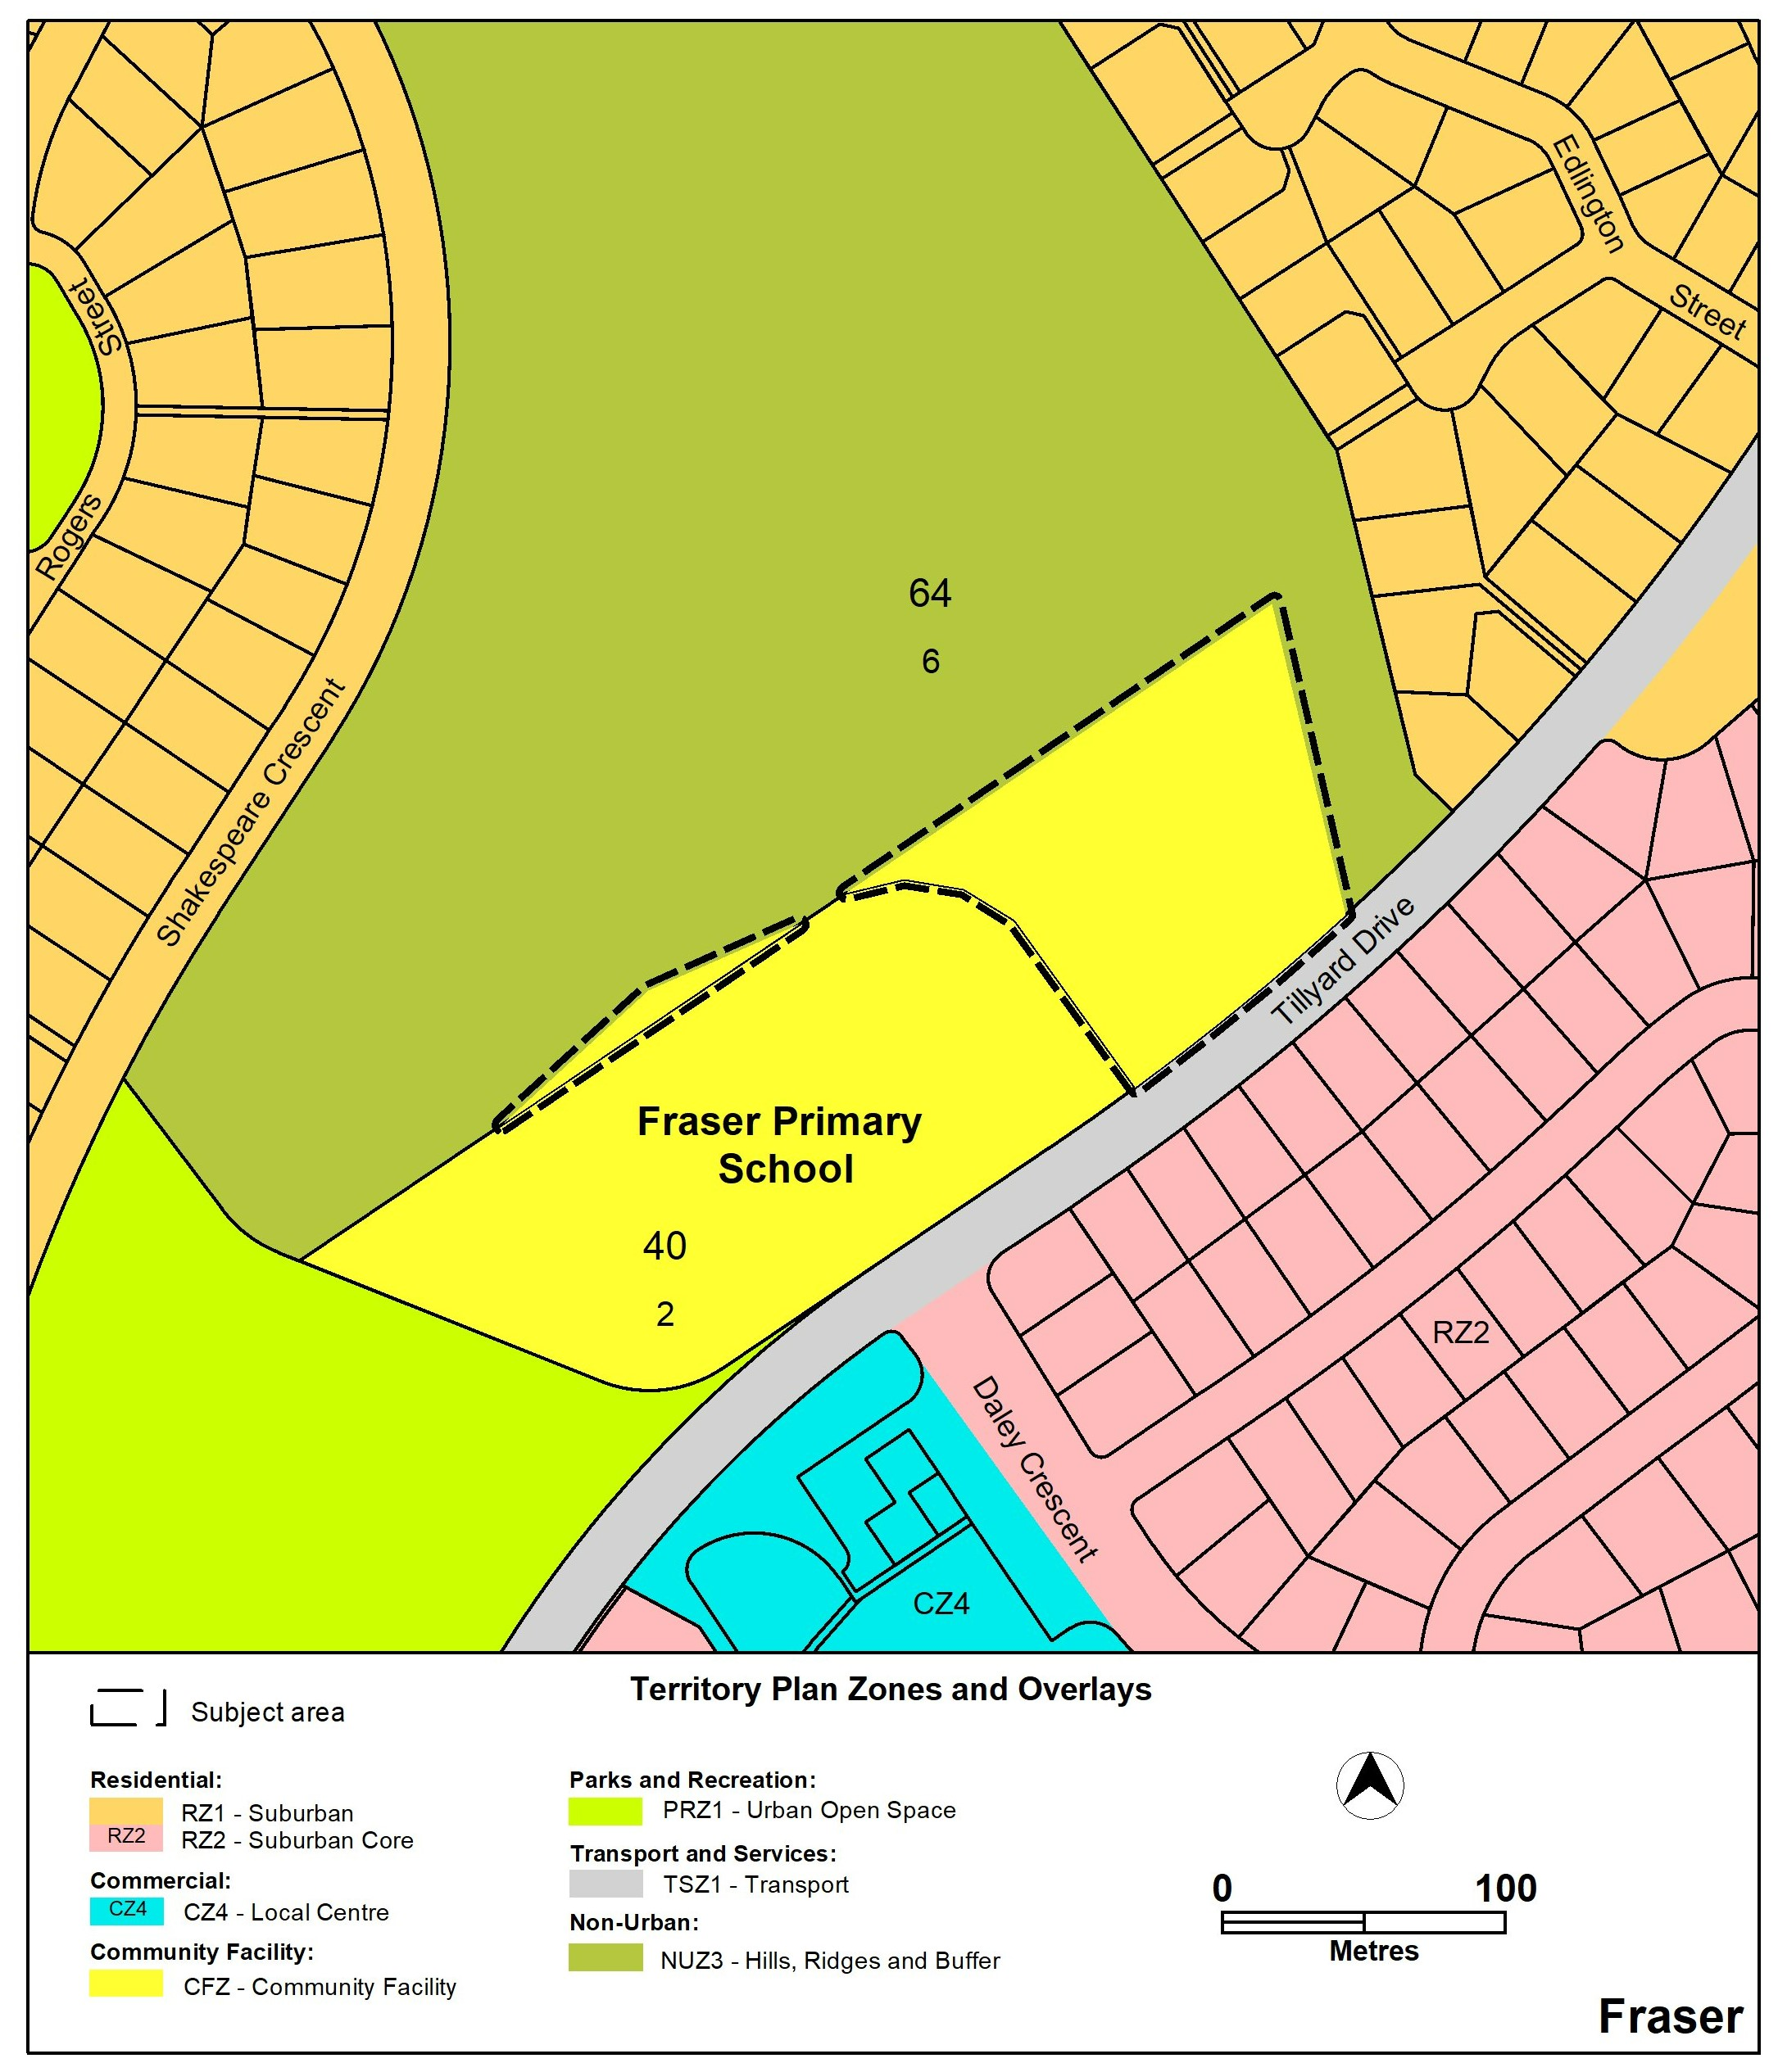
Figure 3 – Proposed Territory Plan zoning
- REASONS FOR THE MAJOR PLAN AMENDMENT
Fraser Primary School is situated within an existing block of approximately 2.6 ha. Responding to increases in enrolment demand from the local Priority Enrolment Area, school facilities have been expanded incrementally over several years. New teaching spaces have been accommodated within the existing block and this, in turn has reduced the available outdoor space.

The school reports an increase in requirements for teacher supervision during break times due to line-of-site issues related to disconnected available play spaces. There is also pressure on the existing outdoor spaces within the school grounds due to the number of children accessing and playing on the area daily. An increase in the area of available outdoor space will improve the ability for students and staff to access outdoor space for learning and play.

The rezoning will enable the required expansion of the school site within the Community Facility zone. The proposal also regularises the zoning of existing structures located to the north-west of Block 2 Section 40.

- CONSULTATION
  - Consultation with entities
In accordance with section 62 of the Planning Act the Authority must consult with each of the following in relation to this MPA:
- the National Capital Authority
- the Conservator of Flora and Fauna
- the Environment Protection Authority
- the Heritage Council
- each referral entity
- if unleased or leased public land, each custodian of the land likely to be affected.
  - Consultation with the public
Written comments were invited from the public on this MPA from 9 December 2024 to 21 February 2025.

One comment was received during the public consultation period which supported the proposed rezoning, traffic recommendations and made suggestions for safer streetside parking.

Comments received from the public during the consultation period were considered by the Minister in approving this MPA.

- MAJOR PLAN AMENDMENT 01
This section details how MPA-01 proposes to amend the Territory Plan.
  - Amendment to the Territory Plan Map
The relevant part of the Territory Plan map is varied in accordance with Figure 3.

Figure 3 –Territory Plan Map
  - Amendment to the Belconnen District Policy

A. Land Use Table; Locality; Fraser; Relevant parcel or Figure
Omit

Block 2 Section 40

Insert with hyperlink to Figure 24A

PD1 Figure 24A

B. Figures – Assessable and Prohibited Development; Figure 24
Insert with hyperlink to Land Use Table

Figure 24A Fraser
Link back to Land Use Table

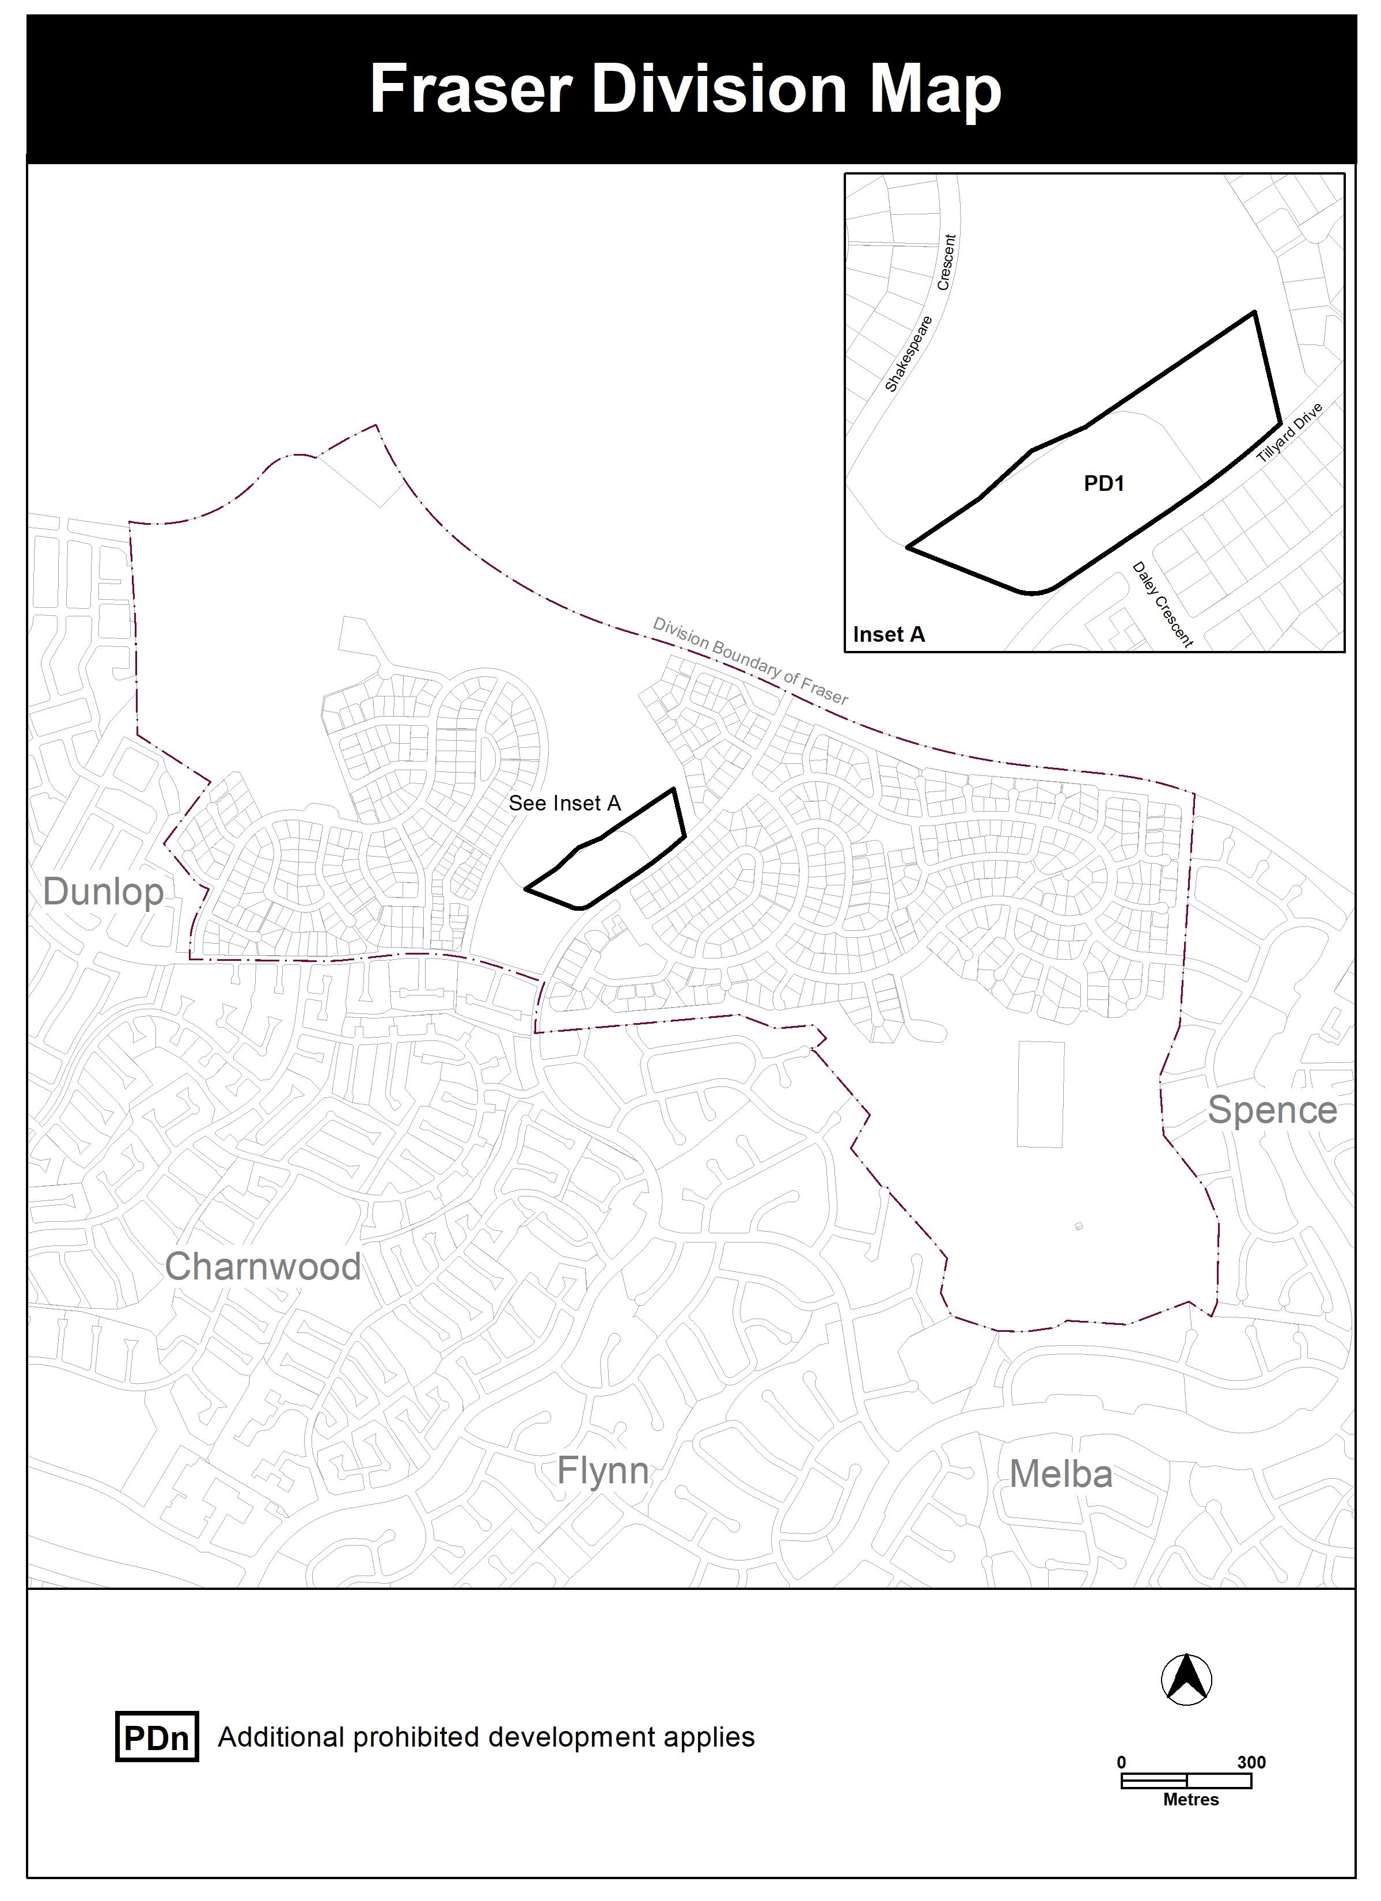
INTERPRETATION SERVICE
To speak to someone in a language other than English please telephone the Telephone Interpreter Service (TIS) 13 14 50
LANGUAGE | DETAILS
English | If you need an interpreter please call: 13 14 50
Mandarin (Simplified Chinese) / 简体中文 | 如果您需要翻译，请致电：13 14 50
Arabic / العربية | إذا كنت بحاجة إلى مترجم شفهي اتصل بالرقم: 50 14 13
Cantonese (Traditional Chinese) / 繁體中文 | 如果你需要傳譯員，請致電：13 14 50
Vietnamese /  Tiếng Việt | Nếu bạn cần thông dịch viên, xin gọi: 13 14 50
Korean / 한국어 | 통역사가 필요할 경우 다음 번호로 전화하시기 바랍니다: 13 14 50
Spanish / Español | Si necesita un intérprete, llame al 13 14 50
Persian (Farsi) / فارسی | اگر به مترجم نیاز دارید، لطفاً به این شماره تلفن کنید: 50 14 13
Dari / دری | اگر به یک ترجمان شفاهی نیاز دارید لطفاً به شمارۀ 131450 زنگ بزنید.
Punjabi / ਪੰਜਾਬੀ | ਜੇਕਰ ਤੁਹਾਨੂੰ ਕਿਸੇ ਦੁਭਾਸ਼ੀਏ ਦੀ ਲੋੜ ਹੈ ਤਾਂ ਕਿਰਪਾ ਕਰਕੇ ਫੋਨ ਕਰੋ: 13 14 50
Tamil / தமிழ் | உங்களுக்கு மொழிபெயர்த்துரைப்பாளர் ஒருவர் தேவைப்பட்டால் 13 14 50 என்ற எண்ணை அழைக்கவும்
Greek / Ελληνικά | Αν χρειάζεστε διερμηνέα, τηλεφωνήστε: 13 14 50
Italian / Italiano | Se hai bisogno di un interprete, chiama: 13 14 50
Hazaragi / هزاره گی | اگه ده ترجمان ضرورت ده رید، لطفاً ده شماره 50 14 13 تماس بگیرید.
Thai / ภาษาไทย | หากคุณต้องการล่าม กรุณาโทรไปที่ 13 14 50
Karen / ကညီကျိၥ် | ဖဲနမ့ၢ်လိၣ်ဘၣ်ပှၤကတိၤကျိးထံတၢ်တဂၤအခါ၀ံသးစူၤကိးဘၣ်-၁၃၁ ၄၅၀ တက့ၢ်.

Telephone and Interpreter Service 13 14 50 - Canberra and District - 24 hours a day, seven days a week

