Australian Capital Territory
Heritage (Decision about Provisional Registration of Erindale Brick Banks) Notice 2025
Notifiable instrument NI2025–329
made under the
Heritage Act 2004, s 34, (Notice of decision about provisional registration)

1 Name of instrument
This instrument is the Heritage (Decision about Provisional Registration of Erindale Brick Banks, Wanniassa) Notice 2025.
2 Commencement
This instrument commences on the day after its notification day.
3 Decision about provisional registration
On 24 June 2025, the ACT Heritage Council (the council) decided to provisionally register Erindale Brick Banks, Block 49, Section 132, Wanniassa (the place).
4 Registration details of the place
The registration details of the place are in the schedule.
5 Reasons for the decision
The council decided to provisionally register the place because it is satisfied on reasonable grounds that it is likely to have heritage significance as it is likely to meet one or more of the heritage significance criteria under the Heritage Act 2004, section 10. A detailed statement of reasons, including an assessment against the heritage significance criteria, is provided in the schedule.
6 Date of provisional registration
The date of provisional registration is 25 June 2025 (being the day after the council entered into the heritage register the registration details for the place together with an indication that the registration is provisional).
7 Indication of the council’s intention
The council intends to decide whether to register the place under the Act, division 6.2 during the period of provisional registration.
8 Invitation to make written comments during public consultation period
(1) The council invites written comments about the registration of the place. Any written comments must be made within 4 weeks after the day this notice is notified.
(2) Written comments can be provided to the council by the following methods:
(a) mail to
The Secretary
ACT Heritage Council
480 Northbourne Avenue
DICKSON ACT 2602
(b) email to heritage.registrations@act.gov.au

Mary Clare Swete Kelly
A/g Secretary
ACT Heritage Council
24 June 2025

Schedule

(See sections 4 and 5)


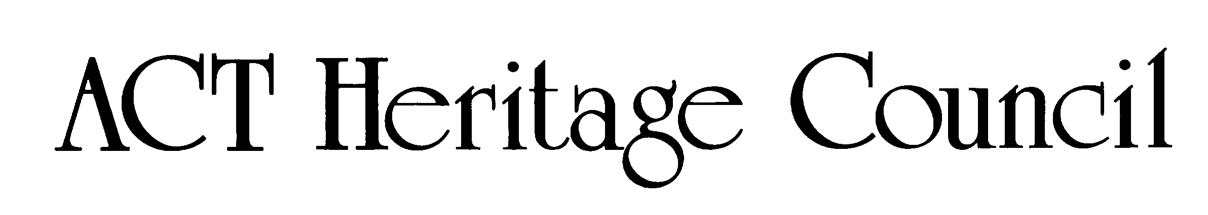
AUSTRALIAN CAPITAL TERRITORY
HERITAGE REGISTER
Provisional Registration
For the purposes of s33 of the Heritage Act 2004, a provisional entry to the heritage register has been prepared by the ACT Heritage Council for the following place:

ERINDALE BRICK BANKS
BLOCK 49 SECTION 132, WANNIASSA
DATE OF DECISION
24 June 2025
DATE OF PROVISIONAL REGISTRATION
25 June 2025 Notifiable Instrument: 2025–
PERIOD OF EFFECT OF PROVISIONAL REGISTRATION
Start Date: 25 June 2025 End Date: 24 November 2025
Extended Period (if applicable) Start Date ________ End Date ________
Copies of the Register Entry are available for inspection at ACT Heritage. For further information please contact:
The Secretary
ACT Heritage Council
480 Northbourne Avenue
DICKSON ACT 2602
Telephone 13 22 81

Statement of Heritage Significance
This statement refers to the heritage significance of the place as required in s12(d) of the Heritage Act 2004.
The Erindale Brick Banks (the Brick Banks) at the Erindale Skatepark are significant for their contribution to the early history of skateboarding in Canberra from the 1970s. The Brick Banks demonstrate the evolution and continuous use of skateboarding facilities in Canberra and Australia from slalom to street and park skateboarding from the 1970s to the present day.
They are a rare example of an intact ‘found’ space, that is, a place appropriated by skateboarders who provide stewardship for the facility. This ‘found’ place and its use by the skateboarding community was recognised by the National Development Commission (NCDC) in line with government policies for youth activities.
The Brick Banks are significant for the combination of slope and angles of the adjacent path together with multiple brick banks of a height, slope and angle that are challenging skateable elements, within a landscape setting of bush, street and urban materials.

Location of the Place
Erindale Brick Banks, also known as ‘The Brick Banks’, ‘Erindale Banks’, ‘The Banks’, ‘The Snake Pit’, Block 49, Section 132, Grattan Court, Wanniassa.
This statement refers to the name and location of the place as required in s12(a) and s12(b) of the Heritage Act 2004.

Description of the Place
Erindale Brick Banks have the following attributes of significance:
The Erindale Brick Banks are located along a pedestrian path connecting Sternberg Crescent to the Erindale College and shops, to the south. The Brick Banks, within the wider Erindale Skatepark, are accessible via Grattan Court to the east, and Cremean Close to the west, and by pedestrian paths to Sternberg Crescent to the north.
The Brick Banks form part of the original landscaping of the Wanniassa Community College, appearing on development plans from 1975 and shown in aerial photographs. They are located immediately north of the Erindale College main building.

The Brick Banks were constructed as retaining walls beneath a grove of trees from the site of the former Erindale Homestead that were retained by the National Capital Development Commission (NCDC).
The Brick Banks themselves are constructed of brick with curved capping, undulating with the terrain, and serve as retaining walls, allowing for a gentle slope from the street into the site for pedestrians. This statement refers to the description of the place as required in s12(c) of the Heritage Act 2004. The attributes described in this section form part of the heritage significance of the place. For the purposes of s12(c) of the Heritage Act 2004, the registration boundary of the place is at Figure 1.

Conservation Objective
The guiding conservation objective is that the Erindale Brick Banks shall be conserved and appropriately managed in a manner respecting its heritage significance.
The ACT Heritage Council may adopt heritage guidelines applicable to the place under s25 of the Heritage Act 2004.
For further information on guidelines applicable to the place, or for advice on proposed works or development, please contact ACT Heritage via email at heritage@act.gov.auor via 13 22 81.

Reason for Provisional Registration
The Council has assessed the Erindale Brick Banks against the heritage significance criteria and is satisfied that the place is likely to have heritage significance when assessed against criteria (a) and (g) under s10 of the Heritage Act 2004. A place is considered to have heritage significance if it meets one or more of the criteria.
Table 1 Criteria that the Council consider have been met.
Criterion | (a) | (b) | (c) | (d) | (e) | (f) | (g) | (h)
Met | Yes | No | No | No | No | No | Yes | No
This statement refers to the heritage significance of the place as required in s12(d) of the Heritage Act 2004.

Assessment Against the Heritage Significance Criteria
This statement refers to the heritage significance of the place as required in s12(d) of the Heritage Act 2004.
The Council’s assessment against the criteria specified in s10 of the Heritage Act 2004 is as follows.
In assessing the heritage significance of the Erindale Brick Banks, the Council considered:
- the original nomination and documentary evidence supplied by the nominator
- the Council’s Heritage Assessment Policy (March 2018)
- information provided by a site inspections on 18/05/24, 24/05/24 and 03/07/24 by ACT Heritage
- the report by ACT Heritage titled, Background Information Erindale Brick Banks, March 2025, containing photographs and information on history, description, condition and integrity.
Pursuant to s10 of the Heritage Act 2004, a place or object has heritage significance if it satisfies one or more of the following criteria. Future research may alter the findings of this assessment.

(a) importance to the course or pattern of the ACT’s cultural or natural history
MEETS CRITERION.
The Council has assessed Erindale Brick Banks against criterion (a) and is satisfied that the place is likely to meet this criterion.
The Erindale Brick Banks at the Erindale Skatepark have a clear association with Canberra’s skateboarding community and demonstrate the course of the ACT’s cultural skateboarding history for more than 40 years – a period covering the introduction of skateboarding to Canberra in the 1970s to the present day. This association is evident in the original fabric which has been maintained and curated by the skateboarding community, the documentary resources maintained by the Canberra Skateboarding Association and the community and the continual influence of the place on Canberra’s skateboarding community and facilities. The development of the site in the 1970s and its expansion in the 1980s and 1990s demonstrate recognition by the National Capital Development Commission (NCDC) and the ACT Government of the use of the Brick Banks by skateboarders and young people, incorporating them into a formal skatepark.
The site emerged at a pivotal time in skateboarding’s history in Canberra and retains its relevance today. The site has an association with a period of the National Capital Development Commission’s early adoption of skateboarding and its policy that actively planned facilities catering to youth in the new suburbs of Tuggeranong and actively promoted facilities for skateboarding in Canberra from the 1970s. This cultural history is evident in the documentary evidence of photographs, ephemera and mobilisation of organised groups such as the Canberra Skateboarding Association and Canberra Region Old School Skateboarders (CROSS) and is representative of youth culture movement and youth culture in action in Canberra.
The Brick Banks represent an intact example of the evolution of skateboarding in the cultural history of the ACT from the early slalom style to street skating ‘found’ places, skating architectural features including challenging vertical elements and as skateboarding culture in the ACT developed. As a seminal and aspirational skate spot and skate tourism destination, the Brick Banks have provided a distinctive location for novices through to advanced skateboarders, inline skaters, BMX and scooter riders, to develop skills and have made an influential contribution to the sport of skateboarding in the ACT - including by Olympic team members. The Brick Banks are iconic within the Canberra, interstate and international skateboarding communities. They contribute to Canberra’s reputation for landmark skateboarding infrastructure with a lengthy and continuous community and cultural association which has influenced the course of skateboarding in the ACT. As an early skateboarding place, the banks have seen adaptation and change over time, demonstrating scope for ongoing modification.
The Erindale Brick Banks are a site of cultural significance to the skateboarding community who value the location, setting and form of the brick retaining walls that have been adopted as an unusual skateboarding surface. The slope and angle of the walls together with height and angle of entry are valued for the contribution they have made for skateboarders in Canberra since the 1970s. The significance of the banks is a product of their origins, form, location and their adaptability over time, together with their enduring contribution to the Canberra skateboarding community.

(b) has uncommon, rare or endangered aspects of the ACT’s cultural or natural history
Does not meet criterion.
The Council has assessed Erindale Brick Banks against criterion (b) and is not satisfied that the place is likely to meet this criterion.
The Erindale Brick Banks have a clear association with Canberra’s skateboarding community and have made an influential contribution to skateboarding in the ACT, however this association is not rare and endangered in the context of other skateboarding locations in the ACT including Charnwood, Kambah, Tuggeranong, Belconnen and Civic and does not meet the threshold required under this criterion.

(c) potential to yield important information that will contribute to an understanding of the ACT’s cultural or natural history
Does not meet criterion.
The Council has assessed Erindale Brick Banks against criterion (c) and is not satisfied that the place is likely to meet this criterion.
The site of the Erindale Brick Banks was substantially altered in the 1960s and 1970s as shown in aerial photographs, in preparation for the development of Erindale Group Centre and has remained substantially unaltered since the late 1970s and early 1980s. The trees under which the Brick Banks are located are remnants of the Erindale Homestead.
The Brick Banks relate to the early adoption of skateboarding in Canberra by the NCDC who actively explored options for skateboarding by examining best practice in Australia and New Zealand in the 1970s. While the Brick Banks are part of this history, the fabric of the site is unlikely to provide additional information that is not available from other locations or sources.

(d) importance in demonstrating the principal characteristics of a class of cultural or natural places or objects
Does not meet criterion.
The Council has assessed Erindale Brick Banks against criterion (d) and is not satisfied that the place is likely to meet this criterion.
To date, no study of skateboarding in the ACT has been published which could provide a relevant understanding of the class of skateboarding facilities in Canberra. Whilst research has provided evidence of policy and infrastructure provision in the 1970s and 1980s, an audit and assessment of existing skateboarding facilities has not been undertaken. This work could provide a valuable contribution in the future.

(e) importance in exhibiting particular aesthetic characteristics valued by the ACT community or a cultural group in the ACT
Does not meet criterion.
The Erindale Brick Banks are not assessed as having aesthetic characteristics valued by the wider ACT community. The Brick Banks are valued by the past and present skateboarding community because their planning and design coincidentally facilitates a challenging style of street skating not found in other locations, to this degree. This is not a particular aesthetic characteristic, but rather a characteristic of the existing built environment.

(f) importance in demonstrating a high degree of creative or technical achievement for a particular period
Does not meet criterion.
The Council has assessed Erindale Brick Banks against criterion (f) and is not satisfied that the place is likely to meet this criterion.
The fabric of the Brick Banks has been in situ since the mid- to late- 1970s. Whilst there is a level of creative and technical achievement in how they were laid, the retaining walls are not out of the ordinary for this period. Had the walls been constructed as a purpose-built skateboarding facility at this time, they may demonstrate a highly technical achievement, as engineering drawings for skateparks were rare at that time, as evidenced by comments from correspondence with Council officers from Albany W.A. As a ‘found’ space the Brick Banks demonstrate a creative adaptation of use by the skateboarding community illustrating the progression of skateboarding in Canberra however not in the manner for which this criterion is intended, and not to a threshold level.

(g) has a strong or special association with the ACT community, or a cultural group in the ACT for social, cultural or spiritual reasons
MEETS CRITERION.
The Council has assessed Erindale Brick Banks against criterion (g) and is satisfied that the place is likely to meet this criterion.
The ACT Heritage Assessment Policy (2018) provides two definitions of a cultural group:
- a group of people within a society with a shared ethnic or cultural background, or
- a group of people connected through the same way of living, which has been transmitted from one generation to another.
Skateboarders in Canberra form a community with a shared cultural background. The local skateboarding culture emphasises community, education, and sharing spaces and knowledge to encourage new skateboarders and families.
The Erindale Brick Banks have been a central meeting place for more than 40 years, hosting renowned skaters and challenging enthusiasts with its steep banks and vertical elements. This site pays homage to the 1970s and 1980s skateboarding styles and remains a nostalgic spot for skaters to revisit and improve their skills.
The Brick Banks represent early skateboarding facilities in Canberra, showcasing the evolution from street to park skateboarding and different skill levels. It is a rare example of the downhill slalom style from the mid-1970s, which remains popular due to the advocacy of the skateboarding community. The site has a strong association with Canberra's skateboarding culture, providing a sense of place and history for over 40 years. The community's attachment is evident through documentation, care, and social media, making it an iconic and recognisable spot for skaters.
The Brick Banks are a monument to the "found" spaces favoured by skateboarders from the 1970s to the present day, representing Canberra's early skateboarding history. The skateboarding community regularly gathers there for social, educational, memorial, and recreational activities, demonstrating their enduring connection to the site. Overall, the Brick Banks are highly valued by Canberra's skateboarding community for their historical significance and contribution to the local and Territory history.

(h) has a special association with the life or work of a person, or people, important to the history of the ACT.
Does not meet criterion.
The Council has assessed Erindale Brick Banks against criterion (h) and is not satisfied that the place is likely to meet this criterion.
The Erindale Brick Banks have been skated by many skateboarders of national and international repute, notably the American Tony Hawk and the Bones Brigade in 1989 and Canberra’s Ethan Copeland. However, there is currently no evidence to suggest a special association with an individual whose life or work has made a contribution to the ACT’s history.

Registration Boundary
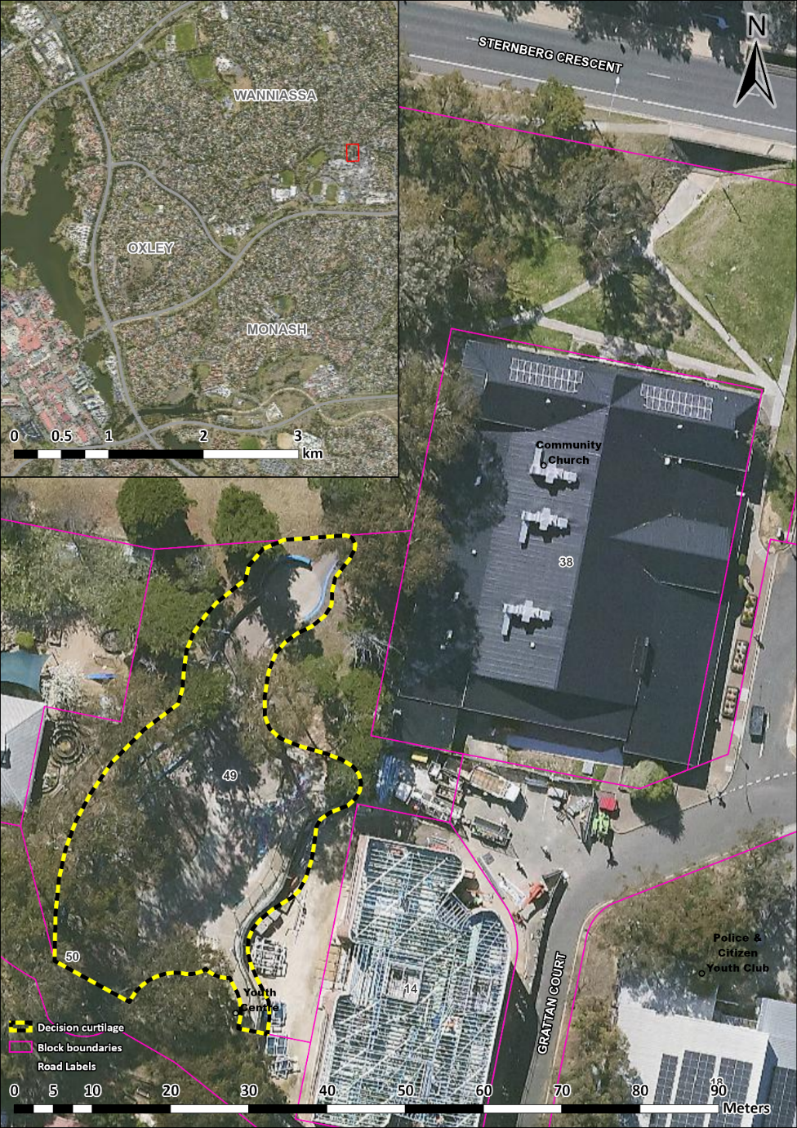
Figure 1 - Registration boundary.

