Australian Capital Territory

Planning (Lawson FUA Uplift) Minor Plan Amendment 2025

**Notifiable instrument NI2025-40**

made under the

Planning Act 2023, s 85 (Making minor plan amendments)

**1 Name of instrument**

This instrument is the *Planning (Lawson FUA Uplift) Minor Plan Amendment 2025*.

**2 Commencement**

This instrument commences on the day after notification.

**3 Minor plan amendment**

I am satisfied under the *Planning Act 2023*, section 85 (1) (a) that Minor Plan Amendment 2024-06 is a minor plan amendment to the Territory Plan.

**4 Dictionary**

In this instrument:

***Minor Plan Amendment 2024-06*** means the minor plan amendment in schedule 1.

Freya O’Brien

Delegate of the territory planning authority

28 January 2025

**Schedule 1**



MINOR PLAN AMENDMENT TO THE TERRITORY PLAN

2024–06

Lawson FUA uplift

This minor plan amendment was prepared

under part 5.3 of the *Planning Act 2023*

Contents

1.0 INTRODUCTION 1

1.1 Outline of the process 1

1.2 Summary of the proposal 1

2.0 PROPOSED TERRITORY PLAN CHANGES 2

2.1 Part B – Territory Plan Maps 2

2.2 Part D – District Policies 5

3.0 TERRITORY PLAN AMENDMENT 6

3.1 Amendment to the Territory Plan Maps (Part B) 6

3.2 Amendment to the Belconnen District Policy (D02) 7

INTERPRETATION SERVICE 8

1. INTRODUCTION
   1. Outline of the process

Minor plan amendment 2024-06 (MA2024-06) to the Territory Plan is minor plan amendment (MA) prepared under section 84 (1) (c) of the *Planning Act 2023* (the Act).

Section 84 of the Planning Act outlines the different types of MAs, some which require limited consultation to be undertaken and some which do not require consultation to be undertaken. This MA is consistent with the provisions under section 84 (1) (c) of the Act and therefore no consultation is needed.

Under Section 85 of the Act a MA can only be made if the MA is not inconsistent with the planning strategy or any relevant district strategy.

The MA is not inconsistent with the planning strategy or the Belconnen district strategy.

The National Capital Authority will be advised of this MA.

For more information on the content of the Territory Plan and minor plan amendment processes please refer to the planning website [www.planning.act.gov.au/professionals/our-planning-system/the-territory-plan/amendments-to-the-territory-plan](http://www.planning.act.gov.au/professionals/our-planning-system/the-territory-plan/amendments-to-the-territory-plan).

* 1. Summary of the proposal

MA2024-06 proposes to:

* remove part of the future urban area overlay from land in the division of Lawson and add ongoing provisions consistent with the approved estate development plan.

1. PROPOSED TERRITORY PLAN CHANGES

MA2024-01 proposes changes to parts of the following Territory Plan documents:

* Part B – Territory Plan Maps
* Part D – District Policies
  + D02 – Belconnen District Policy
  1. Part B – Territory Plan Maps

The Territory Plan map is varied to identify the zones and overlays that apply to land ceasing to be in a future urban area.

**Lawson** - Location map

**Lawson** – Existing Territory Plan map

**Lawson** – Proposed Territory Plan map

* 1. Part D – District Policies

The Belconnen District Policy will be varied to identify new provisions that apply to land ceasing to be in a future urban area.

Proposed new Figure 13:

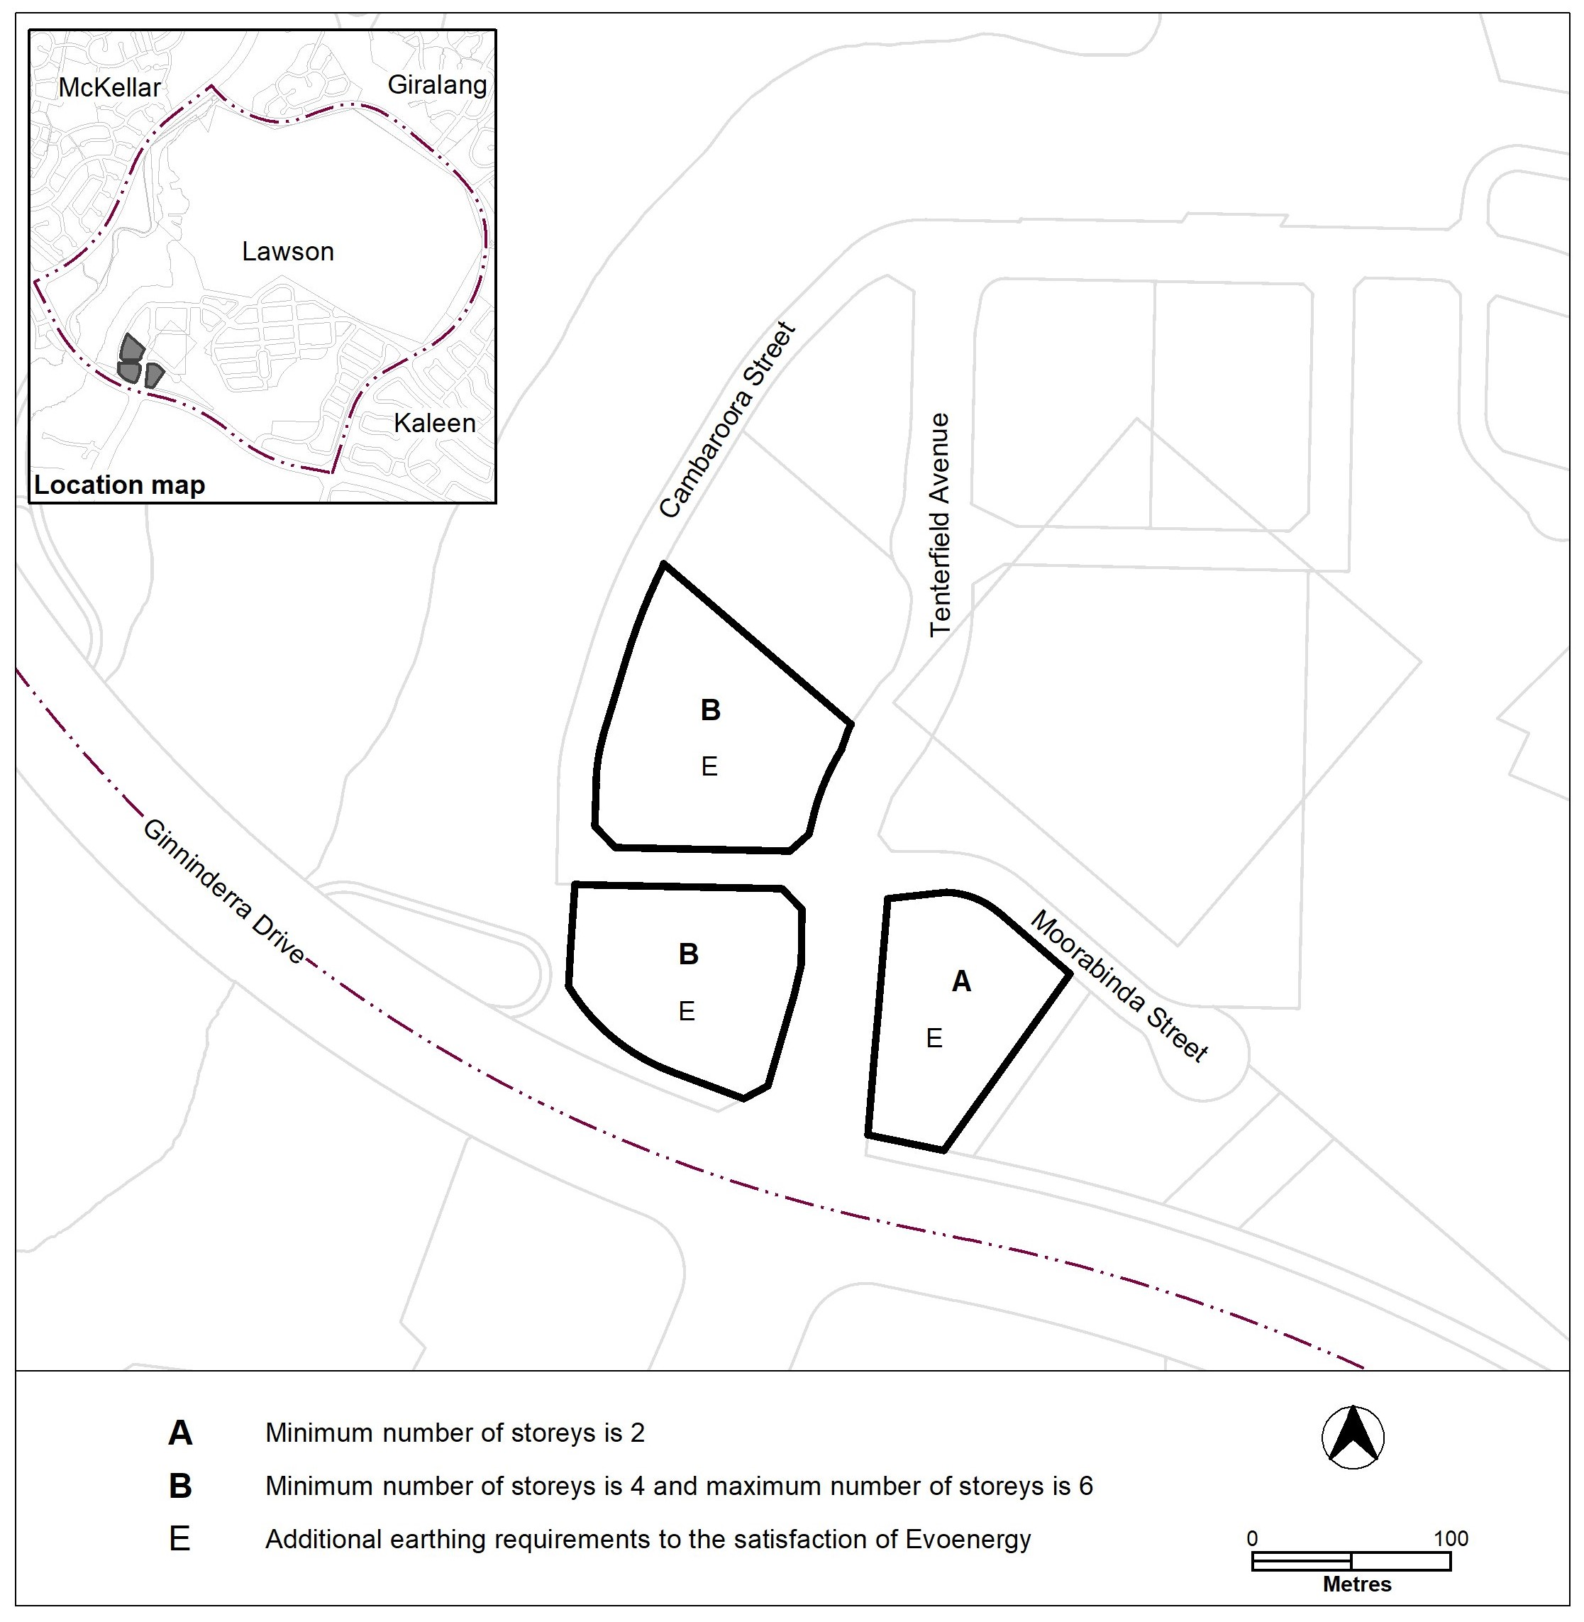

1. TERRITORY PLAN AMENDMENT
   1. Amendment to the Territory Plan Maps (Part B)

1. Lawson

The relevant part of the Territory Plan map is varied as indicated below.

* 1. Amendment to the Belconnen District Policy (D02)

2. Assessment Requirements; Lawson, Figure 13;

*Substitute*

**Figure 13 Lawson – Building heights and earthing requirements**



INTERPRETATION SERVICE

