Australian Capital Territory

Nature Conservation (Closed Reserves) Declaration 2025 (No 6)

Notifiable instrument NI2025–413
made under the
Nature Conservation Act 2014, s 259 (Conservator may close reserve)

1 Name of instrument
This instrument is the Nature Conservation (Closed Reserves) Declaration 2025 (No 6).

2 Commencement
This instrument commences at 6:00 pm on 21 July 2025.

3 Declaration
I declare that public access to:
- the reserves mentioned in schedule 1; and
- those parts of Mount Ainslie Nature Reserve, indicated in the maps at schedule 2,
is prohibited during the closure times mentioned in schedule 3.

4 Exceptions
Section 3 does not apply to:
- a person accompanied by a conservation officer exercising a function under the Act; or
- a person who is:
  - implementing the Nature Conservation (Eastern Grey Kangaroo) Controlled Native Species Management Plan 2017 (DI2017-37) within the areas declared under section 3 (closed reserves); or
  - controlling a pest animal species in the closed reserves; and
  - contracted by the Territory to conduct the activity mentioned in paragraph (i) or (ii); or
  - authorised in writing by the custodian of the closed reserve accessed by the person, to conduct the activity mentioned in paragraph (i) or (ii).

5 Expiry
This instrument expires on Thursday 31st July

Karen Taylor
Delegate of the Conservator of Flora and Fauna

16 July 2025
Schedule 1 Reserves fully closed
(see s 3)

Reserves

Mount Majura Nature Reserve

Mount Majura Nature Reserve
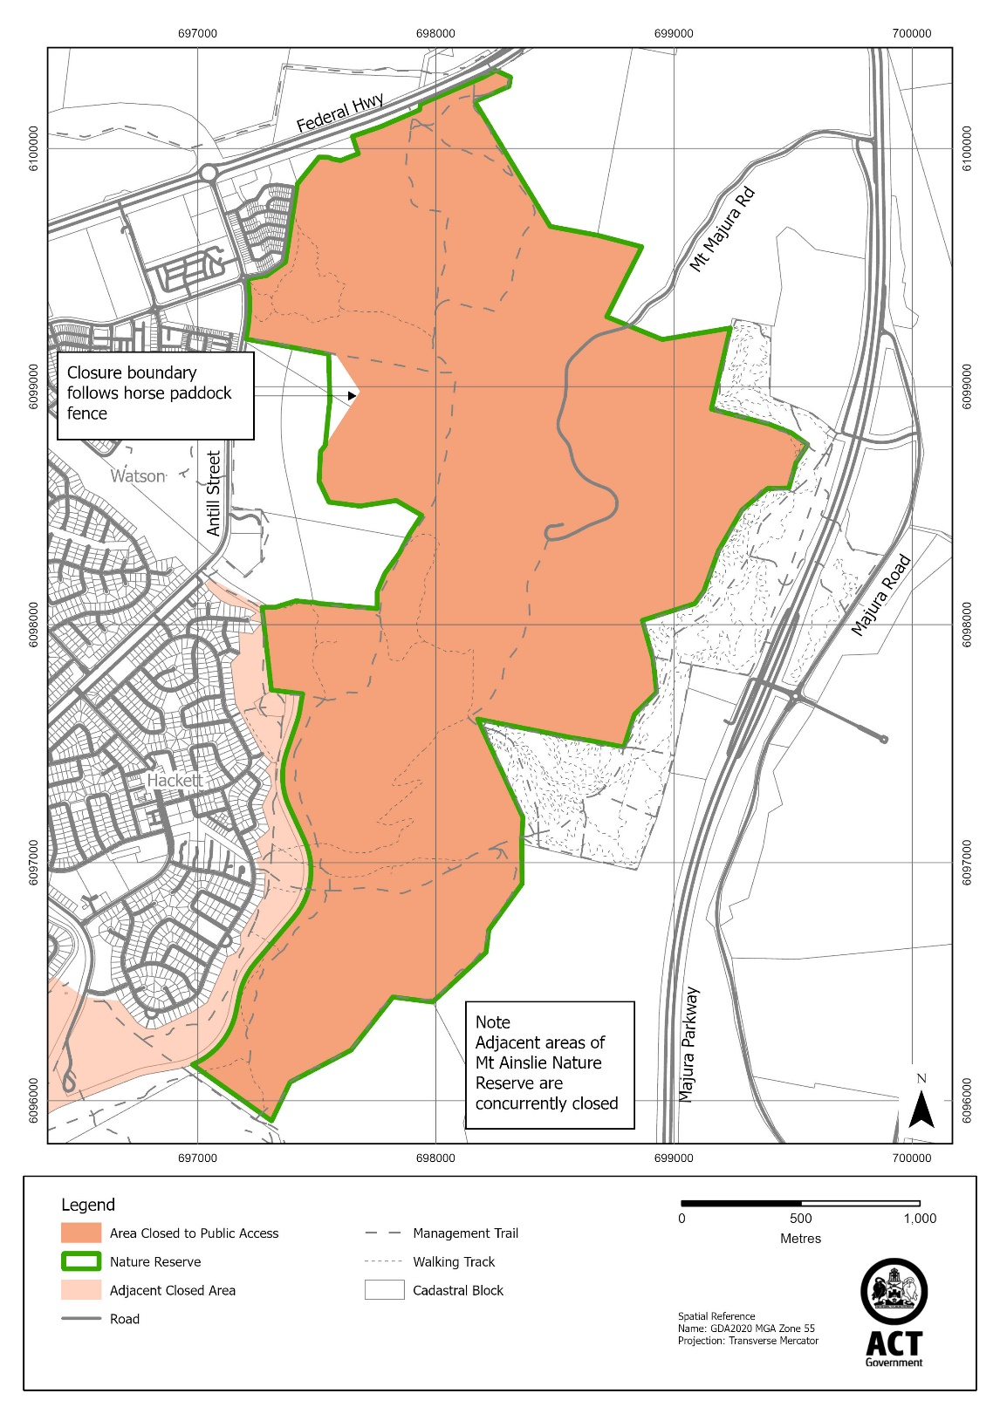
Schedule 2 Reserves partially closed
(see s 3)

Mount Ainslie Nature Reserve

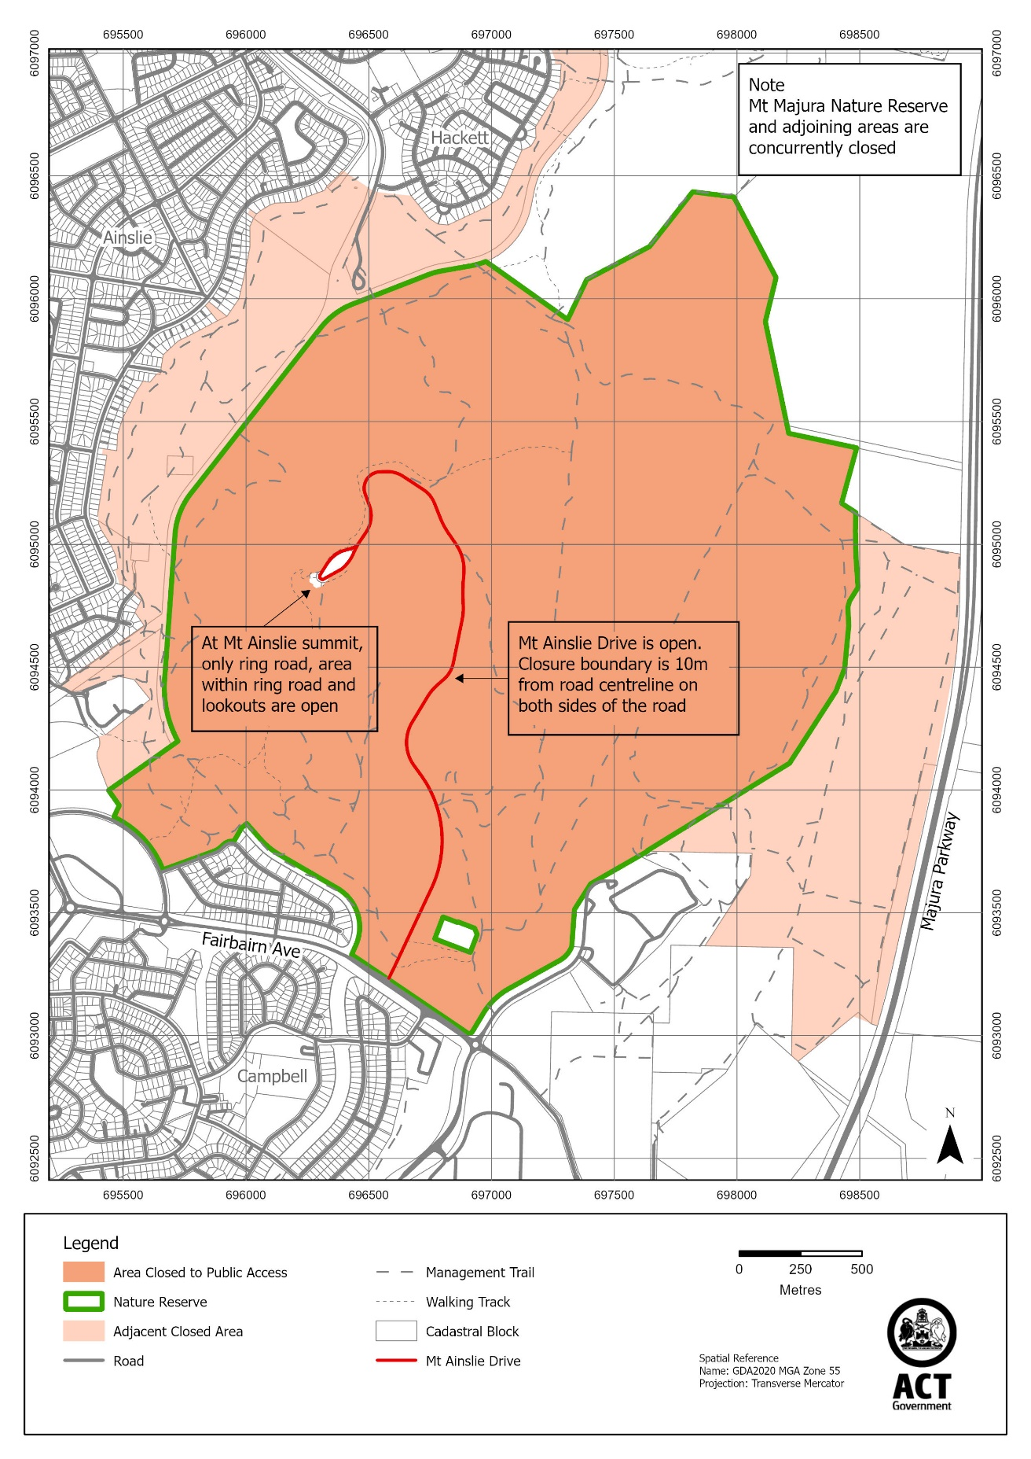
Schedule 3 Closure times
(see s 3)

Times when public access is prohibited

Beginning at 6:00 pm every Monday, Tuesday, Wednesday and Thursday and ending on the following day at 6:00 am.

Note The closure beginning on Thursday 31 July 2025 will end at midnight 1 August 2025.

