Australian Capital Territory
Road Transport (Public Passenger Services) Information to be Displayed in Taxis Approval 2025 (No 1)
Notifiable Instrument NI2025–518
made under the
Road Transport (Public Passenger Services) Regulation 2002, section 102 (Information to be displayed in taxis)

1 Name of instrument
The name of this instrument is the Road Transport (Public Passenger Services) Information to be Displayed in Taxis Approval 2025 (No 1).

2 Commencement
This instrument commences the day after its notification.

3 Approval
I approve the information to be displayed in a taxi as specified in Schedule 1 of this instrument.

4 Revocation
This instrument revokes NI2016-419 dated 29 July 2016.
Francois Patron
Manager, Vehicle Safety Standards, Access Canberra as a delegate for the Road Transport Authority
23 September 2025

TAXI USERS – YOUR RIGHTS AND RESPONSIBILITIES
Your rights  As a taxi user you have the right to:  - Decide on the route.  - See the taximeter.  - Refuse a multiple hiring.  - Have the radio on or off.  - Have the air conditioning on or off.  - See the taxi identification number.  - See the driver’s Public Vehicle Driver Authority Card.  Your driver should:  - Be courteous and helpful.  - Know and obey of all the road rules.  - Be clean, neat and tidy.  - Display his Public Vehicle Driver Authority Card.  Your taxi should be:  - Smoke free.  - Clean and tidy.  - Well maintained. | Your responsibilities  As a taxi user you must:  - Pay the correct fare including any tolls and booking fees.  - Pay a fare deposit, if requested by the driver, prior to commencing the hiring.  - Not eat, drink or act in an offensive way.  - Ensure any children under 16 are secured in an approved child restraint.  The driver can refuse to take you:  - if you are drunk, and / or  - likely to soil the vehicle, and /or  - refuse to pay a fare deposit when requested.  - If you soil or damage the taxi, the  driver can charge you a $135 fee  for cleaning costs.  - Please let the driver know if you need change from $50 or more.  - If paying by credit/debit card or merchants card, a maximum 5% surcharge may apply to the final fare. | Compliments or complaints  If you have any complaints or compliments about your taxi driver or trip, please contact:  Name of  Transport  Booking Service  Phone Number:  Email:
- Stickers
- Maximum number of passengers stickers:
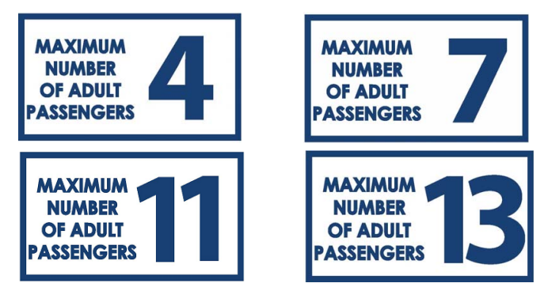
- Security camera declaration sticker:

- Consumables prohibition sticker
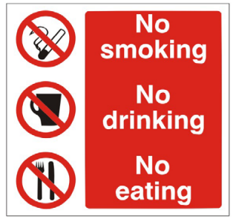
- Fees and charges sticker
You are a  passenger in:  TX_______  Transport Booking  Service Name  For Bookings call: | From JULY 20__ TAXI CHARGES  $6.00 Flagfall ‐ No Booking Fee  $62.20 per hour Waiting Fee  - Rate 1 ‐ $2.50 / Kilometre – To operate 6AM – 9PM Mon – Fri  - Rate 2 ‐ $2.80 / Kilometre – To operate 9PM – 6AM Mon – Fri  - Rate 2 applies to all day Saturday, Sunday and Public Holidays  Multiple Hiring ‐ $4.50 Flagfall  - Rate 3 ‐ $1.85 / Kilometre – To operate 6AM – 9PM Mon – Fri  - Rate 4 ‐ $2.10 / Kilometre – To operate 9PM – 6AM Mon – Fri  - Rate 4 applies to all day Saturday, Sunday and Public Holidays  SOILING CHARGE ‐ $135  AIRPORT TOLL ‐ $3.00 – COMMISIONAIRES FEE ‐ $1.20  A DEPOSIT MAY BE REQUESTED AND PAID PRIOR TO  COMMENCEMENT OF THE HIRING.  THE DRIVER MUST AT ALL TIMES ENGAGE THE TAXI METER  **FARE EVASION IS AN OFFENCE AND CARRIES A MAX PENALTY OF $________**

From JULY 20__ HIGH OCCUPANCY TAXI
$9.00 Flagfall ‐ No Booking Fee ‐ $62.20 per hour Waiting Fee
WHERE THIS VEHICLE IS HIRED BY A GROUP OF FIVE TO SEVEN
(5‐7) PERSONS, THE FOLLOWING RATES APPLY:
- Rate 5‐ $3.70 / Kilometre – To operate 6AM – 9PM Mon – Fri
- Rate 6‐ $4.30 / Kilometre – To operate 9PM – 6AM Mon – Fri
- Rate 6 applies to all day Saturday, Sunday and Public Holidays
WHERE THIS VEHICLE IS HIRED BY EIGHT (8) OR MORE PERSONS, THE FOLLOWING RATES APPLY:
- Rate 7 ‐ $4.65 / Kilometre – To operate 6AM – 9PM Mon – Fri
- Rate 8 ‐ $5.40 / Kilometre – To operate 9PM – 6AM Mon – Fri
- Rate 8 applies to all day Saturday, Sunday and Public Holidays
A DEPOSIT MAY BE REQUESTED AND PAID PRIOR TO COMMENCEMENT OF THE HIRING.
THE DRIVER MUST AT ALL TIMES ENGAGE THE TAXI METER
** FARE EVASION IS AN OFFENCE AND CARRIES A MAX PENALTY OF $_______ **

